# Developing of ANN model and the optimization of technological process of drinking water preparation using PSO algorithm

1. In the first part of the master project, several models of multiple linear regressions and artificial neural networks have been created, which, based on the quality of the raw and drinking water that are given at the entrance, determine the amount of chemical substances added during the water purification. Results of modeling are given in the following diagrams:
   * MLR aluminum-sulfate
     + Prediction based on training data set (x-axis: Predicted values of Al2(SO4)3 dosages, y-axis: Measured values of Al2(SO4)3 dosages)

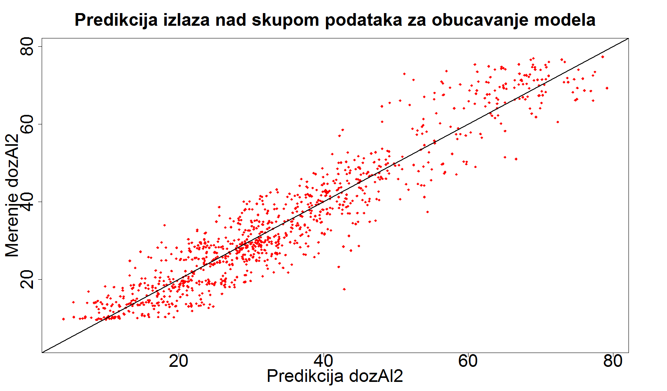

* + - Prediction based on test data set (x-axis: Predicted values of Al2(SO4)3 dosages, y-axis: Measured values of Al2(SO4)3 dosages)

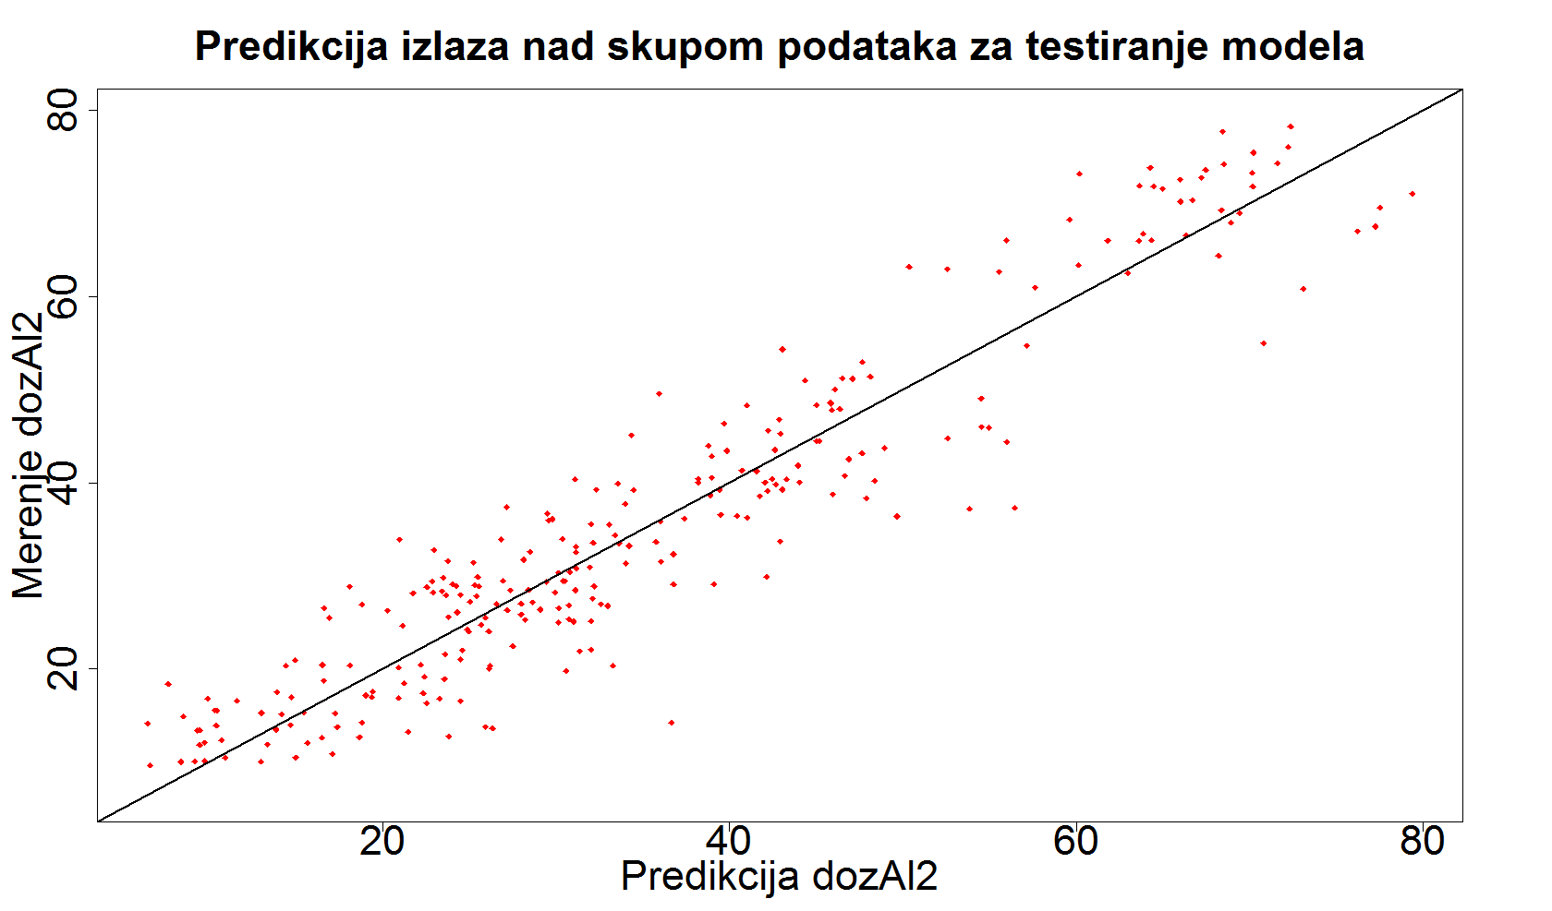

* + ANN aluminum-sulfate (ANN topology: 28-36-22-1)
    - Prediction based on training data set (x-axis: Predicted values of Al2(SO4)3 dosages, y-axis: Measured values of Al2(SO4)3 dosages)

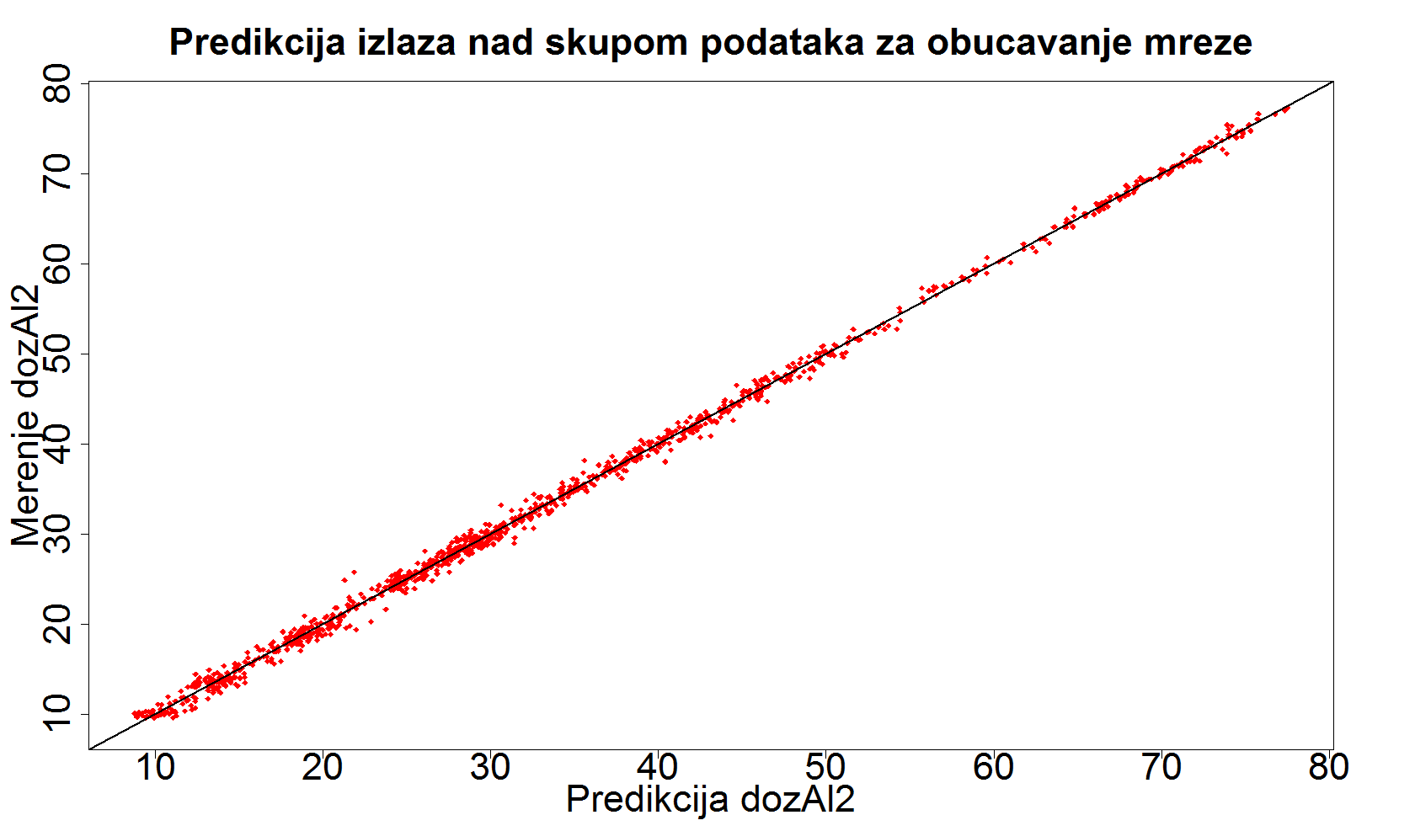

* + - Prediction based on test data set (x-axis: Predicted values of Al2(SO4)3 dosages, y-axis: Measured values of Al2(SO4)3 dosages)

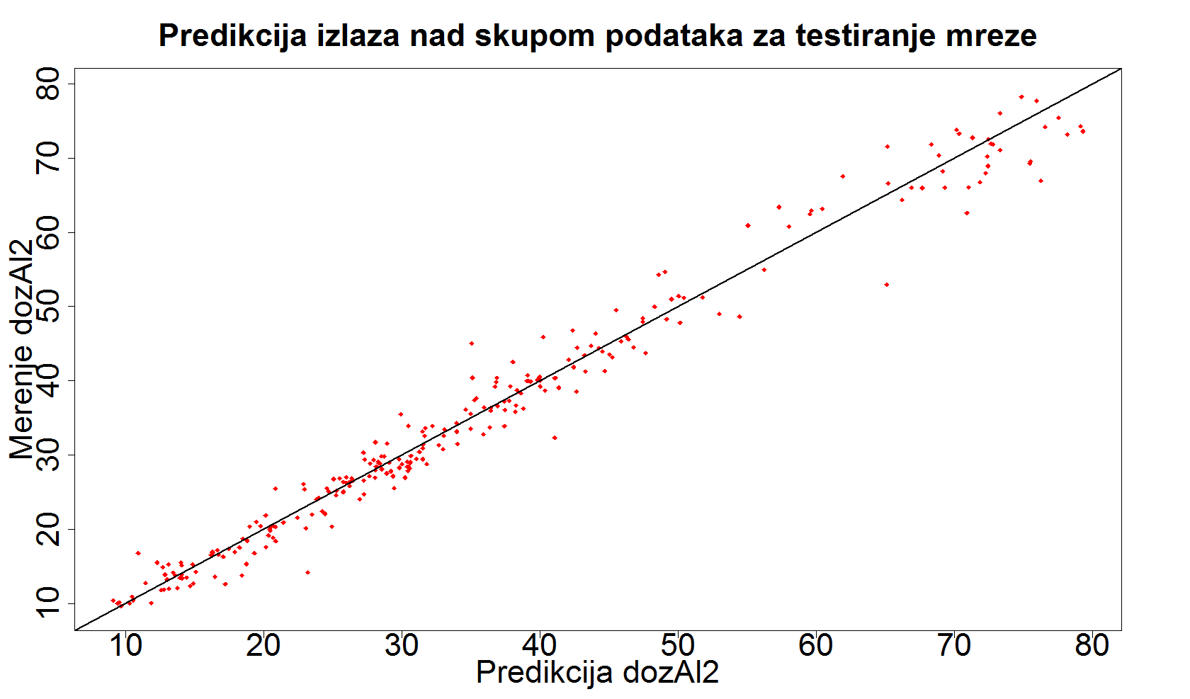

* + - Stability assessment of model based on calculating RMSE through k-fold cross validation method (k=10, range of dosage values: 10 – 78 g/m3, x-axis: RMSE through 10 iterations, y-axis: frequency)

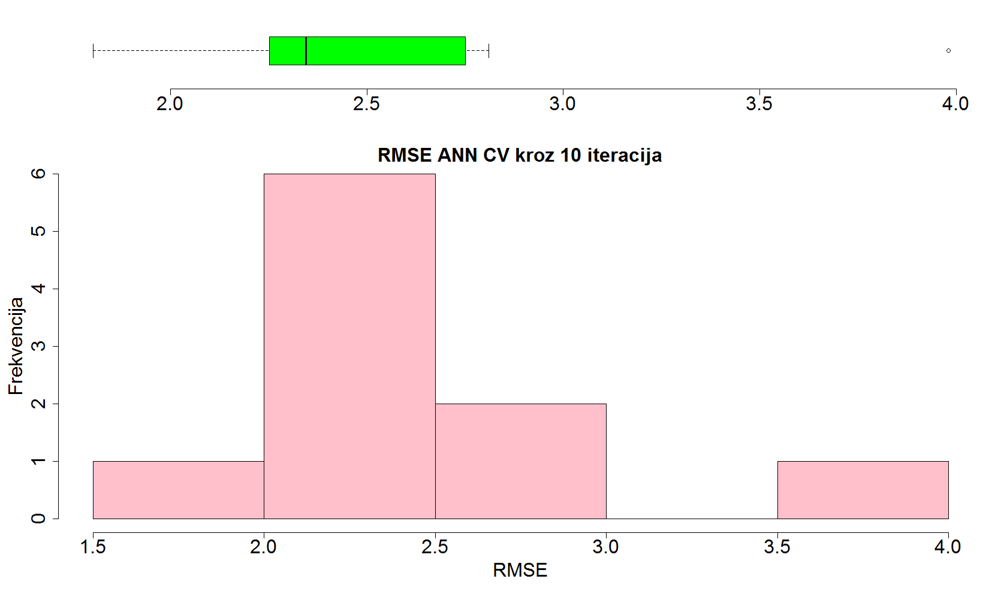

* + ANN chlorine (ANN topology: 28-36-22-1)
    - Prediction based on training data set (x-axis: Predicted values of Cl2 dosages, y-axis: Measured values of Cl2 dosages)

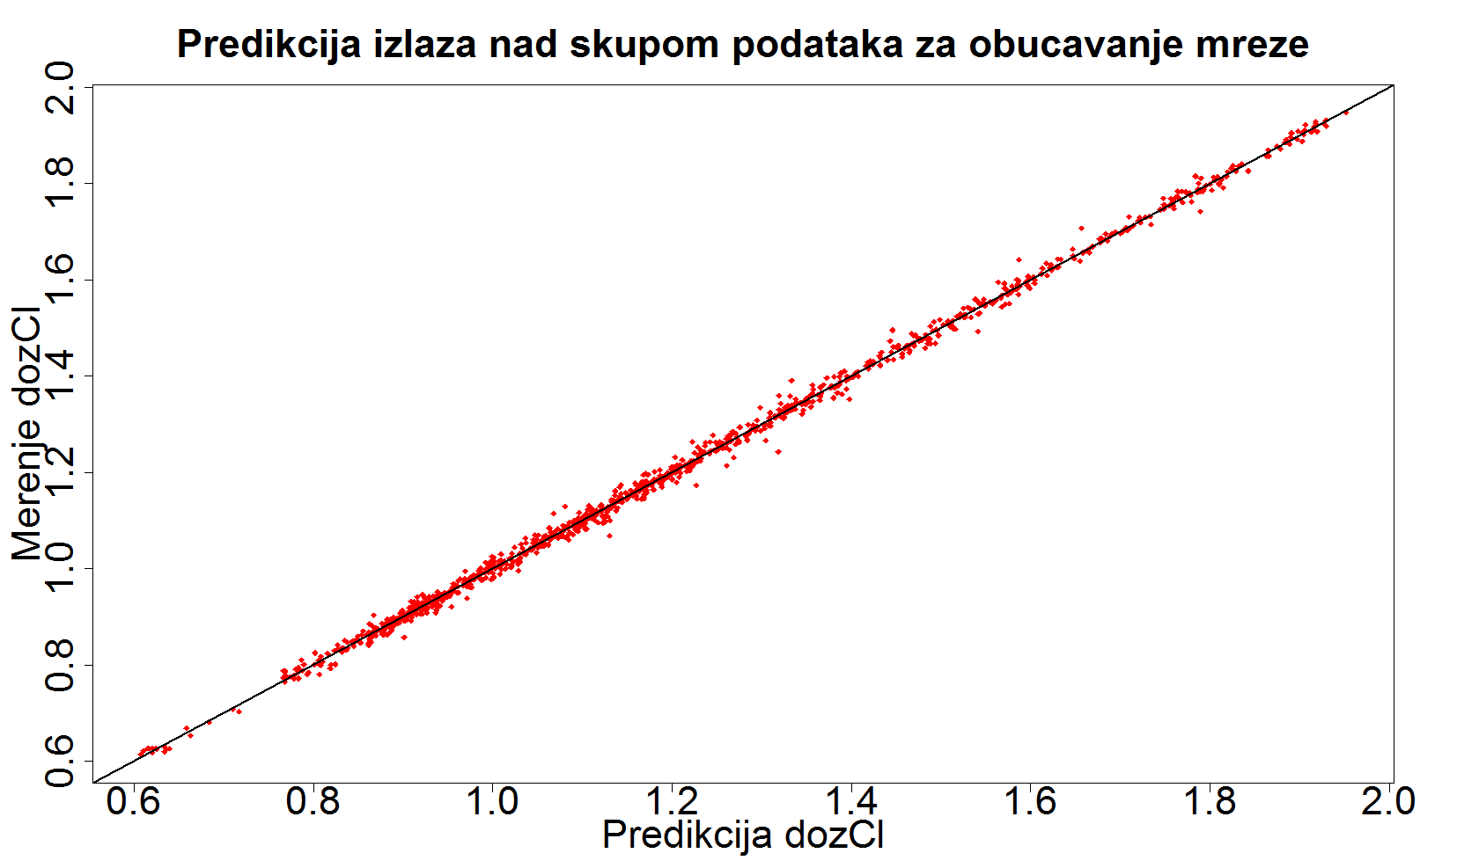

* + - Prediction based on test data set (x-axis: Predicted values of Cl2 dosages, y-axis: Measured values of Cl2 dosages)

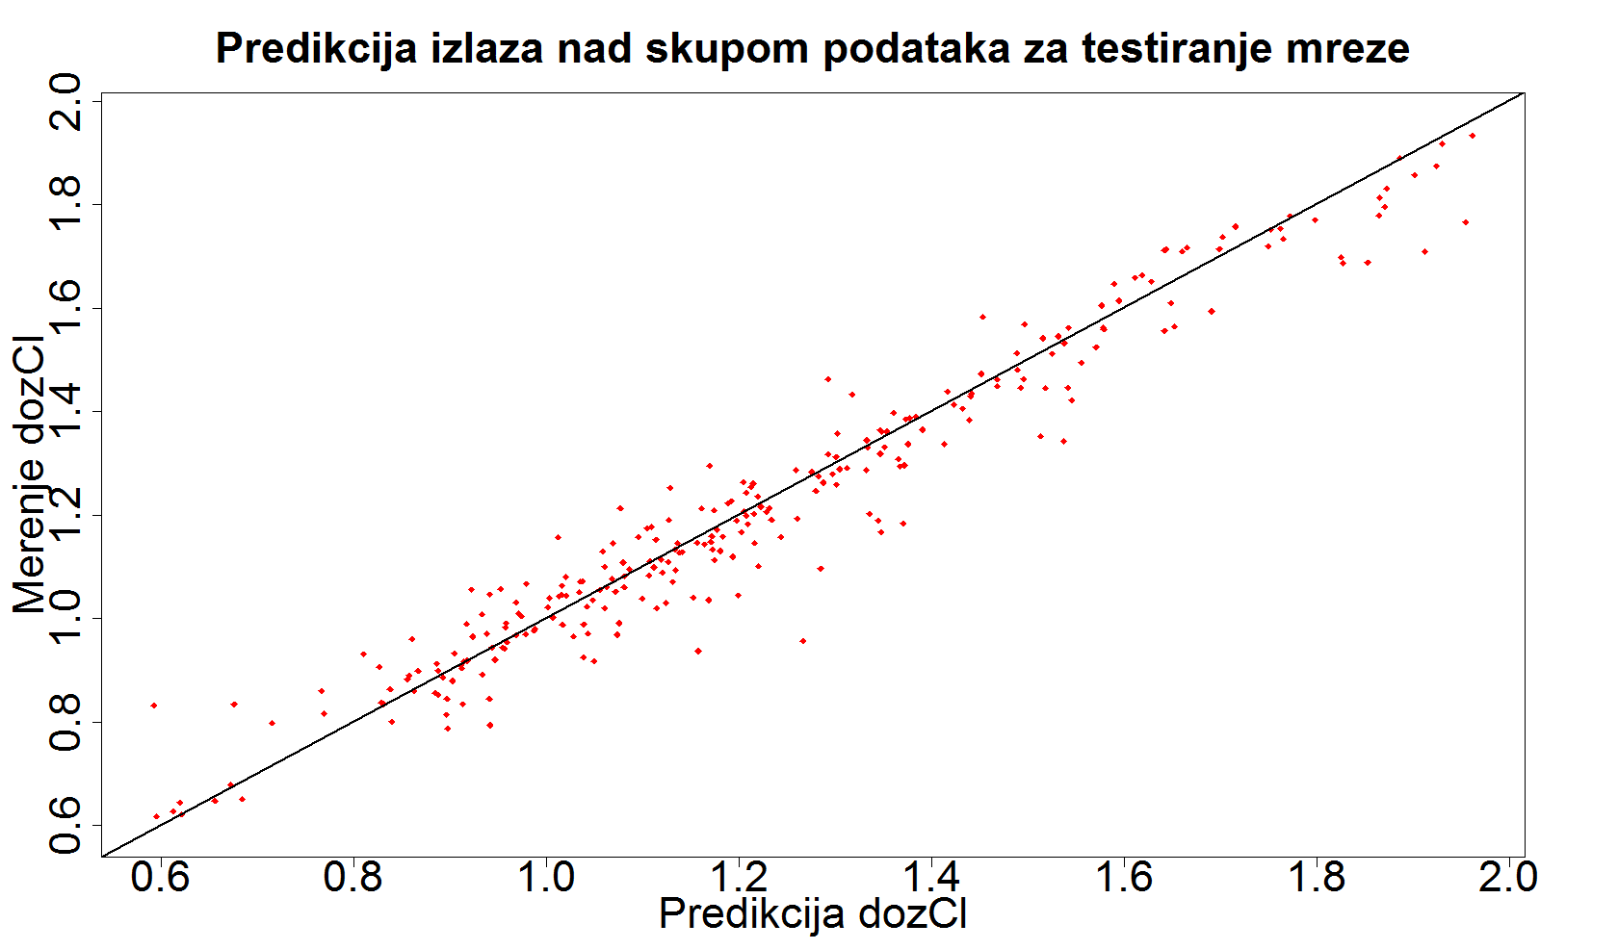

* + - Stability assessment of model based on calculating RMSE through k-fold cross validation method (k=10, range of dosage values: 0.61 – 1.95 g/m3, x-axis: RMSE through 10 iterations, y-axis: frequency)

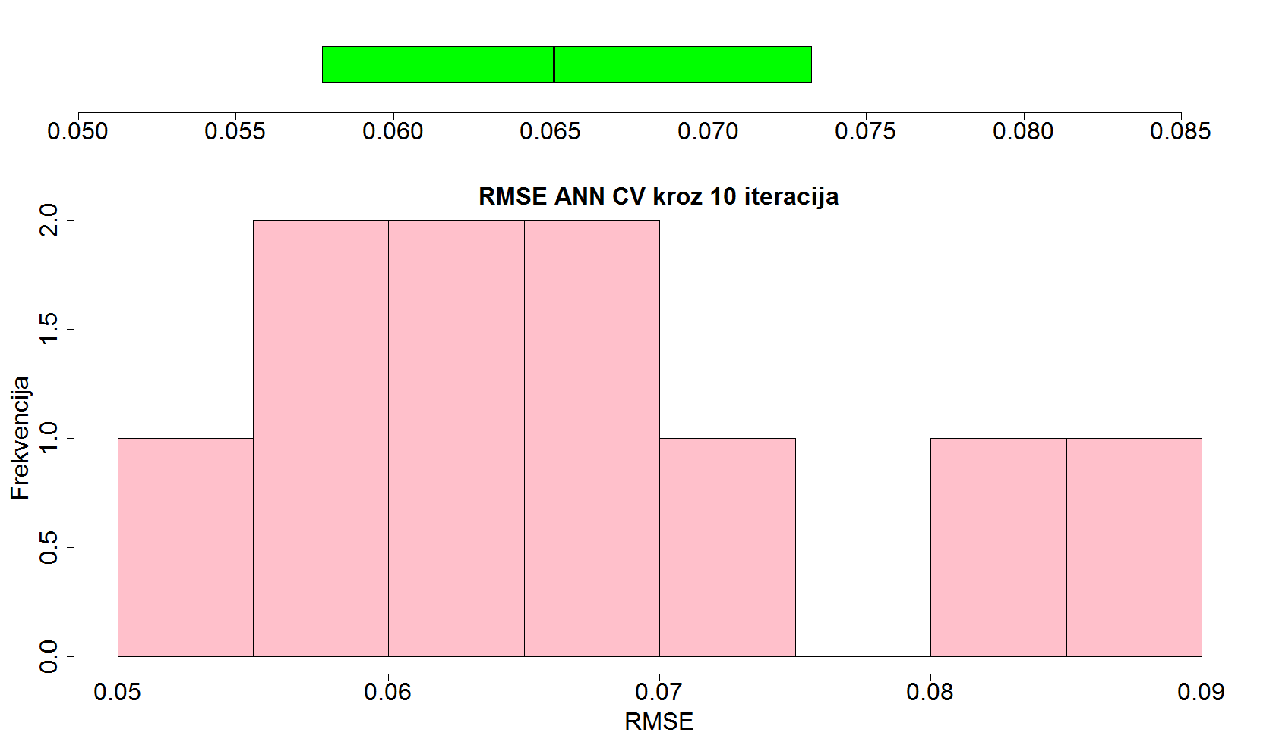

* + ANN polyelectrolytes (ANN topology: 28-36-22-1)
    - Prediction based on training data set (x-axis: Predicted values of polyelectrolytes dosages, y-axis: Measured values of polyelectrolytes dosages)

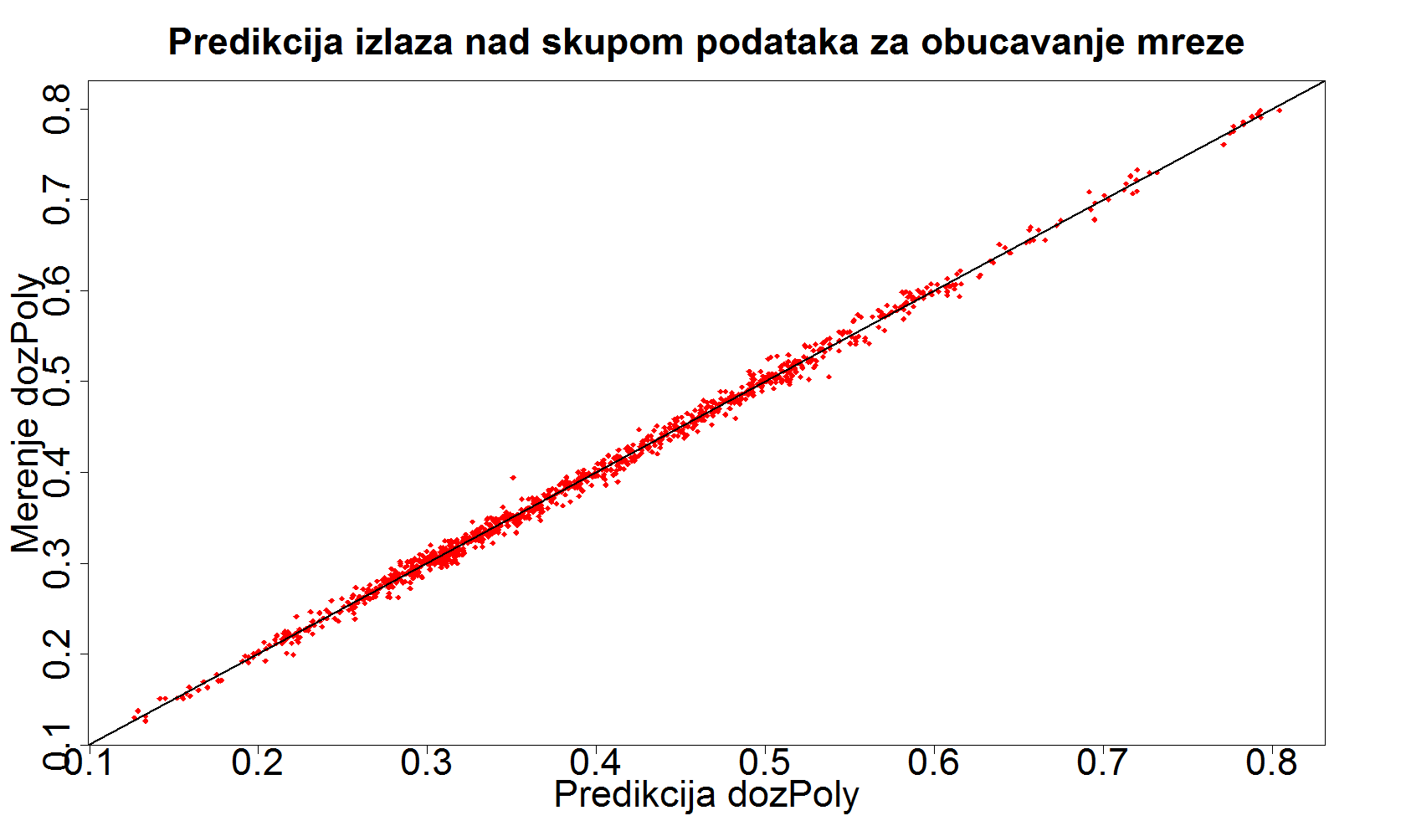

* + - Prediction based on test data set (x-axis: Predicted values of polyelectrolytes dosages, y-axis: Measured values of polyelectrolytes dosages)

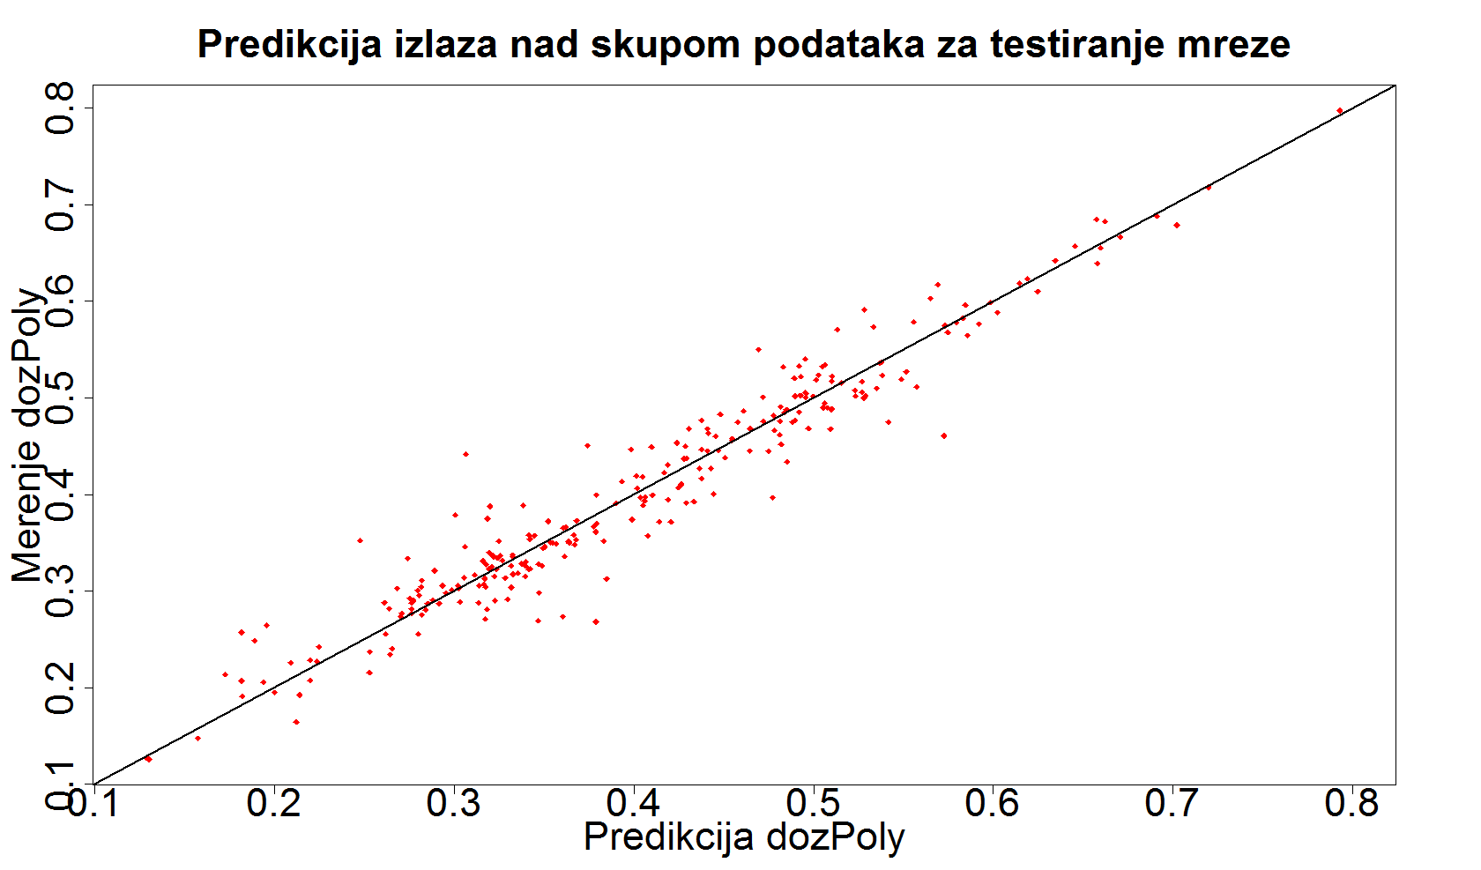

* + - Stability assessment of model based on calculating RMSE through k-fold cross validation method (k=10, range of dosage values: 0.13 – 0.8 g/m3, x-axis: RMSE through 10 iterations, y-axis: frequency)

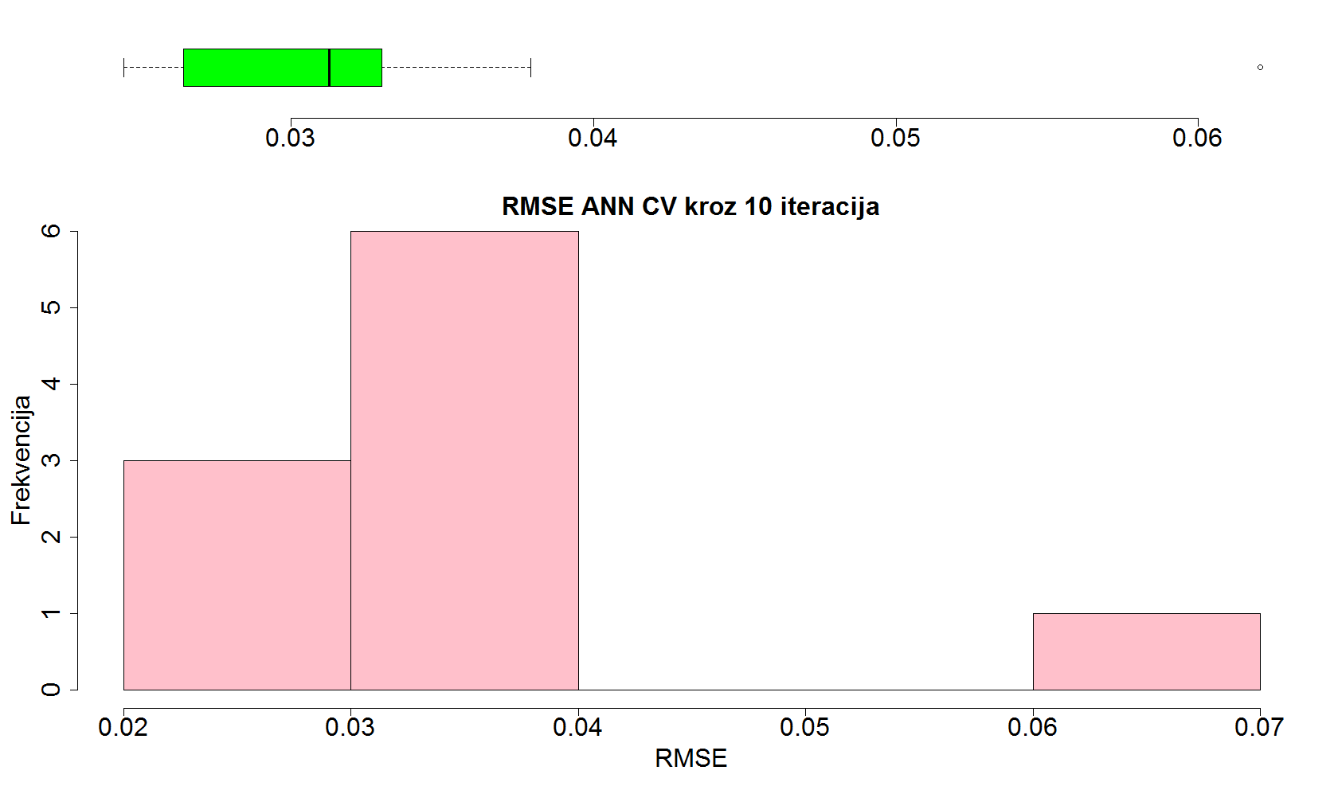

1. In the second part of the paper, using the process of PSO optimization, and with the created models, minimum dose of the necessary substances is determined in order to get drinking water of satisfied quality for given raw water. Optimization results are given below:
   * Aluminum-sulfate – the following diagrams show the values of the parameters of the drinking water as well as the quantity of aluminum-sulfate dosage. Minimum values of variables are marked with green points, maximal values are marked with red points, and the values that are obtained by optimization are marked with blue points. The green rectangle is used to mark dosage of water with aluminum-sulfate. It is possible to spot that dosage value tends to the minimal value.

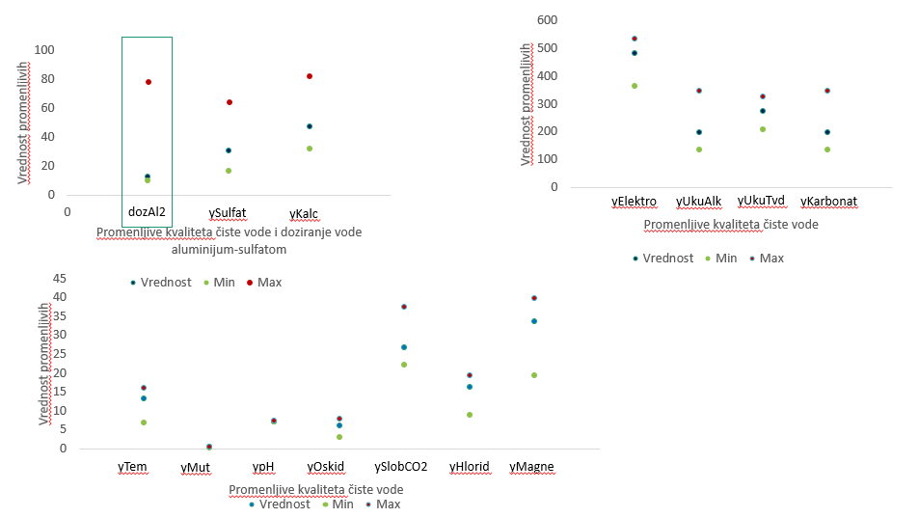

* + Chlorine - the following diagrams show the values of the parameters of the drinking water as well as the quantity of chlorine dosage. Minimum values of variables are marked with green points, maximal values are marked with red points, and the values that are obtained by optimization are marked with blue points. The green rectangle is used to mark dosage of water with chlorine. It is possible to spot that dosage value tends to the minimal value.

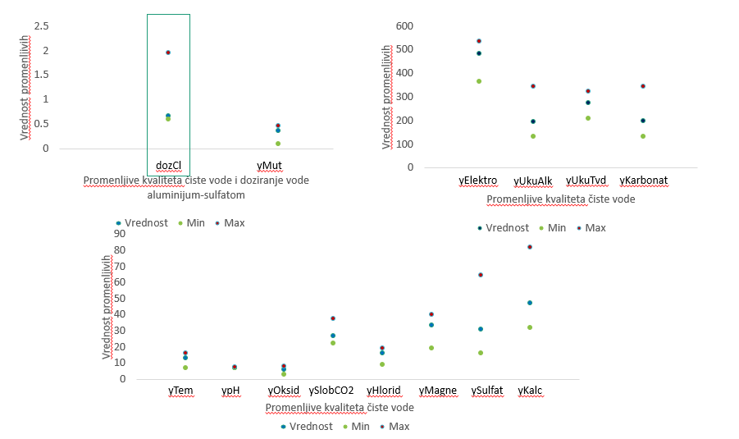

* + Polyelectrolytes - the following diagrams show the values of the parameters of the drinking water as well as the quantity of polyelectrolytes dosage. Minimum values of variables are marked with green points, maximal values are marked with red points, and the values that are obtained by optimization are marked with blue points. The green rectangle is used to mark dosage of water with polyelectrolytes. It is possible to spot that dosage value tends to the minimal value.

