**Fajlovi su:**

Calculator.java

Start.java

**LOC**

===============================================================================

EXTENSION NAME : linecounter

EXTENSION VERSION : 0.2.7

-------------------------------------------------------------------------------

count time : 2023-06-16 18:36:09

count workspace : c:\Users\tijan\OneDrive\Dokumenti\TijanaLeginTCP

total files : 2

total code lines : 148

total comment lines : 5

total blank lines : 60

statistics

| extension| total code| total comment| total blank|percent|

-------------------------------------------------------------------------

| .java| 148| 5| 60| 1.0e+2|

-------------------------------------------------------------------------

Calculator.java, code is 129, comment is 5, blank is 53.

Start.java, code is 19, comment is 0, blank is 7.

**Calculator.java (ciklomatska slozenost)**

| Function Name | Start Line | End Line | Cyclomatic Complexity (Threshold: 10) | Lines of Code (Threshold: 50) | Parameter Count (Threshold: 4) |
| --- | --- | --- | --- | --- | --- |
| Calculator::Operations::Operations | 14 | 15 | 1 | 2 | 0 |
| Calculator::Operations::ToString | 17 | 19 | 1 | 3 | 0 |
| Calculator::Run | 23 | 25 | 1 | 3 | 1 |
| Calculator::evaluateExpression | 27 | 71 | 12 | 33 | 1 |
| Calculator::Calculate | 73 | 185 | 12 | 77 | 2 |

**Start.java (cilomatska slozenost)**

| Function Name | Start Line | End Line | Cyclomatic Complexity (Threshold: 10) | Lines of Code (Threshold: 50) | Parameter Count (Threshold: 4) |
| --- | --- | --- | --- | --- | --- |
| Start::main | 5 | 24 | 3 | 16 | 1 |

Calculator.java ( konvertovan u javaScript file) calculator.js

**Calculator.js (kognitivna slozenost)**

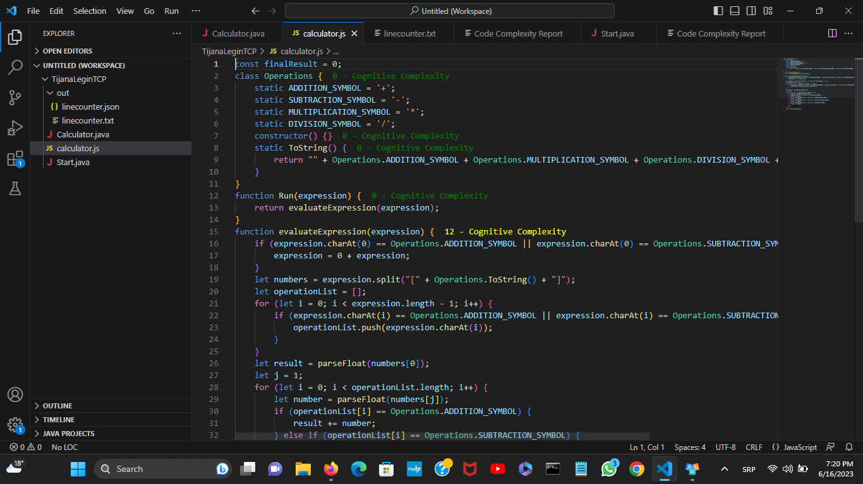

**Start.js ( kognitivna slozenost)**

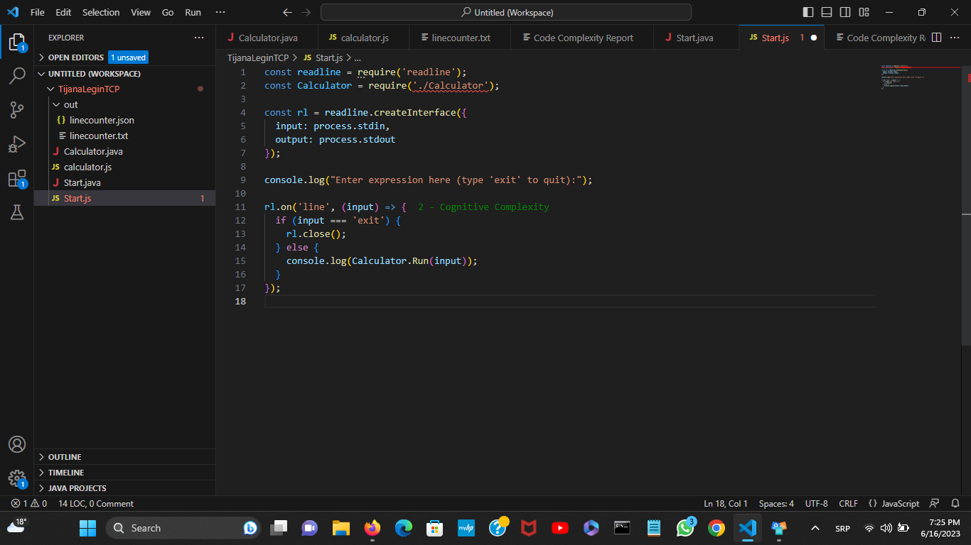

**TIJANA LEGIN**