1. Sylvaccess
To adapt the Sylvaccess application into a plugin for QGIS, I first had to
Understand the operation. For this, I used Sylvaccess and tested it with a
Digital Terrain Model (DTM), derived from high-resolution spatial data (LiDAR,
Radar,...). The chosen test area is the Meisenthal, an area west of Mulhouse in the
Haut-Rhin, right next to Oberbruck. The MNT represents the elevation at each point, which
Allows for a very precise representation of the terrain and its particularities.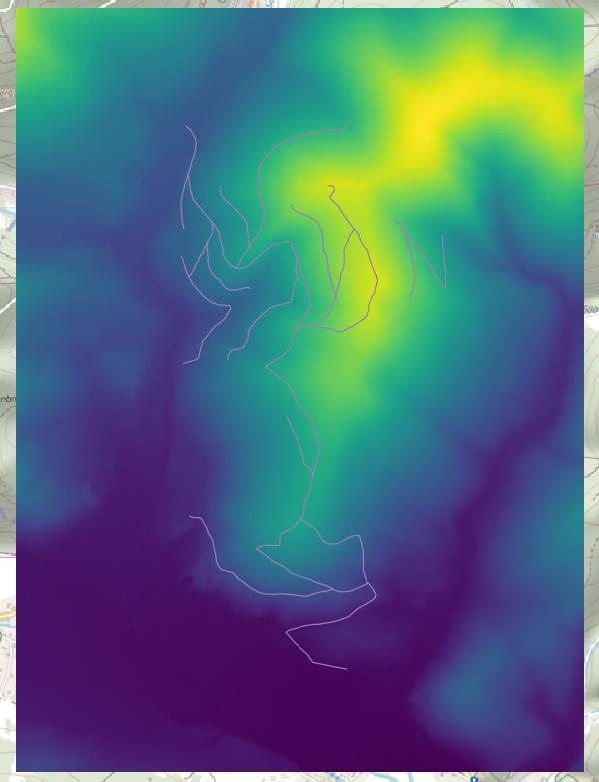
Here is the MNT of the meisenthal, as well as the servicing of the area. By giving it to Sylvaccess, with
the service file, I can draw three different maps according to my need:
- One that gives me the accessibility for a forest tractor
- One that gives me accessibility for a forest porter
- One that gives me the cable skidding lines that it is possible to set up.
Here is for example the area where a forest tractor can go to the meisenthal, the
areas that he cannot wait are either too steep or too far from the service.
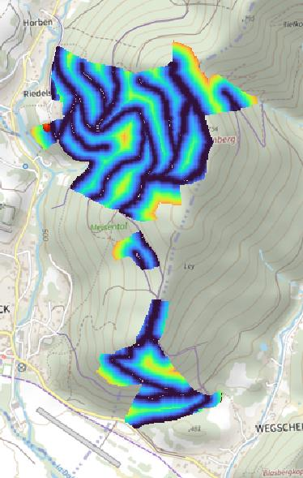
These test data will also be useful to me in the future so I can compare them with my
plugin.
Then, I recreated the user interface of Sylvaccess, which is the only one of the three applications to
have one. Here is the Spatial Input page of the interface as it appears in QGIS.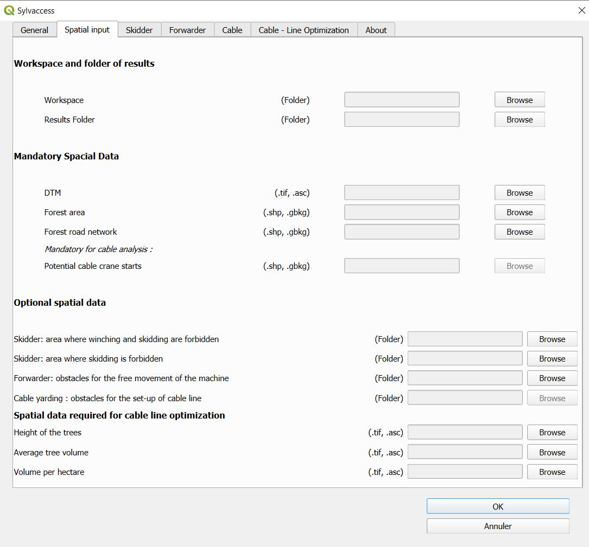This page allows to give the plugins the link to all the spatial data of which it could
need, as well as obstacle files if, for example, there is a rock or a house at
avoid.
Then, I had to retrieve the code from Sylvaccess and adapt it for use in QGIS, it took
remove the cython parts and redo these functions here in python, change the method of
translation of simple "if langue == French" has a call to a Pyqt5 method (a library
python) to subsequently be able to translate everything on Qt Linguist and thus have a file of
translation for each desired language. This also allows users to add a
translation if they wish, without having to modify the code. Then, I had to use it again
from the Pyqt5 library to connect the different items of my interface to my code. I have thus
functions that only deal with linking buttons, reading written data, or
know the status of a checkbox. Once all this is done, I was able to test my plugins and see
that it outputs the same results as the application. Unfortunately, due to an error
recently discovered in the latest versions of QGIS, the plugins run much more
slowly. Add to that, the transition from cython to python for a good part of the functions
of calculation, and we end up with enormous execution times. The calculation for the tractor and the
carrier take 7 and 15 minutes respectively on average, which leaves a time
reasonable for mapping.

On the other hand, due to the complexity and the mass of calculation that
requires the cable lines, the execution time amounts to more than 48 hours (no execution
complete perform). The problems with the cables mainly come from the calculation mass, here are the steps from the calculation of cable lines:
1- Accessibility calculation for a cable truck
2- For each accessible pixel, Sylvaccess tests in 360 directions which are possible.
3- Comparison of viable lines to see which are better.
The problem comes of course from step 2 which requires making 360 very complex calculations
for each pixel of the accessible MNT.
I was nevertheless able to slightly optimize the plugin by getting rid of pieces of code never
called up (between 10 and 15% of the total code) and greatly simplifying the storage of variables.
This allowed me to reach 7 and 15 minutes for the tractor and carrier announced earlier, in
starting from 12 and 24 minutes. Which makes a reduction of about 40% which is not at all
negligible.
2. SylvaRoad
The transition from SylvaRoad to a plugin was much easier than for Sylvaccess, I actually had
already acquired experience in the field and I also now knew the errors not to
do, as well as the methods that work well. Thus, after understanding the
operation of the application, I was able to create an interface that follows: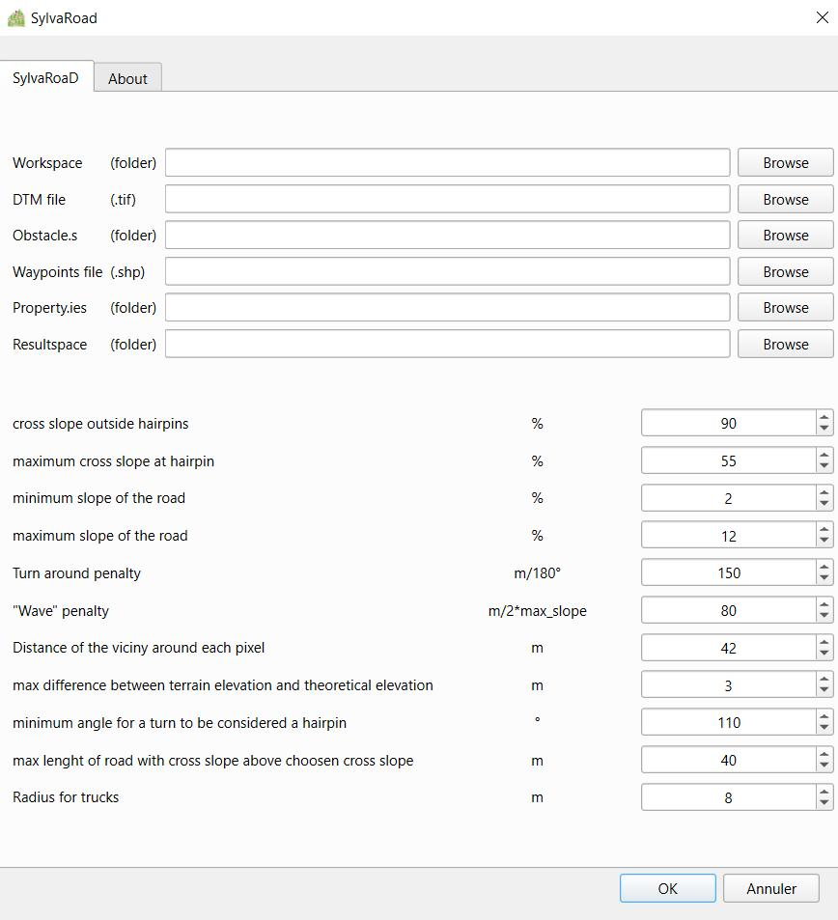SylvaRoad takes as input the MNT as well as a point path that traces the new
service that one wishes to create, or at least the two points that one wishes to connect.
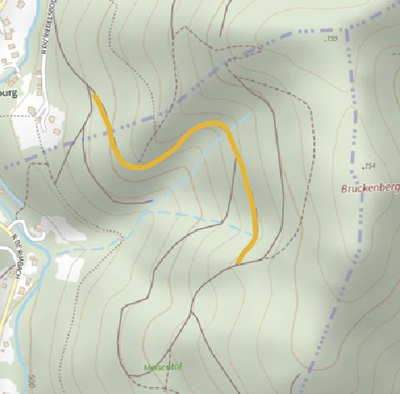
In yellow, the path that one wishes to trace in the meisenthal. The development of the plugin follows the same steps as for Sylvaccess. On the other hand for SylvaRoad, it was impossible for me to make the plugin work or even the application on which it is based. No matter the test conditions or the place of execution, SylvaRoad never gave me any results.
So I resolved to use a similar plugin available on QGIS, Forest Road
Designer, made by Spaniards. Beyond the language barrier, the application not being
translated, they do not have quite the same functionalities. SylvaRoad avoids private land, which Forest Road Designer does not. Conversely, Forest Road Designer allows the path to be traced manually by sections, which SylvaRoad does not allow. Here is the path that could be taken to connect the 2 ends of my segments
while allowing the truck to pass:
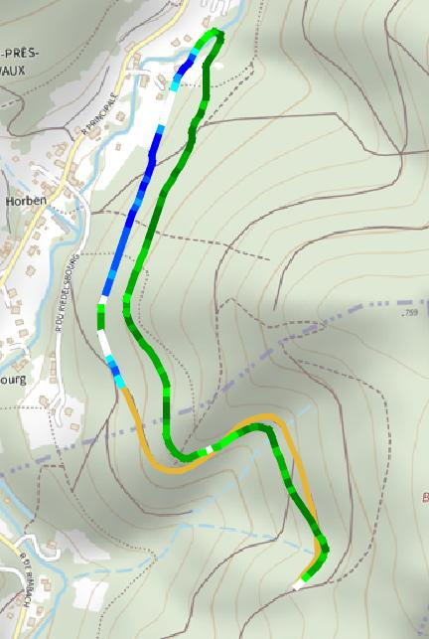
The path that is possible to take for a truck makes a wide detour to be able to
allow to take an epignle without overturning. Unfortunately, this path is not
viable given that it crosses the property of several inhabitants of the village next door.
3. CubaRoad
CubaRoad aims to determine how many tons of excavation and backfill are needed for the
construction of a new service in the forest. Thus, we can get a fairly accurate idea
of the difference between the two and thus be able to foresee the necessary costs if the
backfilling is superior to clearing. The application passage follows the same method
only for Sylvaccess and SylvaRoad. Here is the interface I created for CubaRoad: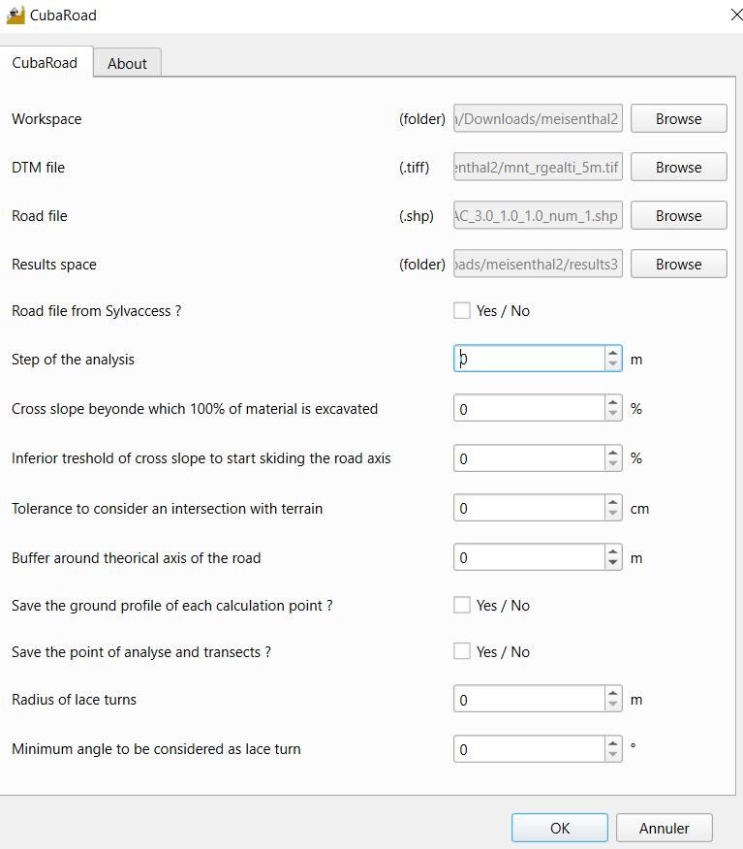
We can notice the box that asks us if our route comes from SylvaRoad. If it’s the
case, CubaRoad avoids pin-related calculations because it considers them to be already viable if it come from SylvaRoad. Unfortunately, I couldn’t obtain a route file from
SylvaRoad to be able to test it. But thanks to the road provided by Forest Road Designer, I have been able to test CubaRoad and confirm that it is operational.
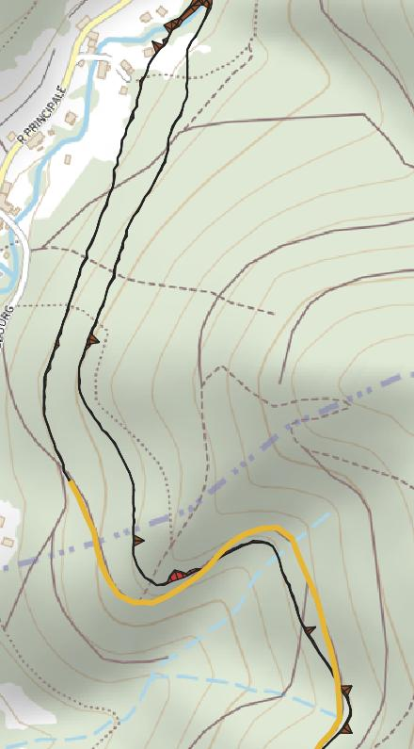
We can see in red everything that needs to be cleared/backfilled. In addition to the map, there are summary Excel tables: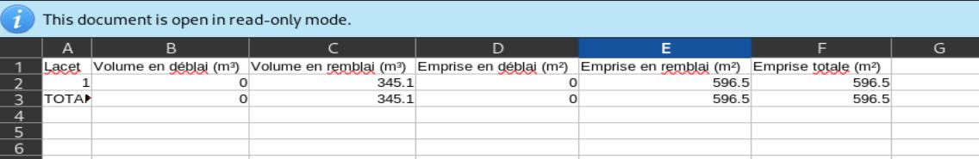
Above, the excel that summarizes the data related to the pins, there is only one, which is the
turn furthest to the north.

