Report 2

Floating-Point Multiplier

Team Members:

Tijmen Van Der Beek

Dylan Easterly

**Floating Point encoding**

1-bit Sign bit

5-bit Exponent

10-bit Mantissa

**Block Diagram**

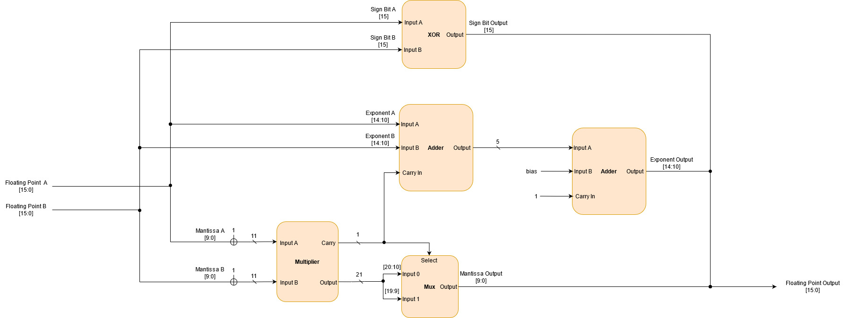

**Division of Work**

Tijmen Van Der Beek:

-Adders

Dylan Easterly:

-Multiplier

Undecide:

-Mux

Done:

-XOR

**Progress**

We have discussed the design and encoding of the floating-point multiplier and are now working on our parts of the project.