**Quản lý khách hàng**

-Use case QL KH :

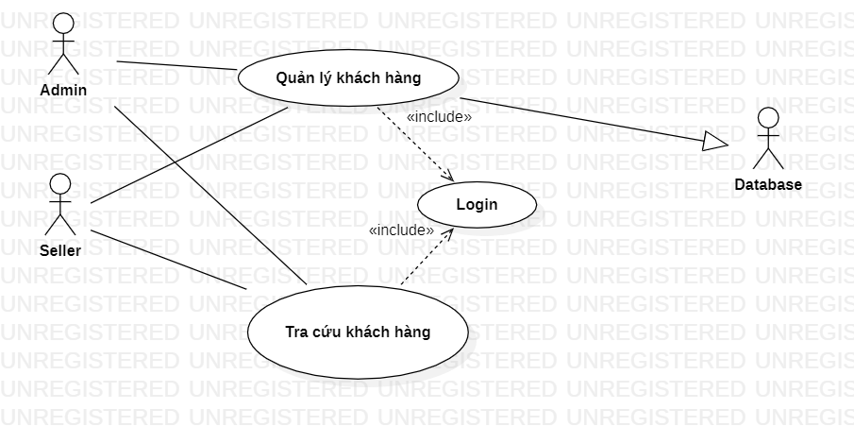

-Activity QLKH

