a. Vẽ lược đồ CSDL quan hệ
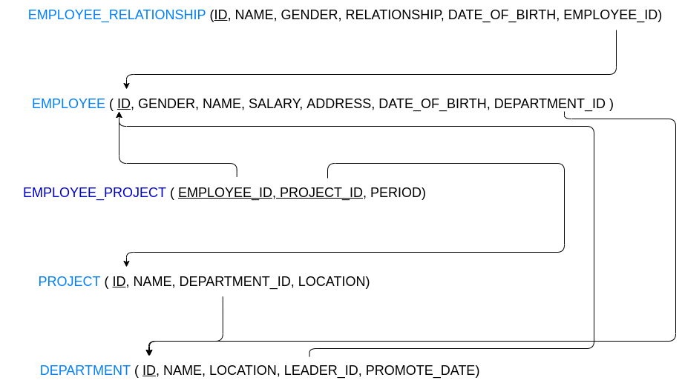

b. Vẽ các bảng dữ liệu và thêm dữ liệu mẫu
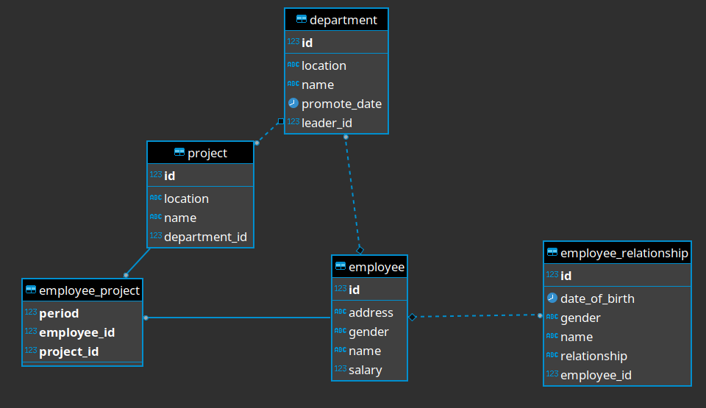

department
id | location | name | promote_date | leader_id
1 | Floor 3 | HR | 2021-10-09 07:37:39.139 | 1
2 | Floor 3 | DEV BACK-END | 2021-10-09 07:37:39.139 | 2

employee
id | name | address | gender | salary
1 | LongTPT | Nguyen Khoa, p2, q4, TPHCM | MALE | 5000000
2 | VuLTH | Bien Hoa, Dong Nai | FEMALE | 10000000

employee_project
employee_id | project_id | period
1 | 1 | 1000
2 | 1 | 1000

employee_relationship
id | name | date_of_birth | gender | relationship | employee_id
1 | Me Vu | 1979-10-08 07:38:39.138 | FEMALE | ME | 2
2 | Cha Vu | 1959-10-09 00:00:00.000 | MALE | CHA | 2

project
id | name | department_id | location
1 | LOS | 2 | FLOOR 3
2 | eKYC | 2 | FLOOR 4

