1.) Foreign Key(reference):
-superssn (ssn of employee table) : one-to-many
-mgrssn(ssn of employee table) : one-to-many
-dno(dnumber of department table) : one-to-many
-dnumber of dept_location (dnumber of department table) : one-to-many
-dnum of project table(dnumber of department table) : one-to-many
-essn of works_on(ssn of employee table) : one-to-one
-pno of works_on(pnumber of project table) : one-to-one
-essn of department table(ssn of employee table) : one-to-one
3.)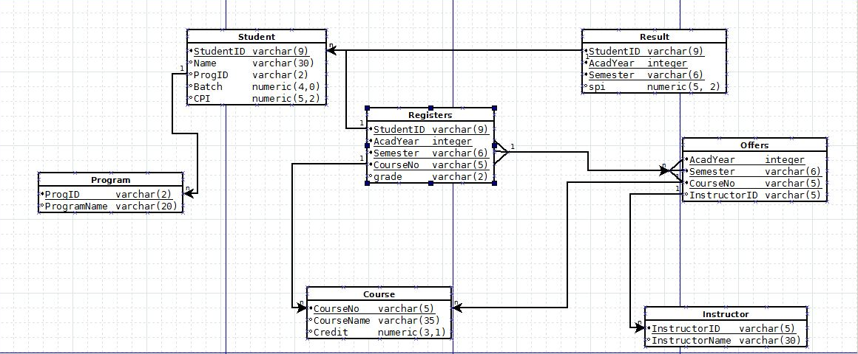
4.)
CREATE SCHEMA MyFaceBook;
SET search_path TO MyFaceBook;
CREATE TABLE city(
city_name varchar(20) PRIMARY KEY,
country varchar(20)
);
CREATE TABLE "user"(
user_id decimal(5,0) PRIMARY KEY,
user_name varchar(20),
email varchar(30),
join_date DATE,
city_name varchar(20),
FOREIGN KEY(city_name) references city (city_name)
);
CREATE TABLE friend(
user_id decimal(5,0),
friend_id decimal(5,0),
friend_since DATE,
count_msgs_in integer,
count_msgs_out integer,
FOREIGN KEY(user_id) REFERENCES "user"(user_id),
FOREIGN KEY(friend_id) REFERENCES "user"(user_id)
);
CREATE TABLE post(
post_id decimal(5,0),
user_id decimal(5,0),
time_stamp Timestamp,
"text" text,
FOREIGN KEY(user_id) REFERENCES "user"(user_id),
PRIMARY KEY(post_id,user_id)
);
create TABLE like(
post_id decimal(5,0),
user_id decimal(5,0),
like_type varchar(10),
FOREIGN KEY(user_id) REFERENCES "user"(user_id),
PRIMARY KEY(post_id,user_id),
FOREIGN KEY(post_id, user_id) REFERENCES "post"(post_id,user_id)
);

5.)
SET SEARCH_PATH TO MyFaceBook;
BEGIN;
INSERT INTO city VALUES
('MUMBAI','INDIA');
INSERT INTO city VALUES
('GANDHINAGAR','INDIA');

INSERT INTO user VALUES
('00001','abc','abc@gmai',TO_DATE('10/10/2017', 'MM/DD/YYYY'),'MUMBAI');
INSERT INTO user VALUES
('00002','xyz','xyz@gmai',TO_DATE('12/1/2017', 'MM/DD/YYYY'),'GANDHINAGAR');
INSERT INTO user VALUES
('00003','mnp','mnp@gmai',TO_DATE('26/6/2017', 'MM/DD/YYYY'),'GANDHINAGAR');

commit;
INSERT INTO friend VALUES
('00001','00002',TO_DATE('12/12/2017', 'MM/DD/YYYY'),'45','67');
INSERT INTO friend VALUES
('00002','00003',TO_DATE('12/1/2018', 'MM/DD/YYYY'),'17','85');

INSERT INTO post VALUES
('23455', '00001', CURRENT_TIMESTAMP, 'HI HO');
INSERT INTO post VALUES
('23452', '00002', CURRENT_TIMESTAMP, 'HIHA HO');

INSERT INTO "like" VALUES
('23452', '00002', 'LIKE');
INSERT INTO "like" VALUES
('23455', '00003', 'UNLIKE');

COMMIT;

