BIODIVERSITY

- Biodiversity is the variety and differences among living organisms from all sources, including terrestrial, marine, and other aquatic ecosystems and the ecological complexes of which they are a part.
- It is virtually synonymous with “Life on earth”.
- Biologists most often define "biological diversity" or "biodiversity" as the "totality of genes, species, and ecosystems of a region".
- The biodiversity found on Earth today consists of many millions of distinct biological species, which is the product of nearly 3.5 billion years of evolution.

Biodiversity

Genetic diversity Species diversity Ecological diversity
Variety of versions of the Number of different kinds of number of niches, trophic same genes within individual organisms within individual levels, and ecological
species communities or ecosystem process that capture energy, sustain food webs
and recycle the materials
within system.

- Alpha Diversity: Within community diversity. Alpha diversity refers to the diversity of organisms sharing the same Community/Habitat.
e.g. High tree diversity in throughout the Amazon Rainforests of Ecuador
- Beta Diversity: Between community diversity. It refers to the diversity of organisms sharing two habitats.
- Gamma Diversity: Diversity of the habitat over the total landscape or geographical area is called gamma diversity ( β = γ/α )
Values of Biodiversity
- Food: About 80,000 edible plants and about 90% of present day food crops have been domesticated from wild.
- Drugs & Medicines: About 75% of world’s population depends on plants or plant extracts.
- Biodiversity can aid ecosystem stability - for instance, it is estimated that 95 percent of the potential pests and disease-carrying organisms in the world are controlled by natural predators and competitors. Maintaining biodiversity can be essential for pest control and other ecological functions.
- Fuel: Forests have been used since ages for fuel wood. Fossil fuels are also products of Biodiversity.
- Social Value: Many of the plants like Tulsi, Lotus, Peepal etc are considered holy and sacred.

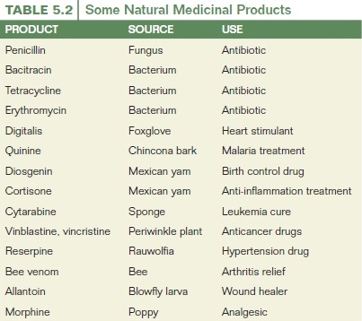

HOT- SPOTS OF BIODIVERSITY

- A biodiversity hotspot is a bio-geographic region with a significant reservoir of biodiversity that is threatened with destruction.
- An area is designated as a hot spot when it contains at least 0.5% of plant species as endemic- restricted to a certain place.
- There are 25 such hot spots of biodiversity on a global level, out of which two are present in India.
- These hot spots covering less than 2% of the world’s land area are found to have about 50% of the terrestrial biodiversity.

Examples
- The hotspot includes all of Cambodia, Vietnam & Laos, and nearly the entire areas of Thailand, Myanmar & Bhutan as well as part of Nepal, far eastern India and extreme southern China.
- In addition, it covers several offshore Islands including Mainan Islands in the south China Sea and Andaman & Nicobar Islands in Indian Ocean.
- Western Ghats and Sri Lanka, also known as the “Sahyadri Hills” encompasses the Montana forests in the southwestern parts of India and on the neighboring Islands of Sri Lanka.
- The entire extent of hotspot was originally about 1,82,500 square kms, but due to tremendous population pressure, now only 12,445 square Km or 6.8% is in pristine – original condition.
- The important populations include Asian elephant, Indian tigers and the endangered lion tailed macaque.

Criteria for determining hot-spots
- No. of Endemic Species i.e. the species which are found nowhere else.
- Degree of threat, which is measured in terms of Habitat loss.
WHAT THREATENS BIODIVERSITY?

Extinction;
- One species in a decade is normal.
- In last century, more than thousand species have become extinct due to human impact mostly invertebrates, fungi, and microbes.
- In geologic history almost 99% of the species have become extinct, before human being came into existence.
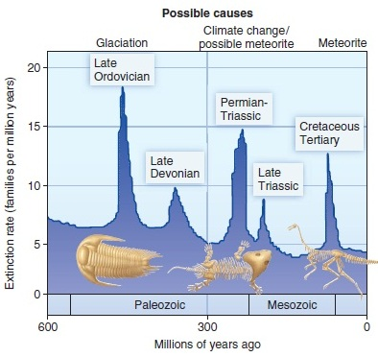

HIPPO – the sixth mass extinction
Habitat destruction, Invasive species, Pollution, Population of humans, and Overharvesting.

- Habitat destruction, forests and grasslands to farm land, is usually the main threat. Sometimes we destroy habitat as a side effect of resource extraction, such as mining, dam-building, and indiscriminate fishing methods.

- Fragmentation Reduces Habitat to Small, Isolated Areas. Breaking up habitat reduces biodiversity because many species, such as bears and large cats, require large territories to subsist.
What is biodiversity worth?

Is conservation necessarily contradictory to good economic sense?

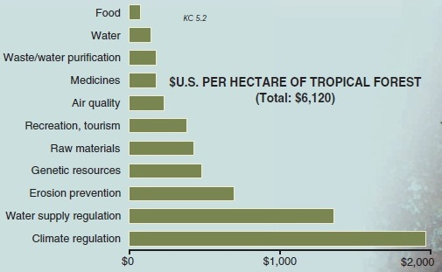

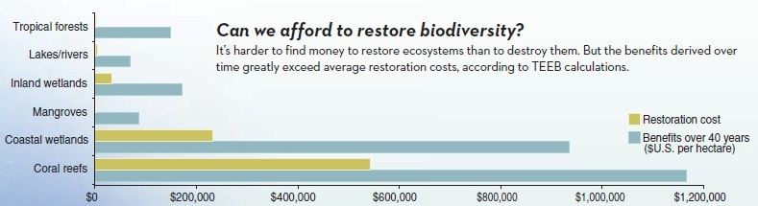

BIODIVERSITY PROTECTION

- Protect enough habitats for viable populations of all native species in a given region.
- Manage at regional scales large enough to accommodate natural disturbances (fire, wind, climate change, etc.).
- Plan over a period of centuries, so that species and ecosystems can continue to evolve.
- Allow for human use and occupancy at levels that do not result in significant ecological degradation.

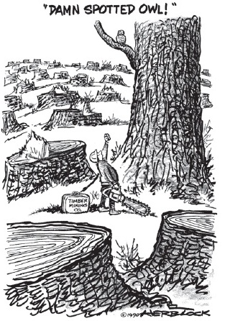

Measure of Biodiversity – Two main factors

- Richness
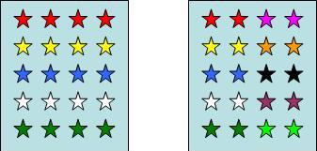

The number of species per sample is a measure of richness. The more species present in a sample, the 'richer' the sample.

- Evenness
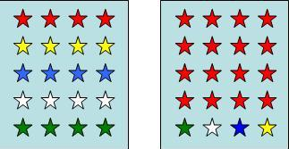

Evenness is a measure of the relative abundance of the different species making up the richness of an area.
 | Numbers of individuals
Flower Species | Sample 1 | Sample 2
Daisy | 300 | 20
Dandelion | 335 | 49
Buttercup | 365 | 931
Total | 1000 | 1000

Species richness indices
Species richness S is the simplest measure of biodiversity and is simply a count of the number of different species in a given area. This measure is strongly dependent on sampling size and effort. Two species richness indices try to account for this problem
- Margalef’s diversity index
D_{Mg} = (S−1) lnN
- Menhinick’s diversity index
D_{Mn} = S / √ N
Where N = the total number of individuals in the sample and
S = the number of species recorded.

Nearly all diversity and evenness indices are based on the relative abundance of species,
Relative abundance p_{i} = N_{i} / N
N_{i} the abundance of the i-th species in the sample and
S
N = ∑ N_{i}
i = 1
S the total number of species in the sample.
If one records the abundance of different species in a sample, it is invariably found that some species are rare, whereas others are more abundant.
As species richness and evenness increase, so diversity increases.

Simpson's Diversity Indices - can actually refer to any one of 3 closely related indices

- Simpson's Index (D) measures the probability that two individuals randomly selected from a sample will belong to the same species (or some category other than species).
D = (n / N)² | 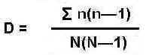
n = the total number of organisms of a particular species
N = the total number of organisms of all species

The value of D ranges between 0 and 1

- Simpson's Index of Diversity 1 – D the value of this index also ranges between 0 and 1, but now, the greater the value, the greater the sample diversity. This makes more sense. In this case, the index represents the probability that two individuals randomly selected from a sample will belong to different species.

- Simpson's Reciprocal Index 1 / D the value of this index starts with 1 as the lowest possible figure. This figure would represent a community containing only one species. The higher the value, the greater the diversity. The maximum value is the number of species (or other category being used) in the sample. For example if there are five species in the sample, then the maximum value is 5.

Shannon index or Shannon entropy

The Shannon entropy quantifies the uncertainty (entropy or degree of surprise) associated with this prediction
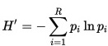

In ecology, p_{i} is often the proportion of individuals belonging to the i th species in the dataset of interest. Then the Shannon entropy quantifies the uncertainty in predicting the species identity of an individual that is taken at random from the dataset.
Calculate D, 1-D, 1 / D
Species | Number (n)
Woodrush | 2
Holly (seedlings) | 8
Bramble | 1
Yorkshire Fog | 1
Sedge | 3
Total (N) | 15

How many samples?
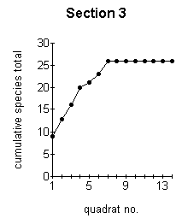
The first sample yielded 9 different species. With the second sample, a total of 13 species had been found. After 5 samples had been examined, the total species number had risen to 21. By the time 7 samples had been taken, no more new species were being found. At this point, further sampling is becoming unnecessary. This graph therefore shows us that for this particular habitat, we need to sample at least 7 samples in each sampling period. Further sampling will merely waste time and duplicate results.

