Paper Title (use style: paper title)
Subtitle as needed

Author’s Name
line 1 (of Affiliation): dept. name of organization
line 2: name of organization, acronyms acceptable
line 3: City, Country
line 4: e-mail: name@xyz.com

Abstract—Summary of your work…
Keywords-keyword1; keyword2; …

Introduction (Heading 1)
This template, modified in MS Word 2007 and saved as a “Word 97-2003 Document” for the PC, provides authors with most of the formatting specifications needed for preparing electronic versions of their papers. All standard paper components have been specified for three reasons: (1) ease of use when formatting individual papers, (2) automatic compliance to electronic requirements that facilitate the concurrent or later production of electronic products, and (3) conformity of style throughout a conference proceedings. Margins, column widths, line spacing, and type styles are built-in; examples of the type styles are provided throughout this document and are identified in italic type, within parentheses, following the example. Some components, such as multi-leveled equations, graphics, and tables are not prescribed, although the various table text styles are provided. The formatter will need to create these components, incorporating the applicable criteria that follow.

- Background of the selected topic:
- Why this problem needs solving?
- What is the importance of this topic?
- What is the state-of-the-art? (optional)
- Objectives of your work

Datasets
- Description of the dataset used:
- General description of the data (e.g., if it is digital image, what is the resolution of the image, …etc)
- How is the data obtained/constructed?
- Sample size?

Proposed Methods
- Description of the proposed method(s)
- Detailed architecture and setting/configurations (e.g. if it is a neural network model, how many layers, how many units in each layers, …etc)
- Reasons behind choosing/designing the method(s)

Experiments and Results

Experimental Setup
- Description of the setup during your experiments
- Training procedure
- How do you divide your data into training, test
- Is there a validation set for finetuning?
- Number of epochs/iterations
- …etc

Evaluation Protocols
- What are the metrics used?
- Why those metrics?

Results
- Report of results (evaluated using the metrics used in Section IV. B
- Discussion about the results obtained

Conclusion
- Summary
- Final thoughts
- Perspective/future work (optional)

Acknowledgment
(Optional)

References

- G. Eason, B. Noble, and I. N. Sneddon, “On certain integrals of Lipschitz-Hankel type involving products of Bessel functions,” Phil. Trans. Roy. Soc. London, vol. A247, pp. 529–551, April 1955. (references)
- J. Clerk Maxwell, A Treatise on Electricity and Magnetism, 3rd ed., vol. 2. Oxford: Clarendon, 1892, pp.68–73.
- I. S. Jacobs and C. P. Bean, “Fine particles, thin films and exchange anisotropy,” in Magnetism, vol. III, G. T. Rado and H. Suhl, Eds. New York: Academic, 1963, pp. 271–350.
- K. Elissa, “Title of paper if known,” unpublished.
- R. Nicole, “Title of paper with only first word capitalized,” J. Name Stand. Abbrev., in press.
- Y. Yorozu, M. Hirano, K. Oka, and Y. Tagawa, “Electron spectroscopy studies on magneto-optical media and plastic substrate interface,” IEEE Transl. J. Magn. Japan, vol. 2, pp. 740–741, August 1987 [Digests 9th Annual Conf. Magnetics Japan, p. 301, 1982].
- M. Young, The Technical Writer’s Handbook. Mill Valley, CA: University Science, 1989.
- Electronic Publication: Digital Object Identifiers (DOIs):
Article in a journal:
- D. Kornack and P. Rakic, “Cell Proliferation without Neurogenesis in Adult Primate Neocortex,” Science, vol. 294, Dec. 2001, pp. 2127-2130, doi:10.1126/science.1065467.
Article in a conference proceedings:
- H. Goto, Y. Hasegawa, and M. Tanaka, “Efficient Scheduling Focusing on the Duality of MPL Representatives,” Proc. IEEE Symp. Computational Intelligence in Scheduling (SCIS 07), IEEE Press, Dec. 2007, pp. 57-64, doi:10.1109/SCIS.2007.357670.

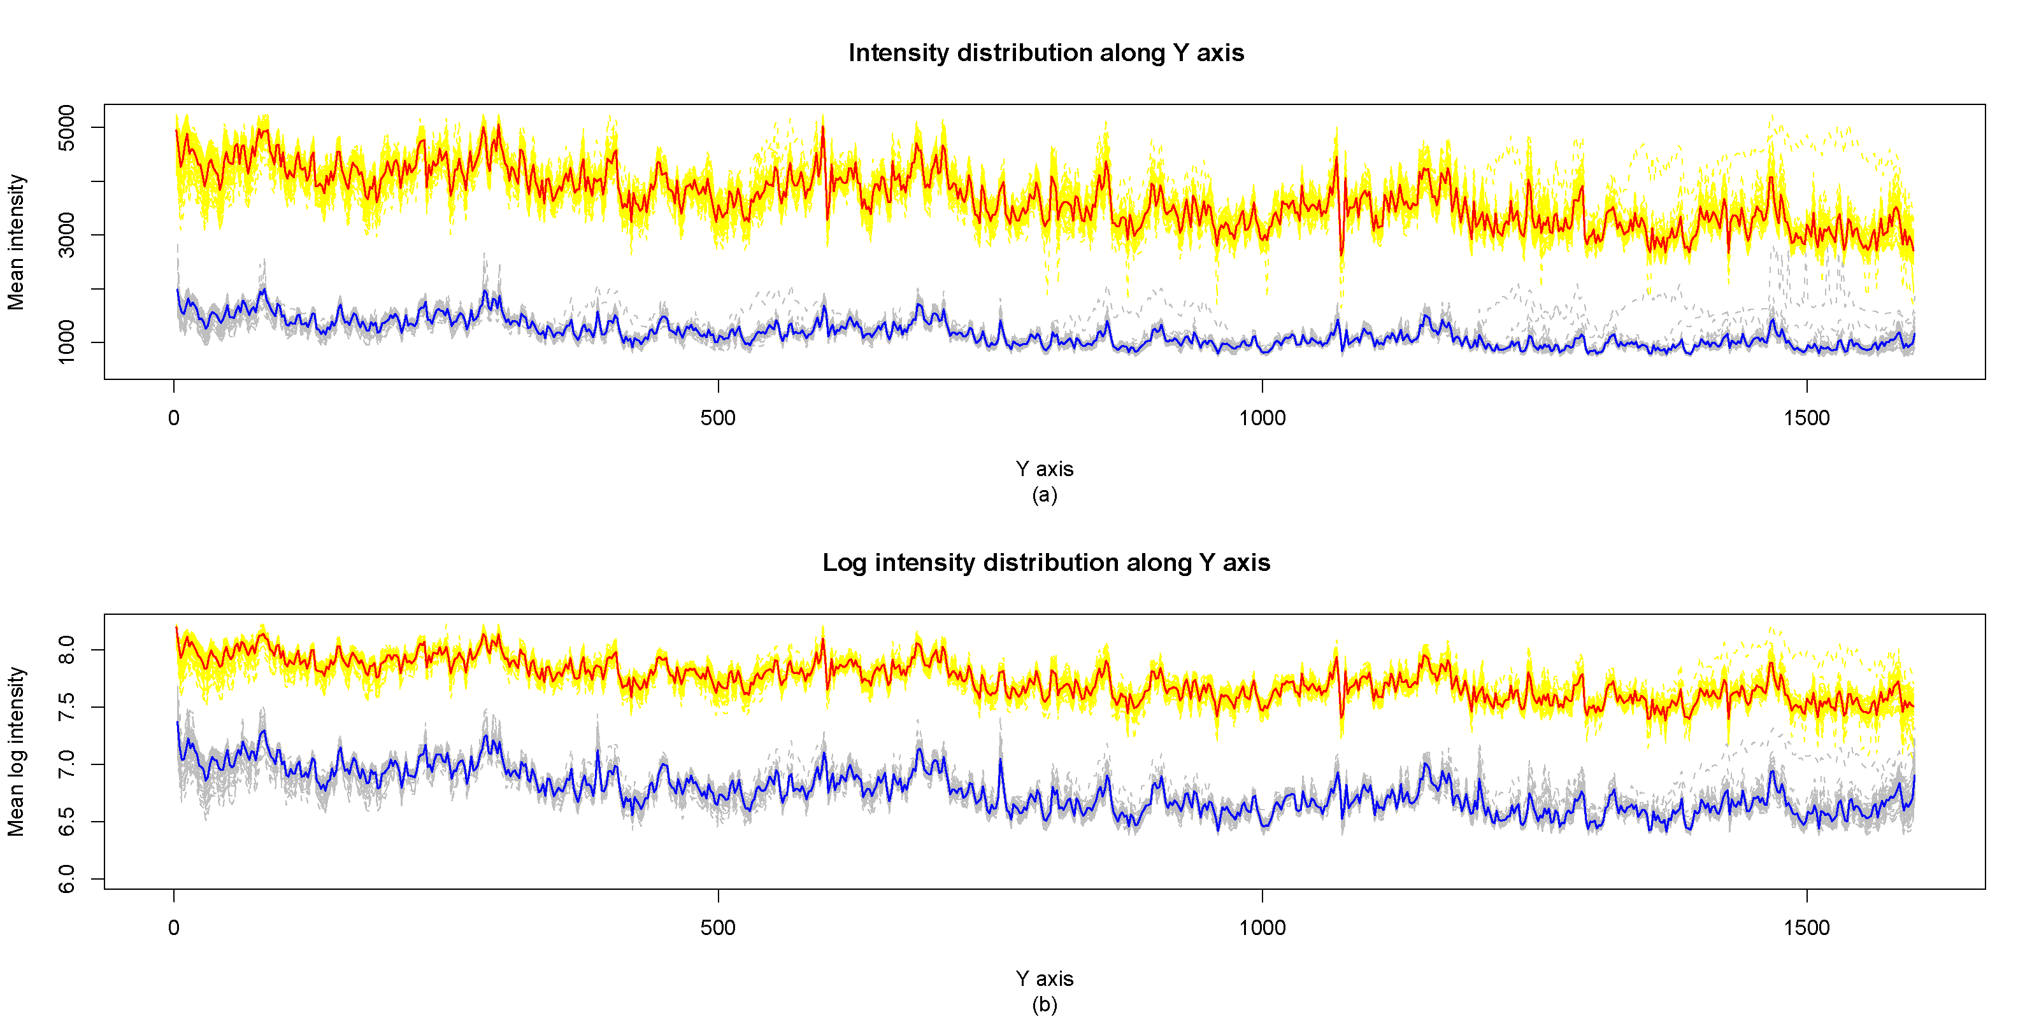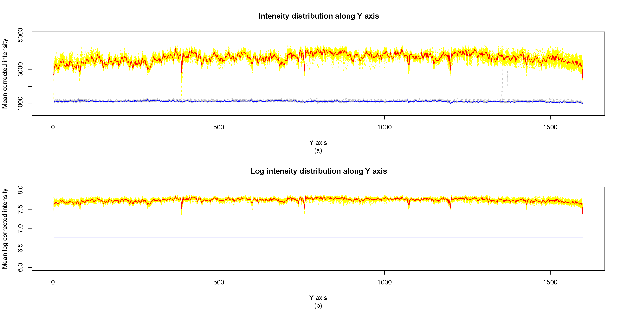
- Example of a TWO-COLUMN figure caption: (a) this is the format for referencing parts of a figure.

