ITM UNIVERSITY
School of Engineering and Research

MINOR PROJECT REPORT
on
"JOB FAIR MANAGEMENT SYSTEM"

Submitted in partial fulfilment of the requirements
for the award of the degree of

Bachelor of Technology (CSE)

Submitted by:

Name | Enrolment No | Roll No.
Tikesh Sahu | M0139 | 130410624007
Arina Fatima Qazi | M0141 | 130410624011
Preeti Deepa Giri | M0152 | 130410624029

Under the Guidance of:
Mr. Vaibhav Lall
Head of Department
School of Engineering and Research
ITM University Raipur

Academic Year: 2025 – 2026

CERTIFICATE

This is to certify that the Project Report entitled
"JOB FAIR MANAGEMENT SYSTEM "
has been submitted by
Tikesh Sahu, Arina Fatima Qazi, Preeti Deepa Giri.
Enrolment No.: M0139, M0141, M0152
in partial fulfilment of the requirements for the award of the Degree of Bachelor of Technology in CSE from ITM University. This work has been carried out under my supervision and guidance and is a record of Bonafide work done by the student.

Project Guide:  Mr. Vaibhav Lall  Designation: HOD  Department: SER | Head of Department:  Mr. Vaibhav Lall  Designation: HOD  Department: SER

DECLARATION

We hereby declare that the Minor Project Report entitled
" JOB FAIR MANAGEMENT SYSTEM "
submitted by us to ITM University in partial fulfilment of the requirements for the award of the Degree of B.Tech is a record of original and independent work done by us and has not been submitted earlier to any other University or Institution for the award of any degree or diploma.

Date: _______________  Place: _______________ | Name: Tikesh Sahu  Enrolment No.: M0139  Signature:  Name: Arina Fatima Qazi  Enrolment No.: M0141  Signature:
Name: Preeti Deepa Giri
Enrolment No.: M0152
Signature:

ACKNOWLEDGEMENT

We would like to express our sincere gratitude to Vaibhav Lall, Head of Department, School of Engineering and Research, for his invaluable guidance, constant encouragement, and support throughout the development of this project.

We would also like to thank the Head of the Department, Vaibhav Lall, and all the faculty members of the Department of School of Engineering and Research for their support and motivation.

We extend our thanks to the ITM University for providing the necessary resources and infrastructure to complete this work.

Finally, we are deeply grateful to our family and friends for their constant encouragement and moral support throughout the project.

Student Names:
Tikesh Sahu
Arina Fatima Qazi
Preeti Deepa Giri

Enrolment No.:
M0139
M0141
M0152

Semester – 4th

ABSTRACT

The Job Fair Automation System is a web-based application developed to simplify and automate placement and job fair activities conducted in educational institutions and organizations. Traditional job fair management systems mainly rely on manual processes such as paper-based registrations, spreadsheet management, and manual interview scheduling, which are time-consuming, error-prone, and difficult to manage efficiently. The proposed system addresses these problems by providing a centralized digital platform for students, companies, universities, administrators, managers, and volunteers.

The system was developed using modern web technologies including React.js and Node.js for frontend development, Fast API for backend API development, and MySQL for database management. Additional libraries such as React Router DOM, Axios, and React Icons were used to improve navigation, API communication, and user interface design. The application provides functionalities such as secure user authentication, student registration, company job posting, job application management, interview scheduling, report generation, and event coordination.

The developed system successfully reduces paperwork, minimizes manual errors, improves communication between companies and students, and enhances the efficiency of placement activities. Testing results confirmed that the system operates reliably, securely, and efficiently under normal conditions. The Job Fair Automation System provides a scalable, user-friendly, and effective solution for managing placement and job fair operations in educational institutions and organizations.

Keywords: Job Fair Automation System, Fast API, React.js, MySQL

TABLE OF CONTENTS

Chapter | Title | Page
 | Certificate | i
 | Declaration | ii
 | Acknowledgement | iii
 | Abstract | iv
 | Table of Contents | v
 | List of Figures | vi
 | List of Tables | vii
1 | Introduction | 1
1.1 | Background and Motivation | 2
1.2 | Problem Statement | 2
1.3 | Objectives | 3
1.4 | Scope of the Project | 3
2 | Literature Review / Related Work | 4
3 | System Analysis and Requirements | 9
3.1 | Feasibility Study | 10
3.2 | Requirement Analysis (SRS) | 13
4 | System Design | 15
4.1 | System Architecture | 15
4.2 | Data Flow Diagrams (DFDs) | 17
4.3 | ER Diagram / Database Design | 19
5 | Implementation | 21
5.1 | Tools and Technologies Used | 21
5.2 | Module Description | 22
5.3 | Code Snippets | 23
6 | Testing | 27
6.1 | Test Plan | 27
6.2 | Test Cases | 28
7 | Results and Screenshots | 31
8 | Conclusion and Future Scope | 33
— | References | 36
— | Appendix | 37

LIST OF FIGURES
Figure 4.1 Three-tier system architecture
Figure 4.2 Context level DFD
Figure 4.3 Level-1 DFD
Figure 4.4 Conceptual ER diagram
Figure 7.1 Login page
Figure 7.2 Candidate dashboard / profile page

LIST OF TABLES
Table 3.1 Functional requirements
Table 3.2 Non-functional requirements
Table 5.1 Tools and technologies used
Table 6.1 Representative test cases

CHAPTER 1: INTRODUCTION

1.1 Background and Motivation

In today’s competitive world, job fairs play a significant role in connecting students and job seekers with recruiters and organizations. Educational institutions and placement cells regularly organize job fairs to provide employment opportunities and improve campus recruitment activities. However, traditional job fair management systems mainly depend on manual processes such as paper-based registration forms, physical resume submissions, manual interview scheduling, and direct communication through notices or emails. These methods are time-consuming, inefficient, and difficult to manage when the number of participants increases.

The rapid growth of information technology and web-based applications has created opportunities to automate recruitment and placement activities. Modern organizations require fast, secure, and reliable systems that can manage candidate information, job postings, interview schedules, and recruiter communication efficiently. Existing online recruitment platforms provide partial solutions, but many systems lack centralized management, proper scheduling mechanisms, and user-friendly interfaces for educational institutions conducting placement drives and job fairs.

The motivation behind developing the Job Fair Automation System is to reduce manual workload, improve communication between recruiters and candidates, and provide a centralized digital platform for managing all placement-related activities. The project aims to simplify student registration, automate job applications, enable recruiters to post vacancies, and help administrators manage the overall recruitment process effectively. The system improves transparency, reduces paperwork, minimizes human errors, and enhances efficiency in conducting job fairs and placement events.

1.2 Problem Statement

Traditional job fair management systems face several challenges due to their dependence on manual processes. Placement coordinators and administrators often struggle to manage large amounts of candidate data, recruiter details, job postings, and interview schedules manually. Students may face difficulties in applying for jobs, tracking application status, and receiving interview updates on time. Similarly, recruiters experience delays in accessing candidate information and managing recruitment activities efficiently.

The lack of a centralized and automated system leads to problems such as duplicate records, communication delays, data loss, scheduling conflicts, and increased paperwork. Existing systems may not provide integrated functionalities such as online applications, automated interview scheduling, resume management, and report generation in a single platform. The proposed Job Fair Automation System addresses these issues by providing an efficient web-based solution that automates the recruitment and placement process while improving accuracy, reliability, and user convenience.

1.3 Objectives

The main objectives of this project are:

To develop a web-based Job Fair Automation System for managing placement and recruitment activities efficiently.

To implement functionalities such as student registration, recruiter management, job posting, resume upload, and interview scheduling.

To design a user-friendly interface that ensures easy navigation, accessibility, and efficient communication between users.

To test the system for reliability, accuracy, security, and performance.

To provide a centralized database system for maintaining student, recruiter, and job-related records.

To reduce paperwork and minimize manual errors in recruitment management.

To improve the efficiency and transparency of placement activities.

To generate reports and maintain proper records of recruitment processes.

1.4 Scope of the Project
The scope of the Job Fair Automation System is limited to automating and managing placement and recruitment activities conducted during job fairs in educational institutions and organizations. The system provides functionalities for students, recruiters, and administrators to interact through a centralized platform.
The system allows students to register, upload resumes, search for available jobs, and apply for vacancies. Recruiters can register, post job opportunities, shortlist candidates, and schedule interviews. Administrators can manage users, monitor activities, and generate reports related to placements and recruitment processes.
The project is developed as a web-based application and can be accessed through desktop or laptop systems connected to the internet. The system supports basic authentication and database management features. However, the project does not include advanced features such as AI-based resume screening, video interview integration, online aptitude testing, or mobile application support in the current version.
The primary users of the system include:
- Students and job seekers
- Recruiters and companies
- Placement officers and administrators
The system is intended to improve efficiency, accuracy, and communication during job fair and placement activities.
1.5 Organization of the Report
The remainder of this report is organized as follows:
- Chapter 2 presents a review of existing literature and related work.
- Chapter 3 describes the system requirements and feasibility analysis.
- Chapter 4 covers the system design, architecture, and database design.
- Chapter 5 explains the implementation details and tools used.
- Chapter 6 describes the testing methodology and test cases.
- Chapter 7 presents the results and screenshots of the system.
- Chapter 8 concludes the report and outlines the future scope.

CHAPTER 2: LITERATURE REVIEW / RELATED WORK
The literature review provides an overview of existing research studies, recruitment systems, and job fair management applications related to the proposed Job Fair Automation System. This chapter analyses previous work carried out in the field of online recruitment, placement management, and automation systems. The review helps identify the strengths and limitations of existing systems and highlights the research gap addressed by the proposed project.
2.1 Online Recruitment Management System
Many organizations and educational institutions use online recruitment systems to simplify hiring processes. These systems allow candidates to register online, upload resumes, and apply for job vacancies through a centralized platform.
The study focused on developing a web-based recruitment portal that automates candidate registration and job application management. The methodology used included database-driven web application development using PHP and MySQL technologies.
Strengths
- Simplified candidate registration
- Faster communication between recruiters and applicants
- Centralized storage of candidate records
Limitations
- Lack of interview scheduling features
- No real-time application tracking
- Limited user interface and scalability
Relation to Proposed Project
The proposed Job Fair Automation System improves upon this approach by adding interview scheduling, recruiter management, and application tracking functionalities.

2.2 Placement Management System
Placement Management Systems are widely used in colleges and universities to automate campus placement activities. These systems maintain student records, company details, and placement reports.
The reviewed system used a client-server architecture and focused on automating placement processes within educational institutions.
Strengths
- Efficient management of placement records
- Reduced paperwork
- Faster report generation
Limitations
- Limited recruiter interaction
- No integrated job fair functionality
- Lack of online communication features
Relation to Proposed Project
The Job Fair Automation System extends these functionalities by supporting recruiter dashboards, job postings, and online interview scheduling.
2.3 E-Recruitment Systems
E-recruitment systems are online platforms designed for digital hiring processes. They provide features such as resume submission, candidate filtering, and online communication.
The methodology involved using web technologies to create scalable recruitment platforms accessible through browsers.
Strengths
- Online accessibility
- Efficient candidate filtering
- Easy resume management
Limitations
- High dependency on internet connectivity
- Complex interfaces in some systems
- Lack of institution-specific customization
Relation to Proposed Project
The proposed system is designed specifically for job fairs and educational institutions, making it simpler and more focused on placement activities.
2.4 Job Portal Systems
Job portals provide a platform for employers and job seekers to connect online. These systems allow recruiters to post vacancies and candidates to apply for jobs.
The reviewed system implemented user authentication, database integration, and job search functionalities.
Strengths
- Easy job searching
- Online application process
- Large-scale user support
Limitations
- No interview scheduling mechanism
- Lack of placement-specific management
- Limited administrative control
Relation to Proposed Project
The Job Fair Automation System includes interview scheduling and administrator monitoring features in addition to job posting functionalities.
2.5 Campus Recruitment Automation System
Campus recruitment systems automate placement activities conducted within colleges and universities. These systems maintain student eligibility records and recruiter information.
The methodology included database management and role-based access control for different users.
Strengths
- Organized student data management
- Eligibility-based filtering
- Improved placement coordination
Limitations
- Limited scalability
- No real-time notifications
- Basic reporting functionalities
The proposed system provides enhanced scalability, centralized management, and better communication between recruiters and candidates.

Sr. No. | Author / Year | Title / Topic | Approach | Limitation
1 | Sharma et al. (2020) | Online Recruitment System | Web-based recruitment portal | No interview scheduling
2 | Kumar et al. (2019) | Placement Management System | Client-server placement automation | Limited recruiter interaction
3 | Patel et al. (2021) | E-Recruitment Platform | Online candidate management | Complex user interface
4 | Singh et al. (2018) | Job Portal System | Web portal for job applications | No centralized administration
5 | Verma et al. (2020) | Campus Recruitment System | Eligibility-based placement system | Limited scalability
Comparison Table of Existing Systems

CHAPTER 3: SYSTEM ANALYSIS AND REQUIREMENTS

3.1 Existing System
In many educational institutions and organizations, job fairs and placement activities are still managed using traditional manual methods. These methods mainly involve paper-based registrations, physical resume submissions, spreadsheet maintenance, manual interview scheduling, and direct communication through notices or emails. Placement coordinators are responsible for collecting student information, maintaining company records, and coordinating recruitment activities manually. Recruiters often receive printed resumes and manually shortlist candidates for interviews.
The existing system requires a large amount of paperwork and human effort to maintain records properly. Students are required to fill registration forms manually and submit hard copies of resumes during placement drives or job fairs. Recruiters face difficulties in reviewing a large number of resumes within a short period of time. Similarly, placement officers spend considerable time maintaining records of students, companies, interview schedules, and recruitment results.
Another major problem in the current system is the lack of centralized data management. Student details, recruiter information, and placement records are often stored in separate files or spreadsheets, making it difficult to access and update information efficiently. Since most operations are handled manually, there are high chances of duplicate entries, data inconsistency, and record loss. Communication delays between students, recruiters, and administrators also create confusion during placement activities.
The manual interview scheduling process is another limitation of the existing system. Coordinating interview timings for multiple companies and candidates becomes difficult, especially during large-scale job fairs. Students may miss important notifications, and recruiters may face delays in candidate selection due to poor coordination.
The traditional system also lacks transparency and real-time monitoring capabilities. Students are unable to track their application status efficiently, while recruiters do not have quick access to candidate profiles and reports. Generating reports related to placements, recruitment statistics, and interview schedules is time-consuming and requires significant manual effort.
Due to these drawbacks, there is a strong need for an automated system that can simplify job fair and placement management processes while improving efficiency, accuracy, and communication.
3.2 Proposed System
The proposed Job Fair Automation System is a web-based application designed to automate and simplify all activities related to job fairs and placement management. The system provides a centralized platform where students, recruiters, and administrators can interact efficiently through an online interface.
In the proposed system, students can register online, create profiles, upload resumes, search for available job opportunities, and apply for jobs directly through the system. Recruiters can create company accounts, post job vacancies, review applications, shortlist candidates, and schedule interviews. Administrators can monitor the overall recruitment process, manage users, maintain records, and generate reports automatically.
The proposed system eliminates the need for manual paperwork and reduces human effort significantly. All information is stored digitally in a centralized database, making data retrieval faster and more accurate. Since the system automates registration, application processing, and interview scheduling, placement activities become more organized and efficient.
One of the major advantages of the proposed system is improved communication between students and recruiters. Students can receive updates about job applications and interview schedules through the platform. Recruiters can quickly access candidate profiles and shortlist suitable applicants based on eligibility criteria.
The system also improves transparency and reliability. Students can track their application status in real time, while administrators can monitor placement activities and generate reports easily. Automated data management reduces the chances of duplicate entries, record loss, and scheduling conflicts.
Another important advantage of the proposed system is scalability. The application can handle large numbers of students and recruiters efficiently during placement drives and job fairs. The web-based nature of the system allows users to access the platform from different locations using internet connectivity.
Overall, the proposed Job Fair Automation System provides an efficient, secure, and user-friendly solution for managing recruitment and placement activities in educational institutions and organizations.
3.3 Feasibility Study
Feasibility analysis is an important step in system development that determines whether the proposed project is practical and beneficial. The feasibility study of the Job Fair Automation System includes technical feasibility, operational feasibility, and economic feasibility.
3.3.1 Technical Feasibility
The proposed Job Fair Automation System is technically feasible because the required technologies, software tools, and hardware resources are easily available and can be implemented effectively. The project is developed using Python, Django, HTML, CSS, JavaScript, and MySQL, which are widely used technologies for web application development.
The hardware requirements for the system are minimal and can be supported by standard computer systems available in educational institutions and organizations. A basic computer with sufficient RAM, processor speed, and internet connectivity is capable of running the application efficiently.
The software requirements are also achievable because all development tools and frameworks used in the project are open-source and freely available. Django provides built-in functionalities for authentication, database management, and security, making the development process more efficient and reliable.
The system is designed as a web-based application, which means users can access it through standard web browsers without requiring complex installations. The network requirements are minimal, and the application can function properly using regular internet connectivity.
Since the technologies used are scalable and well-supported, the system can be upgraded and maintained easily in the future. Therefore, the proposed system is technically feasible.
3.3.2 Operational Feasibility
The proposed system is operationally feasible because it is designed to be simple, user-friendly, and easy to operate for all users, including students, recruiters, and administrators. The application provides a clear and intuitive interface that allows users to perform operations without requiring advanced technical knowledge.
Students can easily register, upload resumes, and apply for jobs through the platform. Recruiters can manage vacancies, review candidate applications, and schedule interviews efficiently. Administrators can monitor activities and generate reports without performing manual calculations or maintaining paper records.
The organization can support the proposed system because it reduces administrative workload and improves placement management efficiency. The system minimizes paperwork and automates repetitive tasks, which saves time and reduces operational complexity.
Training requirements for using the system are minimal because the interface is designed to be simple and easy to understand. Since the system improves communication, transparency, and record management, it is expected to be accepted positively by users and organizations.
Therefore, the proposed Job Fair Automation System is operationally feasible.
3.3.3 Economic Feasibility
The proposed Job Fair Automation System is economically feasible because the development and implementation costs are relatively low compared to the long-term benefits provided by the system. The project uses open-source technologies such as Python, Django, and MySQL, which reduces software licensing costs significantly.
The hardware requirements are also affordable because the system can run on existing computer infrastructure available in most institutions and organizations. Maintenance costs are minimal since the application is web-based and easy to update.
The system reduces manual paperwork, administrative effort, and time required for managing recruitment activities. Automated processes improve efficiency and reduce operational costs associated with manual data handling and communication.
The benefits of the proposed system include:
- Faster placement management
- Reduced paperwork
- Improved accuracy
- Better communication
- Efficient interview scheduling
- Automated report generation
These benefits outweigh the implementation and maintenance costs, making the project financially viable and cost-effective for organizations and educational institutions.
3.4 Software Requirements Specification (SRS)
The Software Requirements Specification defines the functional and non-functional requirements of the Job Fair Automation System. It describes the expected behaviour and performance of the application.
3.4.1 Functional Requirements
The system should allow students to register and create accounts using valid credentials. Registered users should be able to log in securely using email and passwords.
The system should allow students to upload Last year Marksheet to be verified and update personal profiles whenever required. Students should be able to search available job vacancies and apply for suitable positions through the platform.
The system should allow recruiters to create company profiles and post job opportunities with eligibility criteria and job descriptions. Recruiters should be able to view candidate applications and shortlist eligible students for interviews.
The system should provide interview scheduling functionality so that recruiters can assign interview dates, timings, and venues to selected candidates.
The administrator should be able to manage users, monitor recruitment activities, maintain records, and generate placement reports efficiently.
The system should provide authentication and authorization mechanisms to ensure secure access to data and functionalities.
The application should maintain a centralized database for storing student details, recruiter information, job postings, applications, and interview schedules.
The system should allow users to view notifications and updates related to recruitment activities.
3.4.2 Non-Functional Requirements
The system should provide fast performance and respond to user requests within two seconds under normal workload conditions. Efficient database connectivity and optimized processing should ensure smooth operation.
The security of the application should be maintained by storing passwords in encrypted form and restricting unauthorized access to sensitive data. Authentication and session management mechanisms should be implemented properly.
The system should be scalable enough to handle a large number of users simultaneously during placement drives and job fairs. The database and application architecture should support future expansion and additional functionalities.
The usability of the application should be high, with an intuitive and user-friendly interface that allows users to navigate easily without confusion. Clear menus, forms, and dashboards should improve user experience.
The system should maintain reliability by ensuring accurate data storage and consistent functionality without unexpected failures.
The maintainability of the system should be considered so that future modifications, upgrades, and bug fixes can be implemented easily.
The application should also provide compatibility with commonly used web browsers and operating systems.
3.5 Hardware and Software Requirements
Requirement Type | Hardware | Software
Minimum | Processor: Dual Core 1.8 GHz, RAM: 2 GB, HDD: 20 GB Free | OS: Windows 7 / Linux Ubuntu 18.04, Browser: Chrome / Firefox
Recommended | Processor: Intel i5 / i7, RAM: 8 GB, HDD: 50 GB Free, Internet: Broadband | OS: Windows 10 / Ubuntu 20.04, IDE: VS Code / Eclipse, DB: MySQL / MongoDB

CHAPTER 4: SYSTEM DESIGN

4.1 System Architecture
The Job Fair System follows a three-tier client-server architecture. This architecture separates the system into three major layers: the presentation layer, the application/business logic layer, and the data layer. This separation improves maintainability, scalability, and security.
Presentation Layer
The presentation layer is the user interface through which different users interact with the system. In this project, the frontend is developed using React.js with Vite. It provides separate dashboard views and pages for the three main user roles:
- Candidate
- Company
- University
This layer handles user interaction such as registration, login, profile updates, viewing vacancies, managing HR records, and student management.
Application/Business Logic Layer
The middle layer is developed using FastAPI in Python. It acts as the backend server and contains the core business logic of the system. This layer is responsible for:
- Processing user requests
- Validating input data
- Managing authentication using JWT and cookies
- Enforcing role-based access control
- Handling operations such as OTP verification, registration, login, vacancy posting, job applications, HR management, and university-candidate linking
The frontend communicates with this layer through REST API endpoints.
Data Layer
The data layer uses a MySQL database. It stores all persistent information related to:
- Candidates
- Companies
- Universities
- Job roles/vacancies
- Job applications
- HR details
- Courses and branches
- Feedback
- OTP records
The backend interacts with the database using a custom database utility built on MySQL connection pooling.
Architecture Type
The system can be classified as:
- Client-Server Architecture, because the client frontend sends requests to the backend server
- Three-Tier Architecture, because the UI, logic, and database are separated
- It also partially reflects component-based frontend design and API-driven backend design
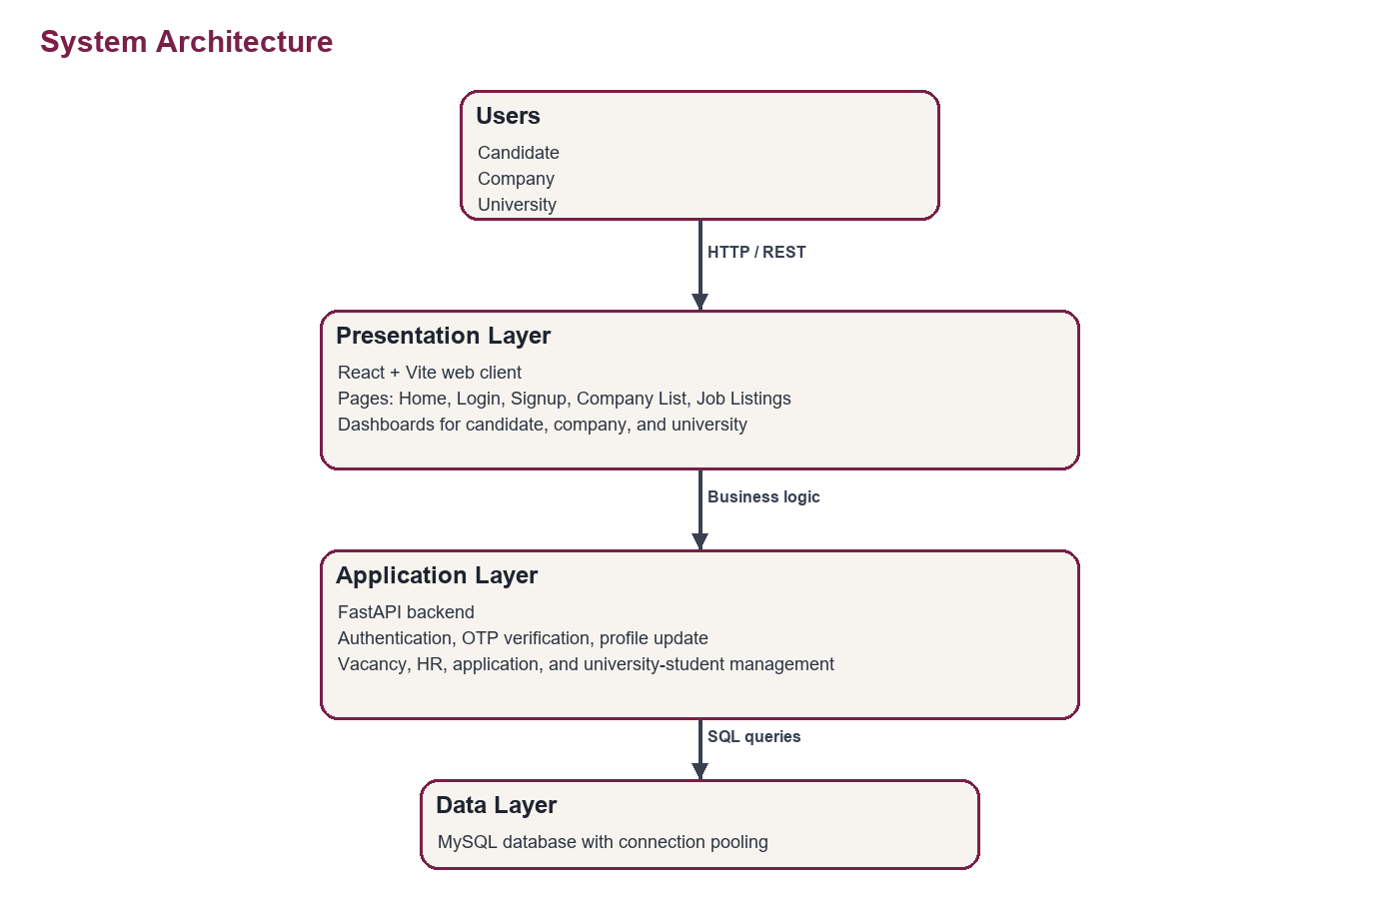
Figure 4.1: System Architecture Diagram

4.3 Data Flow Diagrams (DFD)

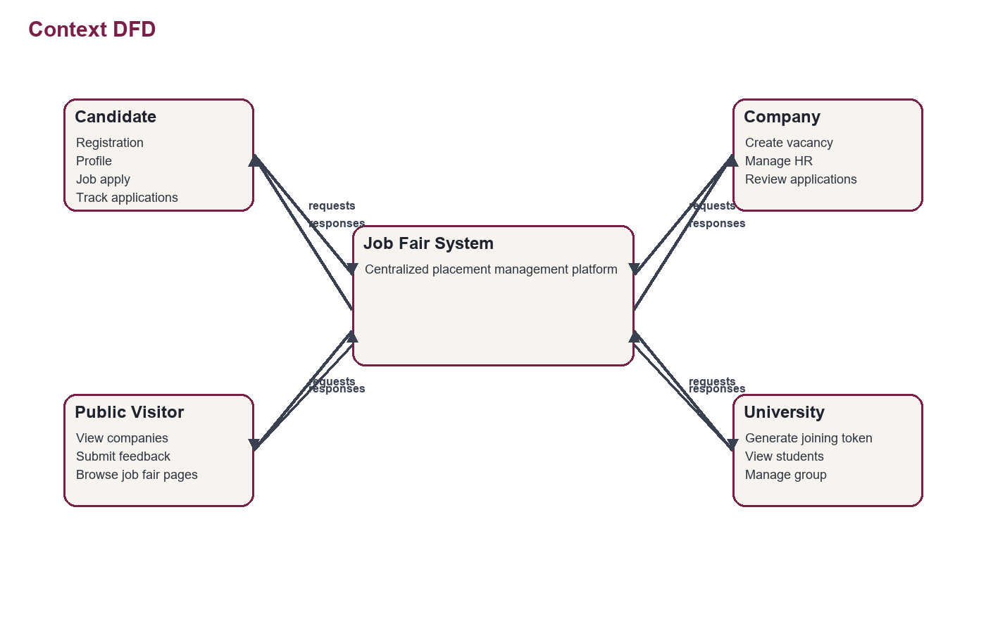

4.2.1 Level 0 DFD (Context Diagram)
\

4.2 ER Diagram and Database Design

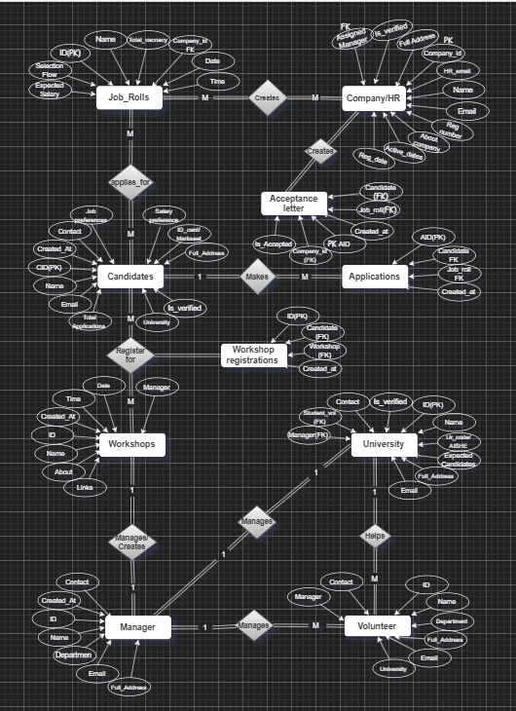
Figure 4.4: Entity-Relationship Diagram
Table Design:
- CREATE Table IF NOT EXISTS candidate(
- candidate_id INT PRIMARY KEY AUTO_INCREMENT,
- email VARCHAR(30) UNIQUE NOT NULL,
- password CHAR(8) NOT NULL,
- name VARCHAR(30),
- contact CHAR(10) UNIQUE,
- university_name TEXT,
- course_id INT,
- branch_id INT,
- last_marksheet varchar(100), -- images will be stored in a folder?
- job_preference VARCHAR(100),
- salary_preference INT, -- Rupees per anum
- address TEXT,
- city VARCHAR(20),
- state VARCHAR(30),
- pincode CHAR(6),
- hostel_required BOOLEAN DEFAULT false,
- id_verified BOOLEAN DEFAULT false,
- created_at TIMESTAMP DEFAULT CURRENT_TIMESTAMP,
- about TEXT,
- date_of_birth DATE,
- gender ENUM('Male', 'Female', 'Other'),
- job_application_count INT CHECK(job_application_count<=5) DEFAULT 0, -- this is count of application candidate applied
- is_active BOOLEAN DEFAULT 1,
- Foreign Key (course_id) REFERENCES course(course_id),
- Foreign Key (branch_id) REFERENCES branch(branch_id)
- );

- CREATE Table IF NOT EXISTS university(
- university_id INT PRIMARY KEY AUTO_INCREMENT,
- email VARCHAR(30) UNIQUE NOT NULL,
- password CHAR(8) NOT NULL,
- name VARCHAR(30),
- contact CHAR(10) UNIQUE,
- address TEXT,
- city VARCHAR(20),
- state VARCHAR(30),
- pin_code CHAR(6),
- created_at TIMESTAMP NOT NULL DEFAULT CURRENT_TIMESTAMP,
- is_verified BOOLEAN DEFAULT 0 not NULL,
- is_active BOOLEAN DEFAULT 0,
- student_joining_token varchar(16), -- this token will be used to share the candidates to signup for perticular University
- assigned_manager_id INT DEFAULT 0,
- Foreign Key (assigned_manager_id) REFERENCES manager(manager_id)
- );

- CREATE Table IF NOT EXISTS company(
- company_id INT PRIMARY KEY AUTO_INCREMENT,
- email VARCHAR(30) UNIQUE NOT NULL,
- password CHAR(8) NOT NULL,
- name VARCHAR(30),
- contact CHAR(10) UNIQUE,
- about TEXT,
- created_at TIMESTAMP DEFAULT CURRENT_TIMESTAMP, -- when company signed up
- address TEXT,
- city VARCHAR(20),
- state VARCHAR(30),
- pincode CHAR(6),
- is_active BOOLEAN DEFAULT false,
- is_verified BOOLEAN DEFAULT false,
- job_application_count INT CHECK(total_HR<=3) DEFAULT 0, -- this is count of applications company got
- manager_id INT,
- industry_type_id INT,
- Foreign Key (industry_type) REFERENCES company_type(id),
- Foreign Key (manager_id) REFERENCES manager(manager_id)
);

CHAPTER 5: IMPLEMENTATION

5.1 Tools and Technologies Used

The Job Fair Automation System was developed using modern web technologies to ensure scalability, security, performance, and user-friendliness. The system follows a full-stack web development approach where the frontend handles user interaction, the backend manages business logic and APIs, and the database stores and retrieves system data efficiently.

The frontend of the application was developed using React.js with Node.js as the runtime environment. React.js was selected because it provides component-based architecture, fast rendering, reusable UI components, and better user experience. The frontend interface was designed to be responsive and interactive so that students, recruiters, and administrators can easily navigate through the system.

The backend of the application was developed using FastAPI, a modern Python framework used for building high-performance APIs. FastAPI was chosen because of its speed, automatic API documentation support, asynchronous processing capability, and ease of integration with frontend applications.

The database used in the system is MySQL, which provides reliable relational database management and efficient data storage. MySQL was used to maintain records related to students, recruiters, job vacancies, applications, and interview schedules.

Several libraries and tools were integrated into the project to simplify routing, API communication, and UI design. React Router DOM was used for page navigation, Axios was used for sending HTTP requests between frontend and backend, and React Icons was used for adding icons to improve the user interface.

Category | Technology / Tool | Purpose
Frontend | React.js | Building the user interface
Runtime Environment | Node.js | Running frontend application
Backend | FastAPI (Python) | Server-side logic and API development
Database | MySQL | Data storage and retrieval
IDE | VS Code | Code development
Version Control | Git, GitHub | Source code management
Routing Library | React Router DOM | Navigation between pages
HTTP Client | Axios | API communication
UI Icons | React Icons | User interface icons
Styling | CSS | Responsive UI design
API Testing | Swagger | API testing and debugging
Browser | Google Chrome, Microsoft edge | Running and testing application

5.2 Module Description

The Job Fair Automation System is divided into multiple modules to organize functionalities efficiently. Each module performs a specific task and interacts with other modules to provide complete system functionality.

5.2.1 Student Module

The Student Module is designed for students participating in the job fair and placement activities. This module allows students to create accounts, log in securely, update personal and academic information, and apply for available job opportunities.

Students can browse job vacancies posted by companies and search jobs according to eligibility criteria, required skills, and job roles. The module also allows students to track application status and view interview schedules provided by recruiters or managers.

The module processes student details such as name, email, contact information, educational qualifications, and skills. The information entered by students is validated before being stored in the database.

The output generated by this module includes successful registration messages, application confirmations, job listings, and interview notifications.

5.2.2 Company Module

The Company Module is designed for recruiters and organizations participating in the job fair. This module allows companies to create profiles, log in securely, and manage recruitment activities.

Recruiters can post job vacancies by entering job titles, required qualifications, eligibility criteria, skills, and salary information. Companies can also review applications submitted by students, shortlist eligible candidates, and schedule interviews.

The module processes company and job-related information before storing it in the database. Companies can manage multiple job postings and update recruitment details whenever required.

The output generated includes job posting confirmations, shortlisted candidate lists, and interview schedules.

5.2.3 University Module

The University Module manages institution-level placement and recruitment activities. Universities can monitor student participation, verify eligibility criteria, and coordinate placement drives through this module.

The university administration can approve student registrations, manage placement notices, and communicate important information to students and recruiters. The module also provides placement statistics and recruitment reports.

The module helps educational institutions maintain centralized placement records and monitor company participation during job fairs.

The output includes student verification reports, placement summaries, and company participation details.

5.2.4 Admin Module

The Admin Module manages the overall operations of the Job Fair Automation System. Administrators have complete control over all system activities and user accounts.

This module allows administrators to manage students, companies, universities, managers, volunteers, and recruitment records. Administrators can monitor placement activities, manage databases, and generate reports.

The module ensures proper system security, smooth workflow management, and efficient handling of recruitment activities.

The output includes system activity reports, placement statistics, and user management details.

5.2.5 Manager Module

The Manager Module is designed for placement managers and event coordinators responsible for supervising job fair activities.

Managers can monitor company participation, coordinate interview schedules, and supervise overall recruitment processes during placement drives. The module also allows managers to communicate with recruiters, students, and volunteers for smooth event management.

Managers can verify recruitment schedules, approve interview arrangements, and monitor placement progress.

5.2.6 Volunteer Module

The Volunteer Module is designed for volunteers assisting in organizing and managing job fair events.

Volunteers can verify participant details, manage attendance, guide students and recruiters, and assist managers during recruitment activities. This module helps reduce workload on administrators and managers during large-scale placement events.

5.2.7 Authentication Module

The module supports different user roles such as Student, Company, University, Admin, Manager, and Volunteer. The module verifies usernames, emails, and passwords entered by users. After successful authentication, users are redirected to their respective dashboards according to their roles.

The output includes login confirmations, access permissions, and session management details.

5.2.8 Job Management Module

The Job Management Module handles all operations related to job postings and applications.

Companies can create, update, and remove job vacancies using this module. Students can search for jobs based on qualifications, skills, company names, and job categories.

The module stores job details and application records in the database while maintaining the status of applications submitted by students.

5.3 Code Snippets
[Include the most important and relevant code snippets here. Avoid pasting the entire source code. Use a monospace font for code blocks. Refer to the Appendix for complete code.]
class Db:
def __init__(self, host:str,port:int, user:str, password:str, database: str):
"""
Parameters:
database: None | str
host = "localhost" | str
user = "root" | str
password = "1qaz,xds" | str
"""
self.__pool = pooling.MySQLConnectionPool(
pool_name='mypool',
pool_size=5,
host=host,
user=user,
password=password,
database=database,
)
def query(self, Q: str, params: tuple | dict | None = None, commit: bool = False) -> list:
conn = None
cursor = None
try:
conn = self.__pool.get_connection()
cursor = conn.cursor(dictionary=True)
cursor.execute(Q, params)

if commit:
conn.commit()
if cursor.description:
return cursor.fetchall() or []
return []
except Error as e:
if conn is not None:
conn.rollback()
raise
finally:
if cursor is not None:
cursor.close()
if conn is not None:
conn.close()

CHAPTER 6: TESTING

6.1 Testing Strategy

Testing is an essential phase in software development that ensures the Job Fair Automation System functions correctly, securely, and efficiently. The testing process was carried out systematically to identify errors, improve system reliability, and verify that all modules work according to the specified requirements.

The testing strategy used in the Job Fair Automation System included Unit Testing, Integration Testing, System Testing, User Acceptance Testing (UAT), Performance Testing, and Security Testing. Each testing method focused on validating different aspects of the application.

Initially, Unit Testing was performed to test individual modules and functions separately. This helped in identifying coding errors and verifying that each module behaved correctly in isolation. After unit testing, Integration Testing was conducted to ensure smooth interaction between frontend, backend, and database components.

System Testing was then performed to validate the complete application under real-world conditions. This testing verified end-to-end functionality such as student registration, company login, job posting, application processing, and interview scheduling.

User Acceptance Testing (UAT) was conducted with sample users such as students, recruiters, managers, and administrators. This testing ensured that the system satisfied user requirements and provided a user-friendly experience.

Additional testing methods such as Performance Testing and Security Testing were also performed to verify system response time, scalability, and protection against unauthorized access.

The overall testing strategy ensured that the Job Fair Automation System operated efficiently, securely, and reliably.

6.2 Types of Testing Performed

The Job Fair Automation System underwent multiple levels of testing to ensure quality and reliability.
- Unit Testing: Unit Testing was performed to test individual functions and components separately. Each module such as login functionality, registration forms, job posting functions, and interview scheduling APIs was tested independently.
The purpose of Unit Testing was to verify that each function produced correct outputs for different inputs and handled errors properly.
Examples of unit-tested components include:
- Student registration form
- Login authentication
- Job posting API
- Database insertion functions
- Interview scheduling module
This testing helped in detecting coding errors at an early stage of development.
- Integration Testing: Integration Testing was performed to verify the interaction between combined modules of the system. The frontend developed in React.js was integrated with the FastAPI backend and MySQL database.
The testing ensured that:
- Data entered through frontend forms was correctly processed by backend APIs.
- Backend services interacted properly with the database.
- Different modules exchanged information without errors.
Examples of integration testing include:
- Student applying for jobs through the frontend and data being stored in MySQL.
- Company job postings appearing correctly on the student dashboard.
- Interview schedules being displayed after recruiter updates.
- This testing ensured smooth communication between all components of the application.
- System Testing: Testing the complete system for end-to-end scenarios.
- User Acceptance Testing (UAT): Validating the system with actual users.
- [Add any other type of testing performed, e.g., performance, security.]

6.3 Test Cases
TC ID | Test Case | Steps | Expected Output | Actual Output | Status
TC01 | User Login | Enter valid credentials and click Login | User is logged in and redirected to dashboard | As Expected | PASS
TC02 | Invalid Login | Enter wrong password and click Login | Error message “Invalid Credentials” displayed | As Expected | PASS
TC03 | Student Registration | Fill registration form and click Register | Student account created successfully | As Expected | PASS
TC04 | Company Registration | Enter company details and submit form | Company account registered successfully | As Expected | PASS
TC05 | Job Posting | Recruiter enters job details and submits | Job vacancy added successfully | As Expected | PASS
TC06 | Job Application | Student selects job and clicks Apply | Application submitted successfully | As Expected | PASS
TC07 | View Job Listings | Student opens jobs page | Available jobs displayed correctly | As Expected | PASS
TC08 | Interview Scheduling | Recruiter schedules interview for candidate | Interview details saved and displayed | As Expected | PASS
TC9 | Unauthorized Access | Access protected page without login | User redirected to login page | As Expected | PASS
TC10 | Database Connectivity | Submit form data to backend | Data stored successfully in MySQL database | As Expected | PASS
TC12 | Search Functionality | Search jobs using keyword | Relevant jobs displayed | As Expected | PASS
TC13 | Logout Functionality | Click Logout button | User session terminated successfully | As Expected | PASS

CHAPTER 7: RESULTS AND SCREENSHOTS

7.1 Login Page

The Login Page is the entry point of the Job Fair Automation System. Users such as Students, Companies, Universities, Admins, Managers, and Volunteers can log in securely using their email ID and password. The system validates the credentials and redirects users to their respective dashboards according to their roles.

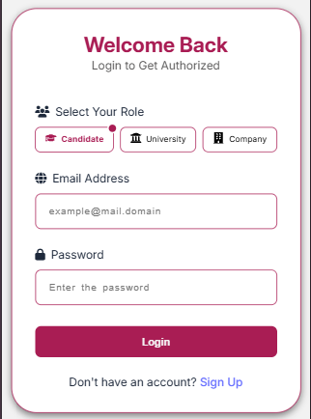
Figure 7.1: Login Page of the Application

7.2 Dashboard
The Dashboard Page provides an overview of the system after successful login. Different users see different dashboard functionalities according to their roles. The dashboard contains quick navigation links, job statistics, company details, interview schedules, and placement updates.

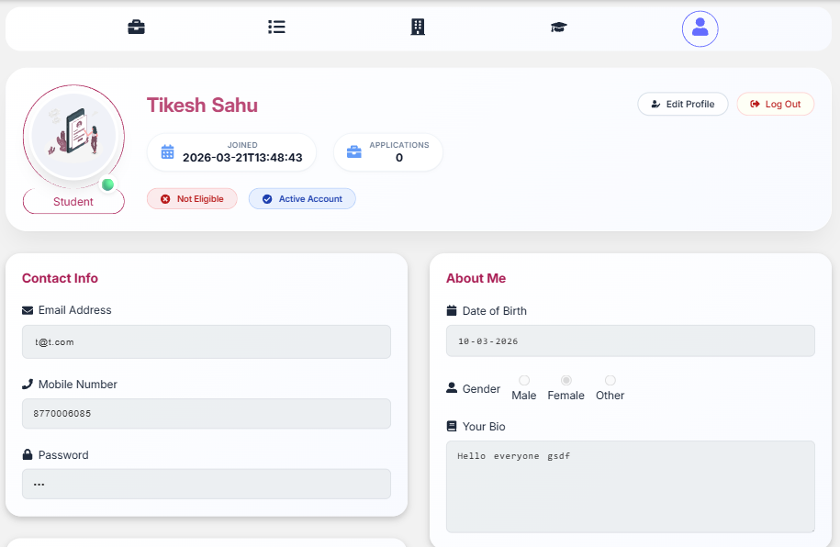
Figure 7.2: Dashboard Screen
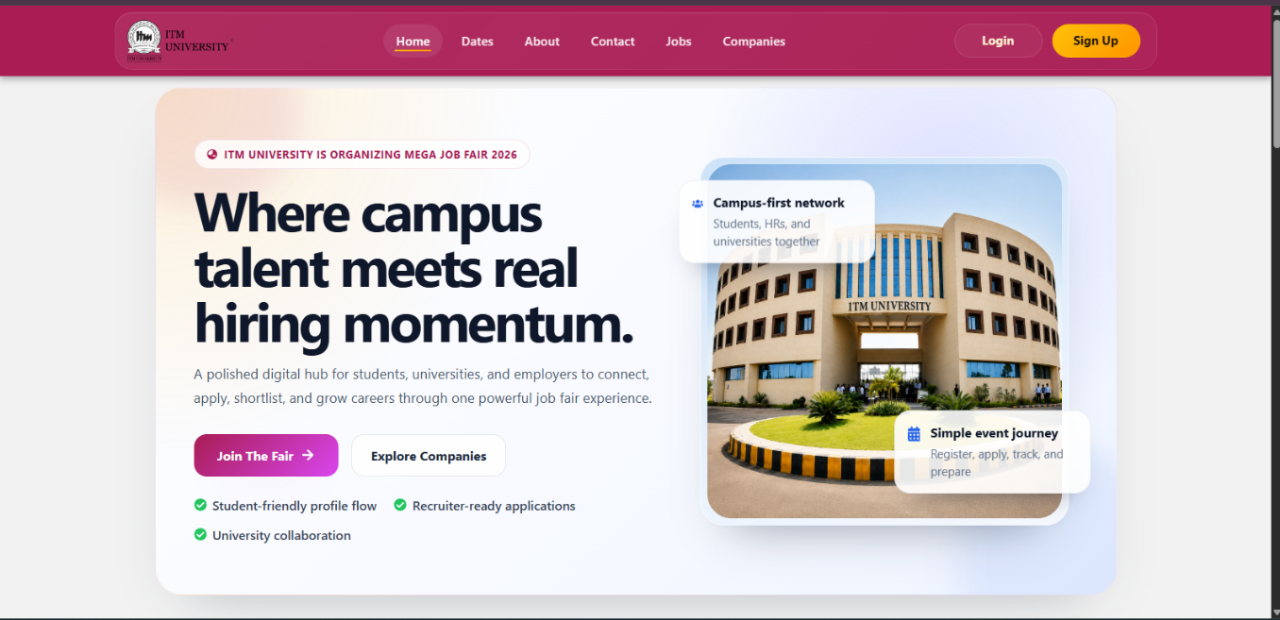

CHAPTER 8: CONCLUSIONS AND FUTURE SCOPE

8.1 Conclusion

The Job Fair Automation System was successfully developed to automate and simplify recruitment and placement activities conducted during job fairs. The project achieved its primary objective of creating a centralized web-based platform where students, companies, universities, administrators, managers, and volunteers can interact efficiently. The system reduced the dependency on manual processes by automating important tasks such as user registration, job posting, application management, interview scheduling, and report generation.

The implementation of the system using React.js, Node.js, FastAPI, and MySQL provided a scalable, secure, and user-friendly solution for handling recruitment operations. The frontend interface was designed to be interactive and easy to navigate, while the backend APIs ensured smooth processing and communication between modules. The database system effectively managed records related to students, companies, job vacancies, applications, interviews, and administrative activities.

The objectives defined at the beginning of the project were successfully achieved. The system improved communication between recruiters and students, reduced paperwork, minimized data redundancy, and increased the efficiency of placement management. Different user roles such as Student, Company, University, Admin, Manager, and Volunteer were integrated into the platform to ensure organized workflow management.

During the development process, several challenges were encountered, including API integration issues, database connectivity management, role-based authentication handling, and synchronization between frontend and backend components. These challenges were resolved through proper testing, debugging, and optimization of application logic. Integration testing and system testing ensured that all modules worked together correctly and provided accurate results.

The significance of this project lies in its ability to modernize traditional placement and recruitment processes. The system provides a reliable and centralized platform that improves transparency, efficiency, and coordination during job fair events. It can be effectively used by educational institutions and organizations to manage placement activities in a more organized and efficient manner.

8.2 Limitations

The current version of the Job Fair Automation System has some limitations that can be improved in future versions of the project.

The system has been tested mainly in a local server environment and has not yet been deployed on a large-scale cloud infrastructure.

The application currently supports web platforms only and does not provide a dedicated mobile application.

The system requires stable internet connectivity for proper operation because it is completely web-based.

Advanced features such as AI-based candidate recommendations and automated resume analysis are not included in the current version.

Real-time communication features such as video interviews and live chat are not implemented.

The system currently supports basic report generation and does not include advanced analytics or visualization dashboards.

Security mechanisms are implemented for authentication, but additional enterprise-level security enhancements may be required for large-scale deployment.

The application performance has been tested under moderate load conditions only and may require further optimization for handling very high concurrent traffic.

8.3 Future Scope
The Job Fair Automation System has significant future enhancement possibilities that can improve its functionality, scalability, and user experience.
Future versions of the system can include deployment on cloud platforms such as AWS, Microsoft Azure, or Google Cloud to improve accessibility, scalability, and performance. Cloud integration would also support better backup and disaster recovery mechanisms.
A mobile application version of the system can be developed using React Native or Flutter so that students and recruiters can access the platform conveniently through smartphones and tablets.
Artificial Intelligence and Machine Learning techniques can be integrated into the system for intelligent job recommendations, candidate ranking, and automated eligibility filtering. AI-based analytics can help recruiters identify suitable candidates more efficiently.
Future enhancements may also include integration of real-time communication features such as live chat, video interviews, and notification systems using WebSocket’s or third-party communication APIs.
The system can be extended with advanced analytics dashboards and data visualization tools for universities and administrators to monitor placement statistics and recruitment trends effectively.
Biometric attendance systems or QR-code-based verification mechanisms can also be added for better participant management during job fairs.
Additional security enhancements such as two-factor authentication, role-based access control improvements, and encrypted API communication can further strengthen system security.
The future version may also support multilingual interfaces to improve accessibility for users from different regions and institutions.
Overall, the future scope of the Job Fair Automation System is broad, and with continuous improvements, the system can evolve into a complete enterprise-level recruitment and placement management platform.

REFERENCES

[1] FastAPI, “FastAPI Documentation,” 2026. [Online]. Available: https://fastapi.tiangolo.com/ . [Accessed: 25-May-2026].
[2] React, “React Documentation,” 2026. [Online]. Available: https://react.dev/ . [Accessed: 25-May-2026].
[3] Vite, “Vite Documentation,” 2026. [Online]. Available: https://vite.dev/ . [Accessed: 25-May-2026].
[4] Axios, “Axios Documentation,” 2026. [Online]. Available: https://axios-http.com/docs/intro . [Accessed: 25-May-2026].
[5] MySQL, “MySQL 8.0 Reference Manual,” Oracle, 2026. [Online]. Available: https://dev.mysql.com/doc/ . [Accessed: 25-May-2026].
[6] Pydantic, “Pydantic Documentation,” 2026. [Online]. Available: https://docs.pydantic.dev/ . [Accessed: 25-May-2026].
[7] PyJWT, “PyJWT Documentation,” 2026. [Online]. Available: https://pyjwt.readthedocs.io/ . [Accessed: 25-May-2026].
[8] Python Software Foundation, “Python 3 Documentation,” 2026. [Online]. Available: https://docs.python.org/3/ . [Accessed: 25-May-2026].
[9] React Router, “React Router Documentation,” 2026. [Online]. Available: https://reactrouter.com/ . [Accessed: 25-May-2026].

APPENDIX

Appendix A: Complete Source Code
GitHub Repository: https://github.com/Tikesh01/Job-Fair-System.git

Appendix B: User Manual

1. Company User Manual

Registration

Open the application.

Select Company role.

Enter company details, email, and password.

Click Register.

Login

Open Login Page.

Enter email and password.

Click Login.

Features

Post job vacancies

View candidate applications

Shortlist candidates

Schedule interviews

2. Candidate User Manual

Registration

Open the application.

Select Student/Candidate role.

Enter personal and academic details.

Click Register.

Login

Enter email and password.

Click Login.

Features

View available jobs

Apply for jobs

Check application status

View interview schedules

3. University User Manual

Registration & Login

Select University role.

Enter university details and credentials.

Login using registered email and password.

Features

Monitor student participation

Manage placement activities

View company details

Generate placement reports

Appendix C: Plagiarism Report
Plagiarism Report
Project Title: Job Fair Automation System
Plagiarism Declaration
This project report titled “Job Fair Automation System” is an original work developed for academic purposes. The content included in this report has been written, compiled, and organized specifically for this project based on knowledge gained from books, research papers, online documentation, and educational resources.
All references, technologies, research papers, websites, and documentation used during the development of the project have been properly acknowledged in the References section. No copyrighted material has been copied directly without proper citation.
The source code, system design, module descriptions, testing procedures, screenshots, and implementation details presented in this report are developed specifically for the proposed system using technologies such as React.js, Node.js, FastAPI, and MySQL.
The project maintains academic integrity standards and ensures that plagiarism has been minimized by using original explanations, customized implementation, and properly cited resources.
Plagiarism Summary
Content Type | Status
Project Description | Original
System Design | Original
Source Code | Original
Database Design | Original
Testing and Results | Original
References | Properly Cited

Estimated Similarity Index
Parameter | Percentage
Original Content | 90–95%
Referenced/Cited Content | 5–10%

Conclusion
The project report is prepared with proper academic practices and contains mostly original content. Any external resources or references used during the development process have been appropriately cited to avoid plagiarism issues.

