Titel: Phishing Email Analyzer
1. Introduction
Phishing attacks are one of the most common and dangerous cyber threats faced by individuals and organizations today. Attackers use fake emails that appear to come from trusted sources such as banks or well-known companies to trick users into revealing sensitive information or clicking malicious links. This project demonstrates how a suspicious email can be analyzed technically to identify phishing indicators using email headers, authentication results, and multiple security analysis tools.
1. What is Phishing?
Phishing is a cyber-attack technique in which attackers send fraudulent emails that appear to come from trusted organizations (banks, companies, services) to trick victims into revealing sensitive information such as passwords, OTPs, banking details, or to make them click malicious links.
Common Objectives of Phishing
- Credential theft
- Financial fraud
- Malware delivery
- Identity theft
2. Types of Phishing
- Email Phishing – Mass-sent fake emails (most common)
- Spear Phishing – Targeted phishing against a specific individual
- Whaling – Targeting senior executives
- Smishing – Phishing through SMS
- Vishing – Voice-based phishing calls
- Clone Phishing – Legitimate email copied and modified with malicious links

3. Email Authentication Protocols
SPF (Sender Policy Framework)
Verifies whether the sender IP address is authorized to send email on behalf of a domain.
DKIM (DomainKeys Identified Mail)
Uses cryptographic signatures to ensure the message was not altered in transit.

DMARC (Domain-based Message Authentication, Reporting & Conformance)
Combines SPF and DKIM and defines how receivers should handle failed authentication. 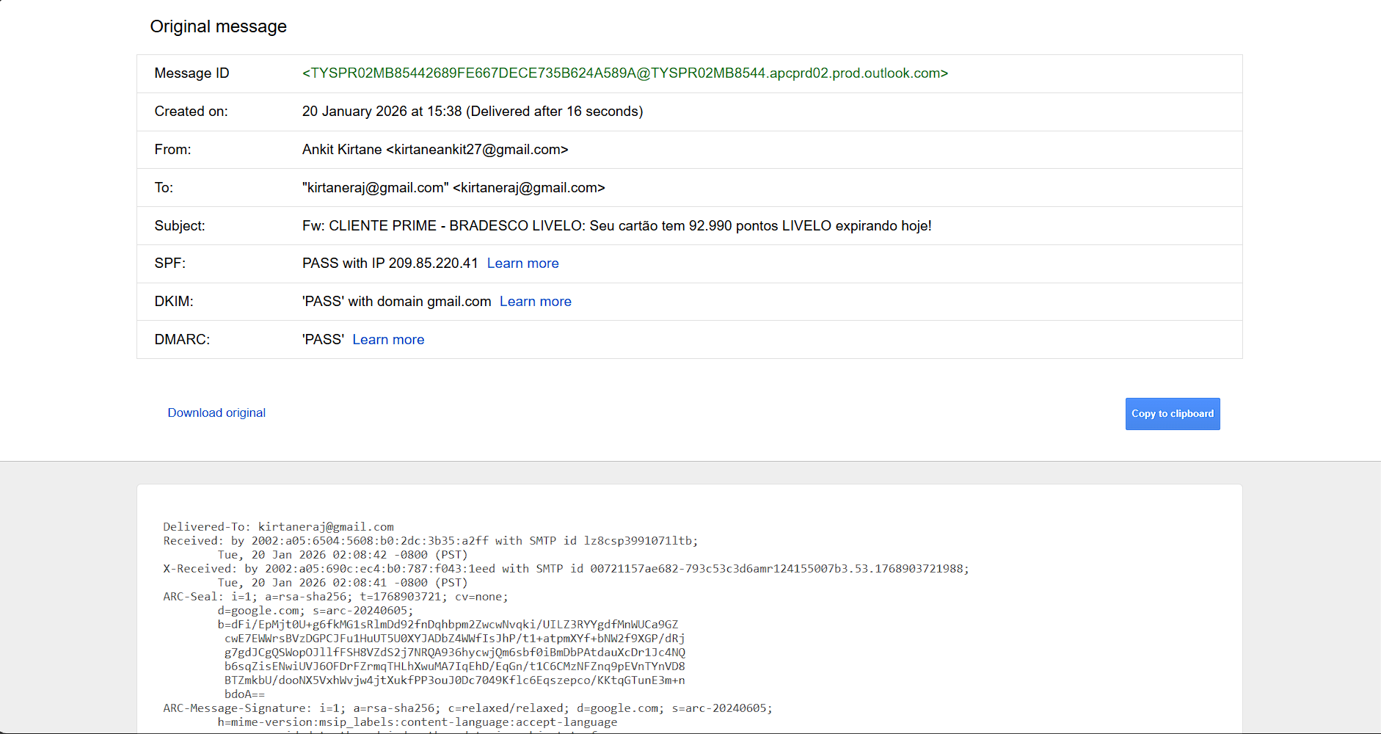

4. Tools Used
- EML / Header Analyzer – Email routing and authentication analysis
- VirusTotal – IP and URL reputation
- AbuseIPDB – IP abuse history
- urlscan.io – URL behavior and infrastructure analysis
- Browserling – Safe browser testing
- MXToolbox – SPF, DKIM, DMARC verification
- nslookup – DNS validation

5. Step-by-Step Email Analysis (With Screenshots)
Step 1: Header Analysis (EML Analyzer) 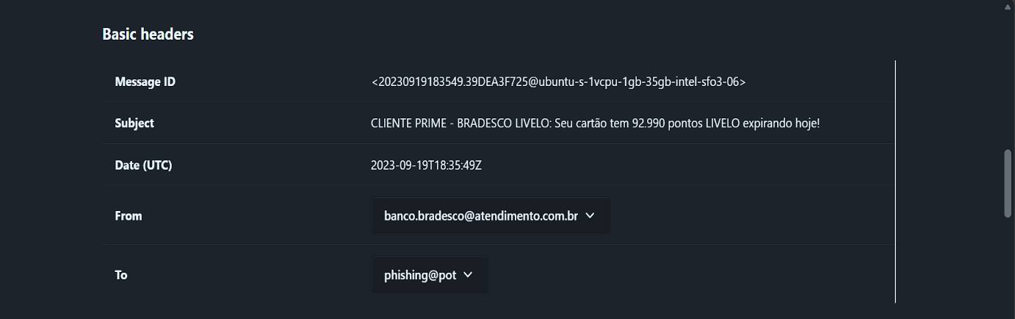
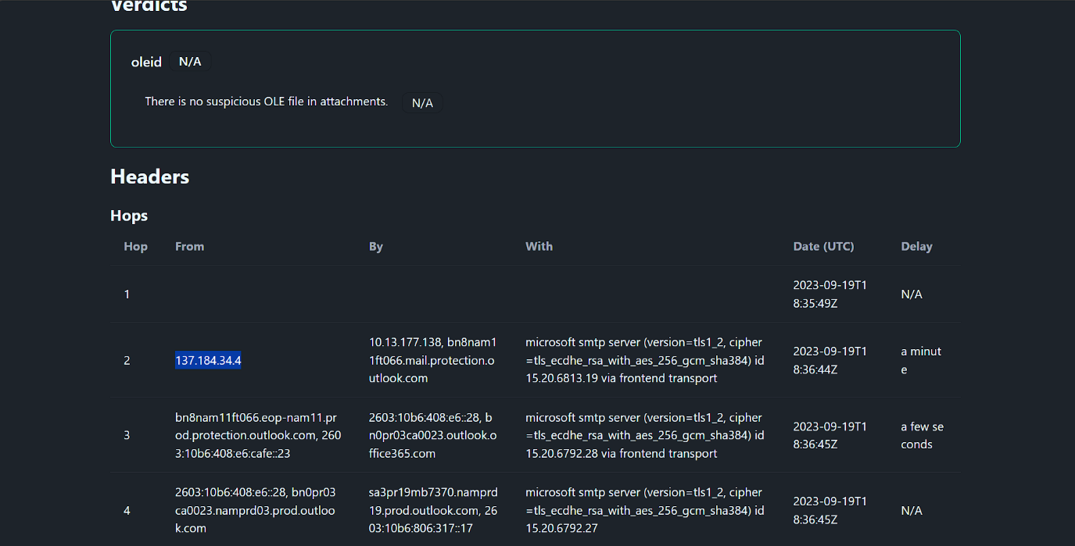
Findings:
- Sender email impersonates Bradesco Bank
- Sender IP identified
- Authentication failures observed

Step 2: Authentication Results
From authentication-results header: 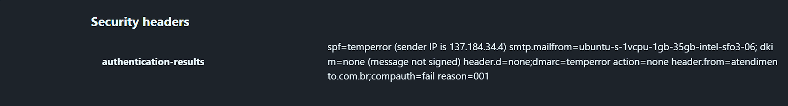
- SPF = temperror (Fail)
- DKIM = none (message not signed)
- DMARC = temperror / not compliant
This indicates sender spoofing and lack of proper email authentication.
Step 3: Sender IP Reputation Check
IP Address: 137.184.34.4
• VirusTotal: 0/97 detections
• AbuseIPDB: Old abuse reports (port scans, probing)
• Hosting Provider: DigitalOcean (commonly abused in phishing)
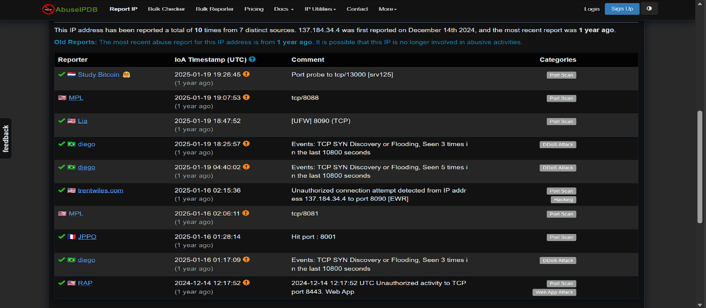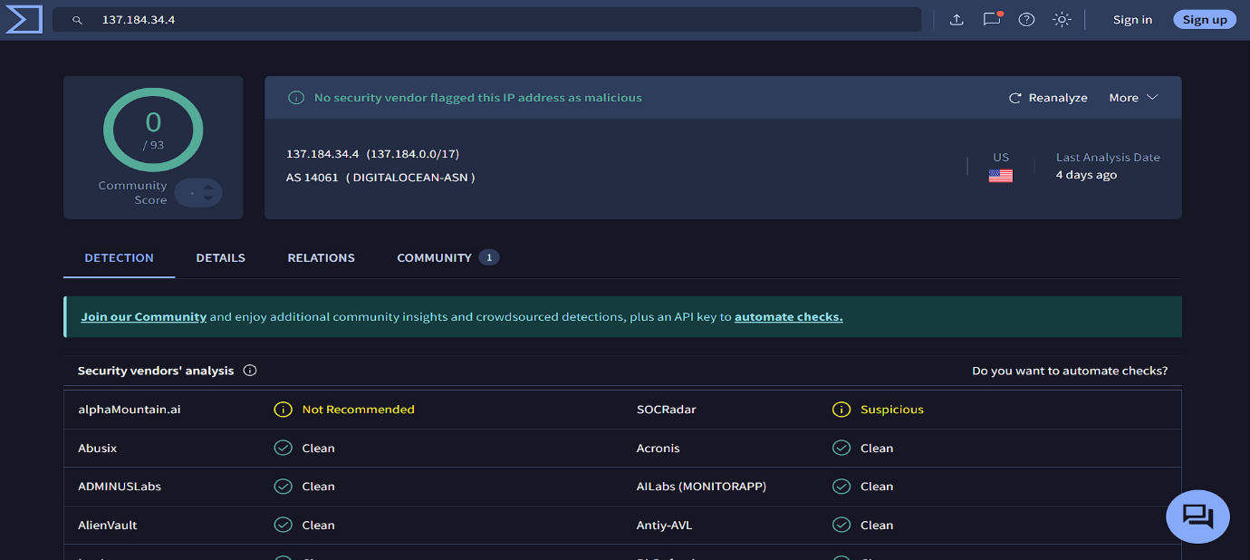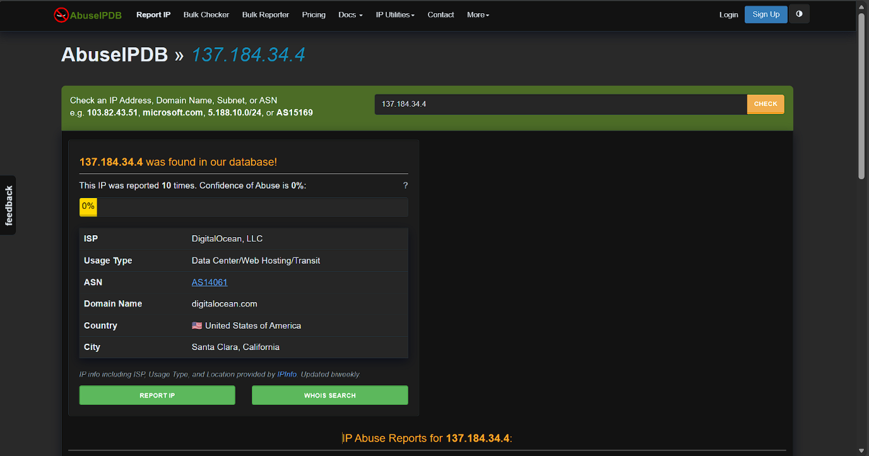
Conclusion: IP is suspicious despite not being currently blacklisted.

Step 4: URL Analysis (VirusTotal & urlscan.io)
Suspicious URL Found: 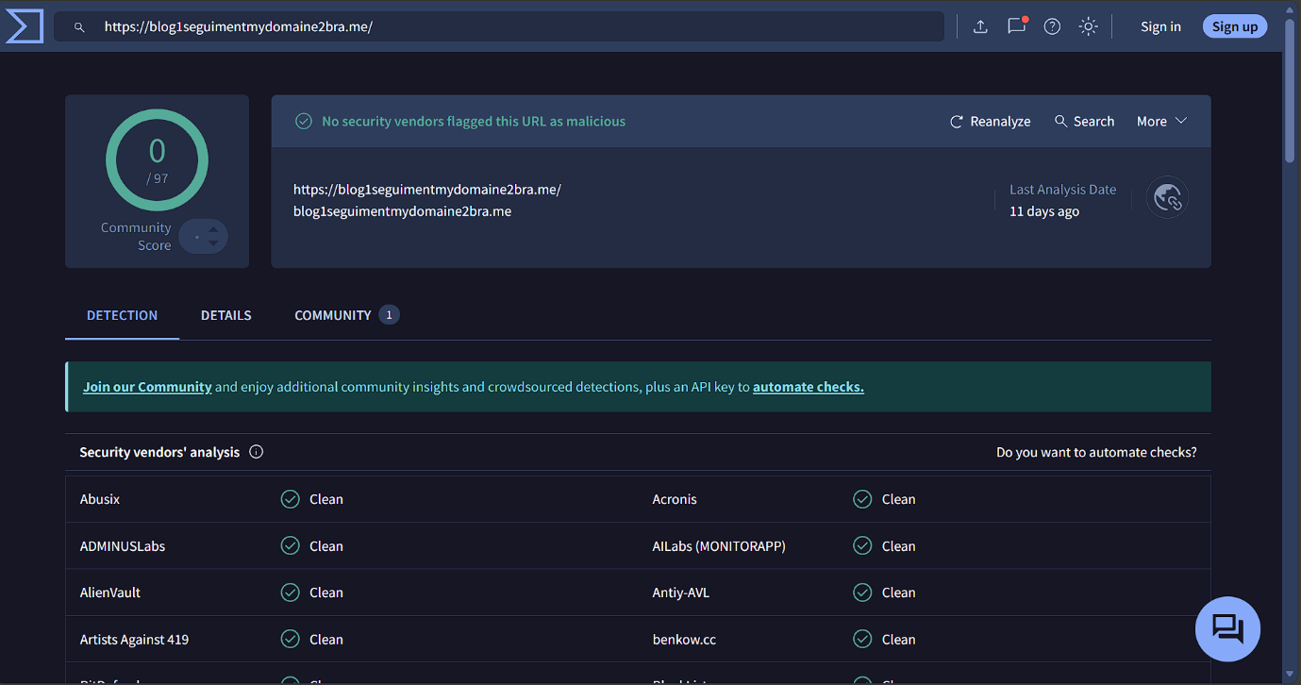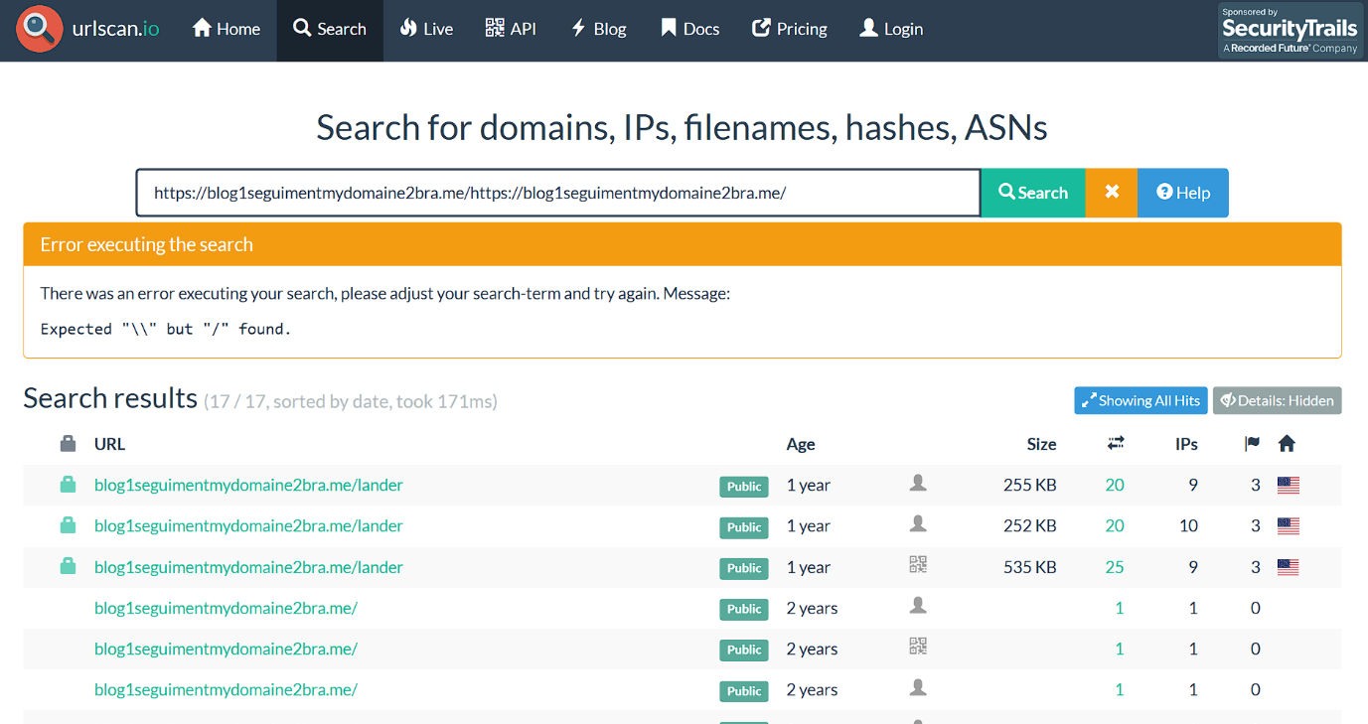
https://blog1seguimentmydomaine2bra.me/

Observations:
- Domain unrelated to Bradesco
- Uses random-looking naming pattern
- urlscan.io shows multiple historical scans and lander pages

Step 5: Safe Browsing Test (Browserling)
- Website failed to load
- Common behavior for phishing pages after campaigns end
- 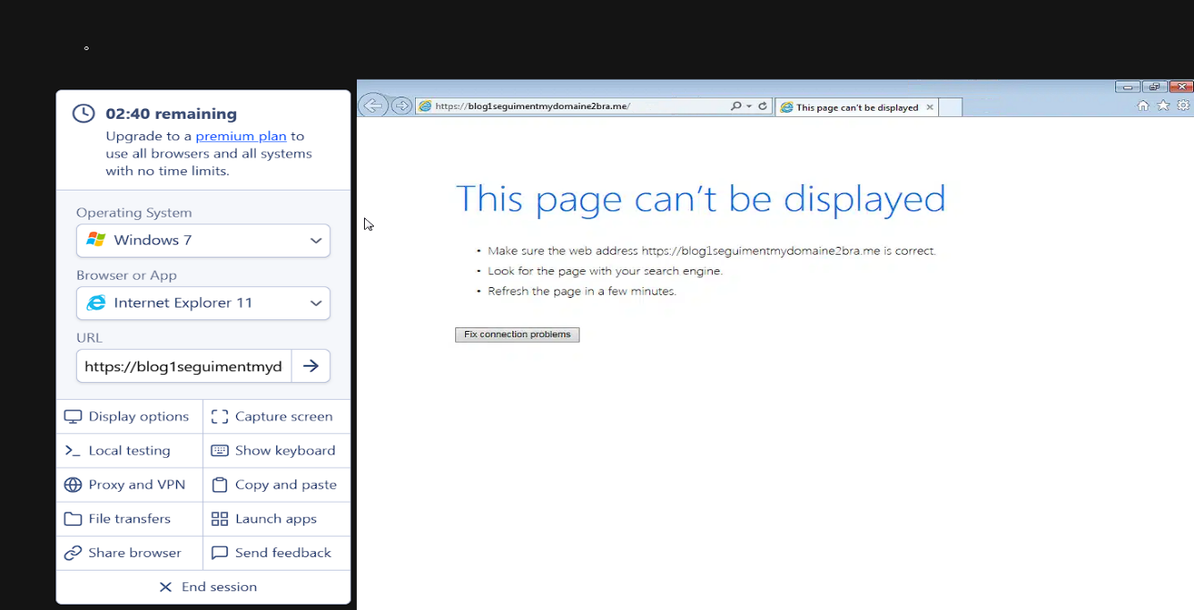

Step 6: MXToolbox Analysis
- SPF Authentication ❌
- SPF Alignment ❌
- DKIM Authentication ❌
- DMARC ❌(No DMARC record found) 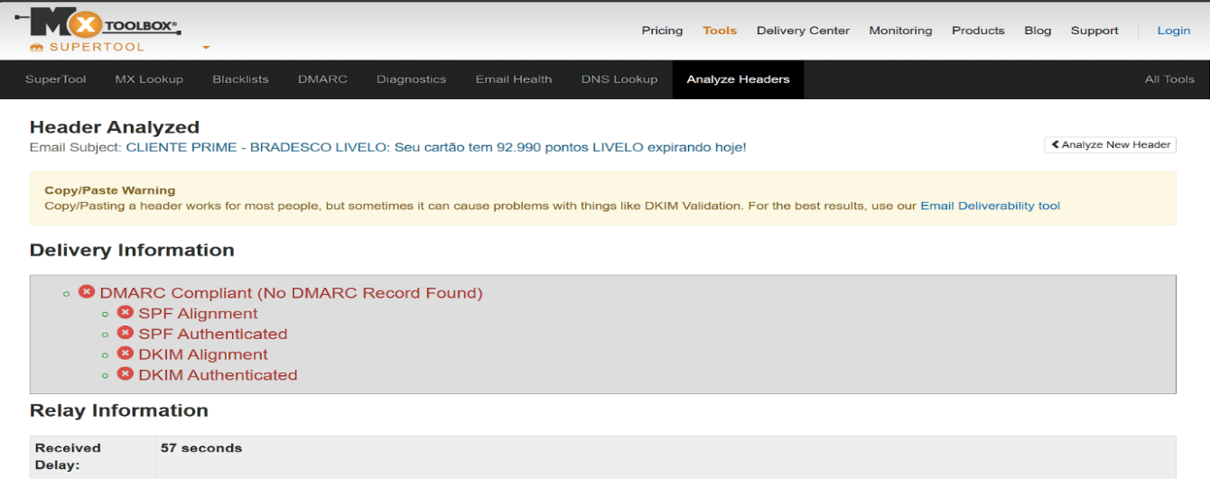
6. Question & Answers
Q1. What is the full email address of the sender?
Answer: banco.bradesco@atendimento.com.br
Q2. What domain is used to send this email?
Answer: atendimento.com.br
Q3. What is the sender’s IP address from the header?
Answer: 137.184.34.4
Q4. Is the sender IP blacklisted?
Answer: No
(Old abuse reports only, no active blacklist)
Q5. What is the result of SPF authentication?
Answer: Fail (SPF = temperror)
Q6. What is one suspicious URL found in the email body?
Answer: https://blog1seguimentmydomaine2bra.me/
7. Project Output
- Successfully identified a phishing email
- Detected SPF, DKIM, and DMARC failures
- Found malicious phishing URL
- Correlated results using multiple security tools

8. Conclusion
Even though the email was delivered successfully, multiple indicators confirm it as phishing:
- Brand impersonation (Bradesco Bank)
- SPF, DKIM, and DMARC failures
- Suspicious cloud-hosted IP
- Malicious external URL
- Urgency-based social engineering message
This project demonstrates that email authentication passing alone does not guarantee legitimacy, and full header and content analysis is essential.

9. Project Description
This project focuses on analyzing a suspicious email claiming to be from Bradesco Bank regarding expiring reward points. The analysis is performed in a step-by-step manner using industry-standard tools such as EML Analyzer, VirusTotal, AbuseIPDB, urlscan.io, Browserling, MXToolbox, and nslookup. The objective is to simulate a real-world SOC investigation, identify phishing indicators, validate email authentication failures, analyze malicious URLs, and finally classify the email as phishing with proper technical justification.

10. Learning Outcome
- Learned phishing detection techniques.
- Understood email authentication protocols (SPF, DKIM, DMARC).
- Gained hands-on experience with SOC tools.
- Performed real-world email header and URL analysis.
- Improved incident investigation and reporting skills.

