Lab Work : Interactive UI

**# Challenge One**: Change the layout so that it looks good in both horizontal and vertical orientations

1. On your computer, make a copy of the HelloToast project folder and rename it to

HelloToastChallenge.

2. Open HelloToastChallenge in Android Studio and refactor it. (Find way on copying and refactoring a project.)

3. Change the layout so that the Toast Button and Count Button appear on the left side, as

shown in the figure below. The TextView appears next to them, but only wide enough to

show its contents. (Hint: Use wrap_content.)

4. Run the app in both horizontal and vertical orientations.

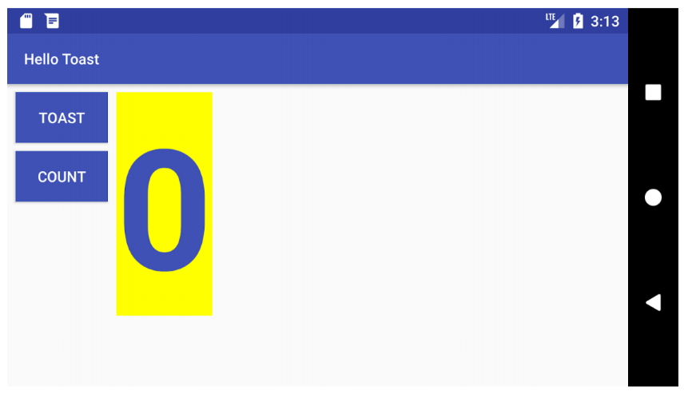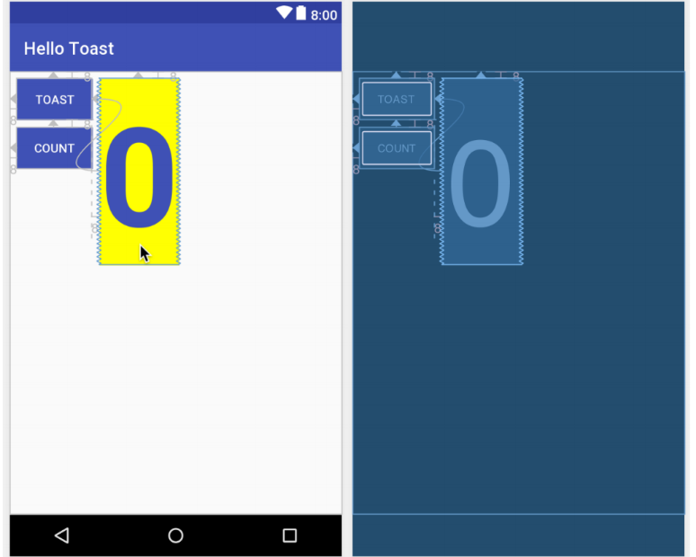



**# Challenge Two :**

1. Design above user interface with help of LinearLayout.

2. Design above user interface with help of RelativeLayout.