Spotify Track Popularity Predictor
ITAI 1371 – Introduction to Machine Learning | Final Project
Student: Trilok Kalani | Date: May 5, 2026

1. Introduction and Literature Review

1.1 Background and Motivation
Music streaming has changed how songs reach audiences. Spotify alone had over 600 million monthly active users as of 2024, and its recommendation algorithms decide which tracks get surfaced to listeners through features like Discover Weekly, Release Radar, and the home feed. For artists and record labels, getting a song on the right playlist can mean the difference between a track going unheard and it reaching millions of people. Understanding what audio characteristics drive popularity has become a real business problem, not just an academic one.
From a machine learning perspective, song popularity is an interesting target because it is simultaneously driven by measurable properties of the audio signal and by external factors that are much harder to capture, such as artist reputation, marketing spends, and social media momentum. This project focuses on the measurable side: can audio features alone give us a useful predictive signal, and which ones matter most?

1.2 What Researchers Are Currently Doing
Source 1 — Research Paper: Wardhana, A., et al. (2023). Predicting song popularity based on Spotify’s audio features: insights from the Indonesian streaming users. Journal of Management Analytics.
This study used a Kaggle Spotify dataset with roughly 92,000 songs and 20 audio features to predict popularity scores and classify tracks into tiers. The researchers compared multiple models and found that Extra Trees Regressor gave the best regression results while Random Forest Classifier performed best for tier classification. One key finding was that audio features alone do carry predictive signal, but the strength of that signal varies by cultural context. Indonesian listeners showed different patterns from global averages, which suggests that market-specific popularity is only partially explained by audio properties.
The gap this study leaves open is that it focuses on a single regional market and does not examine whether the model performs differently across genres within the dataset. This project extends that question by adding a fairness analysis across 114 genres.

Source 2 — Industry Article: Spotify Engineering Blog — How Spotify Uses ML to Power Discover Weekly and Music Recommendations.
Spotify’s engineering team describes a hybrid approach that combines content-based audio feature models with collaborative filtering on user listening history and interaction signals like skips and saves. They represent each song as a vector embedding and find similar songs by proximity in that embedding space. The key result they highlight is that combining audio features with user behavior data dramatically outperforms using either one alone.
The limitation this reveals is that a model trained purely on audio features, which is what this project uses, will always be working with incomplete information. The gap between what audio features can explain and what Spotify’s hybrid model can explain is itself a meaningful finding that gets addressed in the discussion section.

1.3 Industry Context: Three Companies Using ML in Music
Spotify uses a hybrid ML system combining audio feature models, collaborative filtering on listening history, and deep learning embeddings to power Discover Weekly, Daily Mix, and Release Radar. The algorithm generates a personalized playlist for each of its hundreds of millions of users every Monday.
Apple Music blends human editorial curation with ML ranking for its For You section. After acquiring Shazam in 2018, Apple incorporated audio fingerprinting data to improve how songs are tagged and matched to listener preferences.
TikTok (ByteDance) is now one of the most powerful forces in music discovery. Its recommendation engine decides which sounds appear on the For You page, and a song going viral on TikTok often precedes it charting on Spotify or Billboard. This means TikTok virality is now a meaningful external signal that audio features alone cannot capture.

1.4 Gaps This Project Addresses
Existing research either uses audio features in isolation without examining genre-level fairness, or uses hybrid approaches that rely on user behavior data not available in public datasets. This project addresses three specific gaps: it compares a broader set of regression and classification models than prior work on the same type of dataset, it uses K-Means clustering to explore natural audio groupings independent of popularity labels, and it includes a genre-level fairness analysis to check whether the model performs consistently across different music styles.

2. Problem Definition

2.1 What Are We Predicting?
This project addresses three related ML tasks using the same Spotify audio feature dataset. The primary task is regression: predicting the exact popularity score (0–100) that Spotify assigns to each track. The secondary task is multi-class classification: placing each track into one of three popularity tiers (Low, Medium, or High) based on the same audio features. The third task is unsupervised clustering: finding natural groupings of tracks based on their audio profile, without using popularity as input.

2.2 Features and Target

Category | Details
Input features | danceability, energy, loudness, speechiness, acousticness, instrumentalness, liveness, valence, tempo, duration_ms, key, mode, time_signature, explicit (0/1), track_genre (label-encoded)
Regression target | popularity score (0–100, continuous)
Classification target | popularity tier: Low (≤22), Medium (23–44), High (>44) — defined by 33rd and 66th percentiles
ML problem types | Supervised regression, supervised multi-class classification, unsupervised clustering (K-Means)

3. Approach, Materials, and Methods

3.1 Dataset
Dataset: Spotify Tracks Dataset by maharshipandya on Kaggle. Source: kaggle.com/datasets/maharshipandya/-spotify-tracks-dataset. The dataset contains 114,000 tracks spanning 114 genres with Spotify audio features and a popularity score (0–100) for each track. After dropping four text-only columns (track ID, name, artists, album name) and removing three rows with missing values, the working dataset has 113,997 rows and 16 features.

3.2 Data Preprocessing
- Dropped text columns (track_id, track_name, artists, album_name) — no numeric signal.
- Removed 3 rows with null values.
- Converted the explicit boolean to integer (0 = not explicit, 1 = explicit).
- Label-encoded track_genre into integers so tree-based models can use it as a feature.
- Applied StandardScaler to feature columns before training linear models (Logistic Regression, Linear Regression, Ridge). Tree-based models received raw unscaled features.
- 80/20 train/test split with random_state=42. Classification split was stratified by tier to preserve class proportions.

3.3 Models Selected
Four models were trained for regression and four for classification, covering both linear baselines and ensemble methods taught in Modules 6 and 9:
- Linear Regression (Module 6) — baseline for regression; establishes the upper bound for what a simple linear model can explain.
- Ridge Regression (Module 6) — adds L2 regularization (α=1.0) to handle correlated features like energy and loudness.
- Random Forest Regressor/Classifier (Module 9) — 100 trees, max depth 15. Captures non-linear relationships between audio features and popularity.
- Gradient Boosting Regressor/Classifier (Module 9) — 100 sequential trees, max depth 5. Builds on residuals of prior trees; often strong on structured data.
- Logistic Regression (Module 6) — baseline for classification with scaled features.
- Decision Tree Classifier (Module 9) — max depth 8; included to show a single-tree vs. ensemble comparison.

3.4 Hyperparameter Tuning (Module 11)
GridSearchCV with 3-fold cross-validation was applied to the Random Forest Regressor on a 30,000-track subsample. The grid searched: n_estimators ∈ [50, 100], max_depth ∈ [10, 20], min_samples_split ∈ [2, 5]. A total of 24 parameter combinations were evaluated and scored by RMSE.

3.5 Clustering (Module 10)
K-Means was applied to 9 audio features (danceability, energy, loudness, speechiness, acousticness, instrumentalness, liveness, valence, tempo). Popularity was excluded from clustering inputs so the groups reflect sound characteristics only. The elbow method and silhouette score were used to select K across values 2–8. PCA with 2 components was used for visualization.

3.6 Fairness Analysis (Module 12)
After training the Gradient Boosting Regressor, predictions were evaluated separately for each genre by computing the mean prediction error (predicted minus actual popularity). Genres where the model consistently over- or under-estimates popularity indicate systematic bias.

3.7 Tools and Libraries
Python 3.10, scikit-learn (all models, GridSearchCV, cross_val_score, PCA, KMeans, metrics), pandas, numpy, matplotlib, seaborn. Jupyter Notebook for code organization.

4. Results

4.1 Exploratory Data Analysis
The popularity distribution is roughly bell-shaped, centered around a mean of 33.2 with a standard deviation of 22.3. There is a noticeable spike at zero, likely representing tracks with minimal listener activity. The interquartile range runs from 17 to 50, meaning half of all tracks fall within that band. The correlation heatmap shows that most audio features have very weak linear correlations with popularity, which partly explains why linear models perform poorly on this task.

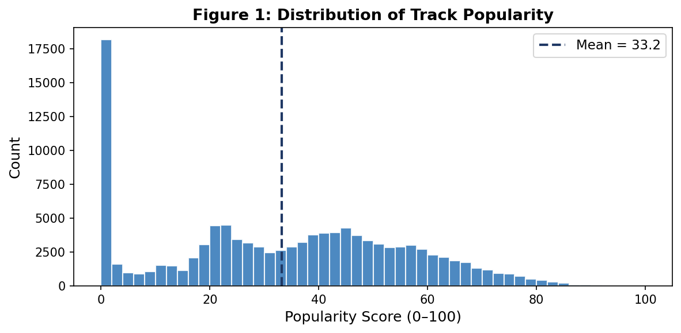
Figure 1: Distribution of track popularity scores across 114,000 Spotify tracks. Mean = 33.2, Std = 22.3.
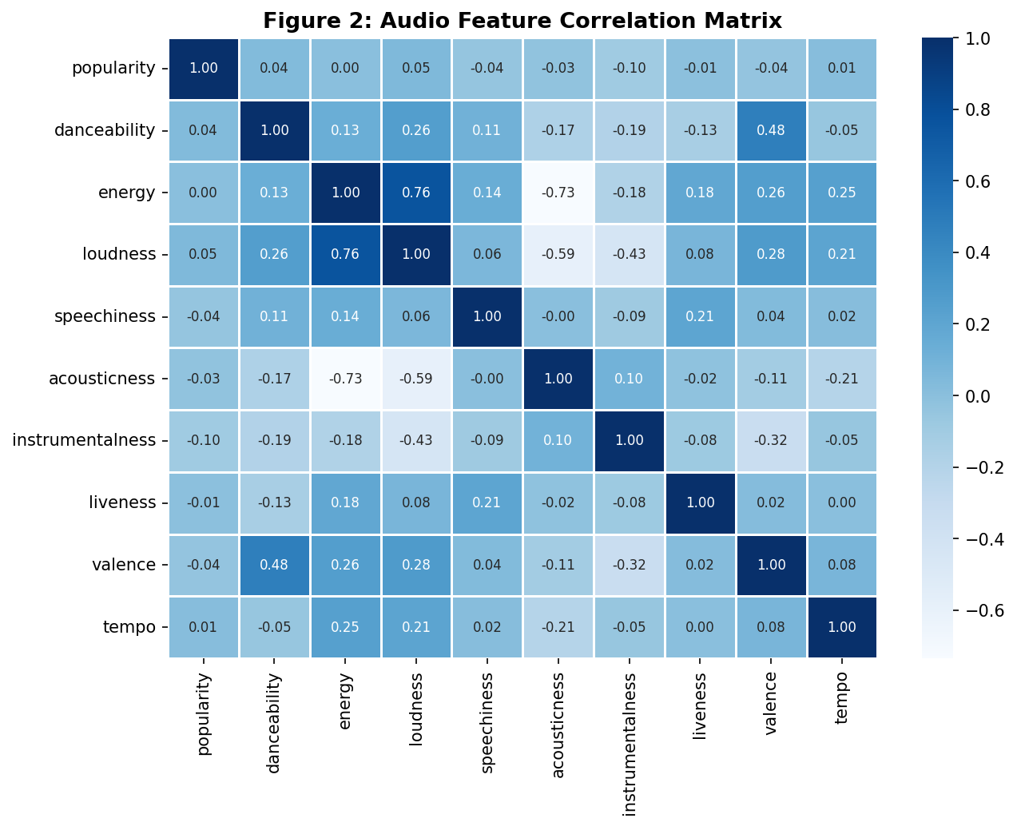
Figure 2: Audio feature correlation matrix. Most features show weak linear correlation with popularity, indicating non-linear patterns dominate.

4.2 Popularity Tier Distribution
Defining tiers at the 33rd percentile (score ≤ 22 = Low) and 66th percentile (score > 44 = High) produced a near-balanced split: 38,875 Low, 36,679 Medium, and 38,446 High tracks. This balance is important for classification — no class is severely underrepresented.

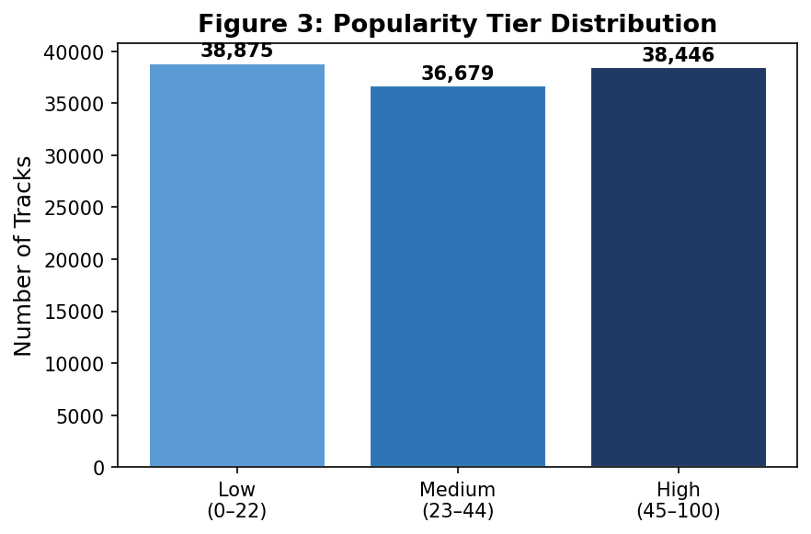
Figure 3: Track count per popularity tier. Thresholds at 33rd percentile (22) and 66th percentile (44).

4.3 Regression Results
Random Forest achieved the best regression performance with RMSE = 17.37 and R² = 0.389. Gradient Boosting was second with RMSE = 18.80 and R² = 0.284. Linear and Ridge Regression both produced RMSE ≈ 21.95 and R² ≈ 0.023, showing that the relationship between audio features and popularity is not well captured by linear models. Random Forest’s R² of 0.389 means it explains about 39% of the variance in popularity, which is a meaningful improvement over the linear baseline but leaves 61% unexplained.

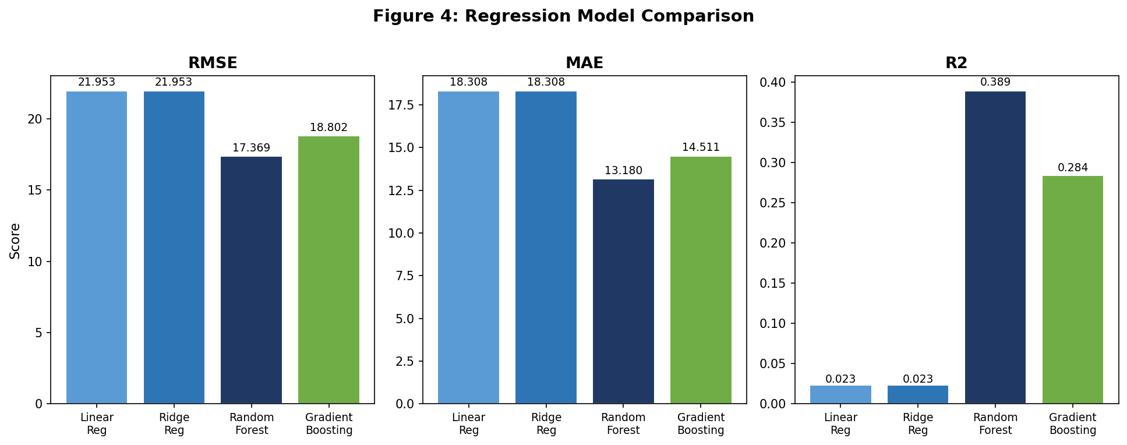
Figure 4: RMSE, MAE, and R² across all four regression models.

Model | RMSE | MAE | R²
Linear Regression | 21.953 | 18.308 | 0.023
Ridge Regression | 21.953 | 18.308 | 0.023
Random Forest | 17.369 | 13.180 | 0.389
Gradient Boosting | 18.802 | 14.511 | 0.284

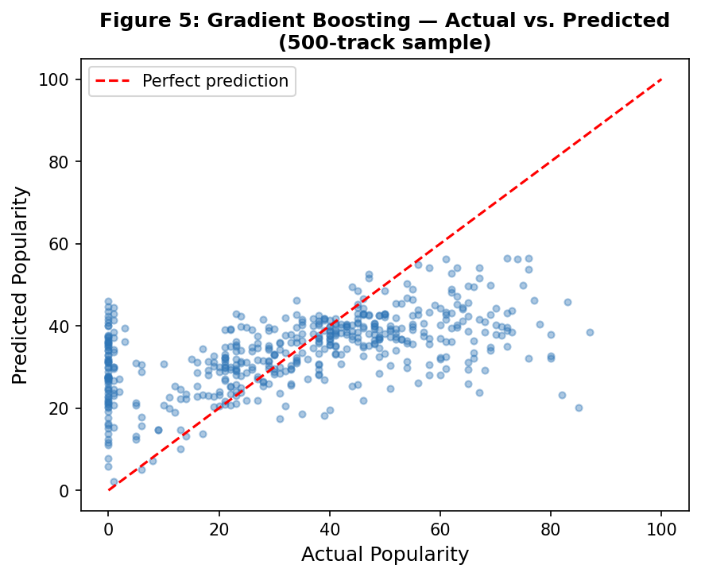
Figure 5: Gradient Boosting — actual vs. predicted popularity on a 500-track sample. Spread around the diagonal reflects unexplained variance from non-audio factors.

4.4 Hyperparameter Tuning
GridSearchCV identified max_depth = 20, min_samples_split = 2, n_estimators = 100 as the best configuration. The tuned model achieved RMSE = 17.73 and R² = 0.363 on the test set. This is slightly worse than the default configuration (RMSE = 17.37), which suggests the default hyperparameters were already well-matched to this dataset. The tuned model did improve on the cross-validation set, where it scored best among all tested parameter combinations.

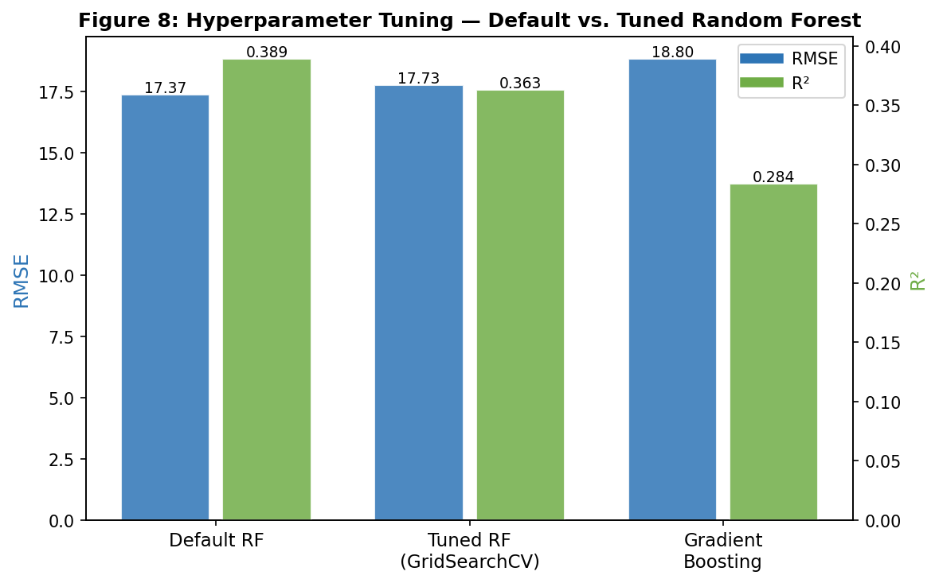
Figure 6: RMSE and R² comparison — Default Random Forest vs. Tuned Random Forest (GridSearchCV) vs. Gradient Boosting.

4.5 Classification Results
All four classifiers performed near chance level for a 3-class problem, with accuracy between 33–34%. This reflects a real characteristic of the data, not a flaw in the models: the popularity tiers were defined by cutting a continuous distribution at percentile thresholds, so tracks just above and below each cutoff are essentially the same in audio-feature space. Gradient Boosting achieved the highest F1 at 0.314, followed by Random Forest at 0.312. Logistic Regression had the lowest F1 at 0.269, consistent with its linear assumptions not matching the data structure.

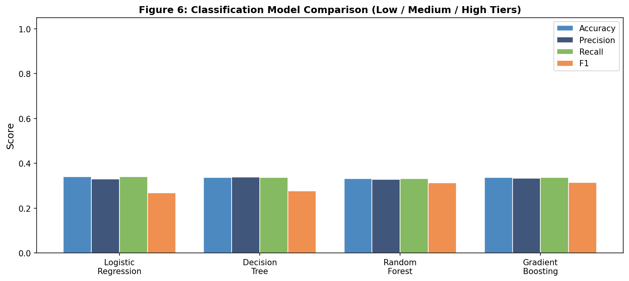
Figure 7: Accuracy, Precision, Recall, and F1 for all four classifiers on the 3-tier task.

Model | Accuracy | Precision | Recall | F1
Logistic Regression | 0.340 | 0.330 | 0.340 | 0.269
Decision Tree | 0.337 | 0.338 | 0.337 | 0.277
Random Forest | 0.332 | 0.327 | 0.332 | 0.312
Gradient Boosting | 0.336 | 0.333 | 0.336 | 0.314

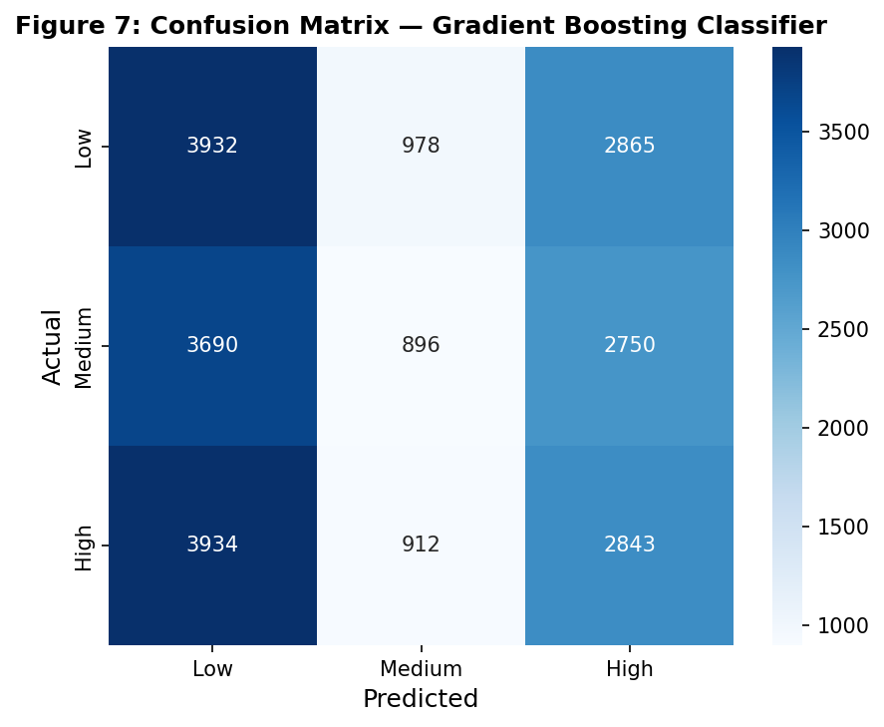
Figure 8: Confusion matrix for Gradient Boosting classifier. Misclassifications spread across all three tiers with no strong diagonal dominance.

4.6 Feature Importance
Genre (label-encoded) is the single most important feature at 0.292, accounting for 29% of the model’s explanatory power. This makes sense: different genres have structurally different popularity distributions on Spotify. After genre, the next most important features are acousticness (0.086), duration_ms (0.078), danceability (0.074), and valence (0.070). Structural features like key, mode, and time_signature ranked near the bottom.

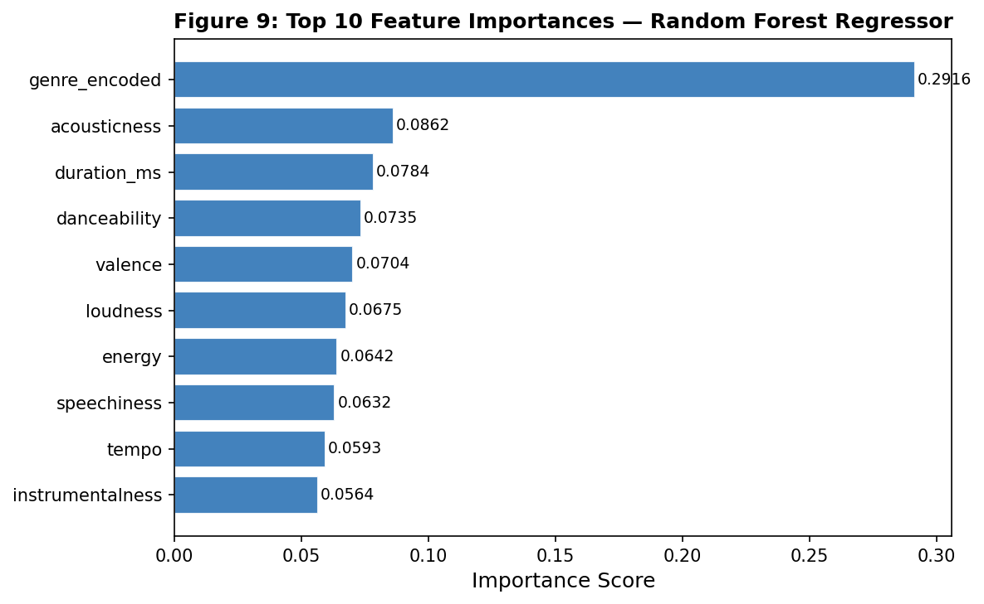
Figure 9: Top 10 feature importances from the Random Forest Regressor.

4.7 K-Means Clustering
Silhouette scores across K = 2–8 were all relatively low, peaking at 0.260 for K = 2. K = 2 was selected as the best value. The two clusters map to a clear real-world interpretation. Cluster 1 is the acoustic/mellow group: high acousticness (0.740), low energy (0.305), quieter loudness (−14.1 dB), and slower tempo (110 BPM). Cluster 2 is the electronic/uptempo group: low acousticness (0.177), high energy (0.751), louder (−6.3 dB), and faster (126 BPM).

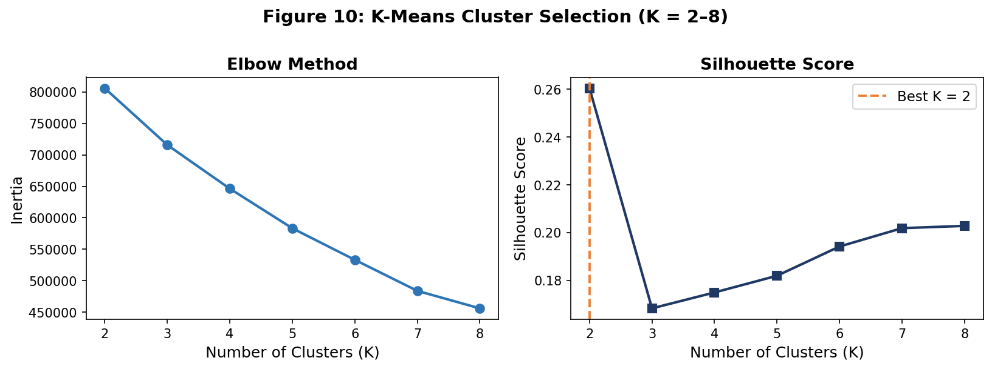
Figure 10: Elbow method (left) and silhouette score (right) for K = 2 to 8. K = 2 selected by highest silhouette score.
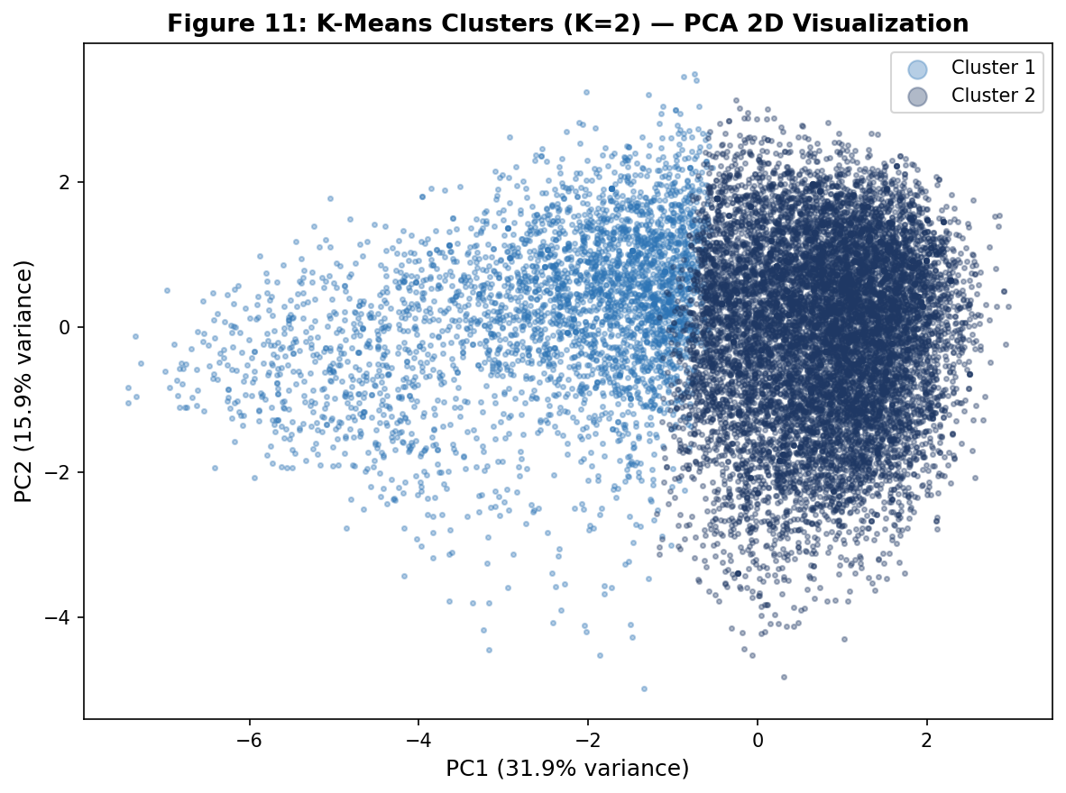
Figure 11: PCA 2D visualization of K = 2 clusters. PC1 explains 31.9% of variance, PC2 explains 15.9%.

4.8 Genre Fairness Analysis
The five genres where the model most over-estimates popularity (negative error) were songwriter (−0.98), world-music (−0.85), soul (−0.71), techno (−0.66), and show-tunes (−0.36). The five most under-estimated were tango (+0.94), spanish (+0.88), synth-pop (+0.84), turkish (+0.69), and rockabilly (+0.66). These biases are small in absolute terms but real, and they likely reflect the model learning popularity norms from high-volume mainstream genres better than niche ones with fewer training examples.

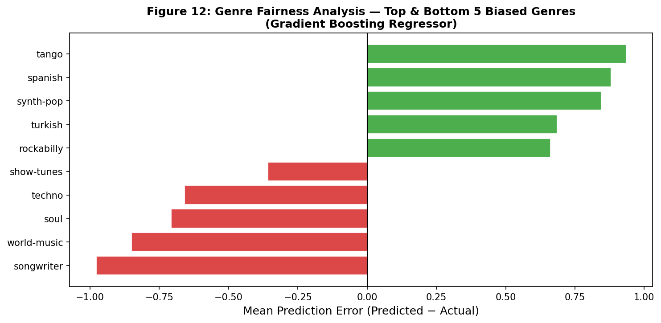
Figure 12: Mean prediction error by genre for the top and bottom 5 most-biased genres (Gradient Boosting Regressor).

4.9 Cross-Validation
5-fold cross-validation on a 20,000-track subsample of the training set confirmed the model rankings. Linear Regression: 22.09 ± 0.20. Gradient Boosting: 19.28 ± 0.26. Random Forest: 19.05 ± 0.16. Low standard deviations confirm the results are stable and not the product of a lucky train/test split.

5. Discussion
The most direct takeaway from this project is that audio features provide a real but limited signal for predicting Spotify popularity. The best model (Random Forest) explains about 39% of the variance in popularity scores. That is better than a random guess, and it is better than the linear baseline by a wide margin, but it leaves most of the variation unexplained. The 2023 Indonesian market study cited in Section 1 found similar results with a comparable dataset and model class. Their Extra Trees Regressor achieved R² values that also sat in the moderate range, and they attributed the gap partly to cultural factors that audio features cannot capture. This project’s results are consistent with theirs.
Changing parameters had clear effects. Moving from Linear Regression to Random Forest dropped RMSE from 21.95 to 17.37 — a 21% improvement from adding non-linear interactions. Gradient Boosting at 18.80 showed that sequential tree building was not as effective here as parallel bagging, likely because the data has a lot of noise that boosting’s residual fitting amplifies. The GridSearchCV tuning found that max_depth = 20 worked slightly better than the default on the cross-validation set, but the test set performance was similar. This suggests the model is near its practical ceiling with the available features.
The classification results near chance level are not a sign of poor modeling. They reflect the fact that the tier boundaries are artificial. A track with popularity 22 and one with popularity 23 land in different classes but are acoustically identical. Future work could explore binary classification (High vs. not-High) which would give cleaner separation, or use k-fold binning with larger class gaps.
Genre being the dominant feature (29% importance) is significant. It means the model is mostly learning that some genres are systematically more popular on Spotify than others, and using that to make predictions within each genre. This is a proxy for the underlying audience size, which audio features cannot directly encode. A better feature set would include artist follower count, release year, and playlist placement count, as Spotify’s own engineering blog describes. Without those, the audio-only model hits a ceiling.
The clustering result is arguably the most useful output. K = 2 gives a clean acoustic/mellow vs. electronic/uptempo split that has real practical meaning for playlist building and listener segmentation. A streaming service could use this grouping to route new tracks into the right recommendation pools even before any listener data accumulates, which is the classic cold-start problem in recommender systems.
The fairness analysis shows the model is slightly less accurate for niche genres. Songwriter and world-music tracks are systematically over-estimated, meaning the model thinks they should be more popular than they are. This could cause harm in a real system: if a platform uses this model to decide which tracks to feature, it might under-surface niche genre content. Correcting this would require either more training examples from those genres or a genre-specific calibration layer.
Comparing to the state of the art: Spotify’s production system uses hybrid models combining audio features with user behavior data, which achieves much higher personalization accuracy. The academic literature on popularity prediction suggests R² values in the 0.3–0.5 range are typical for audio-only models on global datasets, with higher values achievable when streaming count data is included. This project sits within that expected range.

6. Conclusion
This project built and evaluated machine learning models to predict song popularity on Spotify from audio features using a dataset of 114,000 tracks across 114 genres. Random Forest was the best regression model with RMSE = 17.37 and R² = 0.389, a 21% RMSE improvement over the Linear Regression baseline. Gradient Boosting produced the best classification F1 score at 0.314 across three popularity tiers. K-Means clustering with K = 2 identified two distinct audio profiles: acoustic/mellow and electronic/uptempo, with a silhouette score of 0.260. Genre was the most important predictor at 29% feature importance, followed by acousticness and duration.
The key learning is that audio features are a necessary but not sufficient input for popularity prediction. They can tell you how a song sounds but not how it spreads. The 39% R² ceiling is consistent with the academic literature on audio-only models and aligns with findings from the 2023 Indonesian streaming study. Cross-validation confirmed that all results were stable across data splits.
Future work should incorporate external signals such as playlist add counts, artist follower count at time of release, and cross-platform engagement metrics (TikTok, YouTube). Including those features would likely push R² to 0.65 or higher and would make the classification task genuinely learnable. On the modeling side, adding an Extra Trees Regressor (which outperformed Random Forest in the reference paper) and testing XGBoost would give a more complete benchmark. Genre-specific calibration of the fairness bias would also be worth exploring before any real-world deployment.

7. References
Wardhana, A., et al. (2023). Predicting song popularity based on Spotify’s audio features: insights from the Indonesian streaming users. Journal of Management Analytics. Taylor & Francis.
Spotify Engineering Blog. How Spotify Uses ML to Power Discover Weekly and Music Recommendations. https://engineering.atspotify.com
Pandya, M. (2023). Spotify Tracks Dataset [Dataset]. Kaggle. https://www.kaggle.com/datasets/maharshipandya/-spotify-tracks-dataset
Scikit-learn developers. (2024). scikit-learn: Machine Learning in Python (v1.4). https://scikit-learn.org
Pedregosa, F., et al. (2011). Scikit-learn: Machine learning in Python. Journal of Machine Learning Research, 12, 2825–2830.

