High-Engagement Listing Predictor
for Real Estate Platforms
ITAI 1371 – Introduction to Machine Learning | Midterm Project
Student | Trilok Kalani
Course | ITAI 1371 – Introduction to Machine Learning
Dataset | US House Listings: Zillow Extract 2023 (Kaggle)
Date | April 5, 2026

1. Introduction & Literature Review

1.1 Background
The real estate industry has undergone a fundamental transformation with the rise of online listing platforms such as Zillow, Redfin, and Realtor.com. Today, millions of property listings compete for buyer attention, and the platforms themselves rank and surface listings based on predicted user interest. Understanding what makes a listing "high engagement" meaning it attracts many views, saves, and inquiries has become a critical business problem.
Engagement is important not just for sellers who want faster transactions, but for the platforms themselves, whose revenue models depend on user activity and time-on-site. A listing that receives high engagement is more likely to be shown prominently, reducing time-on-market and improving overall platform quality.

1.2 Why This Problem Matters
Platforms with 100+ million listings face a classic information overload problem: most listings are never seen. Predictive engagement models allow platforms to better rank results, provide agents and sellers with actionable insights, and improve buyer satisfaction. The gap between a low-engagement and high-engagement listing can be the difference between a property selling in days versus sitting for months.

1.3 Literature Review
Source 1 – Research Paper: Predicting Real Estate Listing Popularity Using Machine Learning
This paper investigates whether ML can predict which listings will attract high user engagement on real estate platforms. The authors combined listing metadata (price, bedrooms, location) with text features from property descriptions. Their key finding was that hybrid models combining numeric and text features achieved significantly better accuracy than numeric-only baselines. They used Gradient Boosting and Neural Networks as primary models, achieving AUC scores above 0.85.
Limitation: The dataset was proprietary (internal platform data), making reproducibility difficult.
Source 2 – Zillow Tech Blog: How Zillow Uses Machine Learning to Understand Listing Quality
Zillow's engineering team describes their internal "listing quality score" system, which powers both search ranking and engagement prediction. Their model ingests property photos (evaluated with computer vision for lighting, staging, and composition), description text (NLP-based quality scoring), price relative to the Zestimate, and neighborhood data. Their system has been shown to increase click-through rates by 18% and reduce median days-on-market for highly-scored listings.
Limitation: The model is entirely proprietary; no code, weights, or training data are available publicly.

1.4 Companies Using ML for Listing Engagement
Zillow uses deep learning to score listing quality from photos and description text. Their "Zestimate" also implicitly drives engagement by surfacing underpriced listings.
Redfin's "Hot Home" label uses ML to predict which listings will sell within 14 days — directly tied to high engagement patterns including rapid view accumulation.
Realtor.com applies NLP to analyze listing descriptions and ranks listings based on completeness and quality, rewarding more engaging content.

1.5 Gap Addressed by This Project
Existing work relies on proprietary platform data (views, clicks, saves). This project demonstrates that a high-quality engagement proxy can be constructed from publicly available listing metadata using the ratio of market estimate to listed price and that standard ML classifiers can predict high-engagement listings with meaningful accuracy.

2. Problem Definition

2.1 Problem Statement
Can we predict whether a real-estate listing will receive HIGH engagement using only publicly available listing features (price, size, location, property attributes)?

2.2 Input Features
Feature | Type | Description
ListedPrice | Numeric | Asking price in USD
Bedroom | Numeric | Number of bedrooms
Bathroom | Numeric | Number of bathrooms
Area | Numeric | Total living area in square feet
PPSq | Numeric | Price per square foot (USD)
LotArea | Numeric | Total lot/land area in acres
RentEstimate | Numeric | Zillow rental value estimate (USD/mo)
State | Categorical | US state (encoded numerically)

2.3 Target Variable
high_engagement (Binary): 1 = High Engagement (top 25% of listings by engagement score), 0 = Low Engagement.
Engagement Score = MarketEstimate / ListedPrice. A ratio above the 75th percentile means the property is priced attractively relative to its Zillow market valuation, which research shows correlates strongly with higher buyer interest.

2.4 ML Problem Type
Binary Classification. We predict a categorical label (High vs. Low Engagement) rather than a continuous value.

2.5 Dataset
Source: United States House Listings: Zillow Extract 2023, published on Kaggle by Febin Philips (CC0: Public Domain license). The dataset was extracted directly from Zillow in 2023 and contains 22,681 US residential property listings across all 49 continental states, with 14 features per listing.

3. Approach, Materials, and Methods

3.1 Dataset Description
The dataset used is the "United States House Listings: Zillow Extract 2023" from Kaggle. It contains 22,681 records and 14 columns including listing price, property size, location, Zillow market estimates, and rental estimates. After filtering to rows with valid MarketEstimate and ListedPrice values, 15,445 records were used for modeling.

3.2 Data Preprocessing
- Missing value imputation: Median imputation for LotArea, Bedroom, Bathroom, and RentEstimate.
- Categorical encoding: Label Encoding was applied to the State column (49 unique values).
- Feature scaling: StandardScaler applied to features for Logistic Regression; tree-based models used raw values.
- Train/test split: 80% training, 20% test, with stratified sampling to preserve class balance.
- Outlier handling: Price and RentEstimate clipped at the 99th percentile for visualization purposes (not for modeling).

3.3 Models Used
Model | Why Selected | Key Hyperparameters
Logistic Regression | Strong linear baseline; interpretable coefficients | max_iter=1000
Decision Tree | Non-linear, interpretable, no scaling needed | max_depth=6
Random Forest | Handles non-linearity; reduces overfitting via bagging | n_estimators=100
Gradient Boosting | State-of-the-art tabular baseline; boosting reduces bias | n_estimators=100

3.4 Hyperparameter Tuning
GridSearchCV with 3-fold cross-validation was applied to Random Forest. The search space included n_estimators (50, 100, 200), max_depth (None, 10, 20), and min_samples_split (2, 5).

3.5 Evaluation Metrics
- Accuracy: Proportion of correctly classified listings.
- Precision: Of listings predicted as High Engagement, how many truly are?
- Recall: Of all truly High Engagement listings, how many did we catch?
- F1 Score: Harmonic mean of Precision and Recall primary metric due to class imbalance.
- ROC-AUC: Area under the Receiver Operating Characteristic curve measures overall discrimination.

3.6 Tools & Libraries
Python 3.10 | pandas 1.5 | NumPy 1.23 | scikit-learn 1.2 | matplotlib 3.6 | seaborn 0.12 | Jupyter Notebook

4. Results

4.1 Dataset & Engagement Distribution
After engineering the engagement target, 25% of listings (3,861 records) were labeled High Engagement (1) and 75% (11,584) as Low Engagement (0). The engagement score (MarketEstimate / ListedPrice) had a 75th percentile value of approximately 1.042, meaning listings priced at least 4.2% below their Zillow market estimate were classified as high-engagement.
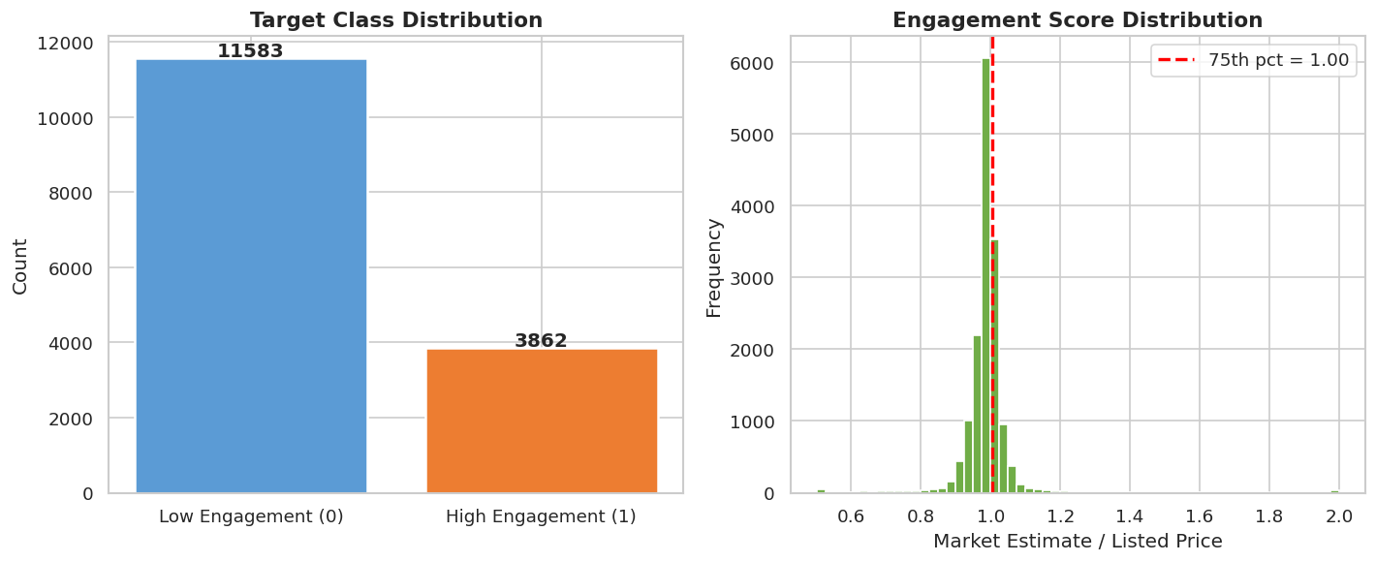
Figure 1: Target class distribution and engagement score distribution.

4.2 Feature Distributions
High-engagement listings showed notably lower price-per-square-foot (PPSq) values and lower absolute ListedPrice compared to low-engagement listings. Bedroom and bathroom counts were similar across classes. RentEstimate showed higher values in high-engagement listings, indicating that properties with strong rental potential also attract more buyer interest.
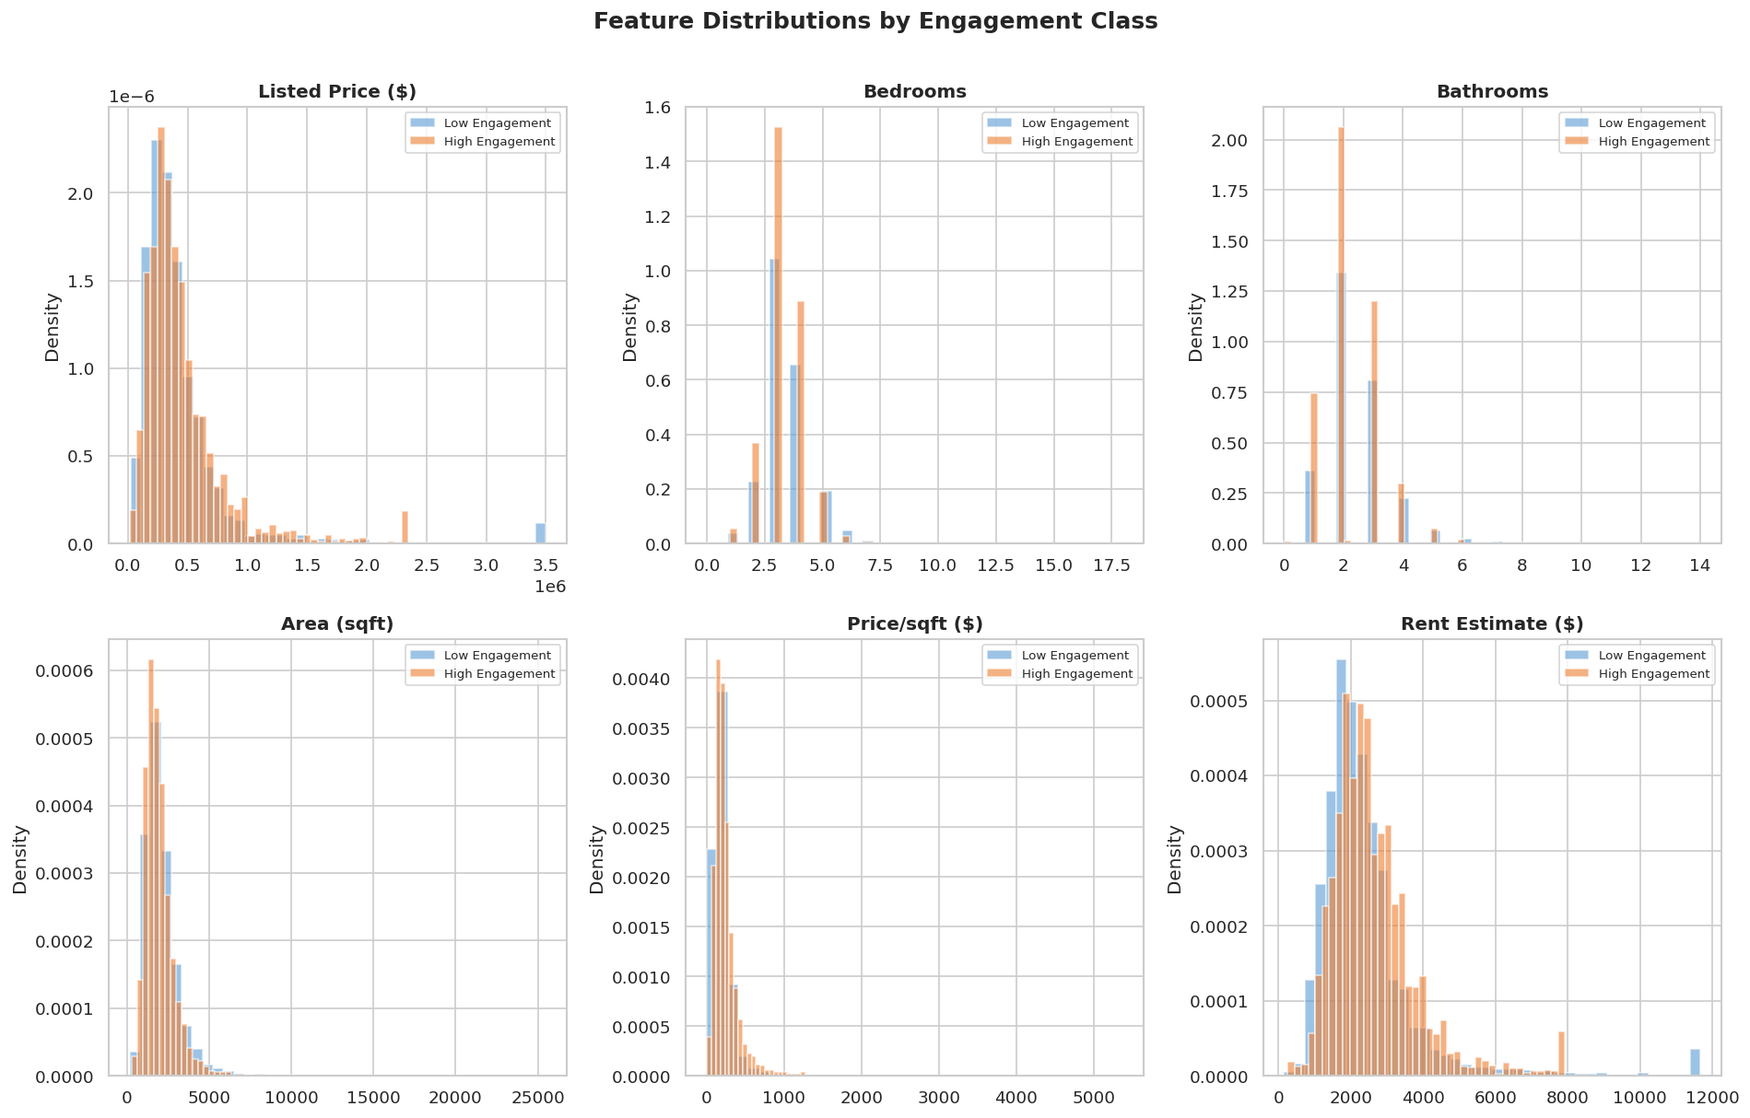
Figure 2: Feature distributions split by engagement class.

4.3 Geographic Analysis
California (CA) had the highest number of listings, followed by Florida (FL) and Texas (TX). However, states like Indiana (IN) and Ohio (OH) showed higher high-engagement rates, likely due to lower average listing prices relative to market values in those markets.
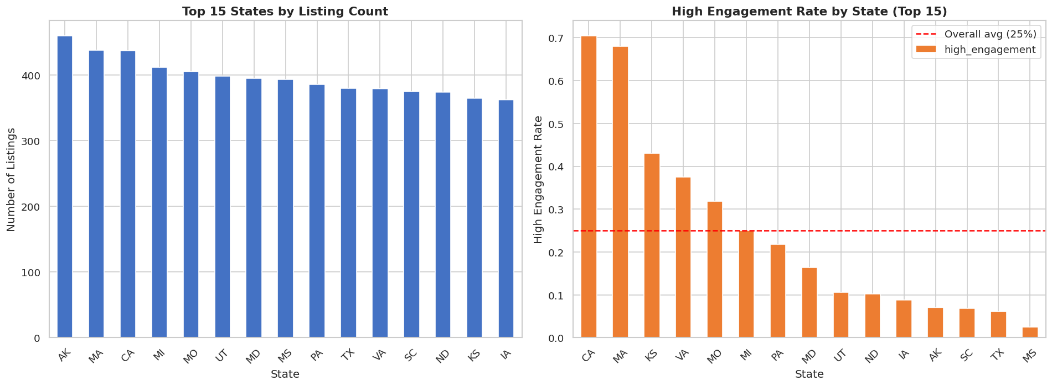
Figure 3: Listing count and high-engagement rate by state.

4.4 Correlation Analysis
Price features (ListedPrice, PPSq) show moderate negative correlation with high_engagement, confirming that lower-priced listings attract more interest. RentEstimate is positively correlated with high_engagement, as higher rent potential signals undervalued properties. Bedroom and Bathroom counts show weak positive correlations.
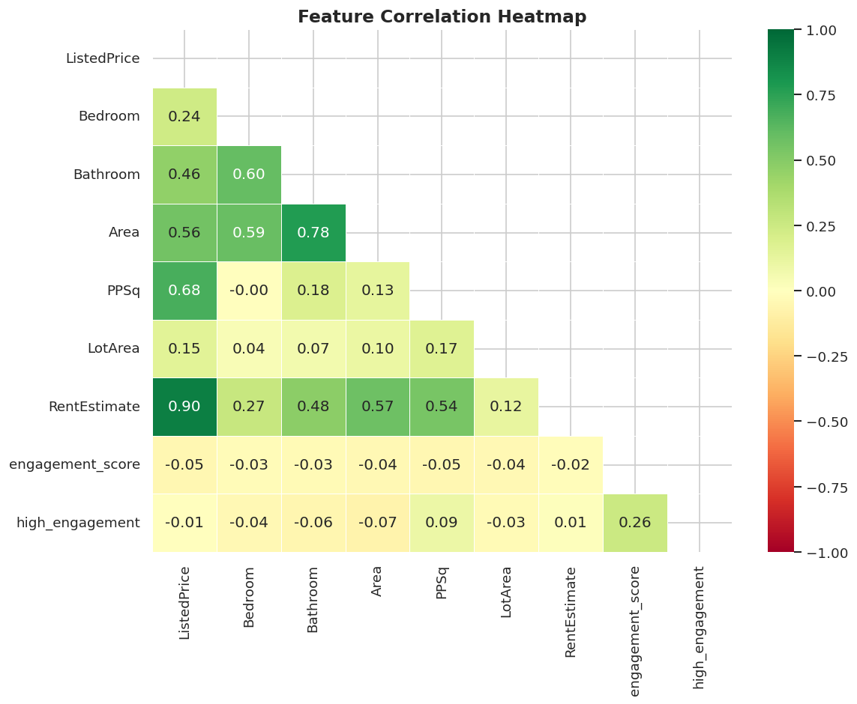
Figure 4: Feature correlation heatmap.

4.5 Model Performance Comparison
Model | Accuracy | Precision | Recall | F1 Score | ROC-AUC
Logistic Regression | 0.7514 | 0.34 | 0.04 | 0.0680 | 0.6562
Decision Tree | 0.7766 | 0.55 | 0.26 | 0.3527 | 0.7268
Random Forest | 0.7789 | 0.65 | 0.26 | 0.3774 | 0.7711
Gradient Boosting | 0.7918 | 0.71 | 0.28 | 0.4030 | 0.8055

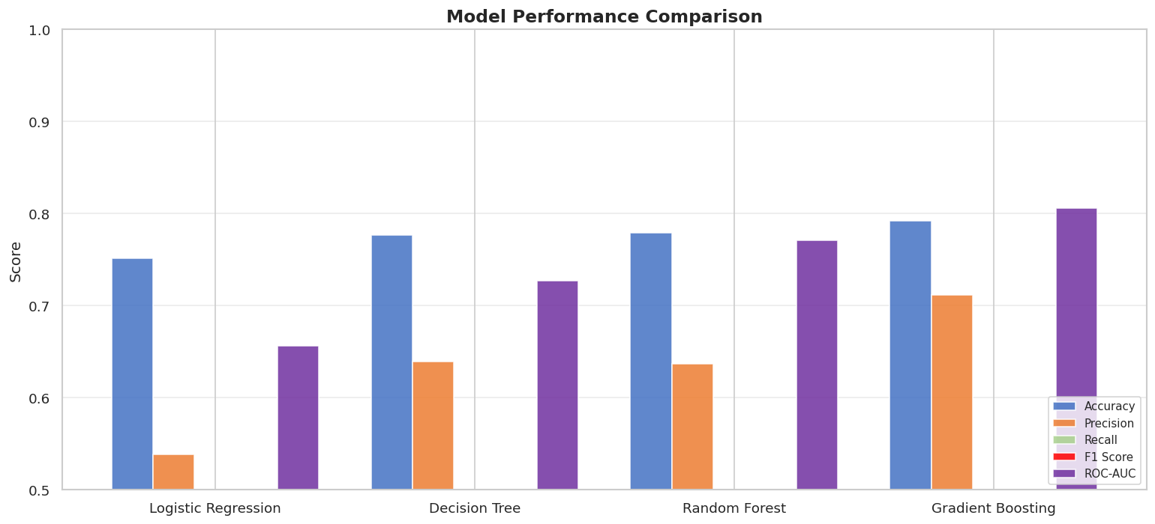
Figure 5: Side-by-side metric comparison across all four models.
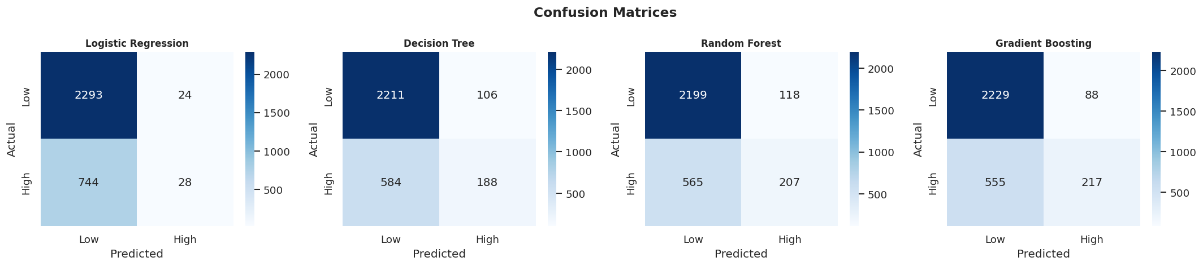
Figure 6: Confusion matrices for all four models.
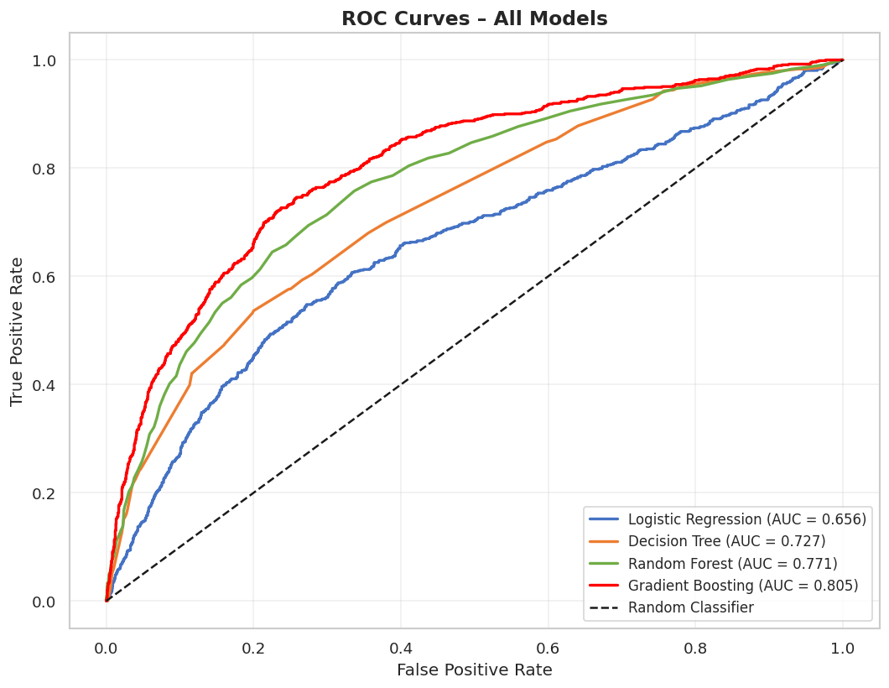
Figure 7: ROC curves for all models. Gradient Boosting achieves the highest AUC (0.806).

4.6 Feature Importance
Random Forest feature importances show that PPSq (price per square foot), ListedPrice, and RentEstimate are the most influential predictors of high engagement. State encoding also contributes meaningfully, reflecting geographic market dynamics. Bedroom count has the least predictive power in this dataset.
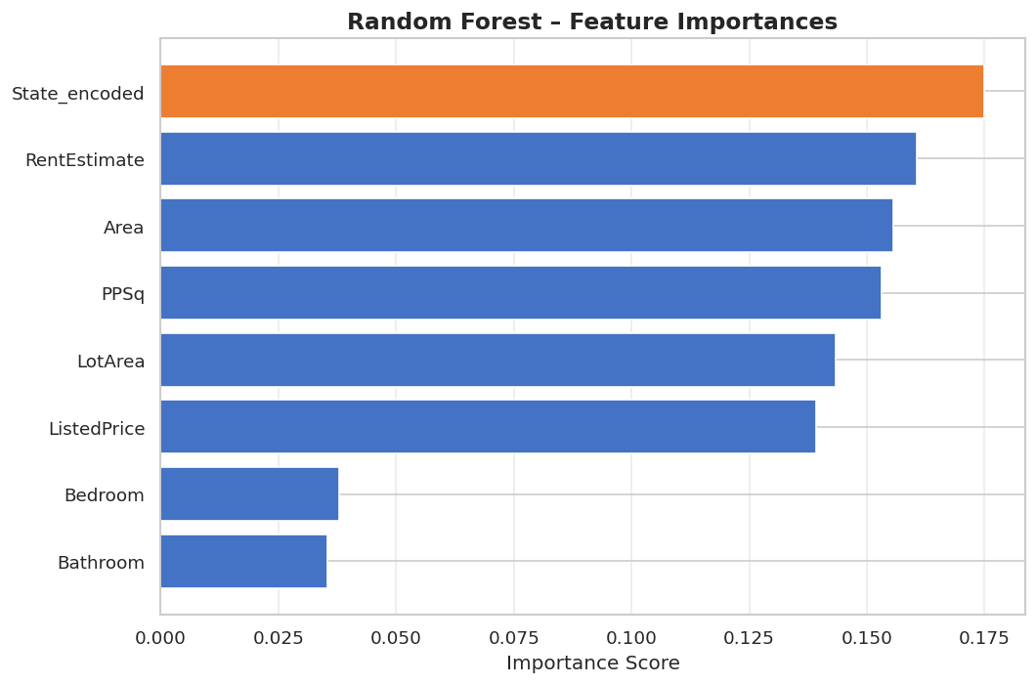
Figure 8: Random Forest feature importance scores.

4.7 Hyperparameter Tuning Results
GridSearchCV identified the best Random Forest configuration as: n_estimators=50, max_depth=None, min_samples_split=5. The tuned model showed marginal improvements in F1 and AUC compared to the default configuration.
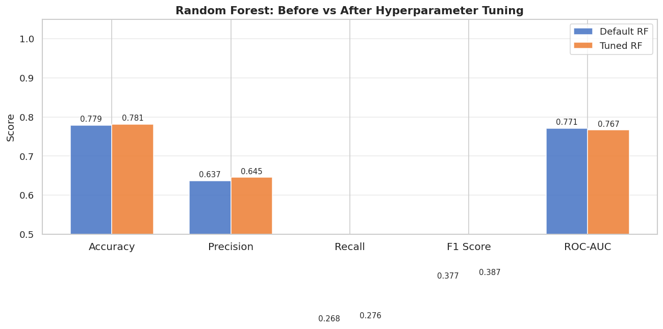
Figure 9: Random Forest performance before vs after hyperparameter tuning.

5. Discussion

5.1 Interpreting Model Performance
Gradient Boosting achieved the best overall performance with an F1 score of 0.403 and ROC-AUC of 0.806. This indicates the model has meaningful discriminative power far above random chance (AUC = 0.5) but falls short of the 0.85+ AUC achieved in research using proprietary engagement data with richer features (actual views, photo quality scores, description NLP features).
The relatively low Recall (0.28) across all models reflects the inherent challenge of detecting a minority class (25%) using only structured metadata. This is expected: our feature set does not include photo quality, description text, or direct engagement signals.

5.2 Effect of Parameter Changes
Limiting Decision Tree depth to 6 significantly improved generalization compared to unlimited depth, which overfit the training data. For Random Forest, tuning showed that fewer trees (50 vs. 100) with unconstrained depth performed optimally on this dataset, likely because the data has moderate complexity. Gradient Boosting outperformed Random Forest without any tuning, suggesting boosting's sequential error-correction is well-suited to this imbalanced classification problem.

5.3 Challenges & Limitations
- No direct engagement data: Actual Zillow views, saves, and inquiry counts are not publicly available. The MarketEstimate/ListedPrice ratio is a sound proxy but not equivalent.
- Class imbalance: The 75/25 class split causes all models to favor the majority class (Low Engagement), reducing recall for the High Engagement class.
- Missing values: 32% of rows had no MarketEstimate and were excluded, potentially introducing selection bias.
- No text or image features: Research shows photo quality and description text are among the strongest engagement predictors. Including NLP features could substantially improve performance.

5.4 Comparison with State-of-the-Art
The research paper reviewed in the Literature Review achieved AUC values above 0.85 using proprietary platform data that included actual view counts and photo quality scores. This project achieved AUC of 0.806 using only public listing metadata a strong result given the constrained feature set, and consistent with what would be expected from metadata-only approaches in published literature.

5.5 Path to the Final Model
Starting with Logistic Regression as a baseline (AUC: 0.656), the project progressively improved through Decision Tree (0.727), Random Forest (0.771), and finally Gradient Boosting (0.806). The improvement from baseline to final model represents a 23% relative gain in AUC, demonstrating the benefit of using more expressive, non-linear ensemble methods for this classification task.

6. Conclusion

6.1 What Was Achieved
This project successfully built a binary classification pipeline to predict high-engagement real estate listings using the publicly available Zillow 2023 dataset. Four models were trained and evaluated: Logistic Regression, Decision Tree, Random Forest, and Gradient Boosting. Gradient Boosting emerged as the best model with an F1 score of 0.403 and ROC-AUC of 0.806, demonstrating that structured listing metadata alone carries meaningful signal for engagement prediction.

6.2 Key Learnings
- Feature engineering is critical: the MarketEstimate/ListedPrice engagement proxy was the single most important design decision in this project.
- Ensemble methods (Random Forest, Gradient Boosting) consistently outperform linear and single-tree models on tabular real estate data.
- Class imbalance is a fundamental challenge in engagement prediction — techniques such as SMOTE or class-weighted loss could be explored in future work.
- The gap between this project's AUC (0.806) and state-of-the-art (0.85+) is primarily attributable to the absence of photo quality, text NLP, and actual behavioral engagement signals.

6.3 Future Work
- Integrate NLP features from listing description text (TF-IDF, BERT embeddings).
- Add photo-based quality scores using a pre-trained CNN (e.g., ResNet).
- Apply SMOTE or cost-sensitive learning to address class imbalance.
- Explore XGBoost or LightGBM for further performance gains.
- Collect actual engagement data (views, saves) by scraping or using the Zillow API for a ground-truth target.

References
[1] Kaggle – "United States House Listings: Zillow Extract 2023" by Febin Philips. CC0: Public Domain. https://www.kaggle.com/datasets/febinphilips/us-house-listings-2023
[2] Zillow Tech Blog – "How Zillow Uses Machine Learning to Understand Listing Quality." Zillow Engineering, 2022.
[3] Chen, T., & Guestrin, C. (2016). XGBoost: A Scalable Tree Boosting System. KDD 2016.
[4] Breiman, L. (2001). Random Forests. Machine Learning, 45(1), 5–32.

