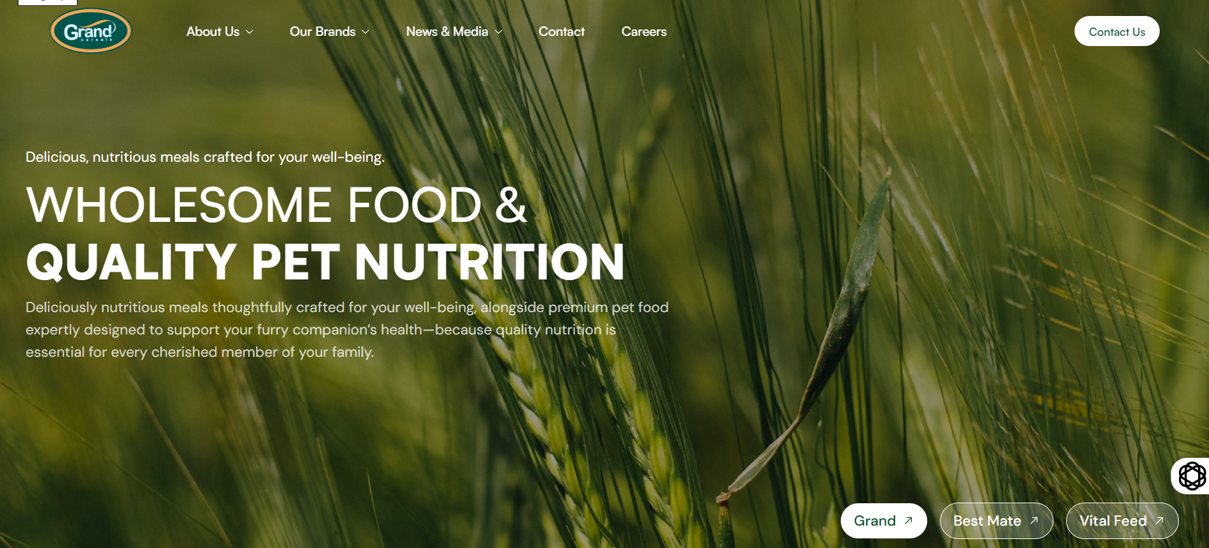
Example of Hero Page (So it will have Sliding of Images)

This is a new video I posted on Youtube, Can It also be displayed?
https://youtu.be/zRMCLGrrsR0
<iframe width="560" height="315" src="https://www.youtube.com/embed/zRMCLGrrsR0?si=ceIkcXtnMF6k1GmF&amp;start=2" title="YouTube video player" frameborder="0" allow="accelerometer; autoplay; clipboard-write; encrypted-media; gyroscope; picture-in-picture; web-share" referrerpolicy="strict-origin-when-cross-origin" allowfullscreen></iframe>

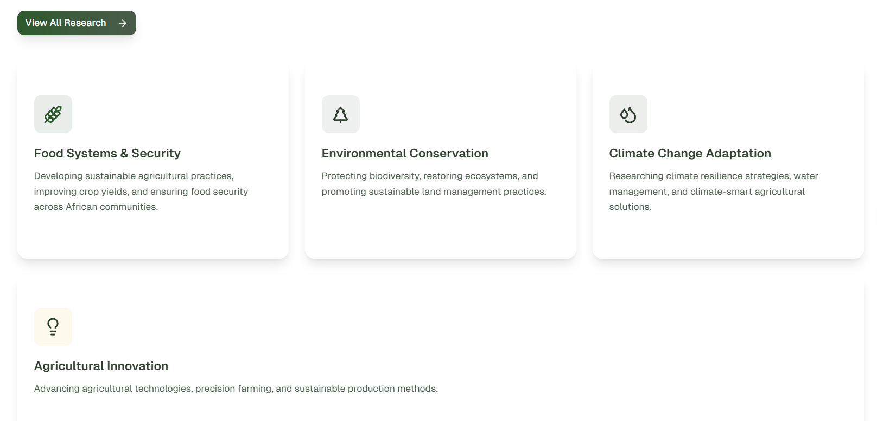
ADD CARDS (Making 6)
Agricultural Development and Value Chain Transformation
By strengthening value chains, we create inclusive opportunities that drive food security, rural prosperity, and national growth.

Livestock Productivity and Animal Health
We partner with stakeholders to build resilient livestock systems that ensure food safety, support rural incomes, and contribute to sustainable protein supply.

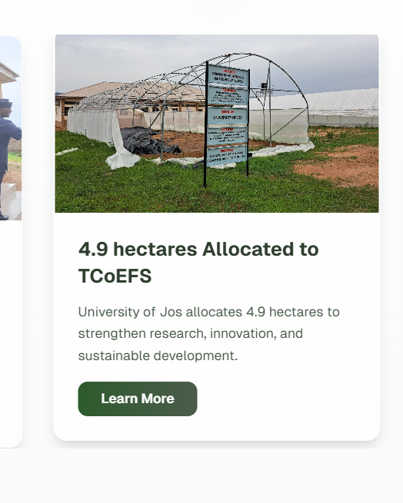
Replace This Picture⬆️
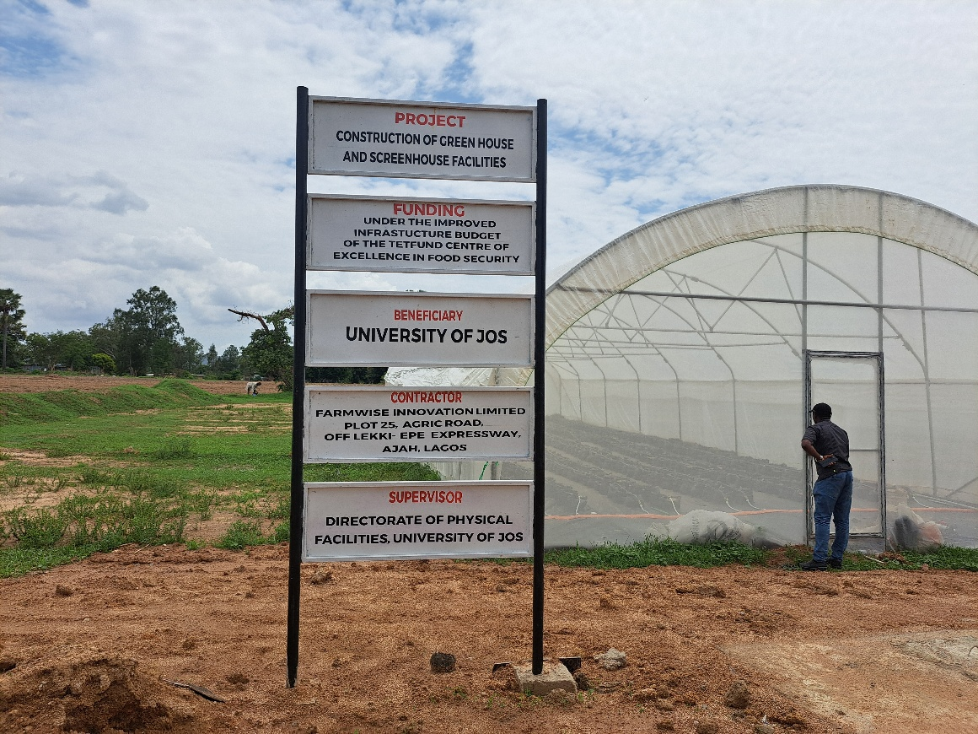

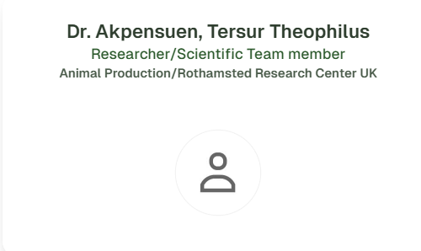
REPLACE WITH:
NAME: Asinamai Athliamai Bitrus
email : bitrusaa@unijos.edu.ng
Tel. 8065680664
Highest Qualification : PhD(Bacteriology and Molecular Biology
Area of Specialization: Antimicrobial resistance of pathogens from food and companion animals, One Health and Vaccine development.

Facebook: https://www.facebook.com/share/19vqPg5CmF/
Linkedin: https://www.linkedin.com/company/tetfund-centre-of-excellence-in-food-security-tcoefs-university-of-jos/
Instagram: https://www.instagram.com/tcoefs?igsh=MXQwNjlvN3AwN2JyYw==

