Unit: ITS320 – Capstone Experience
Assessment: Group Report on Project Detailed Design
Weight: 20%
Due: Week 3

Cover Page
Project Title | Web-Based Cybersecurity Awareness Training and Quiz Platform
Group Member 1 Name & ID | Anagh Dhital – S2500145
Group Member 2 Name & ID | Sunil Khatiwada – S2500034
Group Member 3 Name & ID | Tilak B.K. – S2500734
Group Member 4 Name & ID | Samir Bhandari – S2500059
Group Member 5 Name & ID | Suraj Timsina – S2500471
Supervisor / Lecturer | _______________________________
Trimester | _______________________________
Submission Date | _______________________________

Word Limit
Recommended length: 2500–3000 words. This report totals approximately 2,600 words, excluding the cover page, references, and declaration sections.

Table of Contents
Abstract
Introduction
Problem Identification
Research Methodology
Detailed System Design
Research Findings
Management Implications
Recommendations
Conclusion
References / Bibliography

Abstract
Cybersecurity incidents caused by human error remain a leading risk for organisations of every size, yet small organisations, community groups and individual learners rarely have access to the enterprise-grade security education, training and awareness (SETA) programs used by large corporations. Group 2 addresses this gap through a Web-Based Cybersecurity Awareness Training and Quiz Platform, developed as the ITS320 capstone project. This report reviews peer-reviewed literature on SETA program effectiveness and gamified cybersecurity education, identifying design considerations including the risk of a short-lived “novelty effect” in gamified interventions and the need for periodic reassessment. Drawing on this research, the report proposes a modular, quiz-based web platform built on a three-tier architecture, with role-based access, a diagnostic and reassessment quiz cycle, and administrator analytics. The report concludes with a discussion of stakeholder implications, recommendations for the implementation phase, and an evidence-based rationale for the design choices made.

Introduction
Cybersecurity incidents caused by human error, rather than by technical vulnerabilities alone, continue to represent one of the most persistent risks facing organisations of every size. Employees and everyday users routinely fail to recognise phishing attempts, reuse weak passwords, and mishandle sensitive information, and this behavioural gap is widely regarded in the information security literature as one of the weakest links in an organisation's overall security posture (Alyami et al., 2023). In response, many large organisations have implemented formal Security Education, Training and Awareness (SETA) programs. However, these programs are typically resource-intensive to design, deliver and evaluate, and are consequently far less accessible to small and medium enterprises, community organisations, and individual learners who cannot justify the cost of commercial platforms.
Group 2 has selected the development of a Web-Based Cybersecurity Awareness Training and Quiz Platform as its ITS320 capstone project in direct response to this gap. The proposed system aims to deliver bite-sized, quiz-based cybersecurity education through an accessible web application, allowing non-technical users to build foundational security knowledge at their own pace while giving administrators visibility over learner progress through simple reporting tools. This report documents the detailed design produced during the research and planning phase of the capstone project, following the structure required by the ITS320 Assessment B template.

Problem Identification
The core problem addressed by this project is twofold. First, human error remains a dominant cause of security breaches, and existing SETA literature indicates that awareness programs are inconsistently effective at producing lasting behavioural change; Hu et al. (2022) found that only a small proportion of practitioners considered their organisation's SETA program highly effective, in part because programs focus on one-off knowledge transfer rather than sustained engagement. Second, the organisations and individuals most exposed to this risk, such as small businesses, non-profit groups, students, and members of the general public, are the least likely to have access to a structured awareness program, since commercial SETA platforms are generally priced and designed for enterprise deployment.
This problem is significant because the consequences of a successful phishing or social engineering attack, financial loss, data breach, or reputational damage, are not limited to large organisations; small businesses and individuals face proportionally greater harm from such incidents given their more limited capacity to recover. A low-cost, web-accessible training platform therefore addresses a genuine and currently underserved need, rather than duplicating existing enterprise tooling.

Research Methodology
The team adopted a research-informed design methodology consisting of three stages: literature review, requirements definition, and iterative design modelling. In the first stage, the team conducted a structured search of academic databases (including Scopus-indexed journals accessible through Google Scholar and publisher platforms such as Emerald, Taylor & Francis, and Springer) using search terms including “security education training awareness,” “SETA program effectiveness,” “gamification cybersecurity awareness,” and “cybersecurity quiz platform.” Sources were screened for relevance to non-expert or non-IT audiences, publication in a peer-reviewed journal or peer-reviewed conference proceedings, and recency, with priority given to studies published between 2018 and 2026.
In the second stage, the team translated the problem identified above into a set of functional and non-functional requirements, informed both by the literature and by the team's own experience as end users of corporate and academic training platforms. In the third stage, the team used the validated requirements to produce the system architecture, module breakdown, and data model presented in the following section. This detailed design will serve as the baseline for the implementation phase of the capstone project, where an agile, sprint-based development approach is planned so the platform can be built, tested and refined incrementally.

Detailed System Design

Design Objectives
The proposed platform is guided by four objectives derived directly from the research findings below: to lower the barrier to accessing cybersecurity awareness training for non-technical users; to sustain engagement over time rather than relying on a single training event; to measure learning outcomes through built-in assessment rather than assuming awareness from participation alone; and to remain achievable within the scope, timeline and skillset of a student capstone team.

System Architecture
The platform will be implemented using a three-tier web architecture, illustrated in Figure 1. The presentation tier is a single-page application built with React, providing separate interfaces for learners and administrators. The application tier is a RESTful API built with Node.js and Express, responsible for authentication, quiz delivery and scoring, and gamification logic (points, badges and leaderboard calculation). The data tier uses MongoDB, a document-oriented database well suited to the platform's semi-structured content (training modules, quizzes and question banks). Supporting services include a JSON Web Token (JWT)-based authentication and role-based access control (RBAC) service distinguishing Learner and Administrator roles, a notification service for reassessment reminders, and an analytics and reporting module. The entire stack will be containerised and deployed to a cloud hosting environment over HTTPS/TLS, consistent with the security-conscious nature of the subject matter.
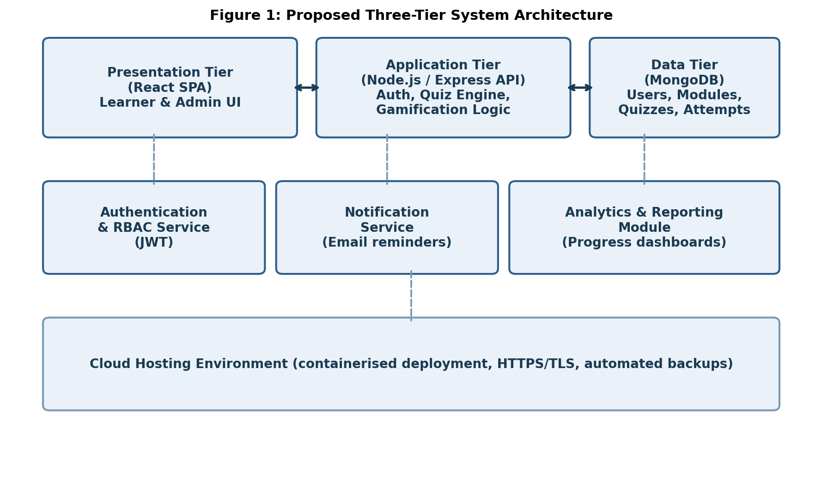
Figure 1. Proposed three-tier system architecture.

Functional Modules
- User Management: registration, login, password reset, and role assignment (Learner or Administrator).
- Diagnostic Assessment: an initial quiz administered at first login to establish the learner's baseline knowledge, informed by Alyami et al. (2023).
- Training Content Delivery: short modules (text, images and short video) covering core topics such as phishing recognition, password hygiene, social engineering and safe device use.
- Gamified Quiz Engine: scenario-based multiple-choice and drag-and-drop questions, immediate feedback, points, badges, and an opt-in leaderboard.
- Reassessment Scheduler: automated quarterly reminders and short refresher quizzes, directly addressing the knowledge-decay and novelty-effect findings discussed below.
- Administrator Dashboard: reporting on completion rates, average scores, and score change between diagnostic and reassessment quizzes.

Learner Journey
Figure 2 illustrates the intended learner journey, from registration through the diagnostic assessment, module content, gamified quiz, and the recurring reassessment cycle that connects back into the workflow. This cyclical structure was deliberately chosen instead of a linear, one-off completion path, in direct response to the durability concerns raised in the research findings below.
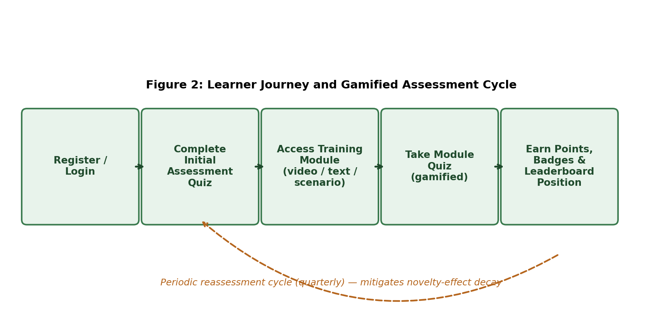
Figure 2. Learner journey and gamified assessment cycle.

Technology Stack
Layer | Selected Technology / Approach
Frontend | React, Tailwind CSS, responsive design for desktop and mobile browsers
Backend / API | Node.js with Express, RESTful endpoints
Database | MongoDB (document store) for content, quizzes and attempts
Authentication | JSON Web Tokens (JWT) with role-based access control
Hosting | Containerised deployment on a cloud platform (e.g. Azure or AWS), HTTPS/TLS
Version Control | Git / GitHub for collaborative development across the group

Core Data Entities
The data model centres on six core entities: User (learner or administrator, with authentication credentials and role); Module (a unit of training content, containing text, media and metadata such as topic and difficulty); Quiz (linked to a module or standalone diagnostic/reassessment quiz, containing an ordered set of questions); Question (scenario text, answer options, correct answer, and difficulty level); Attempt (a record linking a user, a quiz, a score, a timestamp and a status of diagnostic, module or reassessment); and Badge (an achievement definition and the criteria required to earn it, linked to users through an award record). This structure allows the reporting module to compare a learner's diagnostic and reassessment Attempt records over time.

Non-Functional Requirements
- Security: passwords hashed using a strong algorithm (e.g. bcrypt); all traffic encrypted via HTTPS; role-based access control enforced on every API endpoint.
- Usability: mobile-responsive interface suitable for non-technical users, consistent with a platform whose subject matter is cybersecurity awareness itself.
- Performance: quiz pages should load within two seconds under normal conditions to minimise learner drop-off.
- Scalability: the modular API design allows additional training modules or quiz types to be added without restructuring the existing data model.
- Accessibility: interface design will follow WCAG 2.1 AA colour-contrast and keyboard-navigation guidelines where feasible within the project timeline.

Research Findings
A recurring theme across the reviewed literature is that SETA programs are widely adopted but inconsistently effective. Hu et al. (2022), synthesising 80 articles published between 1998 and 2020, found that only a small proportion of practitioners considered their organisation's SETA program to be highly effective, and attributed this partly to a lack of systematic understanding of how such programs influence employees' underlying security beliefs rather than simple knowledge acquisition. This finding directly informed the team's decision to design the platform around short, frequent learning interactions rather than a single long training session, since sustained behavioural change appears to depend on ongoing reinforcement rather than one-off content delivery.
Alyami et al. (2023) developed a lifecycle model of critical success factors for SETA program effectiveness, based on interviews with twenty international security practitioners. Their model organises success factors across four phases: design, development, implementation and evaluation. Two findings from this model were particularly influential for the current design. First, the design phase should begin with an initial assessment of the target audience's existing security knowledge, which the proposed platform operationalises through a diagnostic quiz presented at first login. Second, the evaluation phase should include periodic reassessment of learner performance, which informed the inclusion of a quarterly reassessment cycle in the platform's learner journey (Figure 2).
The choice to build the platform around gamified quizzes, rather than passive video or text-based content, is supported by a substantial and growing body of research. Gwenhure and Rahayu (2024), in a systematic review of gamification for non-IT professionals, found that gamified interventions such as storytelling, leaderboards and interactive scenarios consistently produced short-term improvements in knowledge, engagement and reported behaviour. However, the same review identified a significant limitation: most existing studies evaluate gamified programs only over short time frames, meaning that reported improvements may partly reflect a temporary “novelty effect” rather than durable learning. This finding was treated as a critical design constraint rather than a reason to abandon gamification, and led the team to build repeat engagement, rather than a single gamified session, into the core learner journey.
Sikolia et al. (2023) provide direct empirical evidence relevant to this concern. Their longitudinal experiments found that SETA training reduced phishing susceptibility by roughly half in the period immediately following training, and increased users' cybersecurity knowledge by twelve to seventeen per cent; however, this knowledge gain measurably decayed within a month, particularly for technical-level content, while more applied, scenario-based knowledge persisted for longer. This result reinforced two specific design choices: favouring applied, scenario-style quiz questions over purely definitional ones, and scheduling recurring “refresher” modules rather than relying on a single completion event.
Earlier exploratory work by Scholefield and Shepherd (2019) demonstrated the practical feasibility of a lightweight, quiz-based gamified application for raising security awareness among general users, using a role-playing quiz prototype focused on password security. Participants in their study reported enjoying the gamified format and felt they had genuinely benefited from it, despite the prototype's simplicity. This supports the feasibility of a modest, capstone-scale platform delivering genuine educational value without the scale of a commercial enterprise product.
Finally, a large-scale scoping review by Weeratunge et al. (2026), which analysed 230 primary studies on game-based cybersecurity awareness education published between 2018 and 2024, found that the personal computer remains the dominant delivery platform for this category of application, that most game-based interventions target industry professionals and undergraduate students, and that game-based approaches are more often pitched at intermediate or advanced proficiency levels than non-game-based alternatives. These findings supported the team's decision to prioritise a responsive web application accessible from a standard browser, rather than a native mobile or virtual reality experience, as the most appropriate and achievable platform for the intended non-IT-professional audience within the scope of a capstone project.
Taken together, this body of research identifies six design implications that were carried forward into the system design above: (1) begin with a diagnostic assessment of the learner's existing knowledge; (2) deliver content in short, quiz-based modules rather than long-form sessions; (3) favour applied, scenario-based questions over rote factual recall; (4) build in a recurring reassessment cycle to counter both knowledge decay and the novelty effect; (5) target a standard web platform rather than a specialised or immersive one; and (6) provide administrators with simple analytics to track the initial assessment and subsequent reassessment scores.

Management Implications
For organisations adopting the platform, the primary management implication is a shift from viewing cybersecurity awareness as a single annual compliance event toward treating it as an ongoing, measurable program. Administrators will need to allocate a small amount of recurring time each quarter to review dashboard reports and follow up with learners whose reassessment scores decline, rather than treating training completion as a one-off deliverable. This aligns with the Alyami et al. (2023) finding that SETA program effectiveness depends on sustained communication and periodic evaluation rather than a single delivery event.
For individual learners, the implication is a modest but recurring time commitment, structured around short modules and quizzes rather than lengthy training sessions, which the research findings suggest is more likely to sustain engagement than a single long session. For the development team, the design implies a need to plan the reassessment scheduler and analytics dashboard as core, rather than optional, features from the earliest implementation sprints, since these are the components most directly tied to demonstrating the platform's educational value.

Recommendations
- Prioritise the diagnostic and reassessment quiz functionality early in the implementation phase, since this is the platform's core mechanism for demonstrating measurable learning outcomes.
- Favour applied, scenario-based question writing over rote factual questions when building the initial question bank, consistent with the durability findings reported by Sikolia et al. (2023).
- Keep the first release scoped to a standard responsive web application rather than a mobile app or immersive (AR/VR) experience, given the platform-usage patterns identified by Weeratunge et al. (2026) and the team's available development time.
- Pilot the platform with a small group of non-technical users before broader release, and use their diagnostic-to-reassessment score change as an early indicator of whether the design assumptions in this report hold in practice.
- Revisit the gamification elements (leaderboard, badges) after the pilot to check for signs of the novelty-effect decline identified by Gwenhure and Rahayu (2024), and adjust reward pacing if engagement drops after the first few sessions.

Conclusion
This report has presented the detailed design for a Web-Based Cybersecurity Awareness Training and Quiz Platform, grounded in a structured review of peer-reviewed research on SETA program effectiveness and gamified cybersecurity education. The review identified both the promise and the limitations of gamified approaches, most notably the risk that short-term engagement gains may not translate into durable behavioural change. The proposed three-tier architecture, modular design, and recurring reassessment cycle directly address these limitations while remaining achievable within the scope of a capstone project. Group 2 recommends that the implementation phase proceed using an agile, sprint-based approach, with the diagnostic and reassessment quiz functionality prioritised early so that the platform's core evaluation mechanism can be tested well ahead of final submission.

References / Bibliography
Alyami, A., Sammon, D., Neville, K., & Mahony, C. (2023). The critical success factors for Security Education, Training and Awareness (SETA) program effectiveness: A lifecycle model. Information Technology & People, 36(8), 94–125. https://doi.org/10.1108/ITP-07-2022-0515
Gwenhure, A. K., & Rahayu, F. S. (2024). Gamification of cybersecurity awareness for non-IT professionals: A systematic literature review. International Journal of Serious Games, 11(1), 83–99. https://doi.org/10.17083/ijsg.v11i1.719
Hu, S., Hsu, C. W., & Zhou, Z. (2022). Security education, training, and awareness programs: Literature review. Journal of Computer Information Systems, 62(4), 752–764. https://doi.org/10.1080/08874417.2021.1913671
Scholefield, S., & Shepherd, L. A. (2019). Gamification techniques for raising cyber security awareness. In A. Moallem (Ed.), HCI for cybersecurity, privacy and trust (pp. 191–203). Springer. https://doi.org/10.1007/978-3-030-22351-9_13
Sikolia, D., Biros, D., & Zhang, T. (2023). How effective are SETA programs anyway: Learning and forgetting in security awareness training. Journal of Cybersecurity Education, Research and Practice, 2023(1), Article 4.
Weeratunge, N. H., Hjelsvold, R., & Katt, B. (2026). A systematic scoping review on game-based cybersecurity awareness education. International Journal of Information Security, 25(2), Article 71. https://doi.org/10.1007/s10207-026-01239-9

AI Tool Disclosure
Have AI tools been used during preparation of this report?
☐ Yes ☐ No (tick as applicable — the draft text and research summarisation in this report were AI-assisted; group members should confirm this reflects their actual process before submission)

AI Tools Used
Name of AI Tool(s): _______________________________

Purpose of Use (tick all applicable)
☐ Language editing and grammar checking
☐ Structure and formatting support
☐ Idea brainstorming
☐ Code assistance
☐ Literature search support
Other: _______________________________

Description of AI Use
Provide a brief explanation of how AI tools were used in preparing this report.

Student Declaration
I confirm the following:
The work submitted in this report is my own work.
Any assistance from AI tools has been clearly declared.
All content has been reviewed and verified before submission.
I take full responsibility for the accuracy and integrity of the submitted work.
Student Signature: _______________________________
Date: _______________________________

Supervisor Acknowledgement (Optional)
Supervisor Name: _______________________________
Signature: _______________________________
Date: _______________________________

Submission Checklist
☐ All required report sections included
☐ Problem clearly defined
☐ Methodology explained
☐ System design diagrams included
☐ References properly cited
☐ Word limit followed

