ITS320 — CAPSTONE EXPERIENCE
Assessment B: Group Report — Project Detailed Design
Cybersecurity Awareness Training and Quiz System
A Web-Based Prototype for Cybersecurity Awareness, Assessment, and Reporting
Field | Details
Group Member 1 Name & ID | ____________________________
Group Member 2 Name & ID | ____________________________
Group Member 3 Name & ID | ____________________________
Group Member 4 Name & ID | ____________________________
Group Member 5 Name & ID | ____________________________
Supervisor / Lecturer | ____________________________
Trimester | ____________________________
Submission Date | ____________________________

Table of Contents

Abstract
Human error remains one of the leading causes of cybersecurity incidents, with weak passwords, unsafe browsing habits, and susceptibility to phishing accounting for a substantial share of breaches affecting individuals and organisations. This report presents the detailed design of a web-based Cybersecurity Awareness Training and Quiz System, developed as a capstone project for the NAPS School of IT. The system delivers short instructional modules on core topics — password safety, phishing, safe browsing, multi-factor authentication, and data privacy — followed by multiple-choice quizzes with automatic scoring and feedback. A literature review of gamified and quiz-based security awareness training was combined with a short survey of prospective learners to inform the design. The proposed architecture uses HTML, CSS, and JavaScript for the front end and a MySQL database for storing users, modules, questions, and progress data, with a separate administrative interface for content management and a reporting dashboard for tracking outcomes. The report outlines the problem context, research methodology, system architecture, anticipated findings, management implications, and recommendations, concluding that a lightweight, quiz-driven awareness platform is a feasible and demonstrable solution for improving baseline cybersecurity literacy among general users.

1. Introduction
Cybersecurity threats increasingly target the human element of information systems rather than technical vulnerabilities alone. Attackers exploit weak passwords, unpatched habits, and a lack of awareness of phishing and social engineering to gain access to systems and data. While large organisations often invest in dedicated security awareness programs, many smaller organisations, community groups, and individual users lack access to structured, low-cost training tools that build foundational cybersecurity knowledge. This gap creates an opportunity for a simple, accessible, web-based training and assessment platform that can be deployed quickly and used without specialist infrastructure.
This project, developed by a group of five students as part of the ITS320 Capstone Experience unit, addresses this gap by designing and prototyping a Cybersecurity Awareness Training and Quiz System. The system is intentionally scoped as an educational prototype rather than a production security tool: it does not perform real phishing simulations, collect genuine credentials, or apply machine learning. Instead, it focuses on structured learning content, rule-based multiple-choice quizzes, automatic scoring and feedback, and basic administrative and reporting functionality.
The objectives of this report are to: (1) describe the problem the project addresses and its significance; (2) explain the research methodology used to inform the design; (3) present the detailed system design, including architecture and database structure; (4) summarise research findings from the literature and a preliminary learner survey; and (5) discuss management implications, recommendations, and expected outcomes ahead of implementation.

2. Problem Identification
Numerous industry and academic reports identify human error as the dominant contributing factor in cybersecurity incidents. Weak or reused passwords, clicking on malicious links, and mishandling personal information continue to expose individuals and organisations to unnecessary risk, and studies consistently report that phishing remains one of the most common initial access vectors used by attackers.
Despite this, many general users — including students, small-business staff, and casual internet users — have not received structured cybersecurity education. Formal security awareness programs are often designed for corporate environments, require licensed platforms, or focus narrowly on compliance rather than genuine understanding. There is a need for a simple, low-cost, and easily demonstrable system that can teach essential concepts and verify comprehension through assessment, rather than passive content delivery alone.
The significance of this problem is twofold. First, individuals with low cybersecurity awareness are more likely to fall victim to phishing, weak-password compromise, and privacy breaches, with downstream costs to themselves and any organisation they are connected to. Second, from an educational perspective, a well-designed awareness and quiz platform gives the project team an opportunity to demonstrate applied skills in web development, database design, content management, and reporting — all while producing a genuinely useful artefact. The Cybersecurity Awareness Training and Quiz System is proposed as a direct, scoped response to this problem.

3. Research Methodology
A mixed-method approach combining a literature review and a short learner survey was adopted to ground the system design in existing evidence and in the needs of prospective users.

3.1 Literature Review
A review of peer-reviewed literature on cybersecurity awareness training, gamified and quiz-based learning, and human factors in phishing and password behaviour was conducted using academic databases (IEEE Xplore, ScienceDirect, ACM Digital Library) and Google Scholar. Search terms included combinations of "cybersecurity awareness training", "security awareness quiz", "gamification cybersecurity education", and "phishing susceptibility human factors". Priority was given to studies published from 2019 onward that reported empirical outcomes (for example, pre- and post-training knowledge scores) rather than purely conceptual discussions. The review informed decisions on module topics, quiz design, feedback mechanisms, and the overall pedagogical approach adopted for the prototype.

3.2 Learner Survey
To complement the literature review, the team designed a short online questionnaire (10–12 items) targeted at prospective learners such as fellow students and general computer users. The survey covers: (a) self-rated familiarity with core cybersecurity topics (passwords, phishing, MFA, safe browsing, data privacy); (b) prior exposure to formal security training; (c) preferred learning formats (short text modules, videos, interactive quizzes); and (d) attitudes toward gamified elements such as scores, progress tracking, and certificates. The questionnaire uses a mix of five-point Likert-scale and multiple-choice items and was distributed via a convenience sample within the student cohort. Findings from this survey, together with patterns identified in the literature, directly shaped the module topics, quiz structure, and reporting features described in Section 4.

3.3 Scope and Limitations
Consistent with the project's constraints, the research and resulting design deliberately avoid any use of real phishing emails, live credential capture, or machine-learning-based threat detection. The survey sample is a convenience sample rather than a representative population sample, so findings should be treated as indicative rather than statistically generalisable; this is appropriate for a capstone design prototype but is noted as a limitation for any future scale-up.

4. Detailed System Design
The proposed system follows a conventional three-tier web architecture comprising a presentation layer (HTML, CSS, and JavaScript, styled with a Bootstrap-based framework), an application/logic layer that handles module delivery, quiz scoring, content management, and reporting, and a data layer implemented in MySQL. Figure 1 illustrates the high-level architecture.

4.1 Architecture Overview
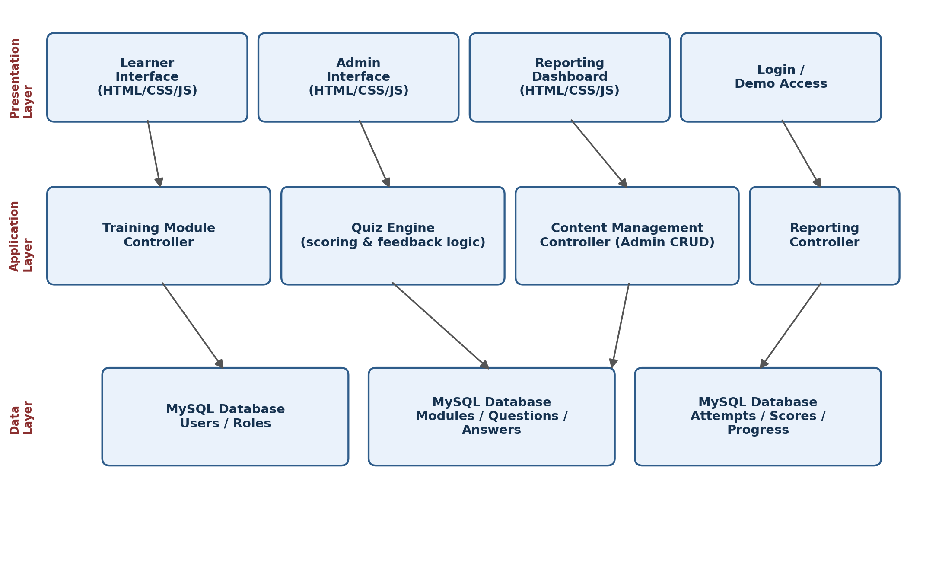
Figure 1. High-level three-tier architecture of the Cybersecurity Awareness Training and Quiz System.
The presentation layer provides four learner- and admin-facing views: the learner interface for browsing modules and taking quizzes, the admin interface for managing content, a reporting dashboard summarising outcomes, and a simple login/demo-access screen. Each view communicates with a corresponding controller in the application layer, which encapsulates the business logic (for example, the quiz engine calculates scores and generates feedback), and each controller reads from and writes to the MySQL data layer.

4.2 Core Training Modules
Consistent with the project scope, the prototype delivers five core training modules:
- Password safety — creating and managing strong, unique passwords.
- Phishing awareness — recognising suspicious emails, links, and requests.
- Safe browsing — avoiding malicious sites, downloads, and pop-ups.
- Multi-factor authentication (MFA) — why and how to enable it.
- Data privacy — protecting personal information online.

4.3 Database Design
The data layer is implemented as a relational MySQL schema. Table 1 summarises the core tables, their key fields, and their purpose within the system. Foreign keys (FK) link questions to modules, answers to questions, and attempts/progress records to both users and modules, allowing the reporting dashboard to aggregate scores by module and by user.
Table | Key Fields | Purpose
Users | user_id (PK), name, email, role (learner/admin), password_hash | Stores learner and administrator accounts for demo login.
Modules | module_id (PK), title, topic, content_body, order_index | Stores the training content for each topic (passwords, phishing, safe browsing, MFA, privacy).
Questions | question_id (PK), module_id (FK), question_text, difficulty | Stores quiz questions linked to a specific module.
Answers | answer_id (PK), question_id (FK), answer_text, is_correct | Stores the multiple-choice options for each question.
Attempts | attempt_id (PK), user_id (FK), module_id (FK), score, date_taken | Records each quiz attempt, score, and timestamp for progress tracking.
Progress | progress_id (PK), user_id (FK), module_id (FK), status, completion_date | Tracks module completion status shown on the learner progress page.
Table 1. Core database tables for the Cybersecurity Awareness Training and Quiz System.

4.4 Quiz Logic and Feedback
Each module is paired with a short multiple-choice quiz (typically five questions). On submission, the quiz engine compares selected answers against the is_correct flag stored in the Answers table, calculates a percentage score, and returns immediate feedback identifying which topics the learner should revisit. Scores and timestamps are written to the Attempts table, allowing learners to retake quizzes and track improvement over time, consistent with the literature's emphasis on repeated engagement over single-session testing.

4.5 Admin and Reporting Functions
Administrators can add, edit, or delete modules and questions through the content-management interface, without requiring changes to the underlying code. The reporting dashboard aggregates data from the Attempts and Progress tables to display total registered users, average scores per module, pass/fail rates, and the topics with the lowest average scores — directly supporting the management implications discussed in Section 6. An optional printable completion certificate may be generated once a learner completes all core modules, in line with the project's optional-enhancement scope.

5. Research Findings
This section summarises findings from the literature review and preliminary learner survey that most directly influenced the system design. As the project is at the design stage, survey figures below should be treated as indicative results from the preliminary sample and updated with final data once full data collection is complete.

5.1 Findings from the Literature
- Quiz-based and gamified awareness training (points, feedback, scenario-based questions) is consistently associated with measurable short-term gains in cybersecurity knowledge compared with passive content delivery, although sustained, long-term retention requires repeated or spaced engagement rather than a single session.
- Phishing susceptibility is strongly linked to specific behavioural patterns — over-reliance on visual trust cues, urgency-driven decision-making, and inconsistent password hygiene — which supports the inclusion of scenario-based multiple-choice questions rather than pure definition recall.
- Human error, particularly weak password management and phishing susceptibility, is repeatedly identified across industry and academic sources as a leading contributor to security incidents, reinforcing the priority given to password safety and phishing modules in the system.
- Reviews of gamified security training caution that novelty effects can inflate perceived short-term effectiveness, suggesting the system should support repeat attempts and progress tracking rather than a single pass/fail assessment.

5.2 Preliminary Survey Findings
Early responses from the learner survey (n to be finalised as data collection continues) indicate that most respondents rate their own knowledge of phishing and password practices as moderate at best, while confidence in recognising multi-factor authentication and data-privacy risks is generally lower. Respondents expressed a preference for short, quiz-driven modules over long-form reading material, and reacted positively to the idea of an immediate score and feedback after each quiz. Support for optional gamified elements, such as a completion certificate, was moderate, suggesting these should remain optional enhancements rather than core requirements — consistent with the project's scope.

6. Management Implications
For the academic client (NAPS School of IT), the system provides a low-cost, reusable teaching resource that can be extended across cohorts and units, demonstrating both the technical capability of capstone teams and a tangible contribution to institutional cybersecurity culture. For administrators, the content-management interface reduces the ongoing effort required to maintain training material, since topics and questions can be added or revised without developer involvement once the prototype is handed over.
For learners, the system offers a self-paced way to build baseline cybersecurity knowledge, with immediate feedback that supports learning rather than simple compliance tracking. For IT support and supervising staff, the reporting dashboard offers early visibility into which topics learners consistently struggle with (for example, low average scores on a specific module), which can guide targeted follow-up training or communication outside the system itself.
More broadly, adopting even a lightweight awareness platform signals that cybersecurity is treated as a shared responsibility rather than solely a technical or IT-department concern — a shift in framing that the literature associates with better long-term security behaviour.

7. Recommendations
- Prioritise the five core modules (password safety, phishing, safe browsing, MFA, and data privacy) for the minimum viable prototype, and treat certificates, badges, and advanced analytics as stretch goals only if time allows.
- Keep the quiz logic simple and rule-based, as scoped, but design questions using realistic, scenario-based wording informed by the literature rather than pure definitional recall, to better reflect real-world decision-making.
- Allow learners to reattempt quizzes and track attempts over time in the database, since the literature suggests that repeated engagement is more effective than a single assessment.
- Finalise and distribute the learner survey to a larger sample before the next milestone so that Section 5 findings can be strengthened with more representative data.
- Maintain strict adherence to the project's ethical and technical constraints: use only sample content and dummy accounts, and avoid any real credential collection, live phishing simulation, or integration with production email systems.
- Plan usability testing with a small group of sample users prior to final submission to confirm that navigation, quiz flow, and the admin interface are intuitive without additional instruction.

8. Conclusion
This report has outlined the detailed design of a web-based Cybersecurity Awareness Training and Quiz System intended to address a well-documented gap: general users frequently lack structured, accessible training in essential cybersecurity practices, and human error remains a leading cause of security incidents. Grounded in a review of peer-reviewed literature and a preliminary learner survey, the proposed system combines short instructional modules, scenario-based multiple-choice quizzes, automatic scoring and feedback, an administrative content-management interface, and a basic reporting dashboard, built on a straightforward HTML/CSS/JavaScript front end with a MySQL database.
The design deliberately remains within the constraints appropriate to a capstone prototype — using only sample data, avoiding real phishing simulation, and relying on simple rule-based logic rather than machine learning — while still offering genuine educational value and a clear demonstration of full-stack development, database design, and applied research skills. Moving into implementation, the project team will build and test the prototype against the requirements set out in this report, incorporating any additional survey data collected, and will evaluate the system against the marking criteria for structure, methodology, and research prior to final submission.

References
Chowdhury, N., Katsikas, S., & Gkioulos, V. (2022). Modeling effective cybersecurity training frameworks: A Delphi method-based study. Computers & Security, 113, 102551. https://doi.org/10.1016/j.cose.2021.102551
Gwenhure, A. K., & Rahayu, F. S. (2024). Gamification of cybersecurity awareness for non-IT professionals: A systematic literature review. International Journal of Serious Games, 11(1), 83–99. https://doi.org/10.17083/ijsg.v11i1.719
Li, L., He, W., Xu, L., Ash, I., Anwar, M., & Yuan, X. (2019). Investigating the impact of cybersecurity policy awareness on employees' cybersecurity behavior. International Journal of Information Management, 45, 13–24. https://doi.org/10.1016/j.ijinfomgt.2018.10.017
Syafitri, W., Shukur, Z., Mokhtar, U. A., Sulaiman, R., & Ibrahim, M. A. (2022). Social engineering attacks prevention: A systematic literature review. IEEE Access, 10, 39325–39343. https://doi.org/10.1109/ACCESS.2022.3162594
Wang, Z., Zhu, H., & Sun, L. (2021). Social engineering in cybersecurity: Effect mechanisms, human vulnerabilities and attack methods. IEEE Access, 9, 11895–11910. https://doi.org/10.1109/ACCESS.2021.3051633
Zhuo, S., Biddle, R., Koh, Y. S., Lottridge, D., & Russello, G. (2023). SoK: Human-centered phishing susceptibility. ACM Transactions on Privacy and Security, 26(3), Article 24. https://doi.org/10.1145/3575797

AI Tool Disclosure
Have AI tools been used during preparation of this report?
☐ Yes
☐ No

AI Tools Used
Name of AI Tool(s): _______________________________________
Purpose of Use (tick all applicable):
☐ Language editing and grammar checking
☐ Structure and formatting support
☐ Idea brainstorming
☐ Code assistance
☐ Literature search support
☐ Other: _________________________________

Description of AI Use
Provide a brief explanation of how AI tools were used in preparing this report.

Student Declaration
I confirm the following:
- The work submitted in this report is my own work.
- Any assistance from AI tools has been clearly declared.
- All content has been reviewed and verified before submission.
- I take full responsibility for the accuracy and integrity of the submitted work.
Student Signature: _______________________________________
Date: _______________________________________

Supervisor Acknowledgement (Optional)
Supervisor Name: _______________________________________
Signature: _______________________________________
Date: _______________________________________

