**OBSTACLE DETECTOR FOR THE BLIND (THIRD EYE)**

Submitted in partial fulfillment of the requirements for the award of

Bachelor of Engineering Degree in Electrical and Electronics Engineering by

**M MANISHANKAR REDDY (Register No. 39140029)**

**B.HARI KRISHNA (Register No. 39140007)**

**M SHIVA (Register No. 39140704)**

**R ARAVIND (Register No. 39140045)**



**DEPARTMENT OF ELECTRICAL AND ELECTRONICS**

# ENGINEERING

**SCHOOL OF ELECTRICAL AND ELECTRONICS ENGINEERING**

**SATHYABAMA**

**INSTITUTE OF SCIENCE AND TECHNOLOGY**

# (DEEMED TO BE UNIVERSITY)

**Accredited with Grade “A” by NAAC**

**JEPPIAAR NAGAR, RAJIV GANDHI SALAI, CHENNAI - 600 119 MAY 2022**



# DEPARTMENT OF ELECTRICAL AND ELECTRONICS ENGINEERING

**BONAFIDE CERTIFICATE**

This is to certify that this Project Report is the bonafide work of **M MANISHANKARREDDY** (Register No. 39140029)**, B.HARI KRISHNA** (Register No. 39140007),**M SHIVA** (Register No. 39140704) and **R ARAVIND** (Register No. 39140045)who carried out the project entitled **“THIRD EYE FOR BLIND"** under our supervision from November 2021 to May 2022.

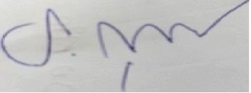

Dr.S.JAYAPRAKASH

**Internal Guide**

Dr. V. SIVACHIDAMBARANATHAN **Head of the Department**

**Submitted for Viva voce Examination held on_____________________** Name:

Signature:

**Internal Examiner External Examiner**

# DECLARATION

We **M MANISHANKAR REDDY**(Reg No. 39100029), **), B.HARI KRISHNA (Register**

**No. 39140007),M SHIVA (Register No. 39140704)** and **R ARAVIND (Register No. 39140045)** hereby declare that the Project Report entitled **“THIRD EYE FOR BLIND”** done by us under the guidance of **Dr.S.JAYAPRAKASH** is submitted in partial fulfillment of the requirements for the award of Bachelor of Engineering degree in Electrical and Electronics Engineering.

1.

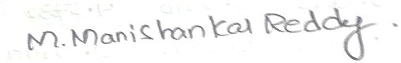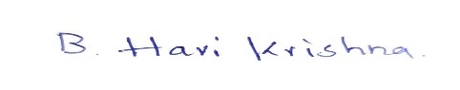

2.

3.

4.

**DATE: 26/04/2022**

**PLACE: Sathyabama Institute Of SIGNATURE OF THE CANDIDATES Science And Technology**

# ACKNOWLEDGEMENT

We are pleased to acknowledge our sincere thanks to Board of Management of **SATHYABAMA** for their kind encouragement in doing this project and for completing it successfully. We are grateful to them.

We convey our thanks to **Dr. N. M. Nandhita.,** Dean, School of Electrical and

Electronics Engineering and **Dr. V. Sivachidambaranathan,** Head of the Department,Dept. of Electrical and Electronics Engineering for providing us necessary support and details at the right time during the progressive reviews.

We would like to express our sincere and deep sense of gratitude to our Project Guide **Dr.S.JAYAPRAKASH** for his valuable guidance, suggestions and constant encouragement paved way for the successful completion of our project work.

We wish to express our thanks to all Teaching and Non-teaching staff members of the Department of Electrical and Electronics Engineering who were helpful in many ways for the completion of the project.

# ABSTRACT

Vision is the most beautiful and important gift from God to all his creatures especially for human beings. But unfortunately there are some people who lack this beauty and are unable to capture the beauty of this world from their own eyes. Third eye for blind is a development which involves various areas such as, software engineering, hardware designing and science that enables visually impaired persons to see and explore the world confidently and independently by recognising the neighbouring objects by using ultrasonic waves and inform the person with a beep ring or vibration.

As per WHO(world health organisation) 2.2 billion people suffer from vision impairment. They are facing troubles in their lifestyle. This device can act as an innovation for the visually impaired people. From a lot of advantages we found the property of being reasonable within a limited cost, a very important merit of the project. The Arduino Pro Mini 328 board is tied like a band. This is provided with ultrasonic sensor, consisting of module. By utilising this sensormodule, the person is able to see the objects near them and can travel effectively. At any point where this sensor senses any object, it informs the person by beep-sound or vibration. In this way this becomes a computerized gadget. Accordingly this gadget will be of utmost use for the blind people and can allow them to move from any place with confidence.

# TABLE OF CONTENTS

**CHAPTER NO TITLE**

1. **INTRODUCTION** 
   1. General Introduction
   2. Literature Survey
   3. Scope Of The Project
   4. Advantages Of The Proposed System
2. **PROJECT DESCRIPTION** 
   1. Block Diagram
   2. Concept Explanation
   3. Hardware Description

## 2.3.1 COMPONENTS:-

1. Arduino nano with cable
2. Ultrasonic sensor
3. Buzzer
4. Zero PCB
5. Vibration Sensor
6. Battery cap
7. Volt battery
8. Solding wire
9. Solding iron
10. Connecting wire

* 1. Wiring Instructions

* 1. Ultra sonic sensor pin

* 1. Making the modules

* 1. Working Operation

* 1. Arduino Programming

* 1. Result

* 1. Benfits

1. **CONCLUSION AND FUTURE SCOPE** 
   1. Conclusion

* 1. Future Scope

* 1. References

# CHAPTER 1 INTRODUCTION

## 1.1 GENERAL INTRODUCTION

As per the definition of blindness, we mean the person without sense of sight. A blind person has no ability to see anything. While struggling for the different levels of comforts of the general population, we have reached to a point where we have started to completely ignore the people who are living a miserable life due to lack of vision. They face enormous challenges in their daily lives and hence end up living a dependent life. They experience a completely different life from the normal people and experience detached and uninterested conduct towards them for being physically disabled. They need other individuals for their movement from one place to another. Sight is the basic sense of life and therefore a person’s movement from place to place in this condition is a major challenge for the visually impaired . The target of this task , This project for the blind or visually impaired person will provide a gadget that is helpful to them as well as the persons who depend on any individual due to lack of sight. Third eye for blind task can be an innovation for the sightless individuals, it will help them to move from here and

there and among different places with confidence by knowing the nearest obstructions while wearing the band which leaves the ultrasonic waves which inform the person with beep-sound or vibration. It can let the person who is not able to move and distinguish even snags due to lack of vision. They just have to put on the gadget as a band/bracelet or it can be adjusted on the dress on their body. As per WHO(world health organisation) 2.2 billion people suffer from vision impairment. They experience a lot of troubles in the daily lives. This device can be an innovation for the physically disabled or blind individuals. The people with physical disability used the common way that is white cane previously that was also efficient, but it had lot of limitations. Second approach is, having a pet ,like a dog ,though it is costly but is helpful .Therefore this task ,Third eye for blind will be developed as a moderate, very productive approach to help the blind person traverse with confidence and more interest. The device acts as an innovation for blinds which helps to solve all issues . At Present, enormous techniques and brilliant innovations are available for the physically disabled people, almost all of these devices have solved some of the issues for the sightless people but there exist many demirits like they require considerable measures of preparing and and high maintenance. The uniqueness of the proposed advancement is, it is fair for everyone, the total cost being under $20 or 1500 INR. In the market, no such devices are available that look like an item that can be worn with so much less effort, clarity. By increasing the usage of the gadget and the upgrading the changes in the model, it would definitely be profitable to the people with less or no vision at all. The basic mechanical gadget that is the strolling stick is manufactured so that it can be used in identifying stationary objects on floors, unbalanced surfaces, holes, steps using the basic mechanical matter. The gadget is fine, convenient but because of compact area it cannot be used for vast snag identification The device works like radar, orientation of the device uses the ultrasonic waves and collect them to note the altitude, direction or also velocity of that object. The separation among the object and person is assessed on the travelling of the wave. Nevertheless, all present systems advise the person about the closeness of the protest at a certain space in forefront or nearby the individual.

The interesting aspects enable the unsighted person in distinguishing snags and grants him access to choose his path properly with no issue. This device can help the person in identifying any type of hindrance like a snag. For surviving the earlier stated restrictions this project work provides primary, productive, customizable and effective solution to the visually impaired.

## 1.2 LITERATURE SURVEY

In the past few years, there has been innovations and development of various techniques and devices or gadgets guiding visually impaired people, thus towards attaining their independent or free movement around the surroundings without any other individual’s support. Few parameters are there but they are having some limitations and restrictions. D. Dakopoulos, N.G. Bourbakis, ”Wearable obstacle Avoidance Electronic Travel Aids for Blind; A Survey” proposed that a relative survey among mobile obstacle detection systems in order to inform the research community and users regarding the abilities of this project and regarding the innovation in adaptive technology for the sightless people. This study is based on different attributes and performance specification of this system that arranges them in categories, offering quantitative-qualitative analysis. M.A Ungar S[5]. He proposed methods for the unsighted people of urban areas. But they didn’t consider the people who cannot afford equipments of high cost. This drawback overcomes in Third eye for blind. Ms Pooja Sharma[6]. She analysed that objects can be detected, but there are drawbacks in terms of angles and distance . On the other hand, third eye for blind has a wide angle for the detection which can be widened with respect to the range of the sensor. Hugo Fernandesc, Joảo Barroso”Blind Guide: an ultrasound sensor based body area network for guiding blind people” . The research introduces supportive formula for sensing obstacles for the sightless persons who generally take help of white-cane or the pet dog, thus for the detection of obstacles by using this device provides a proper solution to the blinds. Based on the Body Area Network of ultrasonic sensors that generate sound-based response, this solution is given. The Body Area Network can be inserted inside cloth fabric, emancipating sightless person from utilizing the seeing-eye dog or that whitecane . Today’s Innovative world is providing many solutions to the visually impaired for example; white-cane having a tip for assisting the movement of the blind people. The cane has different types used in today’s technological world in the form of white cane, laser cane and smart cane. Dogs trained for this purpose are too expensive and unaffordable for certain people[9]. The study discovered [10] that the remote guidance system being very hard to move hence this device will act as most optimized version.

## 1.3 SCOPE OF THE PROJECT

In future with the advancement of quicker response of sensors, like the usage of top notch sensors it can be made highly useful and also the modules that one needs to wear as a bracelet or on any other part of the body can be transformed into a wearable clothing like a coat, so that it can be made fit for working and there can be more advancement in this device for instance we can use piezeo electric plates in the shoes of the user which can generate sufficient electricity that the modules can run on.

## 1.4 ADVANTAGES OF PROPOSED TECHNIQUE

Easy to Carry and Affordable for everyone

 By wearing this device they can fully avoid the use of white cane and such other devices.

This device will the help the blind to navigate without holding stick which is a bit annoying for them.

They can simply wear it as band or cloth and it can function very accurately and the only need a very little bit training to use it.

They can sense the distance between the object and them by the sound and vibration.

# CHAPTER 2 PROJECT DESCRIPTION

## 2.1 BLOCK DIAGRAM OF THIRD EYE



OBSTACLE

ULTRA

SONIC

SENSOR

ARDUINO

NANO

BUZZER

V

9

BATTERY

VIBRATION

SENSOR

**Fig 2.1 Block diagram of Third Eye(Object Detector)**

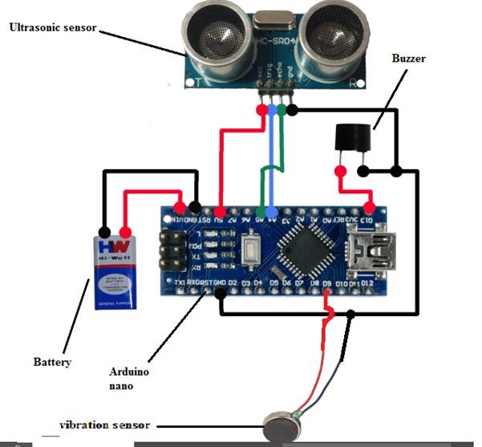

**Fig 2.2 Hardware Circuit of Third Eye(Obstacle Detector)**

## 2.2 CONCEPT EXPLANATION

The third eye for Blind.The project is an innovation which helps the blind person to move around and go from one place to another with speed and confidence by knowing the nearby obstacles using the help of the wearable band which produces the ultrasonic waves which notify them with buzz sound or vibrations.

The detailed description of the individual blocks is given in HARDWARE DESCRIPTION section.

**2.3 HARDWARE DESCRIPTION**

## COMPONENTS:-

1. Arduino nano with cable
2. Ultrasonic sensor
3. Buzzer
4. Zero PCB
5. Vibration Sensor
6. Battery cap
7. Volt battery
8. Solding wire
9. Solding iron
10. Connecting wire

### 1.ARDUINO NANO

Arduino Nano is a type of microcontroller board, and it is designed by Arduino.cc. It can be built with a microcontroller like Atmega328. This microcontroller is also used in the Arduino UNO. It is a small size board and also flexible with a wide variety of applications.

This board has many functions and features like an Arduino Duemilanove board. However, this Nano board is different in packaging. It doesn’t have any DC jack so that the power supply can be given using a small USB port otherwise straightly connected to the pins like VCC & GND. This board can be supplied with 6 to 20volts using a mini USB port on the board.

The communication of an Arduino Nano board can be done using different sources like using an additional Arduino board, a computer, otherwise using microcontrollers. The microcontroller using in Nano board (ATmega328) offers the serial communication (UART TTL). This can be accessible at digital pins like TX, and RX. The Arduino software comprises of a serial monitor to allow easy textual information to transmit and receive from the board.

The programming of an Arduino nano can be done using the Arduino software. Click the Tools option and select the nano board. Microcontroller ATmega328 over the Nano board comes with preprogrammed with a boot loader. This boot loader lets to upload new code without using an exterior hardware programmer. The communication of this can be done with the STK500 protocol.

### ARDUINO NANO DIAGRAM

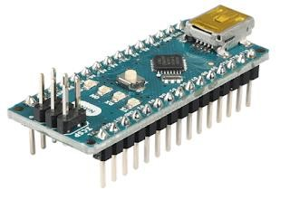

**Arduino Nano Pinout**

Arduino nano pin configuration is shown below and each pin functionality is discussed below.

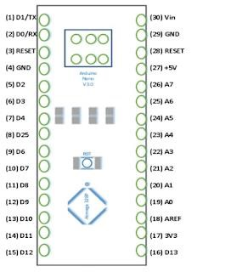

**Power Pin (Vin, 3.3V, 5V, GND):** These pins are power pins

* Vin is the input voltage of the board, and it is used when an external power source is used from 7V to 12V.
* 5V is the regulated power supply voltage of the nano board and it is used to give the supply to the board as well as components.
* 3.3V is the minimum voltage which is generated from the voltage regulator on the board.
* GND is the ground pin of the board

**RST Pin( Reset):** This pin is used to reset the microcontroller

**Analog Pins (A0-A7):** These pins are used to calculate the analog voltage of the board within the range of 0V to 5V

**I/O Pins (Digital Pins from D0 – D13):** These pins are used as an i/p otherwise o/p pins. 0V & 5V

**Serial Pins (Tx, Rx):** These pins are used to transmit & receive TTL serial data.

**External Interrupts (2, 3):** These pins are used to activate an interrupt.

**PWM (3, 5, 6, 9, 11):** These pins are used to provide 8-bit of PWM output.

### 2.ULTRASONIC SENSOR

An ultrasonic sensor is an instrument that measures the distance to an object using ultrasonic sound waves. An ultrasonic sensor uses a transducer to send and receive ultrasonic pulses that relay back information about an object's proximity.

The ultrasonic sensor works on the principle of SONAR and RADAR system which is used to determine the distance to an object. An ultrasonic sensor generates the high-frequency sound (ultrasound) waves. When this ultrasound hits the object, it reflects as echo which is sensed by the receiver. Ultrasonic sensors work by emitting sound waves at a frequency too high for humans to hear.

They then wait for the sound to be reflected back, calculating distance based on the time required. This is similar to how radar measures the time it takes a radio wave to return after hitting an object.

While some sensors use a separate sound emitter and receiver, it’s also possible to combine these into one

For ultrasonic sensing, the most widely used range is 40 to 70 kHz. The frequency determines range and resolution; the lower frequencies produce the greatest sensing range. At 58 kHz, a commonly used frequency, the measurement resolution is one centimeter (cm), and range is up to 11 meters having an ultrasonic element alternate between emitting and receiving signals. This type of sensor can be manufactured in a smaller package than with separate elements, which is convenient for applications where size is at a premium.

Ultrasonic sensors are used around the world, indoors and outdoors in the harshest conditions, for a variety of applications. Our ultrasonic sensors, made with piezoelectric crystals, use high frequency sound waves to resonate a desired frequency and convert electric energy into acoustic energy, and vice versa.

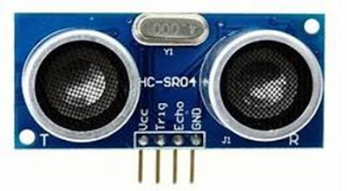

Fig:- Ultrasonic sensor

**3. BUZZER:**

A buzzer or beeper is an audio signalling device, which may be mechanical, electromechanical, or piezoelectric (piezo for short).

Typical uses of buzzers and beepers include alarm devices, timers, and confirmation of user input such as a mouse click or keystroke.

When current is applied to the buzzer it causes the ceramic disk to contract or expand. Changing the This then causes the surrounding disc to vibrate. That's the sound that you hear.

By changing the frequency of the buzzer, the speed of the vibrations changes, which changes the pitch of the resulting sound.

Piezo buzzers are simple devices that can generate basic beeps and tones. They work by using a piezo crystal, a special material that changes shape when voltage is applied to it.

If the crystal pushes against a diaphragm, like a tiny speaker cone, it can generate a pressure wave which the human ear picks up as sound Operating voltage: Normally, the operating voltage for a magnetic buzzer is from 1.5V to 24V, for a piezo buzzer is from 3V to 220V.

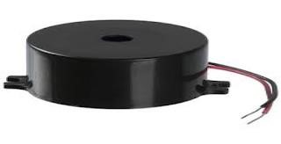

Fig:- buzzer

A "piezo buzzer" is basically a tiny speaker that you can connect directly to an Arduino. ... From the Arduino, you can make sounds with a buzzer by using tone. You have to tell it which pin the buzzer is on, what frequency (in Hertz, Hz) you want, and how long (in milliseconds) you want it to keep making the tone.

**4. ZERO PCB:**

Printed circuit boards (PCBs) are the boards that are used as the base in most electronics – both as a physical support piece and as the wiring area for the surface-mounted and socketed components. PCBs are most commonly made out of fiberglass, composite epoxy, or another composite material.

There are several overall types of PCB boards each with their own particular manufacturing specifications, material types and usages: Single-layer PCBs, Double-layer PCBs, Multi-layer PCBs, Rigid PCBs, Flexible PCBs, Rigid-Flex PCBs, High-frequency PCBs, Aluminumbacked PCBs.

A printed circuit board, or PCB, is used to mechanically support and electrically connect electronic components using conductive pathways, tracks or signal traces etched from copper sheets laminated onto a nonconductive substrate.

As its name suggests, general purpose PCB's are widely used to embed circuits randomly for running of hardware. Its layer is coated with copper and allows proper soldering without any short circuit. General purpose board, connections are not built so connections are to be created.

For instance, printed circuit boards are a development that makes connecting components simpler and cheaper than the way it “used to be done.” Printed circuit boards are conveniently thin and useful boards. They're made from an insulating material and have a metal coated surface.

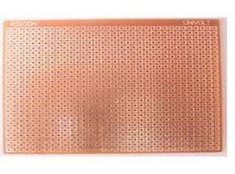

Fig:-Zero PCB

#### 5. VIBRATION SENSOR:-

Shear mode accelerometer (vibration sensor) designs feature sensing crystals attached between a center post and a seismic mass. ... Under acceleration, the mass causes a shear stress to be applied to the sensing crystals. This stress results in a proportional electrical output by the piezoelectric material.

Vibration sensors are sensors for measuring, displaying, and analyzing linear velocity, displacement and proximity, or acceleration. Vibration however subtle and unnoticed by human senses is a telltale sign of machine condition.

The working principle of vibration sensor is a sensor which operates based on different optical otherwise mechanical principles for detecting observed system vibrations. The sensitivity of these sensors normally ranges from 10 mV/g to 100 mV/g, and there are lower and higher sensitivities are also accessible.

In a standard application (50g range), the sensitivity of a typical vibration sensor is 100mV/g, while in

low vibration applications (10g) the sensitivity is 500mV/G

Vibration is most commonly measured using a ceramic piezoelectric sensor or accelerometer. An accelerometer is a sensor that measures the dynamic acceleration of a physical device as a voltage.

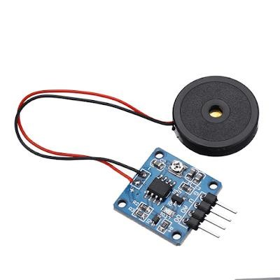

**Fig:- Vibration sensor**

### 6.BATTERY CAP:-

A battery assembled cap, a cylindrical battery with the cap and a method for making the same. ... The vent cap is attached to the battery cover by a hinge connection which allows for play between the vent cap and the battery cover and which allows for rotation of the vent cap.

A battery holder is one or more compartments or chambers for holding a battery.

For dry cells, the holder must also make electrical contact with the battery terminals. For wet cells, cables are often connected to the battery terminals, as is found in automobiles or emergency lighting equipment The purpose of the vent caps is to allow for the escape of gases formed when the battery is charging. In addition, the vent caps allow water and acid levels of the battery to be checked during maintenance. Lead-acid batteries can produce explosive mixtures of hydrogen and oxygen gases when they are being charged.

Battery can play an important role in achieving the target of universal access to clean, reliable and affordable electricity services. Battery is an energy storage device consisting of two or more electrochemical cells that convert stored chemical energy into electrical energy and used as a source of power

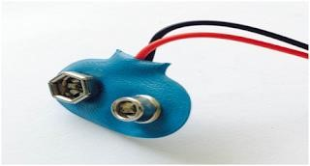

Fig:- Battery cap

#### 7. 9 VOLT BATTERY:-

A battery is an electrochemical device that produces a voltage potential when placing metals of different affinities into an acid solution (electrolyte).

The open circuit voltage (OCV) that develops as part of an electrochemical reaction varies with the metals and electrolyte used

A battery is a device consisting of one or more electrochemical cells with external connections for powering electrical devices such as flashlights, mobile phones, and electric cars. When a battery is supplying electric power, its positive terminal is the cathode and its negative terminal is the anode

A battery is a device consisting of one or more electrochemical cells with external connections for powering electrical devices such as flash lights ,mobilephones and electric cars.When a battery is supplying electric power,its positive terminal is the cathode and its negative terminal is the anode. The terminal marked negative is the source of electrons that will flow through an external electric circuit to the positive terminal. When a battery is connected to an external electric load,a redox reaction converts high-energy reactants to lower-energy products, and the free energy difference is delivered to the external circuit as electrical energy.

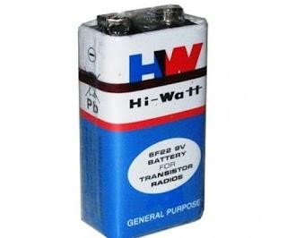

Fig:- Battery

#### 8. SOLDER WIRE:-

Solder is a fusible alloy used to join less fusible metals or wires, etc. ... Solder wire is comprised of different alloys, or of pure tin. Each metal requires a certain type of soldering wire to create strong bonds, because the combinations of metals that comprise soldering wire melt at different temperatures.

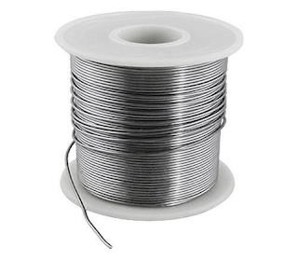

Fig:- solder wire

#### 9. SOLDERING IRON:-

A soldering iron is a hand tool used in soldering. It supplies heat to melt solder so that it can flow into the joint between two workpieces. A soldering iron is composed of a heated metal tip and an insulated handle

The basic purpose of a soldering iron is to create a bond between two workpieces using electronically heated soft metal (ie, the solder). The soldering iron supplies heat to the soldering tip, which is used to melt the solder. The melted solder forms a bond in the joint between two workpieces.

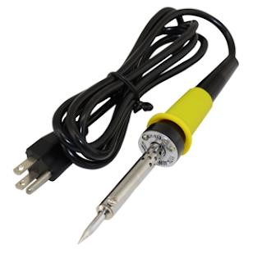

Fig:- soldering iron

### CONNECTING WIRE:-

Connecting wires allows an electrical current to travel from one point on a circuit to another because electricity needs a medium through which it can move. Most of the connecting wires are made up of copper or aluminum. Copper is cheap and good conductivity.

The Function of Connecting Wires. Connecting wires provide a medium to an electrical current so that they can travel from one point on a circuit to another. In the case of computers, wires are embedded into circuit boards to carry pulses of electricity.

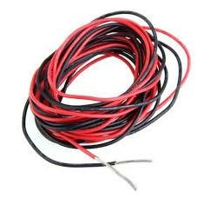

### Fig:- connecting wire

#### WIRING INSTRUCTION:-

Ground of buzzer and vibration sensor to GND of arduino

+ve of middle leg of switch to Arduino pin 5

+ve of Buzzer to first leg of switch

+ve of Vibration motor to third leg of switch

#### ULTRASONIC SENSOR:-

Ultrasonic sensor pin VCC - Arduino pin VCC

Ultrasonic sensor pin GND - Arduino pin GND

Ultrasonic sensor pin Trig - Arduino pin 12

Ultrasonic sensor pin Echo - Arduino PIN 1

##### MAKING THE MODULES:-

1. First cut the pref board in 5 X 3 cm dimension and solder the female headers for the arduino to the board.
2. Then solder the buzzer.
3. Then connect the vibrating motor using the glue gun and solder wires to it.
4. Then connect the LED.
5. Then connect the switch.
6. Then connect header pins for ultrasonic sensors and for battery input.
7. Then solder everything as shown in the circuit diagram.
8. Now connect the arduino and ultrasonic sensor to the board.

**WORKING OPERATIONS**

This proposed system consists the equipment like Arduino mini pro, ultrasonic sensor, pref board, vibrating motor, buzzers for detecting the obstacles and letting the user know about the obstacle, Red LEDs, Switches, Jumper cable, power bank, Male and female header pins, 3.3 volt old mobile battery which is unused or discarded, some elastic and stickers to make the device wearable as a band for wearing for the users. The wiring of the device is done in a following manner.

The Ground of LED, buzzer and vibration motor are connected to GND of the Arduino. The +ve of the LED and the middle leg of switch is connected to the Arduino pin 5. The +ve of the Buzzer is wired to the first leg of the switch and the +ve of the Vibration motor is wired to the third leg of the switch. The Ultrasonic sensor are wired accordingly. The Ultrasonic sensor pin VCC is connected to the Arduino pin VCC, Ultrasonic sensor pin GND is connected to the Arduino pin GND, Ultrasonic sensor pin Trig is attached to the Arduino pin 12, Ultrasonic sensor pin Echo is connected to the Arduino PIN 12. The switch used here is for selecting the mode. (Buzzer or vibration mode.) We first cut the pref board in 5 X 3 cm dimension and solder the female headers for the arduino to the board. Then soldering of the buzzer is carried out. Then using the glue connect the vibrating motor and solder the wires to it. Then connection of the LED is done. Then connect the switch. Connect the header pins for ultrasonic sensors and for the battery input. Then solder all the things and connect the arduino and ultrasonic sensor to the board. Also connect the elastic band to all the modules. For making the module for the hand, connect the ultrasonic sensor to the board by using 4 jumper cables. Then connect a 3.7 volt mobile battery to this module. Then connect the elastic band. In the end after all the cnnections are done to the Arduino board, upload the code to each arduino board and power the 4 other modules using a power bank.

The US sensor is a transducer, and is used in pair as transreceiver. The transmitter emits the US waves and if obstacles are present in the path, the US waves hits the obstacles and gets reflected back, the reflected wave is received by the receiver. The US sensor is a combination of one transmitter and receiver. The time interval between sending and receiving of the US signal is calculated, this time interval is used to calculate the distance between sensor and the obstacle.

The sensors which are placed in waist belt are in such a manner that the Ultrasonic pulses of sensors must not be overlapped one over the other. Sensors has a field of view (coverage) of about 60 degrees for 4 feet distance, as the distance from the sensor increases, the coverage angle decreases. Thus, the objective is to cover a wide angle to detect the obstacles with the help of the ultrasonic sensors to help the blind and make it easy for them to move around easily without any hassle.

Hence, the distance calculation is calculated and the sensor detects and the further procedure of the buzz sound to the user is carried out. Thus, this way Third Eye for Blind will be designed for the visually impaired people and will make it very easy and convenient as it will be a wearable device and thus will help the user in travelling and detecting the obstacles while walking very easily.

#### ARDUINO PROGRAMMING:-

const int pingTrigPin = A4; //Trigger connected to PIN 7 const int pingEchoPin = A5; //Echo connected yo PIN 8 int buz=13; //Buzzer to PIN 4 int buz1=9; void setup() { Serial.begin(9600); pinMode(buz, OUTPUT);

pinMode(buz1, OUTPUT);

}

void loop()

{

long duration, cm;

pinMode(pingTrigPin, OUTPUT); digitalWrite(pingTrigPin, LOW); delayMicroseconds(2); digitalWrite(pingTrigPin, HIGH); delayMicroseconds(5); digitalWrite(pingTrigPin, LOW);

pinMode(pingEchoPin, INPUT);

duration = pulseIn(pingEchoPin, HIGH); cm = microsecondsToCentimeters(duration);

if(cm<=100 && cm>0)

{

int d= map(cm, 1, 100, 20, 2000); digitalWrite(buz, HIGH); digitalWrite(buz1, HIGH); delay(50); digitalWrite(buz, LOW); digitalWrite(buz1, LOW);

delay(d);

}

Serial.print(cm);

Serial.print("cm"); Serial.println();

delay(40);

}

long microsecondsToCentimeters(long microseconds)

{

return microseconds / 29 / 2;

}

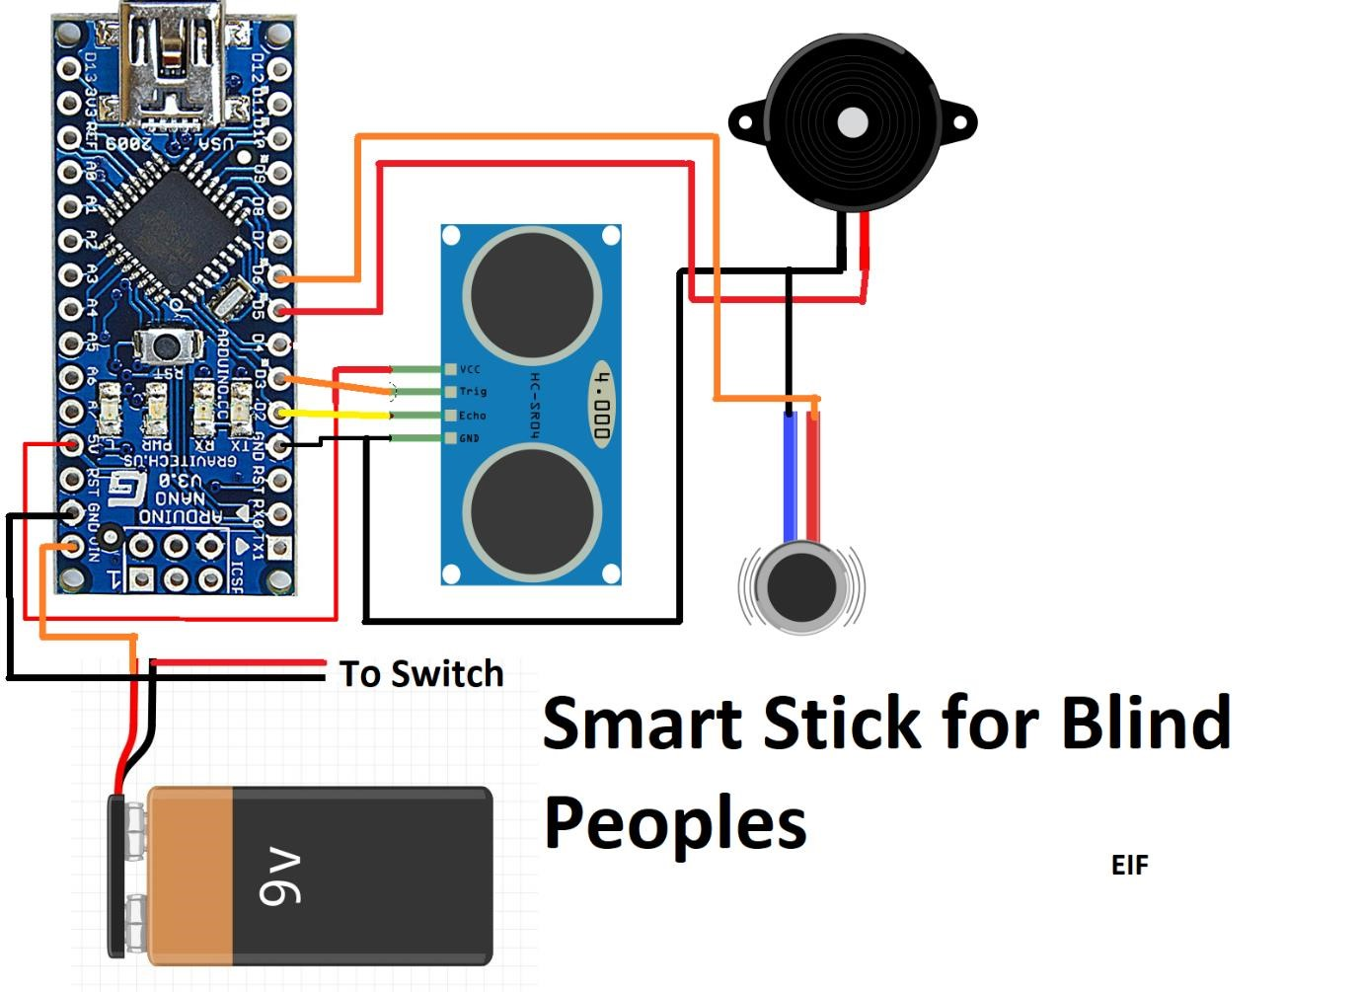

**RESULT:**

THE presented system is designed and configured for the use of the blind and visually disabled people. This device is able to handle several states that the visually impaired people face. This device responds to the user in all the circumstances which is faced by the blind people with the help of the use of the Ultrasonic sensors and the Arduino Board.

Case 1: When the obstacle or the object is in the left it will tell the user that:

The obstacle is in left

Case 2: When the obstacle is in right it will say: The obstacle in right. Case 3: When the obstacle is in front, the device will say: the obstacle is in front. Similarly for all the directions like left, right, back etc it will notify the user wearing it.

#### BENEFITS:-

Third eye for blinds is an innovation to help blind people to navigate with greater comfort, speed and confidence, while making use of ultrasonic waves to detect nearby obstacles and to notify the user through vibration.

This is the first wearable technology for blinds which resolves all the problems of existing technologies.

Now a days there are so many instruments and smart devices for visually impaired peoples for navigation but most of them have certain problems for carrying and the major drawbacks are : Those need a lot of training to use.

The one of the main peculiarity of this innovation is, it is affordable for everyone, the total cost being less than $25 (~1500INR).

There are no such devices available in the market that can be worn like a cloth and having such a low cost and simplicity. When used on a large scale, with improvements in the prototype, it will drastically benefit the community.

**CONCLUSION:**

Thus, this project proposed the design and architecture of a new concept of Arduino based Virtual Eye for the blind people. A simple, cheap, efficient, easy to carry, configurable, easy to handle electronic guidance system with many more amazing properties and advantages is proposed to provide constructive assistant and support for the blind and visually impaired persons. The system will be efficient and unique in its capability in specifying the source and distance of the objects that may encounter the blind. It is able to scan and detect the obstacles in the areas like left, right, and in front of the blind person regardless of its height or depth.

With the proposed architecture, if constructed with at most accuracy, the blind will be able to move from one place to another without others help.

The project as a whole was successful in developing a more durable navigation technique apart from the existing ones. This was just a prototype of the original idea that had to be presented here. The project, if used on a wider scale and distributed to blind people, really has the ability to make an impact to the community.

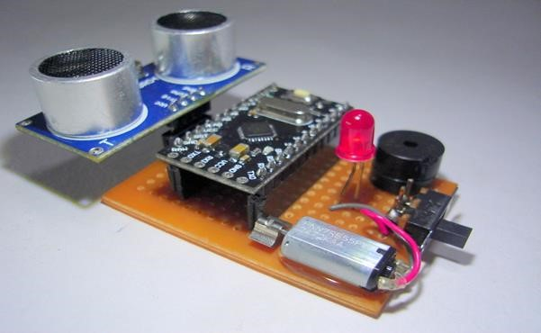

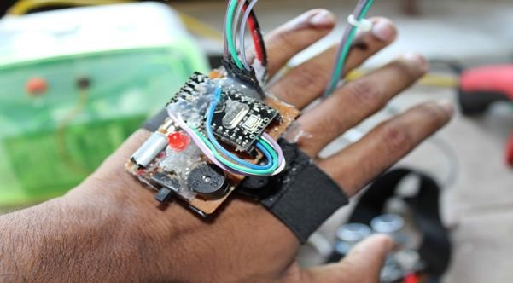

We Can Attach This Project To a Belt And Then It Can Be Used to Fix Hands , Legs Wherever You Want.

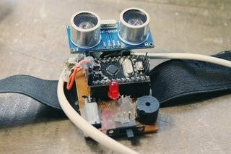

# CHAPTER 3 CONCLUSION & FUTURE SCOPE

**5.1 CONCLUSION:**

Thus, the project, Third Eye for blind people is made sightless individuals to live independently, so as to perform their daily activities easily and more confidently with high level of safety. This Arduino based concept for the blind people is simple, cheap and can be easily carried and maintained. This system is able to scan and detect the hindrances in all directions irrespective of the height or depth the object lies at. With this project, if the construction is done properly, the blind can enjoy the taste of sight and can move freely from one place to another without assistance of the other individual.

**5.2FUTURE SCOPE:**

In future with the advancement of quicker response of sensors, like the usage of top notch sensors it can be made highly useful and also the modules that one needs to wear as a bracelet or on any other part of the body can be transformed into a wearable clothing like a coat, so that it can be made fit for working and there can be more advancement in this device for instance we can use piezeo electric plates in the shoes of the user which can generate sufficient electricity that the modules can run on.

# REFERENCES

[1] Johann Borenstien ,Shraga Shovel, Iwan Ulrich. Guide Cane and the Nav Belt, IEEE Transactions on Robotics & Automation. 2003; 10(1):920. [2] N.G. Bourbakis, D. Dakopoulos. "Wearable Obstacle Avoidance Electronic

Travel Aids for Blind: A Survey", IEEE Trans. Systems Man and Cybernetics

Part C: Applications and Reviews, vol. 40, no. 1, pp. 25-35,2015. [3] Hugo Fernandesc , João Barroso “Blind Guide: an ultrasound sensorbased body area network for guiding blind people “,6th International Conference on Software Development and Technologies for Enhancing Accessibility and Fighting Infoexclusion (DSAI 2015) [4] Sabarish S. Navigation Tool for blind people using Microcontroller, International Journal of Engineering and AdvancedTechnology (IJEAT),2013; 2(4):139-143. [5] Espinosa MA, Ungar

S, Ochaíta E. Blades comparing methods for Introducing Blind and Visually Impaired People to unfamiliar urban environments., Journal of Environmental psychology. 1998; 18:277-287. [6] Pooja Sharma, Shimi SL, Chatterji S. A Review on Obstacle Detection and Vision, International

Journal of Science and Research Technology. 2015; 4(1):1-11. [7] Tahat AA. A wireless ranging system for the blind longcane utilizing a smart-phone, in Proceedings of the 10th International Conference on Telecommunications. (ConTEL '09), IEEE, Zagreb, Croatia, June. View at Scopus. 2009, 111-117. [8] Bolgiano D, Meeks Jr E. A laser cane for theblind, IEEE Journal of Quantum Electronics. View at Google Scholar. 1967; 3(6):268. [9] Amjed Al-Fahoum S, Heba Al-Hmoud B, Ausaila Al- Fraihat A. A Smart Infrared Microcontroller-Based Blind Guidance System”, Hindawi Transactions on Active and Passive Electronic Components. 2013;3(2):1-7.

VIDEO LINK : <https://photos.app.goo.gl/jYX3LEpUXjJEBV5i6>