Module 1
1
https://www.hackerearth.com/practice/basic-programming/input-output/basics-of-input-output/practice-problems/algorithm/io-exercise/ 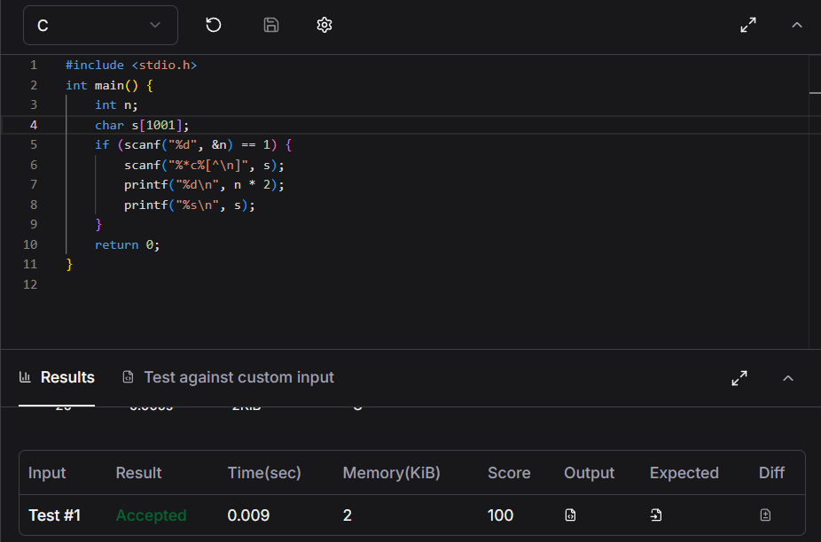
2
https://www.hackerrank.com/challenges/solve-me-first/problem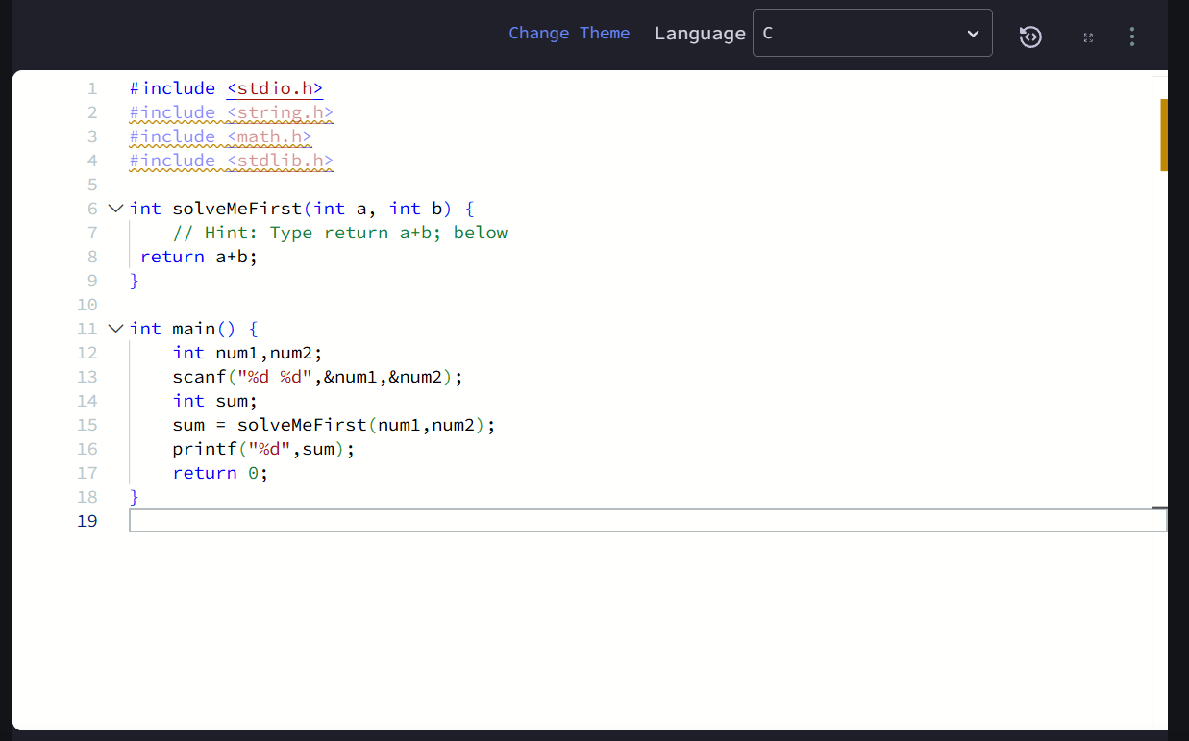

3
https://leetcode.com/problems/add-two-integers/submissions/2193079444/
4
https://leetcode.com/problems/calculate-delayed-arrival-time/
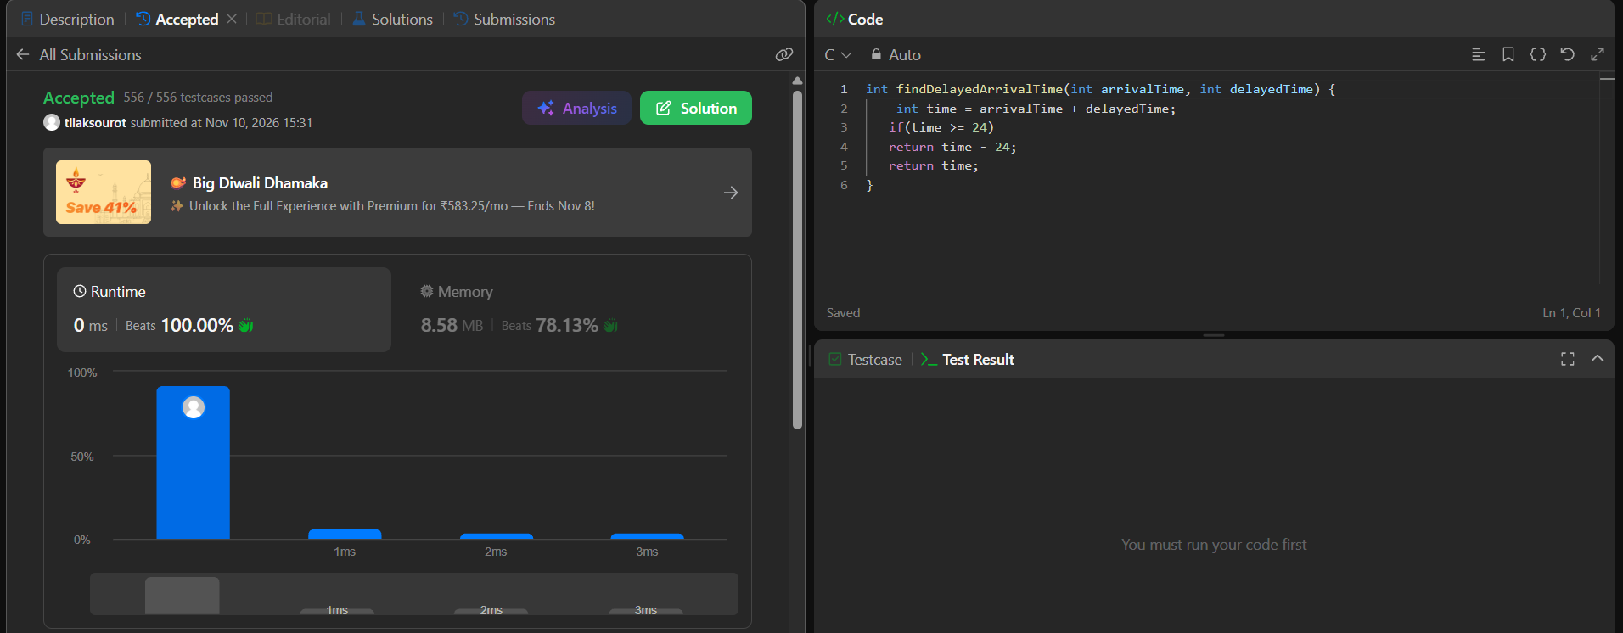5
https://leetcode.com/problems/total-distance-traveled/
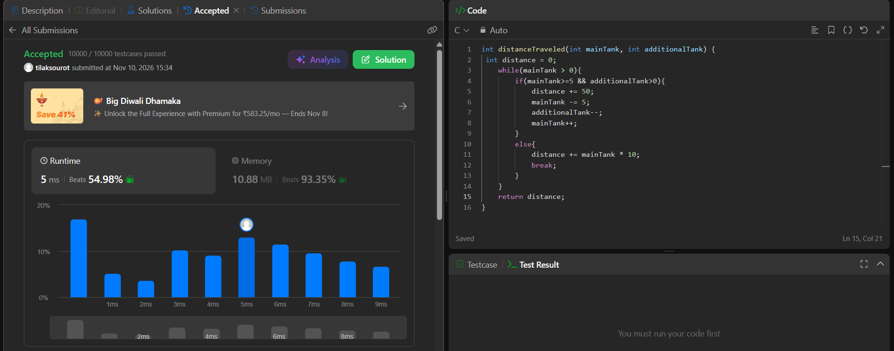module 2
1
https://www.hackerrank.com/challenges/conditional-statements-in-c/problem
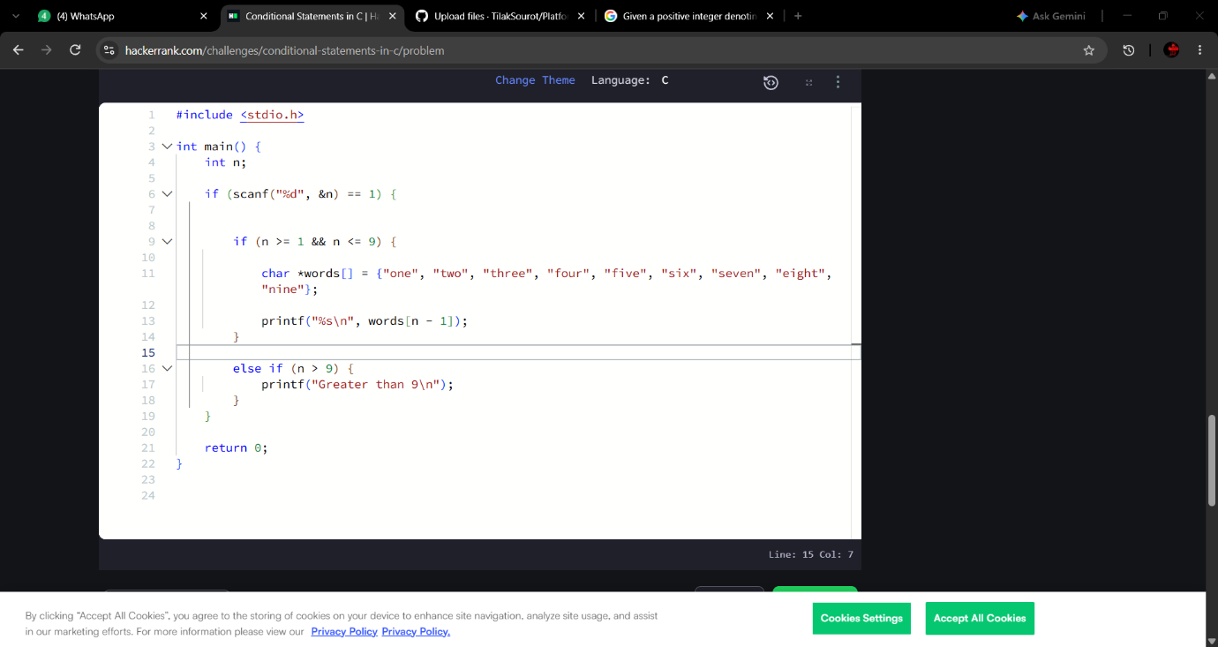2
https://leetcode.com/problems/smallest-even-multiple/description/
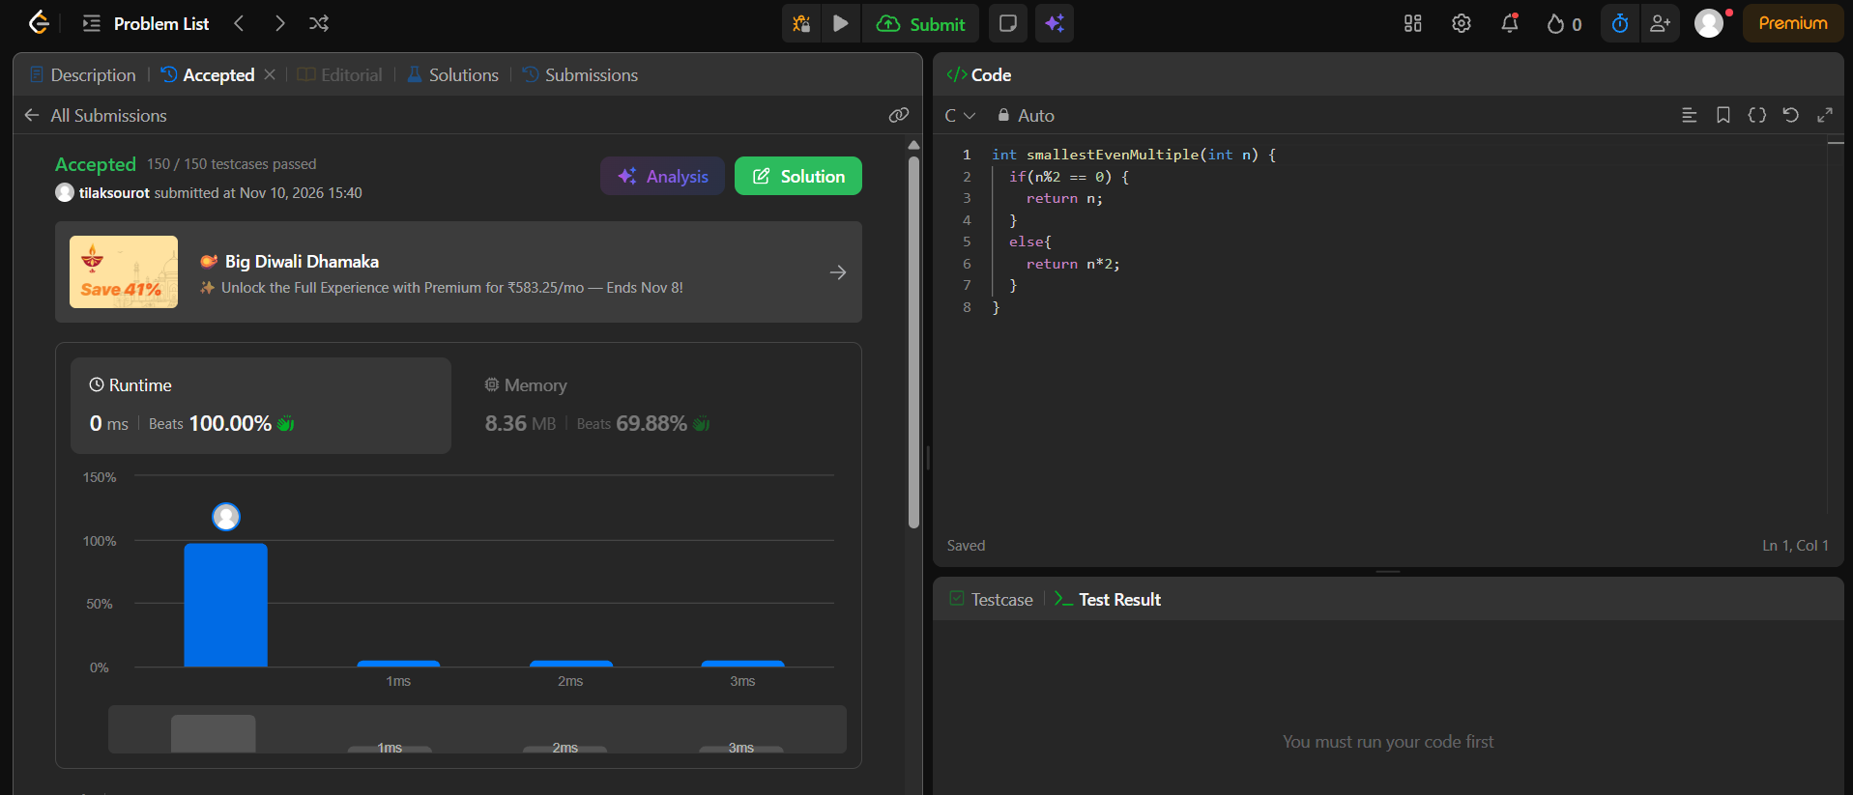3
https://www.hackerrank.com/challenges/grading/problem
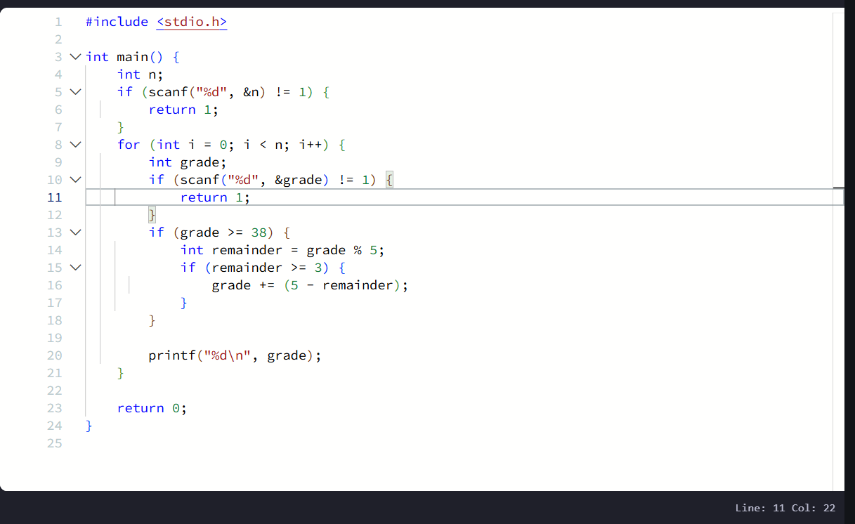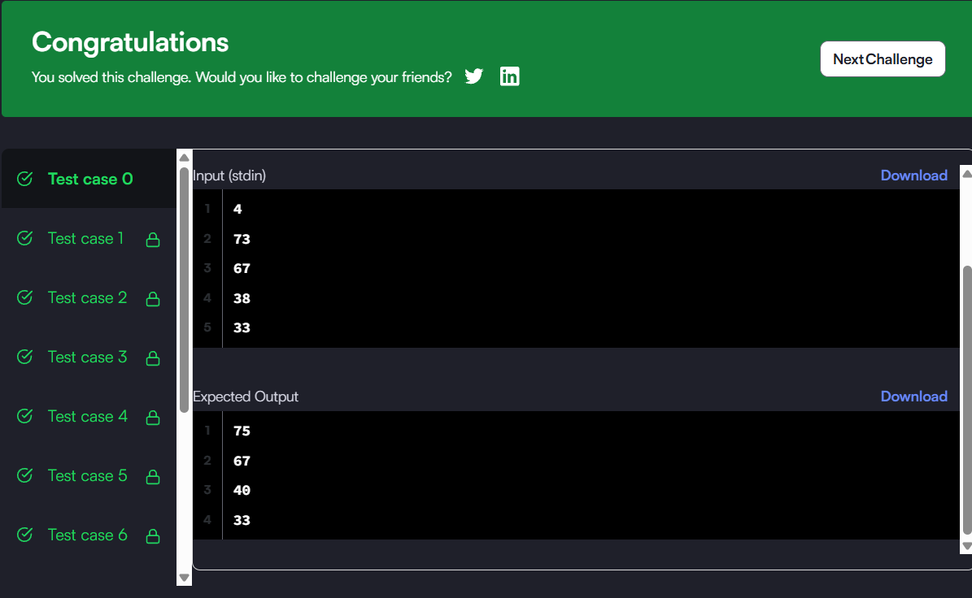4
https://www.hackerearth.com/practice/basic-programming/input-output/basics-of-input-output/practice-problems/algorithm/roy-and-profile-picture/
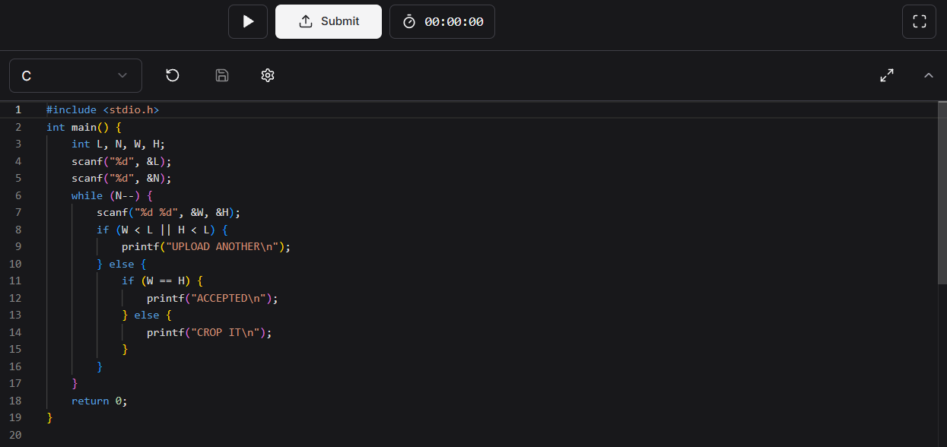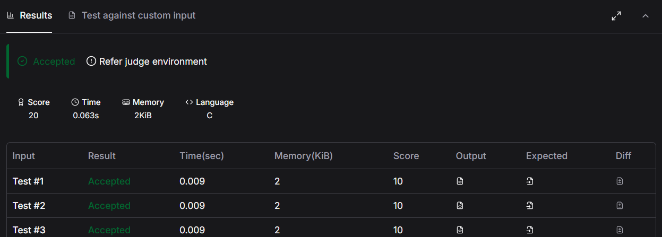5
https://www.hackerrank.com/challenges/fizzbuzz/problem
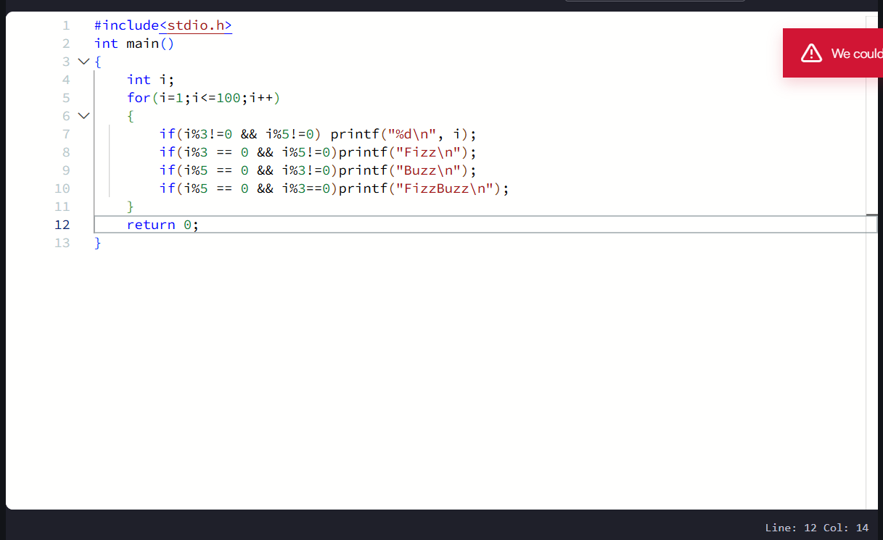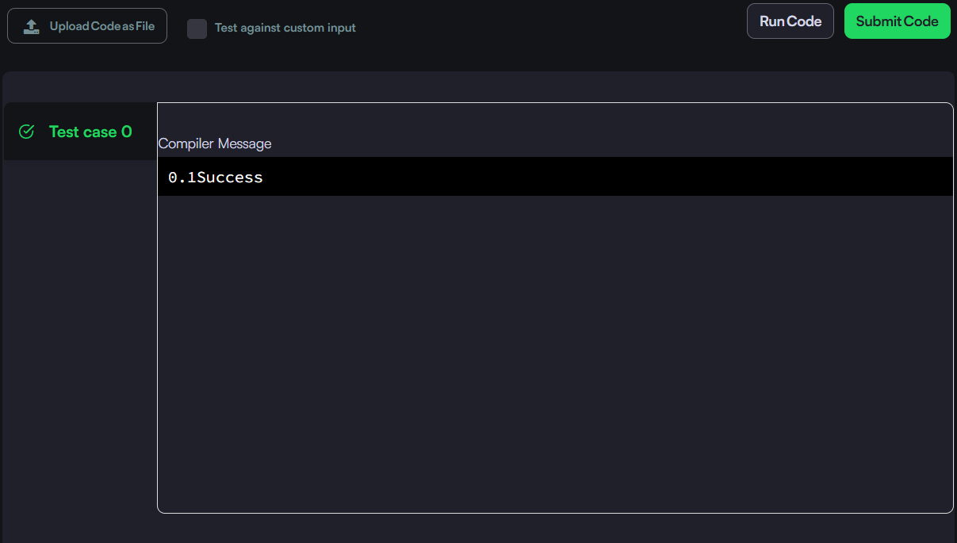module 3
1
https://www.hackerrank.com/challenges/for-loop-in-c/problem

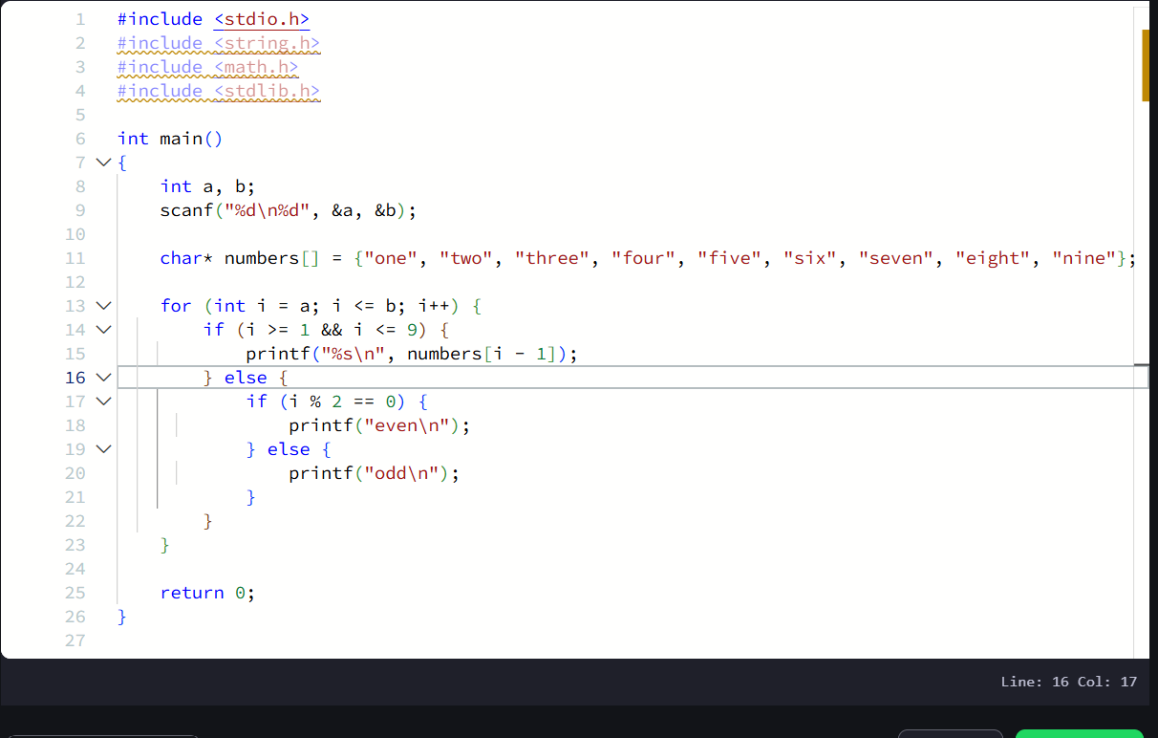2
https://leetcode.com/problems/number-of-steps-to-reduce-a-number-to-zero/
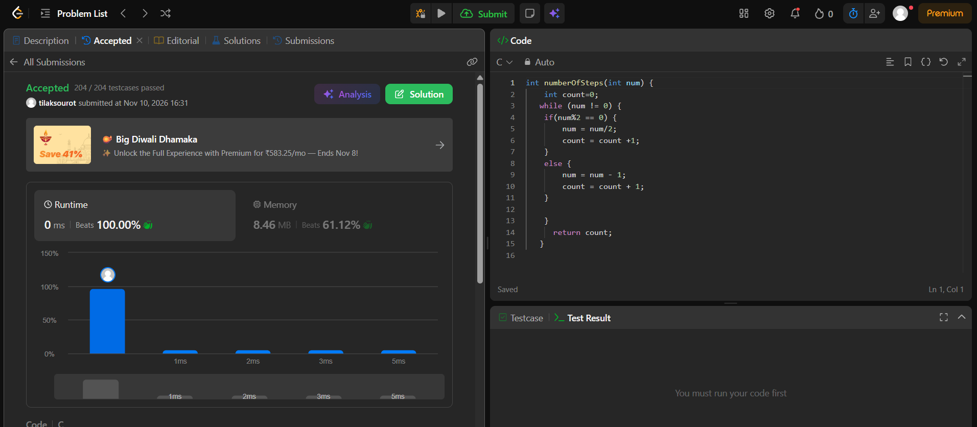3
https://leetcode.com/problems/count-operations-to-obtain-zero/
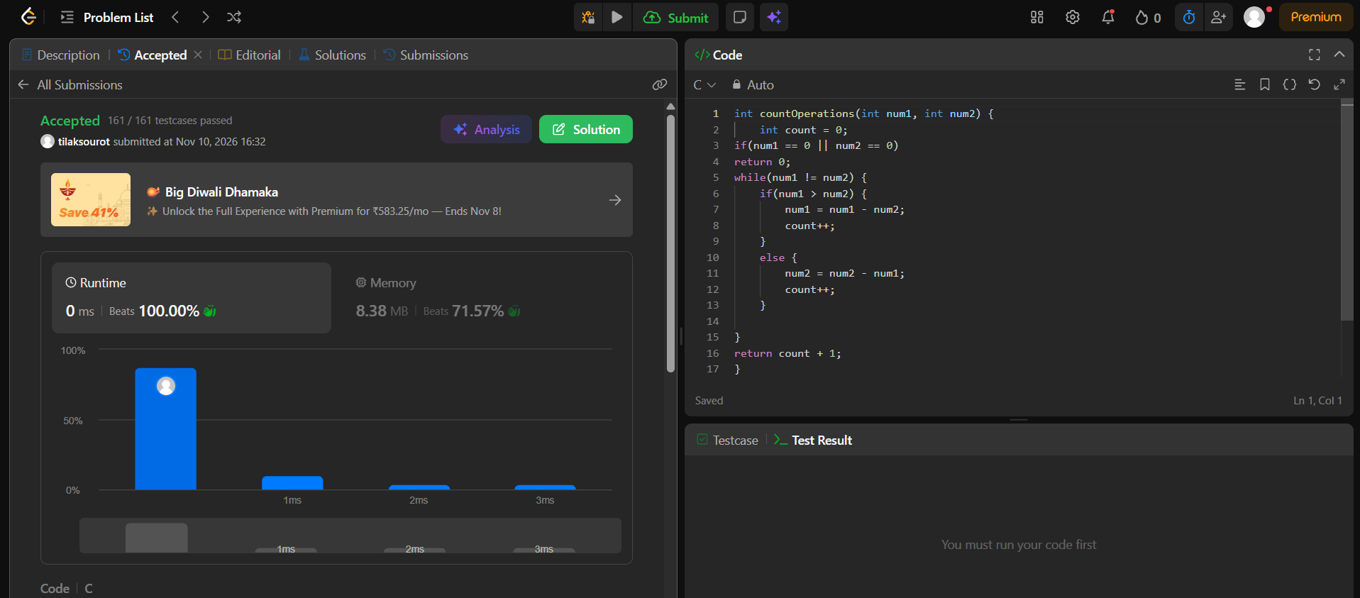4
https://leetcode.com/problems/count-odd-numbers-in-an-interval-range/
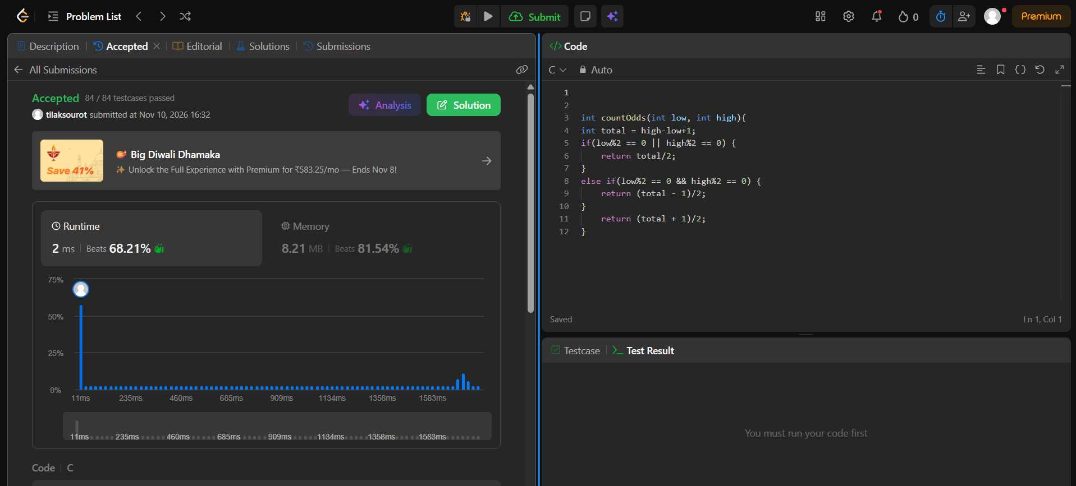5
https://leetcode.com/problems/sum-multiples/
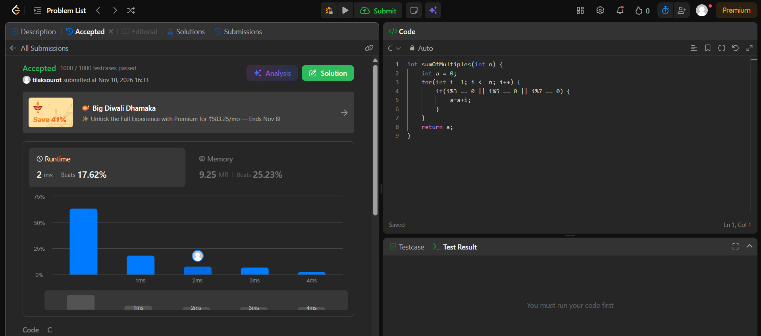6
https://www.hackerrank.com/challenges/kangaroo/problem
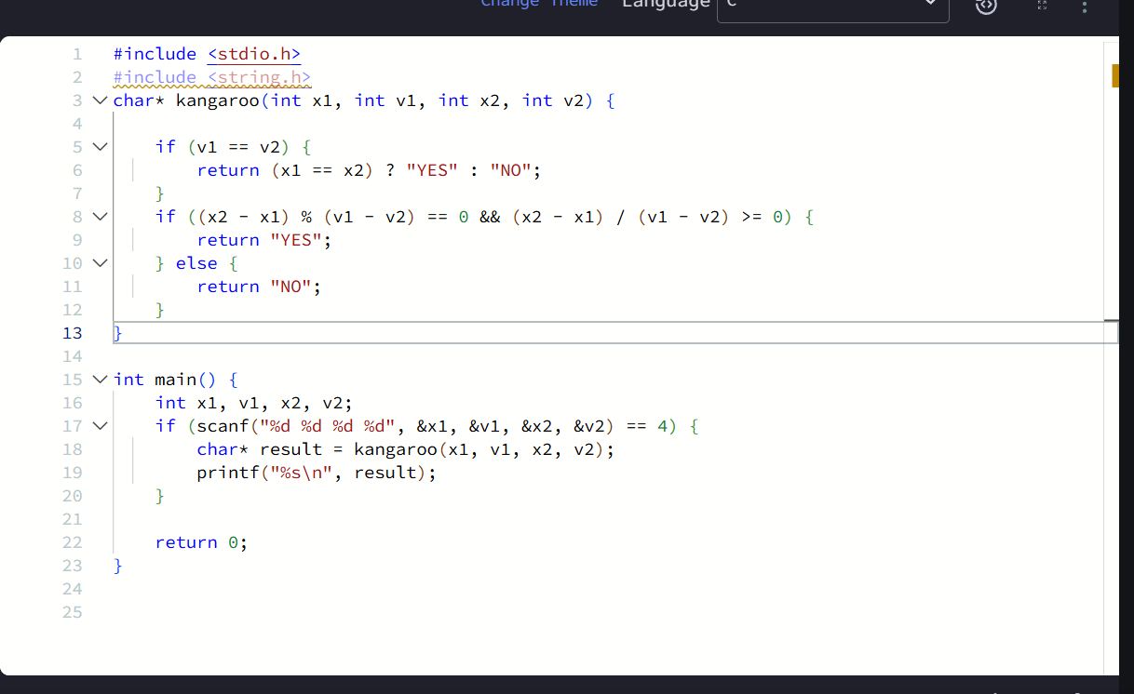module 4
1
https://www.hackerearth.com/problem/algorithm/digit-sum-4/
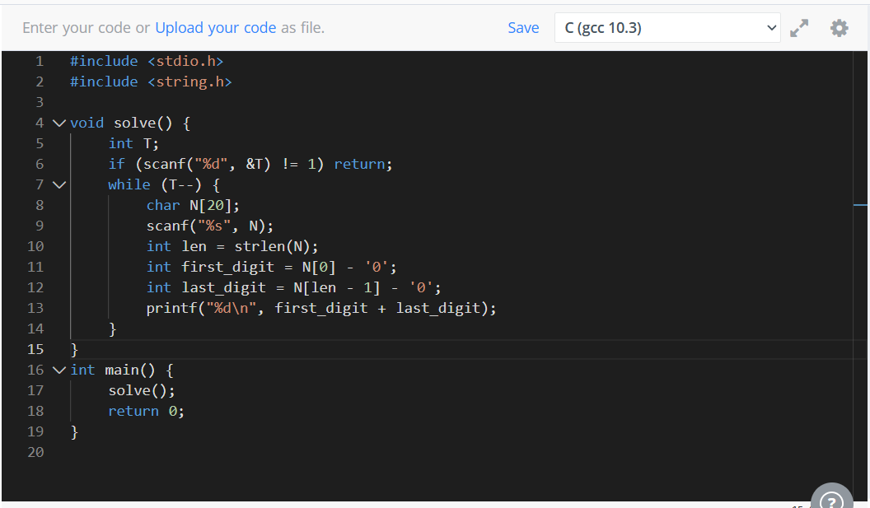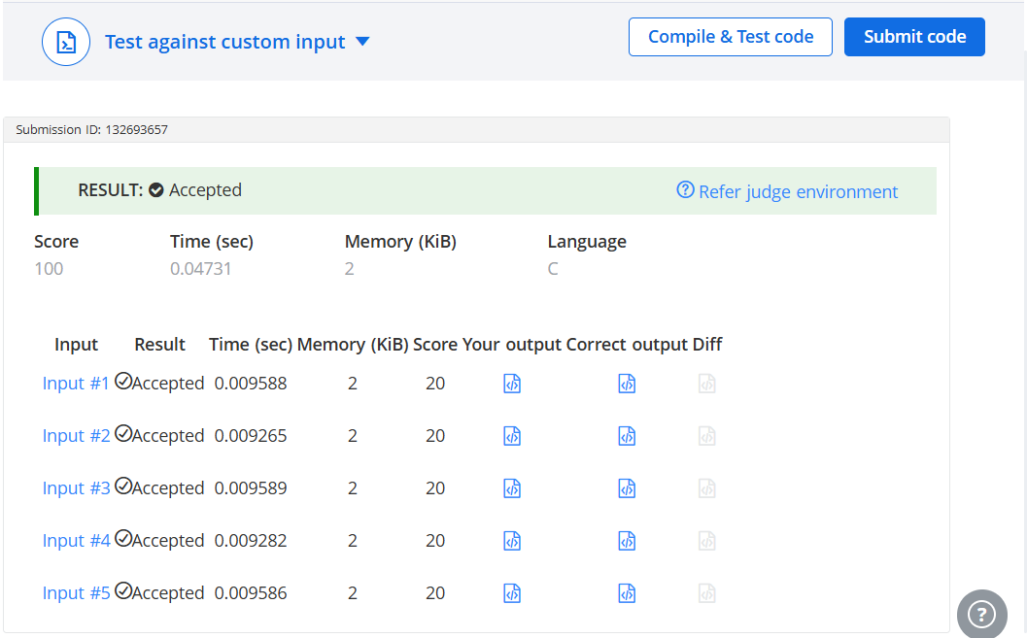2
https://www.hackerrank.com/challenges/find-digits/problem
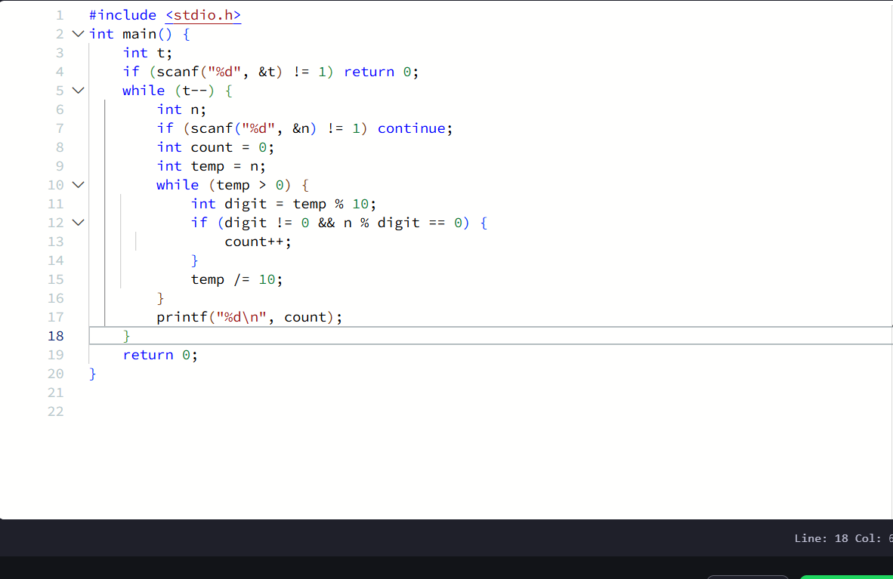3
https://leetcode.com/problems/subtract-the-product-and-sum-of-digits-of-an-integer/
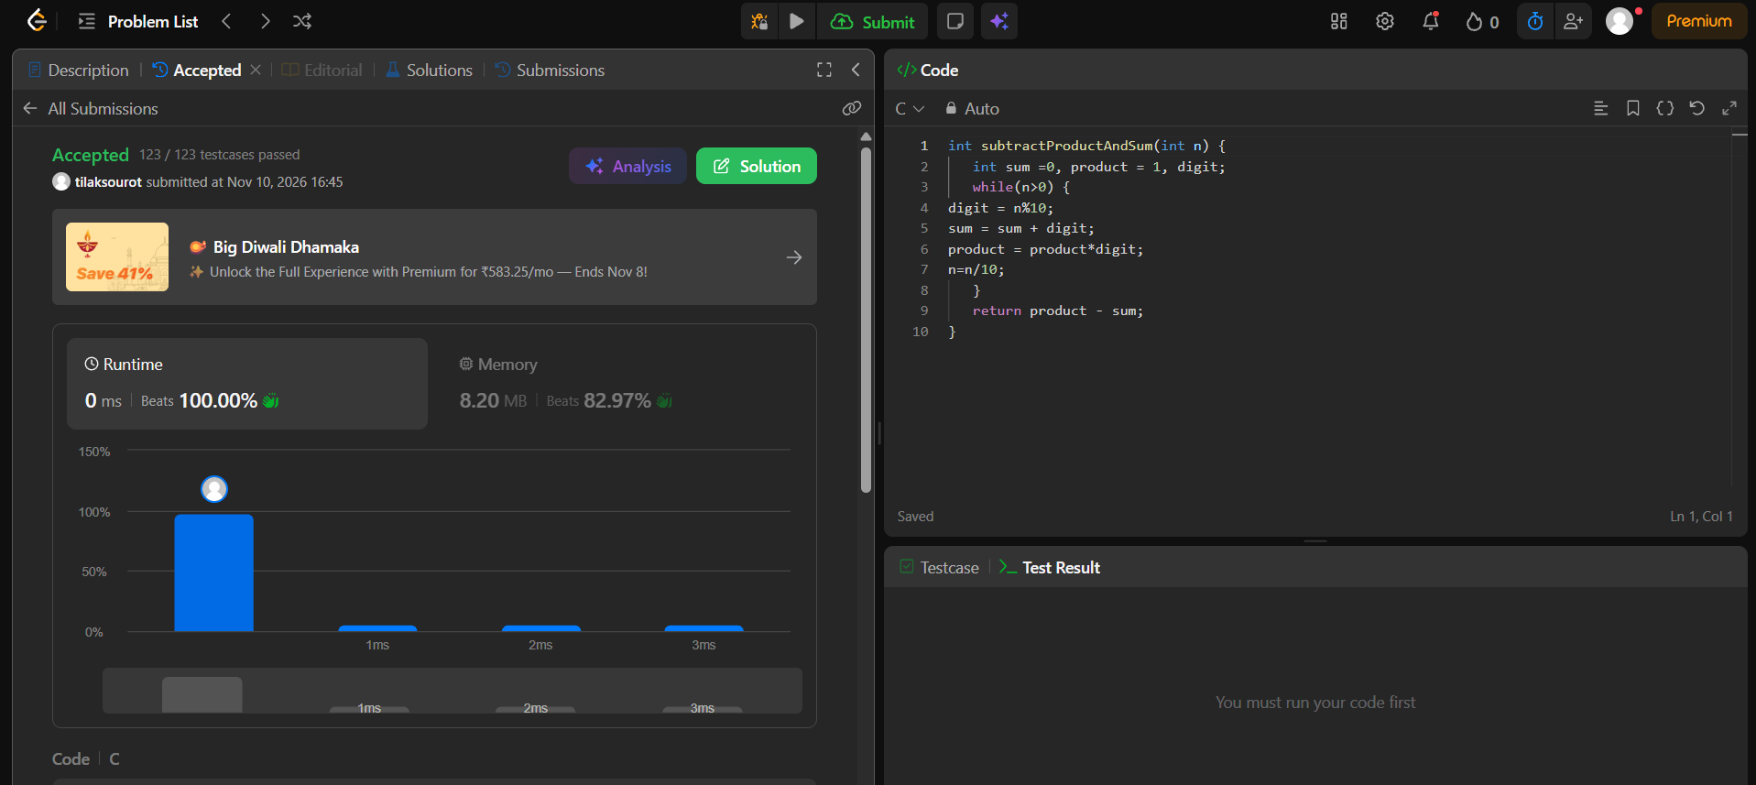4
https://leetcode.com/problems/count-the-digits-that-divide-a-number/
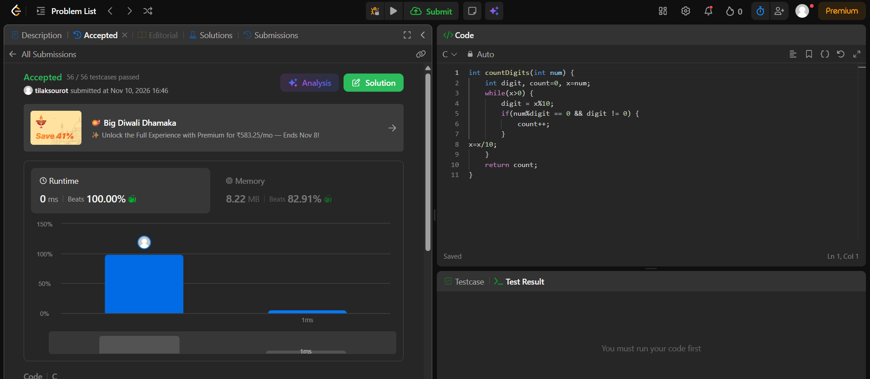5
https://leetcode.com/problems/palindrome-number/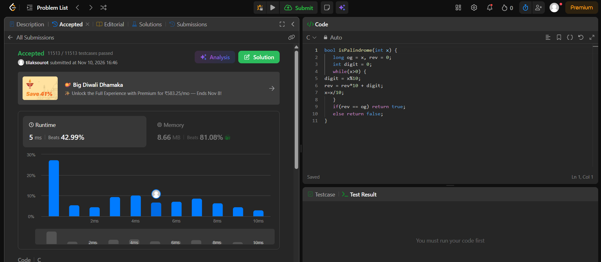
6
https://leetcode.com/problems/reverse-integer/
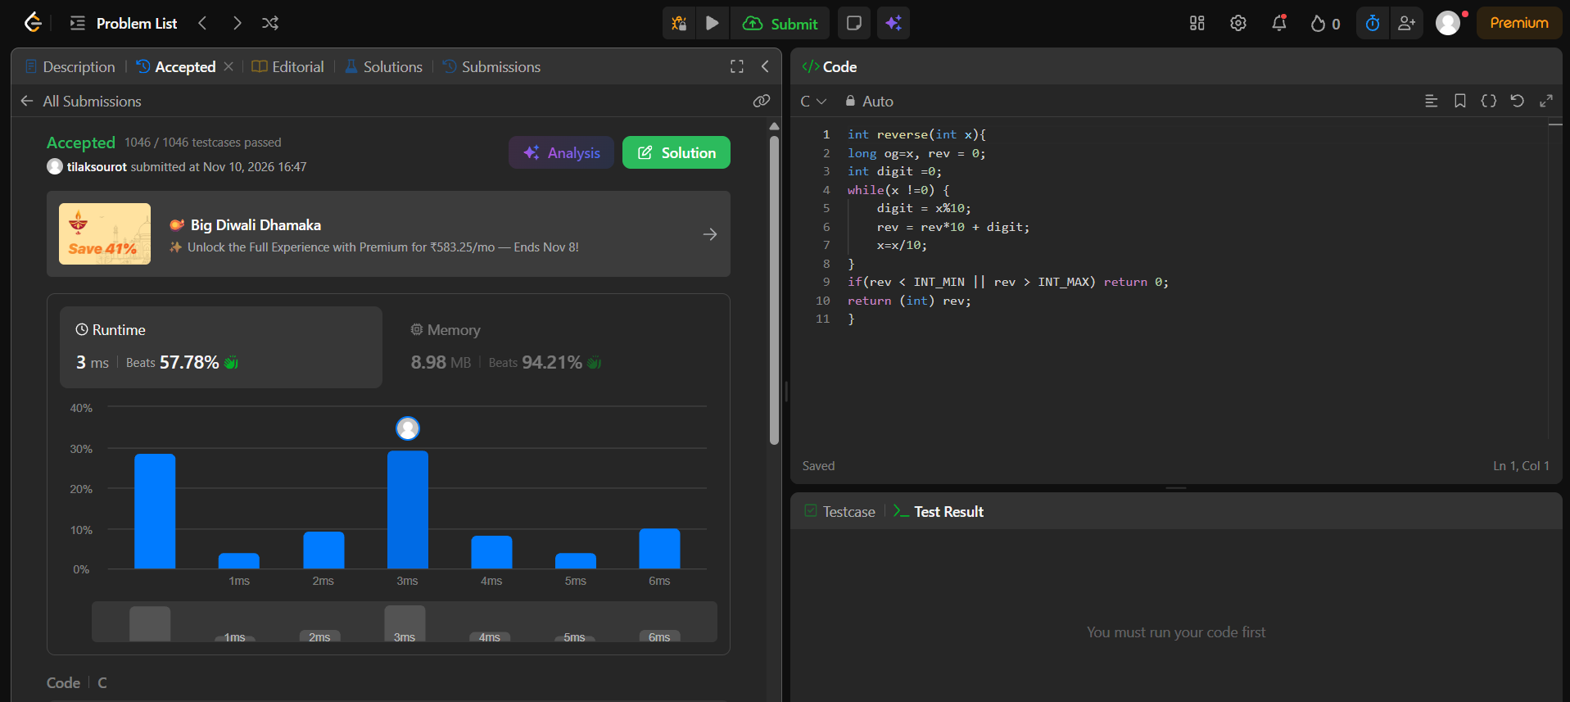module 5
1
https://leetcode.com/problems/power-of-two/submissions/2193119734/

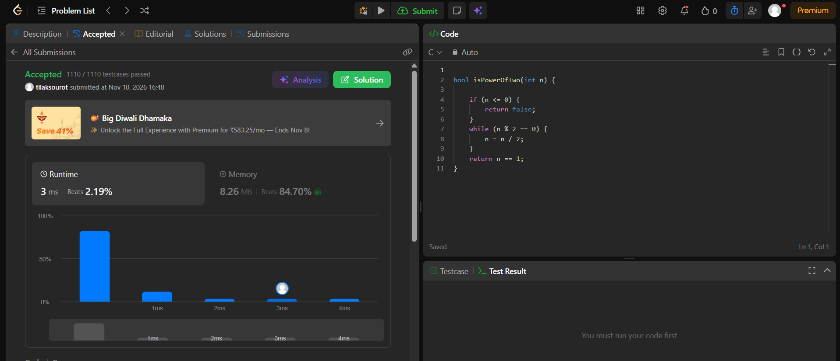
2
https://leetcode.com/problems/power-of-three/
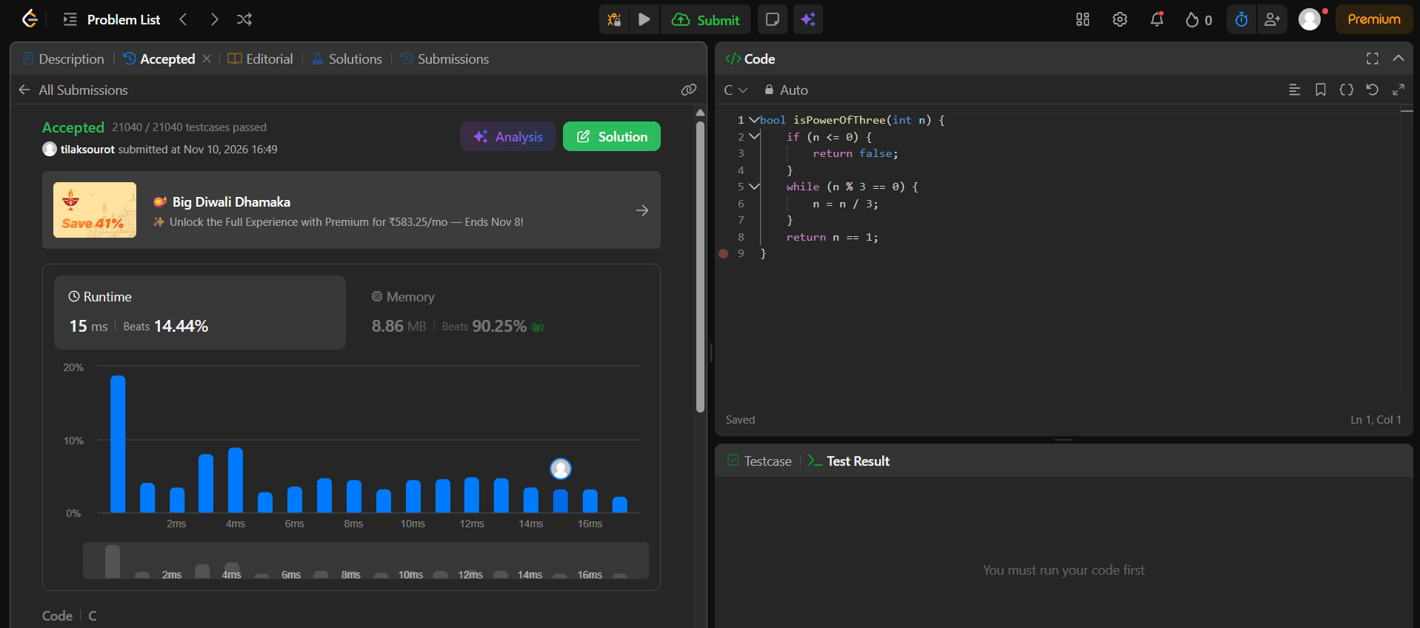3
https://www.hackerearth.com/practice/basic-programming/input-output/basics-of-input-output/practice-problems/algorithm/find-factorial/
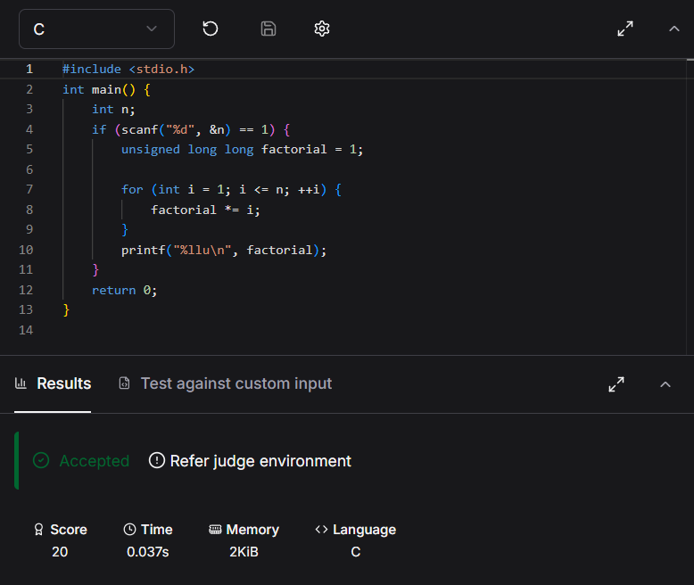4
https://www.hackerearth.com/practice/basic-programming/input-output/basics-of-input-output/practice-problems/algorithm/count-divisors/
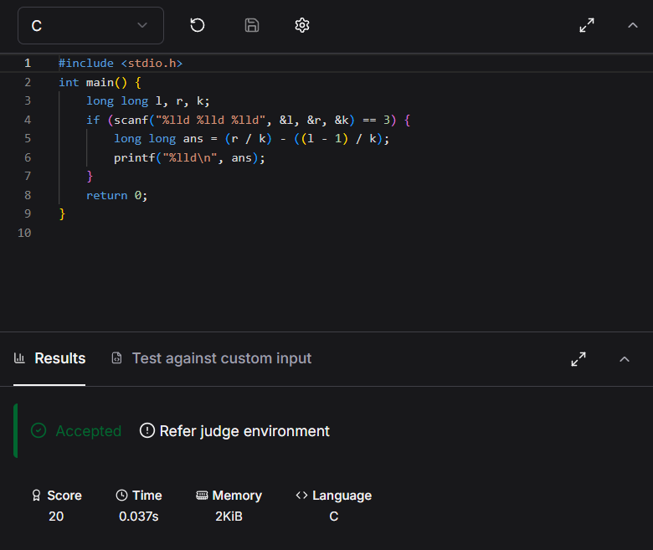5
https://www.hackerearth.com/problem/algorithm/prime-numbers/
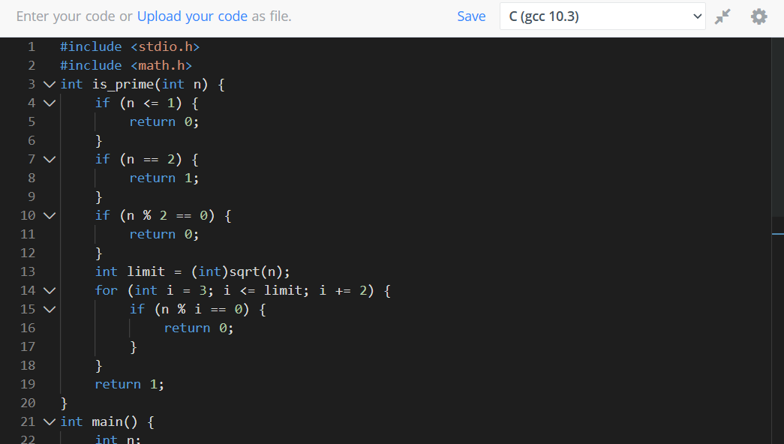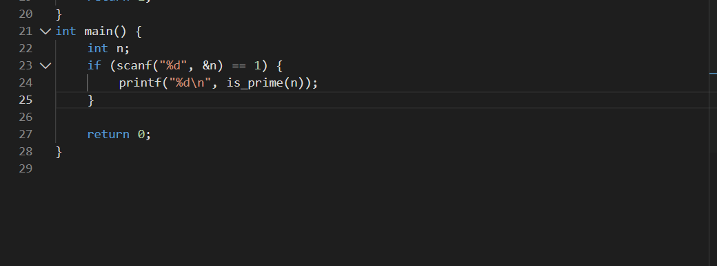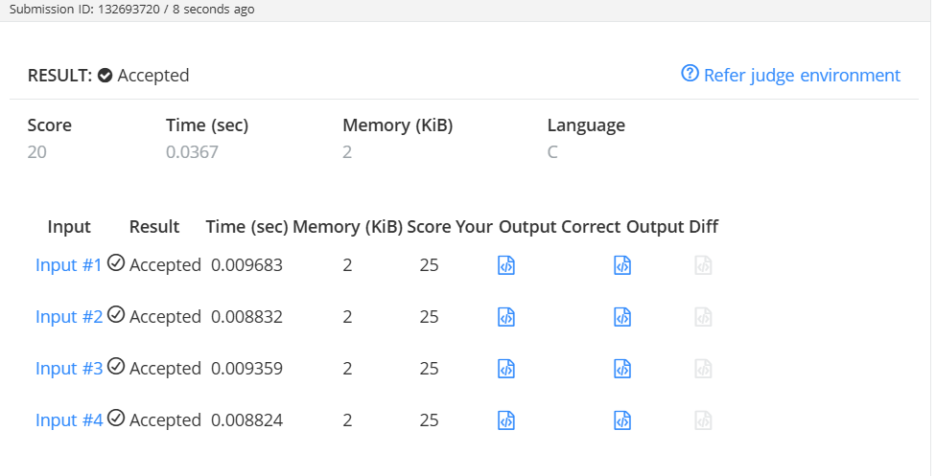
6
https://leetcode.com/problems/perfect-number/
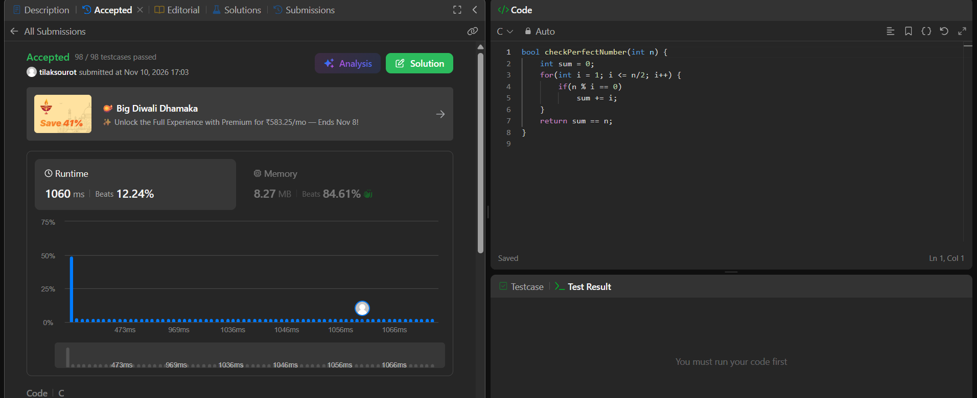
Module 6
1
https://www.hackerrank.com/challenges/staircase/problem
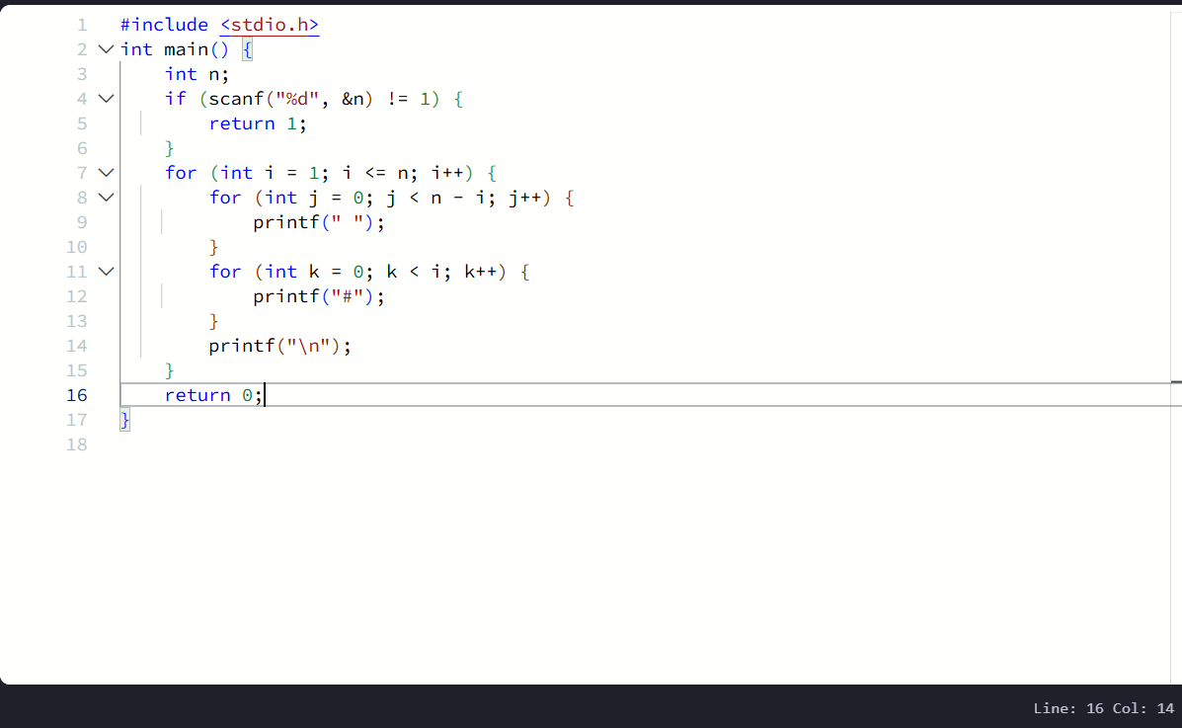
2
https://www.hackerrank.com/challenges/printing-pattern-2/problem


