Question 3:

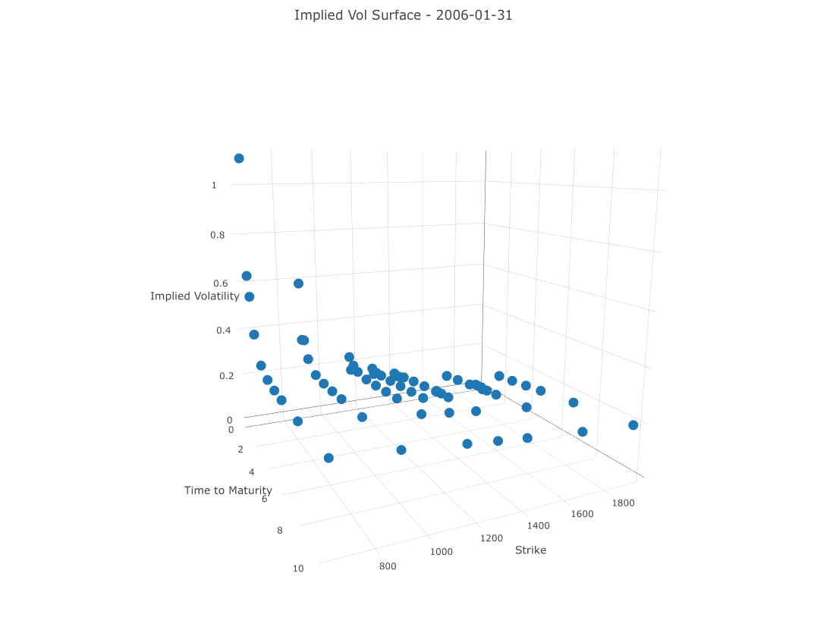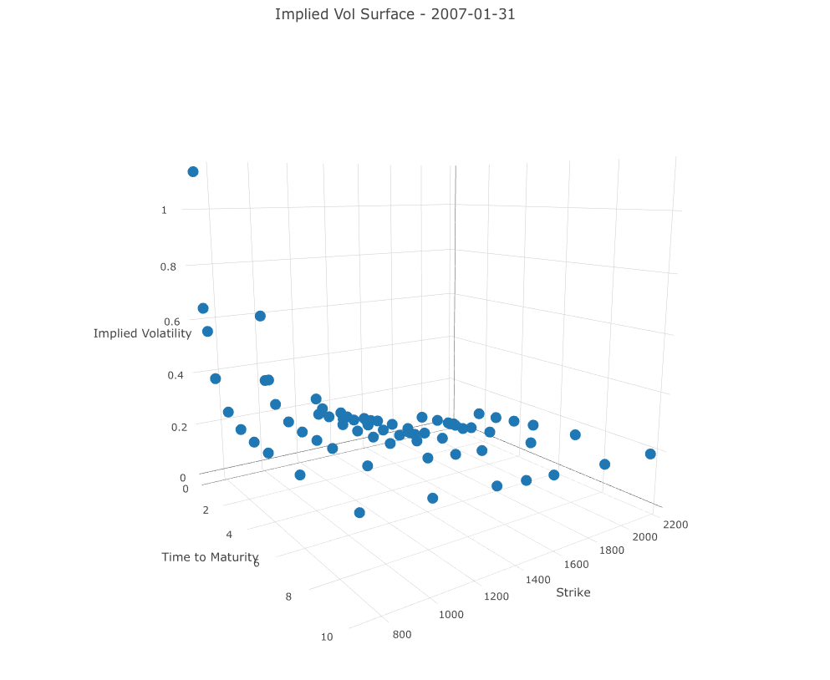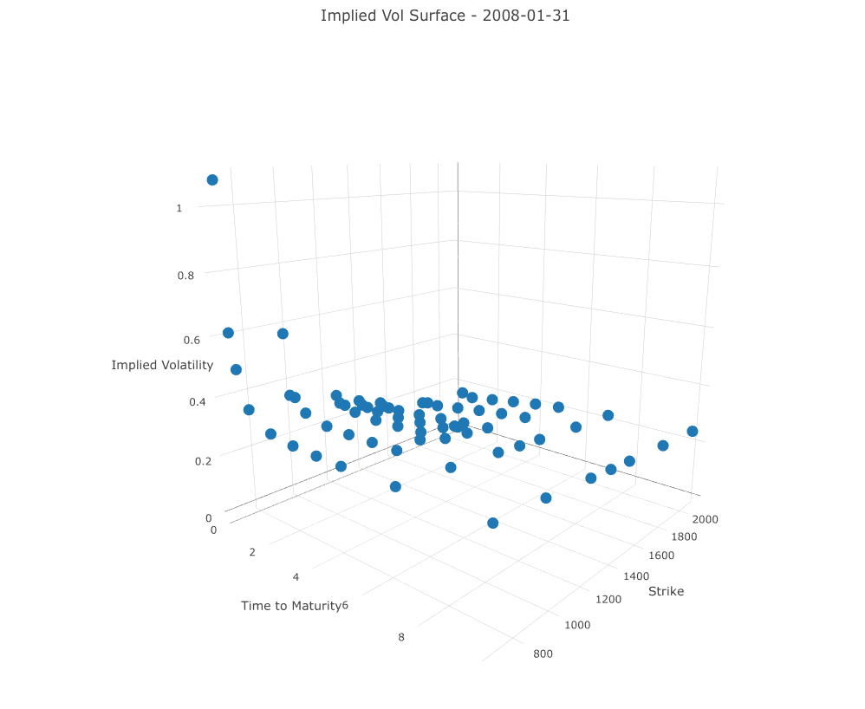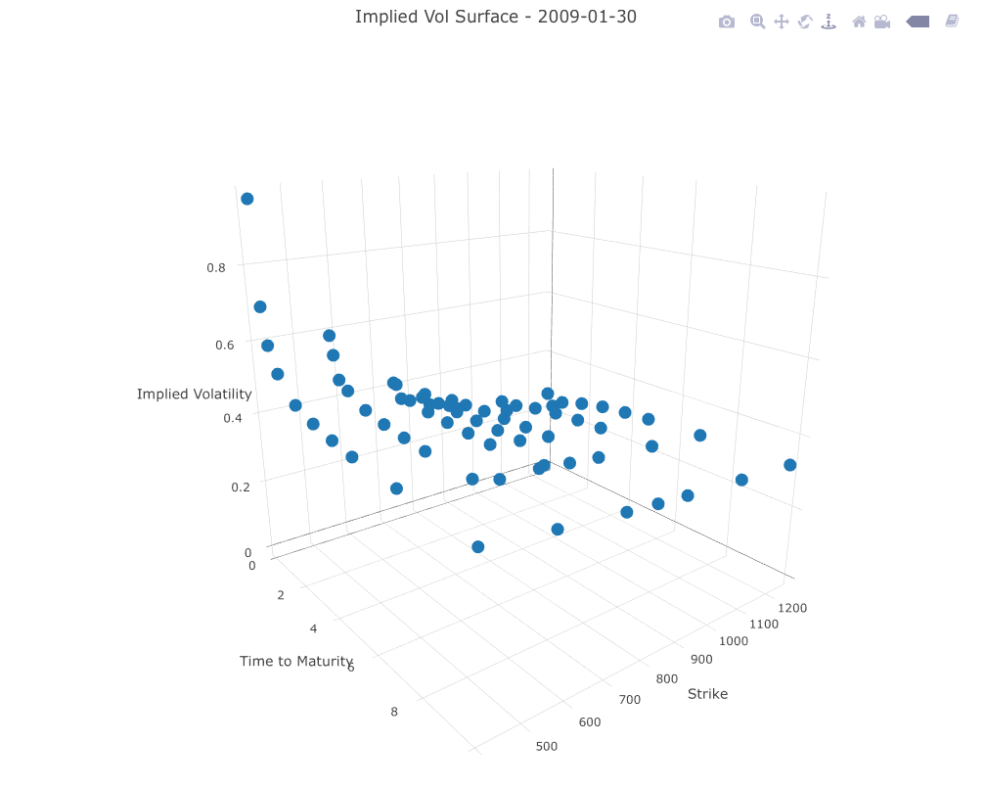

Question 4:

Note: Work on that only at the end! If I have time I will update the plot (put it in a 3D surface as in the previous question).

Plots are in the folder – currently only for 2006-01-31 (more dates can be plotted very quickly)

Question 5

OPEN – will try to think about some BS, but dont expect a real solution

Question 6

Not sure what exactly he wants to hear here. The plots are for the next question.... Maybe he just looks at the R code?

Question 7:

Compare Q4

Question 8: Done already

Question 9:

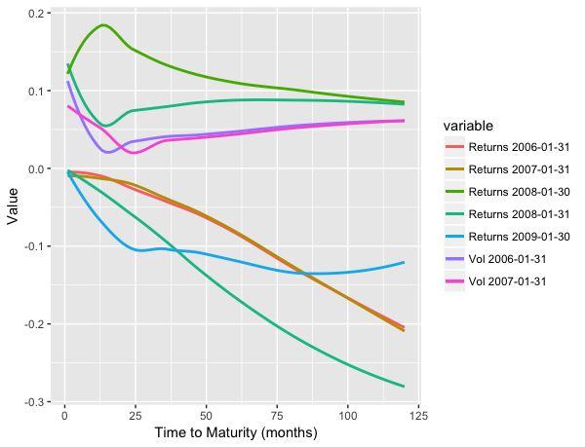

Question 11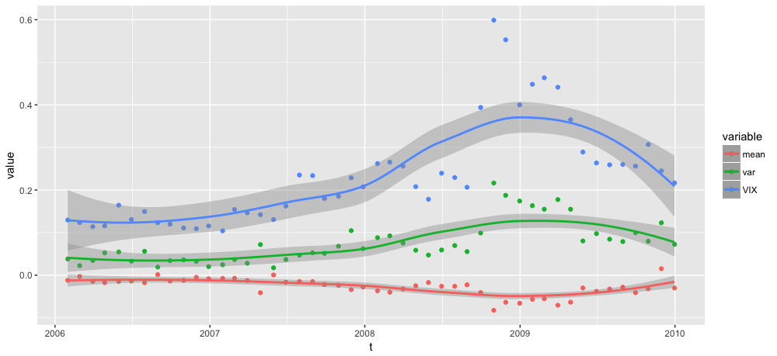

Second plot:

* scaled returns by -10 (to make curves comparable)
* scaled vol by e (2.3....) – i assume there might be an error somewhere (the function contains some exponentials, there might be a +1 missing somewhere; couldnt find it though)

Suggestion: Use second plot. Maybe not mention that Vol is scaled.

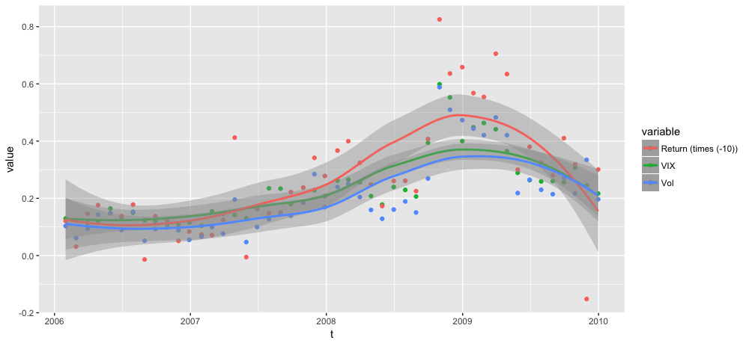

Q12:

Room for some bullshit.

Q13:

Code is written – running it takes several hours. Will do that tomorrow.

Q14:

Havent thought about this yet; depends on Q13.