Dealing with Comments
Jonas Tillman 880106-0255

TODO: Insert comparison GitHub link

Comments in blue

LEFT TODOs:
SAT:
Split into discussion/conclusion
Methodology why 1-5 responses...

SUN:
Extended theory section
Connect to discussion/conclusion

Describe test persons

- General: why user study suitable (for intro/methodology)?

Lars Harrie:
- Describe test persons (see example in HARRIE, L., 2017, attached)

Helena Elvén Eriksson:
- Present in the introduction that this is a user-study and what this means. Involve the reader on what a user-study is, how it is/could be constructed, and argue for your own way of dealing with issues connected to user studies. Relate to what you learned in Research Methodology.
- In Background/methods:
  - The users, describe them, such as if there a certain target group that this study applies to and if so, how. About the users, try to comment on how they are distributed regarding properties such as:
    - Are they randomly picked (are they supposed to represent a population), are they a focus group (seems more likely), what defines this focus group and why did you choose them?
    - Are they working with maps in their jobs? Why did you choose them?
    - Why 34 respondents? Is this a suitable size of your sampling group? How come?
    - Do the respondents share other aspects? How about age/colour blindness/sex/educational background/background in map-making/reading/other?

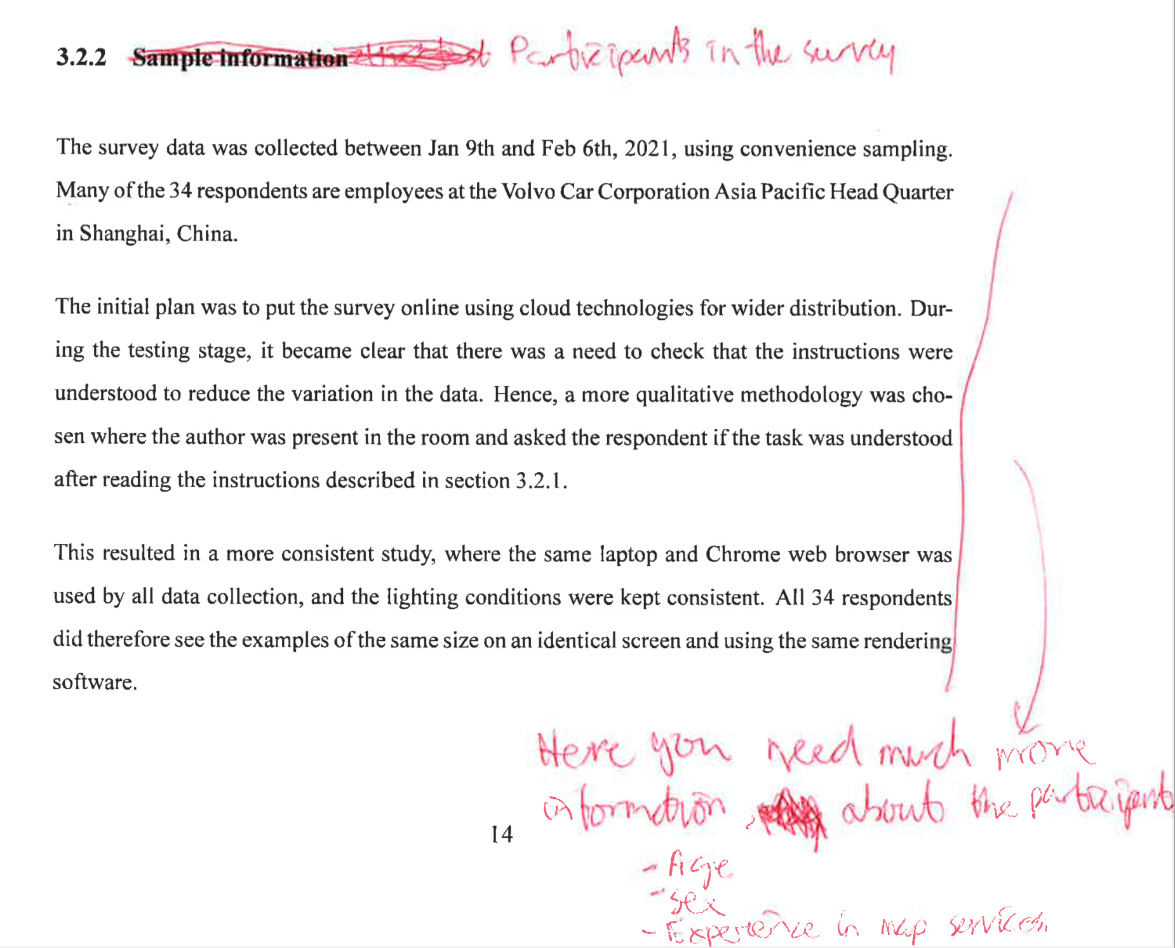

Comment:

Introduction discussing user studies as choice as requested (likely updated slightly for final submission):

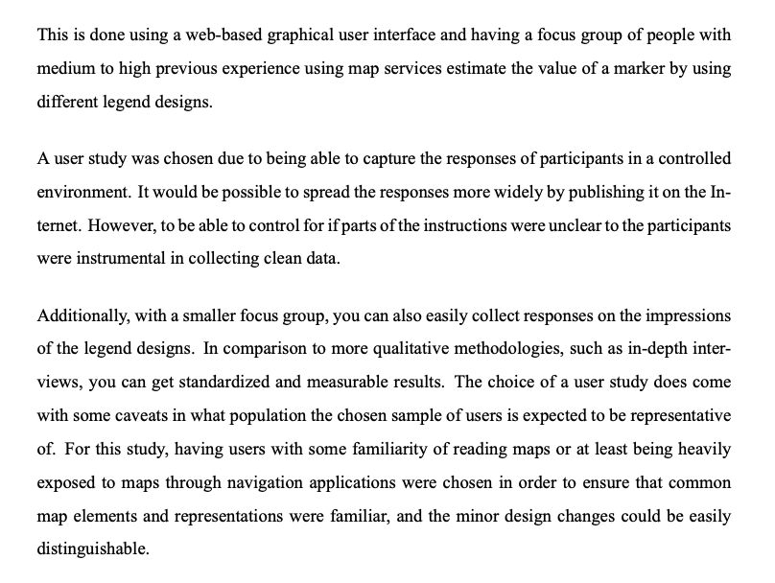

Methods section (Helena’s comments and screenshot above) updated. First version (likely updated slightly for final submission) can be seen below:

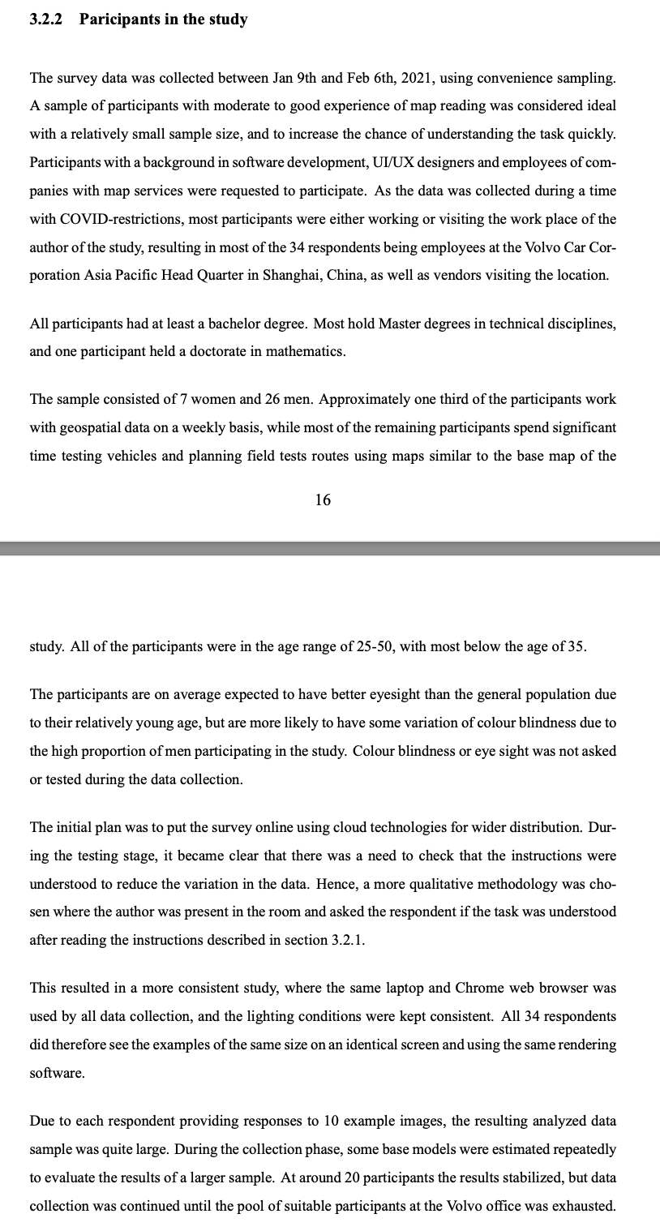

Methodology of data collection

Helena Elvén Eriksson:
- In background/methods:
  - also describe and motive/argue for the form of the questionnaire that you did. Why 10 questions? Exactly what and how did you randomise these questions! Why did you have the respondents answer the way you did (5 alternatives)? Doesn't have to be long, but a paragraph or 2 at least.
  - From oral presentation: I.e. should argue for ways to respond, why 1-5 not linear for example? Or why not just select the one they liked the best (get full data for each respondent)

Theory section extension (Colour)

Lars Harrie:
- Theory-section extended, e.g. about colour based studies (how colours are read and perceived - include some parts on e.g. colour blindness = Brewer)
  - From oral presentation: are there other alternatives:
    - Hatches (lines and colours over the map), different colours, colour ramp, why chose only one colour
    - Response: to limit question, other ones keeping transparency constant. If would have e.g. different colours and colour scale (“double encoding”) is common, but does not isolate effect for questions. (Answer: what are the advantages of only one colour)
- Check articles (and references in them)
- User study example + hatches option (see example in HARRIE, L., 2017, attached)
- Bring in Brewer again?
- Stefan Seipel, et al. Visualization of 3D Property Data and Assessment of the Impact of Rendering Attributes (check references)

Helena Elvén Eriksson:
- A last thought: During the presentation, you told us that you tested if the different colours had any effect on the accuracy, and it didn't, so you didn't present anything about this in your study. However, a "no correlation" is also an important result. If possible, I would suggest you to implement the outcome of your results in your study, especially since Lars suggests you to provide more background material on this issue.

From oral presentation:
- How background colours work together
  - Transparency effect on top of other colours
  - 3D cartography (miscategorization due to overlay of colours [])
  - Response: did try different colours to remove such effects, BUT checked results if any correlation

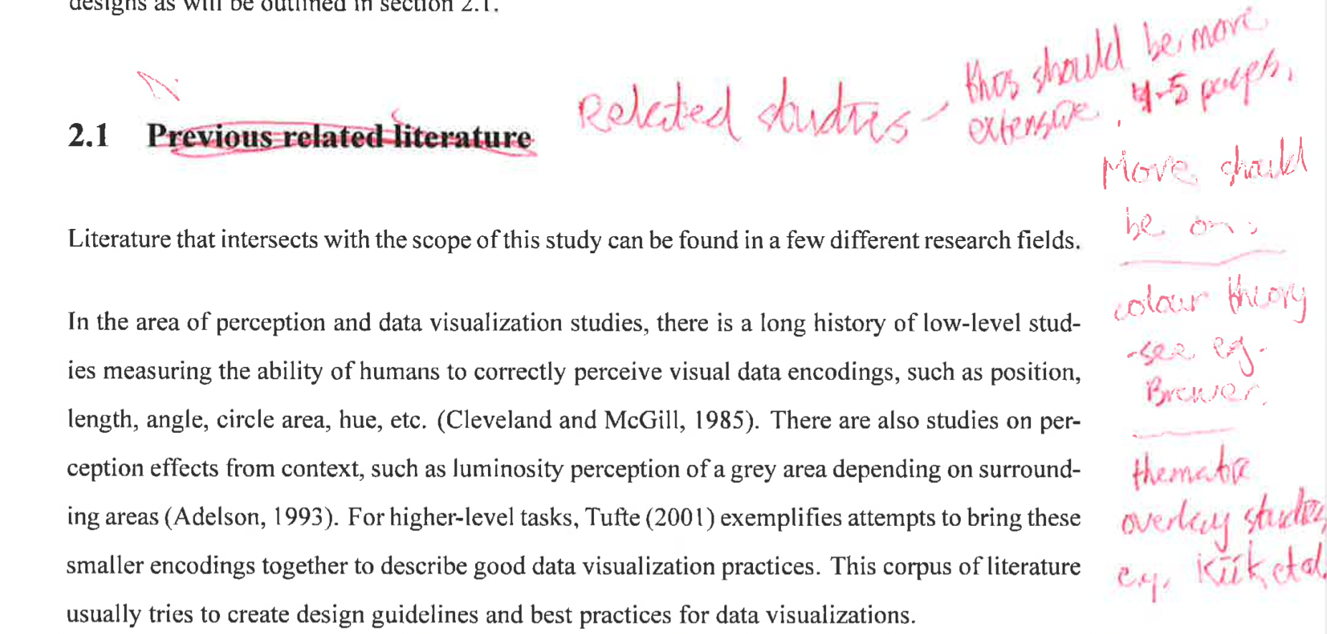
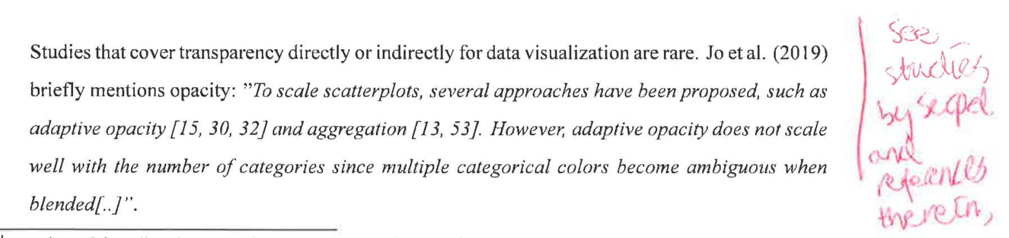

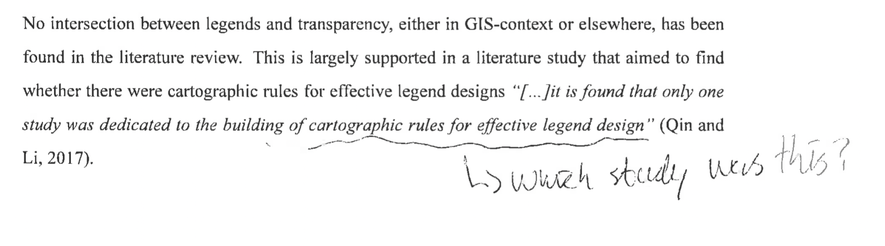

Methodology (Data analysis)

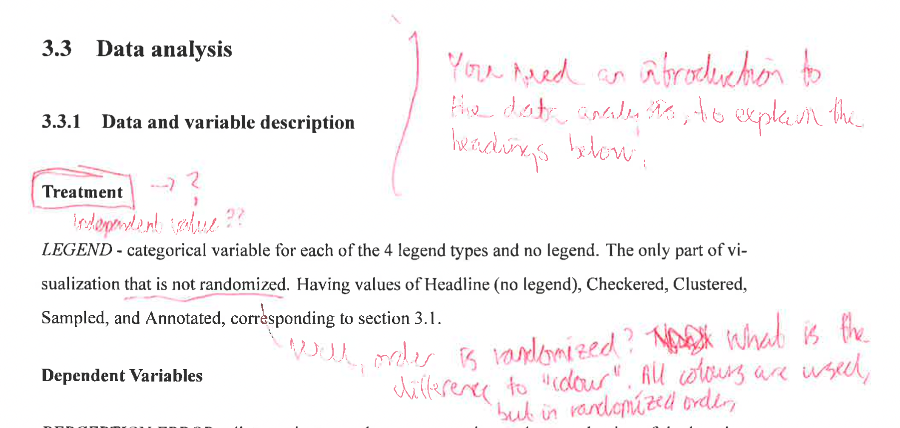
Comment:
LEGEND moved to independent variables and made clear that it is the main treatment.
Colour randomized through the sequence selection section moved from footnotes moved from footnotes. Starting colour is randomized for each respondent – so statement should still hold true.

Introduction of the subheadings is introduced (likely to not match the screenshot below after review before submission).

Result:

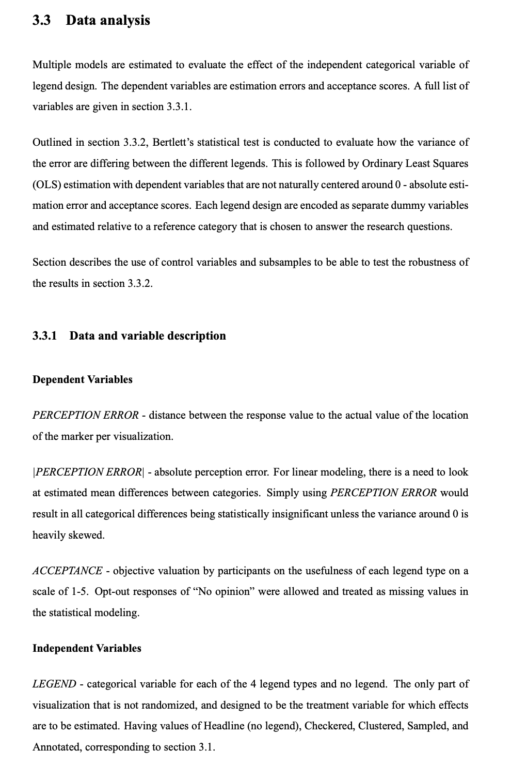

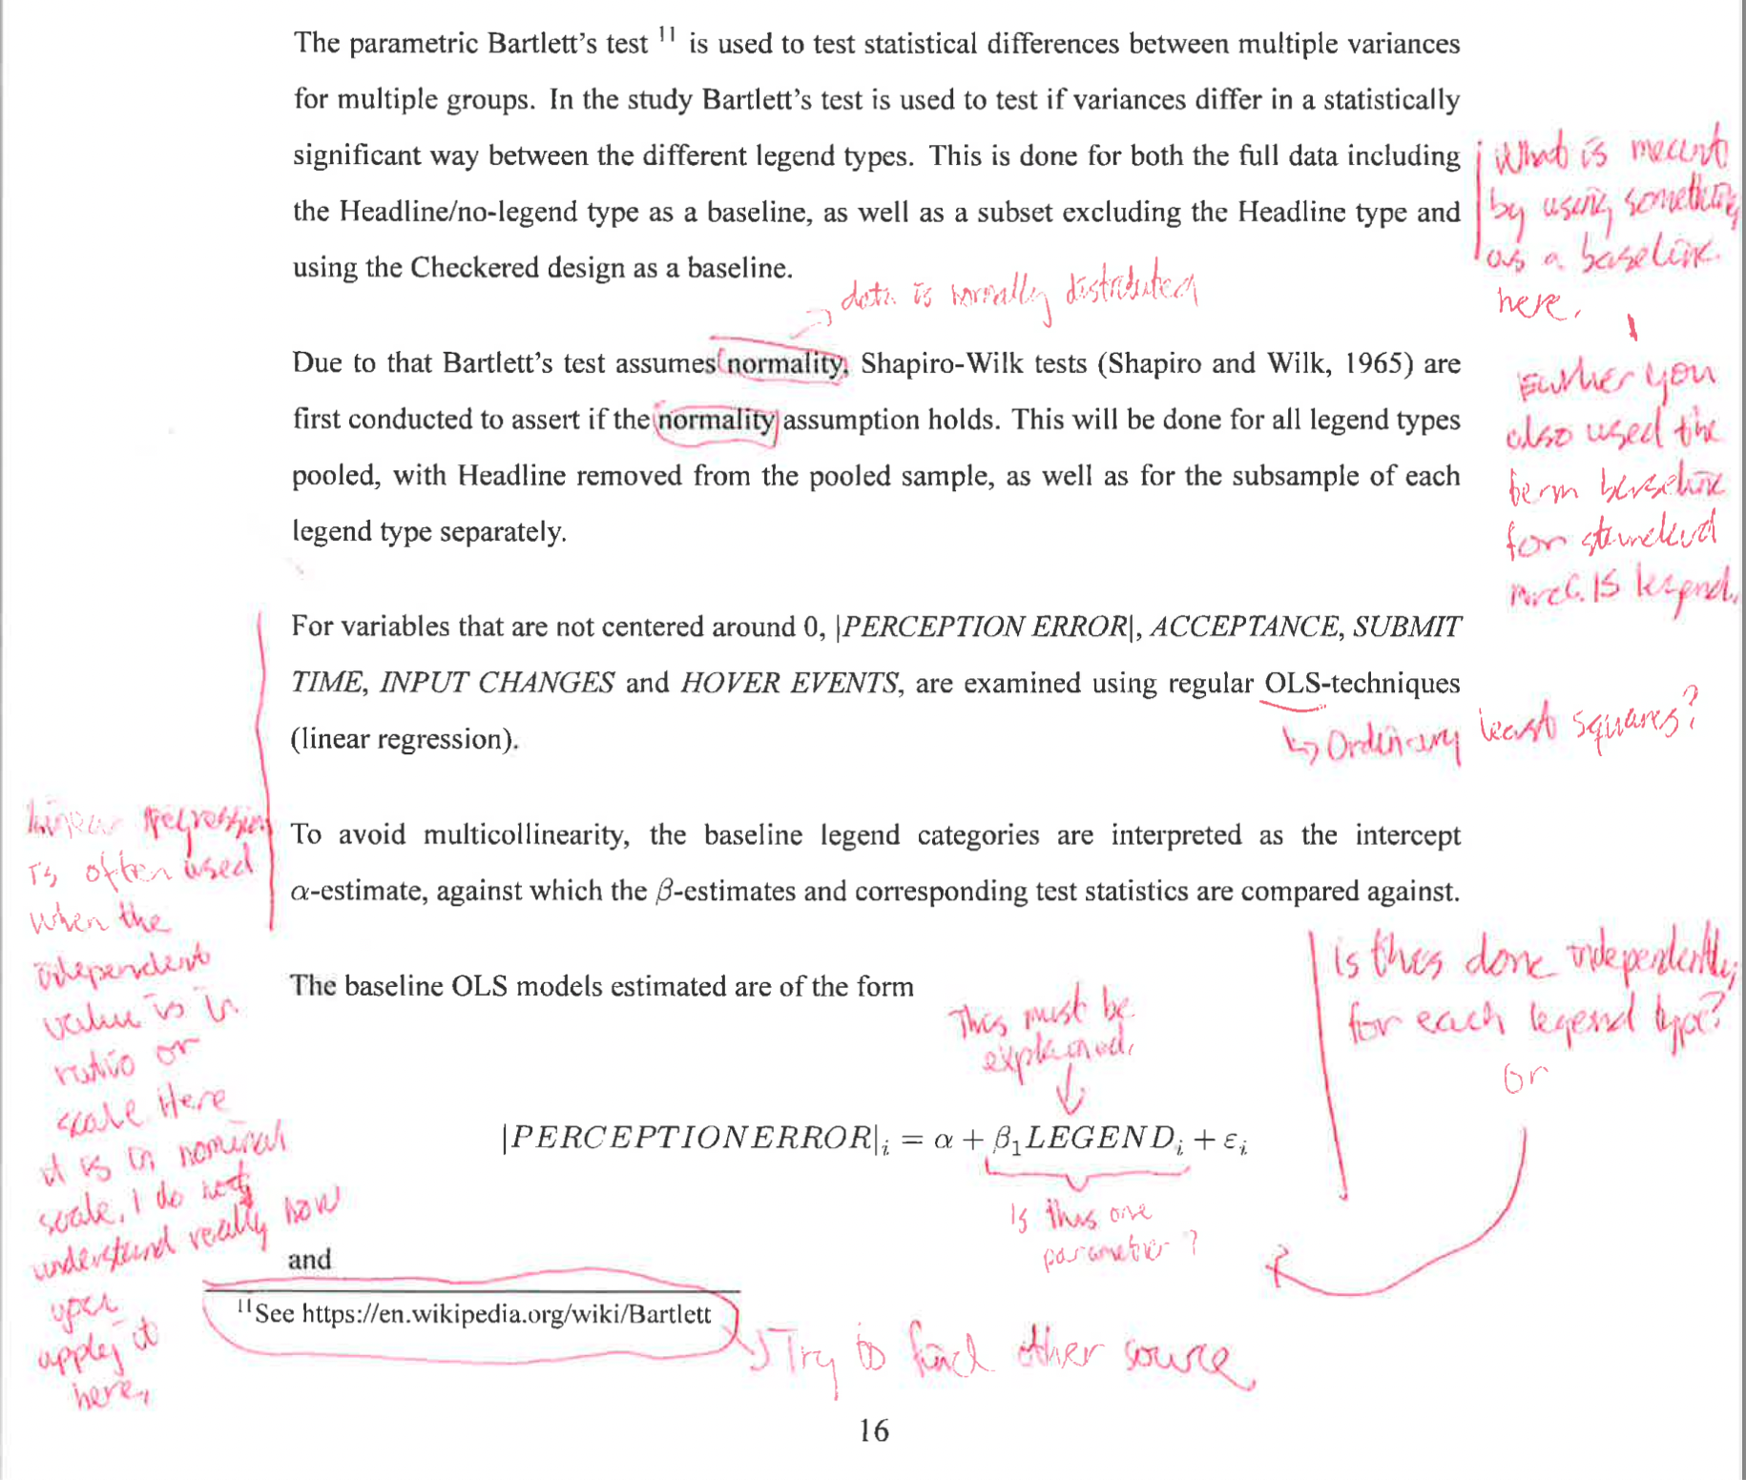
Comment:
- Earlier error of subset (1) for Beta corrected => subset (i) corrected throughout to show how there are separate dummy variables estimated for each categorical category.
- Removed reference to reference categories, as it is not a correct description – you can not set a certain reference categories for the test – only if variance of any category are different from the others.
- “Data is normally distributed” formulation used
- OLS included in acronym list and written out at first usage.
- One sentence introduced to explain that the legend categories can be interpreted as separate dummy variables, so that it is clear that the models are not run separately for each legend type.
- Not able to find the source book to check content, most resources refers to a statistics textbook from 1983 instead of the original papers – no update.

Result:

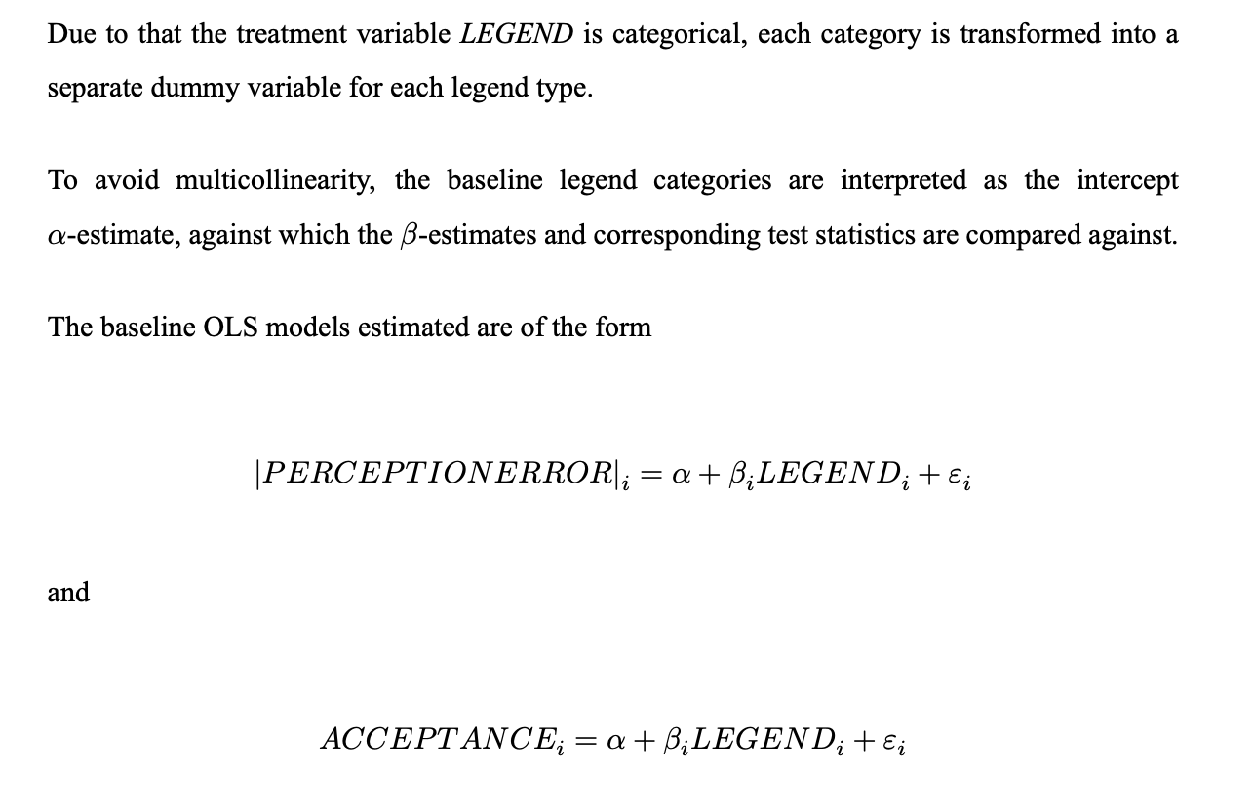

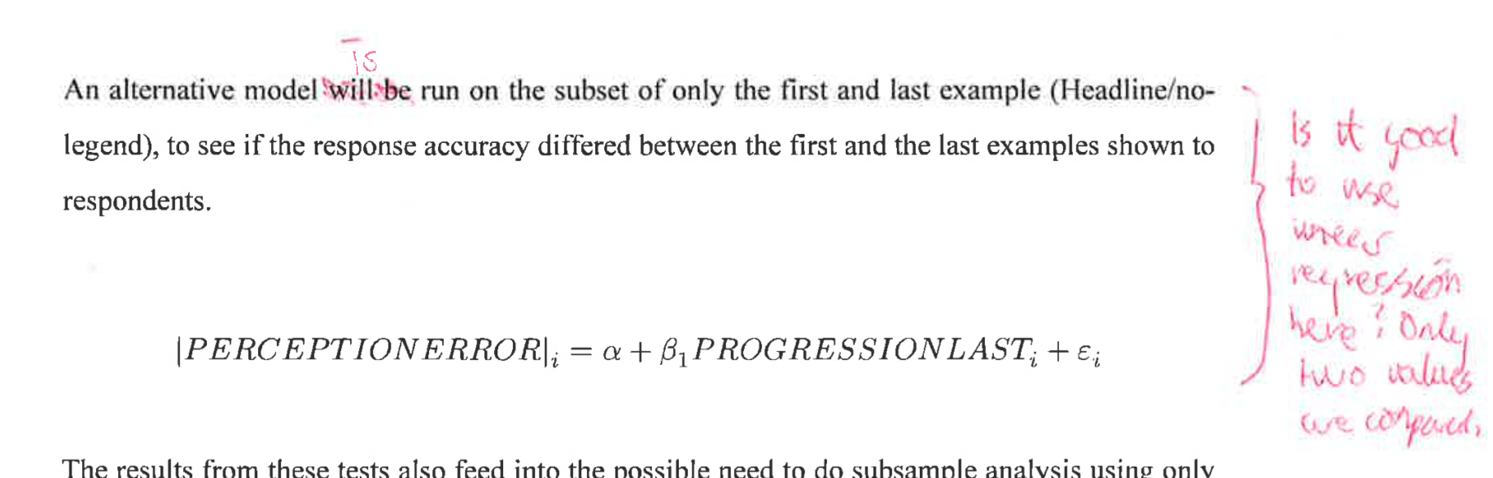
Comment:
will be => is
Made clearer that PROGRESSIONLAST is a dummy variable.

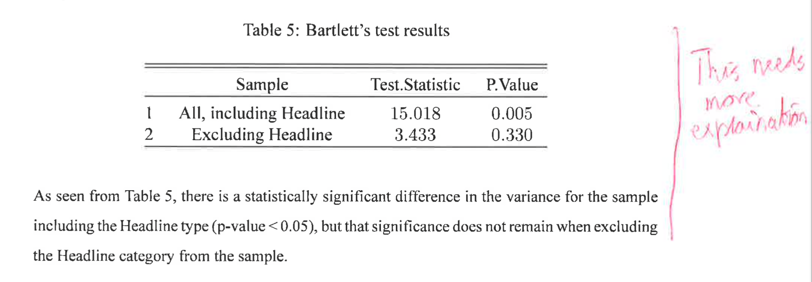
Comment:
Introduced some interpretation to the results.

Comment:
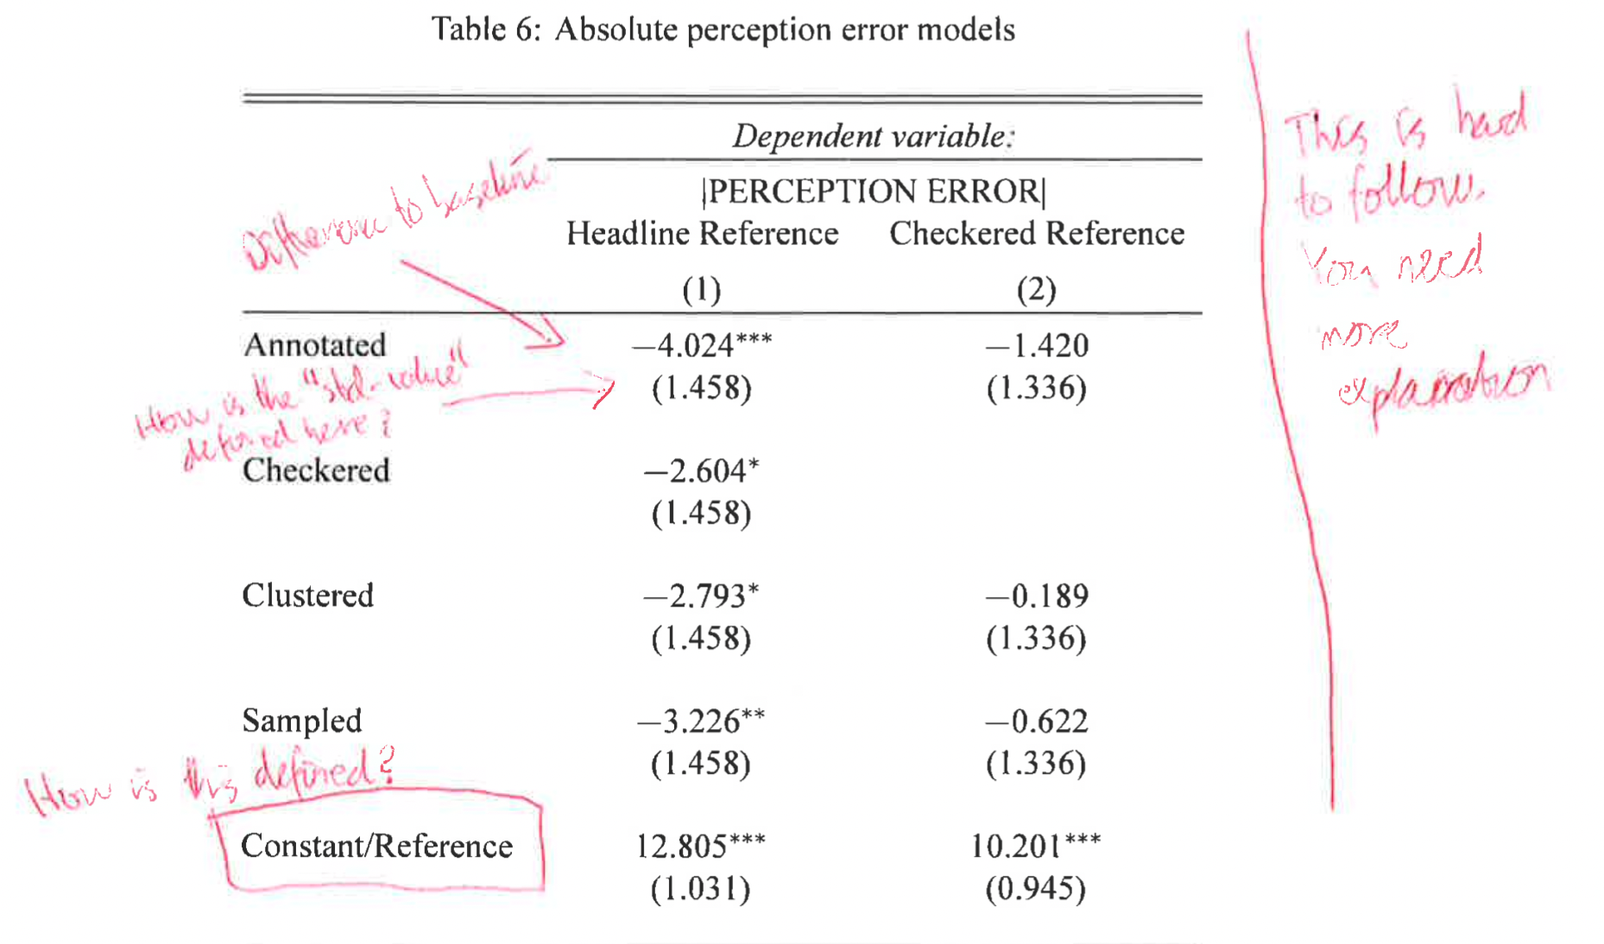
Everything, except standard errors is explained (standard errors are used to calculate the
statistical significance, not different to any other OLS-model (https://stats.stackexchange.com/questions/234727/standard-errors-of-regression-coefficients-in-a-dummy-variable-regression-model). So the information is included in the significance indicators (stars*). The standard error calculation likely to have been uncertain due to earlier unclarity of the model definition.
Result:

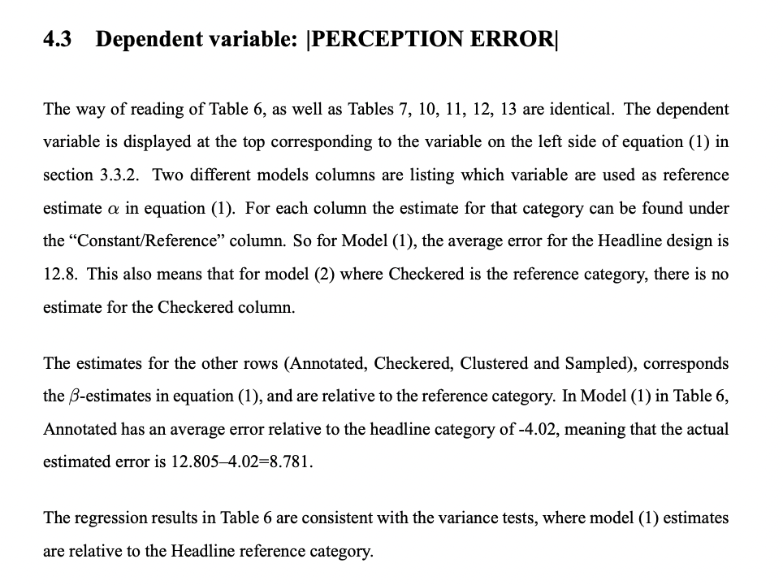

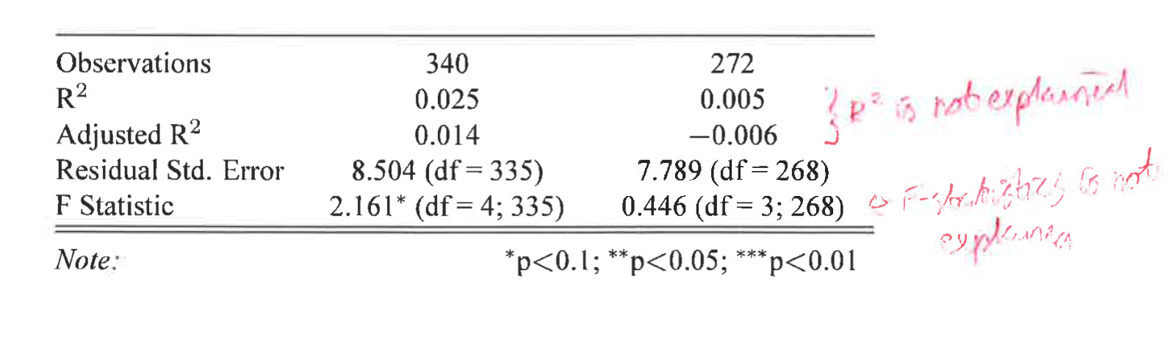

Comment:
These were default output using a R-model → Latex table package.
R² commonly over-interpreted, and not very useful when dealing with dummy variables.
F statistic describes if the model over all has any significance.
These are just clutter in the discussion. Cleaning up by finding the setting to remove the overall model statistics as seen below:

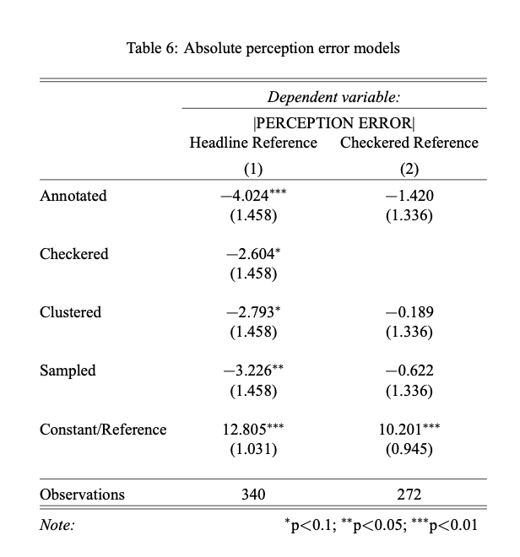

Discussion/Conclusions



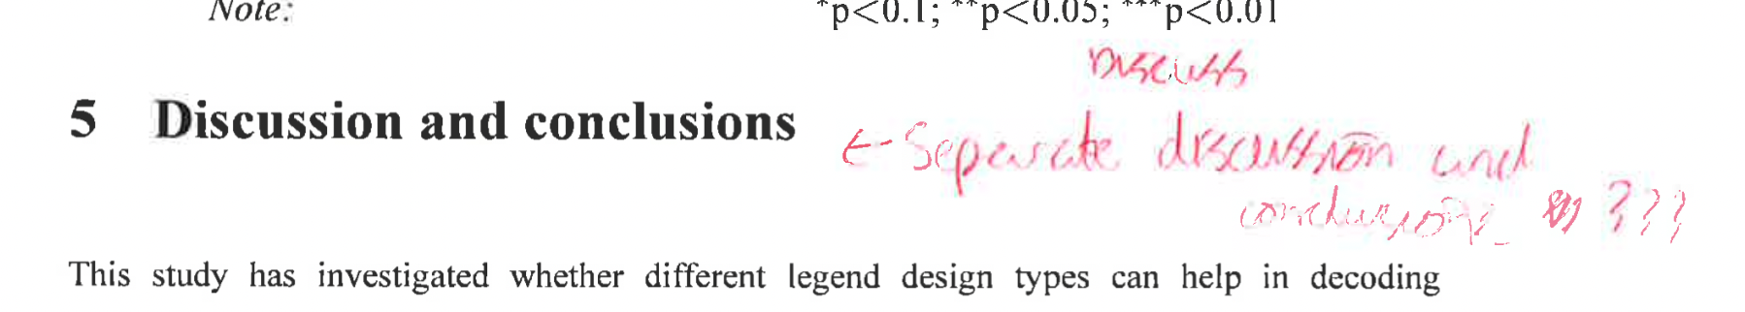

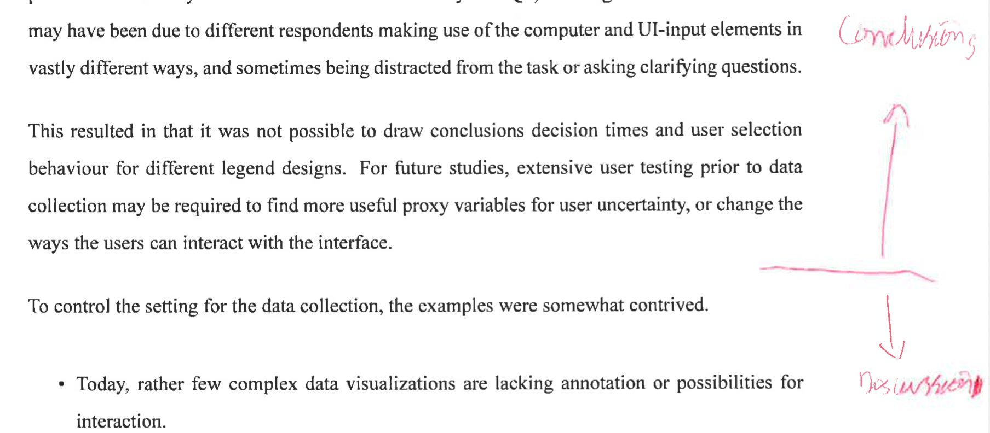

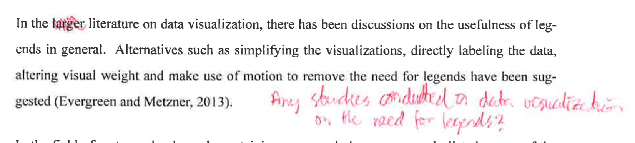

Helena Elvén Eriksson:
- Insert a separate chapter for the discussion and a separate for the conclusions. The conclusions could be ½ to 1 page and preferably in 1 paragraph. Here you only claim how each of the RQ were solved (if they were solved).
- Discussion:
  - Skip the first paragraph. Never repeat what you did or the the intention with the study in the discussion. This is a very very common mistake.
  - Some part of the discussion would be better suited in the Methodology section, such as the settings/considerations that you did (the bulleted list).
  - Make sure that you "take care" of aspects that you introduce/describe in the background and methods sections. Compare your method/results to studies/theories that you describe in the first par of your study (anything before the Results chapter).
  - Future perspective:
    - suggest improvements and/or developments. For instance my suggestion to link accuracy (RQ2) with performance (RQ3). Did the respondents that preferred a certain legend actually perform better when they were given examples where the legend that they preferred was used?
    - How could the time/hesitation perspective be taken cared of? Propose a methodology where the last RQ would have been more reliable.
  - From oral presentation: discuss problems with user studies generally

EYE TRACKING WOULD BE ABLE TO DISCOUNT...

General/MISC

Helena Elvén Eriksson:
Why not inserting an example of how the questionnaire could look for a user, both the intro, and each of the questions.
Comment:
I believe these figures in the thesis already covers this. It does not cover each part of the intro, but it is basically first intro:

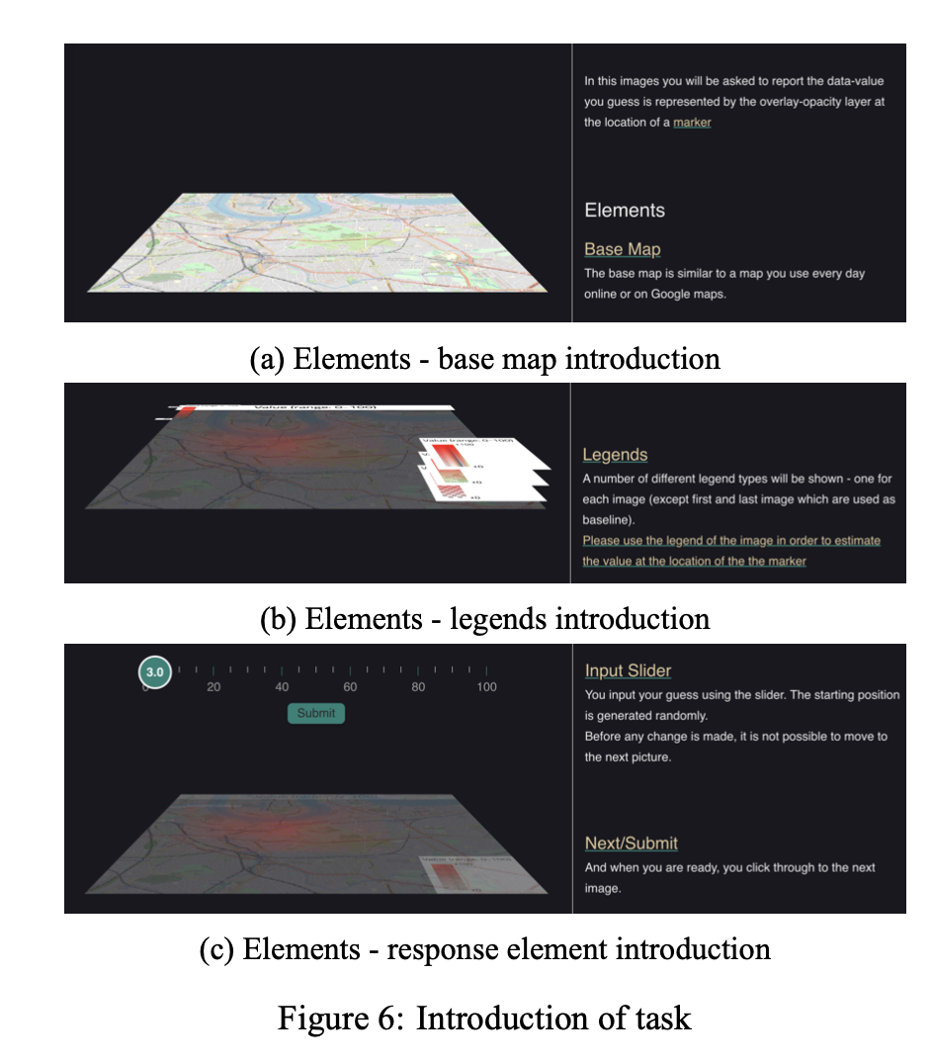

Followed by this view 10 times, with different examples:

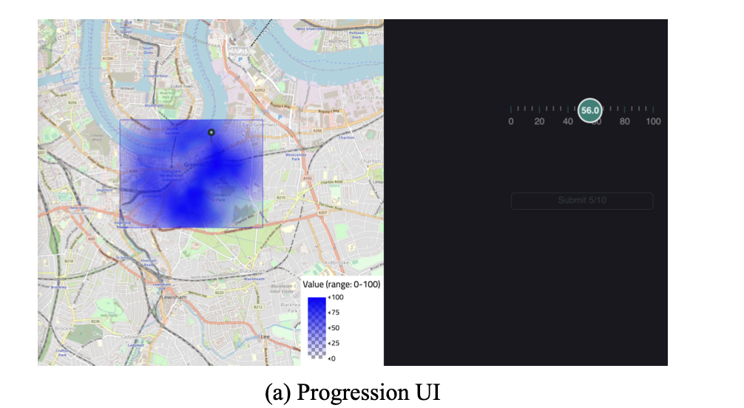

Ending with acceptance questions:

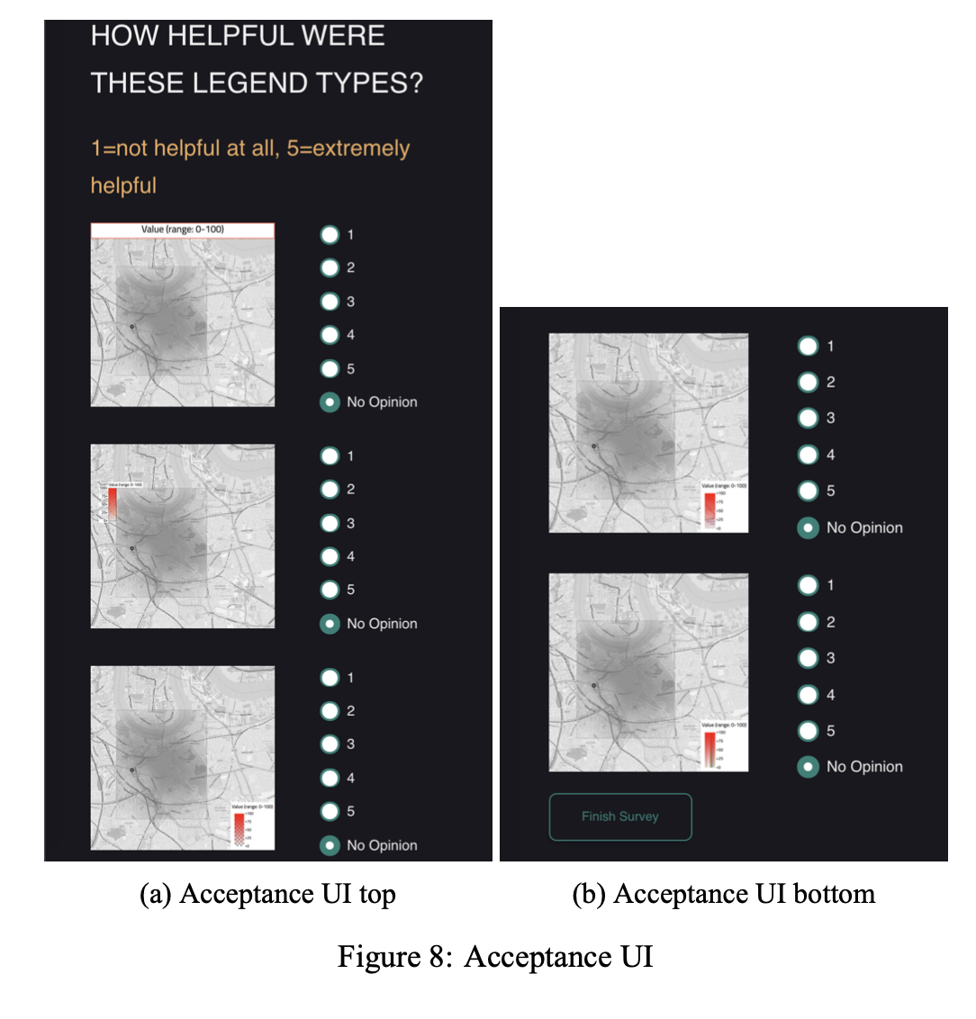

From oral presentation:
- Discussion on familiarity or novelty: people tend to prefer what they are used to see
- Talk about classified instead of continuous legends as design
- Did respondents that preferred certain legends perform better for those?
  - Response: The preferred categories were so consistently high, that it is not easy to isolate this as a variable (would only have 1 or 2 people in the group that doesn’t liked certain legend types)

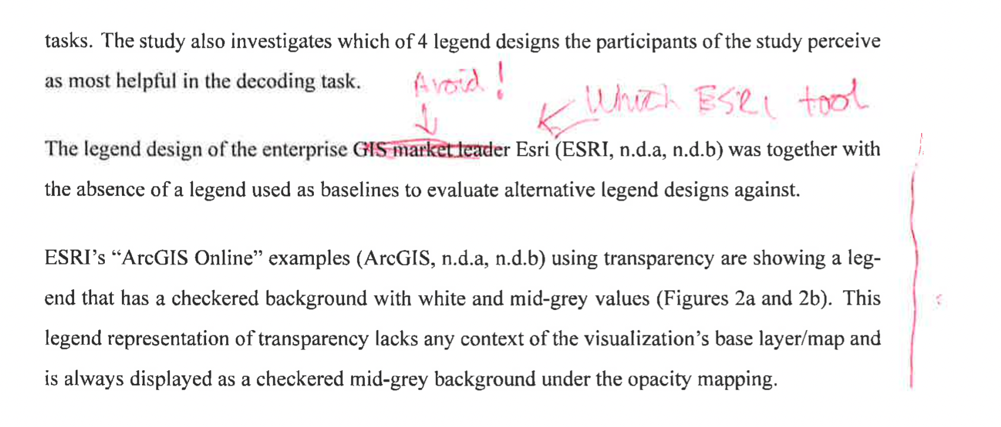
Minor clarifications/work arounds to remove unclarities – RESOLVED
Comment: clarification below

Comment: Removed “market leader” and added the tool explicitly.

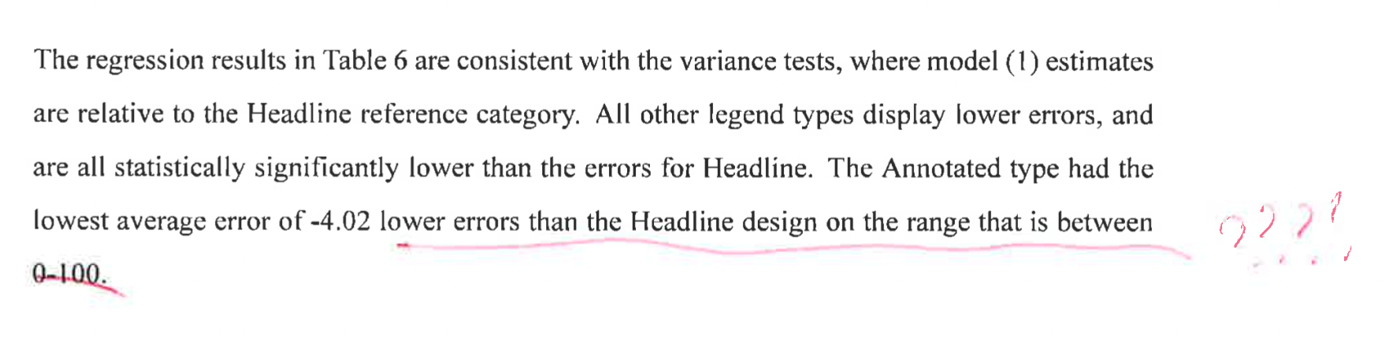
Comment: The range made this unclear, simply removed “on the range that is between 0-100”.

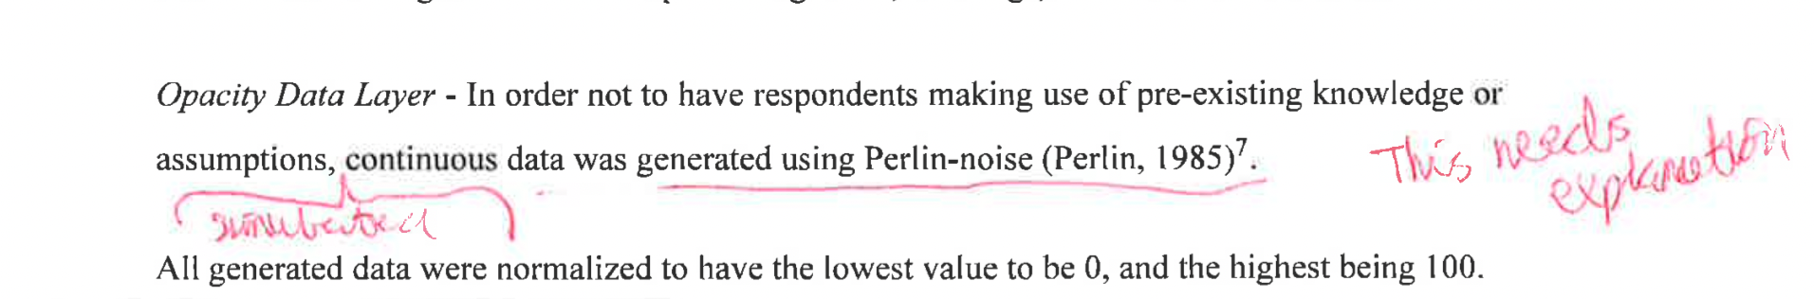
Comment: Included “simulated” and appended a short explanation of what Perlin noise is and common usages:
“The Perlin-noise family of algorithms are an alternative to other ways to generate data, such as using random noise, pure trigonometrical functions or statistical distributions. Due to the unpredictable and highly natural look of Perlin-noise it is commonly used in computer-generated imagery (e.g. in computer generated art and in video games).”

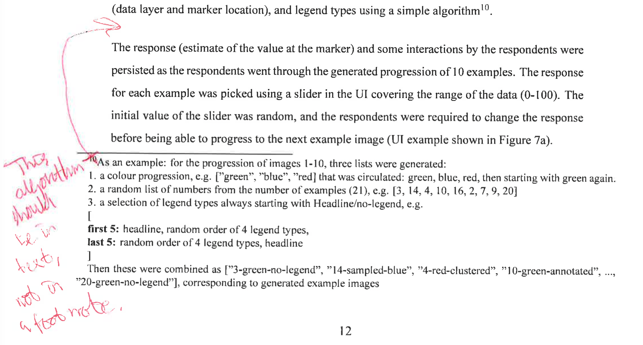
Comment: Moved it up, and included a complete example, resulting in:

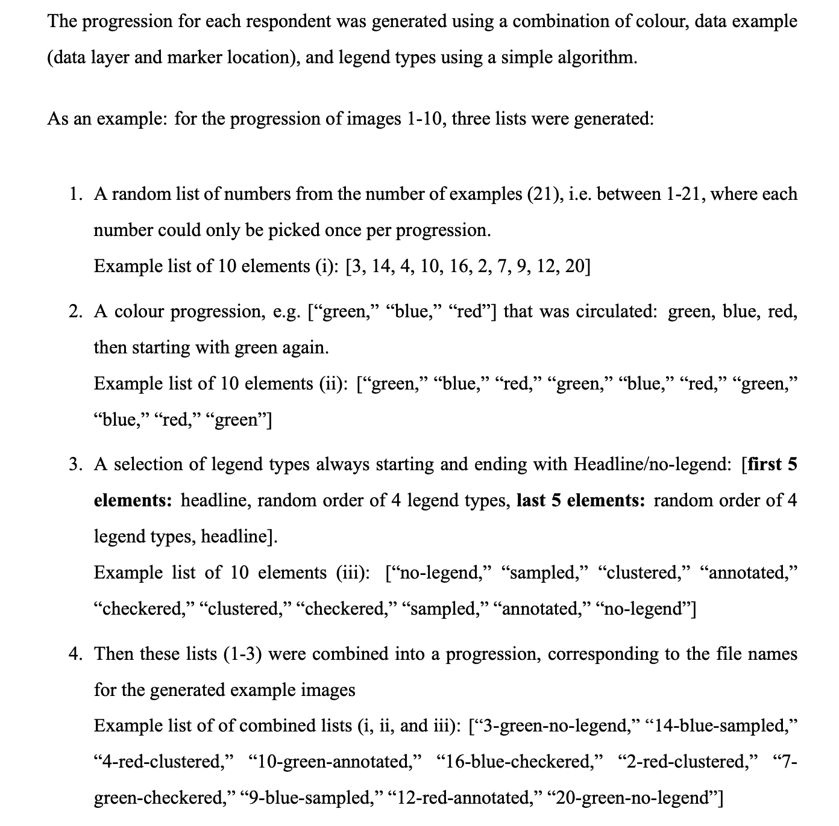

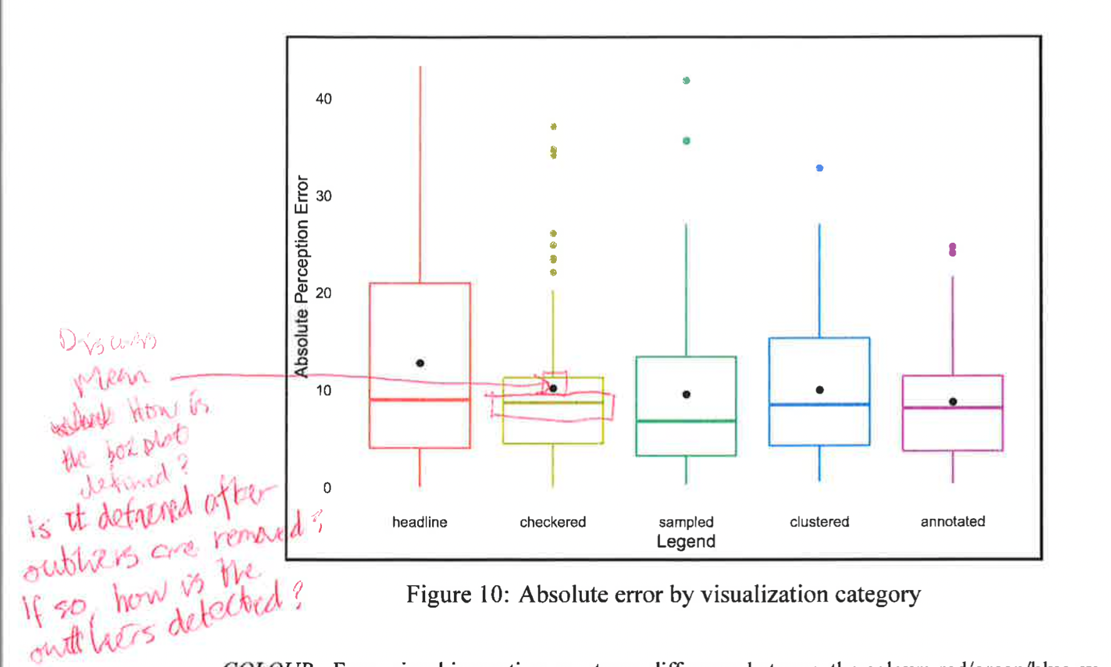

Comment: As I realize that box plots may need a lot of description (no, they are constructed using all points, not removing outliers. However, since median [line in the box], and inter-quantile ranges may not be as clear as using the violin plots throughout, I change the 2 box plots to violin plots) and alter the text:
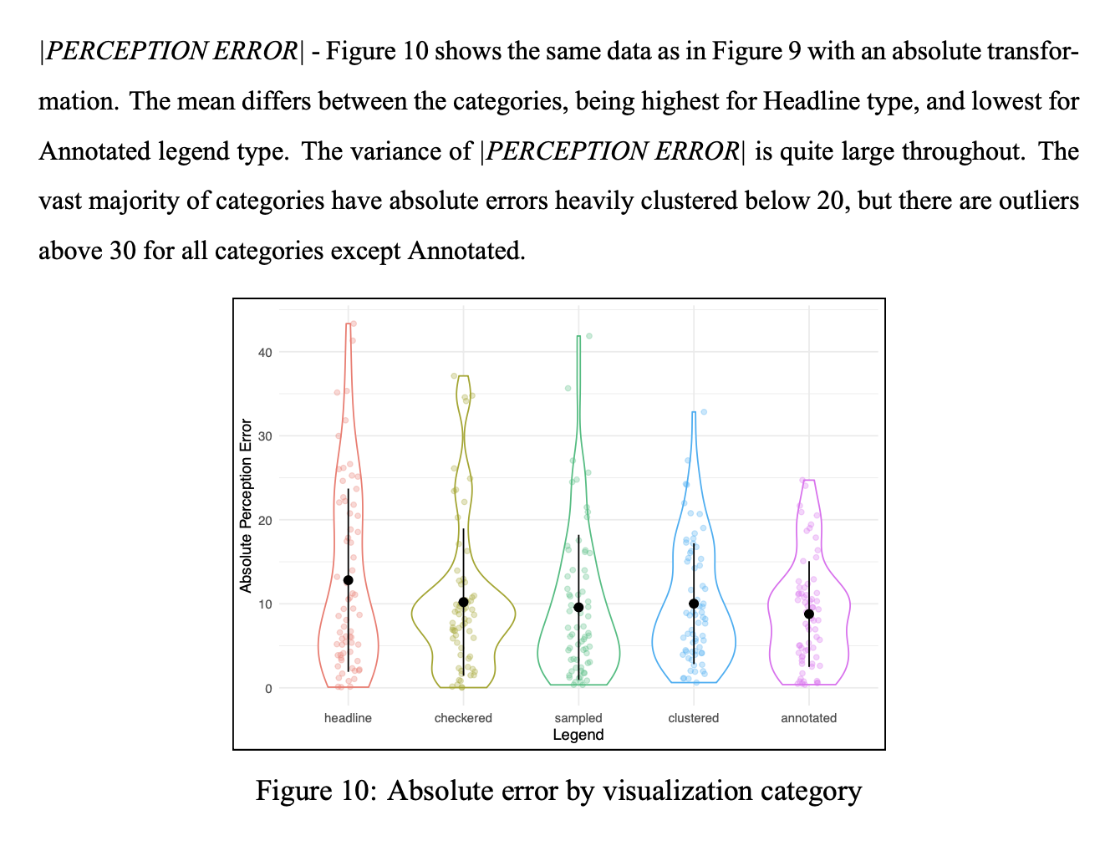

Formatting/spelling/details – RESOLVED
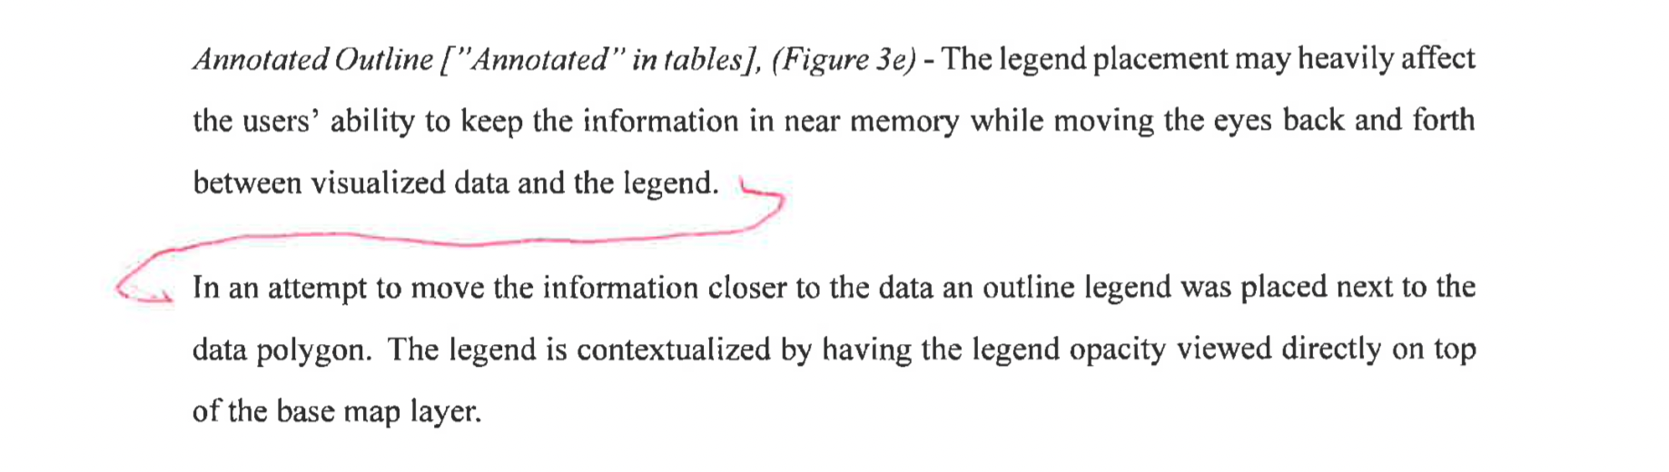
Comment: Just updating as suggested

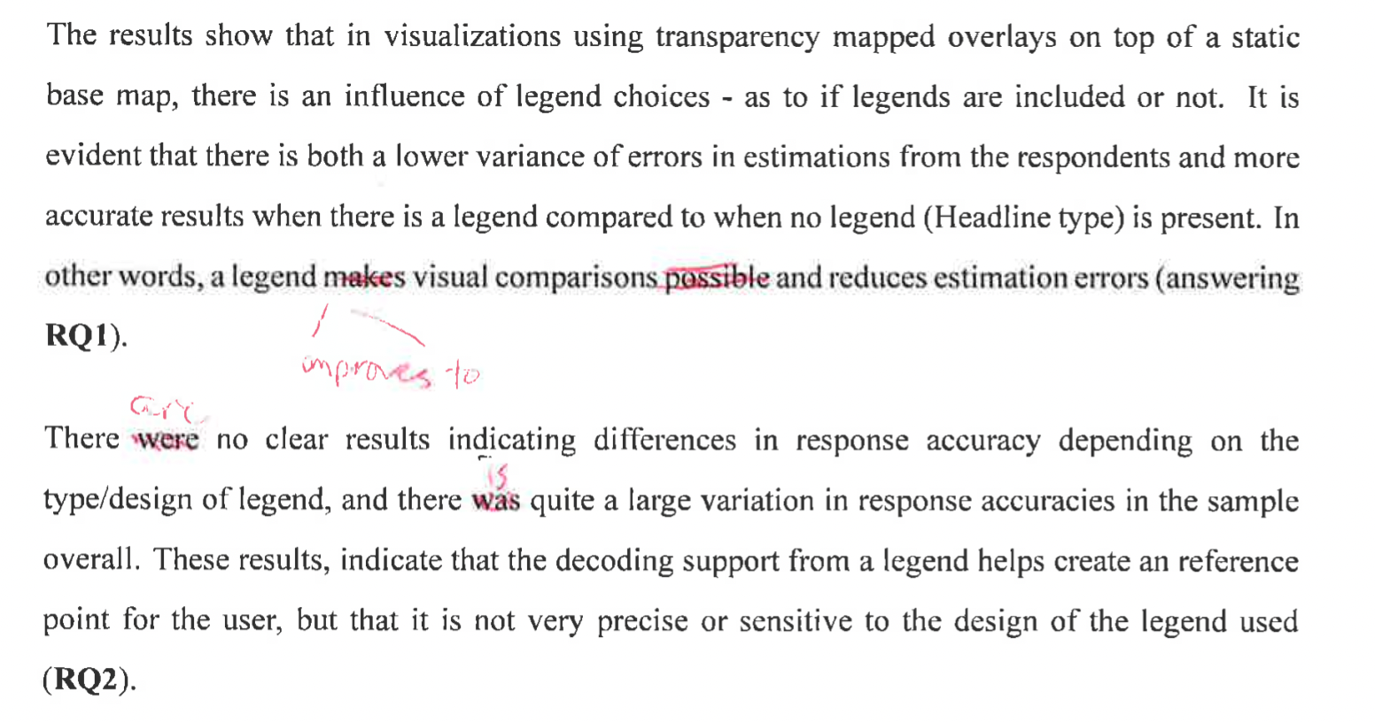

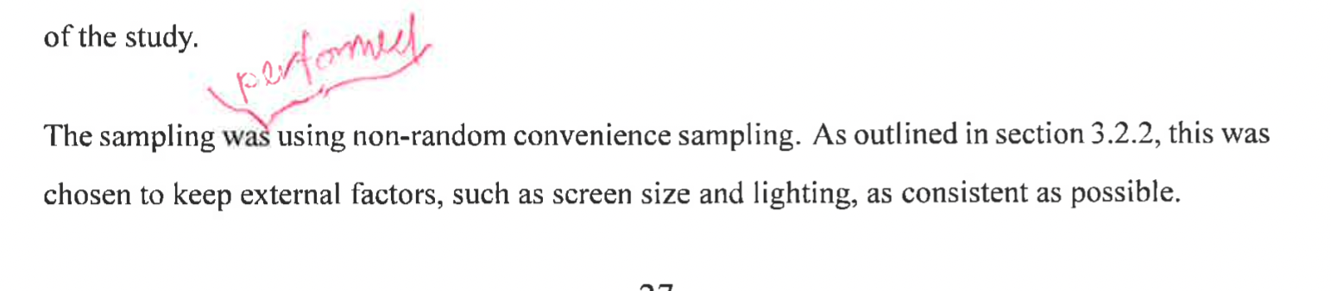
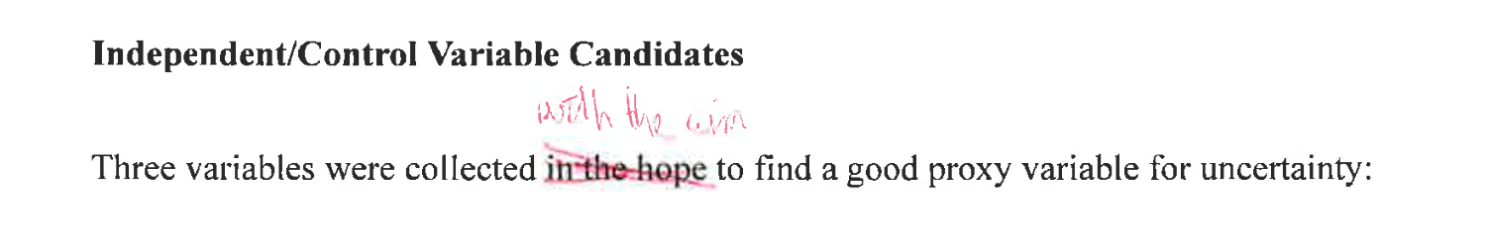
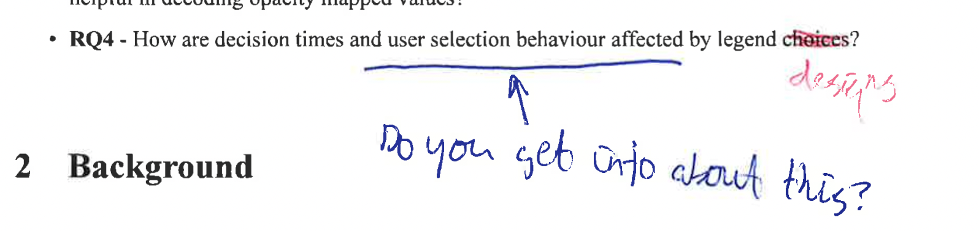
Comment: “On getting info”, no update done as clarified later in the thesis that the data was collected.

Placement – RESOLVED

Comment: Managed to solve the placement issue globally by removing floats, and needed to reduce size of some figures. Does create some space on pages where the figure and table sizes forces page breaks.

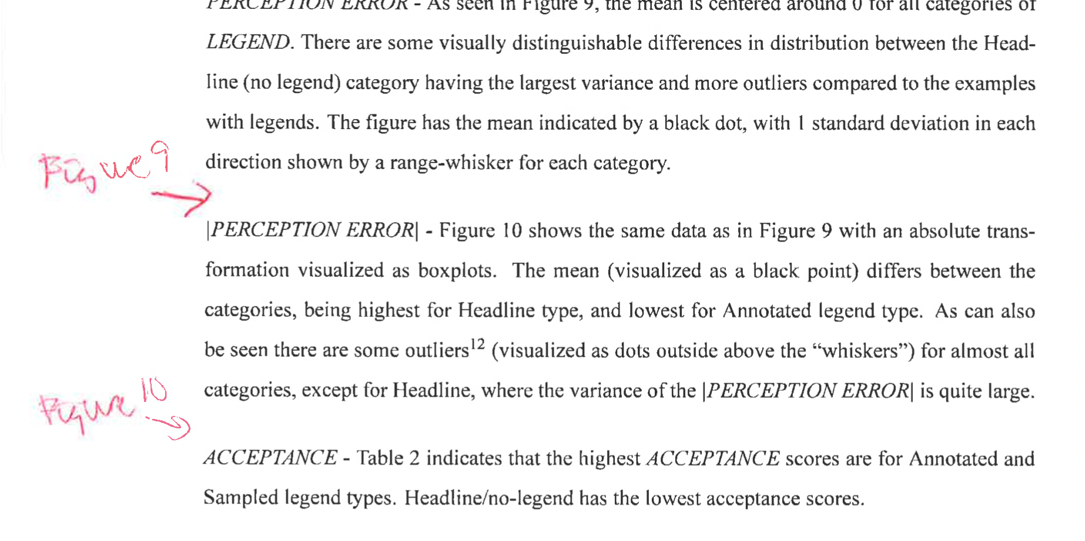

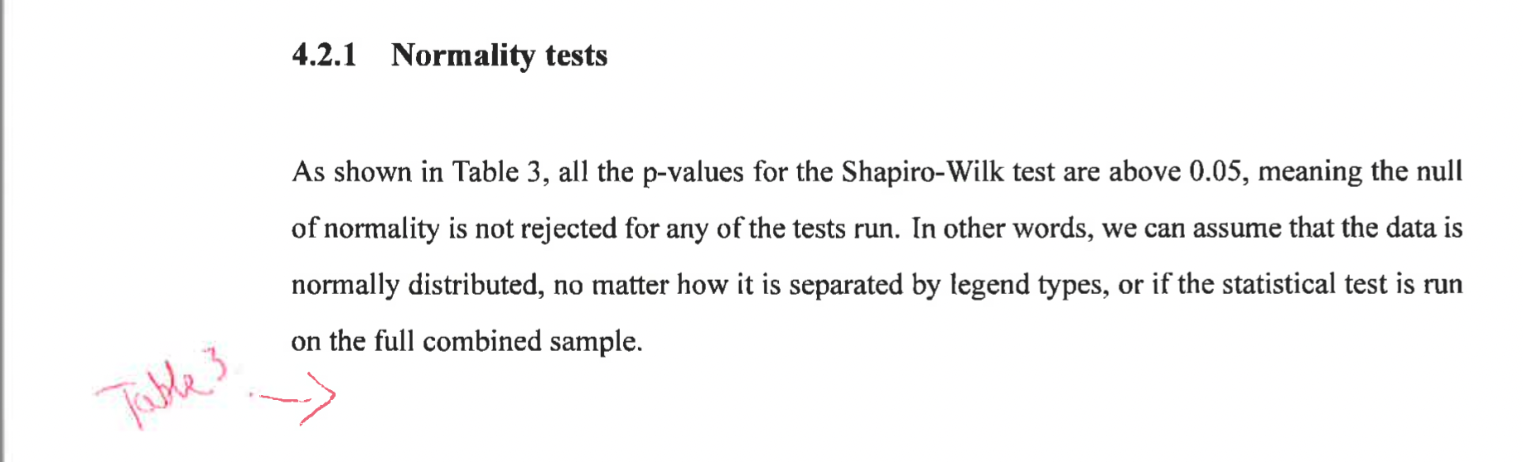
Results:

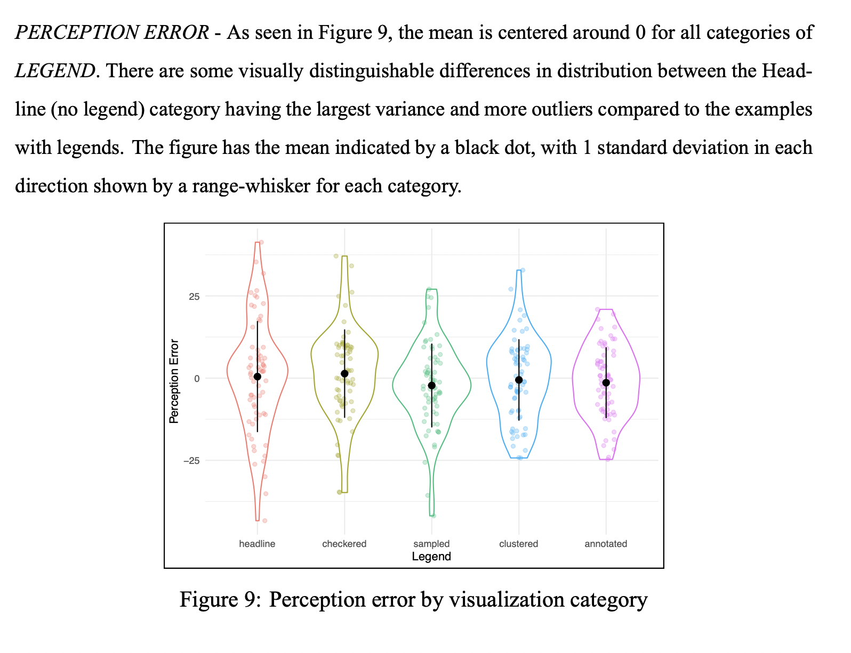

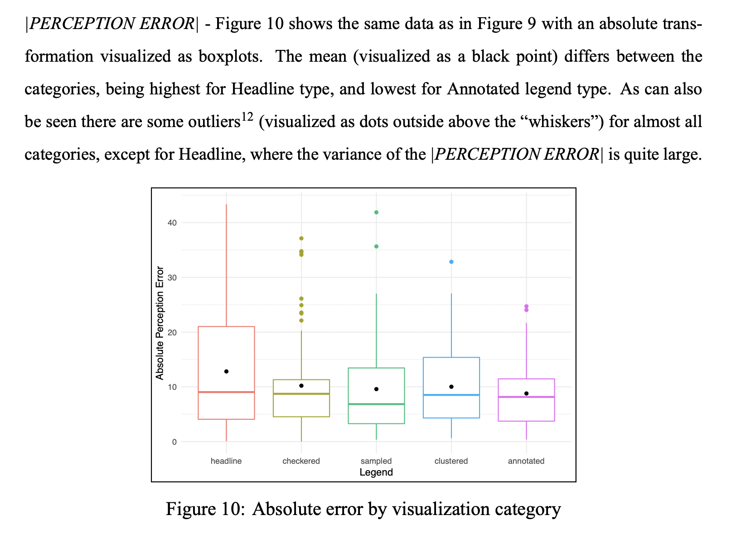

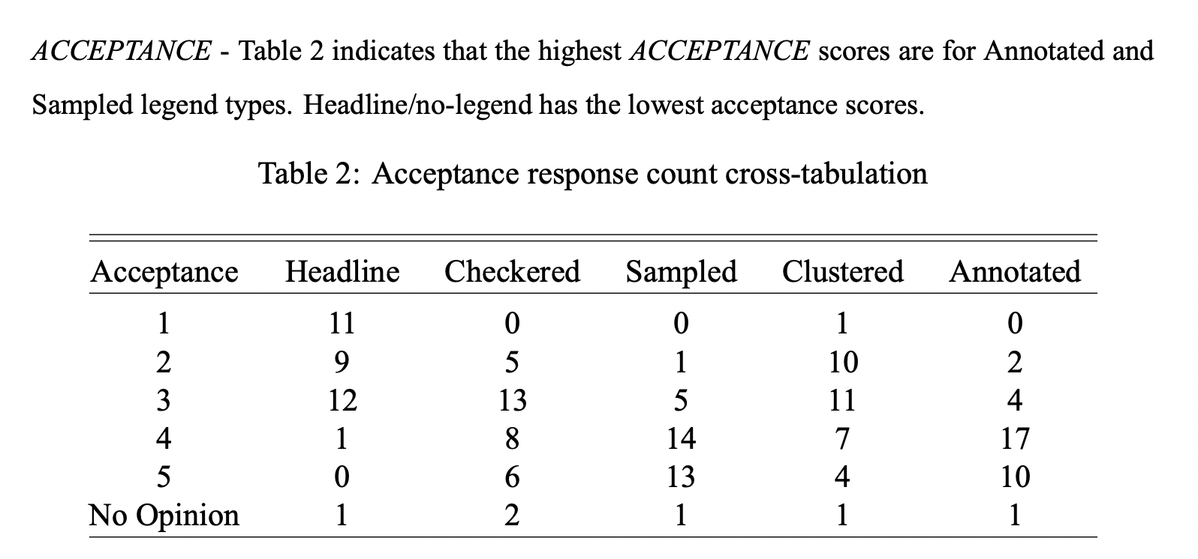

TODO: Read through before submission + spell check + check that new considerations introduced covered in conclusions/discussion

