Dealing with Comments
Jonas Tillman 880106-0255

TODO: Insert comparison GitHub link

Comments in blue

Describe test persons

Lars Harrie:
- Describe test persons (see example in HARRIE, L., 2017, attached)

Helena Elvén Eriksson:
- Present in the introduction that this is a user-study and what this means. Involve the reader on what a user-study is, how it is/could be constructed, and argue for your own way of dealing with issues connected to user studies. Relate to what you learned in Research Methodology.
- In Background/methods:
  - The users, describe them, such as if there a certain target group that this study applies to and if so, how. About the users, try to comment on how they are distributed regarding properties such as:
    - Are they randomly picked (are they supposed to represent a population), are they a focus group (seems more likely), what defines this focus group and why did you choose them?
    - Are they working with maps in their jobs? Why did you choose them?
    - Why 34 respondents? Is this a suitable size of your sampling group? How come?
    - Do the respondents share other aspects? How about age/colour blindness/sex/educational background/background in map-making/reading/other?

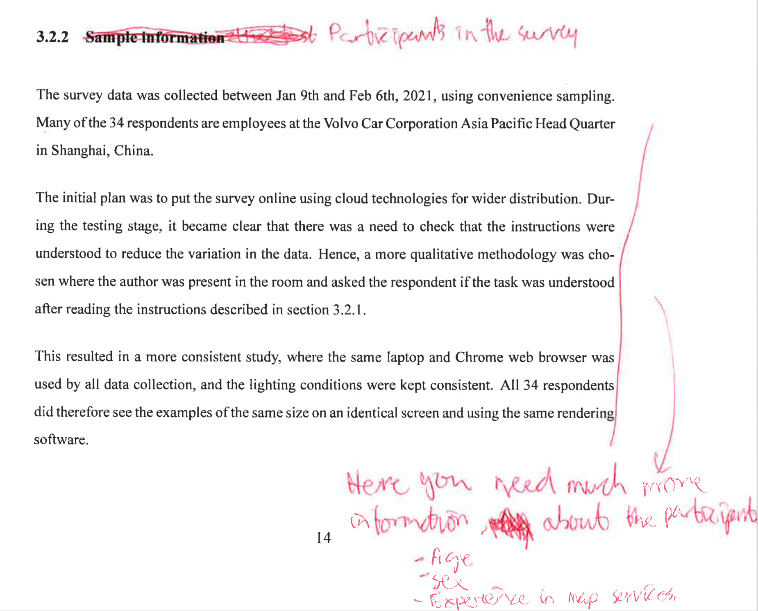
- General: why user study suitable?

Methodology of data collection

Helena Elvén Eriksson:
- In background/methods:
  - also describe and motive/argue for the form of the questionnaire that you did. Why 10 questions? Exactly what and how did you randomise these questions! Why did you have the respondents answer the way you did (5 alternatives)? Doesn't have to be long, but a paragraph or 2 at least.
  - From oral presentation: I.e. should argue for ways to respond, why 1-5 not linear for example? Or why not just select the one they liked the best (get full data for each respondent)

Lars Harrie:
- From oral presentation:
  - Very short discussion on the technical development
  - Could show architecture diagram

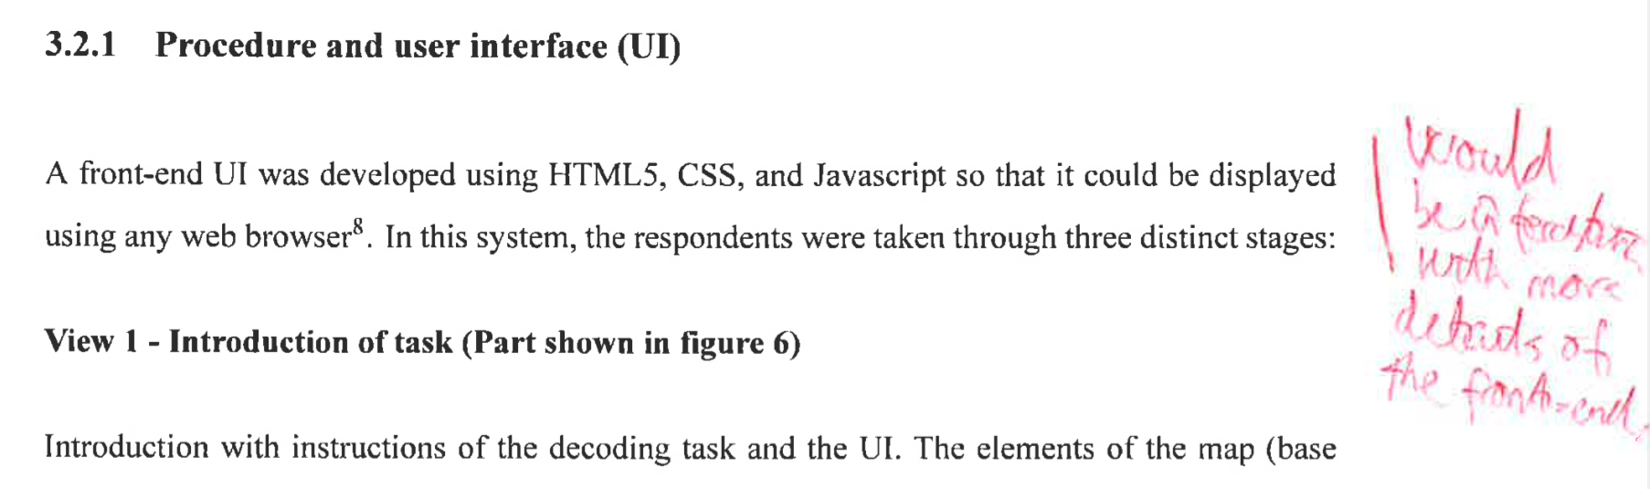

Theory section extension (Colour)

Lars Harrie:
- Theory-section extended, e.g. about colour based studies (how colours are read and perceived - include some parts on e.g. colour blindness = Brewer)
  - From oral presentation: are there other alternatives:
    - Hatches (lines and colours over the map), different colours, colour ramp, why chose only one colour
    - Response: to limit question, other ones keeping transparency constant. If would have e.g. different colours and colour scale (“double encoding”) is common, but does not isolate effect for questions. (Answer: what are the advantages of only one colour)
- Check articles (and references in them)
- User study example + hatches option (see example in HARRIE, L., 2017, attached)
- Bring in Brewer again?
- Stefan Seipel, et al. Visualization of 3D Property Data and Assessment of the Impact of Rendering Attributes (check references)

Helena Elvén Eriksson:
- A last thought: During the presentation, you told us that you tested if the different colours had any effect on the accuracy, and it didn't, so you didn't present anything about this in your study. However, a "no correlation" is also an important result. If possible, I would suggest you to implement the outcome of your results in your study, especially since Lars suggests you to provide more background material on this issue.

From oral presentation:
- How background colours work together
  - Transparency effect on top of other colours
  - 3D cartography (miscategorization due to overlay of colours [])
  - Response: did try different colours to remove such effects, BUT checked results if any correlation

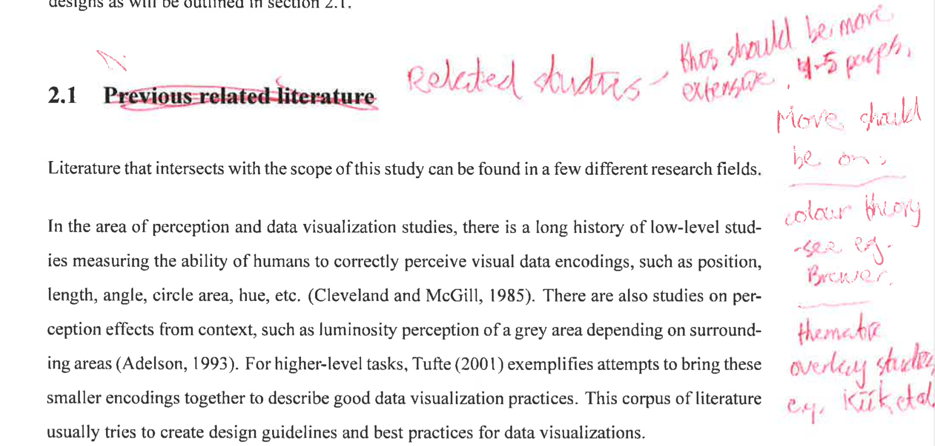

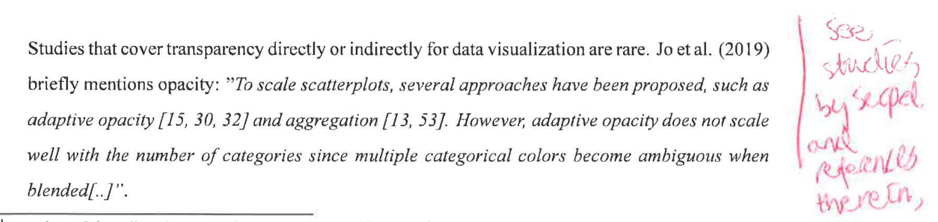

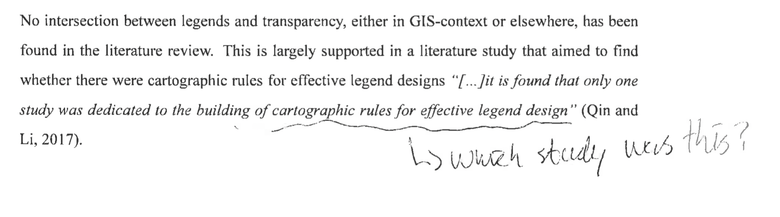

Methodology (Data analysis)
- Clarify “Linear regression” really dummy variables since categorical variable

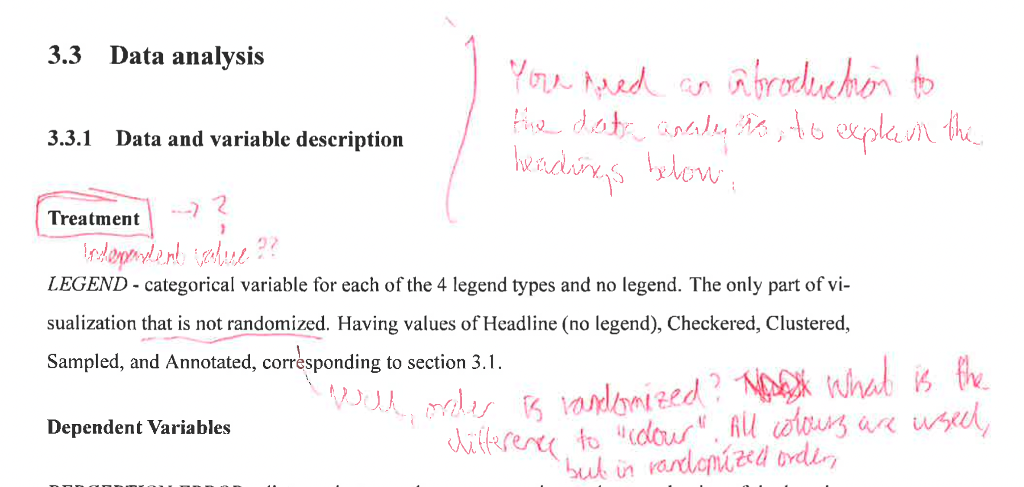

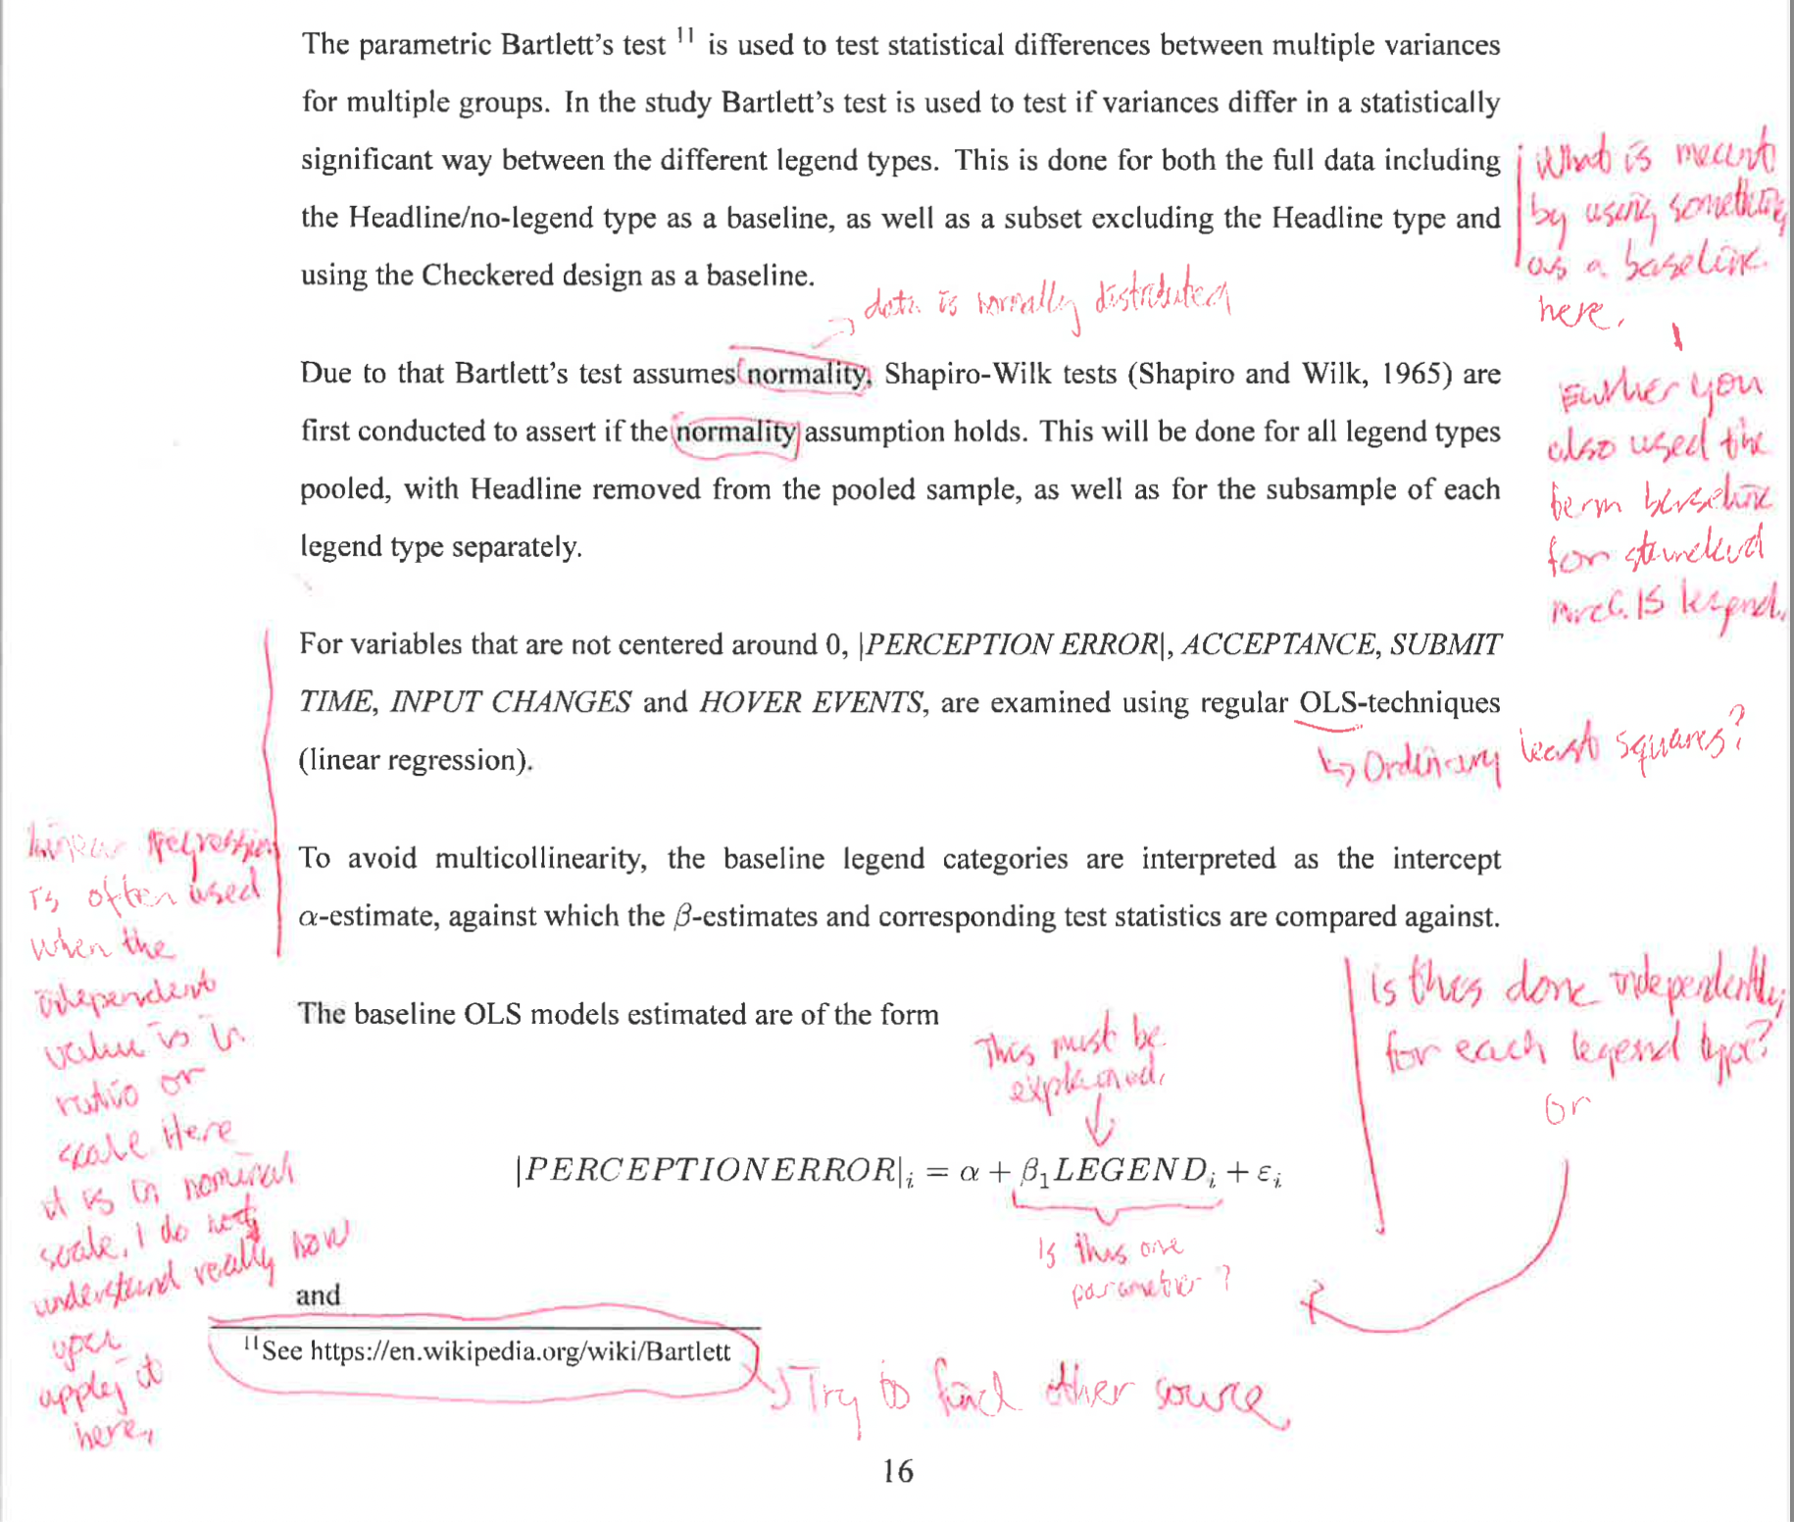

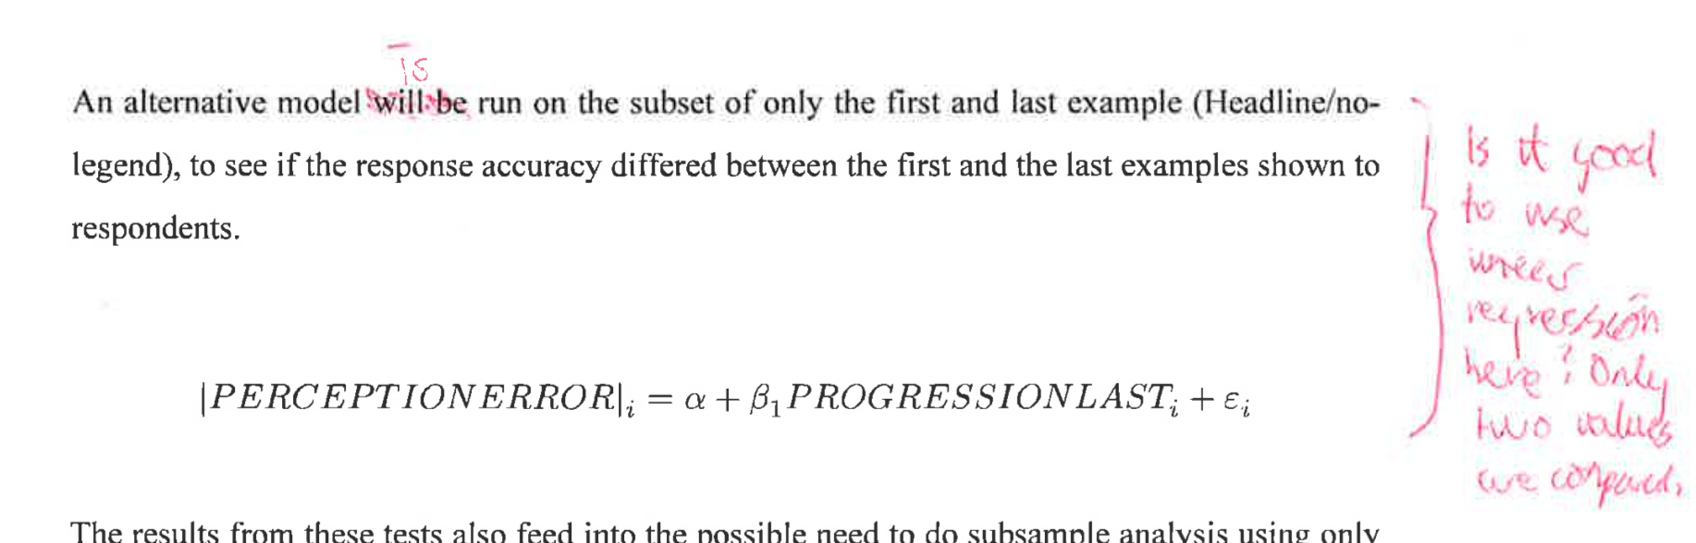

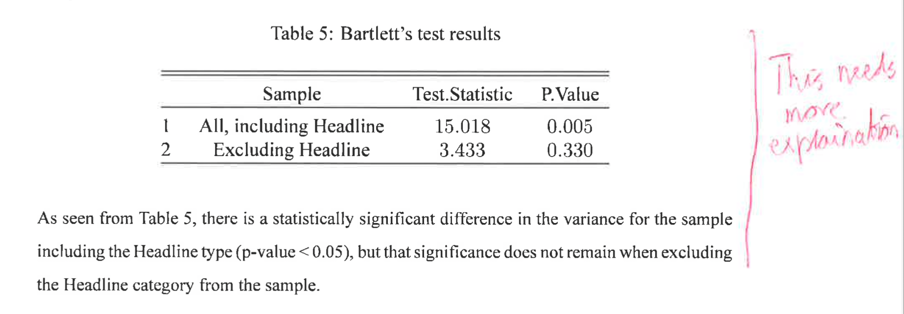
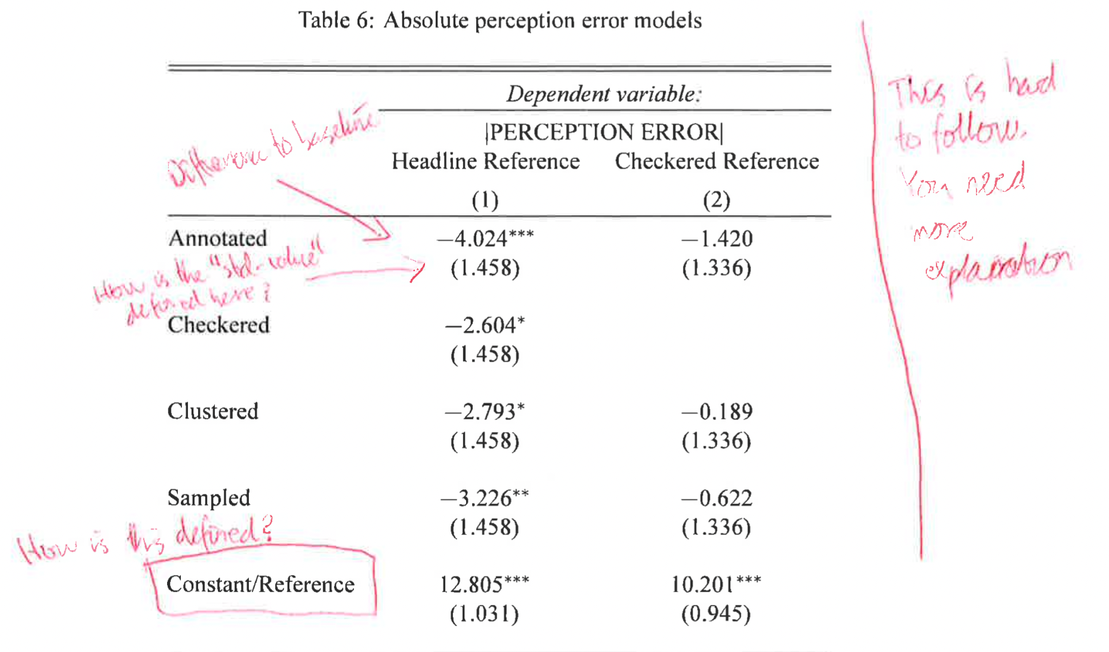

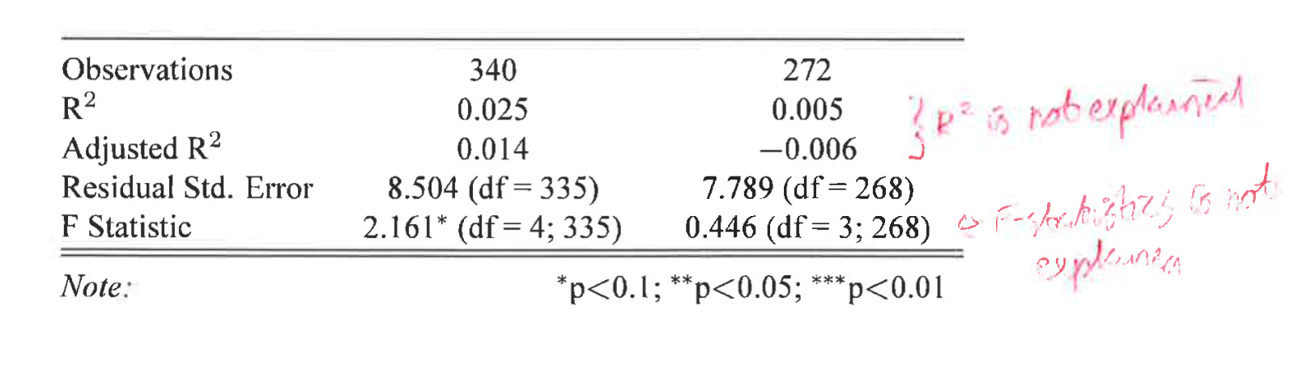

Discussion/Conclusions



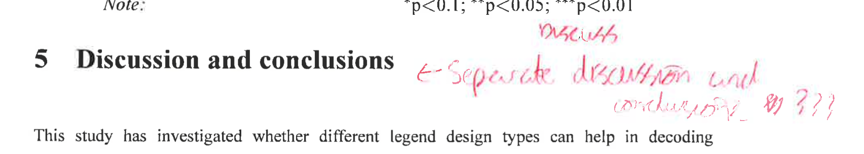

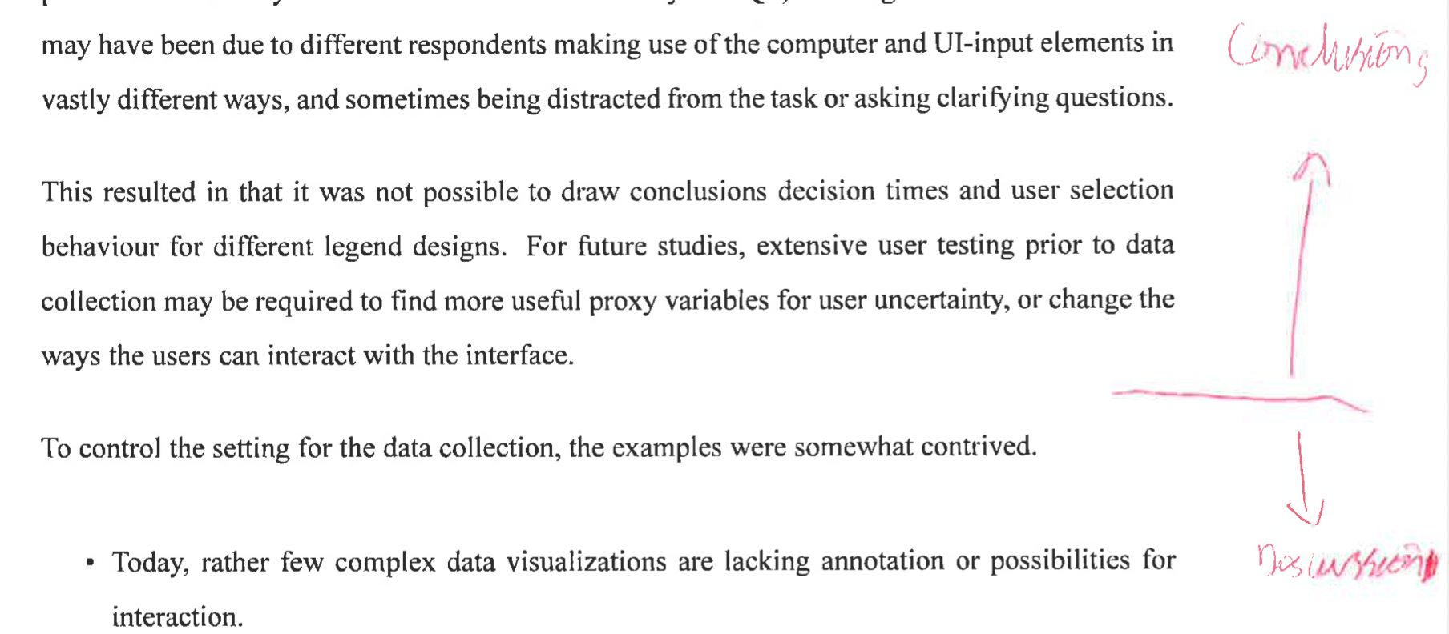

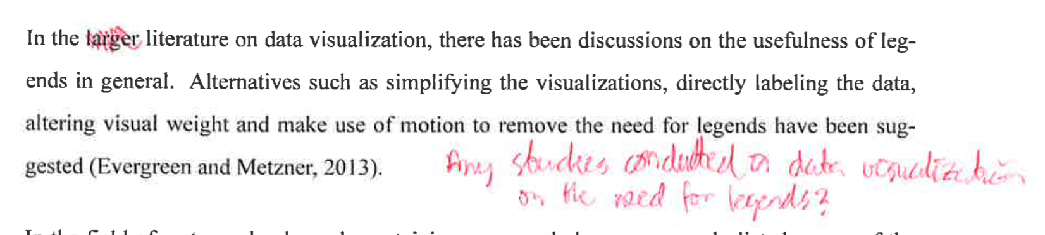

Helena Elvén Eriksson:
- Insert a separate chapter for the discussion and a separate for the conclusions. The conclusions could be ½ to 1 page and preferably in 1 paragraph. Here you only claim how each of the RQ were solved (if they were solved).
- Discussion:
  - Skip the first paragraph. Never repeat what you did or the the intention with the study in the discussion. This is a very very common mistake.
  - Some part of the discussion would be better suited in the Methodology section, such as the settings/considerations that you did (the bulleted list).
  - Make sure that you "take care" of aspects that you introduce/describe in the background and methods sections. Compare your method/results to studies/theories that you describe in the first par of your study (anything before the Results chapter).
  - Future perspective:
    - suggest improvements and/or developments. For instance my suggestion to link accuracy (RQ2) with performance (RQ3). Did the respondents that preferred a certain legend actually perform better when they were given examples where the legend that they preferred was used?
    - How could the time/hesitation perspective be taken cared of? Propose a methodology where the last RQ would have been more reliable.
  - From oral presentation: discuss problems with user studies generally

General/MISC

Helena Elvén Eriksson:
Why not inserting an example of how the questionnaire could look for a user, both the intro, and each of the questions.

From oral presentation:
- Discussion on familiarity or novelty: people tend to prefer what they are used to see
- Did respondents that preferred certain legends perform better for those?
  - Response: corresponds so closely to the actual results, not enough variation
- Talk about classified instead of continuous legends as design

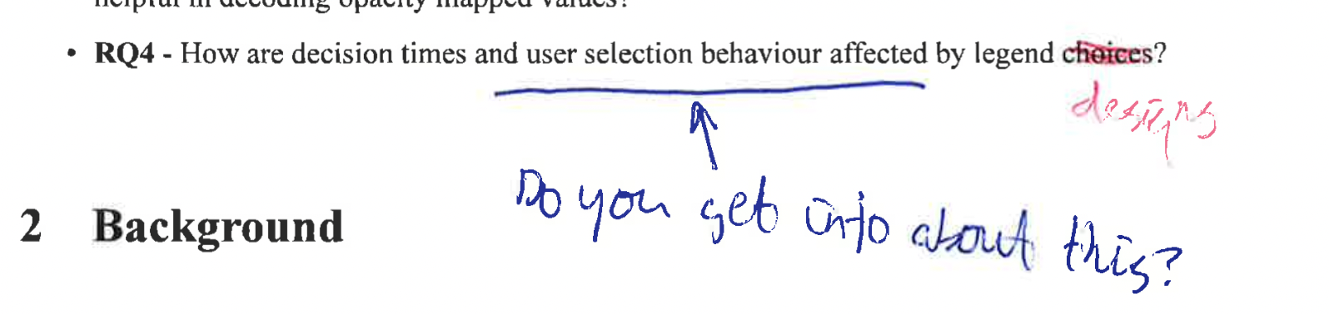

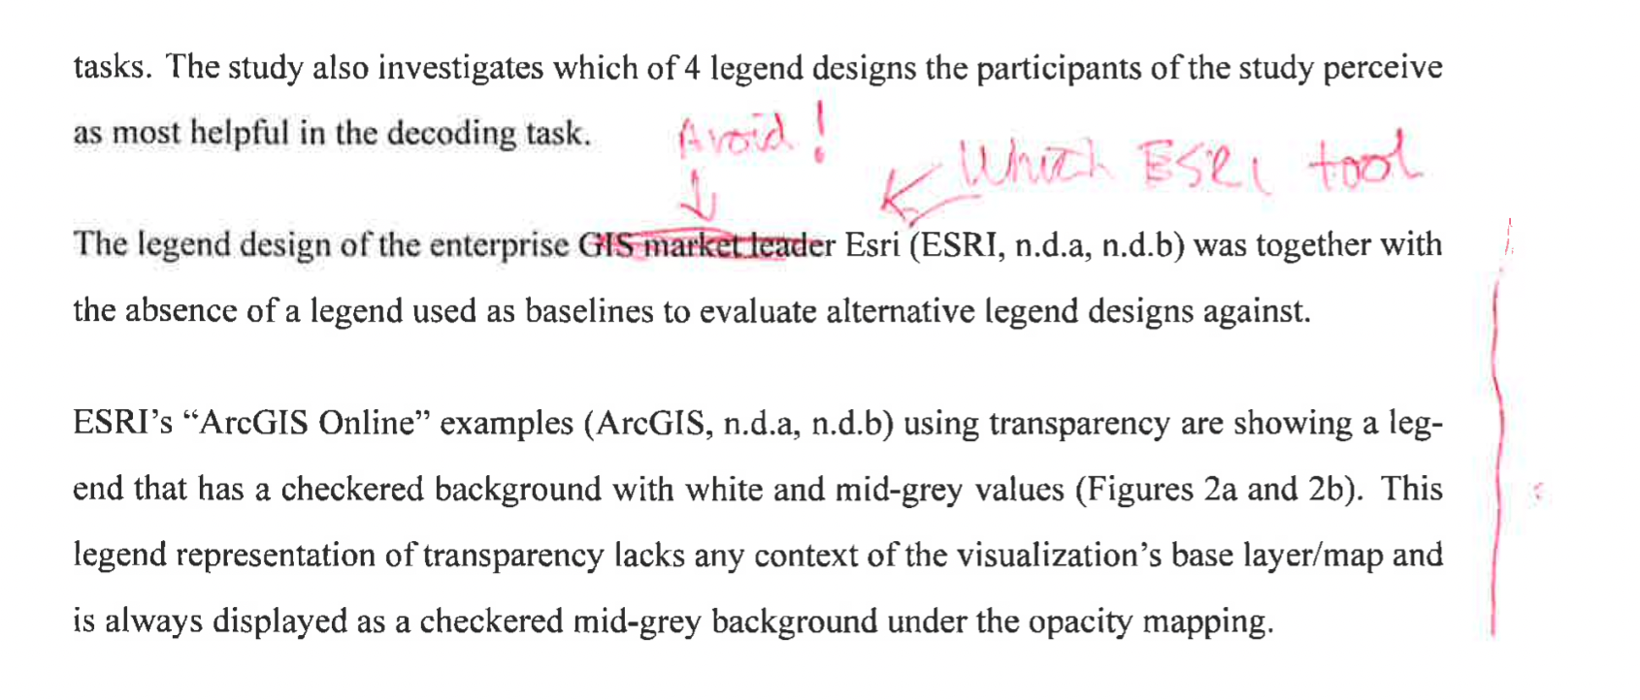

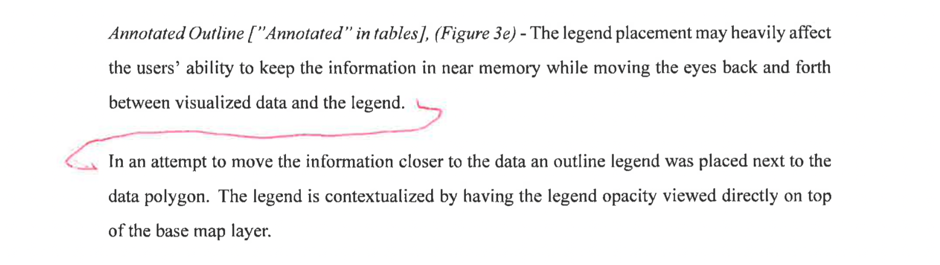
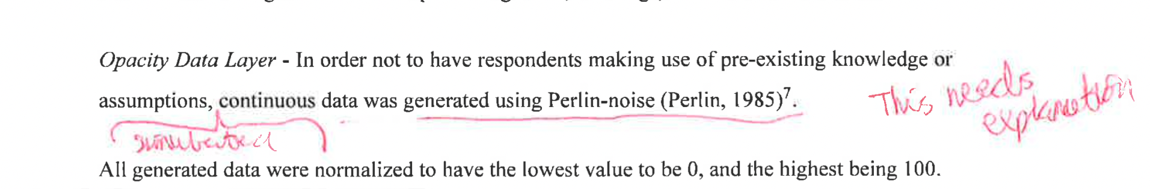

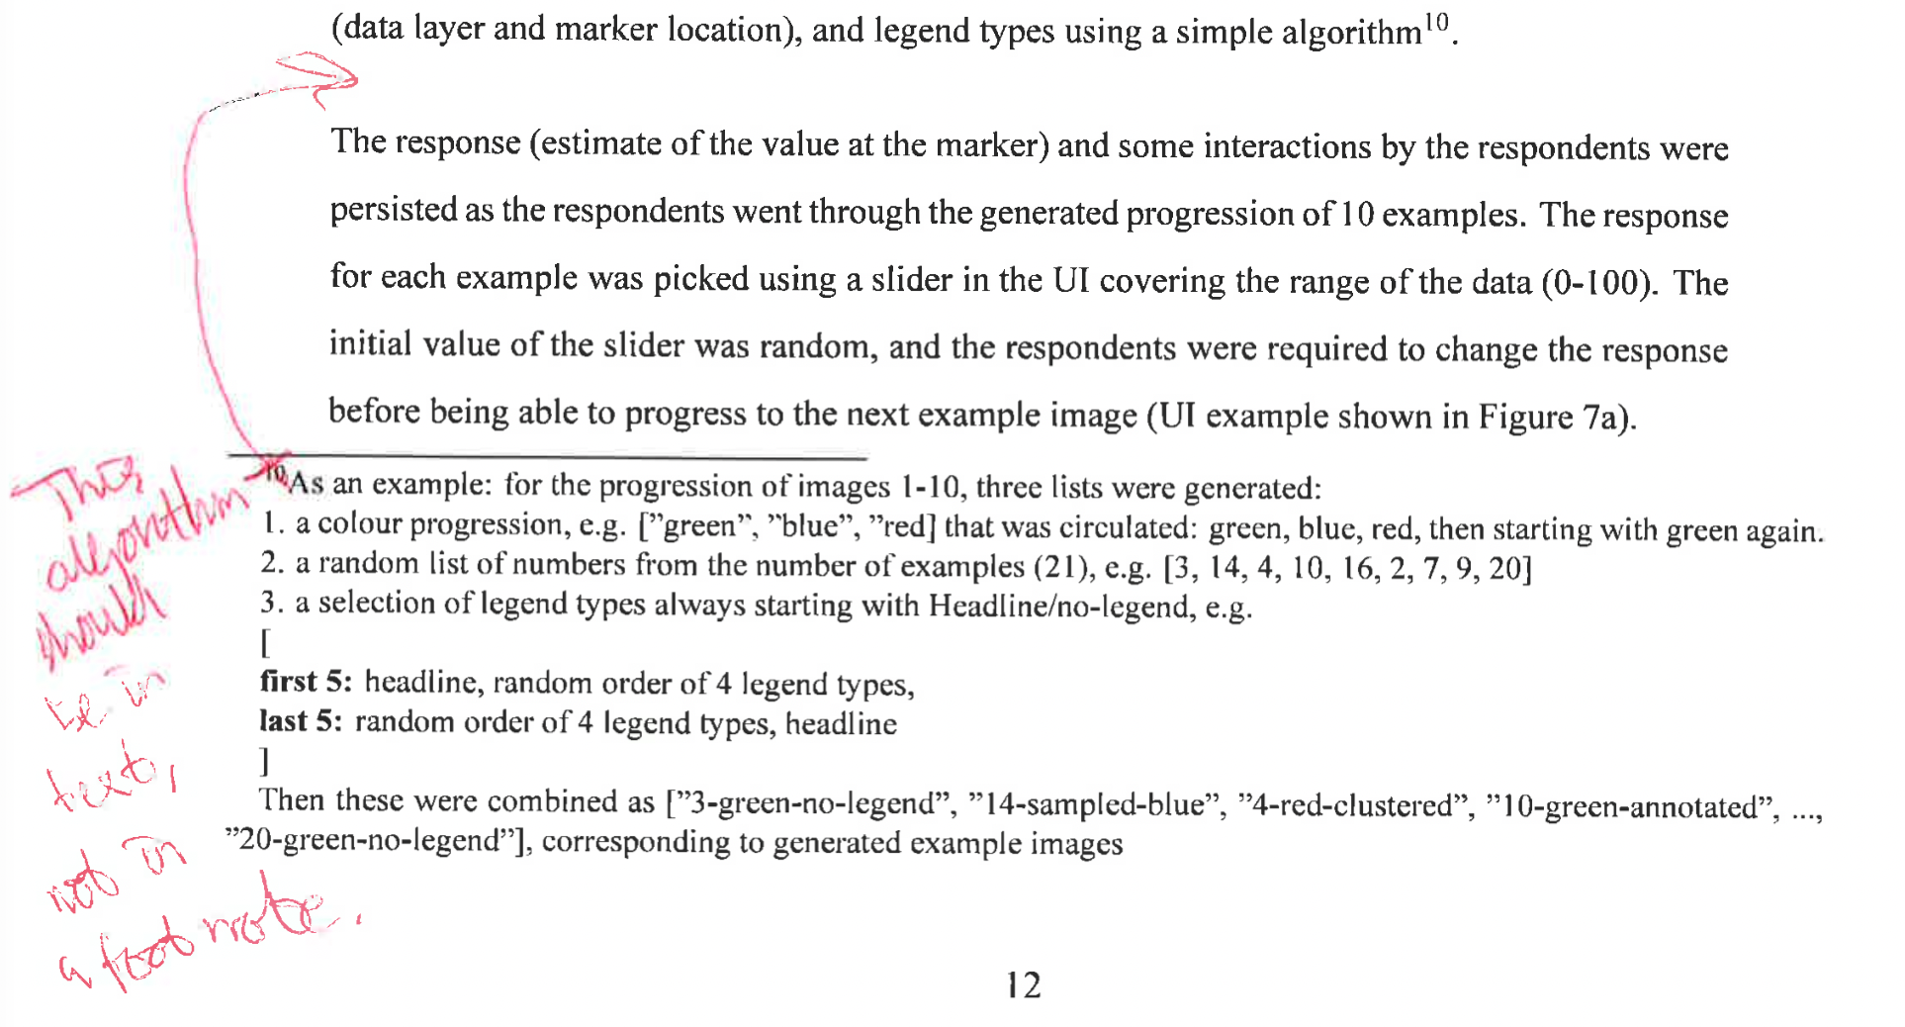

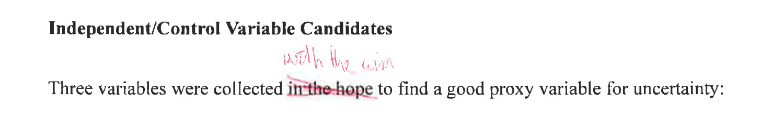

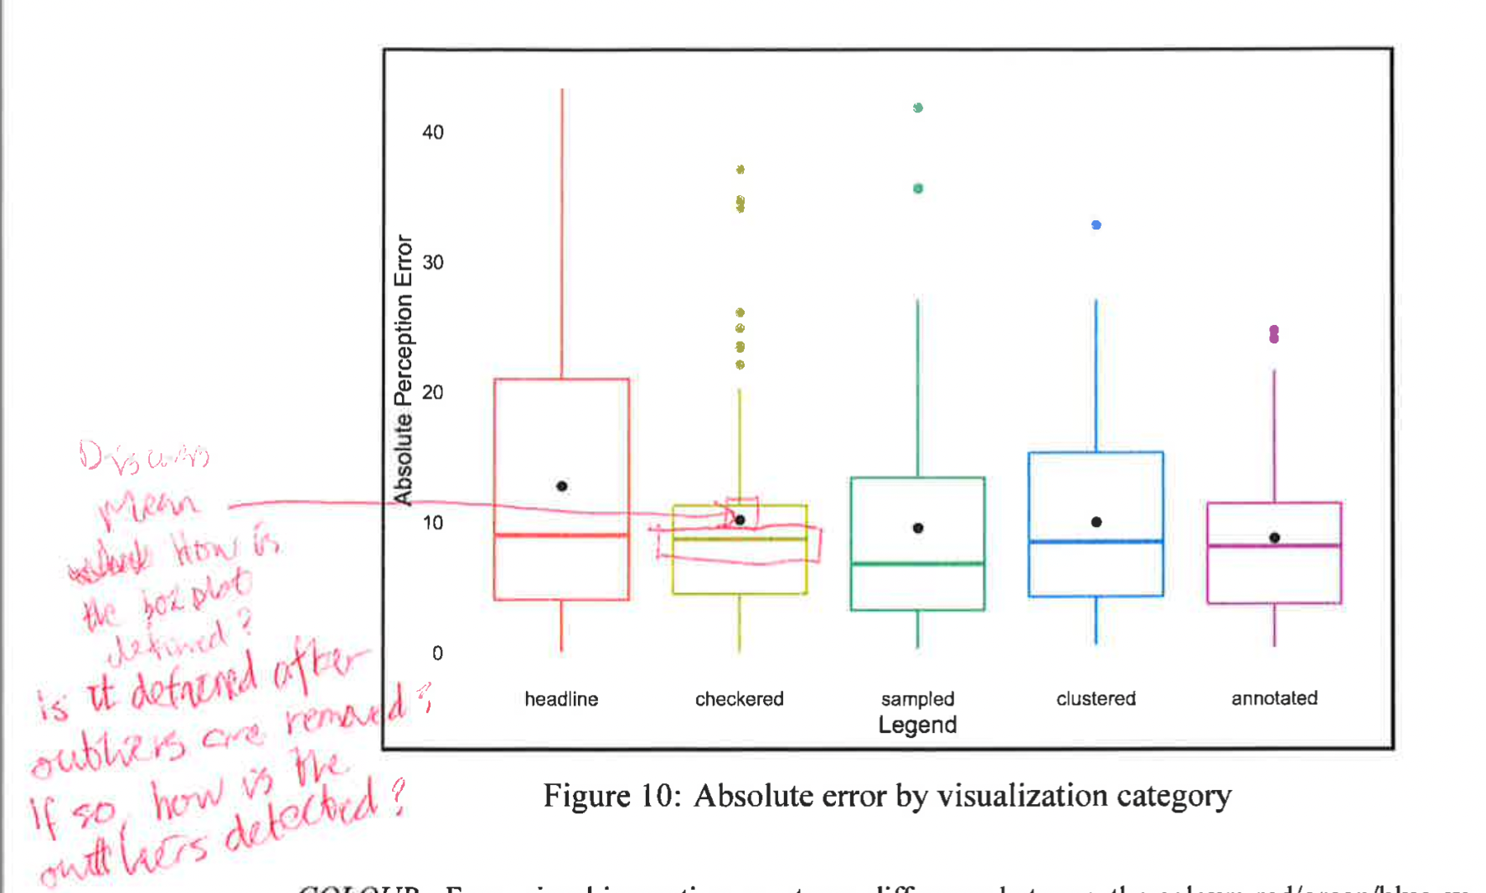

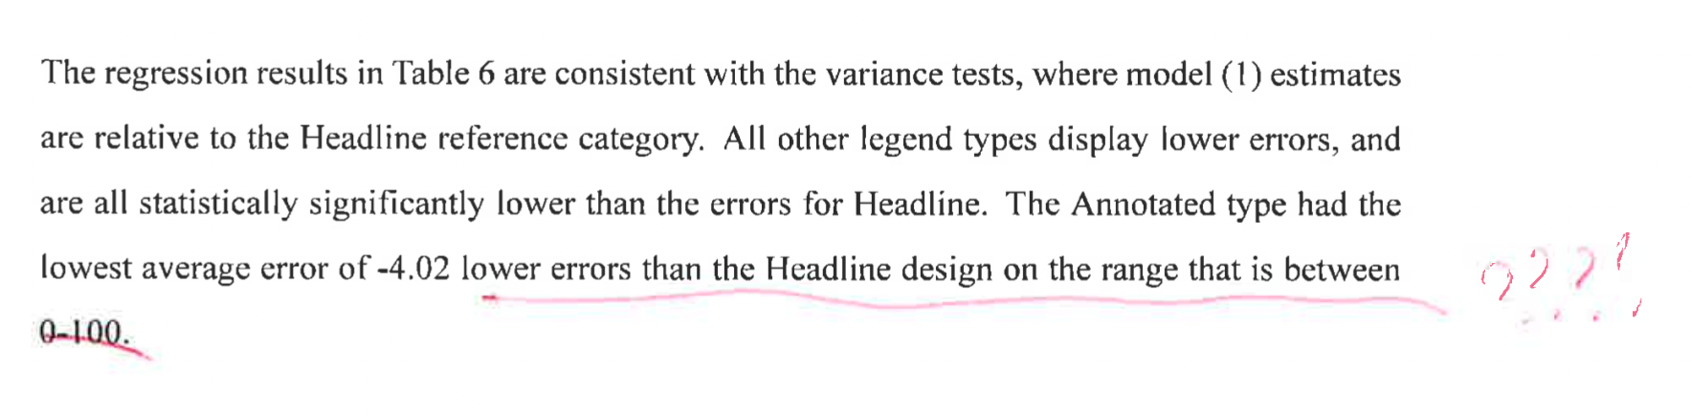

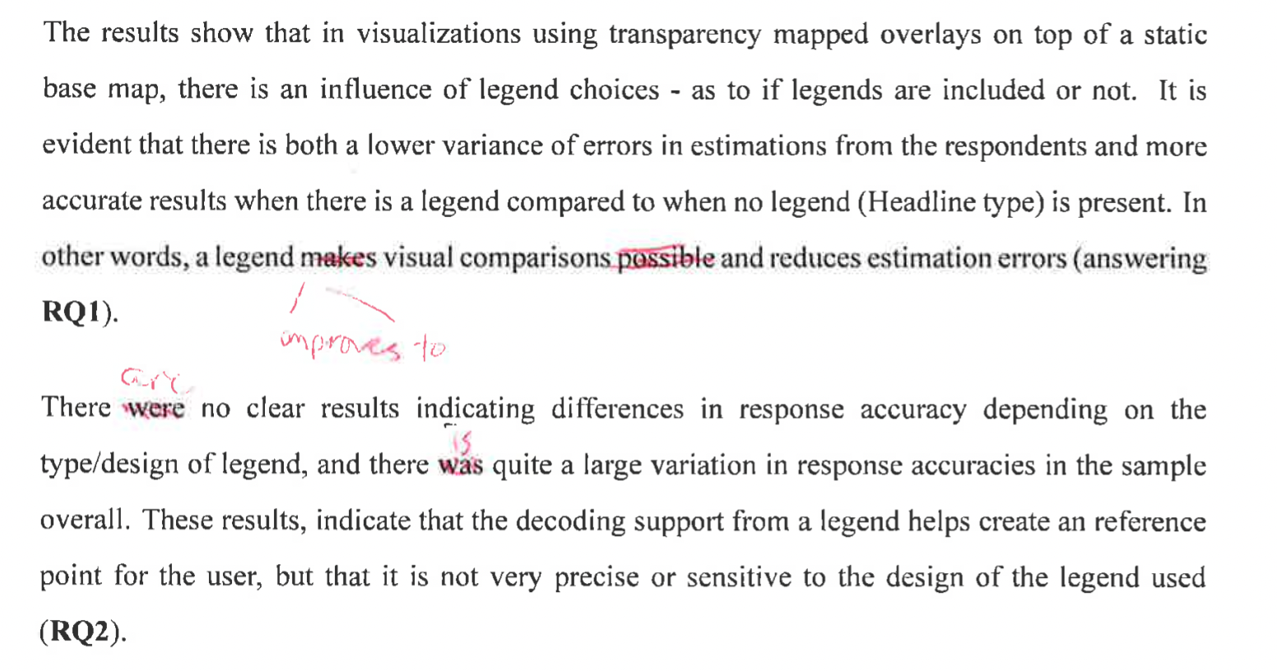

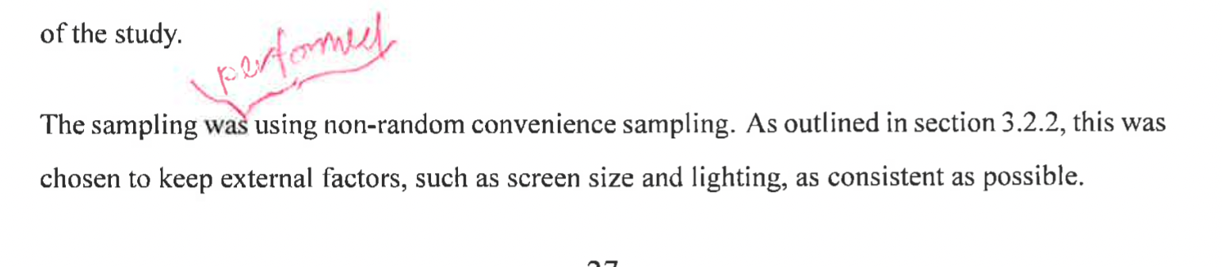

Placement – RESOLVED

Comment: Managed to solve the placement issue globally by removing floats, and needed to reduce size of some figures
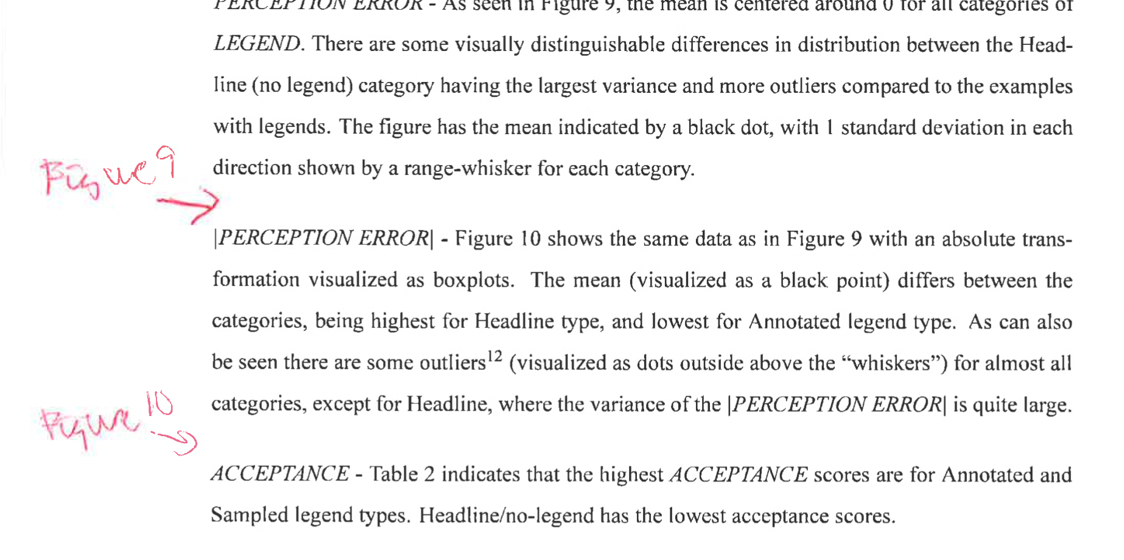

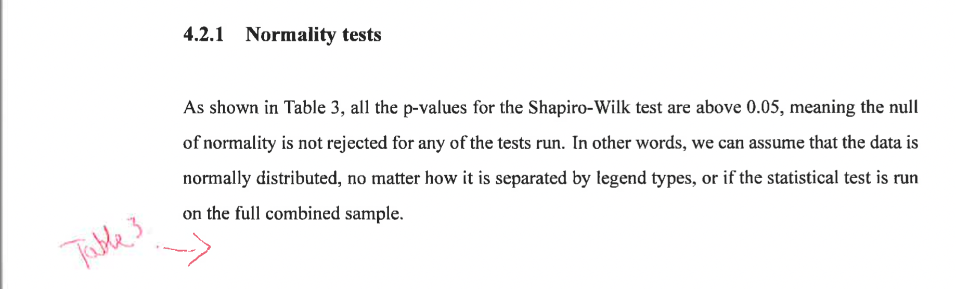
Results:

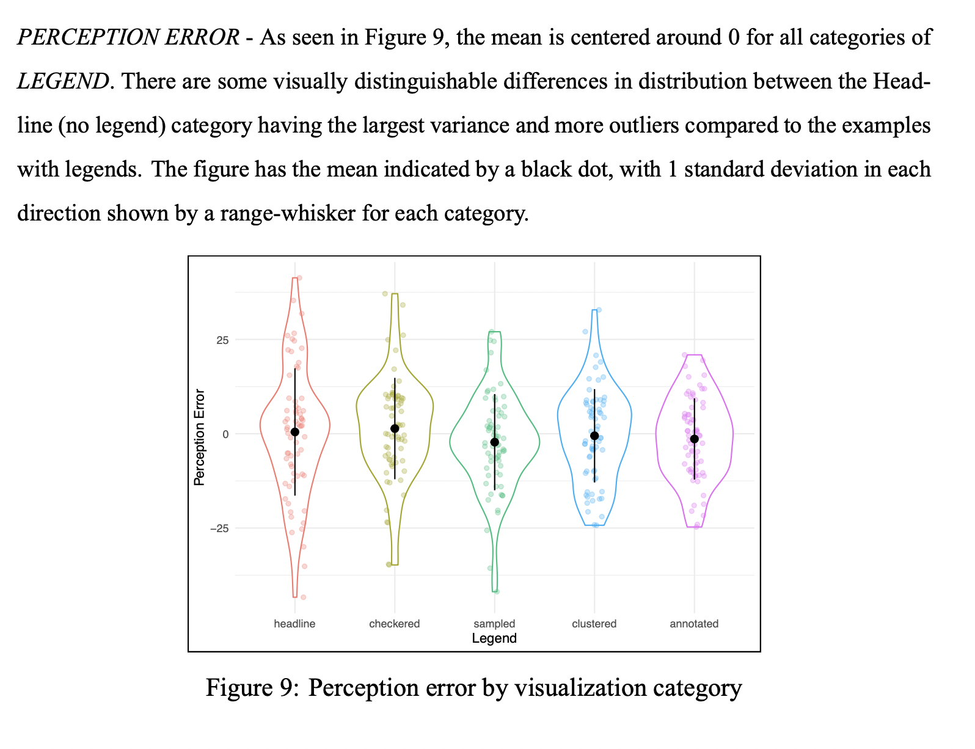

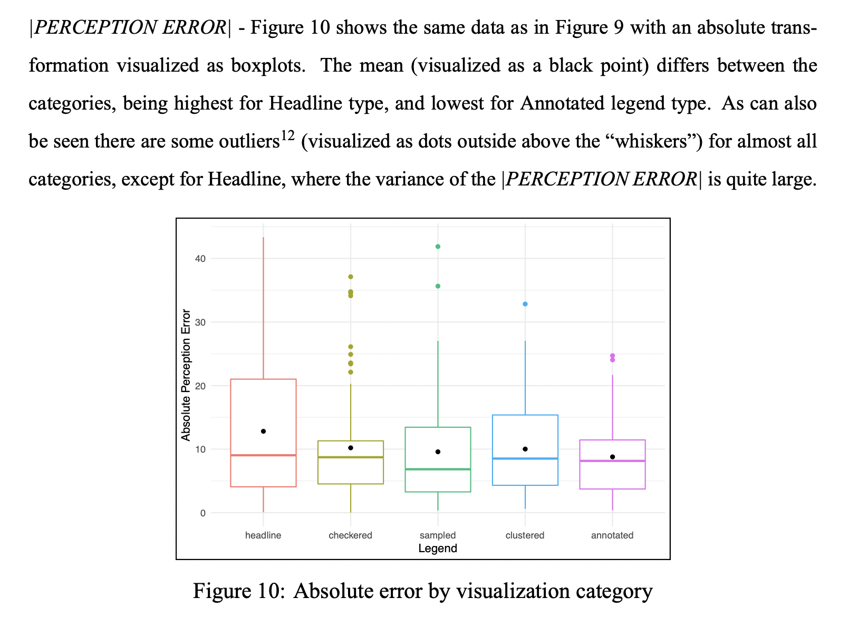

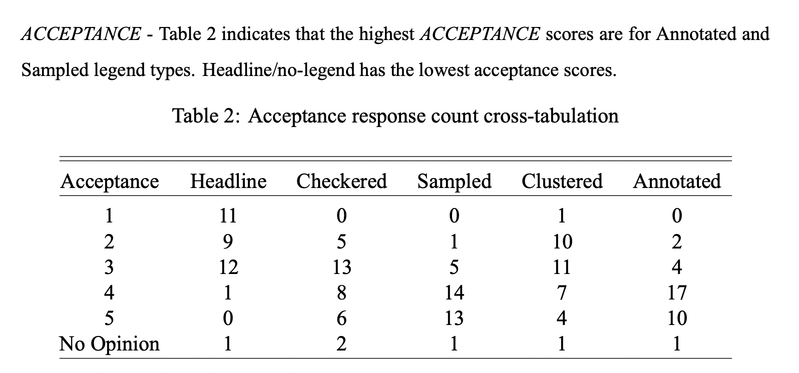

TODO: Read through before submission

