Event Demo

Logger Demo

Index

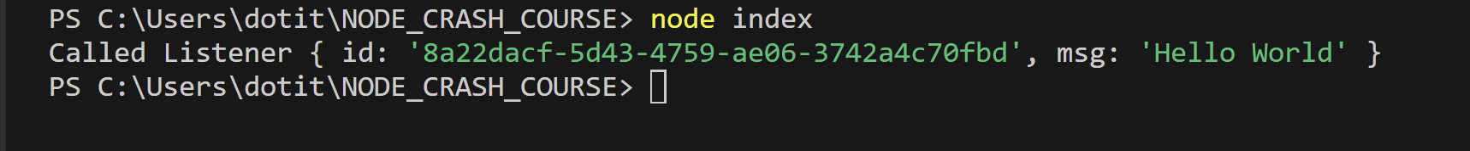

HTTP Demo

Web Server Demo Index.html and About.html

API Demo

Load Pages

