ETCH-03 Chamber B Recovery
Control token T9445-DOCX-LEAKCHECK-33. Hold the next lot and verify chamber pressure before recipe recovery.
- Complete a leak check.
- Review RF match trend.
Signal | Limit | Action
Pressure | 12 Pa | Hold lot
RF Match | 85 % | Escalate
Controlled wafer evidence: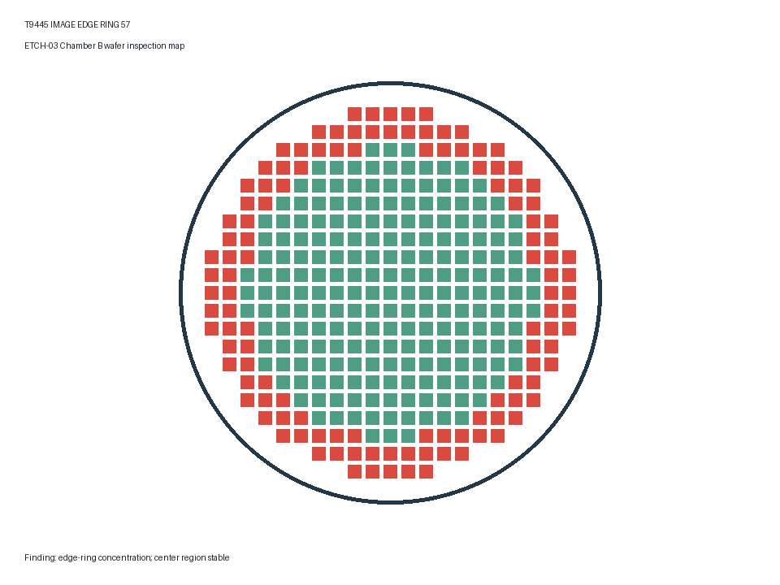

Release Criteria
Release only after pressure and RF match return inside limits.

