Exploratory Data Analysis Report

The data contains 398 observations (rows) and 9 variables (columns), 7 of which are numeric:

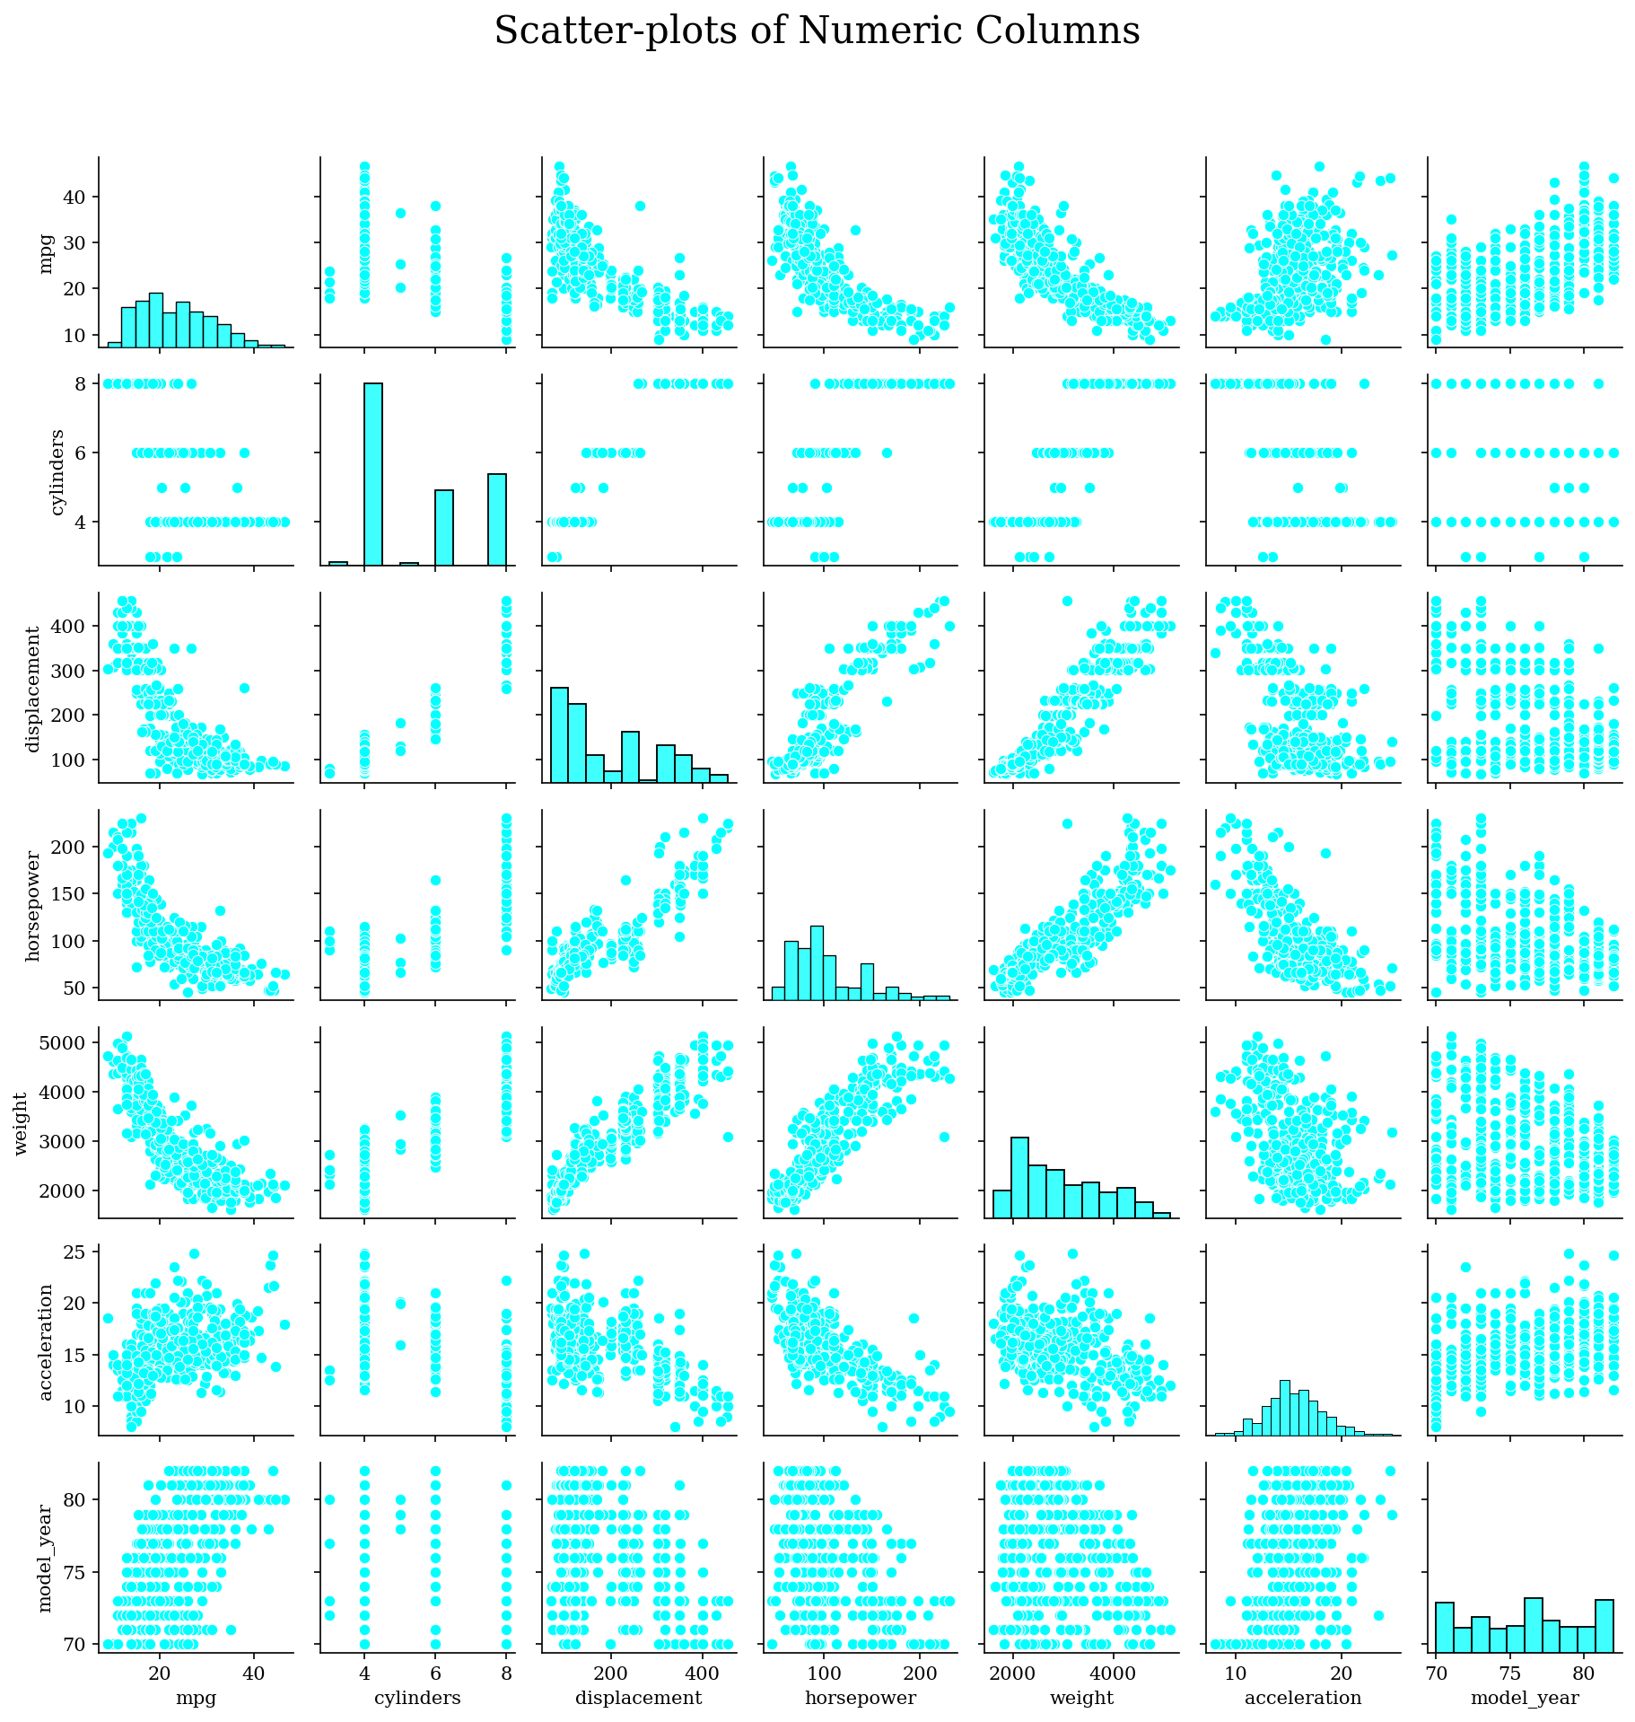

## 1. Mpg

Mpg has 129 unique values. None of its values are missing.

#### Summary Statistics

|  |  |
| --- | --- |
| Number of observations | 398.0 |
| Average | 23.5146 |
| Standard Deviation | 7.816 |
| Minimum | 9.0 |
| Lower Quartile | 17.5 |
| Median | 23.0 |
| Upper Quartile | 29.0 |
| Maximum | 46.6 |
| Skewness | 0.4571 |
| Kurtosis | -0.5108 |

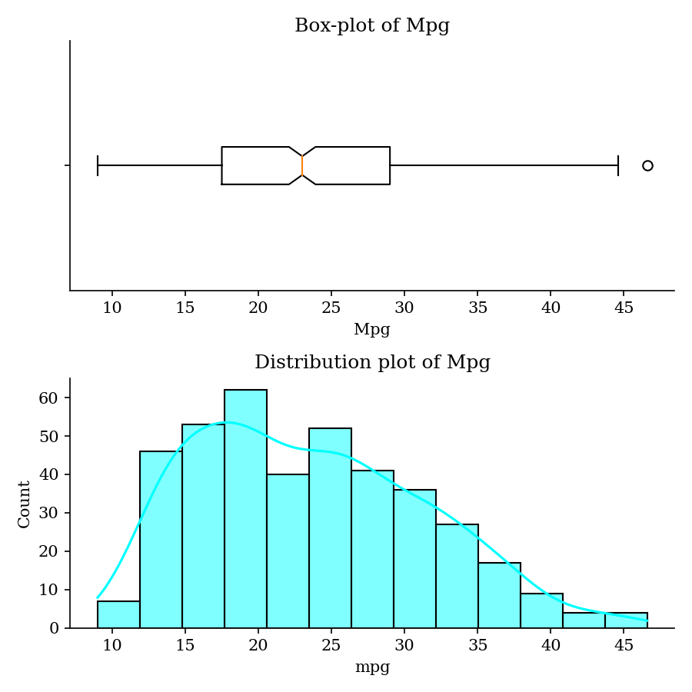

## 2. Cylinders

Cylinders has 5 unique values. None of its values are missing.

#### Summary Statistics

|  |  |
| --- | --- |
| Number of observations | 398.0 |
| Average | 5.4548 |
| Standard Deviation | 1.701 |
| Minimum | 3.0 |
| Lower Quartile | 4.0 |
| Median | 4.0 |
| Upper Quartile | 8.0 |
| Maximum | 8.0 |
| Skewness | 0.5269 |
| Kurtosis | -1.3767 |

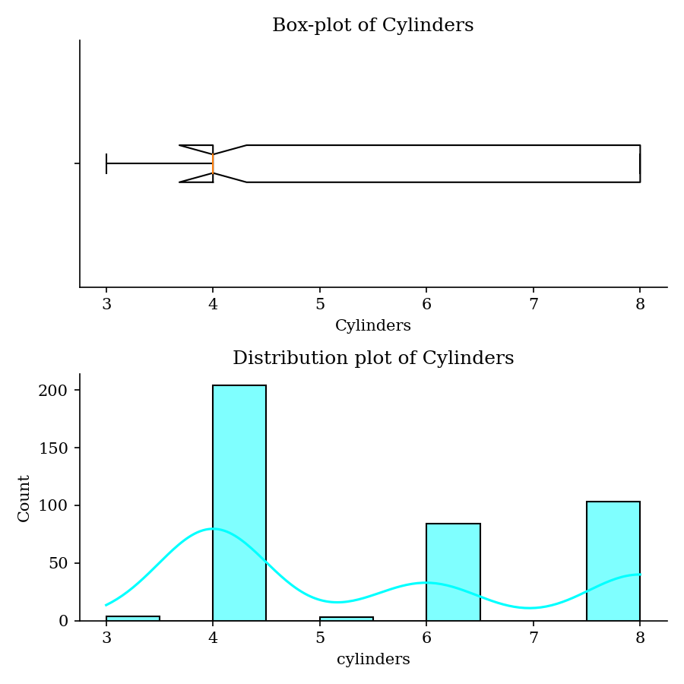

## 3. Displacement

Displacement has 82 unique values. None of its values are missing.

#### Summary Statistics

|  |  |
| --- | --- |
| Number of observations | 398.0 |
| Average | 193.4259 |
| Standard Deviation | 104.2698 |
| Minimum | 68.0 |
| Lower Quartile | 104.25 |
| Median | 148.5 |
| Upper Quartile | 262.0 |
| Maximum | 455.0 |
| Skewness | 0.7196 |
| Kurtosis | -0.7466 |

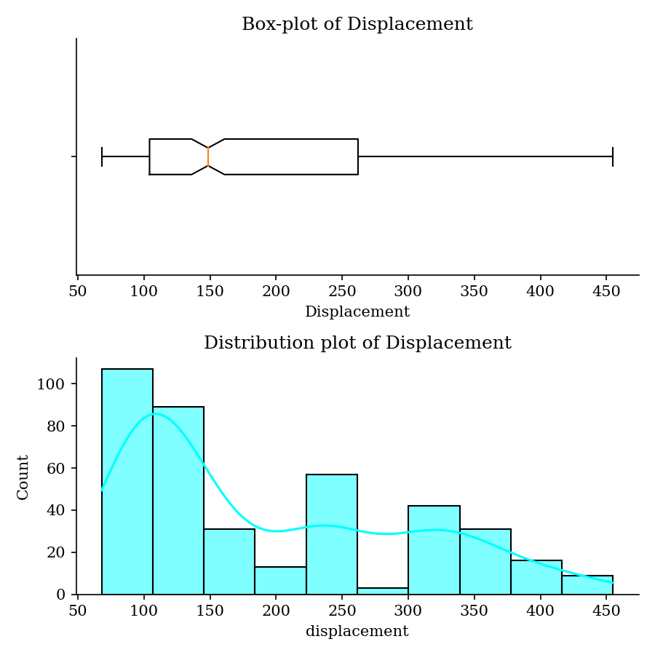

## 4. Horsepower

Horsepower has 93 unique values. 6 (1.51%) of its values are missing.

#### Summary Statistics

|  |  |
| --- | --- |
| Number of observations | 392.0 |
| Average | 104.4694 |
| Standard Deviation | 38.4912 |
| Minimum | 46.0 |
| Lower Quartile | 75.0 |
| Median | 93.5 |
| Upper Quartile | 126.0 |
| Maximum | 230.0 |
| Skewness | 1.0873 |
| Kurtosis | 0.6969 |

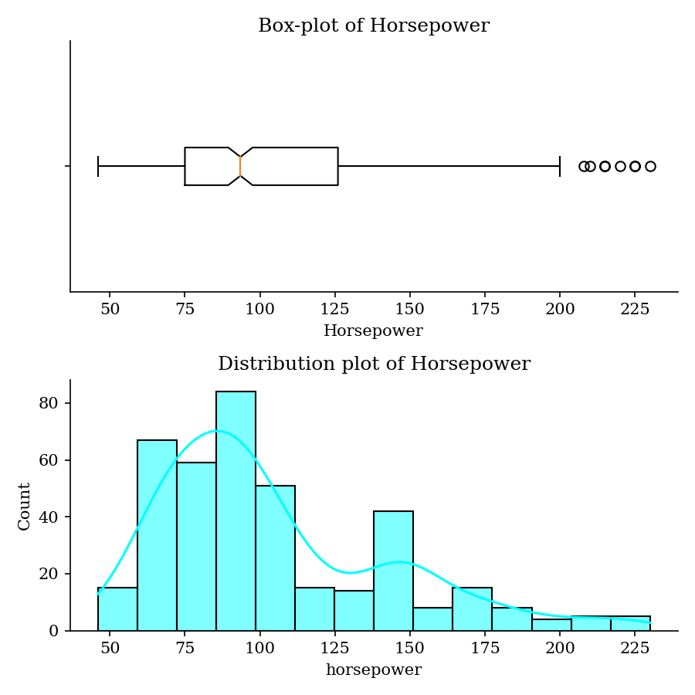

## 5. Weight

Weight has 351 unique values. None of its values are missing.

#### Summary Statistics

|  |  |
| --- | --- |
| Number of observations | 398.0 |
| Average | 2970.4246 |
| Standard Deviation | 846.8418 |
| Minimum | 1613.0 |
| Lower Quartile | 2223.75 |
| Median | 2803.5 |
| Upper Quartile | 3608.0 |
| Maximum | 5140.0 |
| Skewness | 0.5311 |
| Kurtosis | -0.7855 |

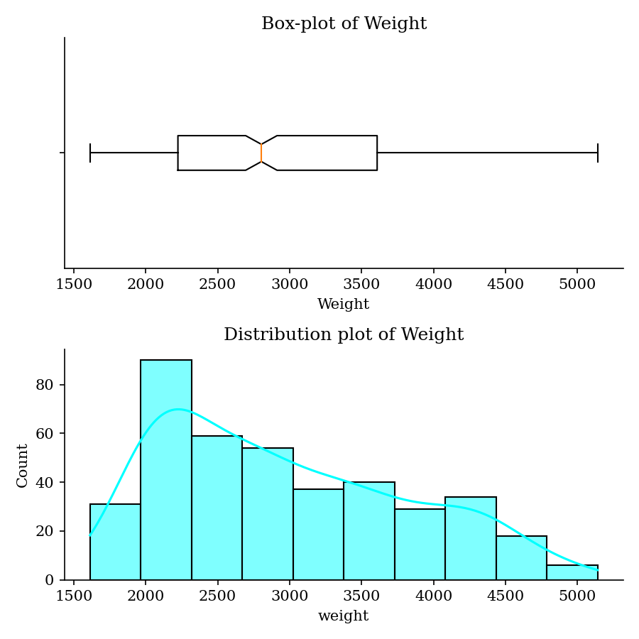

## 6. Acceleration

Acceleration has 95 unique values. None of its values are missing.

#### Summary Statistics

|  |  |
| --- | --- |
| Number of observations | 398.0 |
| Average | 15.5681 |
| Standard Deviation | 2.7577 |
| Minimum | 8.0 |
| Lower Quartile | 13.825 |
| Median | 15.5 |
| Upper Quartile | 17.175 |
| Maximum | 24.8 |
| Skewness | 0.2788 |
| Kurtosis | 0.4195 |

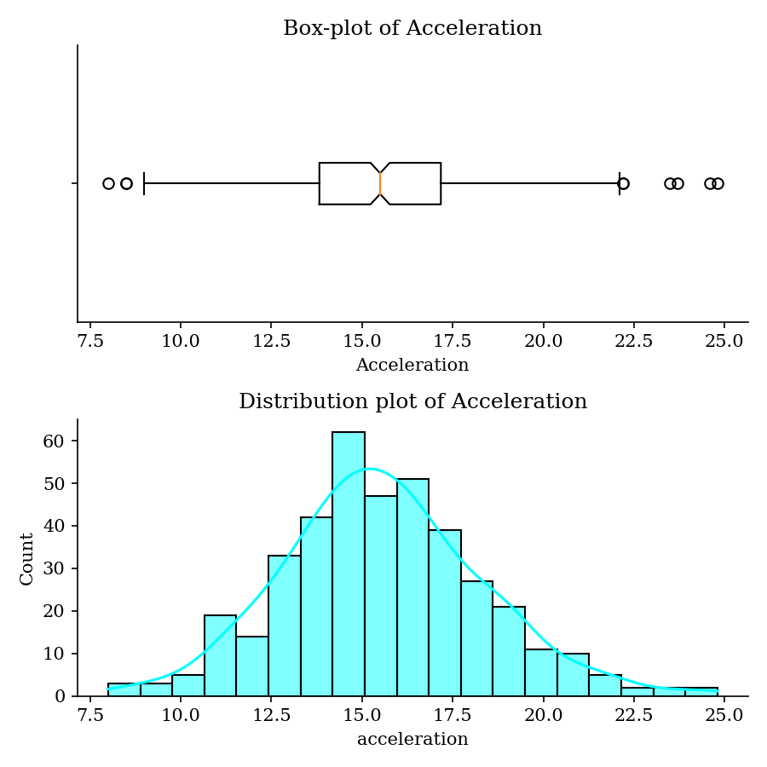

## 7. Model_Year

Model_year has 13 unique values. None of its values are missing.

#### Summary Statistics

|  |  |
| --- | --- |
| Number of observations | 398.0 |
| Average | 76.0101 |
| Standard Deviation | 3.6976 |
| Minimum | 70.0 |
| Lower Quartile | 73.0 |
| Median | 76.0 |
| Upper Quartile | 79.0 |
| Maximum | 82.0 |
| Skewness | 0.0115 |
| Kurtosis | -1.1812 |

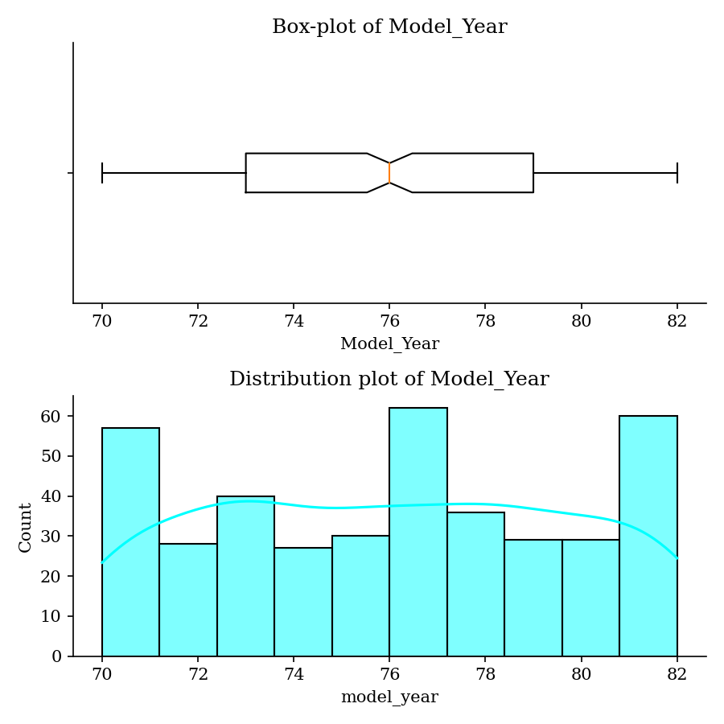

## 8. Origin

Origin has 3 unique values. None of its values are missing.

#### Summary

|  |  |
| --- | --- |
| Number of observations | 398 |
| Unique values | 3 |
| Mode (Highest occurring value) | usa |

#### Most Frequent

|  |  |
| --- | --- |
| usa | 249 (62.56%) |
| japan | 79 (19.85%) |
| europe | 70 (17.59%) |

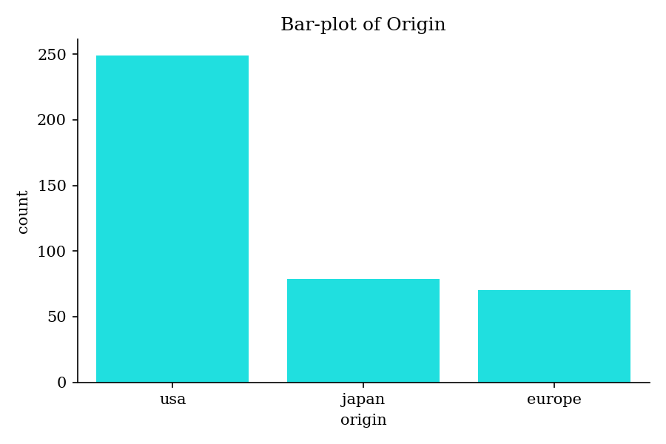

## 9. Name

Name has 305 unique values. None of its values are missing.

#### Summary

|  |  |
| --- | --- |
| Number of observations | 398 |
| Unique values | 305 |
| Mode (Highest occurring value) | ford pinto |

#### Most Frequent

|  |  |
| --- | --- |
| ford pinto | 6 (1.51%) |
| toyota corolla | 5 (1.26%) |
| amc matador | 5 (1.26%) |
| ford maverick | 5 (1.26%) |
| chevrolet chevette | 4 (1.01%) |

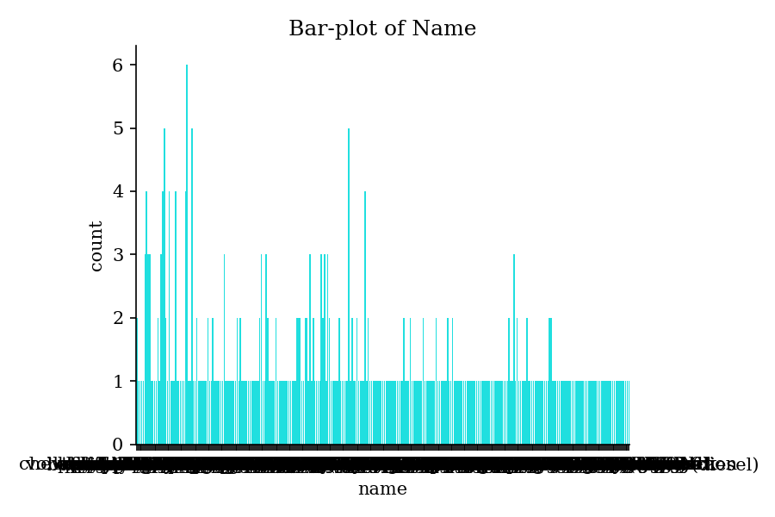

# Bivariate Analysis (Correlation)

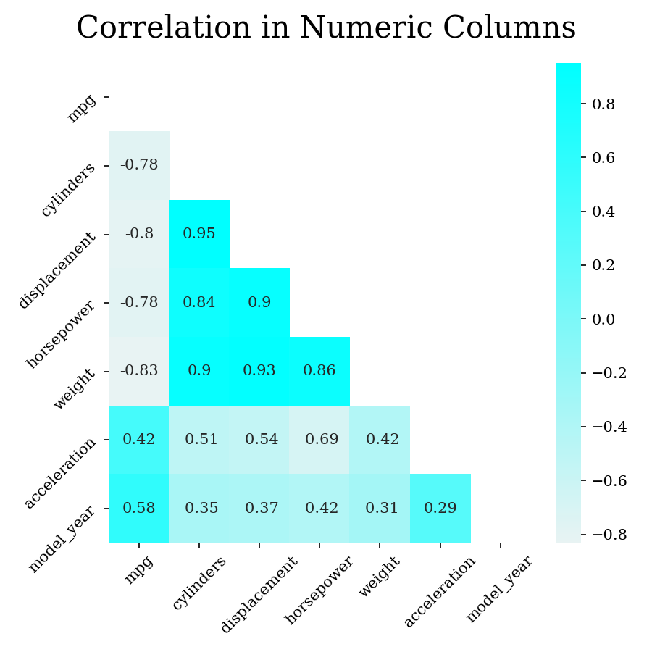

## 1. Mpg vs Cylinders

Mpg and Cylinders have strong negative correlation (-0.78).

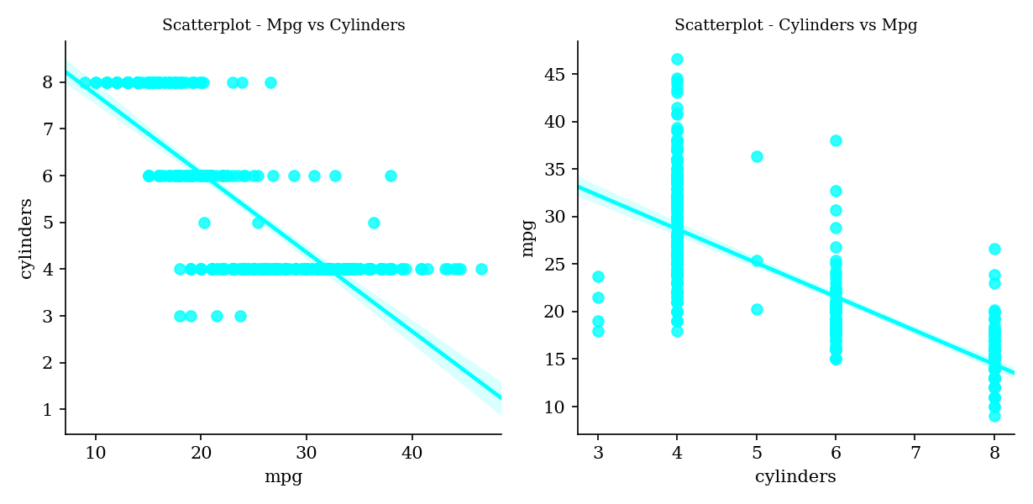

## 2. Mpg vs Displacement

Mpg and Displacement have strong negative correlation (-0.80).

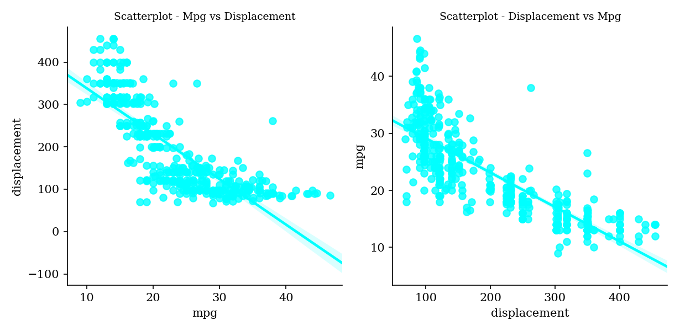

## 3. Mpg vs Horsepower

Mpg and Horsepower have strong negative correlation (-0.78).

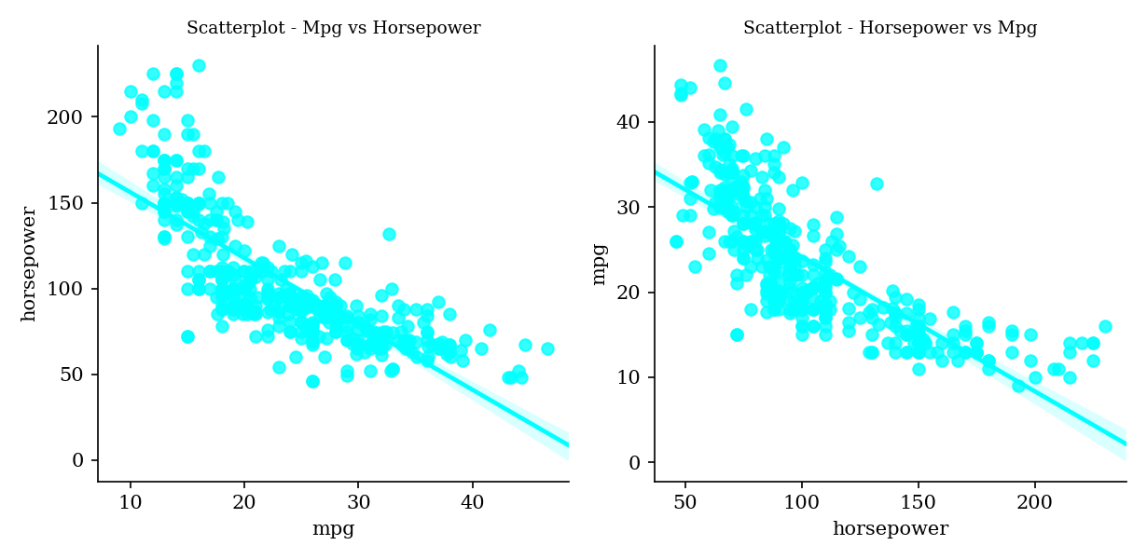

## 4. Mpg vs Weight

Mpg and Weight have strong negative correlation (-0.83).

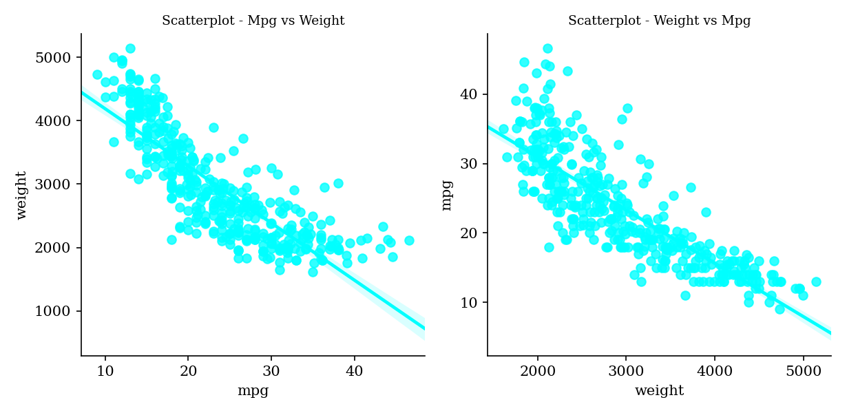

## 5. Mpg vs Acceleration

Mpg and Acceleration have weak positive correlation (0.42).

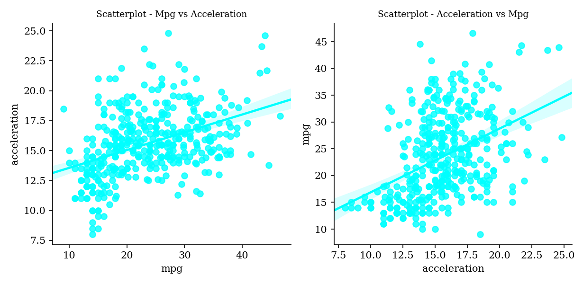

## 6. Mpg vs Model_Year

Mpg and Model_year have moderate positive correlation (0.58).

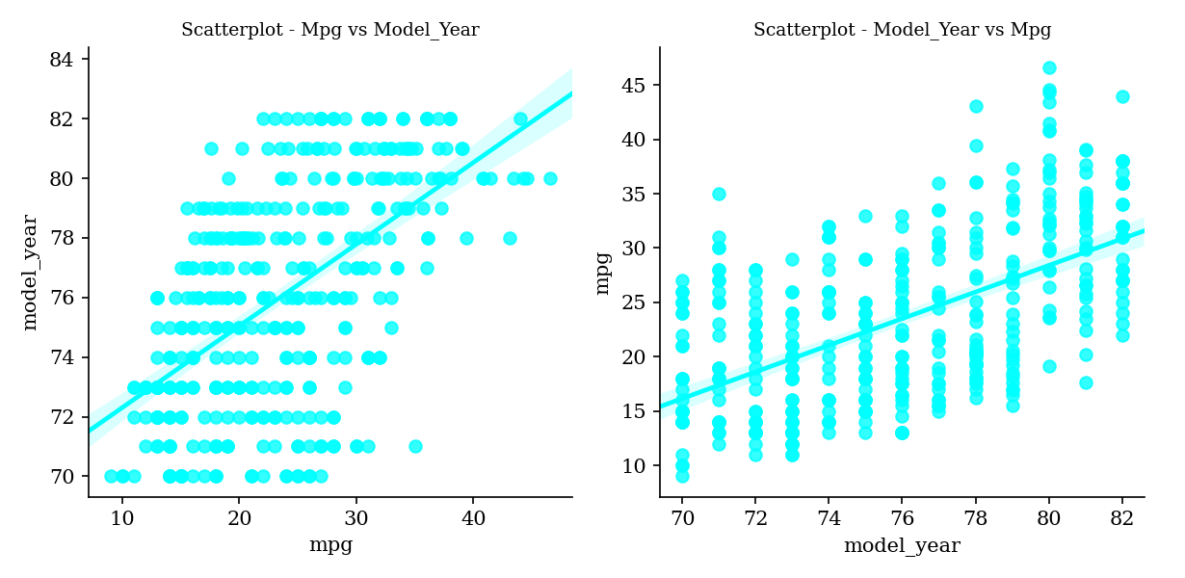

## 7. Cylinders vs Displacement

Cylinders and Displacement have very strong positive correlation (0.95).

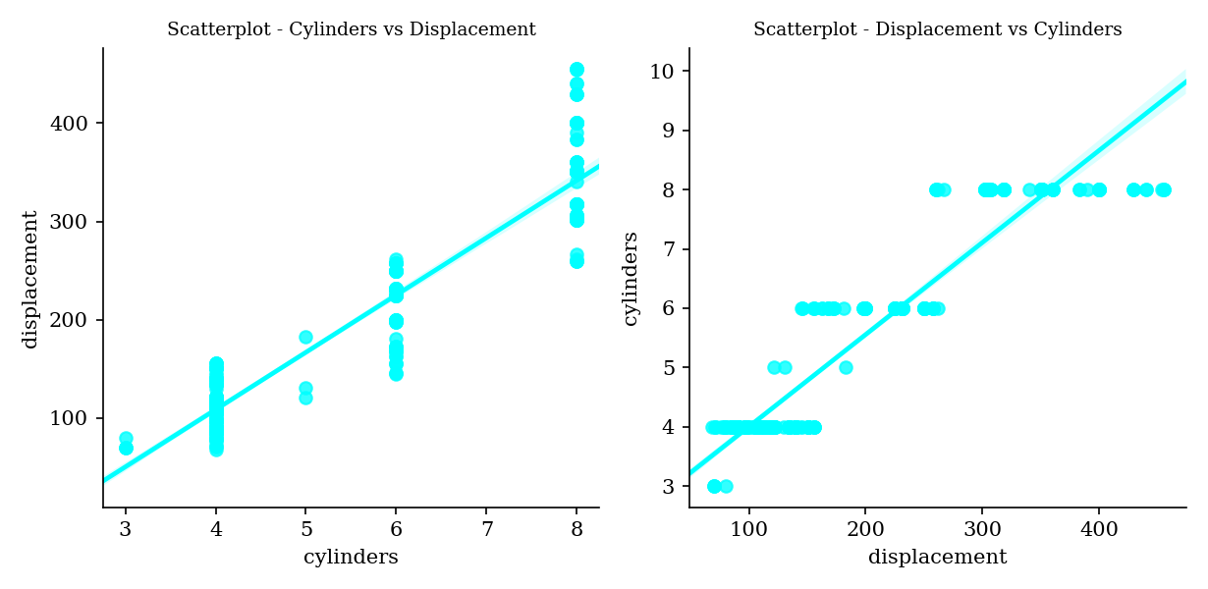

## 8. Cylinders vs Horsepower

Cylinders and Horsepower have strong positive correlation (0.84).

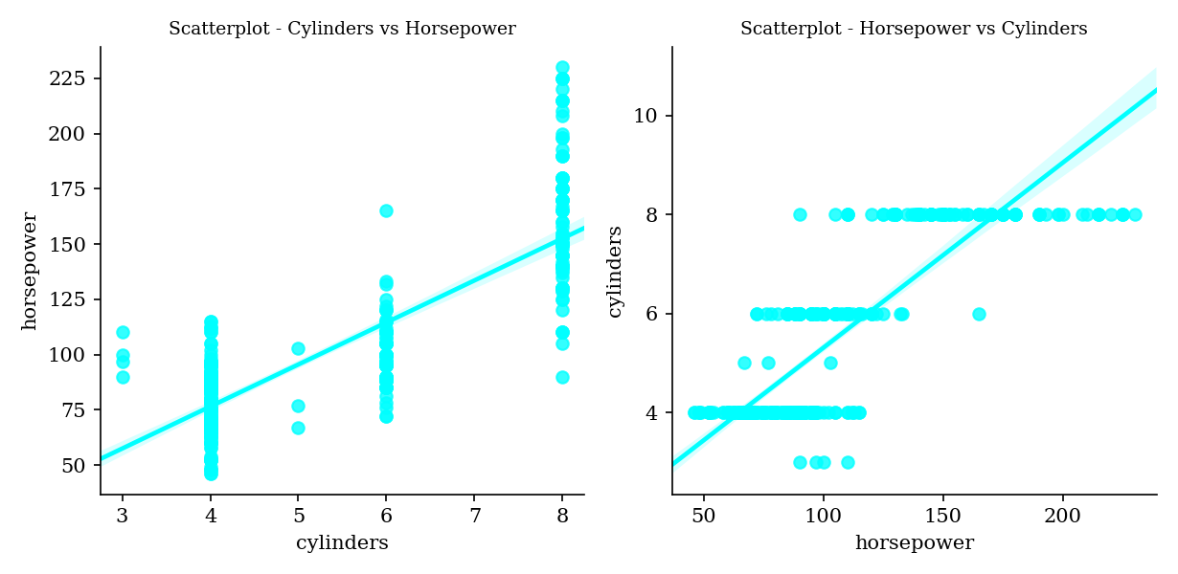

## 9. Cylinders vs Weight

Cylinders and Weight have strong positive correlation (0.90).

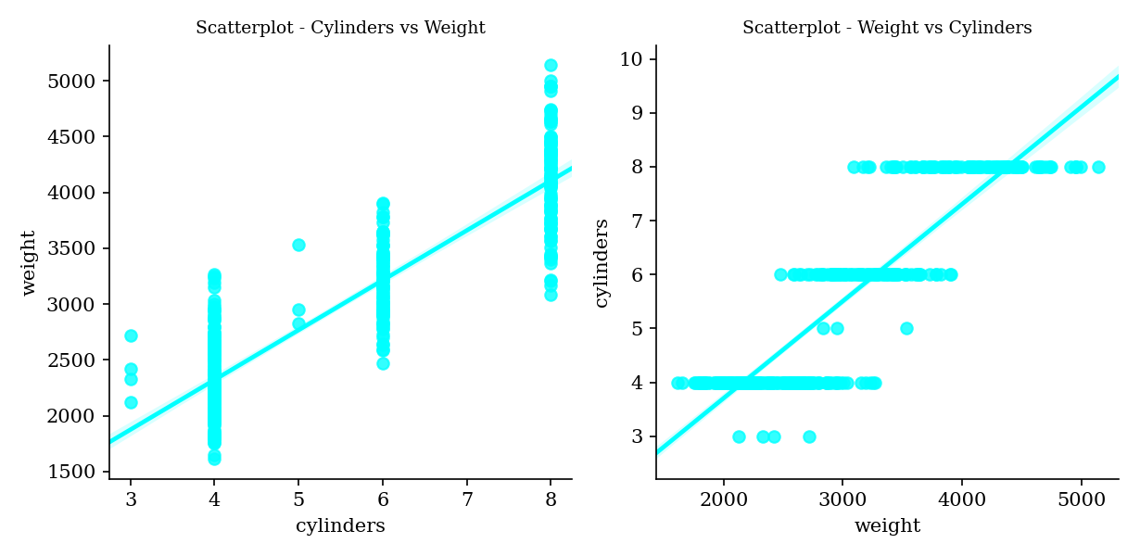

## 10. Cylinders vs Acceleration

Cylinders and Acceleration have moderate negative correlation (-0.51).

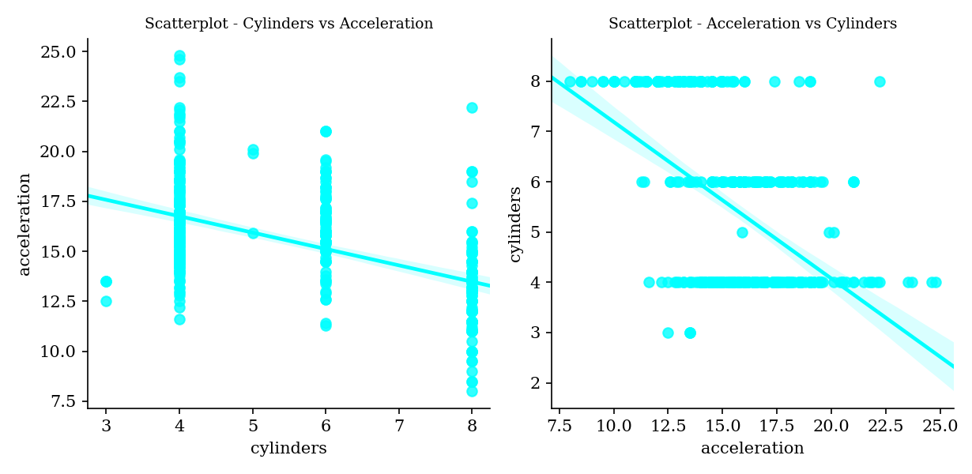

## 11. Cylinders vs Model_Year

Cylinders and Model_year have weak negative correlation (-0.35).

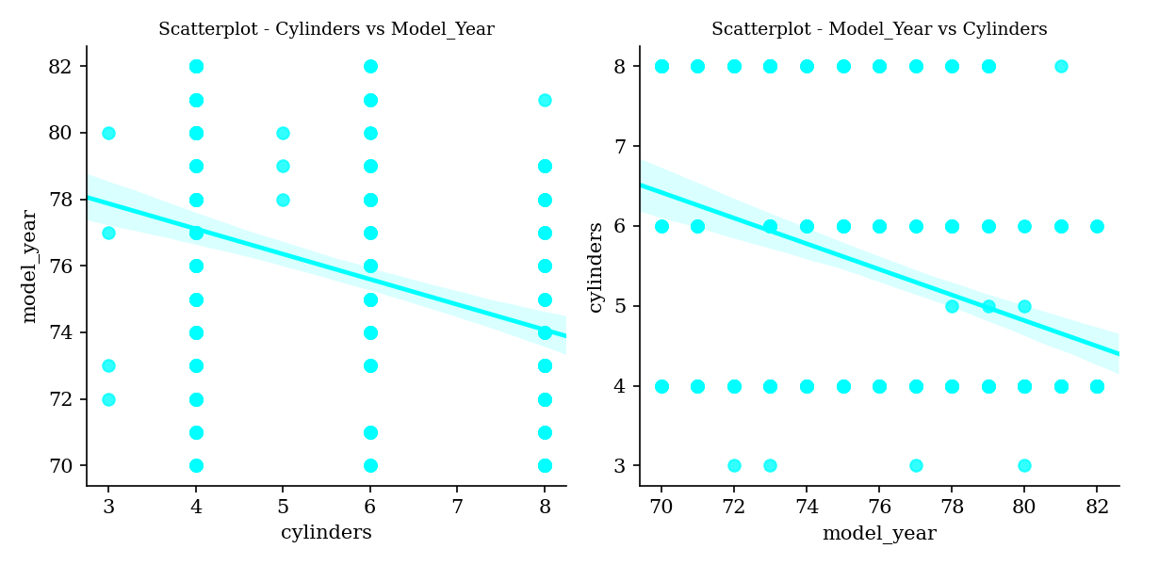

## 12. Displacement vs Horsepower

Displacement and Horsepower have strong positive correlation (0.90).

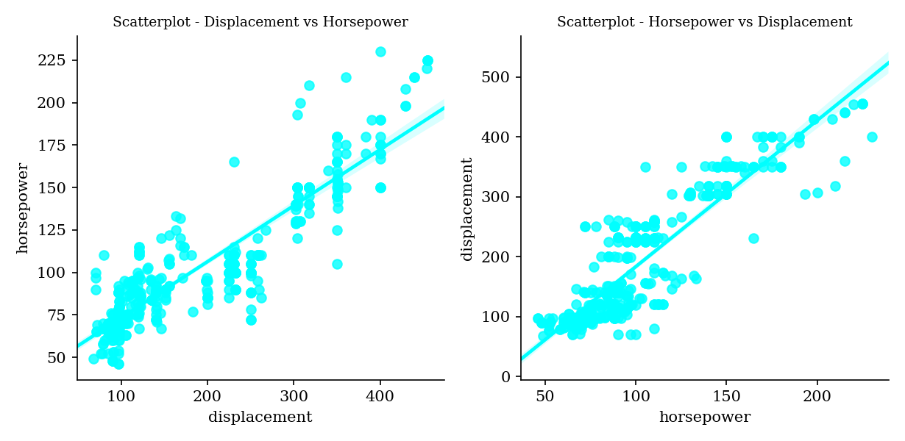

## 13. Displacement vs Weight

Displacement and Weight have very strong positive correlation (0.93).

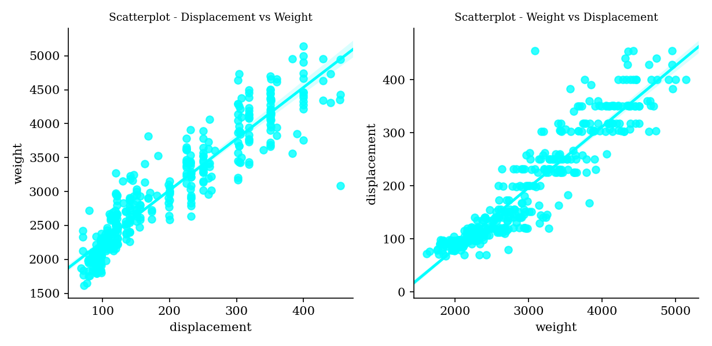

## 14. Displacement vs Acceleration

Displacement and Acceleration have moderate negative correlation (-0.54).

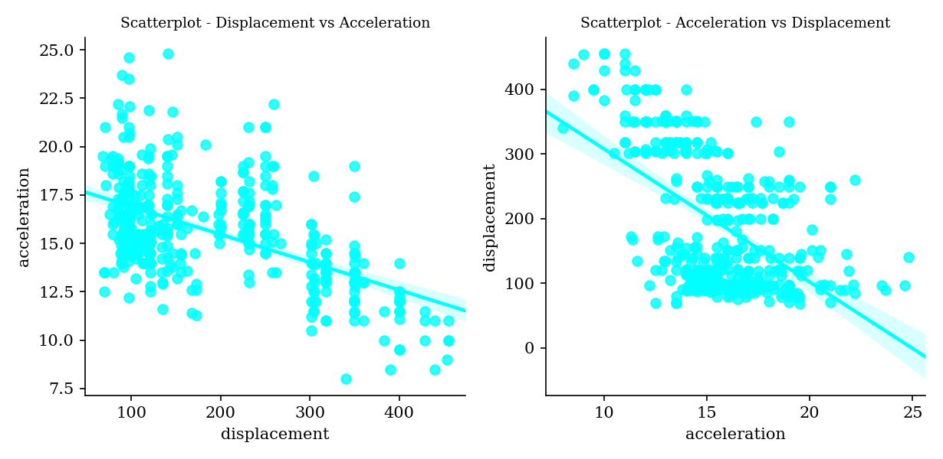

## 15. Displacement vs Model_Year

Displacement and Model_year have weak negative correlation (-0.37).

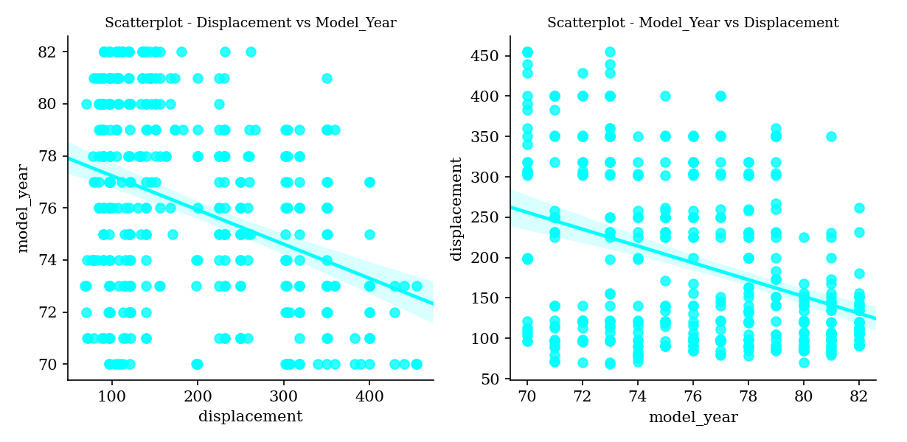

## 16. Horsepower vs Weight

Horsepower and Weight have strong positive correlation (0.86).

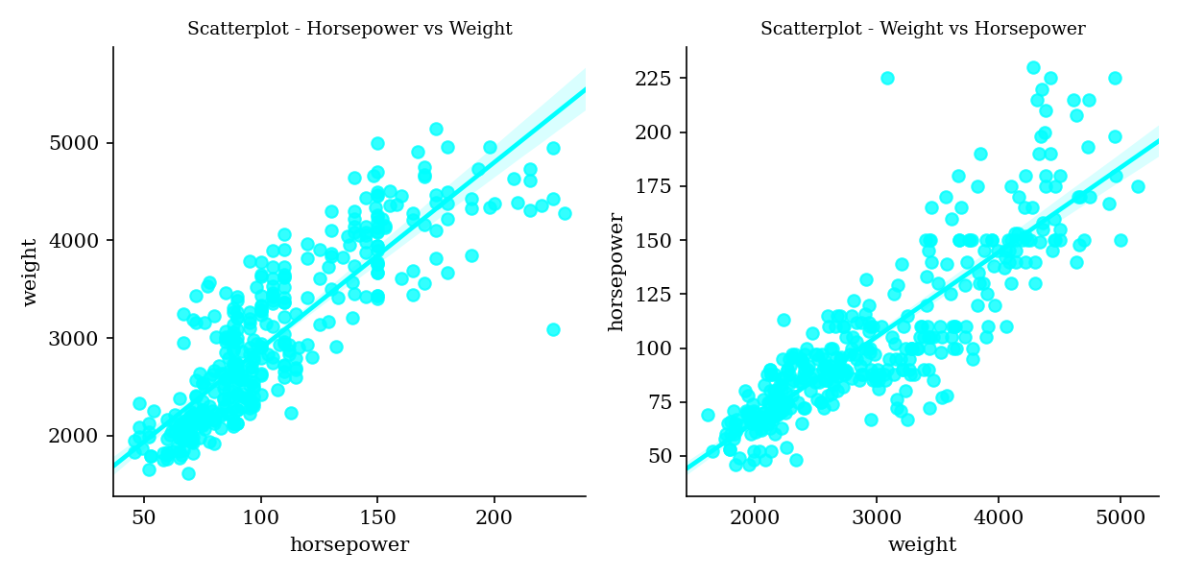

## 17. Horsepower vs Acceleration

Horsepower and Acceleration have moderate negative correlation (-0.69).

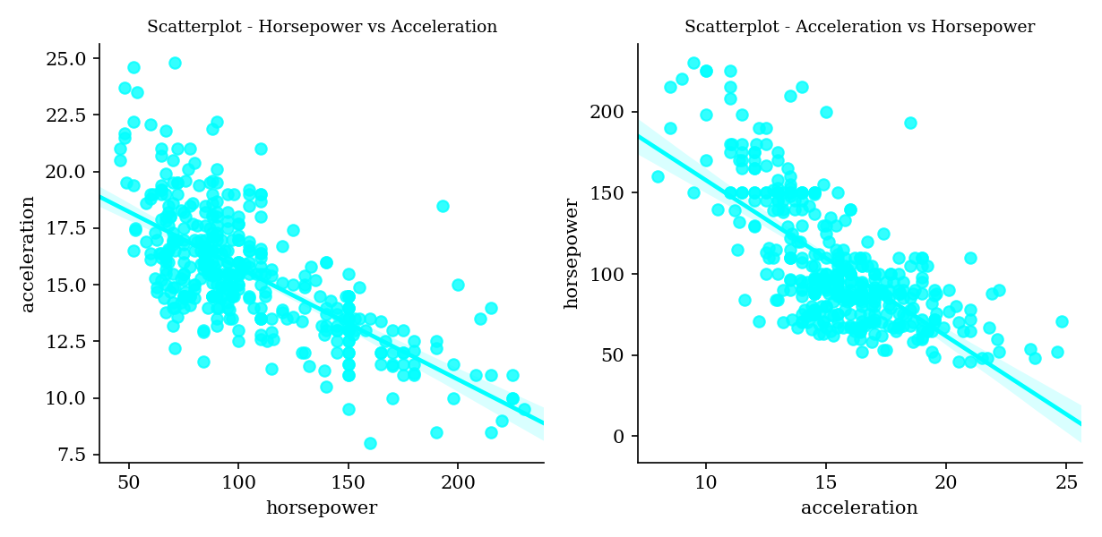

## 18. Horsepower vs Model_Year

Horsepower and Model_year have weak negative correlation (-0.42).

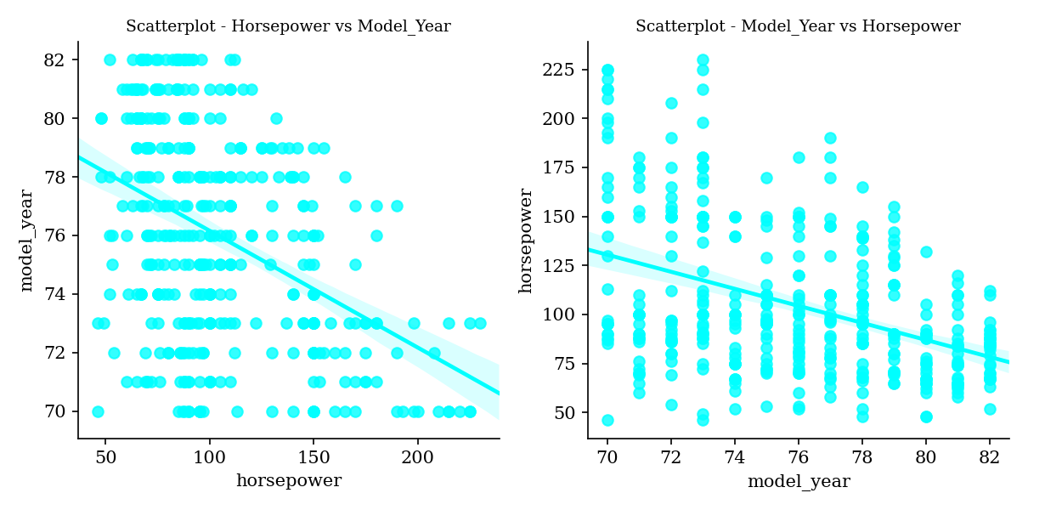

## 19. Weight vs Acceleration

Weight and Acceleration have weak negative correlation (-0.42).

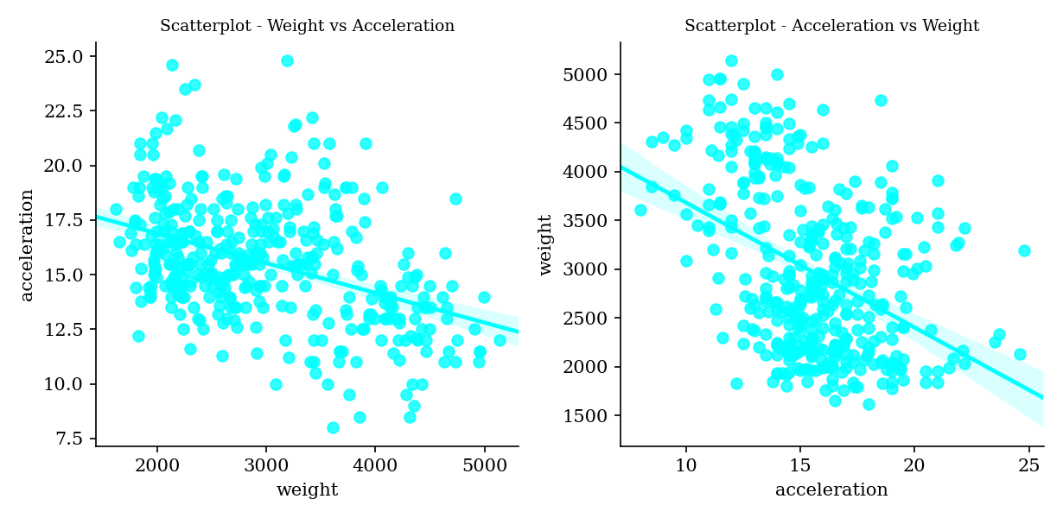

## 20. Weight vs Model_Year

Weight and Model_year have weak negative correlation (-0.31).

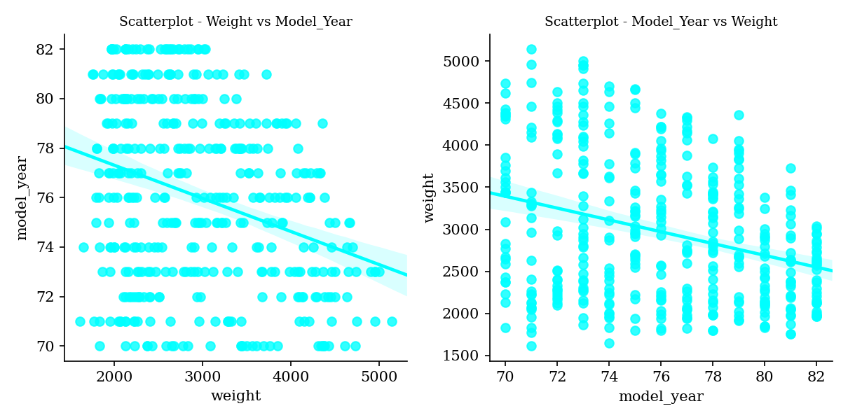

## 21. Acceleration vs Model_Year

Acceleration and Model_year have very weak positive correlation (0.29).

