Alexander J Freund, Timothy A. Romer, Dat Luong, Jaxson Wirth

Miami University

Department of Computer Science and Software Engineering

Oxford, OH, USA

{freundaj,romerta,dat...,Jaxson...}@miamioh.edu

1. **Introduction:**

What should CIA do to identify the leader of a terrorist group if the resources spent on investigating a person are costly? Where should a series of hospitals be constructed to maximize the number of people that are located near one? By measuring the centralities of a network, we can tell how important/ central a node is with respect to the rest of the network. Centrality measurement methods have been used for biological networks, applied to gene regulatory networks (Koshützki and Schreiber), and also used to assess the prospects for criminal intelligence (Sparrow) or even solving a financial crisis (Kuzubas et al.).

Calculating these centrality measures can be quite expensive in a computational sense which means that it takes a lot of time to calculate. To extend this even further, ranks are taken based on the calculation so nodes in the network each have a rank to compare rather than comparing the centrality values. The goal of this research is to identify whether certain centrality ranks can be accurately predicted using ranks of other centrality measures. form predictionsgenerate synthetic networks, measure the centrality of their nodes, and use these measures to build Forming such accuracy predictions has two advantages: we can use computationally efficient measures, and run them through a fast machine learning model, to predict the outcome of a more computationally demand measure. In addition to saving computation time, researchers can also spend less time generating repetitive information: if one measure can be directly derived from another that has already been analyzed, then there is no need to perform or analyze yet another measurement.

In this paper, we will be identifying various centrality measures and identifying whether a calculated metric can be predicted by other centrality metrics, with regards many types of network. Specifically, our main contributions are as follows as follows:

* Examines 7 different metrics for measuring centrality
* Assesses the correlation between metrics
* Computes the prediction of a metric based on other metrics
* Computes the accuracy of such prediction to identify whether that metrics is truly worth doing and interpreting

The organization of this paper is as follows. In the next section, we will provide a background on the metrics we will be using and the mathematical definitions behind them. Section two will also contain examples of a randomly generated graph and the centrality calculations/ranks will be discussed. Following this, the last section will provide detailed methods on how we generate different types of networks, compute centralities, compute the correlations, and prediction of the metrics.

1. **Background:**

Centrality is the measure of how central a particular node in a graph or network is and the general assumption is that it is typically located in the center of a network or graph (Freeman). There are many forms of centrality measure including simplistic measure such as degree, closeness, betweenness, and load. There are also more complicated measures that have been developed throughout history for other applications such as Page Rank.

In order to know if certain centrality measures are able to predict other centrality measures using different machine learning models, the centrality measures will have to be calculated on graphs that are generated a specified amount of times. These graphs feature scale-free, small-world, random, and scale-free small-world networks. Below will be a discussion on the different centrality measures that are used in this research.

**IIA. Degree Centrality:**

In network science, degree centrality has traditionally been considered to be the simplest measure of centrality and first item to look at when examining centrality (Opsahl et al.). Degree centrality can be defined as the ability for a node to receive information that is flowing through a network. This is measured by the number of links that node has to other nodes (Opsahl et al.).

Consider a given graph , defined as for vertices and edges. We denote the total number of vertices by N. The degree centrality for a vertex is defined as (Opsahl et al.).

**IIB. Closeness Centrality:**

Within graphs, a node is considered to have a high value of ‘closeness’ if it has a relatively low average of shortest path distance to all other nodes (Rochat). This is insinuating that a node with a high value is generally closer to all other nodes in the graph. To calculate this value, take one less than the number of nodes in a graph and divide it by the sum of the shortest path between a node and all other nodes in a graph.

The closeness centrality can be defined mathematically as follows. Closeness centrality is defined as where is the length of the shortest path between vertex y and x (Rochat).

**IIC. Betweenness Centrality:**

Betweenness centrality measures how many times a particular node is situated on the shortest path between two other nodes. This centrality measure is similar to the closeness centrality because both of them involve the calculation of the shortest path between nodes. To calculate this value for a given node v, count how many shortest paths between all pairs of nodes traverse v, and divide by the total number of shortest paths. (Brandes, "Maintaining the duality of closeness and betweenness centrality.").

The betweenness centrality can be defined mathematically as follows. The closeness centrality for a vertex is defined as where is the number of shortest paths between s and t given they contain vertex v and is the number of shortest paths between s and t (Brandes, "Maintaining the duality of closeness and betweenness centrality.").

**IID. Load Centrality:**

The load centrality measure is similar to the betweenness centrality in that it measures the amount of flow that goes through a particular node; however, the load centrality measures the unit amount of information that get split between other nodes. Information is continually split between adjacent nodes until the target is reached. The total amount of information that passes through the node is defined as its load (Brandes, "On variants of shortest-path betweenness centrality and their generic computation.").

The load centrality can be defined mathematically as follows. The load centrality for a vertex is defined as where is the quantity of information that is passed through vertex and are the set of vertices (Maccari et al.).

**IIE. Local Reaching Centrality:**

The local reaching centrality is the measure for a node and its proportion of all other nodes that are reachable in a graph of that particular node. This gives a fundamental assumption that all nodes that are reachable for a node are located in some finite distance away (Mones et al.).

The local reaching centrality can be defined mathematically as follows. The local reaching centrality for a vertex , for a given graph , where the graph can be defined as for vertices and edges is defined as where is the distance formula and is the number of vertices in a graph (Mones et al.).

**IIF. Harmonic Centrality:**

The harmonic centrality measure is similar to the closeness centrality however it addresses the issues of unreachable nodes. The harmonic difference will correct the issues with the average shortest path measure because disconnected nodes can have a potentially misleading value because the average distance could be low if the graph is almost entirely disconnected (Boldi and Vigna).

The harmonic centrality can be defined mathematically as follows. The closeness centrality for a vertex , for a given graph , where the graph can be defined as for vertices and edges is defined as where is the shortest average distance function (Boldi and Vigna).

**IIG. Page Rank:**

The page rank centrality measure has many applications including being the basis for how Google designed its search function (Page et al.). Page rank will rank websites based on the quality of websites that reference that particular website. In terms of networks, page rank will work in a very similar sense as it works in populating a search result. Page rank can be calculated iteratively and will return a probability that a node is accessed via another link. The page rank value at any particular time can be shown as where is the node that is accessed. The page rank for a vertex , for a given graph , where the graph can be defined as for vertices and edges is defined as where is the number of links from a node and c is a factor for normalization. page). Although this is a simplified definition of the page rank calculation, it should suffice for our simplified network application rather than ranking web pages for a search engine (Page et al.).

**IIH. Centrality Ranks:**

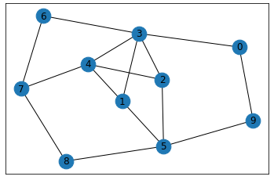

Figure 1. A randomly generated graph with ten nodes and fifteen edges.

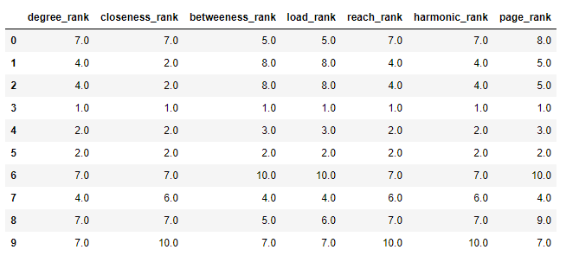

Table 1. The centrality ranks based on the graph depicted in Figure 1.

Using the centrality measures that were highlighted in this section. A random graph was generated and centrality measures were calculated using Networkx 2.3 python library that specializes in networks. Based on the calculations, ranks were obtained after calculating the centrality values then comparing the values with the other vertices in the graph. Figure 1 shows the random graph that was created by the library and Table 1 shows the centrality ranks from the graph.

1. **Methods:**

**IIIA. Resources Used:**  
   
 In order to work with network based systems and analyzing them computationally, we worked with four important Python libraries: Pandas, Numpy, and NetworkX, and scikit-learn. Pandas and Numpy primarily allow us to work with data in general, NetworkX is used to generate network data and measure their centrality, and scikit-learn implements our methods for machine learning.

**IIIB. Overall Process**  
   
 Our data comes from generating data for each of the combinations of scale free and small world; being random, only scale free, only small world, and both scale free and small world. We generate 100 graphs for each type, further subdivided in that by taking 25 of each specified size within the array [100, 200, 400, 800]; thus creating a total of 400 different graph samples.  
 The specific data we are working with is found from a variety of NetworkX functions that allow us to take the data given a graph. The specifics we are working with are as follows; both degree and closeness rank are taken from NetworkX’s degree centrality method, betweenness ranking is taken from the betweenness centrality method, load rank is taken from the load centrality method, and reach rank is taken from the global reaching centrality.  
 Using this data we then calculated correlations, between each element. To calculate this we simply used Pandas’ correlation method. From there we specified to calculate for these three different correlations: pearson, spearman, and kendall.

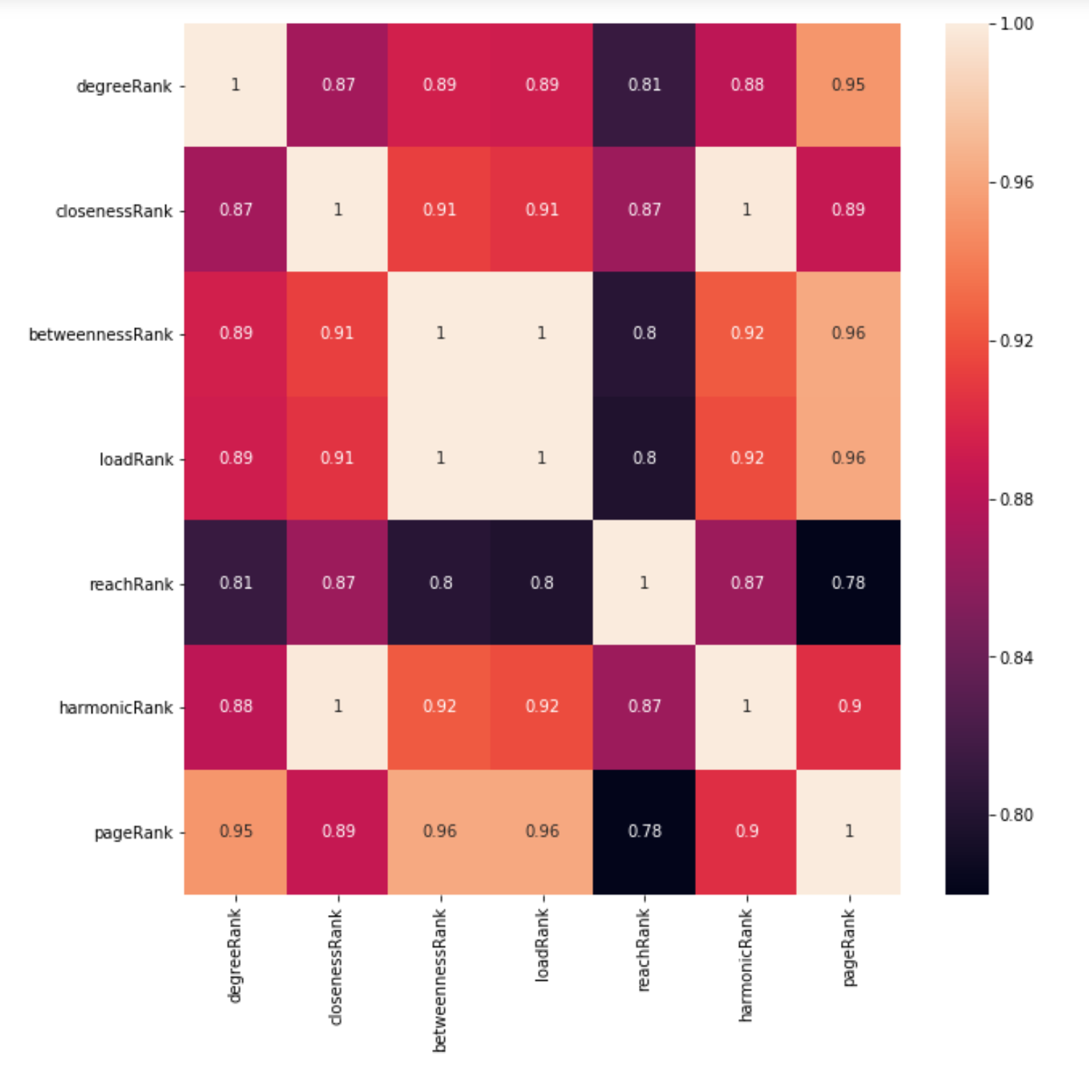

Fig. 8. Correlation Heatmap

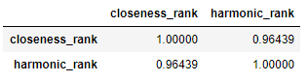

Table 2. Correlation table for closeness rank and harmonic rank for the graph depicted in figure 1.

An important note on correlation, the graph depicted in Figure 1 is a simple graph with all of the nodes connected to one another. So, it should be expected that the results of calculating the harmonic centrality to be similarly ranked as the closeness centrality ranking. In fact, there is an expectation for harmonic centrality to be closely correlated to closeness centrality (Boldi and Vigna). As you can see in Table 1, the closeness ranks, and the harmonic ranks are very close together and the nodes typically have the same rank and show a strong correlation as shown in Table 2.

1. Data Pre-Processing  
     
    As with all forms of machine learning, in order to produce accurate results it is important that we thoroughly clean the data. The process is consistent across each separate machine learning process we use, and will be detailed in this section.  
    First, we create the class outcome columns. The first step of this is to create a dictionary with the max ranking node for each network and centrality type. From there we simply create a binary list for each network type, where the list is comprised of 1 if a network is within the top 25%, and a 0 otherwise.  
      
    Following from that, we must simply split the data and balance it. We split the data with an 80:20 training:testing ratio. The balancing is a simple process of removing the majority until it has the same population as the minority.  
    Finally, we perform a 10-fold cross-validation on the training data.
2. Machine Learning  
     
    Our machine learning process is completed via SKLearn, where we use three different classifiers. The classifiers used are the random forest classifier, decision tree classifier, and the support vector classifier. These classifiers are all supplied via SKLearn.
3. **References:**

[1] Koschützki, Dirk, and Falk Schreiber. “Centrality Analysis Methods for Biological Networks and Their Application to Gene Regulatory Networks.” Gene Regulation and Systems Biology, vol. 2, 2008, doi:10.4137/grsb.s702.

[2] Sparrow, Malcolm K. “The Application of Network Analysis to Criminal Intelligence: An Assessment of the Prospects.” Social Networks, North-Holland, 3 July 2002, https://www.sciencedirect.com/science/article/pii/037887339190008H.

[3] Kuzubaş, Tolga Umut, et al. “Network Centrality Measures and Systemic Risk: An Application to the Turkish Financial Crisis.” Physica A: Statistical Mechanics and Its Applications, North-Holland, 12 Mar. 2014, https://www.sciencedirect.com/science/article/pii/S0378437114002003.

[4] Boldi, Paolo, and Sebastiano Vigna. "Axioms for centrality." *Internet Mathematics* 10.3-4 (2014): 222-262.

[5] Brandes, Ulrik. "On variants of shortest-path betweenness centrality and their generic computation." *Social Networks* 30.2 (2008): 136-145.

[6] Brandes, Ulrik, Stephen P. Borgatti, and Linton C. Freeman. "Maintaining the duality of closeness and betweenness centrality." *Social Networks* 44 (2016): 153-159.

[7] Freeman, Linton C. "Centrality in social networks conceptual clarification." *Social networks* 1.3 (1978): 215-239.

[8] Goh, K-I., Byungnam Kahng, and Doochul Kim. "Universal behavior of load distribution in scale-free networks." *Physical Review Letters* 87.27 (2001): 278701.

[9] Langville, Amy N., and Carl D. Meyer. "A survey of eigenvector methods for web information retrieval." *SIAM review* 47.1 (2005): 135-161.

[10] Maccari, Leonardo, et al. "On the distributed computation of load centrality and its application to DV routing." *IEEE INFOCOM 2018-IEEE Conference on Computer Communications*. IEEE, 2018.

[11] Mones, Enys, Lilla Vicsek, and Tamás Vicsek. "Hierarchy measure for complex networks." *PloS one* 7.3 (2012): e33799.

[12] Opsahl, Tore, Filip Agneessens, and John Skvoretz. "Node centrality in weighted networks: Generalizing degree and shortest paths." *Social networks* 32.3 (2010): 245-251.

[13] Page, Lawrence, et al. *The PageRank citation ranking: Bringing order to the web*. Stanford InfoLab, 1999.

[14] Rochat, Yannick. *Closeness centrality extended to unconnected graphs: The harmonic centrality index*. No. CONF. 2009.