Weak prompts:
- Explain regression
- Help me understand SQL
- Create a dataset

Improved prompts:
- In the context of a data scientist, explain regression using a short explanation then examples with added bullet points for each explanation. Keep it under 500 words.
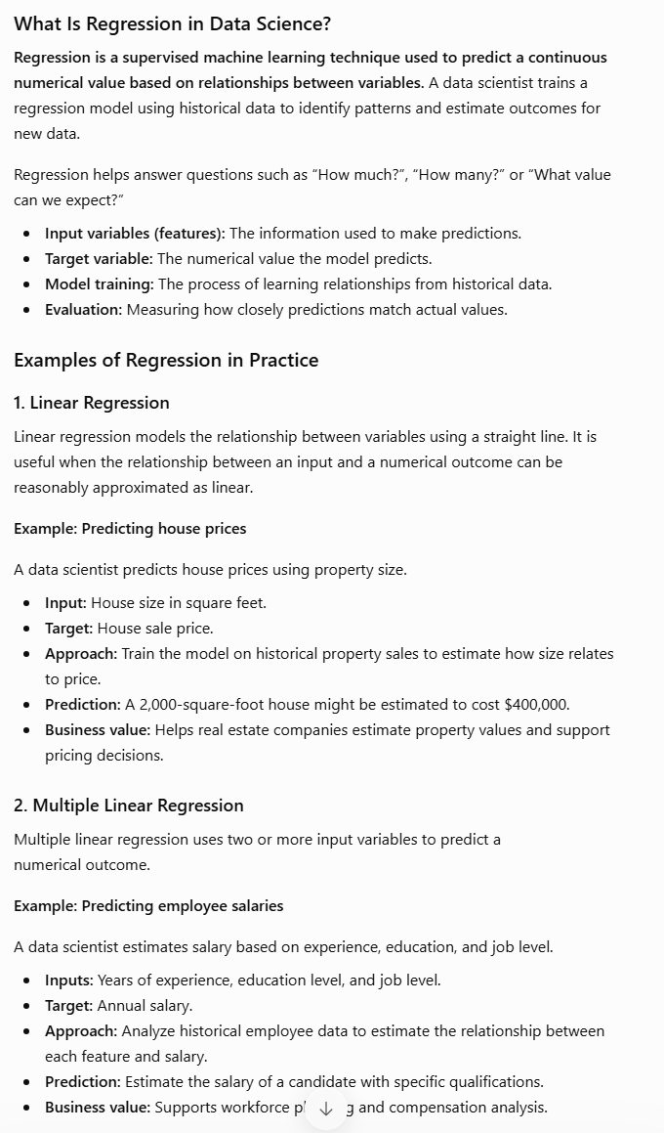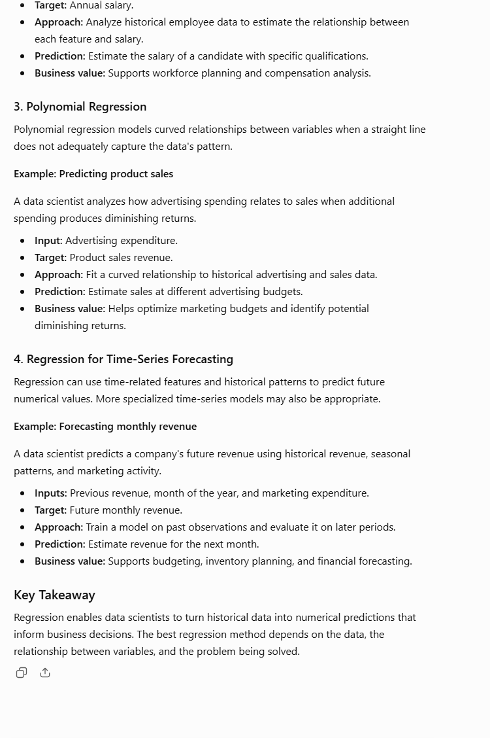
This prompt is improved because it tells the AI the context and which definition of regression it should explain. It gives instructions on format, organization, and a restraint to keep the output short.

- As an instructor, teach a college student who has no prior information about the basics of SQL. Go through the core essentials with examples and a short bullet point list explaining each topic.
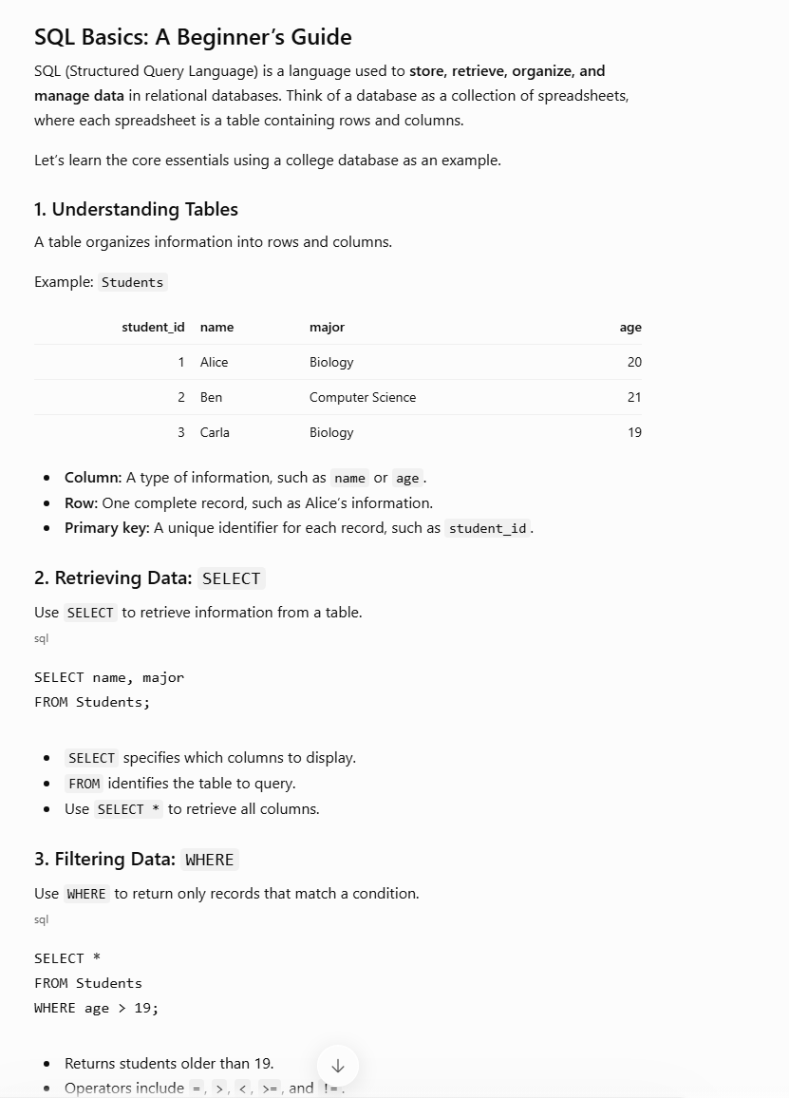 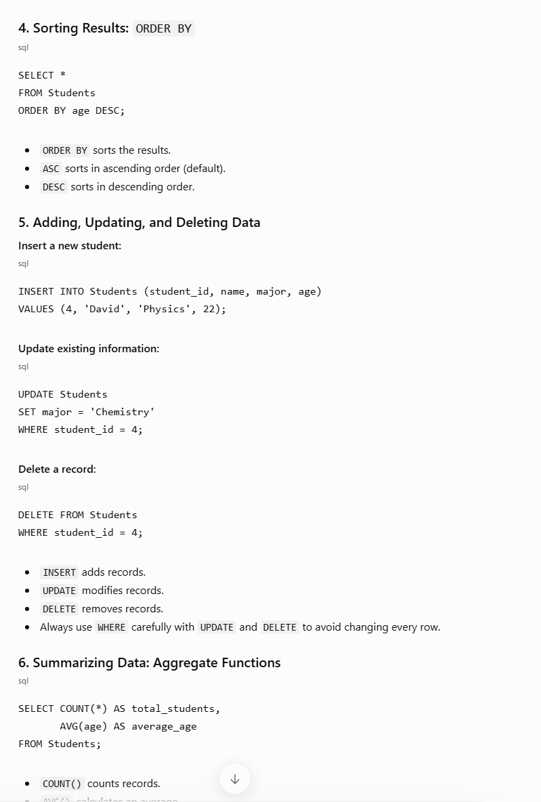
This prompt is improved by providing a role and an audience. It also explains how to organize and format the information with a constraint so the output isn’t too long.
- Make me a dataset for the last 10 years on average housing pricing in the bay area, CA, labeled with the year and the average prices. sort from oldest to newest.
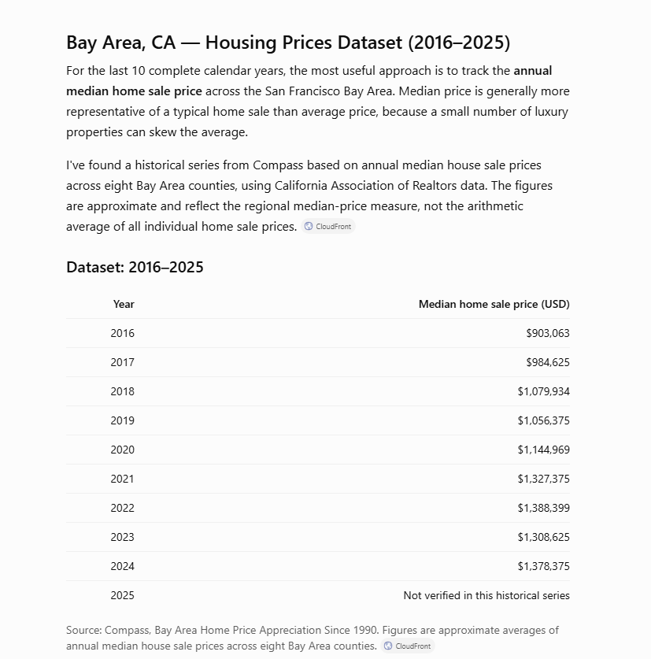
This prompt is improved because it gives a specific topic and tells the AI how to organize the information.

