* **Offset fix**
  + Fit linear y=ax
    - Back and fort
  + Fit met fminsearch
* Error plot around 0

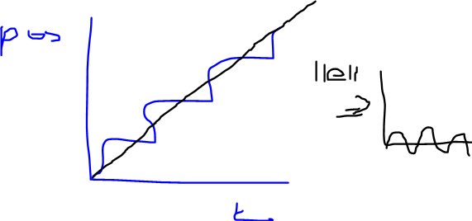

* **Waveform fminsearch on error on interval**
  + At alpha is pi/2 en pi
  + Clams and shears simultaneaously
* Result improved waveforms for (more)monotone error

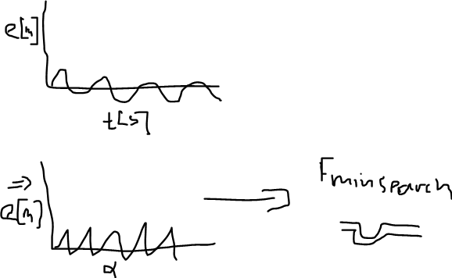

* **Alpha ILC**
  + Time domain
* Result reference and output on each other (probably by shifting)

