Contents

**Report** 2

**Section 1:** 2

**Section 2:** 2

**Section 3:** 3

**Section 4:** 3

**Section 5:** 13

**Report**

**Section 1:**

A concise table containing a checklist of the features you have been able to implement. Please refer to the features list given above in the specification.

|  |  |
| --- | --- |
| **Feature** | **Implementation** |
| a) | * Fully implemented |
| b) | * Fully implemented |
| c) | * Fully implemented |
| d) | * Fully implemented |

**Section 2:**

A concise list of any bugs and/or weaknesses in your app(s) If you don't think there are any bugs or weaknesses then say so though this is quite unlikely. Bugs that are declared in this list will lose you fewer marks than ones that you don't declare!

List of any bugs and weaknesses:

* Flyout Item: I cannot create own layout. Therefore, it is not possible to remove fixed icons in Column 0 so there will still be an icon.
* Popup Filter: It is not possible to create Popup Filter as the original interface on the website.

**Section 3:**

A brief (less than half a page) description of any special strengths of your app(s) that you think should be taken into account in awarding a mark. Please be very specific and realistic in this: vague statements such as "it is easy to use" or "it is well designed" will not gain you marks.

This application is written in Xamarin (IDE: Visual Studio 2019 Community). Xamarin.Forms is an open-source UI framework. Xamarin.Forms allows developers to build Xamarin.Android, Xamarin.IOS, and windows applications from a single shared codebase.

Xamarin.Forms allows developers to create User Interfaces in XAML with code-behind in C #. These interfaces are rendered as performant native controls on each platform.

In addition, the application uses Firebase as Database and data saved as JSON.

Basically the app has shown the main functions of the App are adding, deleting, editing, searching, detailing the required information.

**Section 4:**

Screen shots demonstrating each of the features that you have implemented. Give captions or annotations to explain which features are being demonstrated.

a) Fully implemented (Design app screens - Basic details input screen): Here are all the screen of the app

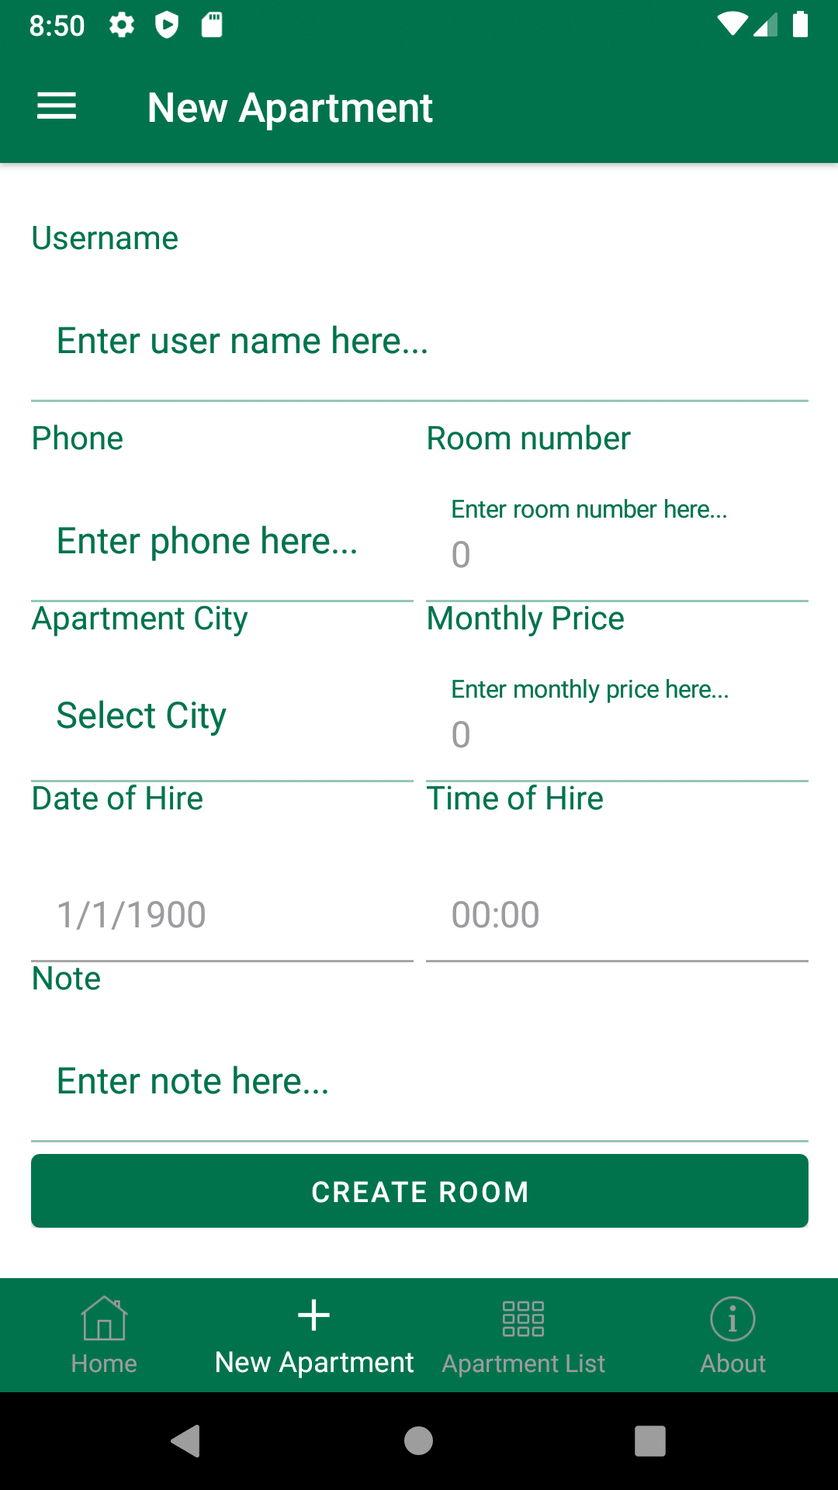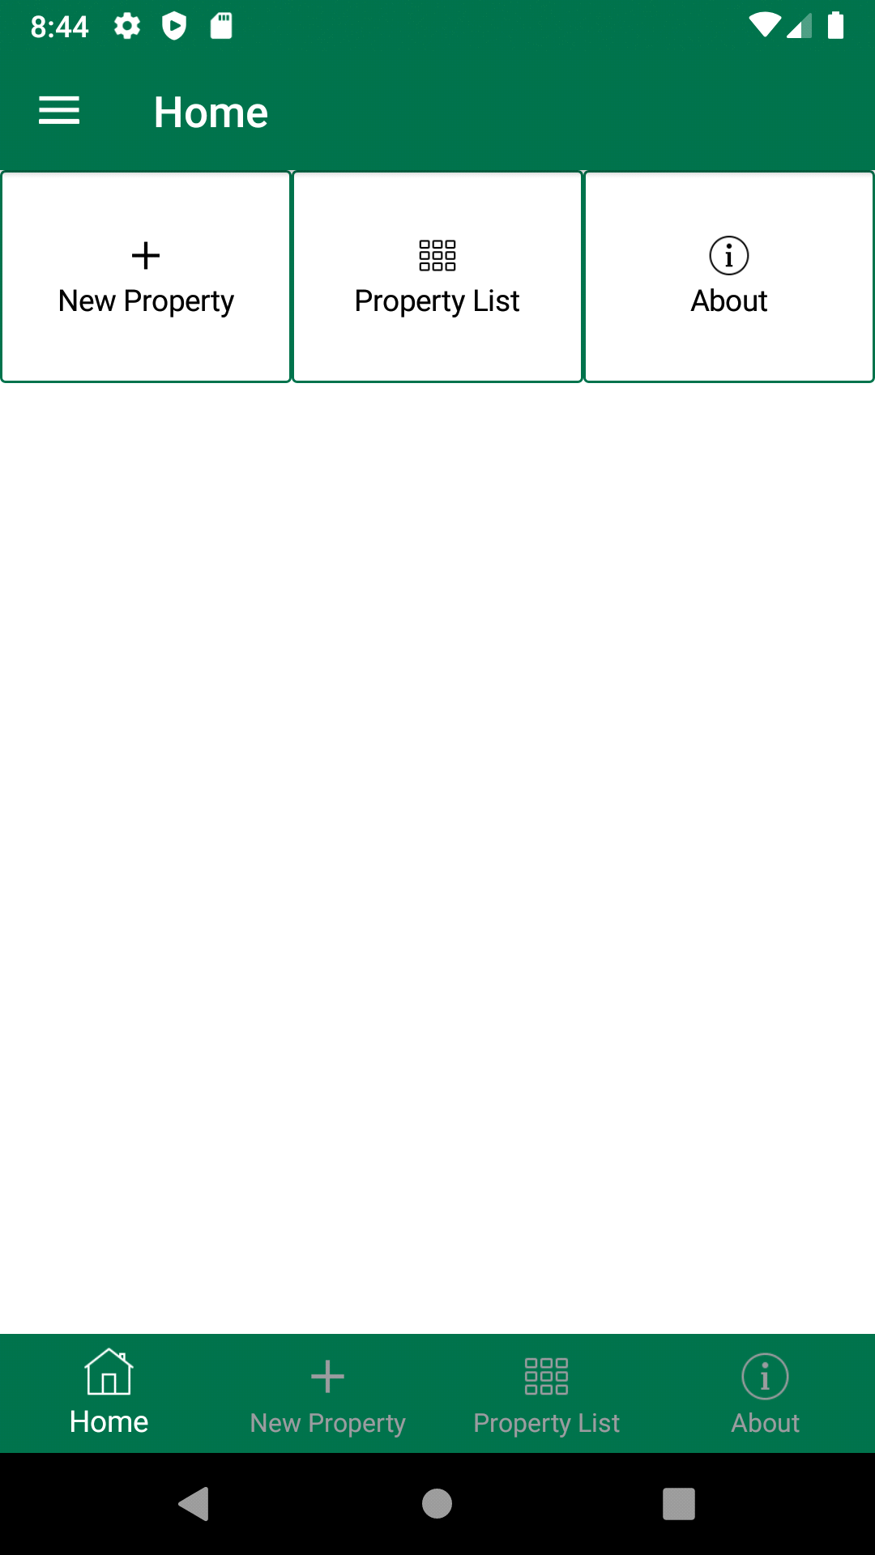

• Design app screens: Home Page and New Apartment Page

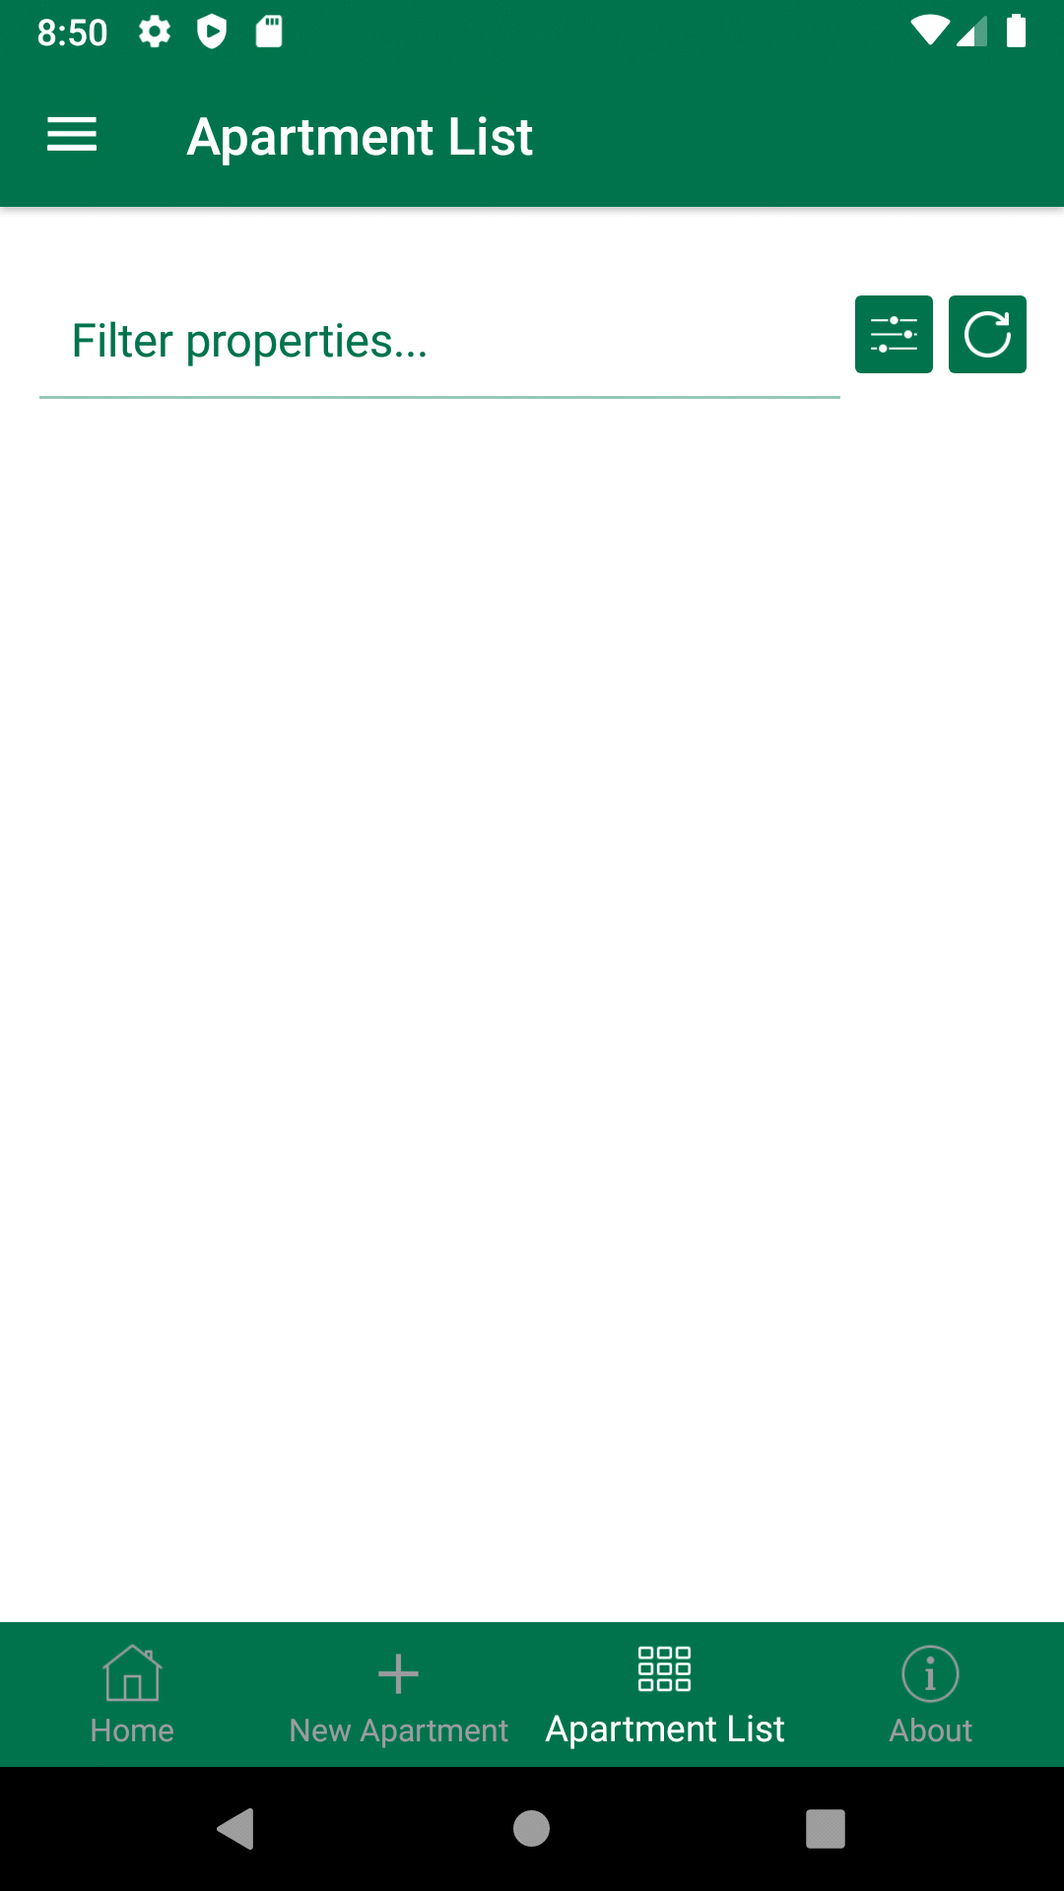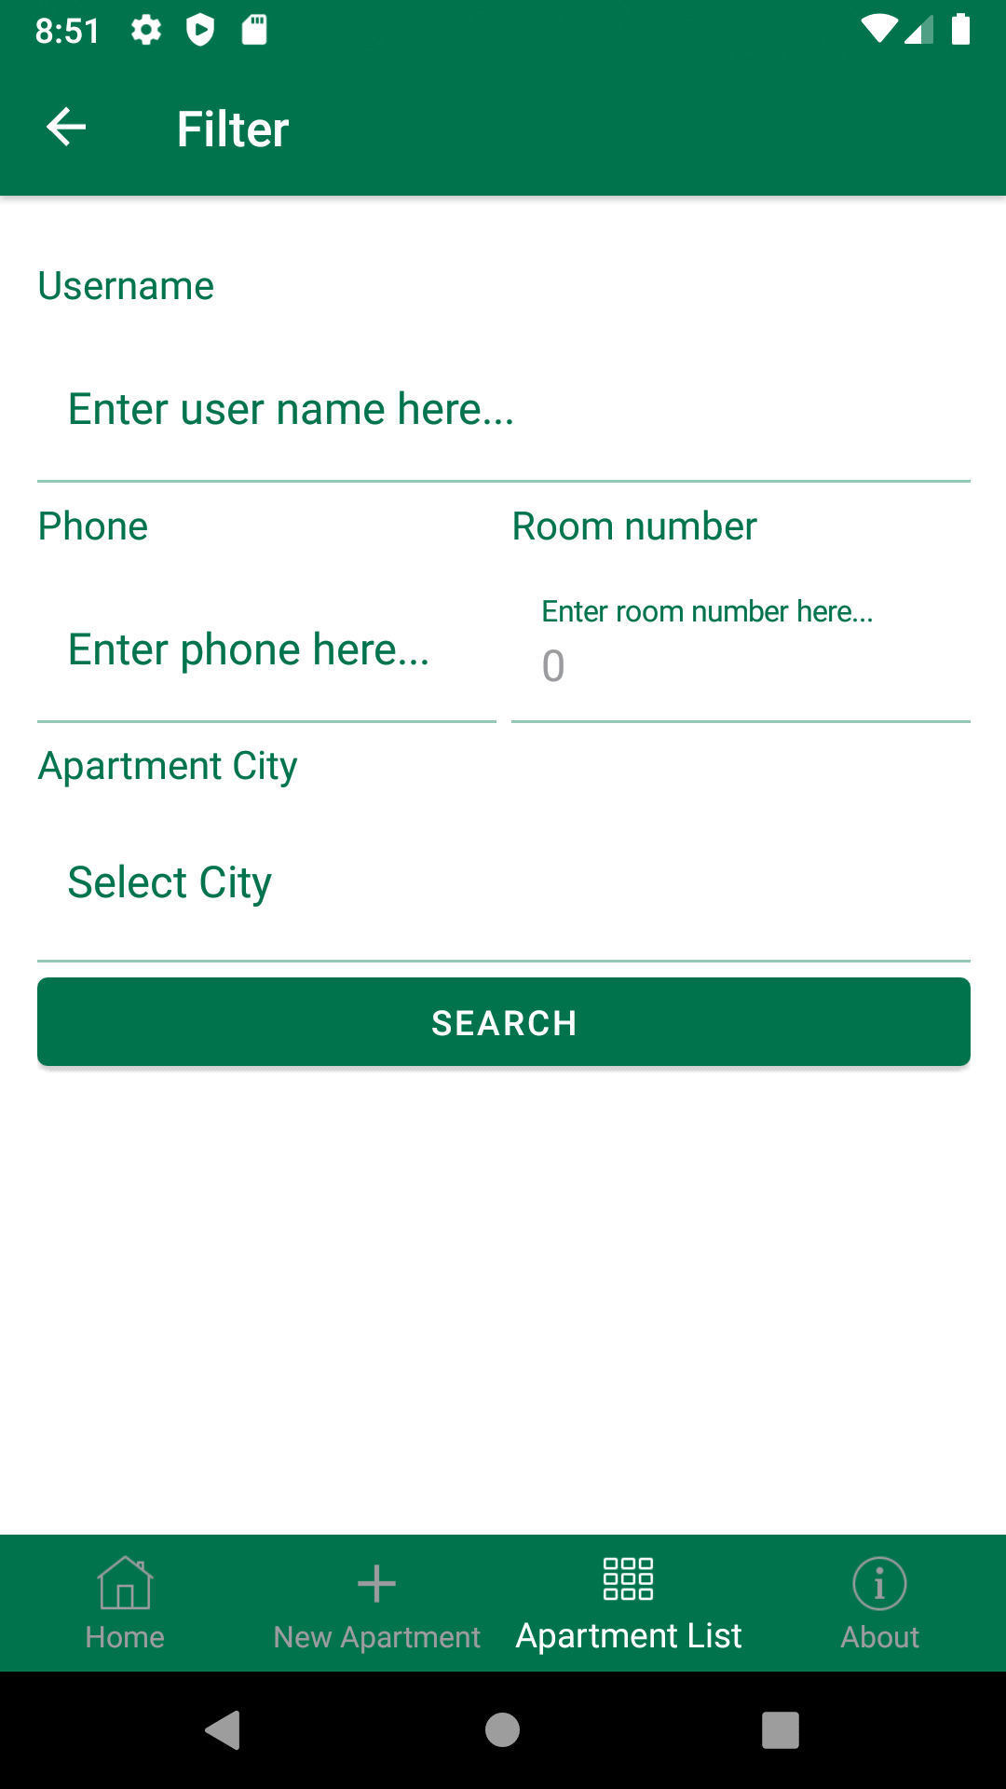

• Design app screens: Apartment List Page and Filter Page

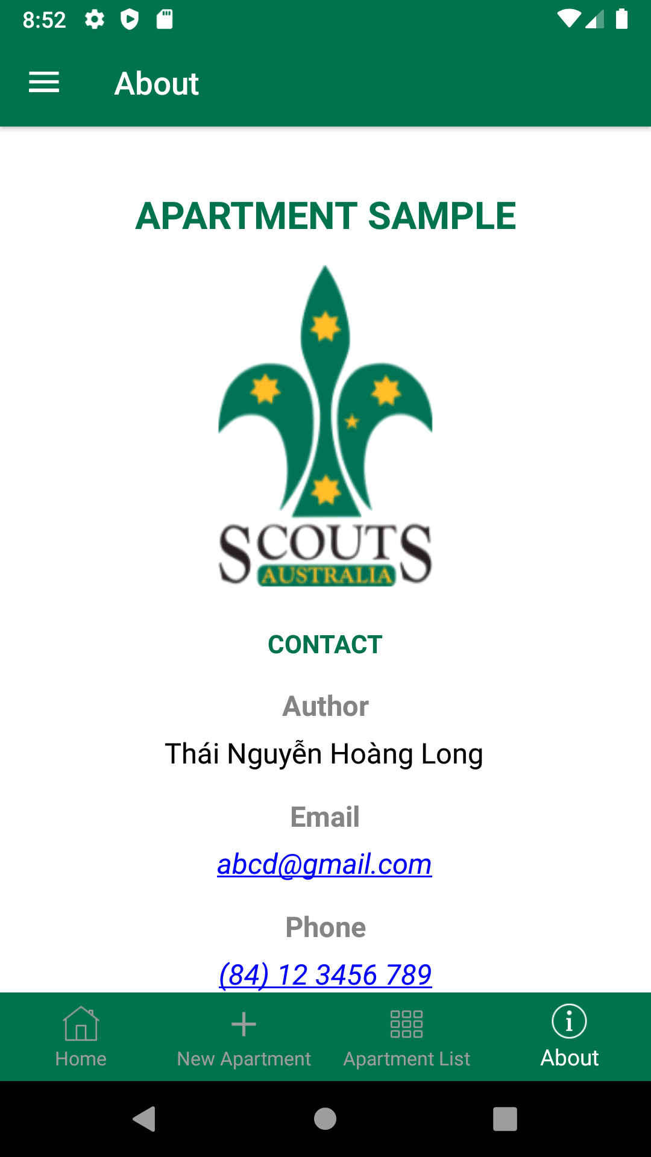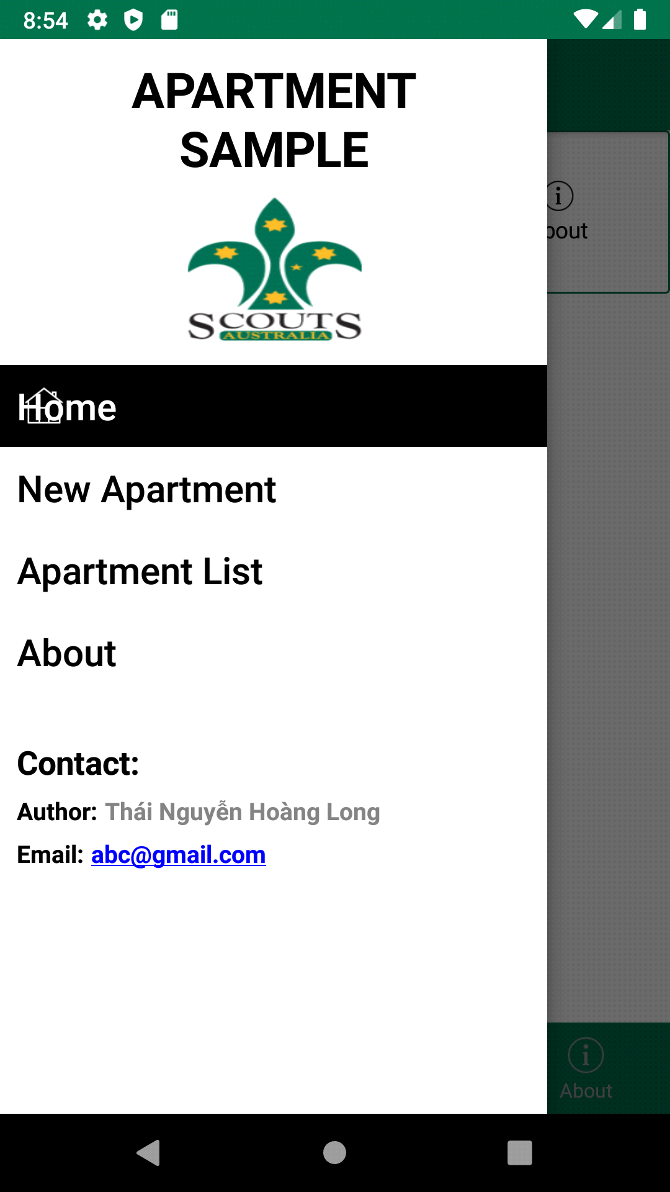

• Design app screens: About Page and Menu Flyout Item

b) Fully implemented (Implement forms validation):

• Required field: Username, Phone, Room Number, Apartment City, Monthly Price, Date of Hire. The app will check the input and if the user doesn’t enter anything in one of the required fields the app should display an error message to the user.

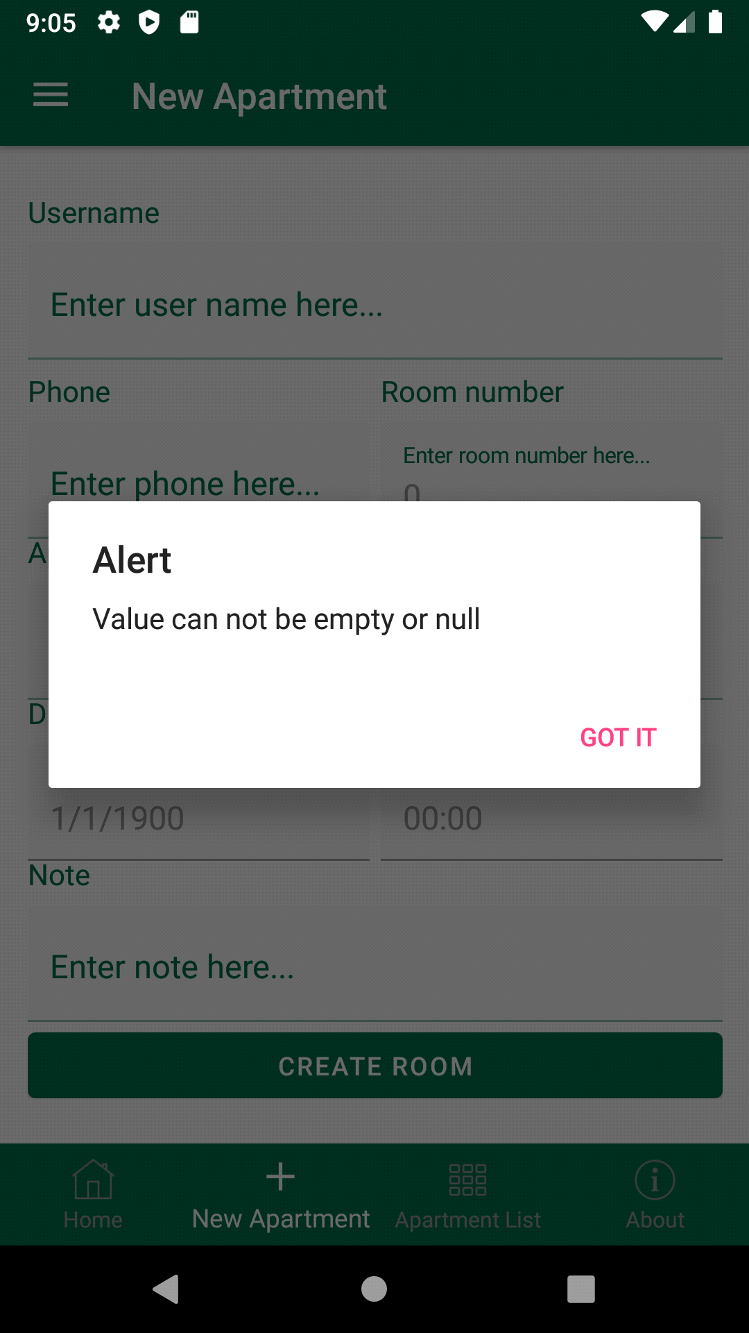

• Optional field: Time of Hire, Note. The user can enter something if they wish but they will not get an error message if they don't enter anything.

• Once the details have been accepted by the app (e.g. no required fields were missing) it should display the details back to the user for confirmation and allow them to go back and change any details that they wish

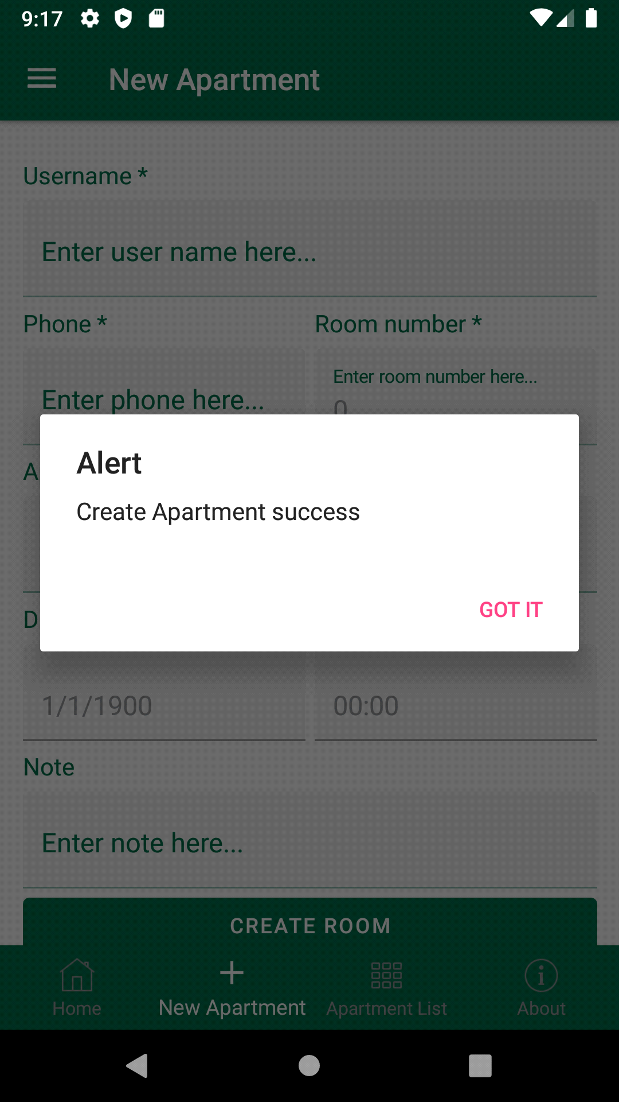

• When the user has completed the necessary fields, it will appear to create a success form

c) Implemented but sometimes it gives an exception. I haven't been able to debug this

(Store, view and delete the basic details and check for duplicate events):

• All the details entered by the user should be stored on the device in a Web Database

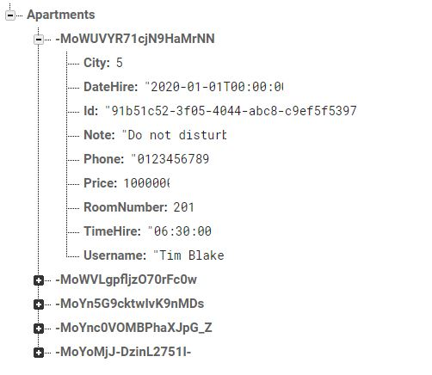

• The user should be able to list all the details for all events entered into the app

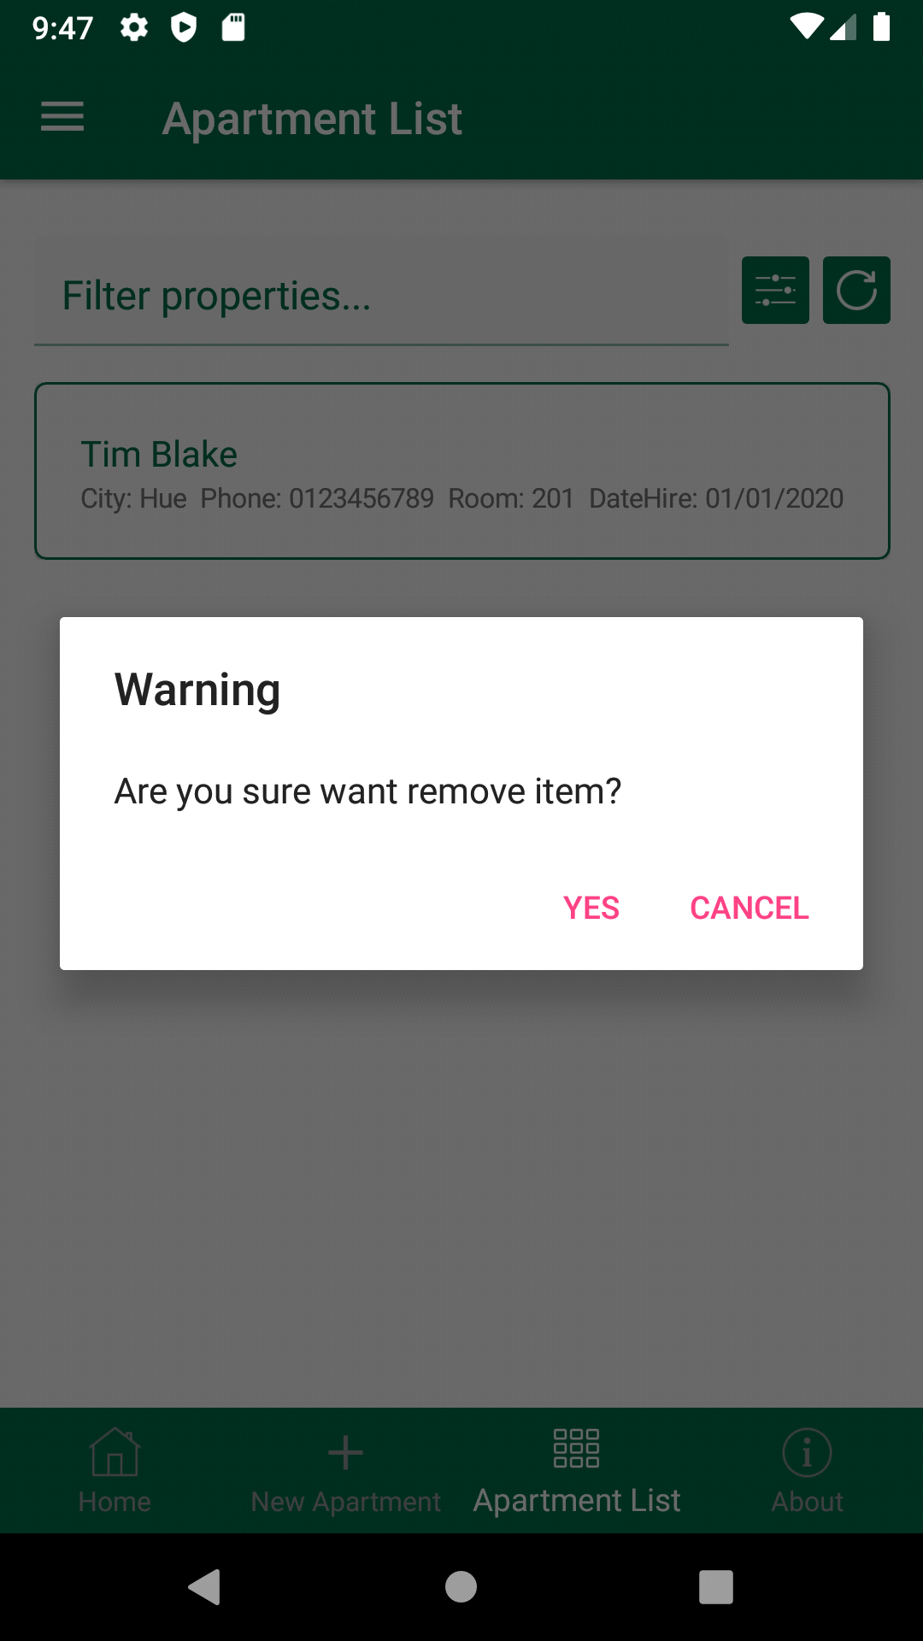

• The user should be able to delete all the details from the database



d) Implemented but the app can only do a simple search by event name (Search):

• The user should be able to search for an event. At its simplest this could mean entering or selecting an event name and displaying the details information about that event. Ideally the user should be able to enter more details and search for an event that match

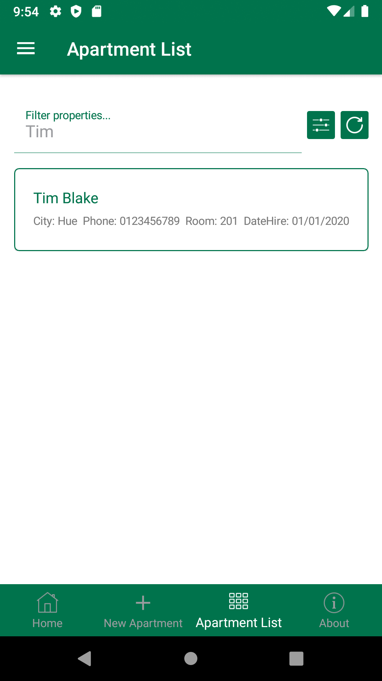

• Search with Username field

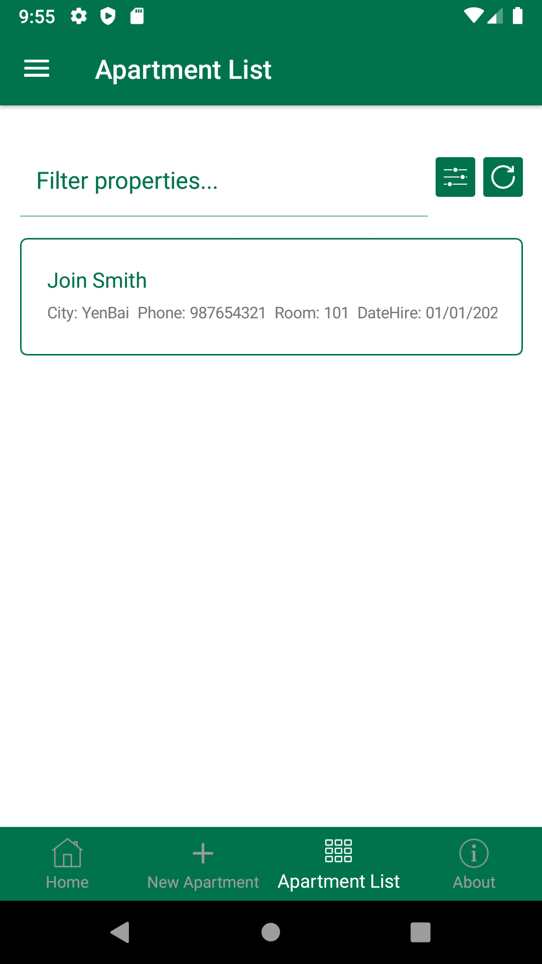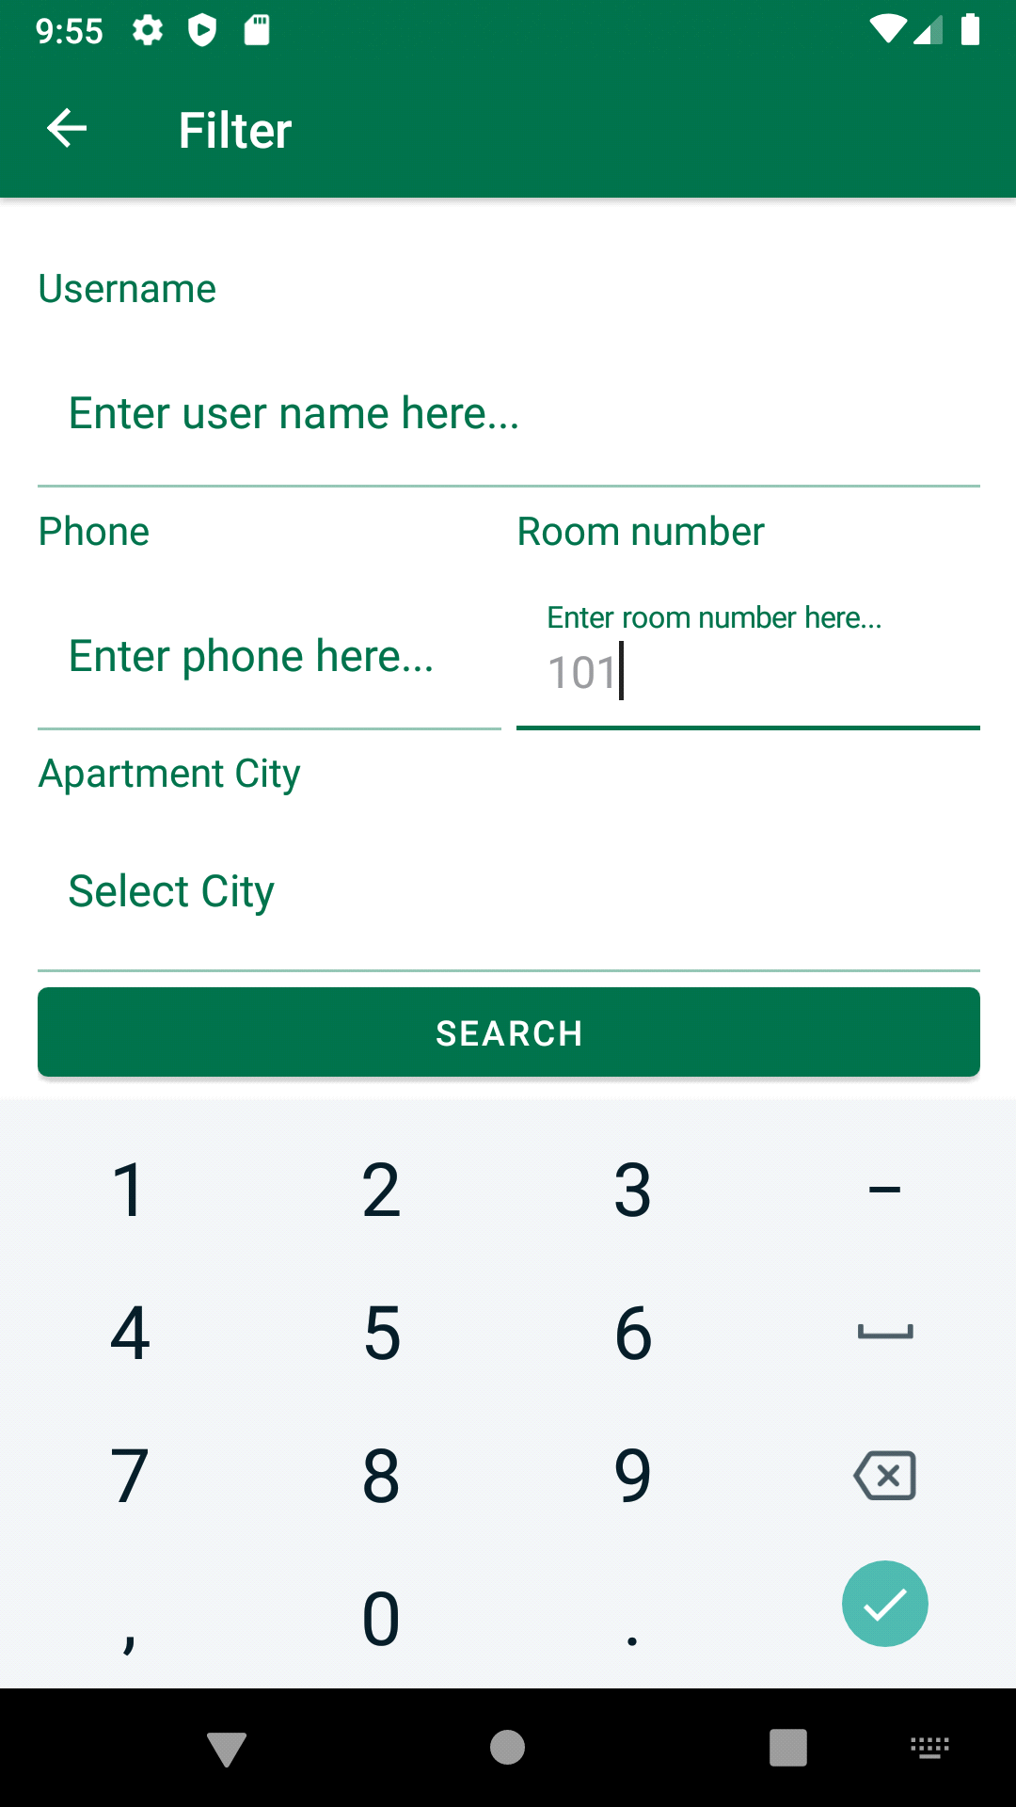

• Search with Filter field

**Section 5:**

An evaluation of your app(s). Write between 300 and 500 words evaluating the app(s) that you have produced. Be specific and justify any statements you make. Just saying things like ‘my app is well designed" without justifying the statement will not gain you any marks. Also explain how your app could be improved. Again, you need to try to be specific e.g. saying something like "It needs to be made more secure by adding security features" will not gain marks. Your evaluation should include, but need not be limited to, the following aspects of your app:

This application is called Apartment Xamarin. Application with the main function is booking, searching room and displays the basic information of Vendor. The interface is designed according to Material Design.

App write in Xamarin Form. Xamarin.Forms Is an Open-Source UI Framework. Xamarin.Forms Is for Developers with the following goals:

• Share UI Layout and Design Across Platforms.

• Share code, test and business logic across platforms.

• Write Cross-Platform Apps in C # with Visual Studio.

Xamarin.Forms provides a consistent API for creating UI elements across platforms.

App is written under the MVVM model (Model - View – View Model) is a separation pattern that was based on the MVP (Model - View - Presenter) Pattern. It's very popular in XAML and some Web Development.

As a separation pattern MVVM aims to provide 3 specific benefits:

• Collaborative Working

• Code reuse

• Ease of Testing

Currently, the app will have an interface suitable for multiple screen sizes and platforms (Android - IOS).

However, the size font still has not changed according to each platform fixed. This leads to small screen phones that will have quite large controls.

Besides, the App does not have any security and the Database also has no security resulting in data and app very weakness to hackers invading and stealing data.