Our Terraform code is using keybase to create login passwords for our iam users. To run the code portion where keybase is used, you may need to install keybase on your system. Here’s how to install it:

1. Go to keybase.io
2. Install keybase for your OS (follow the instructions on keybase.io -> install)
3. After installation, go Linux User Guide link (keybase.io -> install -> Linux User Guide – many useful keybase commands there)
4. Run “run_keybase” command. Make sure you see “success!” on the screen. You may or may not be able to run “run_keybase” command as a root user (I ran into a problem). If you see an error running it as a root, simply create a regular user and run “run_keybase” as that user. Keybase is now running.
5. Run “keybase pgp gen” to generate a pgp key in your secret keychain

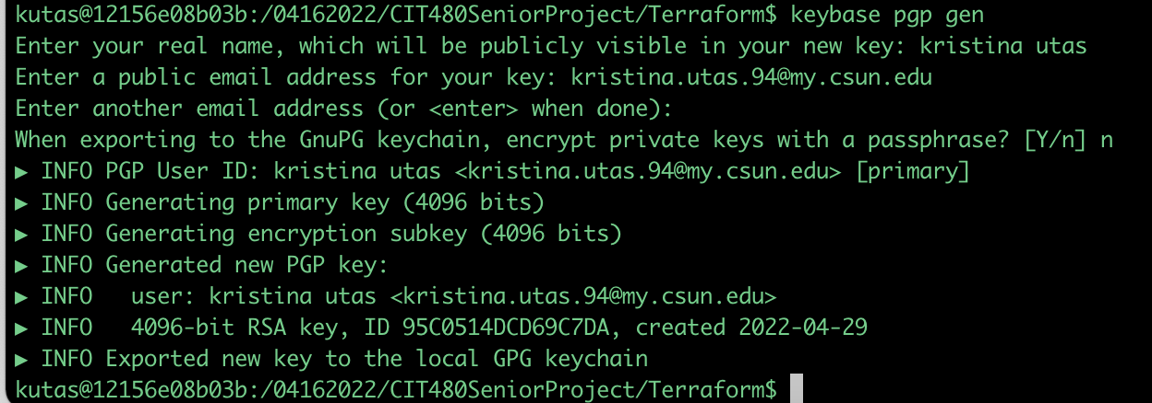

1. You may or may not be able to use my keybase account (my keybase account id is “cit481”). At this point, try running our terraform code and see if you run into any errors. If you don’t, skip to the step called TEST. If you do run into a problem, create your own keybase account. Here’s how:
2. Run “keybase signup” to create an account

1. Run “keybase id” to show your keybase id (you will need it to plug into Terraform code)
2. Go to Terraform -> iam -> main.tf. On line 34, find “keybase:”. Instead of “cit481” that follows “keybase:”, plug in your own keybase id. Save nad close. “Run terraform apply”.
3. TEST:

* Log into your aws account as root
* Go to IAM
* Find users that Terraform created and their special login links.
* Copy and paste one of the console sign-in links (ex. Link for “tabad”) Graphical user interface, text, application, email

  Description automatically generated
* Use login “tabad”

* To find this user’s password, run “terraform show”
* Find a key for your user (ex. tabad)

* To decode, run “echo "plug_your_encrypted_password_here”| base64 --decode | keybase pgp decrypt

It will look something like this, where the highlighted part is your decrypted login password:



* Use this password to sign in as tabad
* You will be asked to reset your password. Use Upper-and-lowercase letters, symbols, and numbers

