# MagMapper

See Andrews's latest version of docs (15th Dec 23 MagnetMapperDocumentation-centre) for more details. This documentation will attempt to provide only information relevant to the operation and adjustments by Timothy Allen. Heading 3 (smallest) headings indicate extra information, which is hopefully unnecessary.

Currently, only rotational measurements are taken. Rectangular measures do not align correctly when measuring an entire plane. The exact reason for this is unknown, but it may be that the motors are jumping or overshooting incorrectly.

## Operation

Take care with the neodymium magnets as they are very strong and may shatter if released directly onto ferromagnetic solids. Wrapping in paper towels, except when necessary, is recommended when getting used to this.

Taking measurements overnight is preferred (although good data may be acquired during the day), barring access to the region directly around the MagMapper and encouraging quiet is recommended due to apparent interference in resulting measurements.

Step 1: Turn on the connected computer.

Step 2: Turn on the MagMapper rig (there is a red switch in addition to the wall plug) and the hall sensor (power supply required).

Step 3: Verify the TCP/IP connection.

Step 4: Open the LabView code.

Step 5: Initialise.

Step 6: Move the boom position with relative or absolute movements if necessary. Insert the magnet in the holder on the table. If this is the first measurement, then the appropriate z coordinate must be determined (being aware that the coordinates vary by several hundred microns each time the rig is initialised).

Step 7: Calibrate.

Step 8: Enter the desired extent of slice/plane/volume coordinates to measure.

Take care that some axes run as negatives; refer to the stickers on the rig for specifics. The rig is designed to start nearest 0, 0, 0. The LabView code does not currently correct reversed start/stop values and incorrectly signed step values. To step in a negative direction, use a negative step.

If the connection is not correctly established, close LabView, turn off the rig and return to step 2. Slight changes in the order can make the connection fail; also, LabView sometimes will just fail. (These steps also solve several other errors presented by LabView).

Step 9: Click run and choose a file to save.

## Python Data Processing

Adjust the path to the files to be processed in the main function, then choose the desired output(s), e.g., plot_3d, print_characteristics.

### Debugging/extending

I do not expect to have completed the code very far past the current primary use case of rotational measurements, and, as such, it likely still contains many TODOs.

This code works by attempting to determine the format/type of measurement presented and then instantiating a class for that format. The methods provided to that class then perform specific processing tasks.

Comments or, more significantly, the code itself should be used to determine use beyond this point as the state of the code will likely change rapidly.

An example flow with reasoning may be added here:

Take rotational measurements with changing x OR y (not both) values and optionally changing z values and save the data.

Change the glob.glob unix style path to include the saved data or set the path variable to the file path.

Uncomment the data.print_characteristic() line to find the overall inhomogeneity.

Uncomment the data.plot_3d() line to visualize the magnetic field.

## LabView Code

The version of the LabView code, which should be included with this, has been modified to centre the hall sensor automatically. This reduces human error and workload regarding centring. Should they be needed, several other versions of the LabView code exist in various places on SharePoint and the R drive.

Both llbs and separate SubVis should both be provided. The llbs ensure that the correct SubVis are used (they have been modified in some cases) while separate SubVis ensure that the data is not lost if any SubVi within the LLB becomes corrupted.

### Details

The MagMapper will take measurements and find the most significant difference in voltage values as the base rotates discretely. It will then iterate through taking steps in x and y directions to minimise this (assuming it starts relatively close to the centre <5mm). This method is preferred to taking continuous measurements as the table spins due to improved consistency in the location of measures, leading to a more accurate picture of the change in voltage at the current coordinates.

Practical distances are 1mm (very rough), 0.05mm (minimum step size) and 0.00625mm (micro-step size, not recommended: did not provide apparent improvement).

It also includes a reformatted block diagram intended to improve readability, an indicator of when the MagMapper is locked and an adjustment of the standard deviation calculation to use the Bessel correction (only ~0.1% change from the previous with 1000 samples). A proper unbiased correction was found unnecessary within the LabVIEW code and can be done in the analysis if needed.

## Pitfalls

Centering

Improperly centred measurements will lose data at the geometric centre of the magnet.

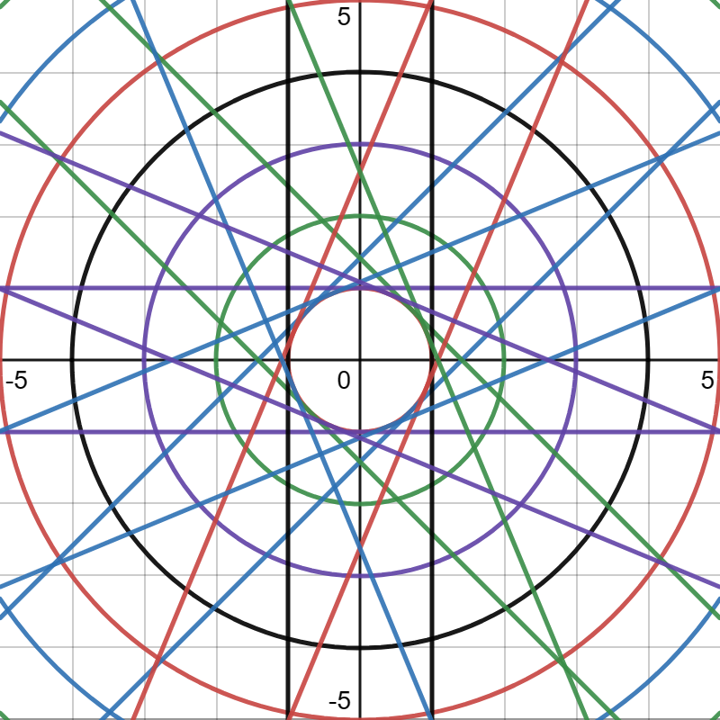

Demonstrates this problem, lines are where the hall sensor moves and intersections are where measurements will be taken.

With low resolution changes to the centre point may cause significant changes to apparent inhomogeneity.

## Rotor dynamics

As a first order approximation aligning centres of magnetism or having them 180 degrees out of line should lead to cylindrical or conical rotating modes respectively.

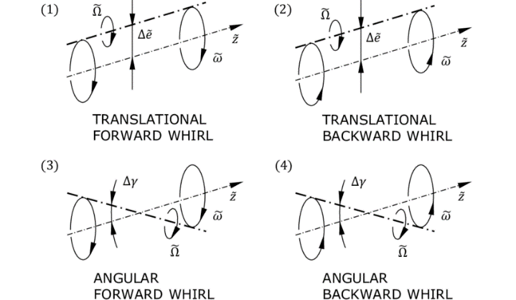

Where cylindrical mode in on top and conical is on the bottom.

## Further work

Evaluation of the effect of the orientation of centres of magnetism on the horizontal bearing could be done with the MagMapper. The initial orientation of the magnet must be recorded for this.

Determination of the source of error in rectangular measures.

Fix jump with table rotation.

Map more magnets and create a library.

Adjust LabView to correct for negative step values and on.