ConvertToDicom

A program to convert image files to DICOM format on OS X

Version 1.0 (beta)
July 15, 2015

Summary
ConvertToDicom is a program for OS X (10.9 or greater) that reads in a series of image files in many different formats and creates a series in DICOM format. The input files can be in any format supported by the the Insight Toolkit (ITK). Currently ITK version 4.8 is contained within ConvertToDicom.
The input is the name of a directory which contains a series of image files. It is assumed that the logical series order is the same as alphabetical order. All of the images must have the same pixel dimensions and should be of the same type. They can even be DICOM images.
The output is a directory tree containing the image series as 2D slices. The viewer will reassemble the 3D volumes as needed.

Using ConvertToDicom

Main window
The application opens with controls to let you select the input directory and the output directory. You can open a dialog in which you set the characteristics of the output series and when ready, you tell ConvertToDicom to do the conversion.
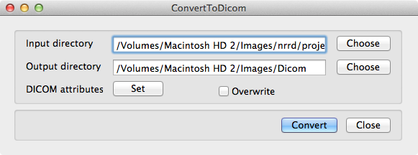
Figure 1: Main window.

Input directory
The directory containing the input image files. This directory can contain nothing but the file(s) containing the image series that you wish to convert and can contain only one image series. The files should have the same dimensions (pixel and physical) and be of the same type. That is, they should be the output of a single imaging experiment.

Output directory
The directory which will contain the DICOM (output) files. This directory actually contains the start of a directory tree with subdirectories with descriptive names.
The DICOM files are stored in the deepest subdirectory each of which can contain only one series. However, a number of series can be stored under one study and a number of studies can be stored under one patient. The components of the directory tree, PatientName, StudyDescription, StudyID, SeriesDescription and SeriesNumber, are set in the DICOM Attributes window (see below).
Output directory/PatientName/StudyDescription - StudyID/SeriesDescription – SeriesNumber/
Figure 2: Output directory structure.

Overwrite
ConvertToDicom will not normally allow you to overwrite the output files. However, you may want to change a parameter and convert the series again. If you check this box any existing files will be deleted before the new ones are written.

DICOM attributes
Open the window which is used to set the attributes of the output files. This is optional but you will almost certainly want to set some of the attributes.

DICOM Attributes, Patient tab

Name
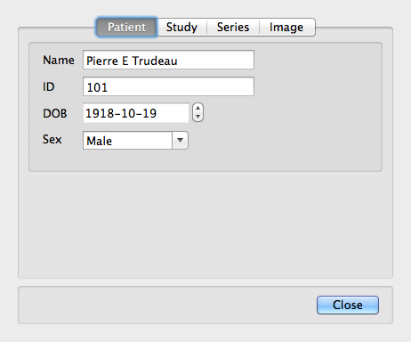
Figure 3: DICOM attributes for the patient.
DICOM attribute (0010,0010) Patient's Name. The name of the patient. It is used to create the first level in the output directory tree.

ID
DICOM attribute (0010,0020) Patient ID. The patient identifier. This is an arbitrary number assigned to the patient.

DOB
DICOM attribute (0010,0030) Patient's Birth Date. The patient's date of birth.

Sex
DICOM attribute (0010,0040) Patient's Sex. The patient's sex.

DICOM Attributes, Study tab

Description
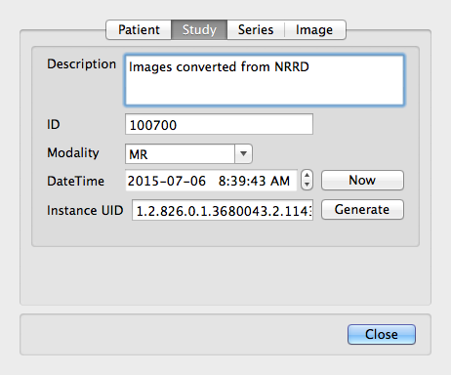
Figure 4: DICOM attributes for the study.

DICOM attribute (0008,1030) Study Description. The study description. This can be anything the user wishes.

ID

DICOM attribute (0020,0010) Study ID. The study identifier. This is an arbitrary number assigned to the study.

Modality

DICOM attribute (0008,0060) Modality. The imaging modality. Select the modality from the list.

DateTime

DICOM attribute (0008,0020) Study Date and DICOM attribute (0008,0030) Study Time. The study date and time. Use the Now button to set this to the current date and time.

Instance UID
DICOM attribute (0020,000d) Study Instance UID. A unique identifier for the Study. The DICOM image viewer will probably use this to sort images so all images from the same study should share this value. Use the Generate button to make a new one if needed.

DICOM Attributes, Series tab

Description
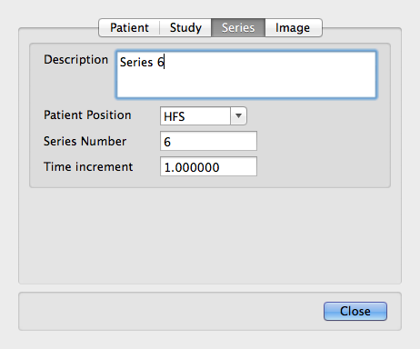
Figure 5: DICOM attributes for the series.

DICOM attribute (0008,103e) Series Description. The series description. This can be anything the user wishes.

Patient Position
DICOM attribute (0018,5100) Patient Position. Select the correct value from the list.

Series Number
DICOM attribute (0020,0011) Series Number. An arbitrary number to identify the series.

Time Increment

DICOM attribute (0008,0032) Acquisition Time. If the images are a time series, this is used to calculate the image acquisition times. The study time is taken as the acquisition time of the first image. The value is in seconds. If the images do not form a time series, set this to 0.0.

DICOM Attributes, Image tab
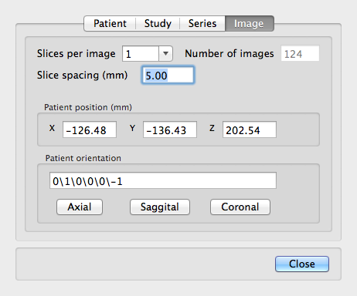
Figure 6: DICOM attributes for the images.

http://itk.org Please check the documentation for the list of files which are supported.
Why would you want to 'convert' DICOM images? There may be times when you want to change the metadata or the series structure and this may be the easiest way of doing it. The metadata that are contained in the original files will be lost and will be replaced with ConvertToDicom's metadata.

