FlightKit

Flight
Logger

v1.0-0

Please note that this equipment is still under development. The developers do not accept any responsibility for loss or damage caused while using this device. Proceed with caution and test all functions thouroughly before actually using this with a model aircraft.
Table of Contents
Description 3
Hardware Facilities 4
Connector Details 5
Data logging settings format 6

Description
Flight logger allows a pilot to accurately record the aircraft's position, IMU data and 6 channels of control input. It also records the battery voltage and (optionally) the RSSI signal from the reciever. It can be used either as a stand-alone board, or in conjunction with a small reciever as a complete package.

The board measures 60mm by 30mm.

Hardware Facilities
- LCD Display port
- Supports LCD displays with serial over I2C interfaces. The software is designed to work with a 20x4 Display.
- The LCD is intended to be plugged in as needed, not to be a permanant feature (of course, if you've got a big enough model...
- Servo PWM input (6 chans)
- Reads the position of 6 servo channels for later correlation with flight data.
- Micro SD card
- Storage for logged data
- Native USB (device port only)
- For programming over USB
- Serial expansion port (3.3v)
- This interface could be used for a live telemetry feed from the model.
- GPS
- The VENUS-638 is a 20Hz GPS unit.
- It needs an antenna for proper operation.
- IMU
- 16-bit measurement accuracy with a selection of ranges.
- Accelerations in X, Y and Z directions.
- Angular rates about X,Y and Z axes.
- Magnetometer readings in X,Y and Z directions.
- All via a single MPU9150 chip.

Connector Details

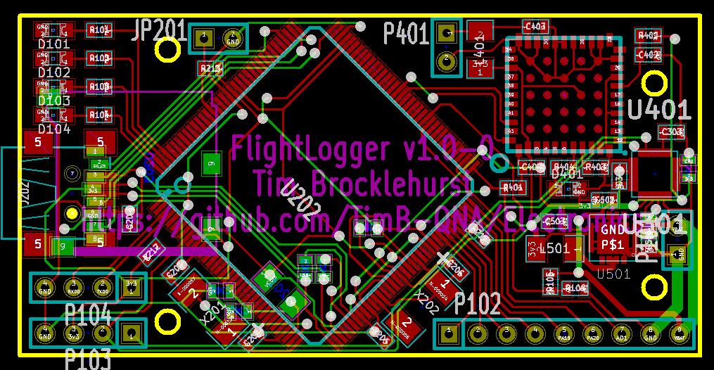

Port | Purpose
P101 | Battery power input
P102 | Servo input channels
P103 | LCD Interface header
P104 | Serial expansion header
JP201 | Software erase jumper
P401 | GPS Antenna port
USB | Native USB port
MicroSD | Slot for storage card

Data logging settings format

