FlightKit

Transmitter
Mixer
Extension

v1.0-0

Please note that this equipment is still under development. The developers do not accept any responsibility for loss or damage caused while using this device. Proceed with caution and test all functions thouroughly before actually using this with a model aircraft.
Table of Contents
Description 3
Hardware Facilities 4
Connector Details 5
Mix settings format 6

Description
Quite often, a pilot will buy the best transmitter they can afford, only to find that it lacks features for a later model. For whatever reason, purchasing a new transmitter may not be an option. This was the situation that the transmitter extension was designed for. The transmitter mixer extension enables the user to add significant mixing capabilities to any transmitter with a buddy-box connection.
The extension is built around an ARM Cortex M3 processor. This gives a very capable platform for pretty much any concievable mixing setup. An LCD display provides status information and allows modification of program settings during flight. All mix setups are stored on a micro-SD card, giving massive storage capability and simple interface with a PC.
The board is electrically very similar to the Arduino Due. The major difference being that the extension uses an FT232RL as a USB to serial device, rather than a dedicated mpu. In order to re-program the ARM chip, it is necessary to erase it first. A jumper is provided for this purpose.
This unit connects via the buddy box interface. While using it you cannot use a buddy box. However, it seems unlikely that this will be an issue if you've run out of mixers!

Hardware Facilities
- LCD Display
- Supports LCD displays with serial over I2C interfaces. The software is designed to work with a 20x4 Display.
- Mode buttons
- Mode up/down
- Control knob
- Gray-mode encoder with push-button for select
- Mix-mode switches
- Four mix-mode switches which can be used to switch between flight modes or dual rates.
- Each switch input supports spdt toggle switches with centre-off.
- PPM input
- Reads the transmitter control positions frm the buddy-box port
- PPM output
- Sends the mixed output to the transmitter's RF output stage.
- You may need to modify your transmitter to bypass the buddy-box switch
- RF Enable output
- Allows the RF output to be disabled for testing (not usually used).
- Micro SD card
- Storage for mixer setups
- Programming and debug terminal over USB
- Native USB (device port only)
- Serial expansion port (3.3v)
- This interface could be used for a live telemetry feed from the model.
- Audio output
- This is a simple tone output which provides audible warnings (e.g. low reciever batteries).
- It could also provide an audio variometer with a suitable telemetry data feed.
- The audio output can also be routed to an earphone.

Connector Details

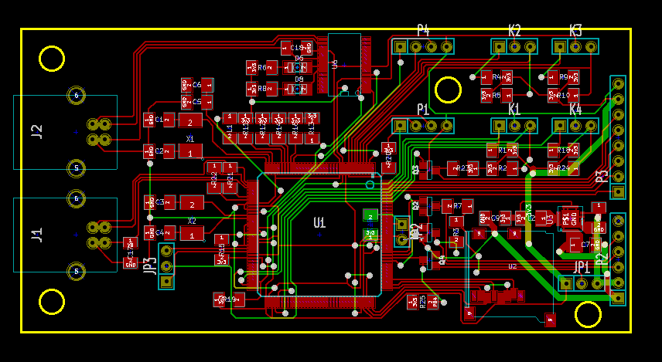

Port | Purpose
J1 | Programming and debug port
J2 | Native USB port
JP1 | Output voltage select
JP2 | Software erase jumper
JP3 | Button illumination mode
P1 | Serial expansion port
P2 | Buddy-box interface
P3 | Mode keys and control knob interface
P4 | I2C LCD interface
K1 | Switch 1
K2 | Switch 2
K3 | Switch 3
K4 | Switch 4

Mix settings format
Mix settings stored in two files inside a tar archive. An XML setup file which is used for the setup GUI, and a plain text configuration file which is used by the extension hardware itself.

