8-1 Activity: Iterating on an Algorithm

Timothy Barrett
Southern New Hampshire University
CS-680-10268 Advanced Algorithms
Dr. Maureen Kinkela
August 30, 2026

Strat Data has been contracted to build an application that validates the presence of a specified word within a given data set. This implementation was given the constraints that it must use a heap data structure and a depth-first search (DFS) to find the specified data. This report documents the development process, test plan results, iterative improvements and an analysis of the algorithm’s efficiency, along with a proposed alternative approach. The Python program iteration.py demonstrates the successful implementation of both the heap and depth-first search, while meeting all eight of the client’s requirements.
The initial version of the program established a working baseline for the application. It keyed the heap on both the sequence and data fields of the data set as tuples and using a recursive DFS search to find the user input word. This helped to establish a starting point that met the requirements and provided a baseline, with which iteration attempts could be compared to assess their efficiency. The next iteration adjusted data handling by dropping the sequence field from the input data, storing only the data fields and ordering them alphabetically in the heap. It also added a conditional in the DFS algorithm that could reduce the amount of searching needed by allowing the parser to rule out subtrees if the current node’s word was alphabetically greater than the target word. The final iteration provided stability to the program by wrapping the filename assignment in a try/except block with a return on failure to prevent crashes resulting from bad file paths. Searches in the current program are case sensitive; another iteration was considered to normalize the data fields to adjust for this but was omitted because it may not meet the client’s expectations and should be discussed with them prior to implementation. Additionally, tracking occurrences of the searched word was considered for an iteration but was omitted for the same reason.
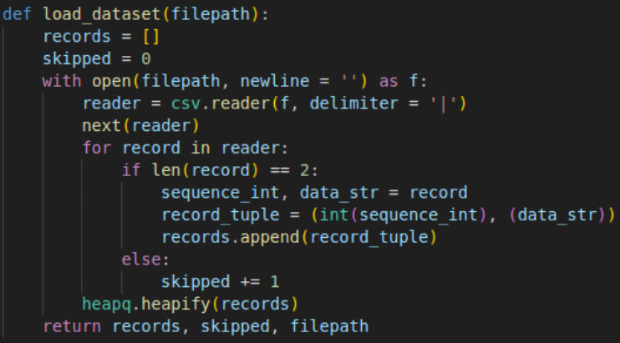
Figure 1: Initial Heap
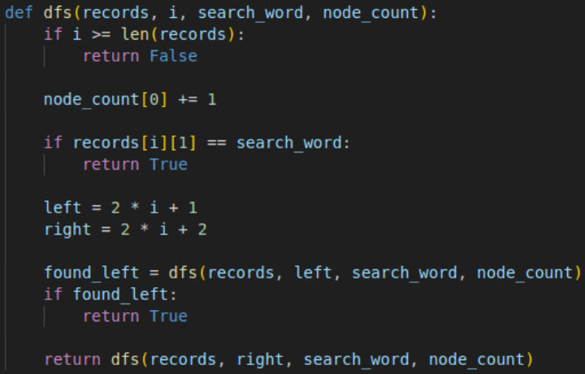
Figure 2: Initial Depth-First Search (DFS)
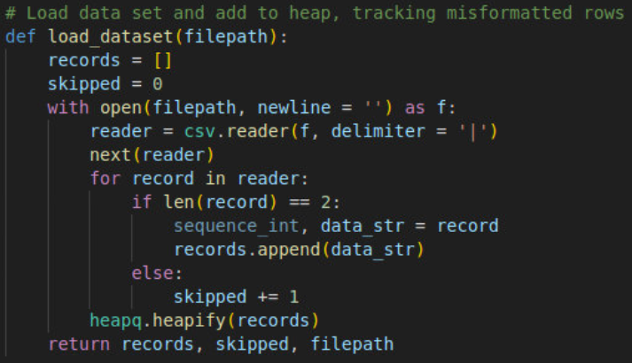
Figure 3: Heap After Iteration
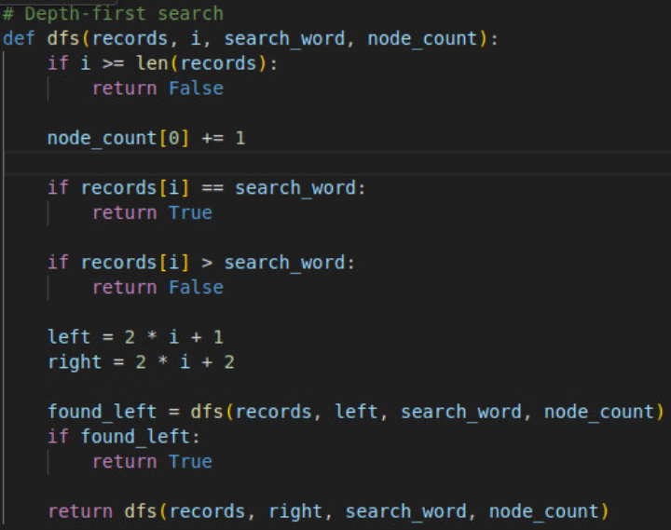
Figure 4: Depth-First Search (DFS) After Iteration
Before considering when to stop iterating, all eight requirements needed to be addressed, and the test plan executed in full after each iteration. After the second iteration, I was able to directly compare successful and failed search results. This revealed that adding the early exit step from subtree comparisons significantly helped in cases where the search word does not exist in the set, while causing a slight decrease in finding words that do exist. This was a key finding that led me to stop iterating because further adjustments to the algorithm were unlikely to meaningfully change the outcome. This is because the tradeoff comes from the heap’s ordering property rather than the algorithm’s traversal design. The overall design structures of the heap and DFS are less suited to search and retrieve workflows than some other options. Additionally, the lack of increased efficiency that would only be compounded by further structural changes presented a practical consideration to stop iterating and present those findings.
Data Set | Iteration | Search word | Found | Time to Complete (s) | Nodes Searched
Data Set 1 | 1 | spoilt | Y | 0.000208 | 261
Data Set 1 | 2 | spoilt | Y | 0.000123 | 272
Data Set 4 | 1 | talion | Y | 0.004039 | 8,197
Data Set 4 | 2 | talion | Y | 0.004278 | 9,703
Data Set 1 | 1 | chicken | N | 0.000456 | 1,000
Data Set 1 | 2 | chicken | N | 0.000470 | 449
Data Set 4 | 1 | chicken | N | 0.097454 | 100,000
Data Set 4 | 2 | chicken | N | 0.025538 | 45,141
Table 1: Result Comparison
Figure 5: Baseline Search Data Set 1
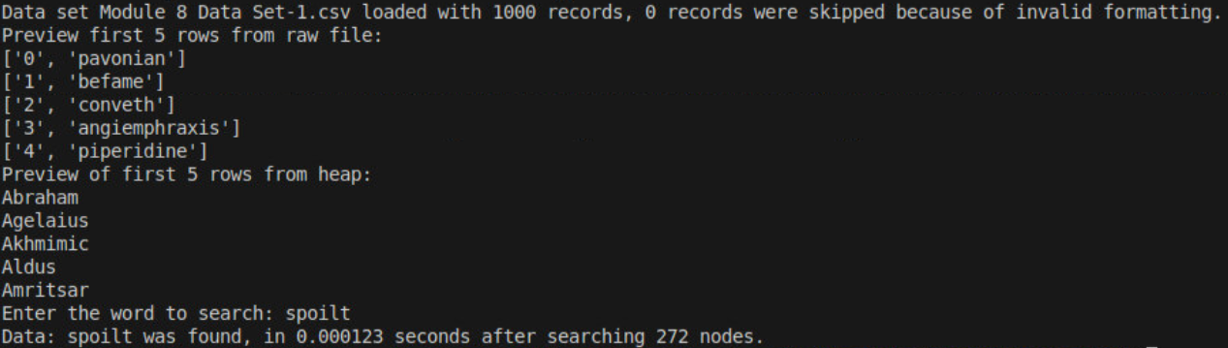
Figure 6: Iteration Search Data Set 1
Figure 7: Baseline Search Data Set 4
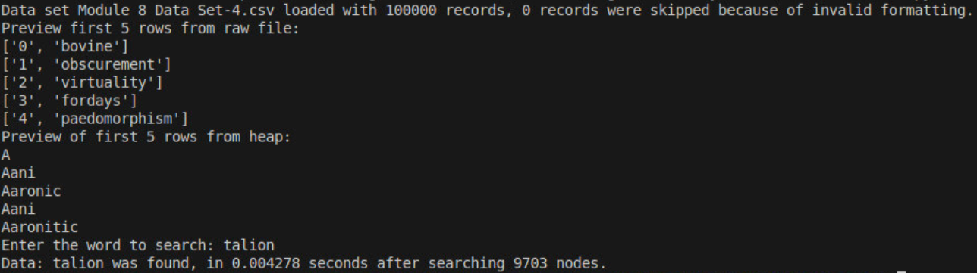
Figure 8: Iteration Search Data Set 4
Figure 9: Baseline Not Found Search Data Set 1
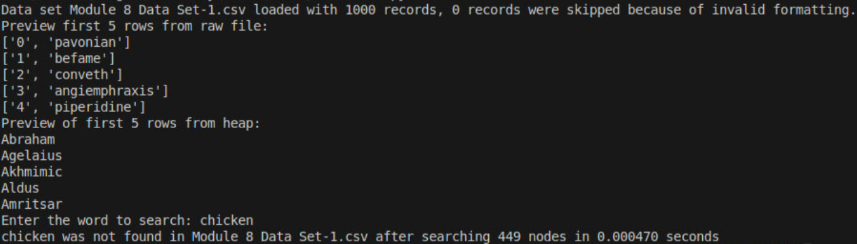
Figure 10: Iteration Not Found Search Data Set 1
Figure 11: Baseline Not Found Search Data Set 4
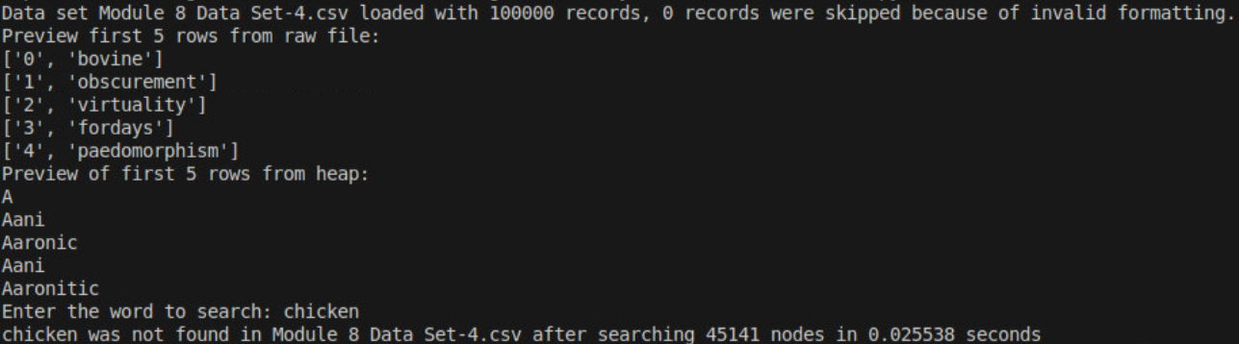
Figure 12: Iteration Not Found Search Data Set 4
The Depth-First Search algorithm was consistently able to perform in all test cases. Iteration of the algorithm helped to improve its efficiency in cases where the search word did not exist. The scale of the data set had a direct impact on performance that was consistent with O(n) worst-case scaling, evidenced by the cases where every node was searched in the data sets. However, the reduction in required comparisons for cases where the word did not exist in the set is where the algorithm’s iteration presented improvement and scalability by reducing the node searches from the entire set to less than half. Meeting the client’s eighth requirement, “…shall be optimized to minimize the time necessary to perform the search function” provided the most challenge. This difficulty stemmed from the constraint of applying a heap and DFS algorithm to the problem. A heap is typically suited for cases dealing with priority such as queues, while DFS is typically suited to tree and graph traversal problems like cycle detection and pathfinding. Therefore, given the client’s specification that minimizing search time is a priority, the heap and DFS pairing is not the most appropriate choice, despite its ability to meet the specifications. A hash table would provide a more efficient way to perform this task. Alternatively, a binary search algorithm on a sorted array would provide an efficient approach that would require less structural changes to the application.
Hash tables store each word by using a hash function to calculate its respective key, which can be used to directly retrieve it when needed. This data structure would avoid the need for a dedicated searching or traversal algorithm. This solution provides an average lookup time complexity of O(1), whereas the current approach has an O(n) complexity at worst. The primary tradeoff presented with the hash table approach is that a poorly crafted hash function can create collisions which can degrade its lookup time to the O(n) complexity that we would be trying to avoid. This can require a few iterations to find an optimal solution and possible maintenance if the data sets were to grow in the future. Additionally, a hash table removes any ordering within the data set when it calculates the hash functions to create the keys. This is where the alternative binary search option comes in, because it can build off the currently sorted heap because it requires a sorted array. It then recursively divides the data structure in half until it finds the matching solution. This alternative has an average case complexity of O(log n), which while worse than the hash table, its implementation requires less overhaul to the current structure of the application. If the most efficient possible lookup times for searched words will be the only requirement of the application going forward, then changing the approach is recommended. However, if future requirements would want operations that were dependent on sorted order, then the heap should be kept.
The iteration.py Python application meets all eight of the client’s requirements. However, the implementation of a heap paired with a DFS algorithm does not provide the optimal solution despite their current success. The hash table or combination of a binary search and sorted array provide strong alternatives to optimally solve this problem, and the choice between the two depends on future requirements of the application.

References
CodeSignal. (n.d.). Mastering the depth-first search algorithm for trees in python. CodeSignal Learn. https://codesignal.com/learn/courses/understanding-and-using-trees-in-python/lessons/mastering-the-depth-first-search-algorithm-for-trees-in-python
GeeksforGeeks. (2025a, July 23). Advantages and disadvantages of Heap. https://www.geeksforgeeks.org/dsa/applications-advantages-and-disadvantages-of-heap/
GeeksforGeeks. (2025b, July 23). Applications, advantages and disadvantages of depth First Search (DFS). https://www.geeksforgeeks.org/dsa/applications-of-depth-first-search/
GeeksforGeeks. (2025c, July 23). Depth first search or DFS for a graph - python. https://www.geeksforgeeks.org/python/python-program-for-depth-first-search-or-dfs-for-a-graph/
GeeksforGeeks. (2025d, July 23). Hash table data structure. https://www.geeksforgeeks.org/dsa/hash-table-data-structure/
GeeksforGeeks. (2026a, March 17). Binary search. https://www.geeksforgeeks.org/dsa/binary-search/
GeeksforGeeks. (2026b, April 6). Heap queue or heapq in Python. https://www.geeksforgeeks.org/python/heap-queue-or-heapq-in-python/

Appendix: Additional Program Screenshots
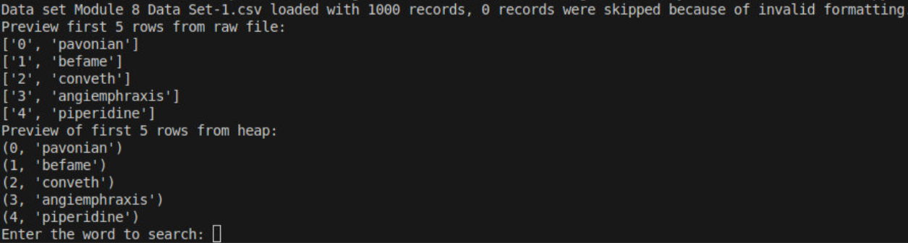
Figure 13: Validation of Reading Data Set 1
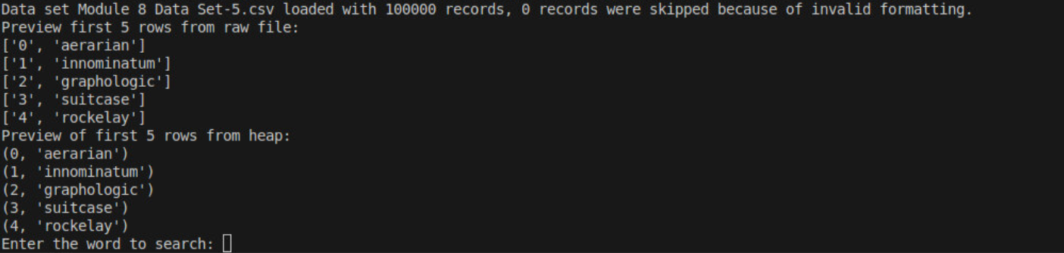
Figure 14: Validation of Reading Data Set 5
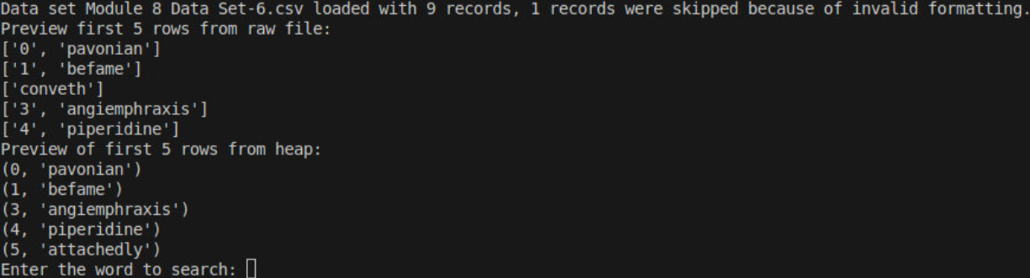
Figure 15: Validation of Reading Malformed Data Set
Figure 16: Edge Case of Searching with Case Sensitivity
Figure 17: Edeg Case of Empty Search Field

