3-1 Assignment: Implementing an Algorithm Within an Application

Timothy Barrett
Southern New Hampshire University
CS-680-10268 Advanced Algorithms
Dr. Maureen Kinkela
July 26, 2026

Algorithm and data structure choice set the tone for an application’s performance. That performance is often measured through the algorithm’s time and space complexity in Big O notation to communicate best, average and worst-case scenarios. Those scenarios determine the limitations of scalability for the algorithm depending on the input size. Data structures can help or hinder the algorithm with handling that input. Algorithm choice and data structure alignment can have a synergistic effect on an application’s efficiency and scalability by maintaining its complexity, evidenced by this report’s focus on heapsort’s implementation with an array.
Heapsort, a comparison-based sorting algorithm (GeeksforGeeks, 2026), is commonly deployed for priority queues to support efficient task management, like priority scheduling in Operating Systems. Cormen et al. (2022) explain that heaps support priority queue operations with insertion, extraction and updating priority in O(log n). After reviewing the data provided, my approach assumes that the data should be sorted for future efficient searching, similar to building a sorted index in database systems. Under that assumption, the application of heapsort provides an efficient way to sort the data and store it for later searches. Binary search was considered but requires the data to be sorted therefore the efficiency that binary search would provide is conditional at best rather than guaranteed. Additionally, depth first search (DFS) was considered but is best fit for hierarchical structures with natural parent-child relationships which this data does not appear to have.
According to Cormen et al. (2022), heapsort combines the attributes of insertion sort and merge sort for a time complexity of O(n log n) while sorting elements in place. The final complexity is gathered from the two stages of the algorithm, heapify() and heap_sort(). The heapify() function repeatedly shifts nodes by making comparisons of the records, in this case the integer key. The heapsort() function builds the heap by calling heapify() on each non-leaf node, then iteratively moves the root accordingly in response to the shifts and comparisons performed by the heapify() function resulting in the final sorted order. The building procedure happens in O(n) time; combined with the extraction of the max element at O(n log n), the final complexity is O(n log n) because it is the higher order term. “O-notation characterizes an upper bound on the asymptotic behavior of a function. In other words, it says that a function grows no faster than a certain rate, based on the highest-order term.” (Cormen et al., 2022) The current structure implements a recursive heapify() call resulting in O(log n) space complexity. This was chosen for code clarity and readability. However, future iterations concerned with scalability could implement an iterative approach, avoiding the recursive call stack entirely, and achieve a constant O(1) space complexity. According to GeeksforGeeks (2026), heapsort’s primary advantage is that it carries a guaranteed time complexity of O(n log n). The height of the binary heap equates to log n, which ensures its consistent performance and makes it suitable for large datasets.
The ability to sort in place saves time and space complexity that is otherwise lost or a tradeoff in comparable sorting algorithms. Additionally, because a heap is always a complete tree, both its height and performance remain consistent no matter the order of the input. This is evidenced through the consistent output times attached to this report, showing that datasets 2 – 5 (each 100,000 records) are sorted within relatively similar timeframes. When compared to the results of dataset 1 (1,000) records, the increase by roughly 1.6 seconds is a minimal increase in a difference of sorting 99,000 additional records. This directly displays the strength of heapsort’s scalability. While the current recursive approach’s O(log n) space complexity is still a relatively small memory cost, it could be considered a limitation to scalability if data was expected to grow exponentially, but the logarithmic growth is still exceptionally minimal. However, this could be combated with the iterative approach mentioned above for a stricter approach to memory management.
This application of the heapsort algorithm uses a binary heap implemented as an array because it removes the need for pointers. Avoiding pointers avoids the need to constantly update them as nodes are shifted during sorting. Each array element holds a record from the dataset, the four field tuple (key, data-a, data-b, validation), the first of which is converted to an integer type for cheaper and faster comparisons during sorting. Arrays store the items contiguously, granting cache friendliness, they also allow access to any position in the structure at constant O(1) time. The limitations to this are that array based heaps require some upfront knowledge of the dataset’s size.
During implementation I faced a few minor challenges. Small syntax errors caused a few failed attempts to run the application, like missing parentheses in the integer type conversion call and a dropped parameter (n and i) from the heapify() function definition. These were small errors that originated from quick typing and light reviews on my part but were easy to track down and rectify through iteration. However, inconsistent naming conventions for the provided data files caused an additional slowdown. Extra spaces exist in 3 of the five file names, copying and pasting the names into the code rather than manual typing fixed the issue. These were all subtle bugs that silently failed instead of crashing instantly, making them take a few more minutes to track down than a typical syntax error. A more rigorous review of the code as it was written would have avoided their occurrence.
This algorithm was very efficient in managing large datasets, completing all sorting in about 5.5 seconds with an average sort time of 1.12 seconds. That average is slightly skewed considering one dataset contains 1,000 records and the other four contain 100,000 records. However, that gap between them is small, which is evidenced by the individual sort times where the first dataset (1,000 records) completed in about 0.006 seconds, and the longest a large set (100,000) took was about 1.662. I would absolutely consider using heapsort in a real project because its guaranteed O(n log n) complexity, capability for O(1) space complexity, and general ease of implementation make it a powerful and useful tool in solving complex computing and sorting problems. The largest caveat that it presents is that it is considered unstable, meaning it does not preserve the natural order of equal elements. This dataset’s keys were unique making the instability a non-issue. However, in the case of OS priority scheduling this could be an issue where there are duplicate keys, so that kind of specific implementation would require more consideration to navigate.
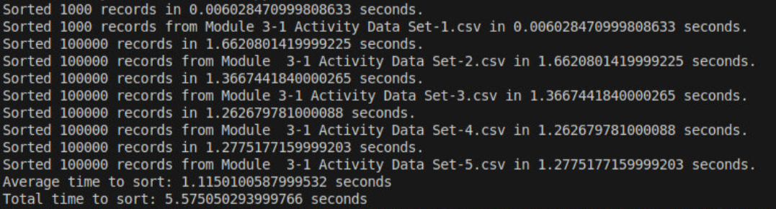
Figure 1: Application Output Times
This application implements the heapsort algorithm with an array backed heap data structure to sort and store a large dataset, while making it readily available for efficient searching. Heapsort’s guaranteed O(n log n) runtime complexity and O(log n) space complexity make it very efficient for sorting and storing the large datasets. The sorted results in the array enable fast lookups that could be efficiently leveraged by partnering a strong searching algorithm like binary search to efficiently retrieve the data. Heapsort is an efficient and straightforward way to handle large datasets without duplicated keys that I would be excited to use in my future development work.
References
Cormen, T. H., Leiserson, C. E., Rivest, R. L., & Stein, C. (2022). Introduction to algorithms. The MIT Press. 2026, https://mbsdirect.vitalsource.com/reader/books/9780262367509
GeeksforGeeks. (2025a, November 7). Stable and unstable sorting algorithms - geeksforgeeks. https://www.geeksforgeeks.org/dsa/stable-and-unstable-sorting-algorithms/
GeeksforGeeks. (2025b, December 20). Binary search | python - geeksforgeeks. https://www.geeksforgeeks.org/python/python-program-for-binary-search/
GeeksforGeeks. (2026a, February 5). Heap sort - geeksforgeeks. https://www.geeksforgeeks.org/dsa/heap-sort/
GeeksforGeeks. (2026b, March 28). Big O notation - geeksforgeeks. https://www.geeksforgeeks.org/dsa/analysis-algorithms-big-o-analysis/
GeeksforGeeks. (2026c, July 10). Introduction to Max-heap - geeksforgeeks. https://www.geeksforgeeks.org/dsa/introduction-to-max-heap-data-structure/
GeeksforGeeks. (2026d, July 21). Depth first search or DFS for a graph - geeksforgeeks. https://www.geeksforgeeks.org/dsa/depth-first-search-or-dfs-for-a-graph/
Mirzakhanyan, A. (2023, September 19). Understanding Heap sort and its applications | by Andranik Mirzakhanyan | Medium. Medium. https://medium.com/@mirzakhanyan89/understanding-heap-sort-and-its-applications-356000f3bf6

