9-1 Project Two: Technical Report

Timothy Barrett
Southern New Hampshire University
CS-680-10268 Advanced Algorithms
Dr. Maureen Kinkela
September 6, 2026

ACME Neural Intelligence (ANI) is working to reduce the storage size of their large data sets by implementing the Huffman Coding algorithm. However, an in-house solution is sought to avoid risks associated with intellectual property rights and export control regulations. The huffman.py application has been built without using external libraries to implement the Huffman algorithm or heap data structure operations. This report details the design decisions, output, performance and complexity of the application to communicate its successful implementation and its potential improvements.
The application leverages a namedtuple, minheap, the Node class, list and bytearray data structures throughout its execution. The namedtuple, Record, holds the name of each of the six fields in an immutable structure with efficient indexed access. The minheap, created without the use of the heapq library, serves as a priority queue that keeps the smallest element at the top of the tree, or front of the queue. The Node class provides the structure to build and manage the Huffman Tree with internal and leaf nodes. Finally, the lists and bytearrays helped with intermediate data storage during append and join operations that allowed the joining of strings to be packed as bytes into the bytearray. Each data structure plays a key role in working with the algorithm to successfully establish the pipeline that loads a data set, reads the data to build a tree and code table, compress the data, then uncompress it and verify no data was lost.
The Huffman algorithm is a greedy algorithm, meaning at each step it chooses the current best option without considering the future implications that choice carries. For this case, that approach helps to find the most efficient solution because it means building the tree with the shorter binary codes, or most frequent characters, closer to the top thereby reducing the amount of traversal required to decode them. The algorithm progresses from counting the frequency of unique characters to constructing the tree from the priority queue, then recursively generating the binary codes for the encoding/decoding processes to packing and unpacking the bytes to compress and uncompress them. The impact of the implementation of this algorithm is nearly a 38% reduction in file size across each data set. While that consistency is a result of the structure of the data when constructing the prefix-free codes, the results displayed across Figures 1 - 4 demonstrate the overall effectiveness of the Huffman algorithm.
The overall performance of the application is shown in Figures 1 – 4 that were captured as output of the application while executing its test plan. Each of the core operations or reading the original, writing the compressed, reading the compressed, and writing the uncompressed file were individually timed during their execution, each completing in well under a second for the smaller and larger data sets.
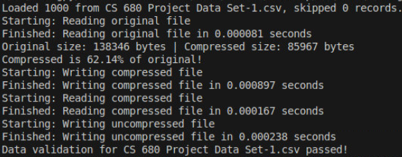
Figure 1: Data Set 1 Output
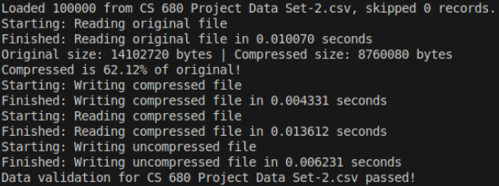
Figure 2: data Set 2 Output
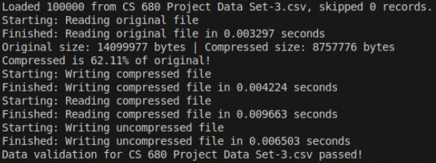
Figure 3: Data Set 3 Output
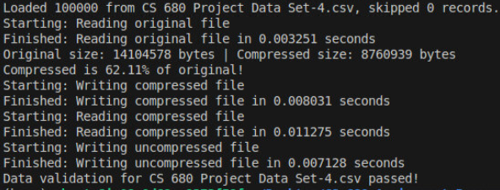
Figure 4: Data Set 4 Output
The data requirements and determining the appropriate structures to handle that data in the application came directly from the data itself. The six field pipe-delimited structure dictated that a structure that supported named access rather than string splitting across the board was the best fit to ensure fields remained accurate when reassembled. Compressing the file uniformly provided a simplified approach to compress the entire file for storage purposes, whereas a per record or per field approach would have overcomplicated the algorithm beyond ACME’s current needs. The namedtuple provided an immutable structure to hold each of the fields, both with safety that they could not be altered incidentally and provided efficient indexed access to them when needed. A sorted list could essentially provide the same structure as a minheap with a simpler implementation. However, the reduced efficiency of insertion into a sorted list when compared to the heap, made the heap the optimal choice because of the process of building the tree. Applying the list append and bytearray join functions helped to avoid arbitrarily inflating the complexity of the program because strings are immutable in Python. Therefore, constantly concatenating them would result in constantly storing a new string for each iteration, potentially leading to quadratic time complexity for large data sets. Appending the values to a list provided a constant time operation that could be followed by the join operation to do a single pass on that list to create a single string and simplify the encoding process.
The expected output of the application is a compressed file that yields a significant reduction in size when compared to the input file it was generated from. This serves ANI’s primary goal of reducing the size of their larger data set files. Additionally, the generation of a new file once that compressed file is uncompressed and maintains the original data supports that goal because the data’s integrity is as important as the compression itself. Losing data within the file corrupts the integrity of the data, impacting its future usefulness. The lossless result is a key component of the Huffman algorithm that makes it a great fit for this application, and the storage of the code table in the compressed file’s own header makes them self-contained. Meaning the newly generated compressed files do not rely on any other secondary files to uncompress and decode them.
The primary constraints that limit the application are time complexity, memory complexity and alphabet size. Most operations in the application impose a linear scaling time complexity because each byte within the data set needs to be processed. While this is a constraint that cannot be improved, it is also a benefit because those operations are predictable and do not provide opportunity for a worst-case inflation of usage. Memory complexity is stable in the current version of the application but poses a risk that should be monitored because it reads an entire file into memory at once with the read() function. Excessively large files could begin to degrade performance and create data loss because of overflow. Finally, tree construction is dependent on unique characters, which for the current data sets stays relatively small because of the limited characters that can appear. A single byte is limited to representing 256 distinct values at most and sets a restriction on the potential alphabet size regardless of data set size.
The test plan created for this application has been executed in full across all four data sets. The results indicate that no malformed data was present because all records from each set were successfully loaded and parsed. The overall performance of each core function highlighted within the test plan demonstrated that the application can reliably and efficiently run while scaling with the size of the data set. Compression rates that were output during each iteration over the data sets exhibited around a 38% reduction in file size, compared to each file’s original size. Furthermore, each uncompressed file passed the verify() function that compares the newly uncompressed file byte for byte with the original. Indicating that the algorithm was able to successfully take the data in, compress and decompress it accurately with no data loss in the process, fulfilling ANI’s requirements. Figures 1 – 4 found earlier in this report are the outputs achieved while executing the test plan that accompanies this report, and the table below compiles those results for comparison.
Data Set | Read Original | Write Compressed | Read Compressed | Write Uncompressed | Original Size (Bytes) | Compressed Size (Bytes)
1 | 0.000081 | 0.000897 | 0.000167 | 0.000238 | 138,346 | 85,967
2 | 0.010070 | 0.004331 | 0.013612 | 0.006231 | 14,102,720 | 8,760,080
3 | 0.003297 | 0.004224 | 0.009663 | 0.006503 | 14,099,977 | 8,757,776
4 | 0.003251 | 0.008031 | 0.011275 | 0.007128 | 14,104,578 | 8,760,939
Table 1: Test Plan Results
The Huffman Coding Algorithm itself carries a time complexity of O(n log n) and a space complexity of O(n), where n represents the number of unique characters within the data. This is because Huffman coding includes the step of creating the tree and code table and does not include the other steps of the pipeline implemented within this application. While this implementation of the Huffman algorithm in the huffman.py program does not use libraries and is manually built, it still mirrors the complexity of a typical Huffman deployment. However, the complete application performs several operations including reading, frequency counting, encoding, bit packing, unpacking, decoding and reading again, that each scale with the size of the file.
Table 2 details the time and space complexity of each individual function within the application. The variable m is used across all functions to represent the memory complexity of each. As detailed previously, the time complexity is where the algorithmic solution deviates, requiring two distinct variables to accurately measure and describe the overall performance of the application. The variable n, as noted above, is used to represent the number of unique characters within the data set and needs to be differentiated because it is bound to the 256-character limitation mentioned earlier in this report, thereby limiting the amount that they may scale. The term s is used to differentiate where the file size determines the rate at which complexity scales and is differentiated because that factor is unbound and could scale limitlessly as a data set grew. The potential for unbound scaling versus the bound scale of n makes s the higher order term for the complete algorithmic solution.
Function | Time Complexity | Space Complexity
Char_freq() | O(s) | O(m)
Huff_tree() | O(n log n) | O(m)
Build_huff_table() | O(n) | O(m)
Encoder() | O(s) | O(m)
Packing() | O(s) | O(m)
Unpacking() | O(s) | O(m)
Decode() | O(s) | O(m)
Read_compressed() | O(s) | O(m)
Write_uncompressed() | O(s) | O(m)
Highest Order Term | O(s) | O(m)
Table 2: Time & Space Complexity
Memory usage is a major weakness in potential future uses of the application because the linear scaling is a result of reading the entire data file into memory at once. However, this only presents a problem in cases that use files with substantially more data than the current sets. There is currently no stable handling of missing files or malformed data implemented. Skipped records are counted but not returned or meaningfully captured for review. Additionally, missing files and empty files would crash the application in its current state.
The application reads an entire file into memory at once and keeps that data in memory while creating the bitstream and packing the bytearray. The practical limitation that this imposes is not necessarily related to a specific record count in a file but instead is on the amount of memory available on the system that runs the program. A streaming approach in place of the current f.read() approach could mitigate this memory concern because it processes the data one line at a time rather than in its entirety but would introduce a complexity concern where the data would need to be iterated over multiple times to successfully build the Huffman Tree. This was a direct tradeoff that was considered for this implementation and avoided with a singular pass through the f.read() approach because of the limited size of the data sets. Additionally, exception handling could be added to mitigate the risk of crashes related to empty or incorrect file paths. This was a small structural step that was avoided in this implementation because it exceeded the current expectations of the testing plan but should be implemented for further stability prior to deployment. Finally, handling of skipped records can be addressed by storing the indexes of those records when incrementing the skipped count for team members to review the data.
The list append and join operation during the encoding process helped to avoid a naïve concatenation approach that could have inflated the complexity of the application. This decision directly influences the performance of the application by avoiding a quadratic O(n²) worst-case complexity for building long strings for encoding. Additionally, the use of a minheap instead of a sorted list to construct the priority queue impacted performance by avoiding inflated complexities. These decisions demonstrate the overall effectiveness of appropriate data structure choice and implementation can have on an algorithm’s performance.
The factor that has the greatest impact on the proposed algorithmic solution in the huffman.py program, is the size of the input file. As mentioned previously in this report, the size of potential unique characters that may appear in the data sets is limited and its byte representation is limited to 256 characters. The size of the incoming data files is the unknown factor that can fluctuate and creates an unbound factor that dominates the complexity of this solution despite the mitigations in place.
In the interest of further optimization of the algorithm for parallelization, some pieces of the algorithm could be parallelized with some additional work. For example, the char_freq() and encoder() functions could be parallelized. The char_freq() counts the frequency of character, the file could be split into different parts, depending on the number of additional processors, each counted separately and combined in the end for a final count. The encoder() similarly can independently encode each byte followed by the concatenation step at the end. The tree construction step on the other hand presents a challenge because it utilizes a singular heap to perform its merge steps on the tree through recurring push and pop operations. This process is inherently sequential and splitting it across processors could disturb the accuracy of the final tree. Additionally, the decoder() function presents a challenging approach to parallelization where bits need to be read sequentially and splitting them could potentially disturb their respective codes. Therefore, the application does present with opportunity for some parallelization, but it is specific to individual functions, and the added implementation complexity should be considered against the potential performance benefit.
The huffman.py application implements the Huffman coding algorithm that is custom built with no external libraries to handle compression, decompression or heap operations, which satisfies ACME Neural Intelligence’s specifications. The application has been tested according to the accompanying test plan to verify that it reliably compresses input data, and guarantees a lossless result after decompression, in line with the Huffman Coding behaviors and ANI’s goals. While the tree construction performs at O(n log n) complexity, matching the standard for Huffman Coding, the application heavily performs linearly O(s) due to the potential for unbound file sizes that must be read into memory. This application meets ANI’s currently stated goals and with proposed improvements could be made production ready.

References
Cormen, T. H., Leiserson, C. E., Rivest, R. L., & Stein, C. (2022). Introduction to algorithms. The MIT Press. 2026, https://mbsdirect.vitalsource.com/reader/books/9780262367509
GeeksforGeeks. (2023, April 24). Python: Inserting item in sorted list maintaining order. https://www.geeksforgeeks.org/python/python-inserting-item-in-sorted-list-maintaining-order/
GeeksforGeeks. (2025, September 5). Reading a file in Python. https://www.geeksforgeeks.org/python/how-to-read-from-a-file-in-python/
GeeksforGeeks. (2026a, March 6). Huffman coding in python. https://www.geeksforgeeks.org/dsa/huffman-coding-in-python/
GeeksforGeeks. (2026b, March 28). Big O notation. https://www.geeksforgeeks.org/dsa/analysis-algorithms-big-o-analysis/
GeeksforGeeks. (2026b, April 11). Min Heap in python. https://www.geeksforgeeks.org/python/min-heap-in-python/
GeeksforGeeks. (2026c, July 17). Namedtuple in python. https://www.geeksforgeeks.org/python/namedtuple-in-python/
Lenovo. (2026, July 29). Parallelization: What is Parallelization & the different types. Parallelization: What is Parallelization & the Different Types | Lenovo US. https://www.lenovo.com/us/en/glossary/parallelization/?orgRef=https%253A%252F%252Fwww.google.com%252F&srsltid=AfmBOopwYycAIpIAkbb4VQsUCfQm_SF4rJZ2MZOGGvO5l2QXzIOVt7cX
Zaczyński, B. (2025, March 31). Python’s Bytearray: A mutable sequence of Bytes. Real Python. https://realpython.com/python-bytearray/

