**Case 5: On-Time Performance of Airline XXX**

Case 5

Case Issues and solution



Submitted by:

Timothy Aditya Sutantyo (12135707),

Course:   
2021W437223

Betriebliche Informationssysteme

Institut für Wirtschaftsinformatik, Produktionswirtschaft und Logistik

Fakultät für Betriebswirtschaft

der Leopold-Franzens-Universität Innsbruck

# **Table of Contents**

Table of Contents 1

Executive Summary 2

Introduction 2

Case Study 3

Overview 3

Delay Analysis 5

When is Airline YYY and Airline XXX flights delayed, and vice versa? 11

Is weather causing the delay? 14

Conclusions 19

# **Executive Summary**

Recently, Airline XXX, the regional carrier of Airline YYY has faced pressure from Airline YYY due to complaints that many of their flights are delayed. Therefore, the researcher decided to dig in deeper into provided data set. The researcher decided to develop a small program in Python to determine whether route, time-frame, or day, contribute to the delays, as well as if Airline XXX was indeed less punctual than Airline YYY. Mann-Whitney U Test proves that Airline YYY wasn’t more punctual than Airline YYY. Furthermore, neither the route nor the time-frame of the flight affected the delay of both aircraft. However, most flights were delayed on Wednesdays and Sundays. Further investigation of the delayed flights revealed that while some of the delays could be attributed to bad weather in the airports, the congestion of the airports (particularly AAA airport) may be the main reason here, as most of the date of the delays overlapped between Airline YYY and Airline XXX.

# **Introduction**

Airline XXX, a small regional airline, was contracted to be the regional carrier of Airline YYY, a major European airline. Airline XXX schedules flights between Airline YYY’s hub in AAA, to other major airports in Europe. However, there had been allegations from the media that Airline XXX’s delay record is horrendous. This can be particularly damaging to Airline YYY’s reputation, as passengers think that a ticket purchased from Airline YYY means that the flight is operated by Airline YYY, when that flight is operated by Airline XXX.

According to European Union Aviation Safety Agency (EASA), there are four classifications of flight status:

* On time
* Delayed
* Diverted
* Cancelled

For this case, the flights between AAA and BBB, and between AAA and CCC.

# **Case Study**

## **Overview**

Table 1 Overview of delayed flights for Airline YYY

|  |  |
| --- | --- |
| Total number of flights | 120 |
| Total number of successful flights (flights that are not cancelled) | 117 |
| Delayed flights | 31 |
| Percentage of delayed flights (in %) | 26.50 |
| Mean duration of delay in minutes | 10.92 |
| Median duration of delay in minutes | 13 |

Table 2 Overview of delayed flights for Airline XXX

|  |  |
| --- | --- |
| Total number of flights | 240 |
| Total number of successful flights (flights that are not cancelled) | 240 |
| Delayed flights | 63 |
| Percentage of delayed flights (in %) | 26.25 |
| Mean duration of delay in minutes | 15.66 |
| Median duration of delay in minutes | 9 |

Table 1 and Table 2 shows the general overview of Airline YYY and Airline XXX flights. As there were several flights that are cancelled, the researcher decided to only count the flights that are commenced. This makes the finding of the mean of delay duration, as well as constructing the histogram, easier. As shown on these two tables, it turns out that the delay percentage for Airline YYY and Airline XXX was not far, with 26.50% and 26.25 arrival delay percentage, respectively.

The first thing to do was to see confirm using statistical tests that Airline XXX delay rate was not higher than Airline YYY. To determine if tests based on normal distribution could be used, the researcher decided to draw histogram of the delay duration of the Airline YYY and Airline XXX.

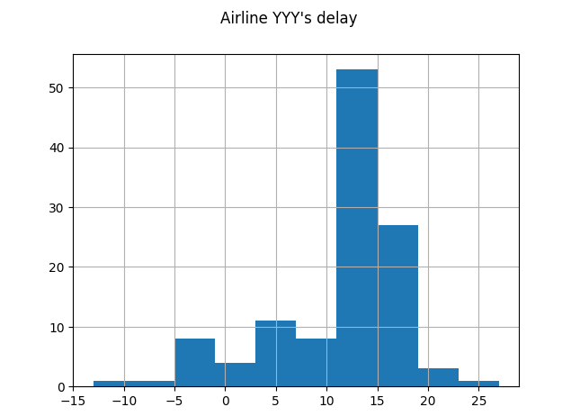

Figure 1 Histogram of the arrival delay for Airline YYY

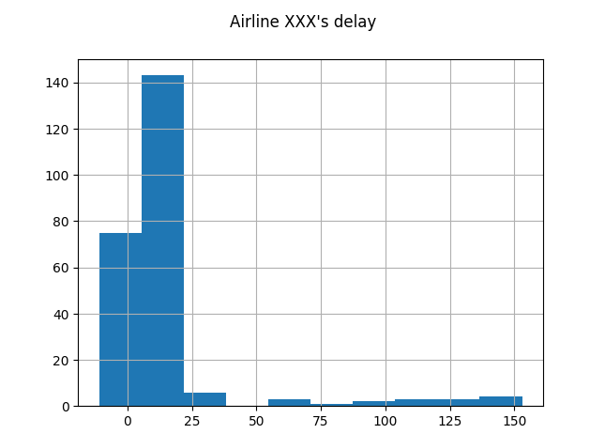

Figure 2 Histogram of the arrival delay for Airline XXX

Figure 1 and Figure 2 shows the histogram of the arrival delay in minutes for Airline YYY and Airline XXX, respectively. Both are skewed, so therefore the researcher also decided to take the median of delay of the two airlines. Hence, tests that assume the data to be normally distributed, such as t-test (Kim, 2015), ANOVA (Chen et al., 2016) are not able to be used. Instead, the researcher elects to use Mann-Whitney U Test, which, like t-test, test the differences between two groups on a single variable. However, Mann-Whitney U Test does not require the data to be normally distributed, making it ideal to compare the mean of the two data.

The hypotheses are as follows:

* Null hypothesis (h0): The average delay time between Airline YYY and Airline XXX were equal.
* Alternative Hypothesis (h1): The average delay time between Airline YYY and Airline XXX were not equal.

The researcher decided to use SciPy module to quickly run the test. The p-value obtained turned out to be around 0.016, which, when using 95% confidence, is less than 0.05. Hence, null hypothesis was rejected, and the delay time of Airline YYY was roughly equal to the delay of Airline XXX.

## **Delay Analysis**

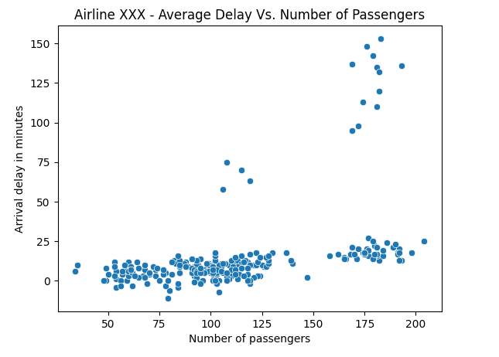

Figure 3 Scatter plot of Average delay vs. number of passengers

Figure 3 shows the scatter plot of the average delay versus the number of passengers in Airline XXX flights. Most of the flights had delays at most 25 minutes. However, a few Airline XXX flights were delayed by more than 50 minutes. All flights that had severe delays consists of more than 100 passengers.

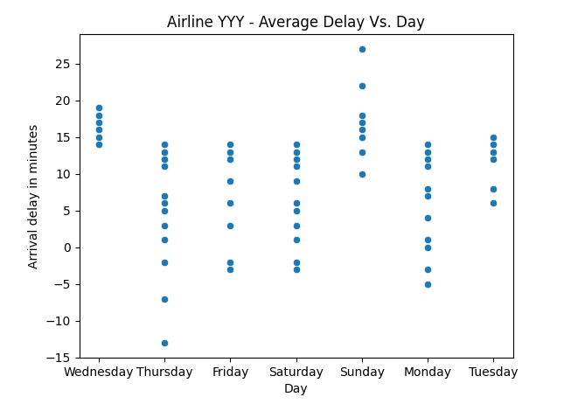

Figure 4 Airline YYY - Scatter plot of average delay vs day

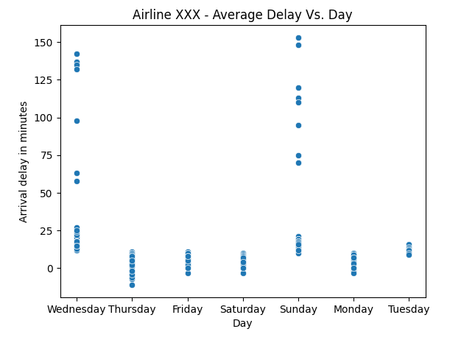

Figure 5 Airline XXX - Scatter plot of average delay vs. day

Figure 4 and Figure 5 shows the comparison of the arrival delay versus the days for Airline YYY and Airline XXX, respectively. Both airlines experienced more severe delay on Sunday and Wednesday, however once again, Airline XXX experienced more severe delays.

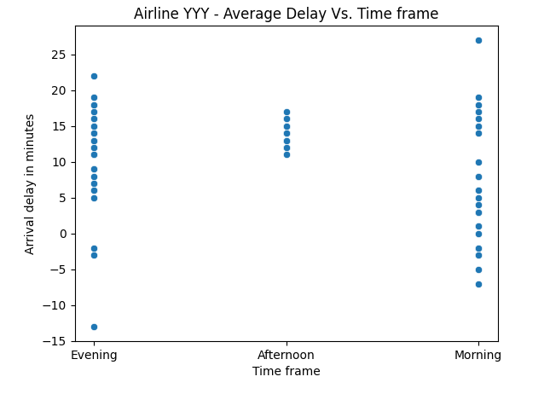

Figure 6 Airline YYY - Average delay vs. time frame

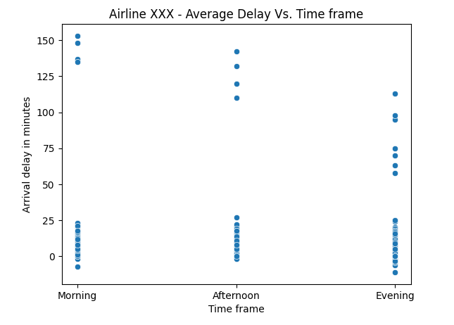

Figure 7 Airline XXX - Average delay vs time frame

Figure 6 and Figure 7 shows the average delay against time frame for Airline YYY and Airline XXX, respectively. Morning flights are flights between 06:00 and 11:59, afternoon flights between 12:00 and 17:59, and evening flights between 18:00 and 23:59. Airline YYY had the most overall delay on the afternoon. On the other hand, Airline XXX experienced most severe delays on the morning flights. However, it experienced delays more than 50 minutes in morning, afternoon, and evening. This suggests that the time the airlines conducted the flight does not contribute to the delay.

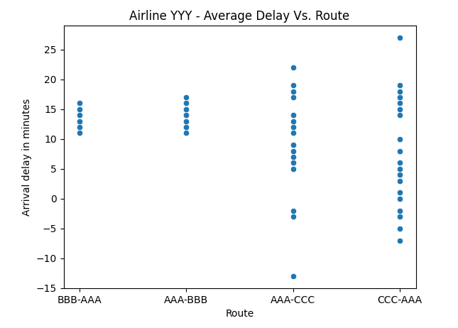

Figure 8 Airline YYY - Average delay vs route

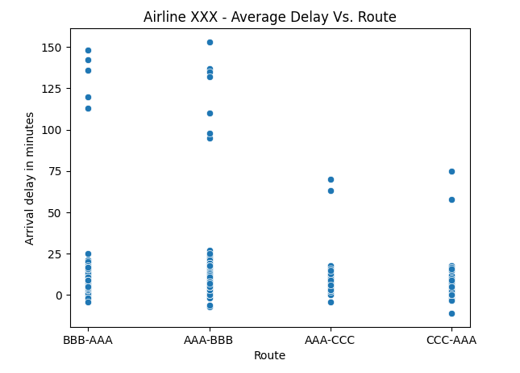

Figure 9 Airline XXX - Average delay vs. Route

Figure 8 and Figure 9 shows the average delays versus route for Airline YYY and Airline XXX, respectively. Both airports experienced more overall delays in the BBB – AAA route, and vice versa. However, more severe delays are experienced by Airline XXX in the BBB – AAA route.

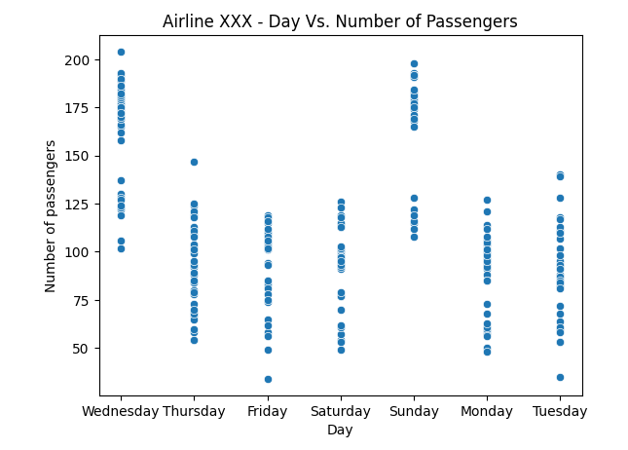

Figure 10 Airline XXX - Scatterplot of day vs. number of passengers

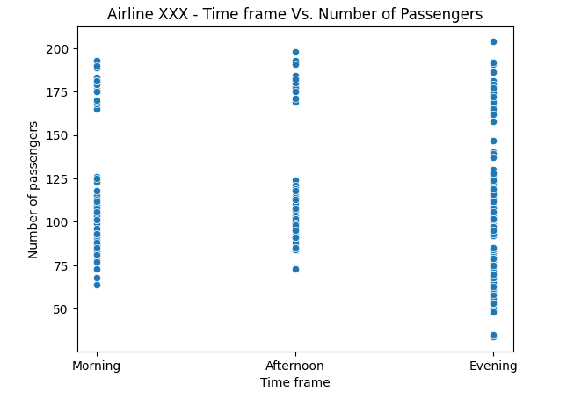

Figure 11 Airline XXX - Scatter plot of time frame vs. Number of passengers

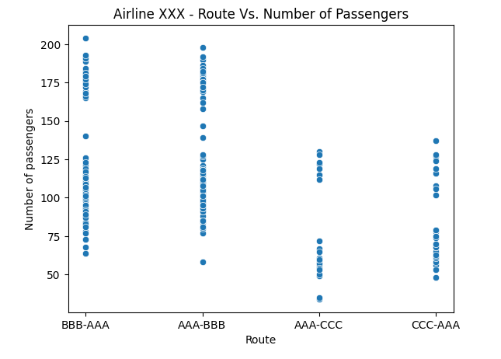

Figure 12 Airline XXX - Scatter plot of Route vs. Number of passengers

Figure 10 shows the scatter plot of day against the number of passengers in Airline XXX. There were more passengers on Wednesday and Sunday than the other days, which may explain why there were severe delays on Wednesday and Sunday.

Figure 11 shows the scatter plot of time frame against the number of passengers in Airline XXX. The distribution of passengers during morning, afternoon, and night was roughly equal.

Figure 12 shows scatter plot of route against number of passengers in Airline XXX. There were more passengers overall for the route of BBB to AAA, and vice versa.

Table 3 Number of flights and delayed flights against time for Airline YYY

|  |  |  |  |  |
| --- | --- | --- | --- | --- |
| Departure Time | Total number of flights | Number of delayed flights | Percentage of delayed flights (%) | Median of delay (Minutes) |
| Night (00:00 – 05:59) | 0 | 0 | - | - |
| Morning (06:00 – 11:59) | 30 | 8 | 26.67 | 4.5 |
| Afternoon (12:00 – 17:59) | 29 | 9 | 31.03 | 13.0 |
| Evening (18:00 – 23:59) | 58 | 14 | 24.14 | 13.0 |

Table 4 Number of flights and delayed flights against time for Airline XXX

|  |  |  |  |  |
| --- | --- | --- | --- | --- |
| Departure Time | Total number of flights | Number of delayed flights | Percentage of delayed flights (%) | Median of delay (Minutes) |
| Night (00:00 – 05:59) | 0 | 0 | - | - |
| Morning (06:00 – 11:59) | 60 | 17 | 28.33 | 10.0 |
| Afternoon (12:00 – 17:59) | 60 | 16 | 26.67 | 10.0 |
| Evening (18:00 – 23:59) | 120 | 30 | 25.0 | 9.0 |

Table 3 and Table 4 shows more detailed results for the Airline YYY and Airline XXX, respectively in terms of the time frame. Both flights had no flights on night. The percentage of delayed flights were roughly equal between morning, afternoon, and evening on both Airline YYY and Airline XXX.

Table 5 Number of flights in each day of week for Airline YYY

|  |  |  |  |  |
| --- | --- | --- | --- | --- |
| Day of week | Total number of flights | Number of delayed flights | Percentage of delayed flights (%) | Median of delay (Minutes) |
| Sunday | 14 | 12 | 85.71 | 15.5 |
| Monday | 16 | 0 | 0 | 11.5 |
| Tuesday | 16 | 2 | 12.5 | 14 |
| Wednesday | 19 | 17 | 89.47 | 16 |
| Thursday | 20 | 0 | 0 | 11 |
| Friday | 16 | 0 | 0 | 12.0 |
| Saturday | 16 | 0 | 0 | 11.5 |

Table 6 Number of flights for each day of week for Airline YYY

|  |  |  |  |  |
| --- | --- | --- | --- | --- |
| Day of week | Total number of flights | Number of delayed flights | Percentage of delayed flights (%) | Median of delay (Minutes) |
| Sunday | 32 | 24 | 75.0 | 17.0 |
| Monday | 32 | 0 | 0 | 5.0 |
| Tuesday | 32 | 2 | 6.25 | 12 |
| Wednesday | 40 | 37 | 92.5 | 18 |
| Thursday | 40 | 0 | 0 | 5 |
| Friday | 32 | 0 | 0 | 4.5 |
| Saturday | 32 | 0 | 0 | 5 |

Table 5 and Table 6 shows more detailed results for the Airline YYY and Airline XXX, respectively in terms of the day of week. Both airlines experienced delays only on Sunday, Tuesday, and Wednesday, although Sunday and Wednesday had a lot more delays.

Table 7 Number of flights for each route for Airline YYY

|  |  |  |  |  |
| --- | --- | --- | --- | --- |
| Route | Total number of flights | Number of delayed flights | Percentage of delayed flights (%) | Median of delay (Minutes) |
| BBB - AAA | 28 | 8 | 28.57 | 14 |
| AAA - BBB | 29 | 9 | 31.03 | 13 |
| AAA - CCC | 30 | 6 | 20.0 | 11 |
| CCC - AAA | 30 | 8 | 26.67 | 4.5 |

Table 8 Number of flights for each route for Airline XXX

|  |  |  |  |  |
| --- | --- | --- | --- | --- |
| Route | Total number of flights | Number of delayed flights | Percentage of delayed flights (%) | Median of delay (Minutes) |
| BBB - AAA | 90 | 23 | 25.56 | 10 |
| AAA - BBB | 90 | 26 | 28.89 | 9 |
| AAA - CCC | 30 | 6 | 20.0 | 6.5 |
| CCC - AAA | 30 | 8 | 26.67 | 7.5 |

Table 7 and Table 8 shows more detailed results for the Airline YYY and Airline XXX, respectively in terms of the route. Both airlines experienced delay on all routes, however the BBB – AAA route (and vice versa) had slightly more percentage of delayed fights, as well as the median of delay.

# **When is Airline YYY and Airline XXX flights delayed, and vice versa?**

First, the researcher analyzed on which time the daily departure and arrival times for the two aircraft. To do this, the researcher analyzed the Excel file directly.

Table 9 Departure and Arrival Time for Airline YYY and Airline XXX

|  |  |  |
| --- | --- | --- |
| Route | Airline YYY Departure and Arrival Time | Airline XXX Departure and Arrival time |
| BBB – AAA | 21:55 – 23:35 | 09:10 – 10:40  13:10 – 14:40  18:10 – 19:40 |
| AAA - BBB | 13:35 – 15:15 | 07:45 – 09:15  14:45 – 16:15  20:45 – 22:15 |
| AAA - CCC | 20:20 – 21:35 | 21:15 – 22:25 |
| CCC - AAA | 06:35 – 07:50 | 18:05 – 19:15 |

Then, the researcher saw on which dates and times the flights are delayed. To save time, the researcher used Excel’s filter function, and the researcher filtered the flights that has the delay indicator of ‘1’. From there, the researcher looked at the dates on which the flights are delayed for both airlines.

Table 10 Date in which the flights are late for Airline YYY and Airline XXX

|  |  |  |
| --- | --- | --- |
| Route | Date of late Airline YYY Flights (September 2021) | Date of late Airline XXX Flights (September 2021) |
| BBB – AAA | 1, 5, 8, 14, 15, 19, 22, 26 | 1 (all), 8 (all), 12 (all), 15 (09:10 and 13:10), 19 (09:10 and 13:10), 22 (all), 26 (all), 29 (all) |
| AAA – BBB | 1, 5, 8, 14, 15, 19, 22, 26, 29 | 1 (all), 8 (all), 12 (all), 14 (7:45 and 20:45), 15 (all), 19 (all), 22 (all), 26 (all), 29 (all) |
| AAA – CCC | 1, 8, 12, 19, 26, 29 | 1, 8, 12, 19, 26, 29 |
| CCC – AAA | 1, 8, 12, 15, 19, 22, 26, 29 | 1, 8, 12, 15, 19, 22, 26, 29 |

There were no canceled flights from Airline XXX. On the other hand, three of Airline YYY’s flights were cancelled. These were:

* 12 September 2021, BBB – AAA route at 21:55
* 29 September 2021, BBB – AAA route at 21:55
* 12 September 2021, AAA – BBB route at 13:35

As shown on Figure 3, there were Airline XXX flights which were delayed by over 50 minutes. Again, the filtering function of Excel was used to see the outliers. Table 11 shows the flights of Airline XXX that were delayed by over 50 minutes.

Table 11 Airline XXX flights which are delayed by over 50 minutes

|  |  |  |  |  |  |
| --- | --- | --- | --- | --- | --- |
| **Departure date** | **Route** | **Scheduled departure time** | **Scheduled arrival time** | **Arrival delay in minutes** | **Number of passengers** |
| 12/09/2021 | BBB-AAA | 9:10 | 10:40 | 148 | 176 |
| 12/09/2021 | BBB-AAA | 13:10 | 14:40 | 120 | 182 |
| 12/09/2021 | BBB-AAA | 18:10 | 19:40 | 113 | 174 |
| 29/09/2021 | BBB-AAA | 9:10 | 10:40 | 136 | 193 |
| 29/09/2021 | BBB-AAA | 13:10 | 14:40 | 142 | 179 |
| 08/09/2021 | AAA-BBB | 7:45 | 9:15 | 137 | 169 |
| 12/09/2021 | AAA-BBB | 7:45 | 9:15 | 153 | 183 |
| 12/09/2021 | AAA-BBB | 14:45 | 16:15 | 110 | 181 |
| 12/09/2021 | AAA-BBB | 20:45 | 22:15 | 95 | 169 |
| 29/09/2021 | AAA-BBB | 7:45 | 9:15 | 135 | 181 |
| 29/09/2021 | AAA-BBB | 14:45 | 16:15 | 132 | 182 |
| 29/09/2021 | AAA-BBB | 20:45 | 22:15 | 98 | 172 |
| 12/09/2021 | AAA-CCC | 21:15 | 22:25 | 70 | 115 |
| 29/09/2021 | AAA-CCC | 21:15 | 22:25 | 63 | 119 |
| 12/09/2021 | CCC-AAA | 18:05 | 19:15 | 75 | 108 |
| 29/09/2021 | CCC-AAA | 18:05 | 19:15 | 58 | 106 |

From what is seen on Table 10, most of the delayed Airline XXX occurred at the same dates as Airline YYY, except for 12 September on BBB – AAA route (and vice versa). Table 11 shows that most of the severe delays for Airline XXX occurred on 12 September and 29 September. On these days, Airline YYY decided to cancel these flights instead.

# **Is weather causing the delay?**

According to (FAQ: Weather Delay, 2021), the weather that causes the delay the most are:

* Airport surface winds
* Low visibility
* Winter weather
* Heavy rain and thunderstorms

In this section, the researcher used the data provided by Weather Spark on three airports, namely in BBB, AAA, and CCC. The delay or cancellation was deemed to be caused by weather if the weather was either:

* fog,
* heavy rain,
* freezing rain,
* heavy snow,
* hail, or
* thunderstorm

up to approximately 30 minutes before the arrival of the plane to the destination airport. The flight was deemed to be delayed or cancelled due to wind speed when the wind strength shown on the figures below was stronger than ‘fresh breeze’.

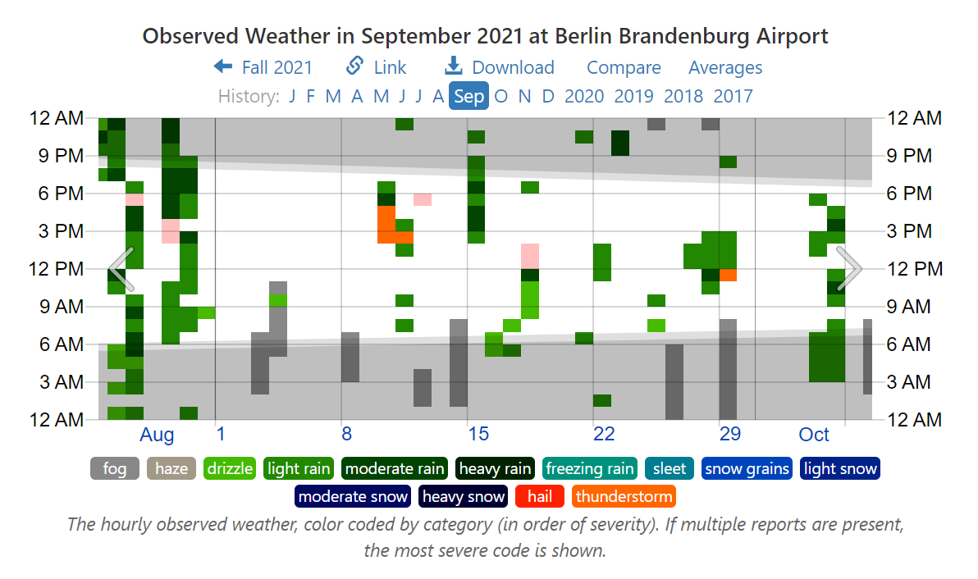

Figure 13 Weather in BBB Airport in September 2021

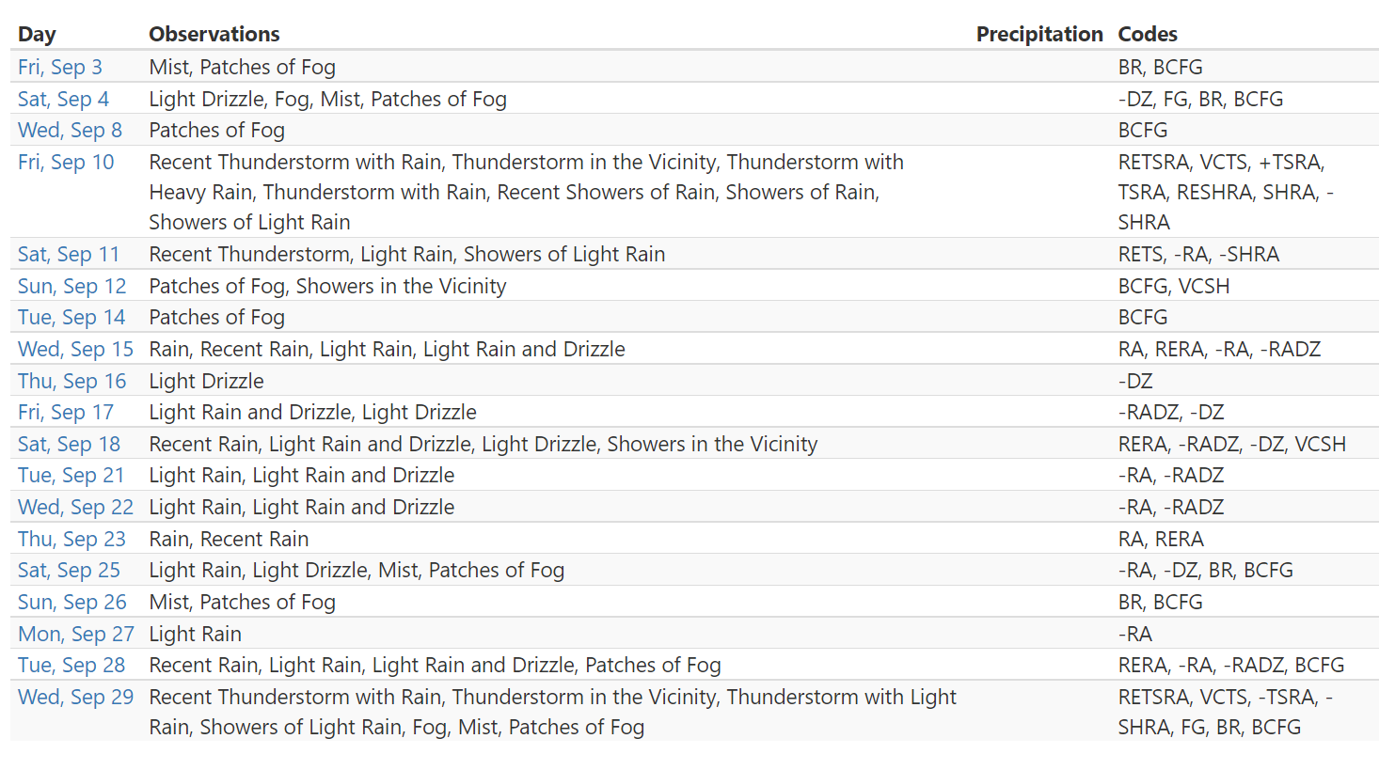

Figure 14 Weather detail in BBB Airport in September 2021

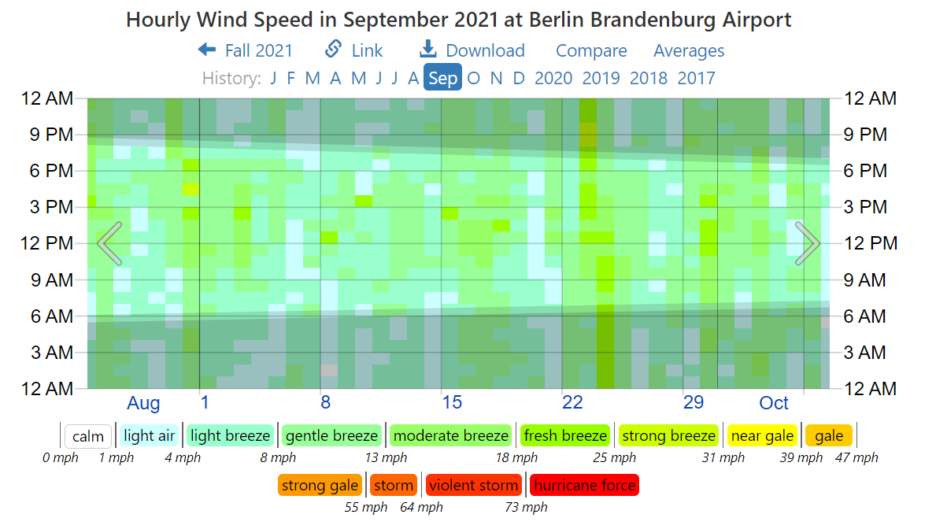

Figure 15 Wind speed in BBB Airport in September 2021

Figure 13 and Figure 14 shows the weather and weather detail in BBB Airport, whereas Figure 15 shows the wind strength. There was a thunderstorm on September 10 and 29, however no flights were late on 10 September, and only a Airline XXX flight took place between 11 AM and 12 PM. There was also a heavy rain on 15 September, the date which the Airline YYY and Airline XXX flights were delayed. Fog was observed on the morning of 26 and 29 September, the latter which may affect Airline XXX AAA – BBB route. There were no strong winds in the airport in September 2021 as well. (September 2021 Weather History at BBB Brandenburg Airport Germany, n.d.)

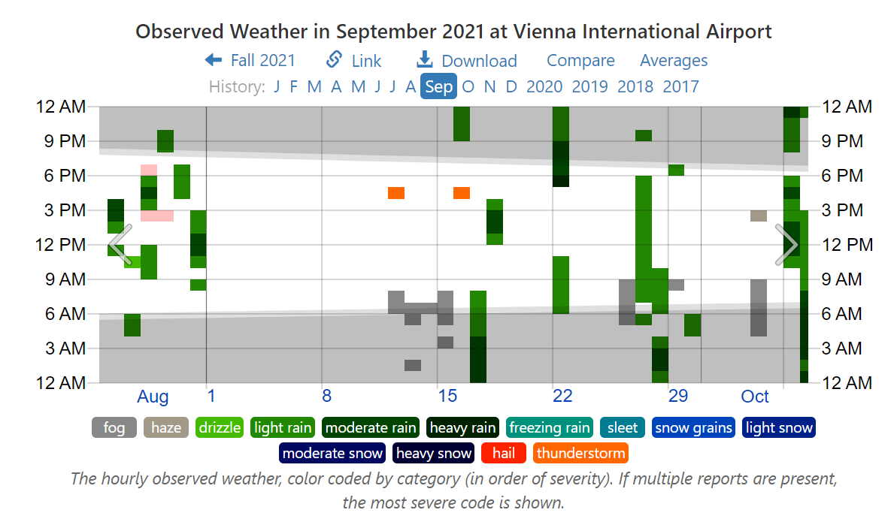

Figure 16 Weather in AAA Airport in September 2021

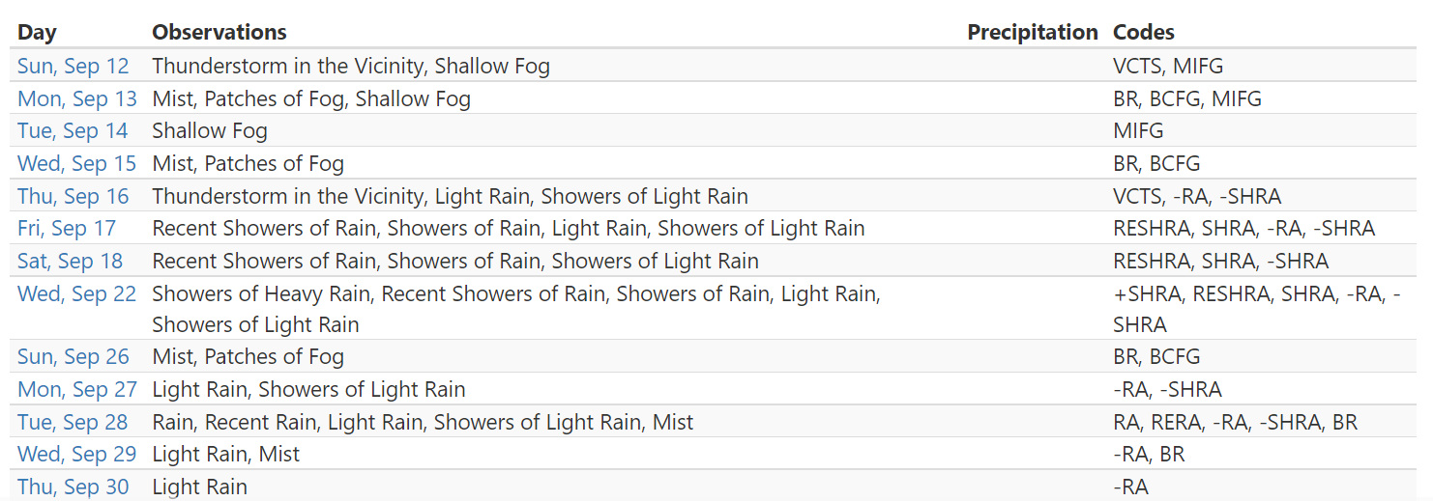

Figure 17 Weather Detail in AAA Airport in September 2021

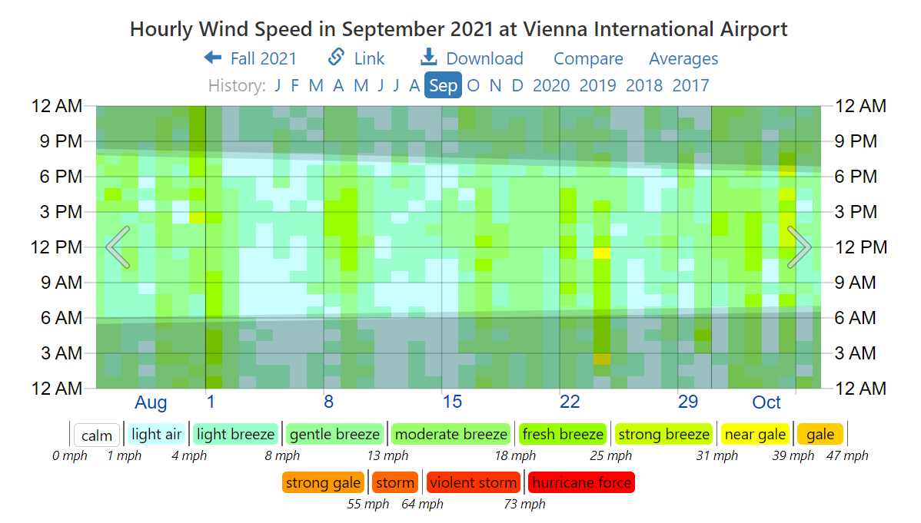

Figure 18 Wind speed in AAA Airport in September 2021

Figure 16 and Figure 17 shows the weather conditions in AAA in September 2021. A thunderstorm existed on 12 September between 16:00 and 17:00, which may cause delay for AAA – BBB flight on 14:45 to 16:15. Fog was present on September 15, likely affecting Airline XXX morning flight for AAA – BBB, as well as Airline YYY’s CCC – AAA route. Heavy rain was also observed on 22 September between 17:00 and 21:00, possibly delaying Airline XXX’s night flights. A fog on 26 and 29 September could also affect Airline XXX’s morning flights. Figure 18 shows the wind speed in AAA Airport in September 2021. “Near Gale” winds were only observed on September 24, of which no flights from either airline were delayed (*September 2021 Weather History at AAA International Airport Austria*, n.d.).

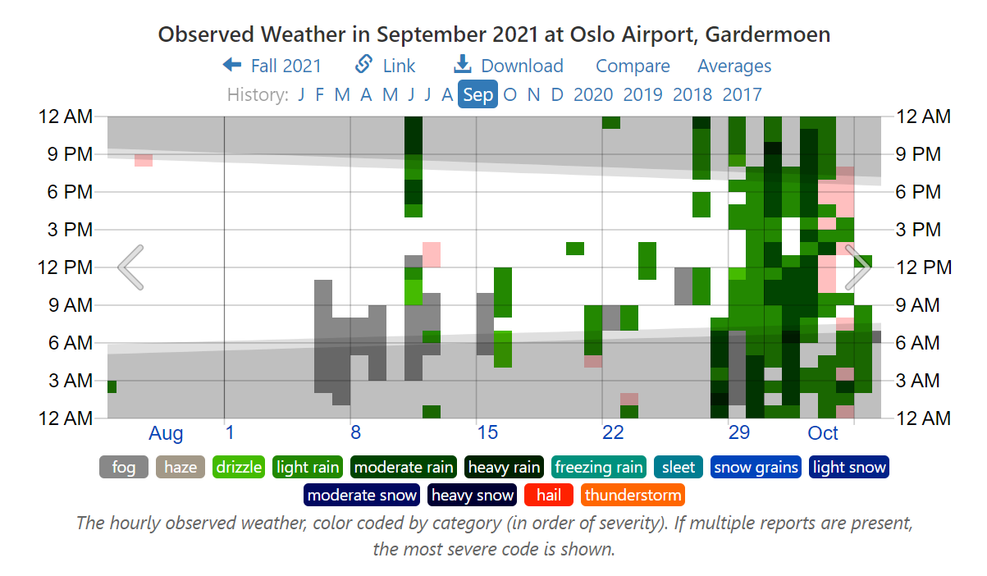

Figure 19 Weather in CCC Airport in September 2021

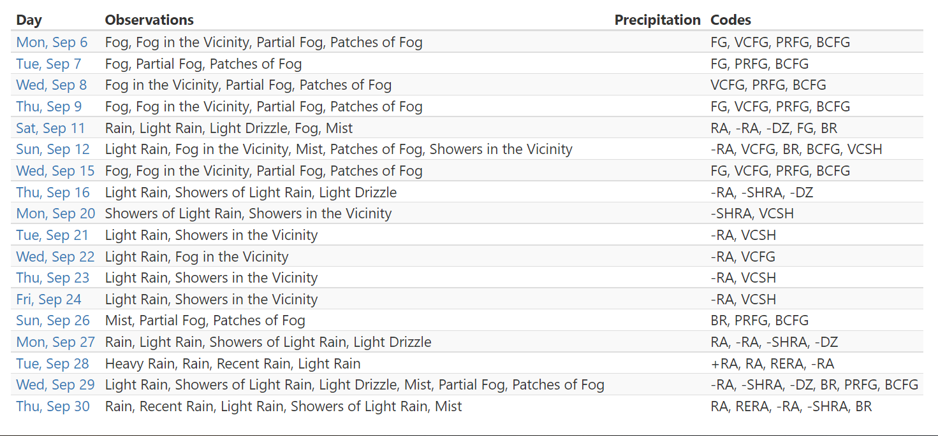

Figure 20 Weather Detail in CCC Airport in September 2021

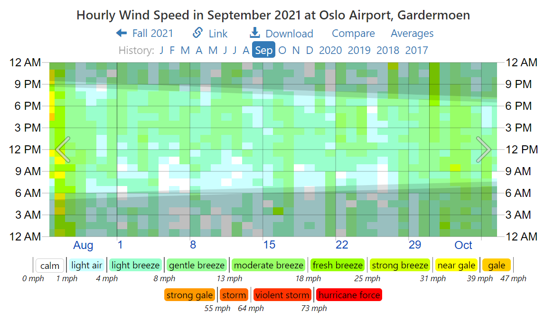

Figure 21 Wind speed in CCC Airport in September 2021

Figure 19 and Figure 20 shows the weather in CCC. Figure 21 shows the wind speed in CCC Airport. There was a fog on the morning of 8, 12, and 29 September, affecting Airline YYY’s CCC – AAA route. Once again, wind strength did not seem to be the factor of the delay for both aircrafts. This means that weather in CCC did not seem to contribute to Airline XXX’s delay ( *September 2021 Weather History at CCC Airport, Gardermoen Norway*, n.d.).

# **Conclusions**

When only the median of the delay time is considered, Airline XXX had less delay time compared to Airline YYY. However, Airline XXX had several flights which are late for over 50 minutes, whereas Airline YYY had none of such issues. This lateness may contribute to the media exaggerating the poor performance of the Airline XXX, not to mention that passengers who were affected by delays more than 50 minutes, and thus miss their connecting flights, would complain louder to the social media.

As for the cause of delay, neither the departure time nor the route seemed to influence whether either Airline XXX or Airline YYY will experience delay. Some of the delays on Airline XXX did occur because of the weather conditions. This was especially prevalent on 29 September, where Airline XXX flights were delayed for over 50 minutes, and two of Airline YYY flights got canceled as well.

However, looking at how Airline YYY cancelled a flight on 12 September and the weather condition, it looks like there was a problem in AAA or BBB Airport that was unrelated to the weather, most notably a security breach in either of the two airports. Airline YYY took the safe route of cancelling the flight instead of making passengers wait anxiously. The cause of the severe delay on 8 September 2021 may be caused by a mechanical problem in the aircraft, especially as only the morning AAA – BBB flight was delayed. The rest of the delays could be attributed to how AAA or BBB Airport can be overcrowded at times, which causes Airline XXX and Airline YYY to need to wait for the other planes to finish boarding / unboarding their passengers.