SCALE-SETI
Phase-1 Design Package
Version 0.3 - Stage-1A Engineering Freeze

Companion to Formal Technical Review - Revision 5
Tim Boccaleri
September 2026
ENGINEERING DEVELOPMENT DOCUMENT
Phase 1 validates a conventional microscopic communication bench, leakage controls, blinding, data integrity, and reproducibility. It is not evidence of cross-scale communication.

Document Control
Item | Value
Document | Scale-SETI Phase-1 Design Package
Version | v0.3
Status | Engineering draft for technical review
Parent document | Scale-SETI Formal Technical Review - Revision 5
Purpose | Convert the Phase-1 concept into a reproducible laboratory implementation package
Change from v0.2 | Freezes the Stage-1A reference implementation; adds component-level fluidic/electrical specifications, dimensioned bench layout, normative JSON schemas, and a deterministic 100-trial synthetic dry-run package.

1. Scope and Phase-1 Boundary
Phase 1 does not attempt to demonstrate cross-scale communication. It validates the experimental machinery required before such a search could be interpreted responsibly. The laboratory must first prove that it can generate unpredictable challenges, send them through a known microscopic communication path, capture receiver data without challenge leakage, quantify ordinary coupling paths, score trials only after the observation window closes, preserve immutable artifacts, and reproduce the procedure independently.
The Phase-1 reference implementation uses an ion or molecular communication path because that class of system is experimentally grounded and can be physically blocked, sham-driven, delayed, replayed, and instrumented. The same protocol can later be ported to more fundamental interfaces only after the reference bench satisfies all acceptance gates.

2. Requirements and Traceability
ID | Requirement | Verification | Gate
PH1-R01 | Generate a fresh challenge only after ARM | RNG audit, timestamp audit, challenge commitment | A4/A5
PH1-R02 | Receiver analysis cannot access challenge plaintext before CLOSE | Access-control test, packet capture, code review | A4
PH1-R03 | Known-link positive controls meet calibrated BER target | At least 1,000,000 transmitted bits or justified equivalent | A2
PH1-R04 | Blocked-path and sham trials establish empirical false-positive floor | At least 1,000 blinded controls before escalation | A4
PH1-R05 | Environmental channels are captured with receiver data | Telemetry completeness and synchronization audit | A3/A5
PH1-R06 | Trial artifacts are immutable after capture close | SHA-256 manifest, append-only archive, audit log | A0/A5
PH1-R07 | A second implementation can reproduce the written procedure | External dry-run / replication review | A6
PH1-R08 | Intentional challenge paths are physically enumerable | Wiring, fluidic, software, and network path review | A3
PH1-R09 | Every analog/digital I/O point is uniquely labeled and documented | I/O map and cable schedule inspection | A0
PH1-R10 | Trial mode is blinded from the receiver/analysis path until CLOSE | Randomization audit and sealed condition record | A4

3. Reference Architecture
The reference architecture separates challenge generation, transmission, microscopic interface, reception, telemetry, capture, and scoring. The physical implementation may vary, but the trust boundaries may not be collapsed during confirmatory trials.
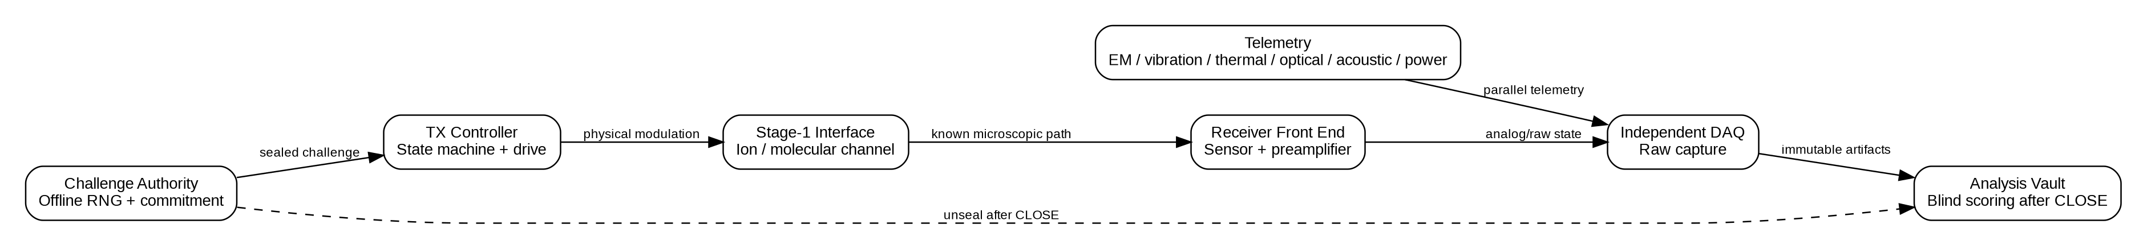
Figure 1. Phase-1 reference architecture.

4. Physical Zones and Isolation Boundaries
The bench is divided into three zones. Zone A contains challenge generation and transmission functions. Zone B contains the microscopic interface and receiver front end. Zone C contains independent acquisition, telemetry aggregation, archival, and post-close analysis transfer.
- Zone A - Challenge / TX: challenge authority, TX host, waveform source, source-measure unit, transmitter driver, and intentional stimulus side.
- Zone B - Interface / RX: microfluidic path, receiver sensor, preamplifier, shielding, and local environmental probes.
- Zone C - DAQ / Archive: independent acquisition host, telemetry aggregator, raw storage, append-only archive, and controlled post-close export.
During blocked-path and confirmatory trials, Zone A must have no routable data path to Zone C. Shared mains power is treated as a potential coupling path and is either separated, isolated, or instrumented.
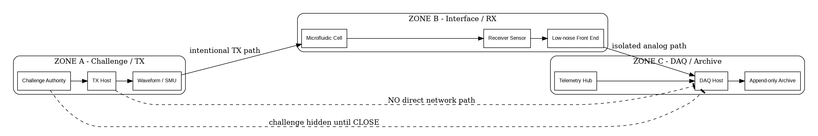
Figure 2. Zone and trust-boundary model.

5. Cable and Wiring Schedule
Cable | From | To | Signal | Medium | Isolation / note
CBL-001 | TX Host | Waveform Source | SCPI/control | USB or isolated Ethernet | Disabled/disconnected during blinded capture if not required
CBL-002 | Waveform Source CH1 | TX Driver / injection electrode | Analog modulation | Shielded coax | Intentional TX path
CBL-003 | SMU HI/LO | TX electrode / sensor bias fixture | DC bias / source-measure | Triax | Guarded; document shield termination
CBL-004 | Receiver Sensor | Low-noise preamp | Sensor output | Triax / shielded pair | Zone B only
CBL-005 | Preamp OUT | DAQ AI0 | Receiver analog | Coax | Prefer isolated front end
CBL-006 | Temperature probe | DAQ AI1 | Temperature | Sensor lead | Telemetry
CBL-007 | Vibration sensor | DAQ AI2 | Accelerometer | Shielded pair | Telemetry
CBL-008 | EM probe | DAQ AI3 | RF/EM envelope | Coax | Telemetry
CBL-009 | Acoustic sensor | DAQ AI4 | Acoustic envelope | Shielded pair | Telemetry
CBL-010 | Optical sensor | DAQ AI5 | Light level | Shielded pair | Telemetry
CBL-011 | TX current monitor | DAQ AI6 | TX current proxy | Isolated analog | Physical telemetry only; no challenge plaintext
CBL-012 | Mains/power monitor | DAQ AI7 | Power/ground telemetry | Isolated sensor | Coupling-path monitoring
CBL-013 | Flow/pressure sensor | DAQ AI8 | Fluidic telemetry | Shielded pair | Interface-state monitoring
CBL-014 | DAQ timing output | Local marker recorder | Trial timing marker | Digital | No challenge data content
CBL-015 | Pump controller | Pump | Flow command | Vendor cable | Zone A; schedule logged
CBL-016 | Valve controller | Selector valve | State command | Vendor cable | Zone A; state transitions logged
CBL-017 | DAQ Host | Immutable archive | Artifact transfer | Dedicated storage link | Controlled / one-way where practical
CBL-018 | Challenge Authority | TX Host | Sealed challenge receipt | Signed removable media / controlled link | Challenge plaintext unavailable to Zone C
CBL-019 | DAQ Host | Export station | Sealed trial bundle | Signed removable media / optical path | Transfer only after CLOSE
CBL-020 | Export station | Analysis Vault | Trial bundle + post-close unseal | Offline transfer | Scoring begins only after validation

All cables receive durable labels at both ends. Unused network interfaces, radios, Bluetooth, Wi-Fi, and management channels are disabled for confirmatory operation unless explicitly listed in the frozen manifest.

6. Reference I/O Map
I/O | Name | Source / destination | Range | Minimum rate | Role
AI0 | RX_MAIN | Receiver preamp | ±1 V or sensor-specific | 10 kS/s initial | Primary receiver signal
AI1 | TEMP_IF | Interface temperature | Sensor-specific | 10 S/s | Thermal telemetry
AI2 | VIB_IF | Interface vibration | ±5 V | 5 kS/s | Mechanical leakage telemetry
AI3 | EM_IF | Local EM probe | ±5 V | 100 kS/s | EM leakage telemetry
AI4 | ACOUSTIC_IF | Acoustic monitor | ±5 V | 48 kS/s | Acoustic leakage telemetry
AI5 | OPTICAL_IF | Optical monitor | 0-5 V | 1 kS/s | Optical leakage telemetry
AI6 | TX_CURRENT_MON | Isolated TX current proxy | ±5 V | 10 kS/s | Physical TX telemetry
AI7 | POWER_MON | Isolated power monitor | ±5 V | 5 kS/s | Shared-power coupling telemetry
AI8 | FLOW_PRESS | Flow / pressure | 0-5 V | 1 kS/s | Fluidic-state telemetry
AI9 | REF_DUMMY | Dummy sensor channel | ±1 V | Match AI0 | Common-mode / pipeline control
DI0 | TRIAL_ARM | Local state marker | TTL | Event | Trial state
DI1 | TX_ACTIVE | TX active marker | TTL | Event | Physical timing only
DI2 | CLOSE_MARK | Capture close marker | TTL | Event | Scoring boundary
DO0 | LOCAL_TEST | DAQ loopback/calibration | TTL | Event | Calibration only; disabled in campaigns

The primary receiver and dummy receiver should use comparable analog conditioning so software or common-mode artifacts can be detected without assuming that only the primary sensor is affected.

7. Environmental Telemetry Channel List
Channel | Measurement objective | Location | Required metadata
Temperature | Detect thermal coupling and drift | Interface and DAQ enclosure | Serial, calibration date, units
Vibration | Detect pump/valve/mechanical timing leakage | Optical table / interface enclosure | Axis, bandwidth, mounting
EM/RF | Detect radiated challenge-correlated emissions | Near interface and cable ingress | Probe, bandwidth, gain
Acoustic | Detect audible/ultrasonic actuation patterns | Zone B enclosure | Sensor type, bandwidth
Optical | Detect LEDs/display/optical leakage | Dark enclosure where practical | Wavelength sensitivity
Power/current | Detect challenge-correlated power signatures | Zone A/shared supply points | Isolation method, CT/shunt spec
Flow/pressure | Confirm fluidic state and schedule fingerprints | Upstream / cell | Range, units, calibration
Room state | Door/open/occupancy event logging | Lab boundary | Event-only by default

Telemetry is part of the preregistered model set and must be captured into the raw trial bundle before scoring. It is not added selectively after an anomalous result.

8. Stage-1 Microfluidic Component Specification
The Stage-1 interface is a known communication path, not an unknown-scale detector. It must be simple enough to model, block, replay, and independently reconstruct.
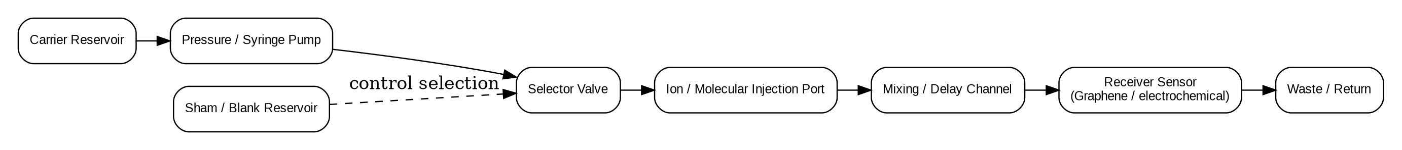
Figure 3. Reference microfluidic signal path.

8.1 Functional requirements
ID | Requirement
MF-R01 | Carrier fluid chemistry is fixed and documented before calibration
MF-R02 | TX symbol states create two measurably distinct receiver states under positive control
MF-R03 | Selector valve or equivalent supports carrier-only/sham operation without changing analysis code
MF-R04 | Path can be physically blocked or bypassed for isolation controls
MF-R05 | Flow, pressure, temperature, and timing are recorded for every trial
MF-R06 | Wetted materials and sensor compatibility are documented
MF-R07 | Dead volume, nominal delay, dispersion, and recovery time are measured before timing is frozen

8.2 Initial component classes
- Pressure-driven or syringe pump with stable low-flow control.
- Two- or multi-position selector valve.
- Carrier reservoir and separate blank/sham reservoir.
- Injection electrode or ion/molecular dosing point.
- Microfluidic channel/cell compatible with the selected receiver.
- Graphene-FET, electrochemical, ion-selective, or equivalent receiver with documented transfer function.
- Upstream/downstream pressure or flow sensing.
- Temperature measurement at the cell.
- Chemically compatible waste/return path.
Exact tubing diameter, channel geometry, concentration, flow rate, and sensor chemistry remain TBD by the chosen lab implementation and must be measured during CAL-03 rather than copied from this concept package.

9. Host and Network Isolation Plan
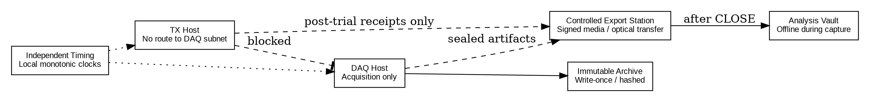
Figure 4. Host/network isolation model.
Host | Primary responsibility | Network posture during capture
HOST-CA | Challenge generation and commitment | Offline; no DAQ route
HOST-TX | TX state machine and hardware control | No route to DAQ/analysis subnet
HOST-DAQ | Receiver + telemetry capture | Acquisition-only; no challenge store access
HOST-ARCH | Immutable/raw archive | Receives sealed trial artifacts
HOST-AN | Analysis and scoring | Offline from capture until CLOSE/unseal
HOST-XFER | Controlled transfer / validation | Signed post-close movement only

9.1 Confirmatory-trial hardening
- Disable Wi-Fi, Bluetooth, cellular modems, and unused NICs.
- Disable automatic cloud synchronization and unapproved remote-management agents.
- Use local accounts and frozen software images.
- Hash OS image, acquisition software, analysis software, and configuration before campaign start.
- Prohibit clipboard/file-share bridges between challenge/TX and DAQ/analysis paths.
- Record firewall rules, route tables, connected USB devices, active processes, and listening ports before and after each campaign.
- Use separate power or measured isolated power where practical.
- Maintain an auditable removable-media transfer procedure when air-gapped transfer is used.
The phrase “air gap” is not accepted as evidence by itself. The isolation package must enumerate physical, electrical, optical, acoustic, RF, software, timing, and human pathways that could transfer challenge information.

10. Software Architecture and Service Interfaces
Service | Inputs | Outputs | Forbidden access
challenge-authority | ARM request, campaign config | challenge_id, commitment, sealed payload | Receiver data
trial-orchestrator | Trial schedule, condition token | State transitions, hardware commands | Expected response in blinded trials
tx-driver | Symbol stream, hardware profile | Instrument commands, TX receipt | Receiver stream
daq-capture | Analog/digital I/O | Immutable raw files, timing log | Challenge plaintext
telemetry-capture | Telemetry I/O | Telemetry files + metadata | Challenge plaintext
artifact-sealer | Raw files, manifests | Hashes, signed bundle | Scoring logic
unseal-service | Sealed challenge, CLOSE evidence | Plaintext challenge + expected transform | Pre-close execution
scorer | Closed/unsealed trial bundle | Decoded response, metrics, p-values | Hardware-control functions
review-tool | Campaign outputs | Reviewer package | Ability to alter raw artifacts

10.1 Minimal service API concepts
challenge-authority /arm returns a trial identifier and commitment record only after the trial is armed. challenge-authority /release is permitted only after CLOSE evidence is present. daq-capture /start accepts trial identifier and acquisition profile but no challenge payload. daq-capture /close finalizes files, computes hashes, and returns an immutable manifest. scorer /score accepts only closed/unsealed bundles.
Authentication can be implementation-specific during development, but confirmatory campaigns should use signed requests or equivalent tamper-evident control logs.

11. Trial State Machine and Timing
Figure 5. Trial state and trust sequence.
The canonical state sequence is ARM -> GENERATE -> COMMIT -> TRANSMIT -> LISTEN/CAPTURE -> CLOSE -> UNSEAL -> SCORE -> ARCHIVE/REVIEW. No analysis process may observe the expected response before CLOSE. Observation windows, transform rules, decoder, and scoring thresholds are frozen before challenge generation.

12. Machine-Readable Trial Schema
A minimum trial record is written before scoring. After CLOSE and unseal, derived fields are appended as a new signed record rather than rewriting the raw acquisition record.
{
"trial_id": "uuid",
"campaign_id": "string",
"protocol_version": 1,
"condition_code_sealed": "opaque-token",
"hardware_config_hash": "sha256",
"software_config_hash": "sha256",
"challenge_commitment": "sha256",
"challenge_bits": null,
"transform_id": 1,
"t_arm_utc": "timestamp",
"t_tx_start_utc": "timestamp",
"t_tx_end_utc": "timestamp",
"t_close_utc": "timestamp",
"raw_receiver_uri": "artifact-ref",
"raw_receiver_sha256": "sha256",
"telemetry_uri": "artifact-ref",
"telemetry_sha256": "sha256",
"decoded_response": null,
"score_status": "SEALED"
}

13. Calibration Worksheets

CAL-01 - Inventory, Identity, and Configuration Freeze
Objective: Establish exactly what hardware/software instance produced the campaign.
Method / record: Instrument manufacturer/model/serial; firmware; calibration status; host image hash; application build hash; cable IDs; sensor serials; fluidic component IDs; network interfaces; disabled radios; operator; date/time.
Pass: All listed items match the approved manifest and no unapproved interface is active.
Worksheet field | Entry
Campaign ID
Apparatus ID
Manifest / build hash
Measured result / deviation
Corrective action
Operator initials / date
Reviewer initials / date

CAL-02 - DAQ and Analog Chain Calibration
Objective: Characterize offset, gain, noise, bandwidth, clipping, timing, and channel crosstalk.
Method / record: Precision source/load or loopback fixture; zero-input capture; known-amplitude sweeps; timing marker injection; adjacent-channel activity test.
Pass: Within manufacturer/lab tolerance and preregistered limits; no crosstalk capable of producing a valid response.
Worksheet field | Entry
Campaign ID
Apparatus ID
Manifest / build hash
Measured result / deviation
Corrective action
Operator initials / date
Reviewer initials / date

CAL-03 - Known Microscopic Channel Transfer Function
Objective: Establish symbol-state separation, transport delay, dispersion, settling/recovery, and BER.
Method / record: Long known-pattern sequences over the complete fluidic path at candidate flow/concentration settings.
Pass: Selected operating point meets BER <= 1e-3 over >=1e6 bits or technically justified equivalent.
Worksheet field | Entry
Campaign ID
Apparatus ID
Manifest / build hash
Measured result / deviation
Corrective action
Operator initials / date
Reviewer initials / date

CAL-04 - Blocked-Path Isolation Survey
Objective: Verify that removing the intended microscopic path removes challenge information from the receiver path.
Method / record: Execute identical TX schedule with the communication route blocked/diverted; record receiver and telemetry channels.
Pass: No preregistered challenge-linked metric exceeds the corrected control threshold.
Worksheet field | Entry
Campaign ID
Apparatus ID
Manifest / build hash
Measured result / deviation
Corrective action
Operator initials / date
Reviewer initials / date

CAL-05 - Telemetry Completeness and Alignment
Objective: Prove that required environmental channels are captured and time-aligned.
Method / record: Inject known events visible in selected telemetry channels and verify timestamps relative to DAQ timing markers.
Pass: >=99% required telemetry completeness; timing uncertainty within declared tolerance.
Worksheet field | Entry
Campaign ID
Apparatus ID
Manifest / build hash
Measured result / deviation
Corrective action
Operator initials / date
Reviewer initials / date

CAL-06 - Blinding and Premature-Access Test
Objective: Demonstrate receiver acquisition and scoring cannot access challenge or expected response before CLOSE.
Method / record: Permissions audit, route/firewall review, packet/log inspection, file-system test, controlled access attempt.
Pass: All pre-close attempts fail and are logged; no challenge material appears in receiver/analysis artifacts.
Worksheet field | Entry
Campaign ID
Apparatus ID
Manifest / build hash
Measured result / deviation
Corrective action
Operator initials / date
Reviewer initials / date

CAL-07 - Artifact Integrity and Recovery
Objective: Verify trial artifacts cannot be silently altered after closure and archive can be reconstructed.
Method / record: Create test trial, seal/hash, copy through archive path, attempt controlled modification, validate detection, restore/re-score.
Pass: Unauthorized changes are detected; hashes reproduce; archived data can be independently re-read and scored.
Worksheet field | Entry
Campaign ID
Apparatus ID
Manifest / build hash
Measured result / deviation
Corrective action
Operator initials / date
Reviewer initials / date

14. Acceptance Gates
Gate | Requirement | Pass criterion | Failure action
A0 | Inventory/hash verification | 100% match to frozen manifest | Stop and reconcile configuration
A1 | DAQ/analog calibration | Within declared tolerance | Recalibrate/repair
A2 | Known-link BER | <=1e-3 over >=1e6 bits or justified equivalent | Tune interface; do not isolate yet
A3 | Leakage survey | No unmodeled path carries challenge information above threshold | Redesign boundary
A4 | Blinded controls | No challenge-linked excess beyond corrected alpha | Debug pipeline
A5 | 100-trial commissioning | >=99% artifact/telemetry completeness; positives decode as specified | Repeat commissioning
A6 | External review | Reviewer disposition permits confirmatory campaign | Hold and remediate

15. 100-Trial Commissioning Campaign
- 25 known-link positive controls
- 25 blocked-path trials
- 20 sham-transmitter trials
- 10 dummy-receiver trials
- 10 delayed-reveal trials
- 10 replay-schedule/fresh-challenge trials
Trial order is randomized and concealed from the receiver-analysis path. Campaign success is based on positive-control performance, null-control behavior, artifact completeness, absence of unexplained leakage, and successful blind scoring - not on any single interesting event.

16. Preregistration Template
Preregistration block | Required fields
Scientific question | Primary hypothesis; null hypothesis; interface; number of trials
Challenge/response | Challenge length; RNG; transform IDs; decoder hash; valid-response definition
Timing | Symbol interval; observation windows; guard interval; maximum clock uncertainty
Primary metric | Endpoint; null distribution; alpha; multiple-testing correction; promotion threshold
Controls | Positive, blocked, sham, dummy, delayed/permuted/replay fractions
Exclusions/failure rules | Hardware failure exclusion; missing data; trial abort; campaign abort
Frozen artifacts | Hardware hash; software hash; protocol hash; analysis-plan hash; signer/date

No primary endpoint, transform, timing window, decoder, or exclusion rule may be changed after unblinding without clearly labeling the resulting analysis as exploratory.

17. Lab Build and Handoff Checklist

Mechanical / fluidic
☐ Bench layout matches controlled drawing
☐ All wetted materials documented
☐ Valve states fail safe / known
☐ Flow and pressure limits documented
☐ Waste path secured
☐ Receiver mount and shielding reproducible

Electrical / instrumentation
☐ All cable IDs installed at both ends
☐ I/O map verified channel-by-channel
☐ Ground/shield plan documented
☐ Unused interfaces disabled
☐ Analog ranges prevent clipping
☐ Isolation devices verified

Computing / software
☐ Host roles separated
☐ OS/application hashes frozen
☐ Route/firewall table captured
☐ Cloud sync and unapproved remote agents disabled
☐ Capture cannot access challenge plaintext
☐ Post-close unseal path tested

Data integrity
☐ Raw receiver data immutable after CLOSE
☐ Telemetry stored with matching trial ID
☐ Hash manifest generated automatically
☐ Controlled transfer procedure tested
☐ Independent readback/scoring verified

Review readiness
☐ CAL-01 through CAL-07 signed
☐ A0 through A5 passed
☐ Open deviations listed
☐ Synthetic example dataset included
☐ External reviewer package generated

18. Change Control
Every change after A0 receives a change identifier, rationale, affected requirements, risk classification, calibration impact, approval, and resulting build hash. Changes to the interface, acquisition chain, challenge path, blinding boundary, decoder, timing, or analysis plan invalidate applicable prior calibration unless a reviewer explicitly documents why recalibration is unnecessary.
Field | Value
Change ID | CHG-YYYY-NNN
Date
Requestor
Description
Reason
Requirements affected
Calibration affected
Risk | Low / Medium / High
Approval
Effective build hash

19. Replication Package
- Formal Technical Review - Revision 5
- Phase-1 Design Package v0.2
- Controlled figures/drawings
- BOM with functional requirements and allowable equivalents
- Cable schedule and I/O map
- Microfluidic component specification
- Host/network isolation plan
- Source repository with tagged release and hashes
- CAL-01 through CAL-07 examples and blank forms
- Preregistration template
- Commissioning dataset schema and synthetic example data
- Issue/deviation log template
- Limitations statement and prohibited interpretations

20. v0.3 Engineering Freeze Decisions
Revision v0.3 resolves the principal implementation decisions left open in v0.2. The choices below define the reference Stage-1A commissioning apparatus. Equivalent substitutions are allowed only through documented change control and must preserve the functional requirements and isolation boundaries.
Decision | v0.3 freeze | Rationale
Symbol carrier | Sodium-chloride concentration keying in aqueous carrier | Safe, inexpensive, well understood, easily blocked/shammed, large measurable contrast
Low symbol | 1 mM NaCl nominal | Clear low-conductivity state while remaining above ultrapure-water instability
High symbol | 10 mM NaCl nominal | Approximately one decade concentration contrast for robust commissioning
Flow control | Two-channel pressure-driven controller; Elveflow OB1 MK4 reference candidate | Closed-loop microfluidic control, TTL triggering, software SDK support
Fluid selection | Bidirectional selector valve; Elveflow MUX Distribution 12/1 reference candidate | Low internal volume and programmable reagent switching
Nominal flow | 200 µL/min | Practical transport delay without unnecessarily high pressure
Receiver | AC conductometric flow cell using platinum electrodes | Conventional physics, analog output, independently characterizable
AC excitation | 1 kHz, 100 mVpp nominal through 100 kΩ 0.1% series resistor | Limits polarization/current while preserving measurable impedance contrast
Primary acquisition | NI USB-6363 or equivalent 16-bit multifunction DAQ | Adequate channel count and acquisition bandwidth
Waveform source | Keysight 33500B family or equivalent | Stable programmable low-distortion excitation
Stage 1B | Graphene-FET or other nanoscale receiver only after Stage-1A acceptance | Prevents novel-sensor behavior from being confused with protocol defects
The concentration values, flow rate, excitation amplitude, and timing are commissioning targets, not scientific constants. CAL-02 and CAL-03 may adjust them if required to achieve stable, non-saturating receiver separation. Any adjustment must be frozen before blinded campaigns begin.

21. Stage-1A Fluidic Implementation Specification
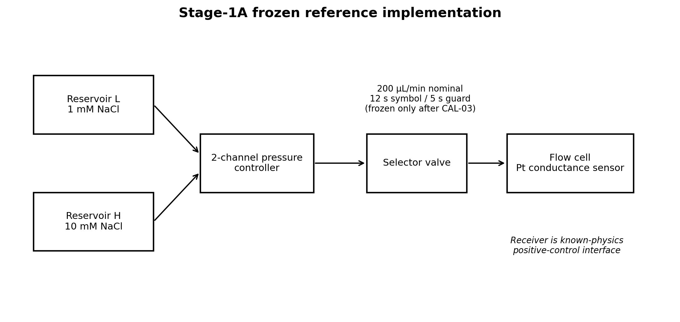
Figure 6. Frozen Stage-1A reference implementation.

21.1 Fluid Chemistry
Use deionized water from a single lot to prepare both states. The initial reference solutions are 1.00 mM NaCl (L) and 10.00 mM NaCl (H). Record reagent manufacturer/lot, balance ID, water source, preparation date, measured temperature, and independent conductivity verification. Prepare enough volume for the complete campaign plus calibration and waste.
A blank/sham solution uses the same composition as the low state. A passive trial leaves the receiver flowing at the low state without challenge-dependent valve motion. BLOCKED, SHAM, and PASSIVE controls therefore test different leakage mechanisms.

21.2 Fluidic Geometry Freeze
The reference fluidic path after the selector valve shall use 1/16-inch OD chemically compatible tubing with an internal diameter near 0.5 mm. The valve-to-receiver length should be held to 100 mm or less where the facility layout permits. All dimensions are recorded in the apparatus manifest.
- Nominal 1.0 mm internal flow bore in the receiver cell.
- Two platinum sensing electrodes exposed to the flowing solution.
- Nominal electrode separation of 1.0 mm across or immediately adjacent to the flow path.
- Minimal trapped volume and no gas pocket above the sensing region.
- Removable fittings so the cell can be replaced by a dummy load or bypass for controls.
The exact cell constant depends on fabricated geometry. CAL-02 therefore establishes the electrical transfer function and CAL-03 measures the end-to-end transport and settling response with the assembled cell rather than relying on CAD geometry alone.

21.3 Timing Targets
The initial engineering target is 200 µL/min, a 12-second symbol interval, and a 5-second guard interval. CAL-03 measures 10-90% and 5-95% transition times for L→H and H→L. The final symbol duration must be at least 1.5 times the slower measured 95% settling time unless a pre-registered equalization/decoder demonstrates lower intersymbol interference.

22. Stage-1A Electrical Receiver Specification
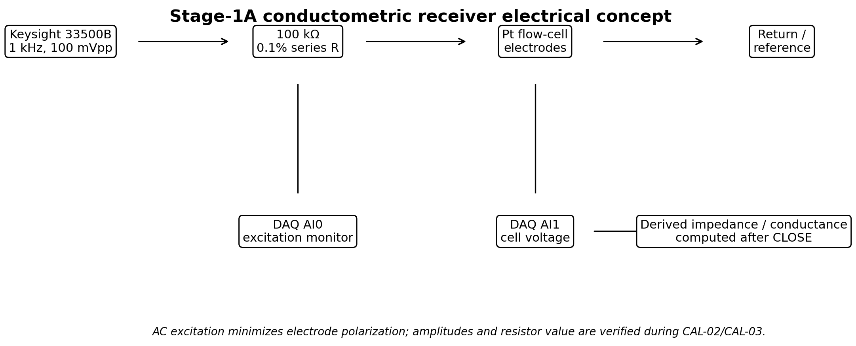
Figure 7. AC conductometric receiver concept.
The reference receiver uses low-amplitude AC excitation so the commissioning channel is dominated by solution impedance rather than DC electrode polarization. The waveform source provides a 1 kHz, 100 mVpp sine wave through a 100 kΩ, 0.1% series resistor into the platinum flow cell. The DAQ records both the source-side excitation and the cell-side voltage. Derived impedance or conductance is calculated after CLOSE from the raw synchronized waveforms.
The final resistor value and excitation amplitude may be changed during CAL-02 to place both L and H states comfortably within the DAQ input range without clipping while keeping electrode current low. The chosen values are then frozen in the hardware manifest.

22.1 DAQ Channel Freeze
Channel | v0.3 assignment | Minimum rate | Note
AI0 | RX_EXCITATION | 20 kS/s | Measures actual 1 kHz excitation
AI1 | RX_CELL | 20 kS/s | Primary receiver waveform
AI2 | TEMP_IF | 10 S/s | Interface temperature
AI3 | VIB_IF | 5 kS/s | Vibration leakage monitor
AI4 | EM_IF | 100 kS/s | EM leakage monitor
AI5 | ACOUSTIC_IF | 48 kS/s | Acoustic leakage monitor
AI6 | OPTICAL_IF | 1 kS/s | Optical leakage monitor
AI7 | POWER_MON | 5 kS/s | Shared-power leakage monitor
AI8 | FLOW_PRESS | 1 kS/s | Flow/pressure state
AI9 | REF_DUMMY | 20 kS/s | Electrically similar dummy receiver
The earlier v0.2 TX current-proxy channel becomes optional during Stage-1A if it would create an unnecessary information bridge. If used, it must be independently isolated and explicitly included in the leakage model.

23. Connector and Wiring Freeze
The reference NI USB-6363 BNC configuration uses BNC analog inputs. BNC center conductors carry the measured signal; shields are bonded according to the finalized grounding plan. Shields must not be connected at multiple points if doing so creates a measurable ground loop.
ID | Source | Destination | Reference implementation
E-001 | AWG CH1 | 100 kΩ series resistor | 50 Ω BNC coax; source configured for high-Z load unless verified otherwise
E-002 | Series resistor output | Pt electrode 1 | Shielded lead; shortest practical run
E-003 | Pt electrode 2 | AWG return/reference | Shielded return
E-004 | Excitation monitor | DAQ AI0 | BNC T or isolated monitor point
E-005 | Cell monitor | DAQ AI1 | High-impedance buffered monitor
E-006 | Dummy network | DAQ AI9 | Fixed RC network approximating receiver impedance
E-007 | ARM marker | DAQ DI | TTL only; no challenge content
E-008 | TX ACTIVE marker | DAQ DI | TTL envelope only; no symbol content
E-009 | CLOSE marker | DAQ DI | TTL event
A pre-campaign continuity and insulation test records DC resistance between every Zone-A signal conductor and every Zone-C signal conductor with the intentional physical interface disconnected. Unexpected conductive paths are a hard failure of A3.

24. Dimensioned Laboratory Reference Layout
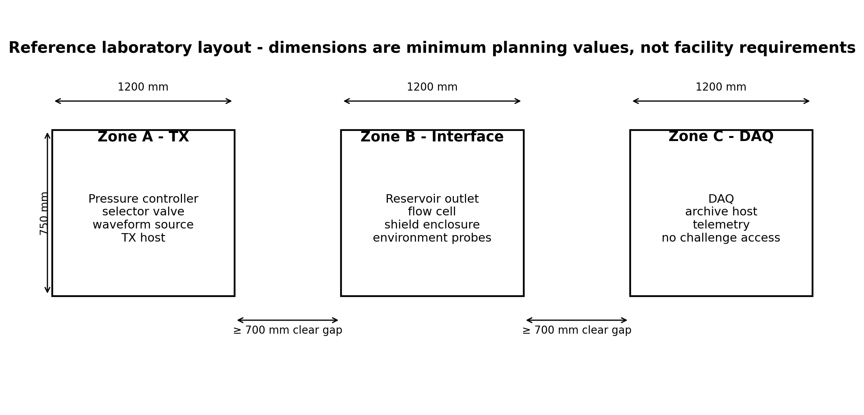
Figure 8. Reference three-zone bench arrangement.
The reference planning layout uses three 1200 mm × 750 mm work surfaces with at least 700 mm clear separation between adjacent zones. This is not a universal facility requirement; the requirement is measurable separation of functions and enumerated coupling paths. Where available, Zone A and Zone C should use separate mains circuits or separately instrumented isolation supplies.
Zone B should contain the minimum active electronics necessary for sensing. Displays, networked computers, status LEDs, and unnecessary switching supplies are excluded from the immediate receiver enclosure during blinded trials.

25. Information-Flow and Software Freeze
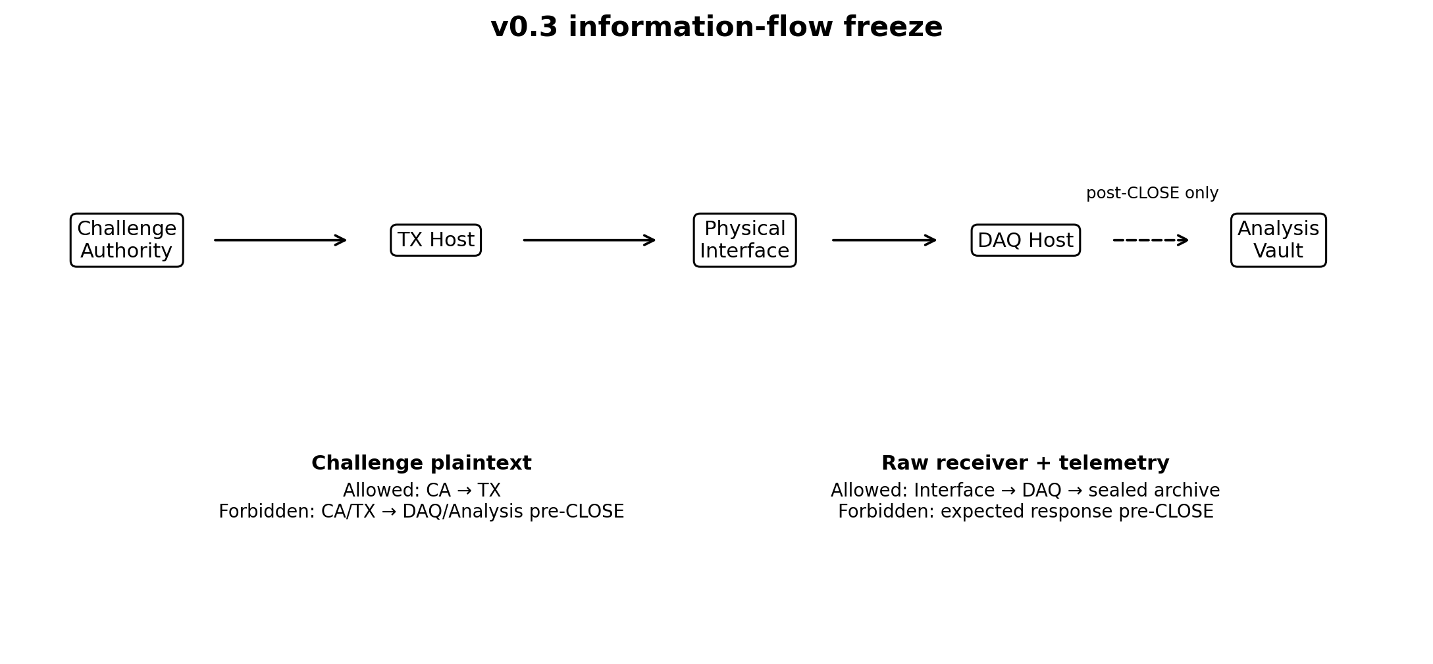
Figure 9. Information-flow freeze for confirmatory operation.
The Challenge Authority may provide plaintext challenge information only to the TX path. The DAQ receives trial identifiers, acquisition settings, and state markers, but never challenge plaintext or expected response before CLOSE. The Analysis Vault receives receiver and telemetry artifacts only after they are sealed, and receives challenge plaintext only after CLOSE evidence has been validated.

25.1 Repository Freeze
/scale-seti-phase1
/challenge-authority
/tx-driver
/daq-capture
/telemetry-capture
/artifact-sealer
/unseal-service
/scorer
/schemas
/tests
/campaigns
No shared application library may contain both challenge-plaintext handling and receiver-decoding functions unless the confirmatory deployment compiles and deploys them into separate trust domains and a code review demonstrates that no pre-CLOSE path exists.

26. Machine-Readable Schemas
v0.3 creates four normative JSON Schema files distributed with the design package:
- trial_record.schema.json - per-trial lifecycle and artifact references.
- campaign_manifest.schema.json - frozen campaign configuration.
- calibration_record.schema.json - CAL-01 through CAL-07 results.
- scoring_output.schema.json - post-CLOSE scoring output.
The schemas use JSON Schema Draft 2020-12. Implementations may store equivalent records in a database, but exported replication bundles must validate against the published schemas or a versioned successor.

27. Synthetic 100-Trial Dry-Run Campaign
Before hardware exists, the software pipeline should be exercised against deterministic synthetic data. v0.3 includes a 100-trial commissioning set with 25 trials in each condition: POSITIVE, BLOCKED, SHAM, and PASSIVE.
The synthetic POSITIVE trials intentionally produce near-perfect challenge recovery. Control trials intentionally produce random 128-bit outputs around the 50% bit-accuracy null expectation. A second file contains normalized receiver and telemetry time series. These files exist only to validate software plumbing and must never be represented as experimental observations.
The included score_campaign.py recomputes Hamming distances, produces condition-level summaries, and applies a deliberately simple sanity gate: high positive-control accuracy and approximately chance-level control accuracy. This is a reference dry-run utility, not the final statistical analysis plan.

27.1 v0.3 Synthetic Expected Behavior
Condition | Trials | Expected bit accuracy | Expected exact matches
POSITIVE | 25 | > 0.98 | Many
BLOCKED | 25 | ~0.50 | 0 expected
SHAM | 25 | ~0.50 | 0 expected
PASSIVE | 25 | ~0.50 | 0 expected

28. Stage-1A Acceptance Additions
The existing A0-A6 gates remain in force. v0.3 adds the following Stage-1A commissioning criteria before the apparatus may enter the 100-trial blinded campaign:
ID | Criterion | Pass condition
A2.1 | L/H electrical separation | Receiver distributions separated without clipping; target Cohen's d ≥ 5 during calibration
A2.2 | Transition repeatability | 95% settling-time CV ≤ 15% across 20 L↔H transitions
A2.3 | Residual memory | After guard interval, prior symbol improves next-symbol prediction by < 1% absolute
A3.1 | Zone isolation | No undocumented conductive/network path between Challenge/TX and DAQ/Analysis
A3.2 | Dummy receiver | Challenge correlation indistinguishable from preregistered null
A4.1 | Blinding dry run | Analysis operator cannot identify condition above chance from metadata before unseal
A5.1 | Schema validation | 100% of campaign records validate against v0.3 schemas
These thresholds are engineering starting points and must receive statistical review before a confirmatory study.

29. Stage 1B Transition Rule
Stage 1B replaces only the receiver interface after Stage-1A completes A0-A6. The challenge authority, blinding, capture, telemetry, archive, and scoring boundaries remain unchanged. The preferred first Stage-1B candidate is a graphene-FET or equivalent nanoscale ion-sensitive receiver with a documented transfer function.
The reason for this sequence is methodological: if a custom nanoscale sensor produces an anomaly before the protocol stack is validated, the experiment cannot distinguish sensor novelty from information-channel novelty. Stage-1A removes that ambiguity.

30. v0.3 Release Artifacts
- DOCX/PDF/Markdown design package
- Four engineering figures
- Four JSON Schema files
- Deterministic 100-trial synthetic campaign
- Synthetic receiver/telemetry traces
- Reference scoring script
- Generated scoring outputs and campaign summary
- README instructions for the dry run
This is the first release intended to be sufficiently concrete that a second team can critique the selected Stage-1A implementation rather than only the concept.

References
1. Zhang, S.; Akan, O. B. “Ion Transmitter for Molecular Communication.” IEEE Transactions on Nanobioscience 25(3), 361-370, 2026.
2. Kuscu, M. et al. “Fabrication and microfluidic analysis of graphene-based molecular communication receiver for Internet of Nano Things.” Scientific Reports 11, 19600, 2021.
3. National Instruments. USB-6363 product specifications: 32 AI, 16-bit, 2 MS/s; multifunction I/O. Accessed September 2026.
4. Keysight Technologies. 33500B Series Trueform Waveform Generators product documentation: 16-bit arbitrary waveform generation. Accessed September 2026.
5. Tektronix/Keithley. Model 2450 Source Measure Unit documentation and specifications. Accessed September 2026.
6. ID Quantique. Quantis QRNG PCIe product documentation. Accessed September 2026.
7. Scale-SETI: A Search for Technological Intelligence Across Physical Scale. Formal Technical Review Draft - Revision 5, September 2026.
8. NI. “USB-6363 Multifunction I/O Device.” Product specifications, accessed September 2026. https://www.ni.com/en/shop/hardware/voltage/model-usb-6363
9. Keysight Technologies. “33500B Series Trueform Waveform Generators.” Data sheet, accessed September 2026. https://www.keysight.com/
10. Elveflow. “OB1 MK4 Microfluidic Flow Controller.” Product specifications, accessed September 2026. https://elveflow.com/microfluidic-products/microfluidics-flow-control-systems/ob1-pressure-controller/
11. Elveflow. “MUX Distribution 12/1 Bidirectional Microfluidic Valve.” Product specifications, accessed September 2026. https://www.elveflow.com/microfluidic-products/microfluidics-flow-control-systems/mux-distrib/

