# TwilTool: User Guide

## Overview

This guide is meant to provide a very basic understanding of TwilTool, including how to distribute it to other computers and configure your Twilio account info.

## System Requirements

Windows 7 or higher

.NET Framework 4.7.1

## Features

### Outbound Messages

* Sends Sms Messages 1 at a time using the configured Twilio Account
* Phone numbers put into the “SMS Phone Numbers” box can be delimited by any of the following:
  + New Line
  + Comma
  + Pipe |
  + Semi colon
* When sending Sms, the tool will watch for duplicates; if an *exact* duplicate is detected, it will simply skip the duplicate instance(s) and move on.

### Inbound Messages

* Pulls all messages for a specified date using the configured Twilio Account
* Quick options for “Today” and “Yesterday”, with the ability to manually choose a different date (Other)

## Deployement

Deploying or distributing the app is done by simply copying the entire contents of the TwilTool folder. You cannot just copy the exe, all files in the TwilTool folder are required.

### Future:

If desired, a future project could be to create a ClickOnce deployment for the tool, which would allow the app to live behind a URL and computers would automatically receive updates when/if published.

## Twilio Configuration

The account settings for Twilio are configurable so that if you ever change the Twilio account phone number or any of the settings, you won’t need to change the code.

You can change the settings by opening the “TwilTool.exe.config” file in a text editor and change the values in the TwilTool.Properties.Settings section.

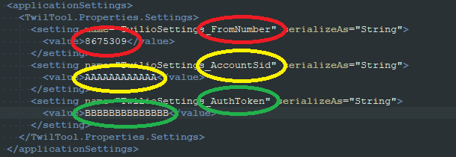

## TroubleShooting

### Missing .NET Framework 4.7.1

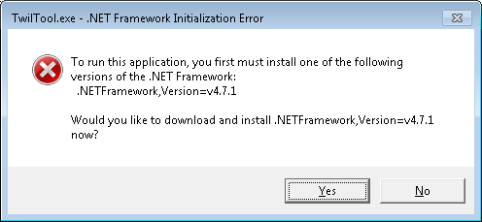

A user may see this box if the .NET framework is not installed. The .NET framework is usually provided by windows via Windows Update, but if it has not been installed on your machine you’ll get the message that you need to install it. Simply click “yes” and you should be sent to a webpage with where/how to download and install the framework. Note: this message is controlled by the windows operating system and is not part of the code base in TwilTool.

### Invalid configuration

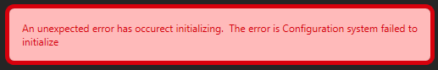

This message typically means that an error was made in the formatting of the configuration file. Ensure that the only changes made to the config file are done so in between the <value> </value> tags. If you accidently alter the value tags, like removing the one of the “>” characters, the config file will not be able to be parsed.

### Invalid Account Sid

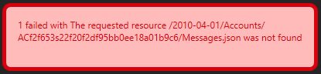

If the Twilio “Account Sid” in the configuration file is incorrect, Twilio will return a message like the one pictured.

### Invalid Auth Token

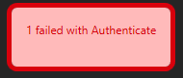

If the Twilio “Auth Token” in the configuration file is incorrect, Twilio will return the “Authenticate” error.

### Invalid Phone Number

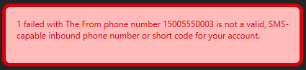

If the Twilio “From Number” in the configuration file is incorrect, Twilio will return a message like the one pictured.

## Error Logs

If the app crashes unexpectedly or is not working as expected, more debugging may be required by an IT professional. TwilTool does it’s best to log any unexpected errors to the following location: %ProgramData%\TwilTool