**Refresh TDE Database Changing Cert and DEK**

In this example, we export a database using its current certificate and restore it from one instance to another. We then change the certificate to the appropriate one for that instance and, then delete the previous one used.

Note: In this test case, we have a database that currently uses a certificates provided by our Certificate Authority. In order to test how to restore from one environment to another without having all certificates in all environments, we export the certificate, create the certificate on the new machine, restore the database, change the certificate that encrypts the database key and, then delete the old certificate initially used for the move (from the other server).

The order of operations will be:

Source:

Look at Certs Being used

Backup Cert and Key

Destination:

Create New Cert from Backup

Restore Database

Check Encryption Status

Alter DEK to use Instance Cert

Delete old Cert

Check Encryption Status and Certs

**Look at Certs Being used**

--Find cert name and corresponding database

use master

go

select db_name(dek.database_id) AS ProtectedDB

, dek.create_date

, c.name

, c.certificate_id

, c.pvt_key_encryption_type_desc

, c.pvt_key_last_backup_date

, c.issuer_name

, c.subject

, c.start_date

, c.expiry_date

from sys.dm_database_encryption_keys dek

inner join master.sys.certificates c on dek.encryptor_thumbprint = c.thumbprint

select * from sys.certificates

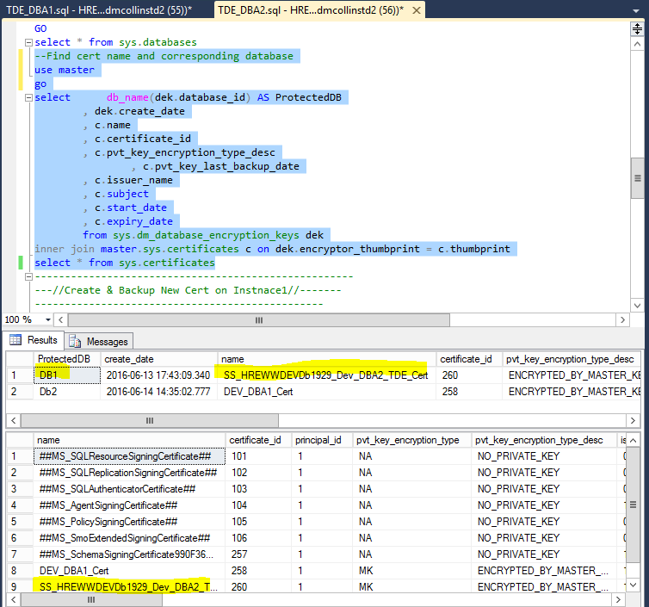

**Backup Cert & Key on Source**

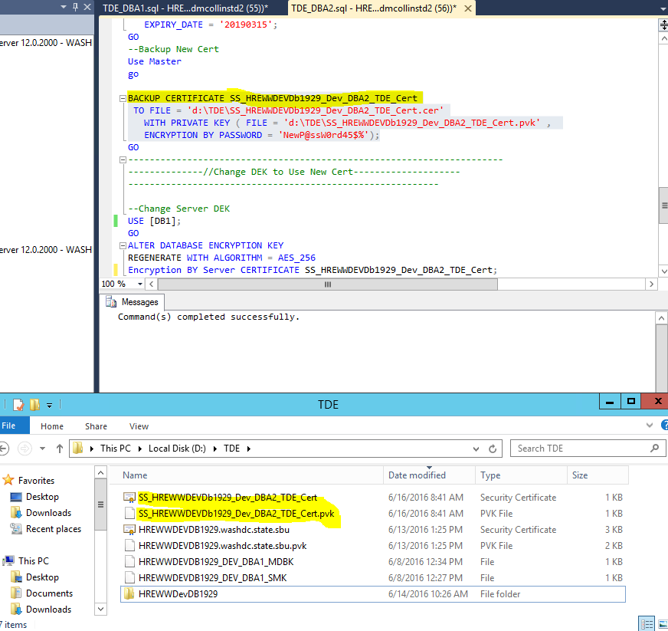

**Backup Database if needed**

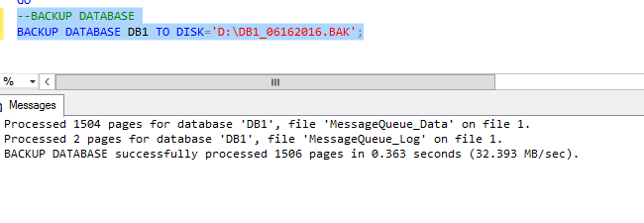

**Look at certs on new server**

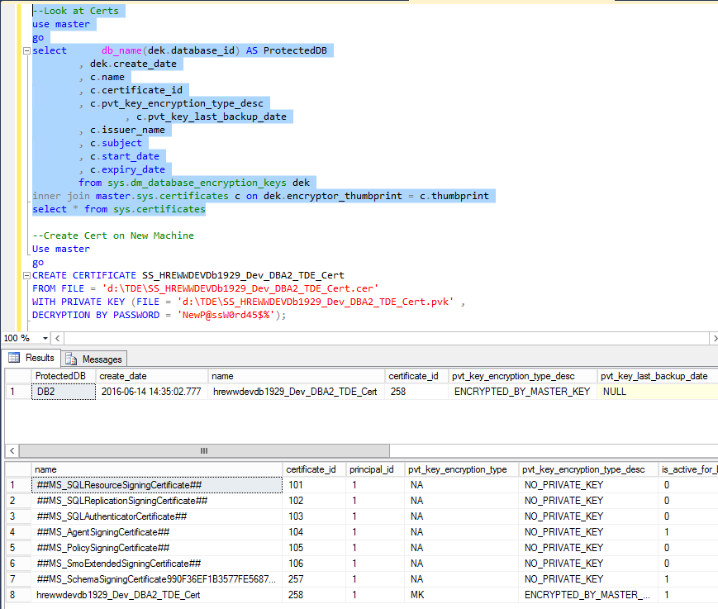

**Create cert on Destination from Source Server**

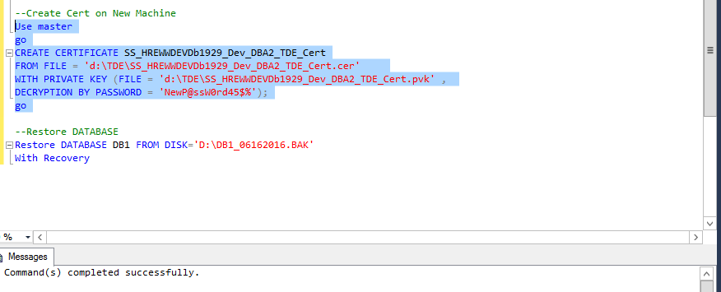

**Make sure Cert is in Master Database**

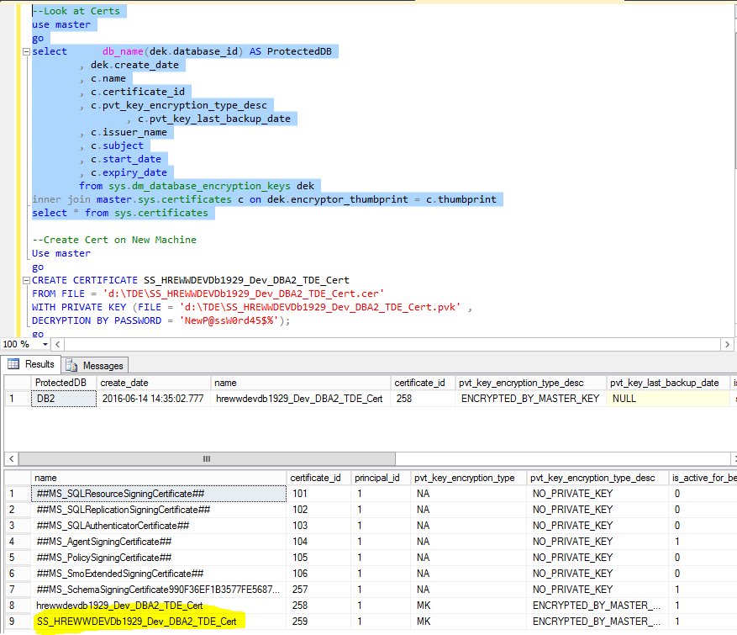

**Restore Database to Destination Server**

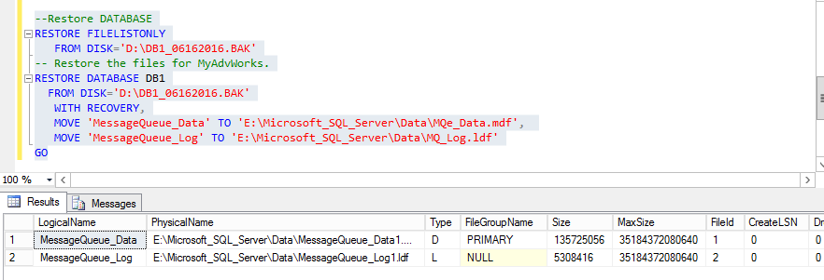

**Look at Certs**

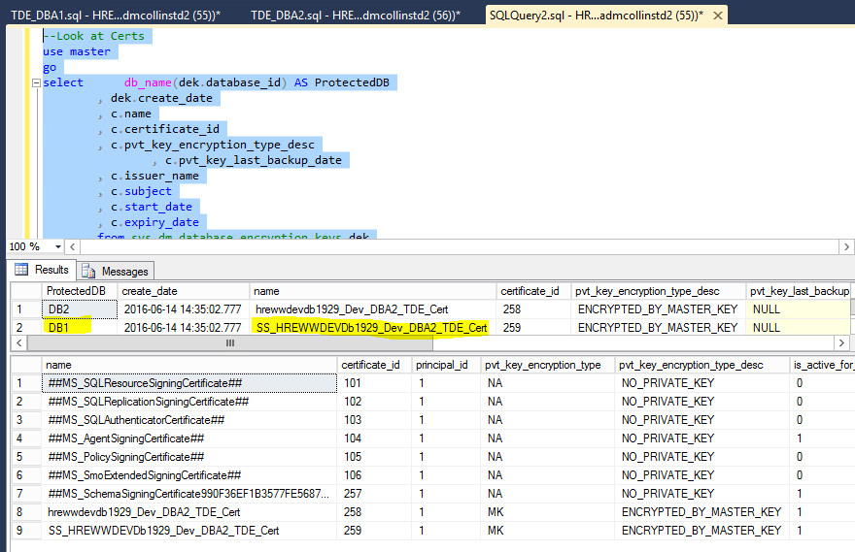

**Change Cert for Database**

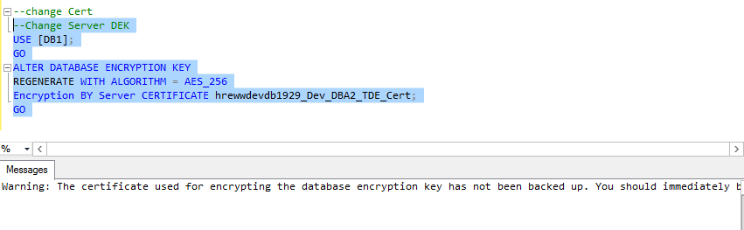

**Drop Source Cert**

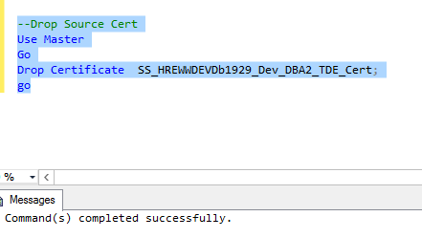

**Check Certs to make sure Source is gone and not used**

