SQL Server TDE and Network Certificate Request

To Request a new Certificate for SQL Server **Transparent Data Encryption**, follow the steps below.

1. Access the Requesting Interface:

Right click on desktop icon to get “Blade”



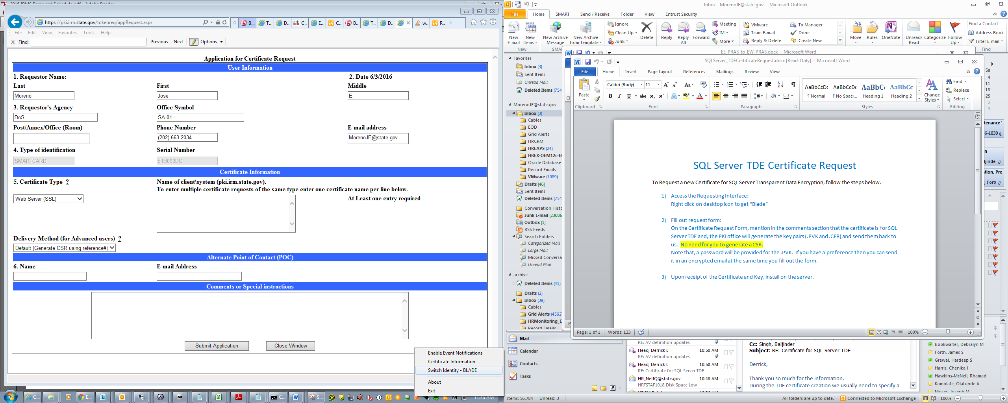

<https://pki.irm.state.gov/tokenreq>

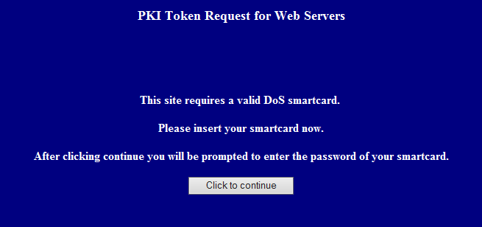

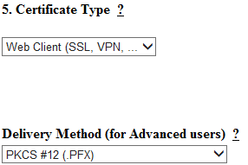

1. Fill out request form:

As noted above use the Certificate Type: Web Client and Delivery Method: PFX

On the Certificate Request Form, **mention in the comments section that the certificate is for SQL Server TDE** and, the PKI office will generate the key pairs (.PVK and .CER) and send them back to us.  No need for you to generate a CSR.

Note that, **a password will be provided for the .PVK.  If you have a preference then you can send it in an encrypted email** at the same time you fill out the form.

1. Upon receipt of the Certificate and Key, install on the server.

----------------------------------------------------------------------------------------------------------------------------

To request a Certificate for **NETWORK ENCRYPTION**, follow the steps below.

For SQL Server 2014 network encryption.

1. The certificate must be issued for **Server Authentication**.
2. The name of the certificate must be the **fully qualified domain name (FQDN)** of the computer.

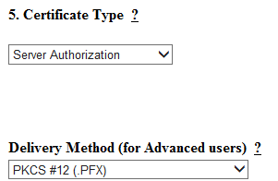

Last updated June, 22 2016………………………………………………………………………Tim Collins