Stevens Institute of Technology
Department of Electrical and Computer Engineering

CpE 646 Pattern Recognition and Classification

Homework 1

Problem 1:
For a one dimensional 2-class problem with 2 actions a₁, a₂ , (a1: choose ω₁; a₂ choose ω₂). We assume P(ω₁) = 3/5, P(ω₂) = 2/5, conditional densities
p(x |ω₁) ~ N(0, 1) and p(x |ω₂) ~ N(2, 4),
where N(µ, σ²) is Normal distribution, µ is mean and σ² is variance.

- Sketch the likelihood function for each class (ref. Figure 2.1). Calculate the likelihood value for each class if x=5.
- Sketch the evidence distribution. Calculate the evidence value if x=5.
- Sketch the posterior probability function for each class (ref. Figure 2.2). Calculate the posterior probability value for each class if x=5.
- Sketch the likelihood ratio function (ref. Figure 2.3). Calculate the likelihood ratio value if x=5.
- Calculate the likelihood ratio threshold for zero-one loss function, i.e. maximum posterior classification
- Calculate the likelihood ratio threshold for the following risk matrix
 | ω₁ | ω₂
a₁ | 0 | 4
a₂ | 2 | 0

- Following 1.6, sketch the Bayes risk (conditional risk R(α_{i}|x) associated with the action α_{i} according to observation x) as a function of x. Calculate the Bayes risk value if x=5.

Problem 2:
For a two dimensional 2-class problem, assume both class conditional densities are Gaussian, with the following estimated distribution parameters
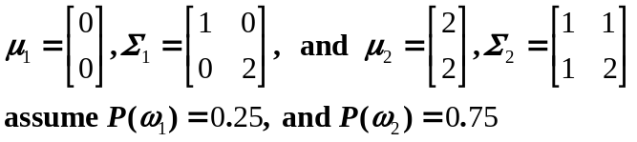

- Calculate the decision boundary.
- Calculate the Bhattacharyya error bound.

