Stevens Institute of Technology
Department of Electrical and Computer Engineering

CpE 646 Pattern Recognition and Classification

Homework 2

Problem 1: For a one dimensional Rayleigh distribution
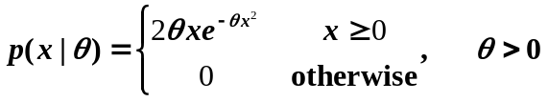

Given n training samples {x₁, x₂, …, x_{n}},
- Calculate the maximum likelihood estimation of parameter θ (follow the example in CPE646-4 pp. 15-16).
- Assume a prior density for θ as a uniform distribution
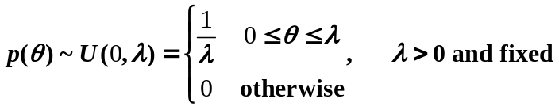

Calculate the Bayesian estimation of parameter θ (follow the example in CPE646-4 pp. 29-32).

Problem 2: For a two dimensional 2-class problem, given the following training sample vectors:
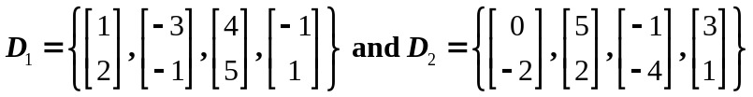

- Calculate the PCA transform vector e for D={D₁, D₂}, and the project of each data sample 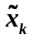 (ref. CPE646-5 pp.21-24).
- Calculate the LDA transform vector w, and the project of each data sample y_{k} (ref. CPE646-5 pp.32-34).
(You can use Matlab to calculate the eigen decomposition and matrix inversion.)

