Homework 2 solutions
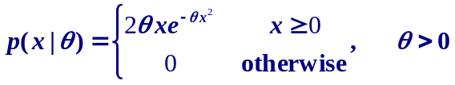
Problem 1.

P1.1 Maximum likelihood estimation
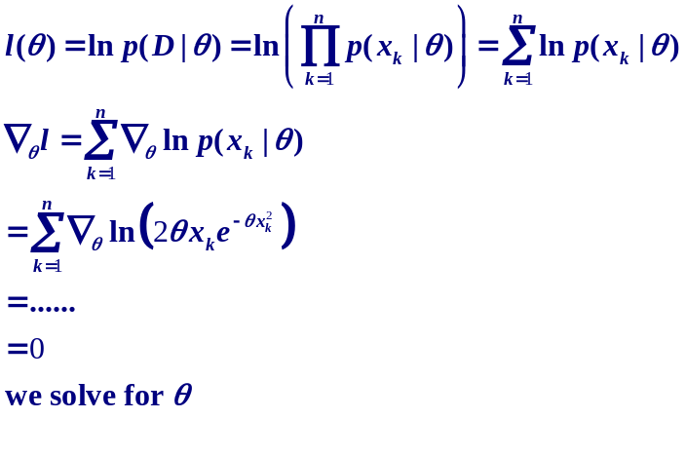

P1.2 Bayesian estimation. Given
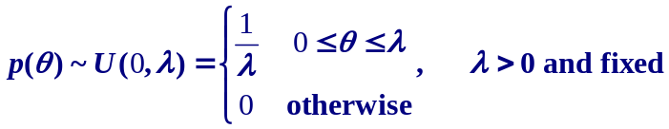

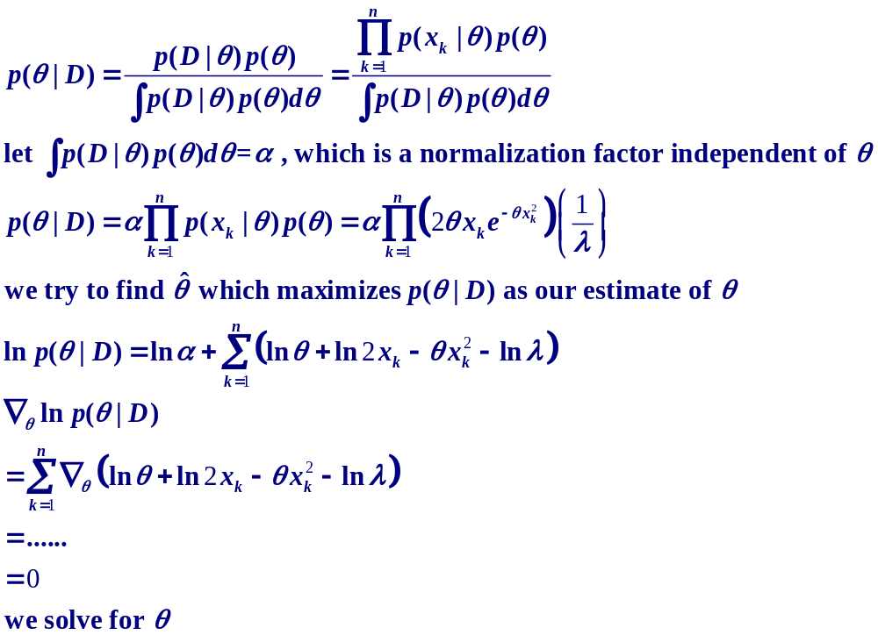We estimate

Problem 2.
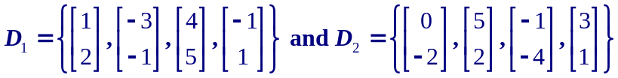

P2.1 PCA
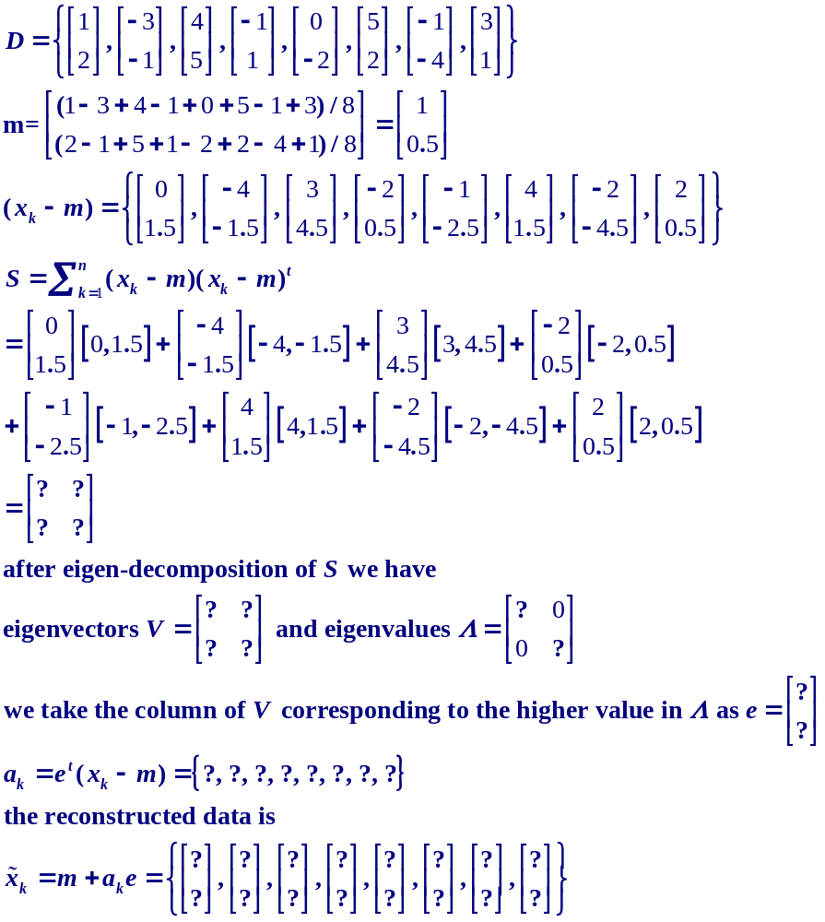

P2.2 LDA
