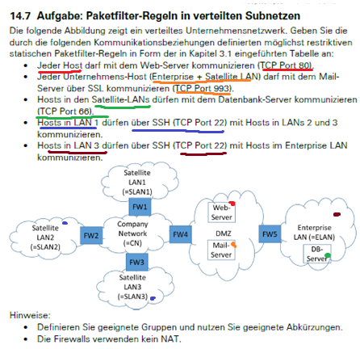

MailServer Gruppe: Enterprise + Satellite LAN

Web-Server Gruppe: Alle

|  |  |  |  |  |  |  |  |  |
| --- | --- | --- | --- | --- | --- | --- | --- | --- |
| Rule | NIC | IP-Src | IP-Dest | Protocol | SrcPort | DestPort | ACK | Action |
| 1 | NICX | WSGr | WS | TCP | 80 | 80 | Any | Permit |
| 2 | NIC2 | WS | WSGr | TCP | 80 | 80 | Yes | Permit |
| 3 | NIC2 | WS | WSGr | TCP | 80 | 80 | Any | Permit |
| 4 | NICX | WSGr | WS | TCP | 80 | 80 | Yes | Permit |
| 3 | NIC3 | MSGr | MS | TCP | 993 | 993 | Any | Permit |
| 4 | NIC4 | MS | MSGr | TCP | 993 | 993 | Yes | Permit |
| 5 | NIC4 | MS | MSGr | TCP | 993 | 993 | Any | Permit |
| 6 | NIC3 | MSGr | MS | TCP | 993 | 993 | Yes | Permit |
| 7 | NIC5 | SLAN1 | DB | TCP | 66 | 66 | Any | Permit |
| 8 | NIC6 | DB | SLAN1 | TCP | 66 | 66 | Yes | Permit |
| 9 | NIC7 | SLAN2 | DB | TCP | 66 | 66 | Any | Permit |
| 10 | NIC6 | DB | SLAN2 | TCP | 66 | 66 | Yes | Permit |
| 11 | NIC8 | SLAN3 | DB | TCP | 66 | 66 | Any | Permit |
| 12 | NIC6 | DB | SLAN3 | TCP | 66 | 66 | Yes | Permit |
| 13 | NIC5 | SLAN1 | SLAN2 | TCP | 22 | 22 | Any | Permit |
| 14 | NIC7 | SLAN2 | SLAN1 | TCP | 22 | 22 | Yes | Permit |
| 15 | NIC7 | SLAN2 | SLAN1 | TCP | 22 | 22 | Any | Permit |
| 16 | NIC5 | SLAN1 | SLAN2 | TCP | 22 | 22 | Yes | Permit |
| 17 | NIC5 | SLAN1 | SLAN3 | TCP | 22 | 22 | Any | Permit |
| 13 | NIC8 | SLAN3 | SLAN1 | TCP | 22 | 22 | Yes | Permit |
| 13 | NIC8 | SLAN3 | SLAN1 | TCP | 22 | 22 | Any | Permit |
| 17 | NIC5 | SLAN1 | SLAN3 | TCP | 22 | 22 | Yes | Permit |
| 18 | NIC8 | SLAN3 | ELAN | TCP | 22 | 22 | Any | Permit |
| 19 | NIC6 | ELAN | SLAN3 | TCP | 22 | 22 | Yes | Permit |
| 20 | Any | Any | Any | Any | Any | Any | Any | Deny |

Ein Bild, das Tisch enthält.

Ein Bild, das Text, Tisch enthält.
