Project Javascript Quiz

Teamnaam: [TEAMNAAM]

Team: R. Springer, M. van Linden

Cohort: 2020

Klant:

Versie: 1.0

Datum: 8-7-2020

Technisch Ontwerp

ROC Mondriaan | Den Haag

2020

# Inhoud

Inhoud 1

1 Klassendiagram 2

2 Sequentiediagram 3

2.1 Applicatie starten 3

2.2 move 4

2.3 re start 5

# Klassendiagram

1

1

1

1

FourInARowView

+constructor(data:Data)  
+bindStartButton()  
+drwawGame(handler: String)  
+Changed(event: FourInARowEvent )  
+drawMove()  
+gameOver()  
+rematchButton(handler: String)

FourInARowController

-Model:FourInARowModel  
-View:FourInARowView

+Constructor()  
+handleUserData(id: Integer)  
+restart()

FourInARowModel

-data([])  
-data.board([])  
-data.currentPlayer(1: Integer)  
-data.gameStatus(playing: String)  
-data.player1Score(0: Integer)  
-data.player2Score(0: Integer)  
-data.winingRow([])

+constructor()  
+Move(id1: Integer)  
+switchPlayer(player: Integer)  
+restart()  
+checkForWin()  
-_commit()

# Sequentiediagram

## Applicatie starten

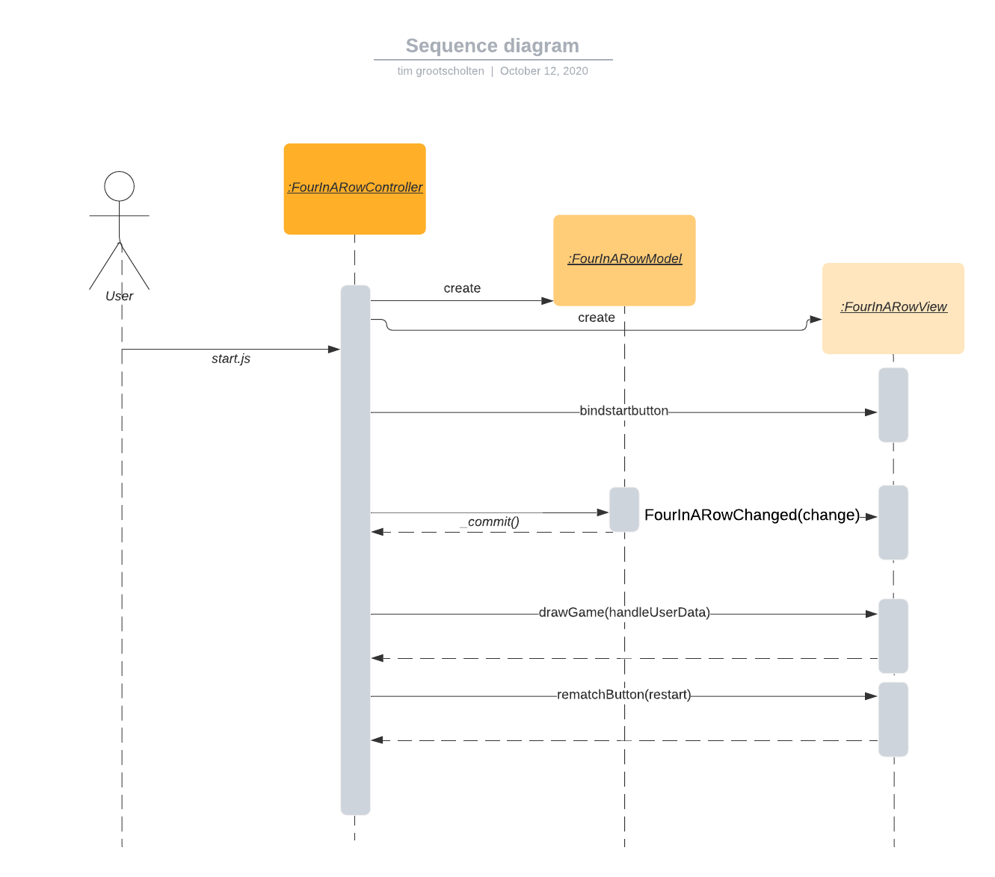

## move

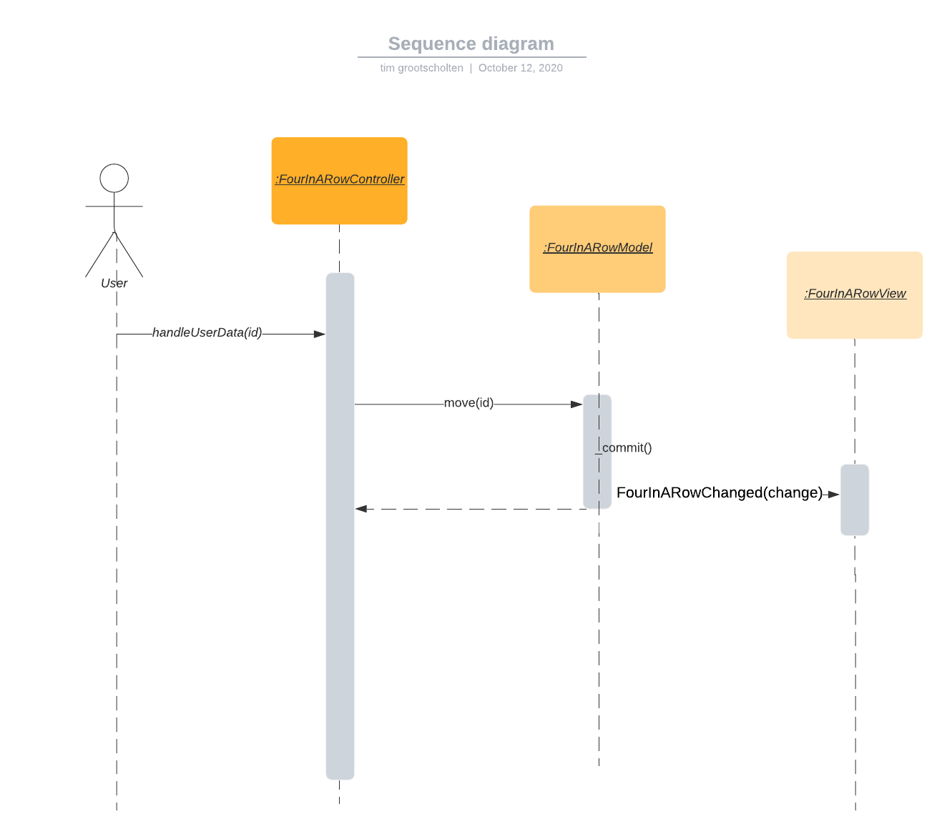

## re start

