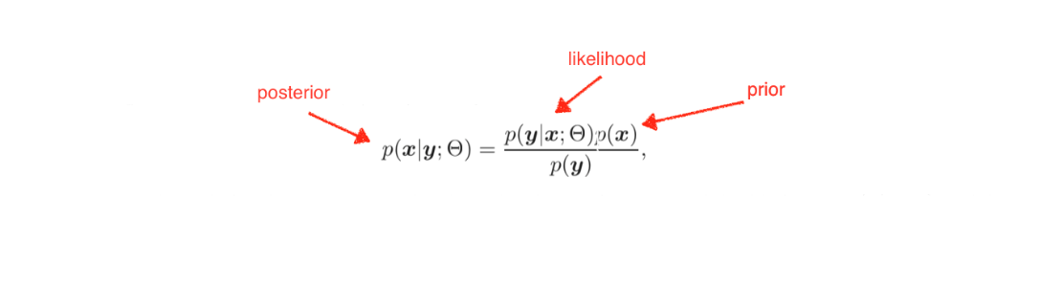

Estimated X

X

Y

Blurring

downsampling

Model N

Model 1

Training Prior

Choice of likelihood distribution

Benchmark:

1. Computation cost
2. Image quality

Test Images