**FNDev2 Coursework**

THMusic: Music Collection

**User Guide**

**Table of Contents**

Scope 3

Introduction 3

Application pages 3

Application Pages 4

The Main Page: Collection Summary by Artist 4

The Albums Detail Page: All albums for selected Artist 6

The search LastFM page: 7

The Search for MP3 page 8

Future Development 9

Album Details Page: 9

Search LastFM Page 9

Search MP3 Page: 9

# Scope

## Introduction

This guide discusses the individual pages that make up the THMusic Music Collection application. Each page is described in turn and includes a sample layout, a description of the functionality and how to use it. It also describes the links to other pages in the application.

## Application pages

The application consists of the 3 separate pages.

***Main page***: this is the Artist summary page, which shows the albums contained in the collection summarised by Artist. It also displays the summaries by Genre and Playlist.

***Album Details page***: this is a split page, showing the albums contained in the selected group on the left and the details of the album on the right

***Search LastFM page***: this allows the LastFM service to be searched for albums and provides the ability to import them.

***Search MP3 page***: this allows the local machine to be searched for audio files to import into the collection.

The main page has application toolbars that provide access to the categories for grouping the albums as well as access to the Import facilities for LastFM and MP3 and audio files.

The following sections describe each page in detail.

# Application Pages

## The Main Page: Collection Summary by Artist

### Description

This page is the opening page of the application. It shows the contents of the collection, summarised by Artist, which is the default grouping. It is possible to summarise the collection by Genre or Playlist.

Figure 1 below shows a sample layout of the page.

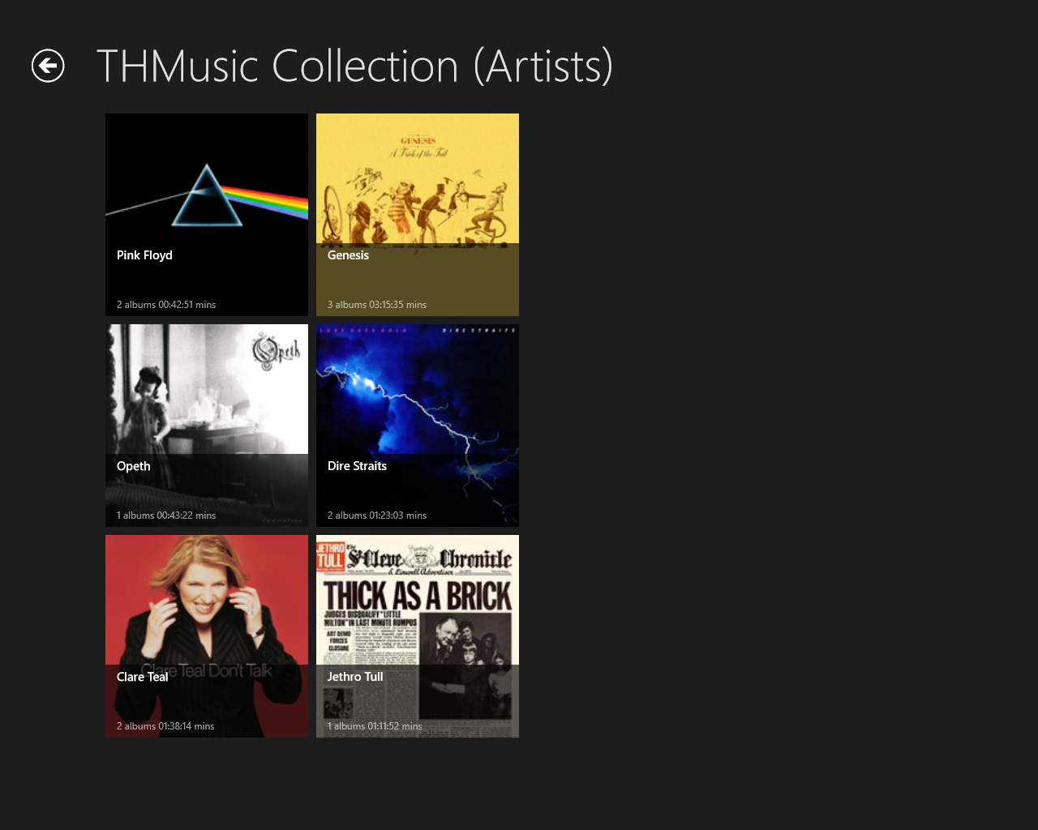

Figure 1 - Main Page, showing summary by Artist

### Functionality

The page requires limited functionality to browse the collection. The standard Windows 8 Store app mouse operations and touches will scroll the collection.

Clicking on a particular image, which is the Artist summary, will move to the details page showing the details for the selected Artist. This applies equally when displaying albums grouped by Genre and by Playlist.

It is possible to alter the summary, to Genre or Playlist. Access to this functionality is via the App bars available on this page. Importing album information into the collection can be done by either Searching the LastFM web site or by searching the local computer music folder for audio files. Access to this functionality is also via the appbars.

Right click the mouse to display the appbars. The top appbar allows the summary to be changed, by seleting the appropriate radio button then clicking the Refresh button that is displayed when the summary is changed. The bottom appbar provides the import functionality. Figure 2 below shows the same opening page with the appbars activated providing the access to this functionality.

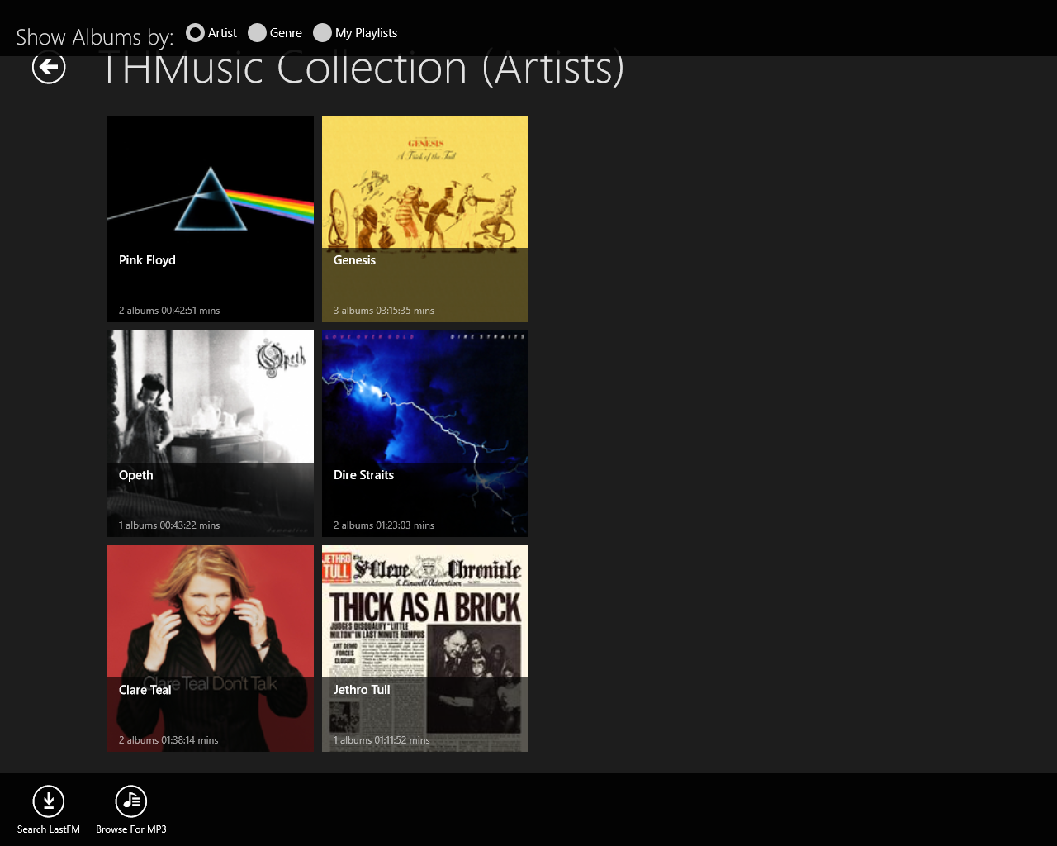

Figure 2 - The main page with AppBars activated

### Links

Click an Artist: Goes to the Album Details page, showing the albums and detail for the Artist

Click the Search LastFM button: Goes to the Search LastFM page

Click the Import MP3 button: opens the ***FileOpenPicker*** to allow selection of audio files.

## The Albums Detail Page: All albums for selected Artist

This page shows the list of albums for the selected Artist. Selecting an album on the list will display the detailed contents of the album on the right hand side panel.

The album information includes all tracks, any wiki related information loaded from LastFM and provides the ability to play a track if it also refers to a locally stored audio file.

Below is a sample of the page layout for an Artist, however, it applies equally for a selected Genre or Playlist. If a playlist is selected, only the tracks included in the playlist are shows for the album rather than all tracks. Figure 3 below shows a sample page with track selected to play.

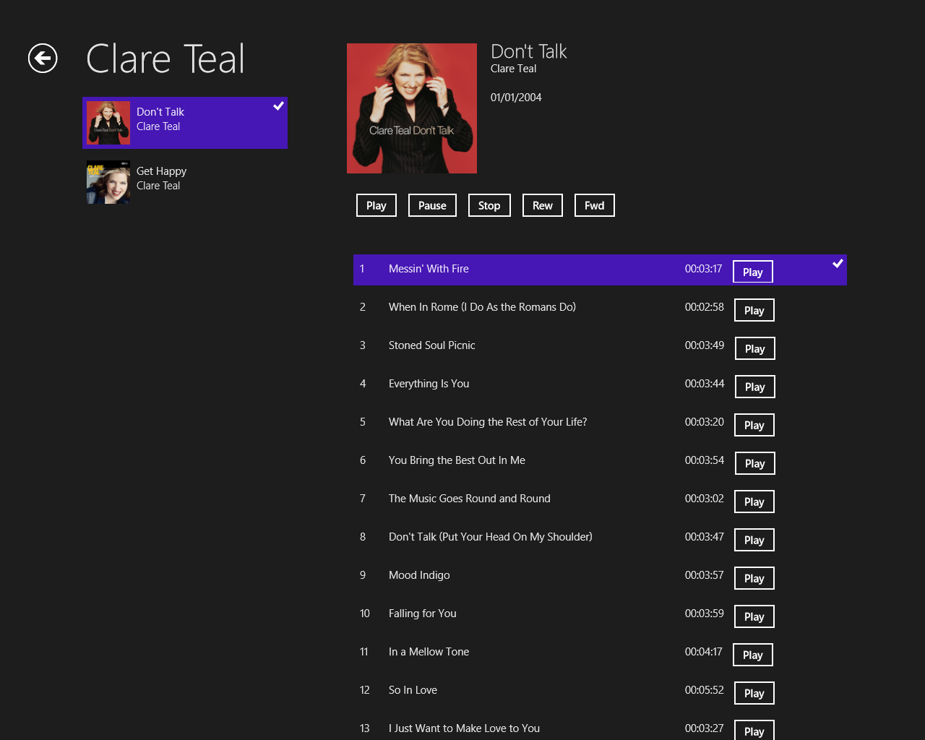

Figure 3 - Album details for a selected Artist, with playable tracks

### Functionality

Selecting an album from the list on the left will display its contents on the right.

If the content for the album is more than a page, the column is scrollable. The wiki information is shown below the tracks. When displaying a Playlist, only the track in the playlist appear under the album details.

Selecting a track for the album will display the medial player button, if the track has a reference to a locally stored audio file. The Play, Stop and Pause buttons work as expected. If a track is playing and another track is selected, it will keep playing until the play button is pressed for the new track.

Links

The only link from this page is the back button which returns to the Main page.

## The search LastFM page:

This page is accessed from the main page by selecting an Artist, or other group summary, image.

It displays a search page, which allows criteria to be entered and then performs a search against the LastFM web service for a matching album’s details. Figure 4 below shows a sample page, with some results displayed.

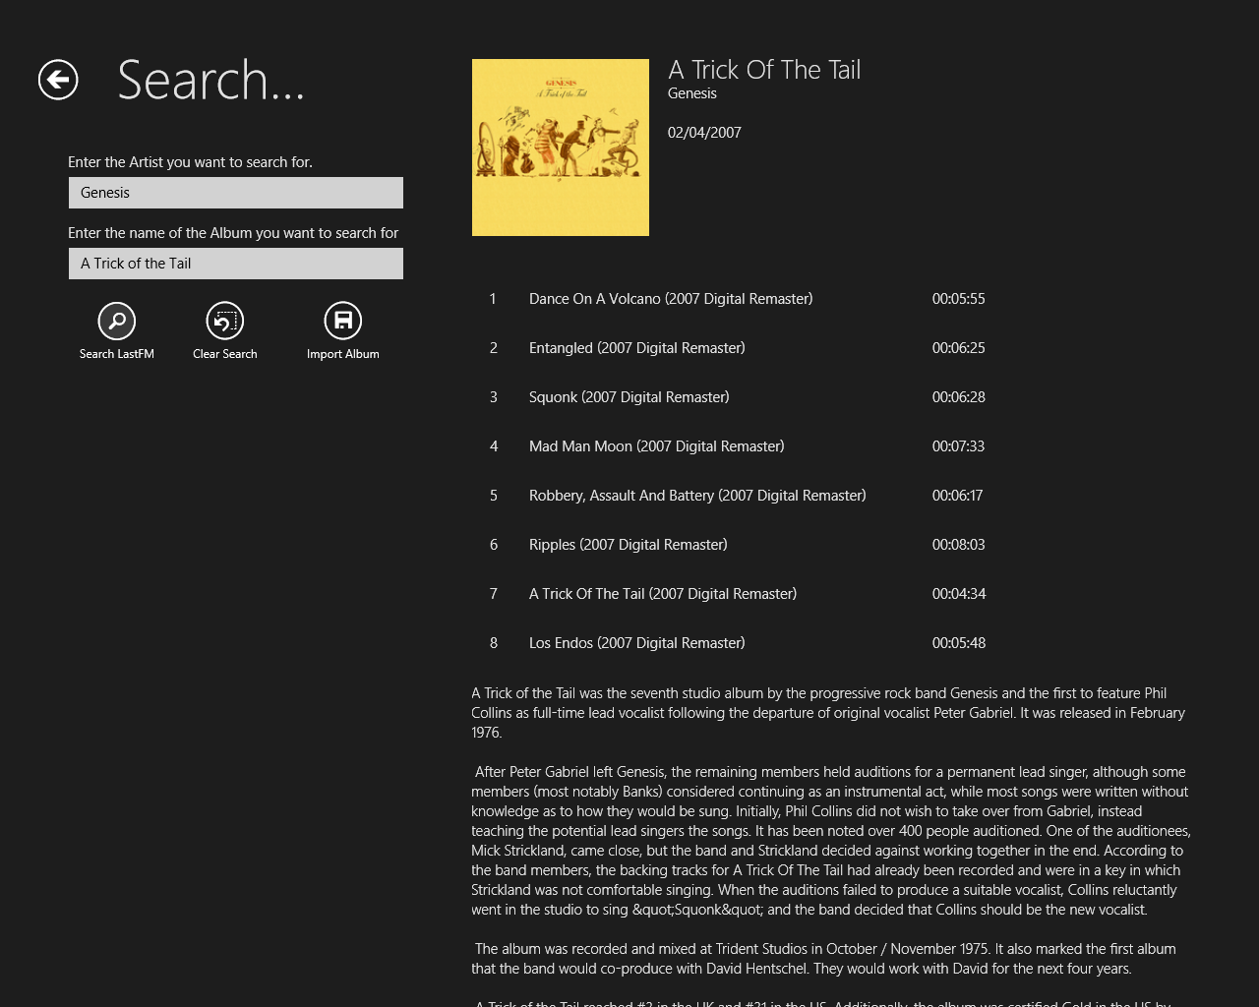

Figure 4 - Search LastFM: with results shown

### Functionality

To perform the search, an Artist Name and an Album name should be entered into the appropriate text box.

Then, clicking the ***Search LastFM*** button will initiate the search. When the results are returned they are displayed in the right column, which is scrollable should the results be more than the screen can display. If the album in not found nothing is shown on the right. This is a potentially long running operation, but currently there is no user feedback to indication this. This should be rectified before any release of the application was intended. See *Future Development* section for this page.

To import the album into the collection, click the ***Import Album*** button.

Clicking the ***Clear Search*** button will clear the search criteria and the results shown.

### Links

The only link from this page is the back button, which returns to the main page

## The Search for MP3 page

This page is the standard FileOpenPicker and allows the local machine to be searched for audio files. It should be noted that the application will only play audio files located within the users Music folder. This is a restriction imposed by the Windows 8 Store application design.

Although the page title is ***Search For MP3***, it will not restrict the search to MP3 files, other audio formats can also be selected. Figure 5 below shows a sample of the page for ***wma*** files.

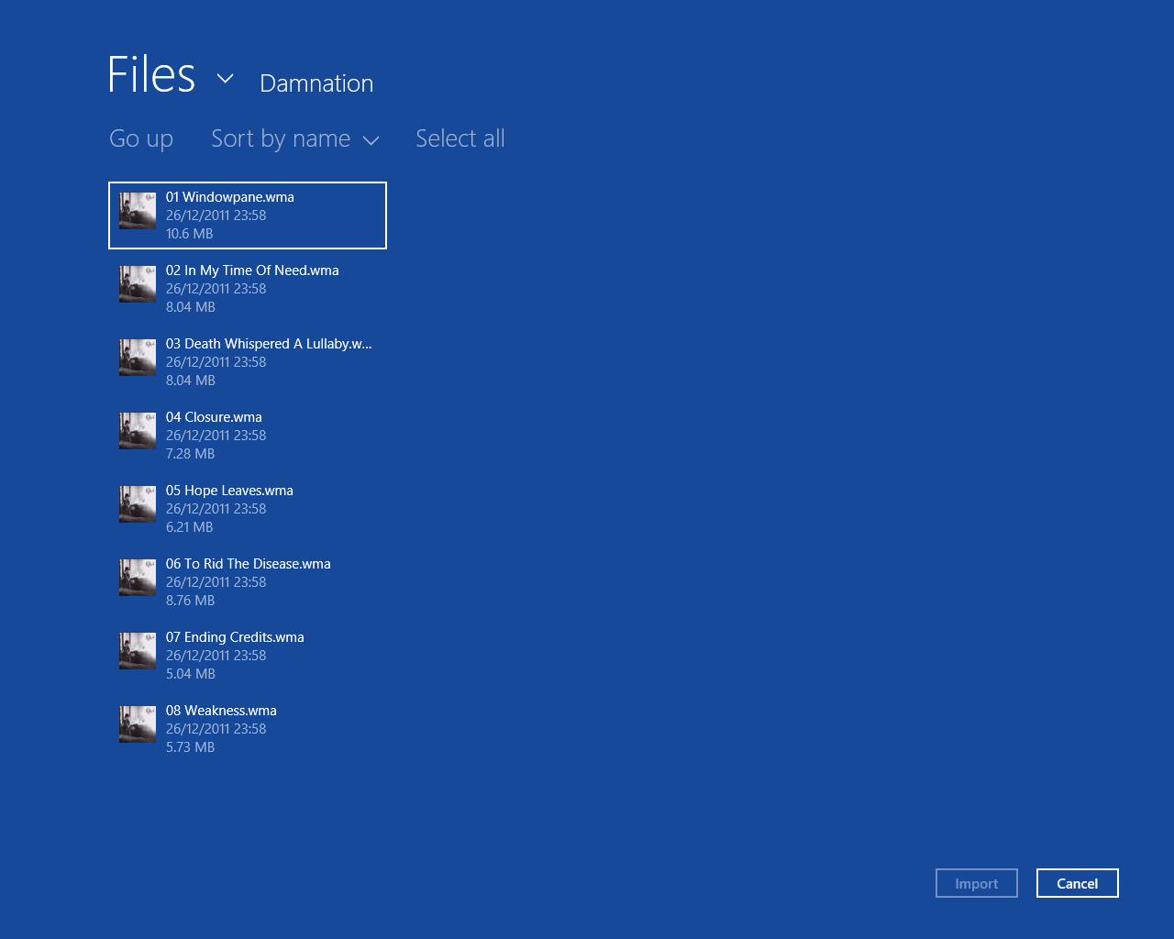

Figure 5 - Search for MP3 files

### Functionality

From this page it is possible to select a single or multiple audio files at a time. The import button will then import the selected audio files into the collection.

Should the Album they belong to already exist, it will attempt to add them to the existing tracks, by matching the track title.

### Links

Clicking the back button will return to the main page

Clicking the cancel button also returns to the main page, without importing anything

Clicking the Import button will import the selected tracks and return to the main page.

# Future Development

## Album Details Page:

* If a track is playable, is should be highlighted in a different colour.
* An option to play all tracks should be included
* A link should be included to add the track to a Playlist. This is highlighted in the System Design document as the Playlist maintenance is not implemented yet, but reserved for future development.

## Search LastFM Page

* When the search is clicked this is a potentially long operation, so the Windows 8 circling dots should be displayed to indicate that a long running task is executing.

## Search MP3 Page:

* This page should also cause a potentially long operation, and the Windows 8 circling dots should also be displayed to indicate this, but these would be displayed on the main page.
* The System Design document highlights in the future development, the caching of LastFM calls to improve the response time of this operation.