The Flavorful Tuscany Meetup

Welcome letter
Dear Guest,
We are delighted to welcome you to the annual Flavorful Tuscany Meetup. We hope you will enjoy the program as well as your stay at the Bilancino Hotel.
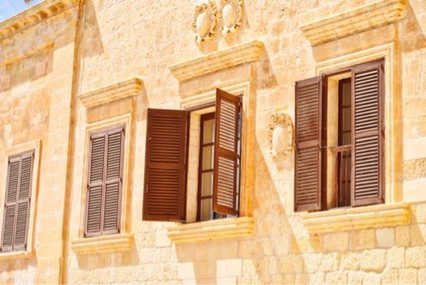
Please find below the full schedule of the event.
Bilancino Hotel
Saturday, July 14
9:30 AM - 11:30 AM | Americano vs. Brewed - “know your coffee” with:  - Giulia Orlanda  - Stefano Garau  - Giuseppe Russo
1:00 PM - 3:00 PM | Regional delicacies of Tuscany - live cooking  Incorporate the freshest ingredients  with Rita Fresco
5:00 PM - 8:00 PM | Tuscan vineyards at a glance - wine-tasting  with Frederico Riscoli
The annual Flavorful Tuscany meetups are always a culinary discovery. You get the best of Tuscan flavors during an intense one-day stay at one of the top hotels in the region. All the sessions are led by top chefs passionate about their profession. I would recommend saving the date in your calendar for this one!
Angelina Calvino, food journalist
Please arrive at the Bilancino Hotel reception desk at least half an hour earlier to ensure that the registration process goes as smoothly as possible.
We look forward to welcoming you to the event.
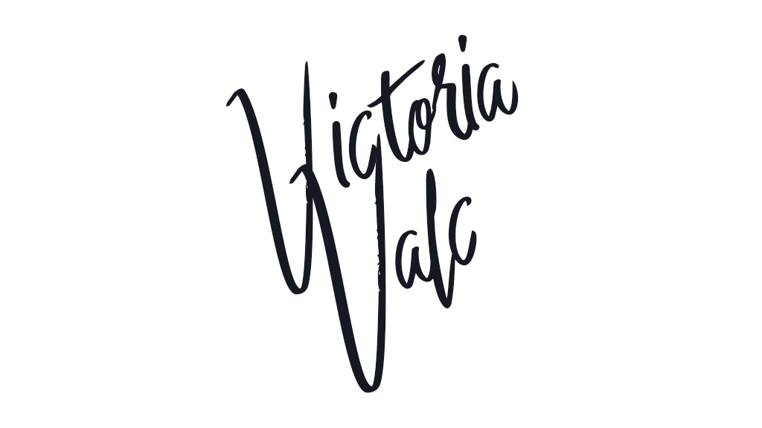
Victoria Valc
Event Manager
Bilancino Hotel

